***SVN Repository in FishEye-Crucible***

* Please refer to [Supported platforms](https://confluence.atlassian.com/display/FISHEYE/Supported+platforms) to see the version of Subversion that is required by FishEye.
* Here I have used http protocol to access svn repository.

Prerequisites are subversion installation with apache 2.2 option ticked while installing (Default is apache 2.0). And, apache httpd server 2.2 like Apache2.2x86

* Uninstall subversion present in your machine.
* Again install subversion with apache2.2 binding in setup wizard
* Goto <https://archive.apache.org/dist/httpd/binaries/win32/> and install [httpd-2.2.25-win32-x86-no_ssl.msi](https://archive.apache.org/dist/httpd/binaries/win32/httpd-2.2.25-win32-x86-no_ssl.msi)
* Below are my commands and output, for example.

D:/>svnadmin create svnhttprepo

D:/svnhttprepo>htpasswd.exe -c

D:/svnhttprepo/basic.password user_name

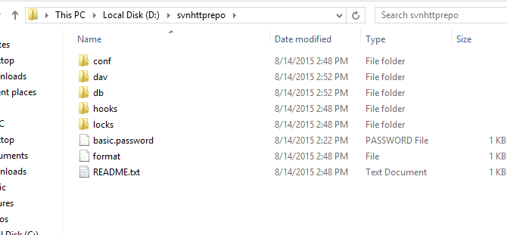

* Copy mod_dav_svn.so and mod_authz_svn.so from subversion bin folder to apache module folder
* Add following lines on your http.conf file

# SVN over HTTP

LoadModule dav_module modules/mod_dav.so

LoadModule dav_svn_module modules/mod_dav_svn.so

LoadModule authz_svn_module modules/mod_authz_svn.so

# Configure Subversion repository

<Location /svn>

DAV svn

SVNPath D:/svnhttprepo

ErrorDocument 404 default

# ErrorDocument 500 default

AuthType Basic

AuthName "Subversion repository"

AuthUserFile D:/svnhttprepo/basic.password

Order deny,allow

Require valid-user

</Location>

* Start your apache server through command line

>httpd.exe

* Check it on your browser.
* For a good UI start your tortoiseSVN.

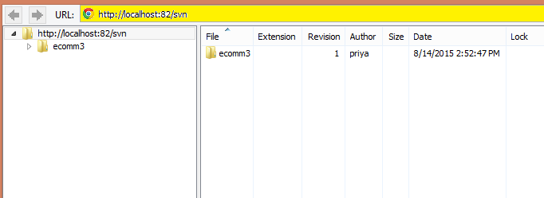

* Now go to FishEye Crucible.
* Add subversion repository
* Give subversion url.
* You can checkout the code anytime you want by clicking on checkout on right top corner. Copy url and run on cmd.
* You can add and create reviews as well as browse svn repository.