Internship Task Report
Task 3: Data Visualization
Intern Name | Priyal Rasal
Internship Role | Data Analyst Intern
Supervisor | [Supervisor Name]
Date | September 1, 2026
Dataset | Global Superstore.csv

1. Objective
Building on the Task 2 EDA findings, this task focused on transforming the cleaned retail sales data into clear, well-designed visuals using Python (Matplotlib and Seaborn) — turning raw numbers into a data story that supports business decision-making, and assembling the result into a small visualization portfolio.

2. Tools Used
- Python 3 with pandas — for data preparation ahead of plotting
- Matplotlib — for core chart rendering and layout control
- Seaborn — for statistical chart types (boxplot, heatmap) and consistent styling
Note: For an interactive, shareable dashboard version of this portfolio, the same charts could be rebuilt in Tableau or Power BI.

3. Data Preparation
Sales and Profit columns were converted to proper numeric types before analysis. Since the Order Date column contained invalid entries, the Year column was used instead for time-based trend analysis.

4. Visualizations

4.1 Yearly Sales Trend

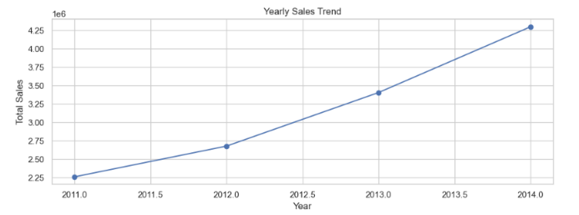Figure 1 — Total sales by year, showing consistent growth from 2011 to 2014.
Story: Sales grew steadily year over year, nearly doubling from 2011 to 2014. This consistent upward trend suggests healthy, sustained business growth rather than a one-time spike.

4.2 Average Sales by Category
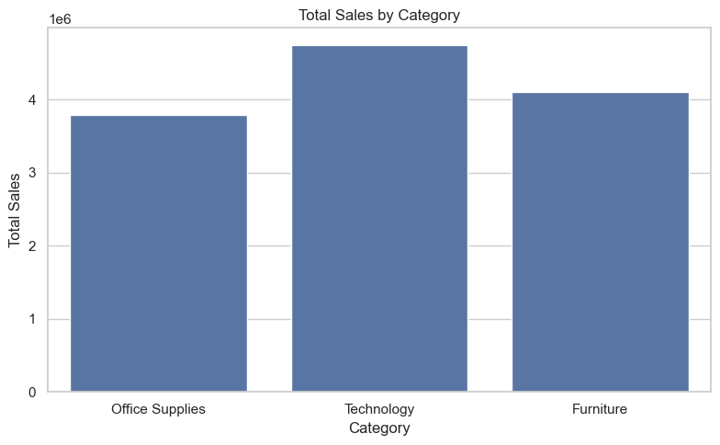
Figure 2 — Technology leads average sales among all categories.

Story: Technology drives the highest total sales, followed by Furniture and Office Supplies.

4.3 Sales Distribution & Outliers by Category
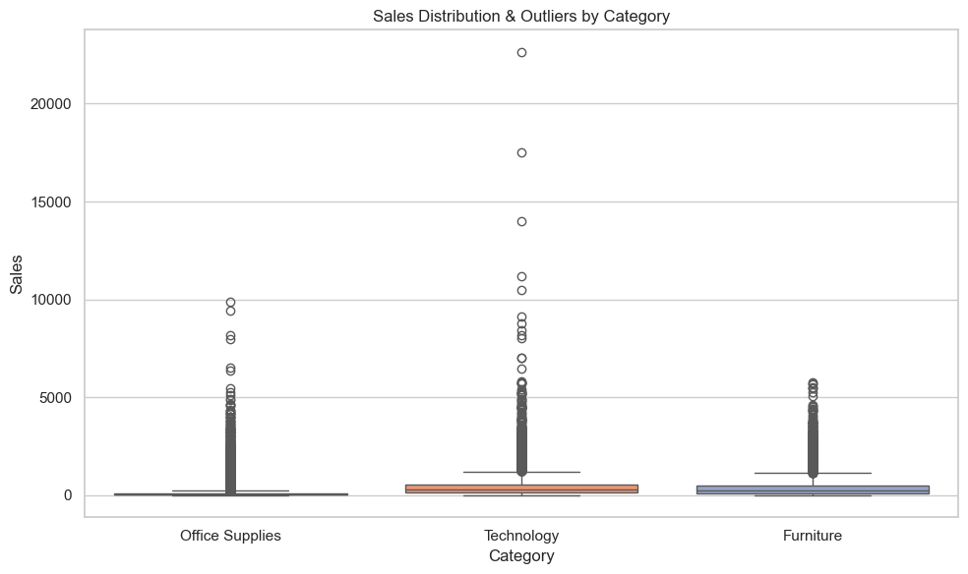
Figure 3 — Boxplot showing the spread and outliers in sales for each product category.
Story: Technology shows the widest spread and the most extreme outliers, with a few orders reaching well above $20,000 — consistent with high-value bulk purchases. Office Supplies and Furniture are far more tightly clustered around lower sales values, meaning their order sizes are more predictable and consistent. This suggests Technology sales are driven by a mix of many small orders and a handful of very large ones, which is worth keeping in mind when forecasting revenue for that category.

4.4 Total Profit by Region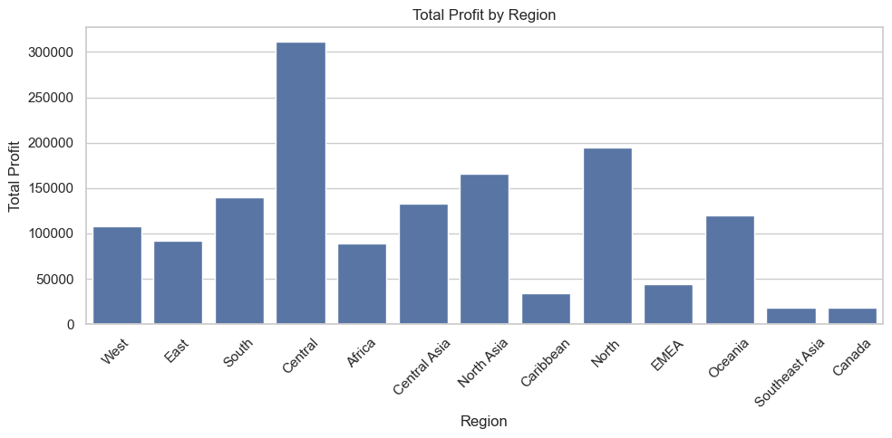

Figure 4 — Central region generates the highest total profit among all regions.
Story: Profit varies significantly by region, Central leads by a wide margin, while regions like Southeast Asia and Canada contribute comparatively little. This could guide where to focus regional strategy or investigate underperformance.

4.5 Correlation Heatmap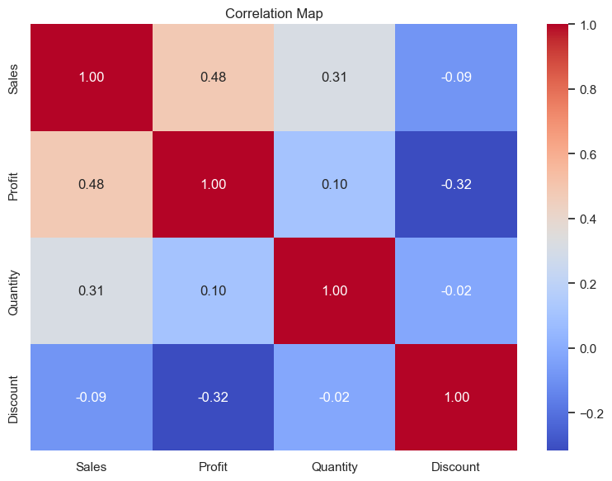
Figure 5 — Discount shows a negative correlation with Profit (r = -0.32).

Story: Sales and Profit are moderately correlated (r = 0.48), as expected. More notably, higher discounts are associated with lower profit (r = -0.32) — suggesting discounting strategy should be reviewed carefully, as it may be eroding margins.

4.6 Unit Price vs. Units Sold

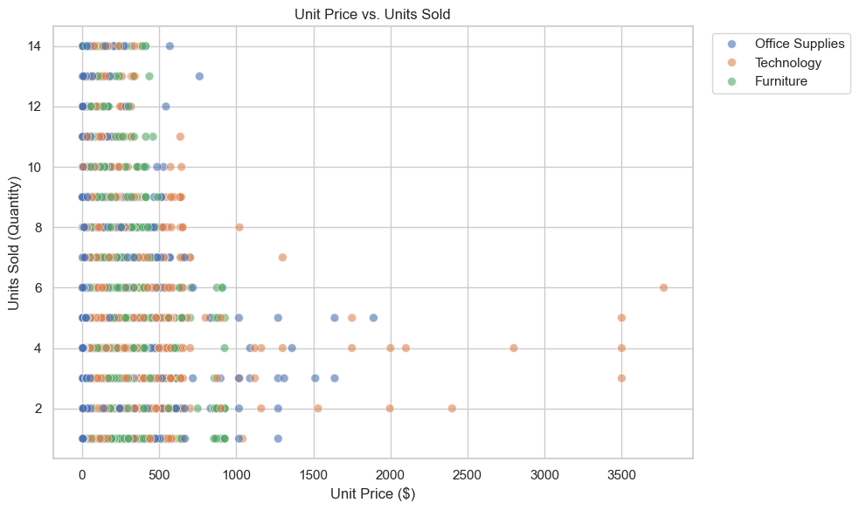

Figure 6 — Scatter plot of price against quantity sold, colored by category.
Story: There's no strong price-sensitivity pattern visible — customers buy similar quantities across a wide price range within each category, suggesting demand isn't highly elastic at these price points.

5. Design Choices
- Consistent color palette (blues) used across charts for a cohesive, professional look.
- Chart type matched to the question: line for trend over time, bar for category comparison, boxplot for distribution/outliers, grouped bar chart for regional comparison, heatmap for relationships, scatter for two-variable patterns.
- Titles and axis labels written in plain language, not just column names, so the charts are readable without extra context.
- Legends placed outside the plot area (scatter chart) to avoid obscuring data points.

6. Key Learnings
- Practiced choosing the right chart type for the question being asked, rather than defaulting to bar charts.
- Learned to pair every chart with a short written insight — a chart alone doesn't tell the story, the caption does.
- Used Seaborn's statistical plot types (boxplot, heatmap) to communicate distribution and correlation more effectively than raw tables.
- Built a small reusable visualization script that can be pointed at any similarly-structured sales dataset.

7. Conclusion
This task turned the raw findings from Task 2 into six clear, decision-ready visuals covering trend, comparison, distribution, share, correlation, and relationship analysis. Together they form a compact visualization portfolio piece that communicates the same insights faster and more persuasively than the underlying tables alone.

