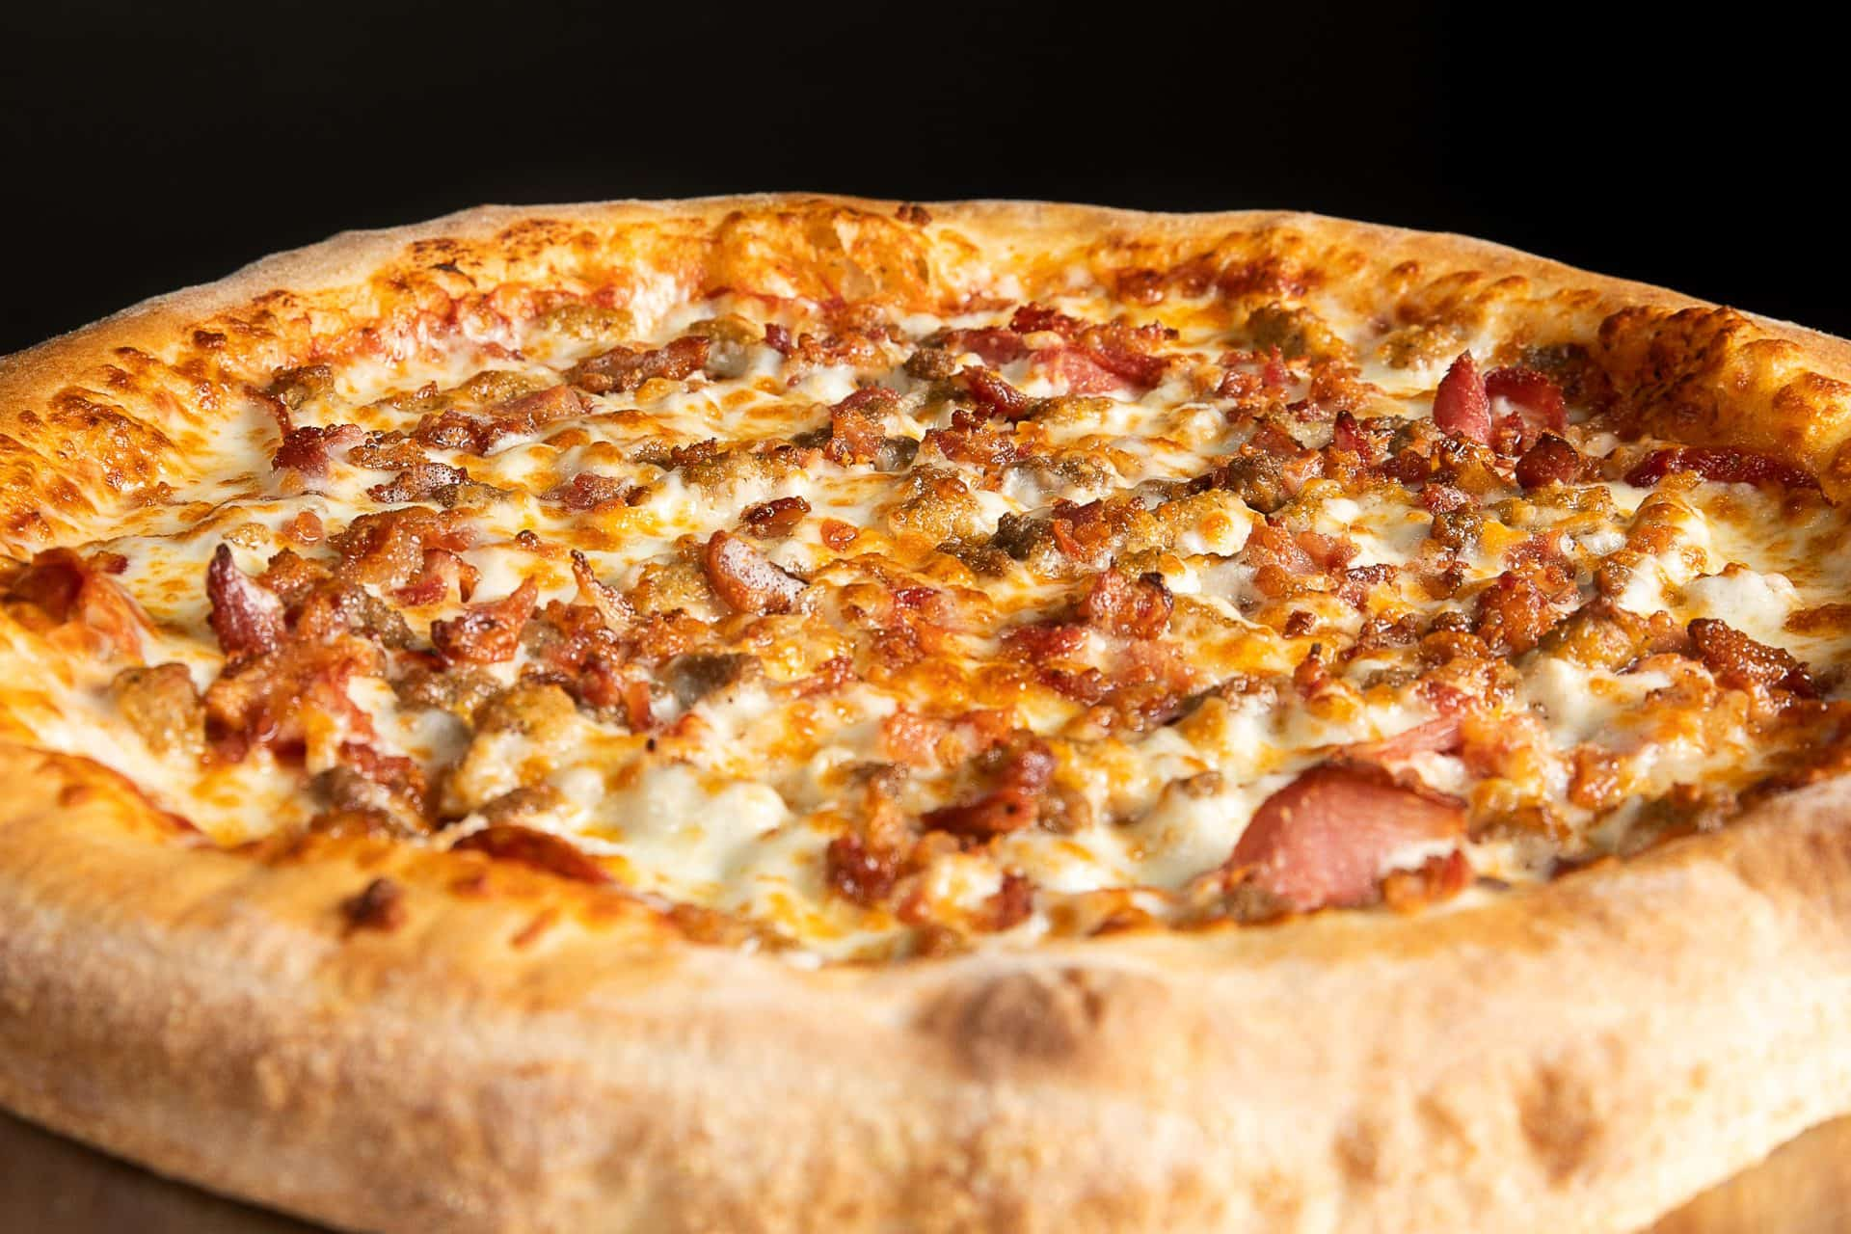

MAD MUSHROOM |

DIGITAL AND SOCIAL MEDIA

MARKETING CASE COMPETITION

Preview Report

Ayushi Sheth, Priyal Vora, Varsha Mestha
March 07, 2022
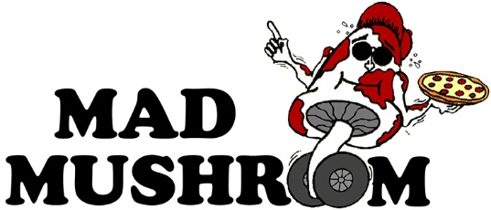
Table of Contents
Client Profile 1
Location
Number of Employee
Industry Sector
Goods Offered
Marketing Personnel

Current Marketing Analysis 1-2

Social Media Overview 2

Company SWOT Analysis 3

Social Media SWOT Analysis 4
Analysis

References 5

Client Profile

Name | Mad Mushroom
Location | 320 W State St, West Lafayette, IN 47906  Mad Mushroom has operations is Indiana and Kentucky.  In Indiana, there are shops in West Lafayette and Lafayette. In Kentucky, Mad Mushroom operates in Lexington, Richmond, and South Lexington
Number of Employees | Mad Mushroom employs 121 people company-wide and 44 in West Lafayette shop
Industry sector | Food & Beverages, Restaurant Chain
Goods offered | Pizza, pasta, sides, cheese sticks, salads, grinders, calzones, desserts
Marketing Personnel | Mike Hansen – Marketing Manager

Current Marketing Analysis

For Indiana, their current target segment looks like an 18–24-year-old college student. However, in future, the potential target segment that they could expand to would be an 18–28-year-old college student, which would cover the average age of Purdue graduate students as well as Ph.D. students. A secondary segment that they should expand to is of the repeat customers, given the fact that Mad Mushroom has established good brand loyalty, being in the prime location of Purdue University, and can hence effectively make use of this for their daily and weekly deals. Furthermore, Mad Mushroom can look into partnering with fraternities, sororities as well as student organizations on campus.
Their main competitors in the Indiana branches are Hotbox Pizza, Papa Johns, Dominos, and Pizza Hut while for their Kentucky branch, their competitors are LaRosa's and Big City.
The marketing position of Mad Mushrooms currently looks like a small independent chain of full-service pizzerias, located primarily near college campuses, whilst expanding to residential areas.
Mad Mushroom currently runs paid ads on Facebook, Instagram, and Twitter. They are, however, moving towards lesser paid marketing on Facebook as their clientele at Purdue has migrated to Instagram as their preferred social media platform. The monthly budget is used to distribute ads via the other platforms with a heavy focus on Instagram/Stories and Twitter.
It also conducts a print ad program that consists of mailers throughout the year. This ranges from menus, postcards, and magnet mailers with various deals and coupons on them.

Social Media Overview

Mad Mushroom has a well-maintained website, and it is present as well as active on 3 social media platforms: Facebook, Instagram, and Twitter.

Platform | Follower Count | Link
Facebook | 2554 | https://www.facebook.com/MadMushroomPurdue/
Instagram | 1336 | https://www.instagram.com/mad.mush/?hl=en
Twitter | 1092 | https://twitter.com/madmushpurdue
Website | NA | https://madmushroom.com

Company SWOT Analysis

STRENGTHS  - Availability in premium location  - Frequent offers and promotions  - High brand recognition among the target customers  - Offers competitive prices  - Wide range of options on the menu  - Large areas of seating  - Operates in student friendly hours | WEAKNESSES  - Less engagement and social media content on Instagram  - Dependability of sales on university schedule
OPPORTUNITIES  - Expansion in the food delivery platforms like Door Dash and Purdue Starship  - Traction from student association partnerships. For example, “Dine to donate” campaign  - User generated and User engagement content through social media platforms  - Engaging activities: In restaurant events or stalls during orientations and start of the new academic year  - Merchandise marketing for Brand awareness and Brand loyalty | THREATS  - High competition  - Easily substitutable product, which can lead to price wars

Social Media SWOT Analysis

STRENGTHS  Facebook:  - Good follower count  - Interactive and relevant content  - The account is specifically for Purdue campus branch only  Instagram:  - Informative and BTS stories  - Hashtags are used for wider reach  - Good follower count  Twitter:  - The account is specifically for Purdue campus branch only  Website:  - Dynamic User Interface  - CTA buttons are clear, and the order funnel is user-friendly  - Deals-specific tabs for price sensitive customers  - Great desktop version load speed  - Lead generation for emails through order placement route  - Visible customer testimonials | WEAKNESSES  Facebook:  - No proper timeline for posting  - Low engagement  Instagram:  - Content is not tailored for the platform  - Very little engagement  - No topical marketing on the feed  - Maximizing the potential of Instagram tools is not implemented  - A Purdue-campus specific page does not exist.  Twitter:  - More retweets and less owned content  - Lower follower count  Website:  - Average load speed for mobile version  - UI and UX of order page are not consistent with the website and can be made more appealing

Analysis:

Mad Mushroom has a subscription-based VIP Program that communicates exclusive deals to the people who have signed up. This can be further highlighted through social media to increase the sign ups, which can lead to targeted advertisement, higher Top of the Mind Awareness, and conversions.
It is important to have social media pages that are specific only to the Purdue campus branch. The marketing for such branches requires lot more nuances and hyperlocal communication in order to increase brand equity for the target segments.

References

https://madmushroom.com/

https://pagespeed.web.dev/

https://www.instagram.com/mad.mush/?hl=en

https://twitter.com/madmushpurdue

https://www.facebook.com/MadMushroomPurdue/

