Q1. PROGRAM FOR CHECKING IF A NUMBER IS PALINDROME OR NOT BY DEFINING FUNCTION.
def check_Palindrome(n): #defining a function which will input a number
temp=n #storing the value of entered number n in variable temp for later comparison
reversed=0 #initializing variable to store the reversed value
while n>0: #initializing the loop
r=n%10
reversed=reversed*10+r
n=n//10
if(temp==reversed):
print("the number is palindrome")
else:
print("the number is not a palindrome")

OUTPUT:
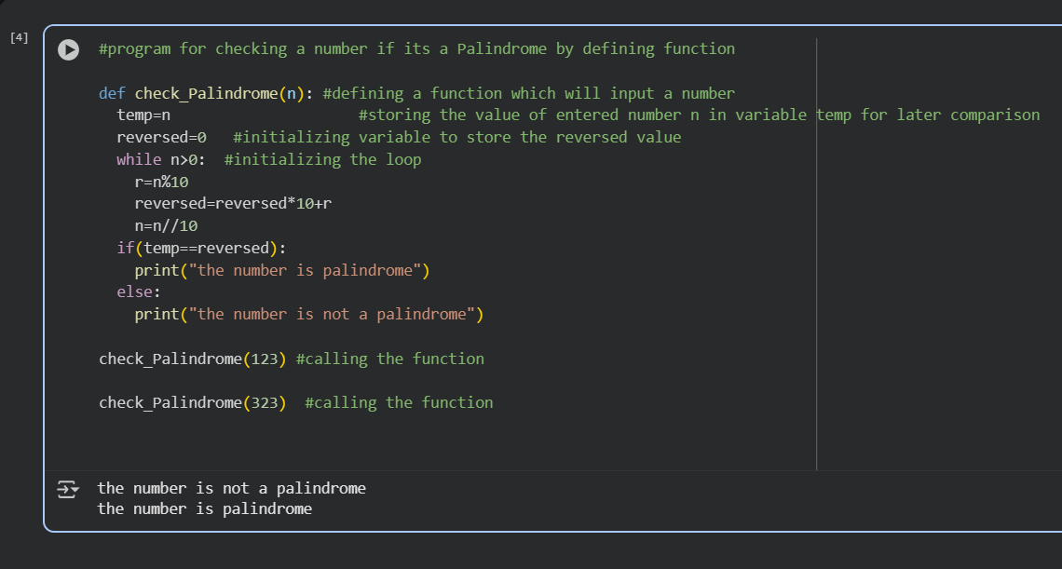

Q2. PROGRAM FOR BASE CONVERSION( HEXADECIMAL , OCTAL , BINARY)
def convert_to_base(n,base):
digits="0123456789ABCDEF"
result=""
if n==0:
return "0"
while n>0:
remainder=n%base
result=digits[remainder]+result
n=n//base
return result

number=int(input("enter a decimal number :"))
print("Binary:" , convert_to_base(number,2))
print("octal:",convert_to_base(number,8))
print("hexadecimal:",convert_to_base(number,16))

DESCRIPTION:

How the Program Works:
- Base Case Check: If the number n is 0, immediately return "0"
- Initialize Variables:
  - Create a digits string containing all possible digit characters (0-9, A-F)
  - Initialize empty result string
- Conversion Loop (while n > 0):
  - Calculate remainder = n % base (get the rightmost digit in target base)
  - Prepend the corresponding character from digits[remainder] to result
  - Update n = n // base (integer division to remove rightmost digit)
- Return Result: Once n becomes 0, return the accumulated result string
- Main Execution:
  - Get a decimal number from user input
  - Convert and print in binary (base 2)
  - Convert and print in octal (base 8)
  - Convert and print in hexadecimal (base 16)
Example: For input 20:
- Binary: 20 → 10100 (base 2)
- Octal: 20 → 24 (base 8)
- Hexadecimal: 20 → 14 (base 16)
The algorithm works by repeatedly dividing by the target base and collecting remainders in reverse order!

OUTPUT:

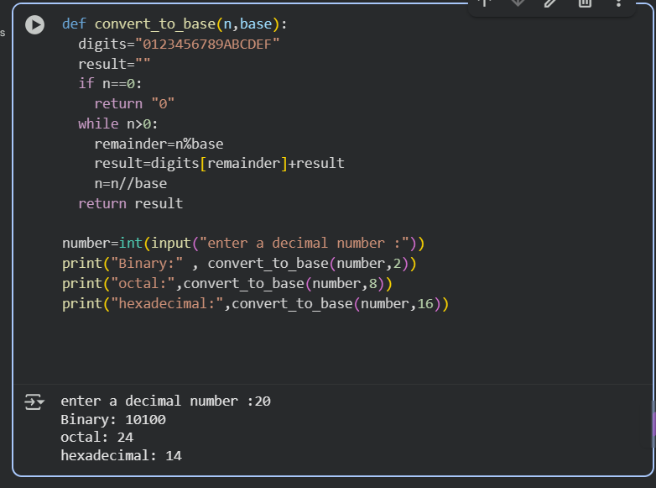

Q3.FINDING SQUARE ROOT FROM QUADRATIC EQUATION
def quadratic_roots(a, b, c): #defining a function which will take a , b ,c integer as input
discriminant = b * b - 4 * a * c #discriminant formula

if discriminant > 0: #setting condition if discriminant greater than 0
root1 = (-b + (discriminant ** 0.5)) / (2 * a)
root2 = (-b - (discriminant ** 0.5)) / (2 * a)
print("roots are",root1,"and" ,root2)
elif discriminant == 0: #discriminant equal to 0
root = -b / (2 * a)
print(root, root)
else:
print("roots are imaginary")

OUTPUT:
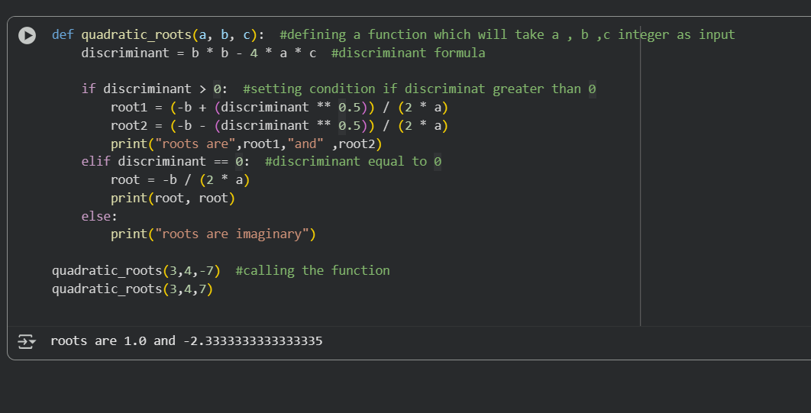

Q4. PROGRAM FOR CHECKING IF THE GIVEN NUMBER IS PRIME OR NOT BY DEFINING FUNCTION
def is_prime(n):
# Numbers less than 2 are not prime
if n <= 1:
print( n,"is not prime")
return False
# Check divisibility from 2 up to n-1
for i in range(2, n):
if n % i == 0:
print(n ,"is not prime")
return False
print(n, "is prime")
return True

#calling the function
is_prime(2)
is_prime(10)

OUTPUT:
