Q1. Can you create a programme or function that employs both positive and negative indexing? Is there any repercussion if you do so?

**Ans: positive and negative indexing can be employed in the same function without any issue as shown below:**

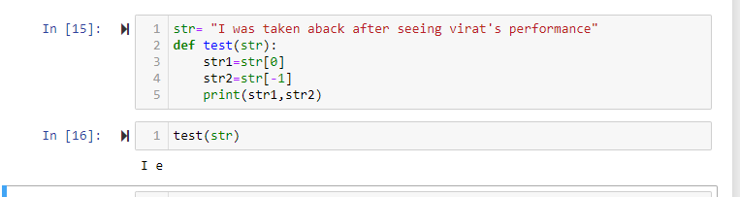

Q2. What is the most effective way of starting with 1,000 elements in a Python list? Assume that all elements should be set to the same value.

**Ans: the most effective way to start with list is to use a for loop.**

Q3. How do you slice a list to get any other part while missing the rest? (For example, suppose you want to make a new list with the elements first, third, fifth, seventh, and so on.)

Ans:

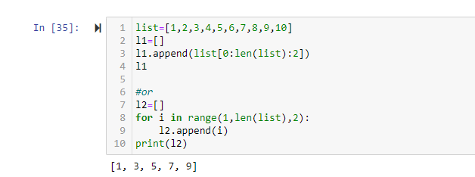

Q4. Explain the distinctions between indexing and slicing.

Ans: **Indexing is used to get a single element whereas, slicing is used to get a sequence of elements.**

Q5. What happens if one of the slicing expression's indexes is out of range?

Ans: **Slicing operation automatically goes upto the last element of the list despite entering the incorrect stop point so it doesn’t raise any error.**

Q6. If you pass a list to a function, and if you want the function to be able to change the values of the list—so that the list is different after the function returns—what action should you avoid?

**Ans: I think the action which shall be avoided is appending the list. Simple assignment operator can be used to override the values of the original list.**

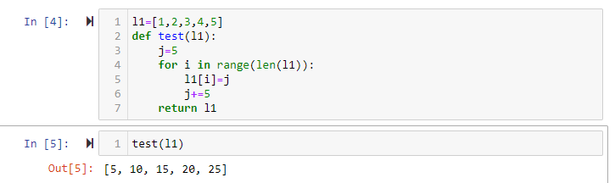

Q7. What is the concept of an unbalanced matrix?

Ans:

**The matrix is called balanced when all the cell in the matrix is balance and a cell is considered is balanced when the value of any particular cell is lower than the number of adjacent cells. If this condition is not met then a matrix is called an unbalanced matrix.**

Q8. Why is it necessary to use either list comprehension or a loop to create arbitrarily large matrices?

Ans: **list comprehension also uses a loop as it becomes imperative to use loops while creating arbitrary large matrices as we can make the loop repeat itself upto a certain number of times depending on the magnitude of the matrix. Without loop, it becomes difficult to manually assign elements to a matrix.**