Q1. Is an assignment operator like += only for show? Is it possible that it would lead to faster results at the runtime?

Ans: **yes, it is faster as it does assignment and addition both in a single statement. It is called in place operation, and it doesn’t create a copy of the input.**

Q2. What is the smallest number of statements you'd have to write in most programming languages to replace the Python expression a, b = a + b, a?

Ans: **In C**

**Int a;**

**Int b;**

**a=a+b;**

**b=a;**

Q3. In Python, what is the most effective way to set a list of 100 integers to 0?

Ans: **l=[0]*100**

Q4. What is the most effective way to initialise a list of 99 integers that repeats the sequence 1, 2, 3? S If necessary, show step-by-step instructions on how to accomplish this.

Ans

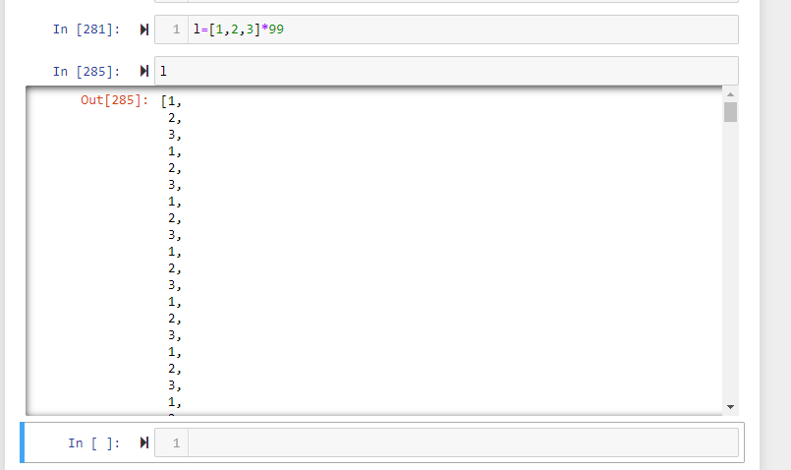

Q5. If you're using IDLE to run a Python application, explain how to print a multidimensional list as efficiently?

Ans:

Q6. Is it possible to use list comprehension with a string? If so, how can you go about doing it?

Ans:

Q7. From the command line, how do you get support with a user-written Python programme? Is this possible from inside IDLE?

Ans:

**Below is an example of how you can run a .py file from command prompt. Yes, you can run a .py file from inside IDLE as well.**

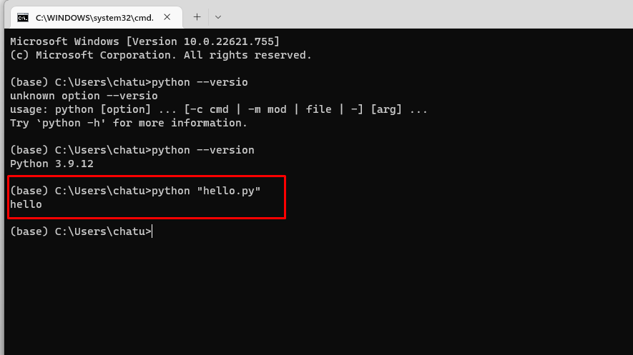

Q8. Functions are said to be “first-class objects” in Python but not in most other languages, such as C++ or Java. What can you do in Python with a function (callable object) that you can't do in C or C++?

Ans: **In Python, a function may accept an argument of any type and return a value of any type without any kind of declaration beforehand unlike other languages such as C or C++**

Q9. How do you distinguish between a wrapper, a wrapped feature, and a decorator?

Ans: **Decorators are a kind of wrapper. Below is the example:**

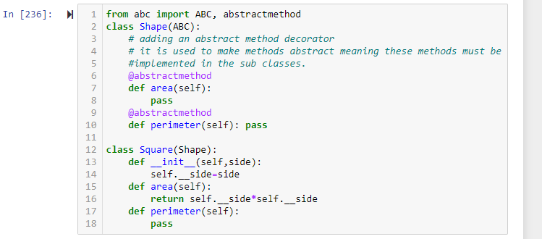

Q10. If a function is a generator function, what does it return?

Ans: **it returns a generator object. It is an iterator object and for that we have to use for loop to get the values.**

Q11. What is the one improvement that must be made to a function in order for it to become a generator function in the Python language?

Ans: **The use of the ‘yield’ keyword**

Q12. Identify at least one benefit of generators.

Ans: **It is good to use generator for large objects where we don’t want to hold the objects into memory before printing on the console. The generators only remembers the logic and previous element to print the next element rather than holding all of the elements before showing them up on the console.**