Q1. What is the benefit of regular expressions?

Ans: **A regular expression is used to find patterns in a large chunk of text. For this, the re module is used.**

Q2. Describe the difference between the effects of "(ab)c+" and "a(bc)+." Which of these, if any, is the unqualified pattern "abc+"?

Ans: **Pattern (ab)c+ matches below:**

**abc**

**abcc**

**abccc**

**abcccc**

**Pattern a(bc)+ matches below:**

**abc**

**abcbc**

**abcbcbc**

**Pattern abc+ matches below:**

**abc**

**abcc**

**abccc**

**abcccc**

**so (ab)c+ and abc+ returns the same match.**

Q3. How much do you need to use the following sentence while using regular expressions?

import re

Ans: **You just need to import the re module once before using all its classes and properties.**

Q4. Which characters have special significance in square brackets when expressing a range, and under what circumstances?

Ans: **caret sign inside a square bracket can make a negative character class which will match all the characters that are not in the character class.**

Q5. How does compiling a regular-expression object benefit you?

Ans: **Creating a regular expression gives you a bit of flexibility and allows you to match the pattern again without rewriting it. In the below example, we have created a compile object with the pattern we want to find so this object can be used multiple times to find the same pattern without having the user to rewrite the pattern.**

Q6. What are some examples of how to use the match object returned by re.match and re.search?

Ans: **re.match() = it looks for the pattern at the beginning of the text only**

**Re.search() = it returns only the first occurrence of the pattern.**

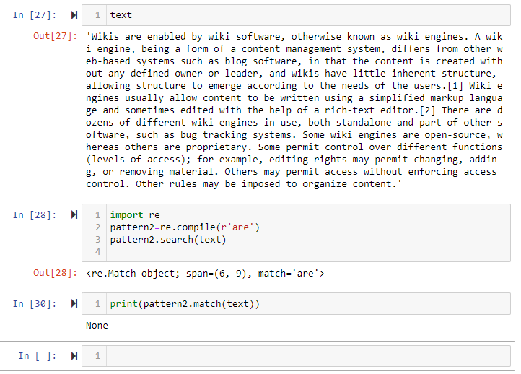

Q7. What is the difference between using a vertical bar (|) as an alteration and using square brackets as a character set?

Ans: **square bracket is used to include a set of characters and vertical bar is used for OR condition for exact string matching.**

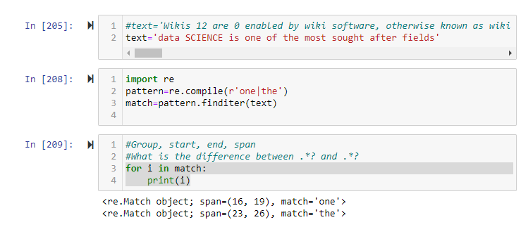

Q8. In regular-expression search patterns, why is it necessary to use the raw-string indicator (r)? In   replacement strings?

Ans: **so the escape characters can’t not be ignored and it includes characters like /r or /n in the search patterns.**