1.What are the two values of the Boolean data type? How do you write them?

**Ans: TRUE and FALSE. Ex) 1>2 and 1<2**

2. What are the three different types of Boolean operators?

**Ans: And, Or, not**

3. Make a list of each Boolean operator's truth tables (i.e. every possible combination of Boolean values for the operator and what it evaluate ).

**Ans:**

|  |  |
| --- | --- |
| **Expression** | **Evaluation** |
| **True And True** | **True** |
| **True And False** | **False** |
| **False And True** | **False** |
| **False And False** | **False** |
| **True or True** | **True** |
| **True or False** | **True** |
| **False or True** | **True** |
| **False or False** | **False** |
| **Not True** | **False** |
| **Not False** | **True** |

4. What are the values of the following expressions?

(5 > 4) and (3 == 5) = **False**

not (5 > 4) = **False**

(5 > 4) or (3 == 5) = **True**

not ((5 > 4) or (3 == 5)) = **False**

(True and True) and (True == False) = **False**

(not False) or (not True) = **True**

5. What are the six comparison operators?

**Ans: <**

**<=**

**>**

**>=**

**==**

**!=**

6. How do you tell the difference between the equal to and assignment operators?Describe a condition and when you would use one.

**Ans: Equal Operator : ==**

**Assignment operator:=**

**Equal operator is used to compare the variables, whereas assignment operator is used to assign a value to a variable.**

7. Identify the three blocks in this code:

spam = 0

if spam == 10:

print('eggs')

if spam > 5:

print('bacon')

else:

print('ham')

print('spam')

print('spam')

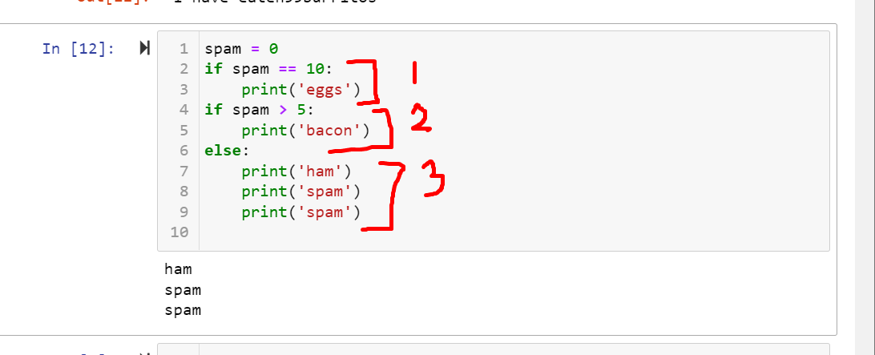

8. Write code that prints Hello if 1 is stored in spam, prints Howdy if 2 is stored in spam, and prints Greetings! if anything else is stored in spam.

**Ans:**

**spam=int(input())**

**if spam == 1:**

**print('Hello')**

**elif spam==2:**

**print('Howdy')**

**else:**

**print('Greetings!')**

9.If your programme is stuck in an endless loop, what keys you’ll press?

**Ans: we can restart the kernel**

10. How can you tell the difference between break and continue?

**Ans: break is used for immediate termination of loop, whereas continue is used to terminate the current iteration.**

11. In a for loop, what is the difference between range(10), range(0, 10), and range(0, 10, 1)?

**Ans: all of them are going to give the same output which are the values from 0 to 9.**

**The range(10) takes the default value of start and step as respectively 0 and 1.**

12. Write a short program that prints the numbers 1 to 10 using a for loop. Then write an equivalent program that prints the numbers 1 to 10 using a while loop.

**Ans:**

**for i in range(1,11):**

**print(i)**

**a=1**

**while a<11:**

**print(a)**

**a=a+1**

13. If you had a function named bacon() inside a module named spam, how would you call it after importing spam?

Ans 13:

spam.bacon()