1. Compare and contrast the float and Decimal classes' benefits and drawbacks.

Ans: **Float can have some errors when performing operations on a floating point number like below: Float class rounds off the number causing the arithmetic operation to generate incorrect numbers.**

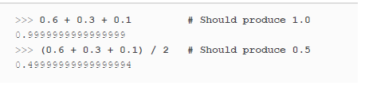

**So to avoid these errors Decimal class should be used.**

**Another important point is that decimal object takes 30 times longer than creating floating-point objects.**

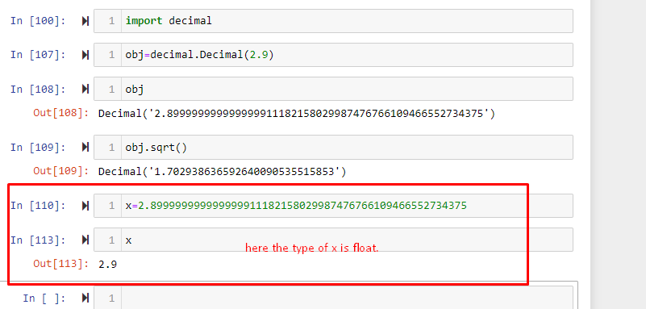

2. Decimal('1.200') and Decimal('1.2') are two objects to consider. In what sense are these the same object? Are these just two ways of representing the exact same value, or do they correspond to different internal states?

Ans: **the values generated by these two are mathematically the same but using the decimal function on ‘1.200’ shows that it doesn’t get rid of the trailing zeroes and keeps the intact value of the decimal number.**

1. What happens if the equality of Decimal('1.200') and Decimal('1.2') is checked?

Ans: **True is returned.**

4. Why is it preferable to start a Decimal object with a string rather than a floating-point value?

Ans: **floating-point value has some rounding error so If we pass the floating point number then the Decimal function would already have the incorrect value to generate a decimal number that is why a number is passed in the form of string.**

5. In an arithmetic phrase, how simple is it to combine Decimal objects with integers?

Ans: **You can multiply integers with Decimal objects freely as well as add them.**

6. Can Decimal objects and floating-point values be combined easily?

Ans: **Adding or multiplying a Decimal object by a floating point value is an error. To perform such an operation, floating point number should be converted into a Decimal object.**

7. Using the Fraction class but not the Decimal class, give an example of a quantity that can be expressed with absolute precision.

Ans: **Below is an example:**

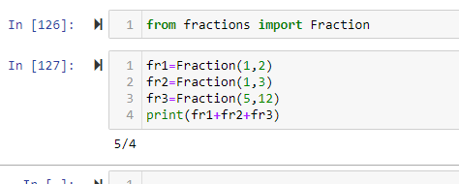

8. Describe a quantity that can be accurately expressed by the Decimal or Fraction classes but not by a floating-point value.

Ans: **due to floating point rounding issue, Fraction or Decimal classes generates inaccurate results that is why the parameters should be passed in as a string.**

For example:

The result is incorrect here.

Q9.Consider the following two fraction objects: Fraction(1, 2) and Fraction (5, 10). Is the internal state of these two objects the same? Why do you think that is?

Ans: **These all are mathematically equivalent. Internal method reduce them to the same internal representation.**

Q10. How do the Fraction class and the integer type (int) relate to each other? Containment or inheritance?

Ans: **The numerator and denominator are integers in the Fraction class. It is inheritance.**