1. Add the current date to the text file today.txt as a string.

Ans:

1. Read the text file today.txt into the string today_string

**Ans:**

1. Parse the date from today_string.

**Ans:**

I

1. List the files in your current directory

**Ans**:

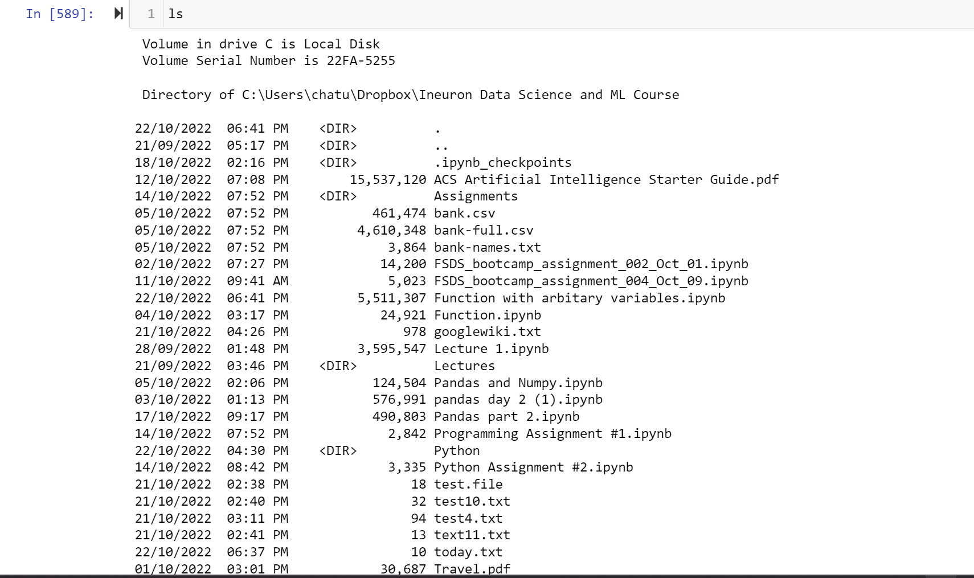

1. Create a list of all of the files in your parent directory (minimum five files should be available).

**Ans:**

path=os.path.dirname(os.getcwd())

os.listdir(path)

1. Use multiprocessing to create three separate processes. Make each one wait a random number of seconds between one and five, print the current time, and then exit.

Ans:

import time as t

import multiprocessing

from datetime import datetime

start=t.perf_counter()

def do_something1():

    print('sleeping 1 second ')

    t.sleep(1)

    print(datetime.now())

    print('done sleeping')

def do_something2():

    print('sleeping 3 second ')

    t.sleep(3)

    print(datetime.now())

    print('done sleeping')

def do_something3():

    print('sleeping 5 second ')

    t.sleep(5)

    print(datetime.now())

    print('done sleeping')

P1=multiprocessing.Process(target=do_something1)

P2=multiprocessing.Process(target=do_something2)

P3=multiprocessing.Process(target=do_something3)

P1.start()

P2.start()

P3.start()

P1.join()

P2.join()

P3.join()

#do_something()

#do_something()

finish=t.perf_counter()

#print(finish-start)

print(f'finished in {round(finish-start,2)} second(s)')

Screenshot:

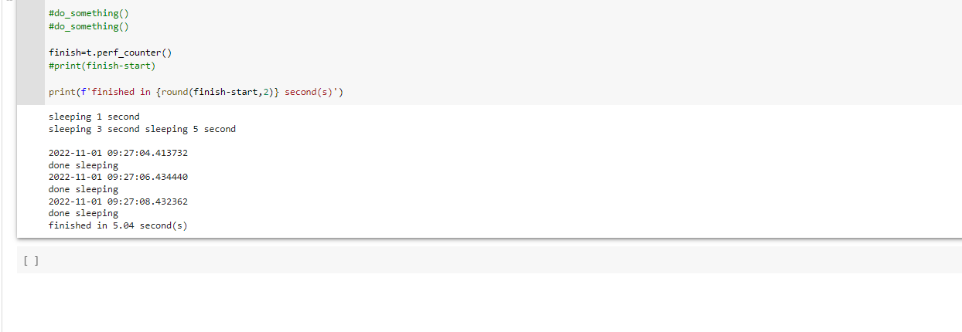

1. Create a date object of your day of birth.

Ans:

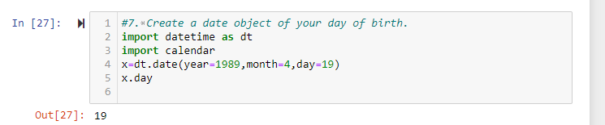

1. What day of the week was your day of birth?

Ans:

1. When will you be (or when were you) 10,000 days old?

Ans:

