Q1. If you have any, what are your choices for increasing the comparison between different figures on the same graph?

Ans: **Bar graph can be used to compare different things on the same graph. Pie chart can also be used to show comparisons between different groups.**

Q2. Can you explain the benefit of compound interest over a higher rate of interest that does not compound after reading this chapter?

Ans: **Compound interest causes your wealth to grow faster as you earn returns on the money you invest as well as returns at the end of every compounding period.**

Q3. What is a histogram, exactly? Name a numpy method for creating such a graph.

Ans: **histogram is a distribution graph which is used to summarise discrete or continuous data through bins. We use the probability distribution function to smoothen the graph and see the distribution of data.**

**Import numpy**

**Np.histogram()**

Q4. If necessary, how do you change the aspect ratios between the X and Y axes?

Ans: **following is the example of how to change aspect ration using matplotlib library.**

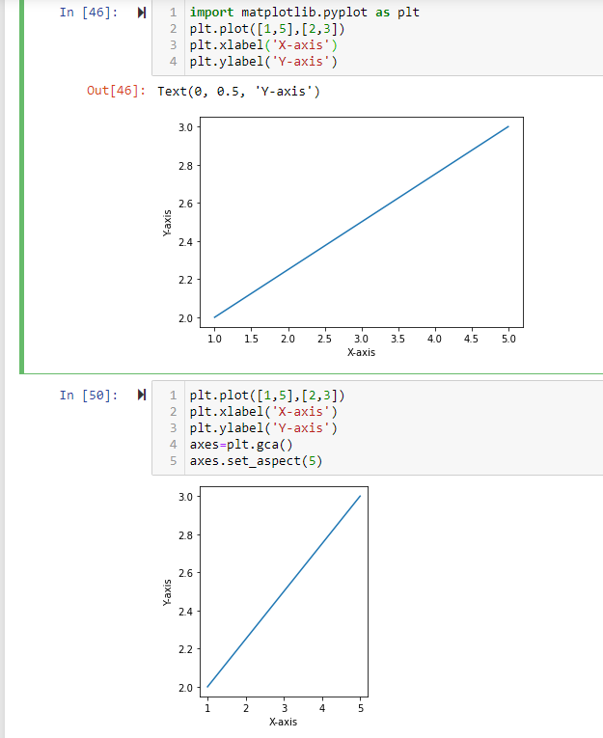

Q5. Compare and contrast the three types of array multiplication between two numpy arrays: dot product, outer product, and regular multiplication of two numpy arrays.

Ans: **np.mulitply() = that is the element wise matrix multiplication.**

**Np.matmul() = that is the matrix product of two arrays.**

**Np.dot() = that is the dot product of two arrays and the result is the same for 1D and 2D arrays.**

Q6. Before you buy a home, which numpy function will you use to measure your monthly mortgage payment?

Ans: **numpy.pmt()**

Q7. Can string data be stored in numpy arrays? If so, list at least one restriction that applies to this data.

**Ans**: **yes, string data can be stored in numpy arrays. The dtype of any numpy array containing string values is the maximum length of any string present in the array. Once set, it will only be able to store new string having length not more than the maximum length at the time of the creation.**