1. What are escape characters, and how do you use them?

**Ans:** character followed by a backslash is an escape character such as \t or \n.

These escape characters don’t get printed and are used like below:

1. What do the escape characters n and t stand for?

Ans: n =new line character

T=tab

1. What is the way to include backslash characters in a string?

Ans:

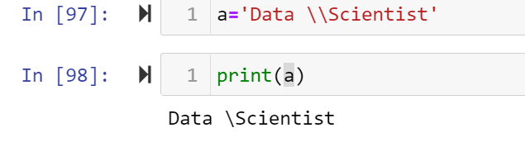

4. The string "Howl's Moving Castle" is a correct value. Why isn't the single quote character in the word Howl's not escaped a problem?

**Ans**: it is correct as it is quoted in the double quote. It would have caused an error if the whole string was quoted in a single quote.

1. How do you write a string of newlines if you don't want to use the n character?

Ans: 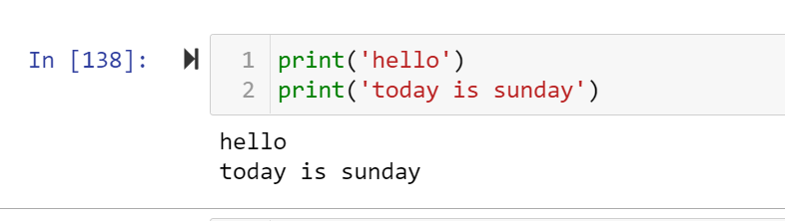

6. What are the values of the given expressions?

'Hello, world!'[1]

'Hello, world!'[0:5]

'Hello, world!'[:5]

'Hello, world!'[3:]

Ans:

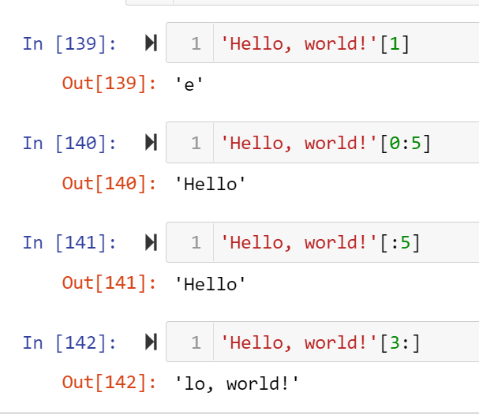

7. What are the values of the following expressions?

'Hello'.upper()

'Hello'.upper().isupper()

'Hello'.upper().lower()

Ans:

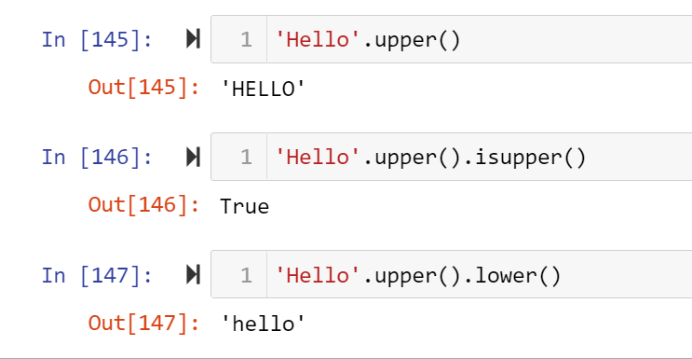

8. What are the values of the following expressions?

'Remember, remember, the fifth of July.'.split()

'-'.join('There can only one.'.split())

Ans:

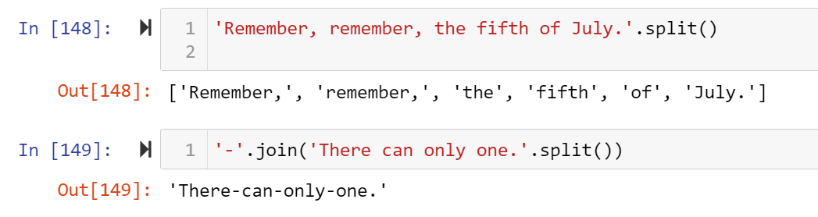

9. What are the methods for right-justifying, left-justifying, and centering a string?

Ans:

These methods are used for string alignment and the methods for these are as follow:

Str.ljsut()

Str.rjust()

Str.center()

10. What is the best way to remove whitespace characters from the start or end?

Ans:

To remove from the left: string.lstrip()

To remove from the right: string.rstrip()

To remove both trailing and leading whitespaces: str.strip()