E-GRAMSWARAJ DIGITAL GOVERNANCE PLATFORM FOR VILLAGE PANCHAYAT OPERATIONS
23CS54C – MODERN WEB TECHNOLOGIES
Submitted by
PRIYA M 2403957610422100
In partial fulfillment for the award of the degree
of
BACHELOR OF ENGINEERING
in
COMPUTER SCIENCE AND ENGINEERING

NATIONAL ENGINEERING COLLEGE
(An Autonomous Institution affiliated to Anna University, Chennai)
K.R.NAGAR, KOVILPATTI - 628503
OCTOBER - 2026

NATIONAL ENGINEERING COLLEGE
(An Autonomous Institution affiliated to Anna University, Chennai)
K.R.NAGAR, KOVILPATTI - 628503
BONAFIDE CERTIFICATE
This is to certify that this project report, “E-GramSwaraj – a village management”, is the bonafide work of PRIYA M (2403957610422100) who carried out the project work under my supervision.
Course Instructor/Guide
Submitted to the 23CS54C – MODERN WEB TECHNOLOGIES Viva-Voce examination held at National Engineering College, K.R.Nagar, Kovilpatti on ____________
Internal Examiner Co Examiner

TABLE OF CONTENTS
CH NO | TITLE | PAGE NO
1 | INTRODUCTION | 3
2 | OBJECTIVES | 4
3 | DESCRIPTION | 5
4 | CLASS DIAGRAM | 6
5 | TABLE STRUCTURES | 7
6 | ER DIAGRAM | 16
7 | TECH STACK | 18
8 | MODULES | 19
9 | CONCLUSION | 58

CHAPTER 1
INTRODUCTION
In the modern governance ecosystem of rural India, the efficient administration of Panchayati Raj institutions plays a vital role in ensuring sustainable community growth, transparent resource allocation, and accountable public service delivery. Historically, managing village infrastructure projects, local asset registries, financial transactions, citizen welfare requisitions, and Gram Sabha meeting records through paper-based or disconnected ledger systems has been time-consuming, prone to human error, and lacking in public transparency. There is an urgent need for a unified digital platform that automates village panchayat operations under one roof.
E-GramSwaraj is a comprehensive, full-stack digital governance web application designed to digitize and automate the complete lifecycle of village panchayat operations—from resident registration and public complaint processing to multi-year development planning, work execution, asset tracking, financial budget allocation, and dynamic multi-lingual governance. The system was specifically built to cater to the operational requirements of South Thittankulam Village Panchayat (LGD Code: 231907, Kovilpatti Taluk, Tamil Nadu - 628502) while offering multi-tenant architectural readiness for seamless scaling to adjacent villages.
The application is organized into six major functional domains: Master Data & Village Profile Management, which maintains foundational records for village geography, wards, demographics, and resident profiles; Citizen Services & Requisitions, which manages resident self-registration, OTP authentication, and service request workflows; Development Plans & Works Execution, which monitors project lifecycles from proposal to contractor allocation and completion; Financial & Budgetary Control, which enforces strict ledger accounting for income, expenditure, and category-wise budgets; Gram Sabha Meetings & Governance, which records meeting schedules, resolutions, and attendance; and Multi-lingual Localization & Business Intelligence, which powers dynamic 8-language translations via Google Cloud Translation API alongside interactive administrative dashboards.

CHAPTER 2
OBJECTIVES
The objectives of E-GramSwaraj are:
- Digitize Panchayat Operations – Replace manual paper registers with an interactive full-stack digital platform for improved operational efficiency, real-time data access, and institutional auditability.
- Centralize Village Master Data – Maintain standardized and validated master records for village demographics, ward boundaries, infrastructure assets, and resident citizen catalogs under a single MySQL database source of truth.
- Automate Development Plan & Works Lifecycle – Streamline village development from initial proposal to financial sanctioning, contractor assignment, milestone tracking, and completion verification with complete history traceability.
- Empower Citizens via Requisitions & Complaints – Provide citizens with direct self-registration, secure OTP verification, and online submission of civic issues (e.g. water supply, street lighting, drainage) with real-time status updates.
- Ensure Financial Transparency & Budget Integrity – Record every receipt and expenditure transaction against category-specific annual budgets, automatically computing remaining balances and preventing budget overallocation.
- Facilitate Digital Gram Sabha Governance – Schedule panchayat board and Gram Sabha meetings, document formal agendas, log gender-disaggregated public attendance, and store official resolutions in an indexed digital format.
- Provide Dynamic Multi-lingual Access – Implement dynamic translations across 8 Indian languages (English, Tamil, Hindi, Telugu, Kannada, Malayalam, Marathi, Bengali) using Google Cloud Translation API backed by a high-speed database cache.
- Enforce Enterprise Security & Role-Based Access – Protect sensitive administrative operations using JWT authentication, salted bcrypt password hashing, express rate limiting, Helmet headers, and strict role-based authorization (ADMIN, PANCHAYAT_OFFICER, OVERSEER, WATER_OPERATOR, CITIZEN).

CHAPTER 3
DESCRIPTION
E-GramSwaraj is a web application for modernizing and digitizing Panchayati Raj administrative and public services inside a village panchayat. A visitor lands on a public village information page, registers or signs in, and is directed to an role-tailored dashboard. The top and sidebar navigation expose the core modules: Village Profile, Citizen Services, Works & Development Plans, Asset Management, Financial Ledger & Budgets, Gram Sabha Meetings, Announcements, Notifications, Analytics, and System Settings.
The system is organized into three main functional areas. Village Master Data & Citizen Catalogue covers village geography, population demographics, ward breakdowns, official contacts, facility registries, and resident citizen profiles. Operations & Project Management covers civic grievance lifecycle (Submitted, Verified, In Progress, Resolved, Rejected), civil works tracking from initial proposal to contractor allocation and completion, and GIS asset mapping with maintenance interval logging. Financial Control & Governance covers receipt/expenditure vouchers, category-wise annual budgets, Gram Sabha meeting scheduling, resolutions, attendance recording, and 8-language dynamic localization.
Five roles exist. A Citizen can submit requisitions, track grievance status, view meeting schedules, and access village information. A Panchayat Officer manages village profiles, approves requisitions, schedules Gram Sabha meetings, and monitors works. An Overseer verifies civil engineering progress and asset maintenance. A Water Operator manages water supply schemes and civic utility assets. An Admin possesses full system privilege to manage user roles, system settings, and security policies. Route protection is enforced in the browser by a protected-route wrapper and on the server by JWT authentication and role-based authorization middleware.
E-GramSwaraj runs in two cooperating modes. The React client maintains a seeded, working dataset in browser local storage and offline cache, allowing screens to render essential data when offline. When the Express REST API backend answers its health check, the application seamlessly communicates with Node.js and Sequelize ORM over MySQL 8.
CHAPTER 4
CLASS DIAGRAM
The class diagram shows the persistent entities of E-GramSwaraj+ together with the controller/service operations that act on them. Every Sequelize ORM model is represented as a class with its attributes, validations, and controller methods that read or modify it. Relationships are logical and relational foreign keys, for example User.villageId refers to Village.id and Work.planId refers to DevelopmentPlan.id.
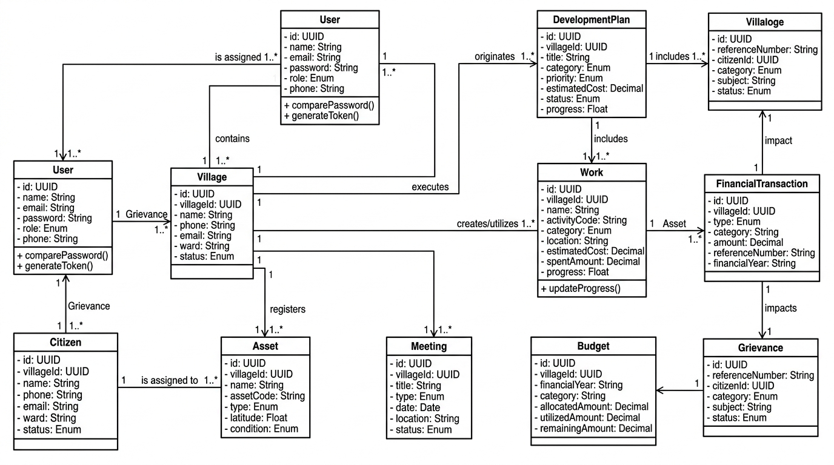
Fig 4.1 Class diagram of E-GramSwaraj+

CHAPTER 5
TABLE STRUCTURES
E-GramSwaraj+ uses MySQL 8, a relational database, with fifteen Sequelize ORM tables. Each table below is the schema of one model: field name, data type, whether it is required (Null = NO), key type (PRI primary key, UNI unique, MUL foreign key) and the default value. Every document receives an automatic _id of type UUID. Sequelize adds createdAt and updatedAt timestamps automatically.
5.1 VILLAGES (villages)
Stores foundational reference data for South Thittankulam Village Panchayat, including geography, population statistics, household counts, ward breakdowns, and official contacts.
Field | Type | Null | Key | Default
id | UUID | NO | PRI | UUIDV4
name | String (varchar 255) | NO |  | null
villageCode | String (varchar 255) | NO | UNI | STK
panchayatName | String (varchar 255) | YES |  | null
taluk | String (varchar 255) | NO |  | Kovilpatti
district | String (varchar 255) | YES |  | Thoothukkudi
state | String (varchar 255) | NO |  | Tamil Nadu
pincode | String (varchar 255) | NO |  | 628502
population | Integer | YES |  | 14317
households | Integer | YES |  | 5386
wards | Integer | YES |  | 9
area | Decimal (14,2) | YES |  | 4.0
latitude | Float | YES |  | 9.1720
longitude | Float | YES |  | 77.8810
lgdCode | String (varchar 255) | YES |  | '231907'
status | enum(ACTIVE, INACTIVE) | NO |  | ACTIVE
createdAt | Date | NO |  | timestamps
Table 5.1 Structure of the villages collection
5.2 USERS (users)
Stores every registered administrative officer and citizen account. Passwords are stored only as salted bcrypt hashes (cost factor 12), and role separates citizens from administrative officers.
Field | Type | Null | Key | Default
_id | UUID | NO | PRI | UUIDV4
name | String (varchar 255) | NO |  | null
email | String (varchar 255) | NO | UNI | null
password | String (bcrypt hash) | NO |  | null
role | enum(ADMIN, OFFICER, OVERSEER, WATER_OPERATOR, CITIZEN) | NO |  | CITIZEN
villageId | UUID | NO | MUL | FK -> villages
phone | String (varchar 255) | YES | UNI | null
designation | String (varchar 255) | YES |  | null
language | enum(en, ta, hi, te, kn, ml, mr, bn) | YES |  | en
status | enum(ACTIVE, INACTIVE) | NO |  | ACTIVE
lastLoginAt | Date | YES |  | null
createdAt / updatedAt | Date | NO |  | timestamps

Table 5.2 Structure of the users collection
5.3 CITIZENS (citizens)
Holds resident citizen profiles linked to specific village wards, phone numbers, and optional user portal account logins.
Field | Type | Null | Key | Default
_id | UUID | NO | PRI | UUIDV4
villageId | UUID | NO | MUL | FK -> villages
name | String (varchar 255) | NO |  | null
Field | Type | Null | Key | Default
phone | String (varchar 255) | YES |  | null
email | String (varchar 255) | YES |  | null
address | String (varchar 255) | YES |  | null
ward | String (varchar 255) | YES |  | Ward 1
gender | enum(MALE, FEMALE, OTHER, '') | YES |  | ''
userId | UUID | YES | MUL | FK -> users
status | enum(ACTIVE, INACTIVE) | NO |  | ACTIVE
createdAt / updatedAt | Date | NO |  | timestamps

Table 5.3 Structure of the citizens collection
5.4 DEVELOPMENT PLANS (developmentPlans)
Stores multi-year Gram Panchayat Development Plans (GPDP) with categories, priority levels, estimated costs, and target completion dates.
Field | Type | Null | Key | Default
_id | UUID | NO | PRI | UUIDV4
villageId | UUID | NO | MUL | FK -> villages
description | Text | YES |  | null
category | enum(Infrastructure, Water, Sanitation, Roads, Education, Health) | NO |  | Infrastructure
priority | enum(LOW, MEDIUM, HIGH, URGENT) | NO |  | MEDIUM
status | enum(PROPOSED, APPROVED, IN_PROGRESS, COMPLETED, REJECTED) | NO |  | PROPOSED
progress | Float | YES |  | 0
financialYear | String (varchar 255) | YES |  | 2026-2027
createdBy | UUID | YES | MUL | FK -> users
createdAt / updatedAt | Date | NO |  | timestamps
Table 5.4 Structure of the developmentPlans collection
5.5 WORKS (works)
Monitors active civil engineering works, tracking activity codes, scheme allocations, estimated vs approved costs, assigned contractors, and completion percentages.
Field | Type | Null | Key | Default
_id | UUID | NO | PRI | UUIDV4
villageId | UUID | NO | MUL | FK -> villages
name | String (varchar 255) | NO |  | null
activityCode | String (varchar 255) | YES |  | null
workType | String (varchar 255) | YES |  | New/Fresh
category | enum(Infrastructure, Water, Sanitation, Roads) | YES |  | null
location | String (varchar 255) | YES |  | null
estimatedCost | Decimal (14,2) | YES |  | 0.00
approvedAmount | Decimal (14,2) | YES |  | 0.00
spentAmount | Decimal (14,2) | YES |  | 0.00
contractor | String (varchar 255) | YES |  | null
status | enum(PLANNED, APPROVED, IN_PROGRESS, COMPLETED, SUSPENDED) | NO |  | PLANNED
progress | Float | YES |  | 0
actualCompletionDate | Date | YES |  | null
createdAt / updatedAt | Date | NO |  | timestamps

Table 5.5 Structure of the works collection

5.6 ASSETS (assets)
Catalogs public physical assets (water tanks, hand pumps, street lights, community halls, roads) with GIS latitude/longitude coordinates and maintenance interval logs.
Field | Type | Null | Key | Default
_id | UUID | NO | PRI | UUIDV4
villageId | UUID | NO | MUL | FK -> villages
name | String (varchar 255) | NO |  | null
assetCode | String (varchar 255) | YES |  | null
type | enum(WATER_TANK, STREET_LIGHT, RO_PLANT, BUILDING, ROAD, DRAINAGE) | NO |  | null
ward | String (varchar 255) | YES |  | null
latitude | Float (-90 to 90) | YES |  | null
longitude | Float (-180 to 180) | YES |  | null
condition | enum(EXCELLENT, GOOD, POOR, NON_FUNCTIONAL) | NO |  | GOOD
estimatedValue | Decimal (14,2) | YES |  | 0.00
maintenanceIntervalDays | Integer | YES |  | 180
status | enum(ACTIVE, INACTIVE, UNDER_MAINTENANCE) | NO |  | ACTIVE
createdAt / updatedAt | Date | NO |  | timestamps

Table 5.6 Structure of the assets collection
5.7 FINANCIAL TRANSACTIONS (financialTransactions)
Records public financial income receipts and expenditure payments linked to voucher references and financial years.
Field | Type | Null | Key | Default
_id | UUID | NO | PRI | UUIDV4
villageId | UUID | NO | MUL | FK -> villages
type | enum(RECEIPT, EXPENDITURE) | NO |  | null
Field | Type | Null | Key | Default
category | String (varchar 255) | NO |  | null
description | Text | YES |  | null
amount | Decimal (14,2) | NO |  | null
referenceNumber | String (varchar 255) | YES |  | null
date | Date | NO |  | CURRENT_TIMESTAMP
financialYear | String (varchar 255) | YES | MUL | Auto-computed
status | enum(COMPLETED, PENDING, CANCELLED) | NO |  | COMPLETED
createdAt / updatedAt | Date | NO |  | timestamps

Table 5.7 Structure of the financialTransactions collection
5.8 BUDGETS (budgets)
Stores annual category budgets with allocated, utilized, and auto-computed remaining funds.
Field | Type | Null | Key | Default
_id | UUID | NO | PRI | UUIDV4
villageId | UUID | NO | MUL | FK -> villages
financialYear | String (varchar 255) | NO | MUL | null
category | String (varchar 255) | NO | MUL | null
allocatedAmount | Decimal (14,2) | NO |  | 0.00
utilizedAmount | Decimal (14,2) | YES |  | 0.00
remainingAmount | Decimal (14,2) | YES |  | Auto-calculated
source | String (varchar 255) | YES |  | State Grant / Tax
createdAt / updatedAt | Date | NO |  | timestamps

Table 5.8 Structure of the budgets collection

5.9 MEETINGS (meetings)
Schedules Gram Sabha and Panchayat Board assembly meetings, documenting agendas, resolutions, and public attendance counts.
Field | Type | Null | Key | Default
_id | UUID | NO | PRI | UUIDV4
villageId | UUID | NO | MUL | FK -> villages
title | String (varchar 255) | NO |  | null
type | enum(GRAM_SABHA, PANCHAYAT_BOARD, WARD_SABHA, STANDING_COMMITTEE) | NO |  | GRAM_SABHA
date | Date | NO |  | null
location | String (varchar 255) | YES |  | Panchayat Office
agenda | JSON Array | YES |  | []
minutes | Text | YES |  | null
decisions | JSON Array | YES |  | []
attendance | JSON Object (total, male, female, officials) | YES |  | {}
status | enum(SCHEDULED, IN_PROGRESS, COMPLETED, CANCELLED) | NO |  | SCHEDULED
createdAt / updatedAt | Date | NO |  | timestamps

Table 5.9 Structure of the meetings collection
5.10 ANNOUNCEMENTS (announcements)
Stores public notices, policy advisories, and village news bulletins.
Field | Type | Null | Key | Default
_id | UUID | NO | PRI | UUIDV4
villageId | UUID | NO | MUL | FK -> villages
title | String (varchar 255) | NO |  | null
description | Text | NO |  | null
Field | Type | Null | Key | Default
category | enum(PUBLIC_INFORMATION, SCHEME_NOTICE, EMERGENCY_ALERT) | NO |  | PUBLIC_INFORMATION
publishDate | Date | NO |  | CURRENT_TIMESTAMP
status | enum(PUBLISHED, DRAFT, ARCHIVED) | NO |  | PUBLISHED
createdAt / updatedAt | Date | NO |  | timestamps

Table 5.10 Structure of the announcements collection
5.11 NOTIFICATIONS (notifications)
In-app alert notifications generated upon requisition status updates, meeting schedules, or system events.
Field | Type | Null | Key | Default
_id | UUID | NO | PRI | UUIDV4
villageId | UUID | NO | MUL | FK -> villages
userId | UUID | NO | MUL | FK -> users
title | String (varchar 255) | NO |  | null
message | Text | YES |  | null
type | enum(SYSTEM, GRIEVANCE, WORK, MEETING) | NO |  | SYSTEM
read | Boolean | NO |  | false
createdAt / updatedAt | Date | NO |  | timestamps

Table 5.11 Structure of the notifications collection

5.12 GRIEVANCES (grievances)
Stores public civic complaint submissions, issue categories, resolution stages, and audit history logs.
Field | Type | Null | Key | Default
_id | UUID | NO | PRI | UUIDV4
villageId | UUID | NO | MUL | FK -> villages
referenceNumber | String (varchar 255) | NO | UNI | Auto-generated
citizenId | UUID | NO | MUL | FK -> citizens
category | enum(Water Supply, Street Lighting, Drainage, Roads, Garbage) | NO |  | null
subject | String (varchar 255) | NO |  | null
description | Text | NO |  | null
ward | String (varchar 255) | YES |  | null
priority | enum(LOW, MEDIUM, HIGH, URGENT) | NO |  | MEDIUM
status | enum(SUBMITTED, ACKNOWLEDGED, IN_PROGRESS, RESOLVED, REJECTED) | NO |  | SUBMITTED
resolution | Text | YES |  | null
createdAt / updatedAt | Date | NO |  | timestamps

Table 5.12 Structure of the grievances collection
5.13 SERVICE REQUESTS (serviceRequests)
Handles citizen applications for official certificates, public service permits, and administrative utility connections.
Field | Type | Null | Key | Default
_id | UUID | NO | PRI | UUIDV4
villageId | UUID | NO | MUL | FK -> villages
applicationNumber | String (varchar 255) | NO | UNI | SR-XXXXXXXX
serviceId | UUID | NO | MUL | FK -> services
applicantName | String (varchar 255) | NO |  | null
applicantPhone | String (varchar 255) | NO |  | null
ward | String (varchar 255) | YES |  | null
status | enum(SUBMITTED, VERIFIED, IN_PROGRESS, APPROVED, REJECTED, COMPLETED) | NO |  | SUBMITTED
assignedOfficer | UUID | YES | MUL | FK -> users
slaDays | Integer | YES |  | 7
createdAt / updatedAt | Date | NO |  | timestamps

Table 5.13 Structure of the serviceRequests collection
5.14 TRANSLATION CACHE (translationCache)
Stores SHA-256 hashed UI source text and dynamic Google Cloud Translation API outputs across 8 Indian languages.
Field | Type | Null | Key | Default
_id | UUID | NO | PRI | UUIDV4
sourceHash | String (varchar 64) | NO | UNI | SHA-256 Hash
sourceText | Text | NO |  | null
sourceLanguage | String (varchar 8) | NO |  | en
targetLanguage | String (varchar 8) | NO |  | ta / hi / te / etc.
translatedText | Text | NO |  | null
createdAt / updatedAt | Date | NO |  | timestamps

Table 5.14 Structure of the translationCache collection

CHAPTER 6
ER DIAGRAM
The entity-relationship diagram shows how the collections relate to one another. MySQL enforces relational foreign key constraints across tables (`villageId`, `userId`, `planId`, `workId`, `serviceId`). The villages collection is the central hub of the model: a village contains users, citizens, development plans, works, assets, financial transactions, budgets, meetings, and service requests.
ENTITY RELATIONSHIP DIAGRAM
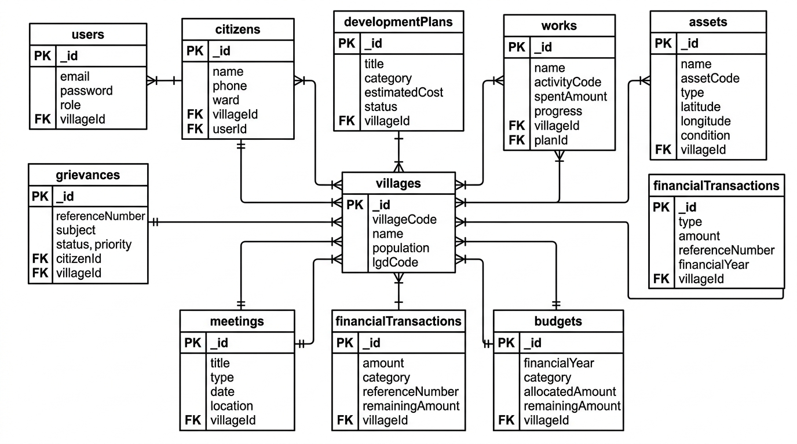
Fig 6.1 Entity relationship diagram of E-GramSwaraj+

RELATIONSHIP SUMMARY
Parent | Child | Cardinality | Reference field
villages | users | 1 : N | users.villageId → villages.id
villages | citizens | 1 : N | citizens.villageId → villages.id
villages | developmentPlans | 1 : N | developmentPlans.villageId → villages.id
villages | works | 1 : N | works.villageId → villages.id
villages | assets | 1 : N | assets.villageId → villages.id
villages | financialTransactions | 1 : N | financialTransactions.villageId → villages.id
villages | budgets | 1 : N | budgets.villageId → villages.id
villages | meetings | 1 : N | meetings.villageId → villages.id
villages | announcements | 1 : N | announcements.villageId → villages.id
users | grievances | 1 : N | grievances.citizenId → users.id
services | serviceRequests | 1 : N | serviceRequests.serviceId → services.id
users | otpVerifications | 1 : N | otpVerifications.userId → users.id

Table 6.1 Relationship Summary of E-GramSwaraj+ Collections

CHAPTER 7
TECH STACK
7.1 TECH STACK
Layer | Technology | Purpose
Frontend UI | React 18 (Vite) | Single-page application with dynamic UI rendering and fast module reloading.
Styling | Tailwind CSS | Utility-first responsive styling with consistent design system tokens.
Routing | React Router v6 | Public, citizen, and officer routes guarded by role-based protected wrappers.
Charts & Maps | Recharts, Leaflet, OpenStreetMap | Interactive financial analytics charts and GIS asset spatial mapping.
Backend Server | Node.js with Express v4 | Asynchronous, event-driven RESTful API server.
Database & ORM | MySQL 8 + Sequelize ORM v6 | Relational database storage with schema migrations, validations, and hooks.
Authentication | JSON Web Tokens (jsonwebtoken) | Stateless, signed 7-day bearer token authentication.
Password Security | bcryptjs | Salted password hashing with cost factor 12.
HTTP Hardening | Helmet, CORS, Express Rate Limit | HTTP header protection, origin control, and rate limiting.
Localization | Google Cloud Translation API + Cache | Dynamic real-time translation across 8 Indian languages with SHA-256 caching.

Table 7.1 Overview of E-GramSwaraj+ Technology Stack

7.2 ARCHITECTURE OVERVIEW
Layer | Technology Component | Responsibility in E-GramSwaraj+
Model | Sequelize ORM + MySQL 8 | Defines relational schemas, data validations, DB queries, and lifecycle hooks.
View | React 18 UI + Tailwind CSS | Renders interactive interfaces, manages client state, displays charts & maps.
Controller | Express.js Route Controllers | Executes business logic, validates API payloads, coordinates Model & View.

Table 7.2 Architecture Layer Overview

CHAPTER 8
MODULES
8.2 Folder Structure
The project is a single repository with two independent applications: the Express API in backend and the React client in frontend. Figure 8.1 shows the backend directory structure, and Figure 8.2 shows the frontend directory structure.
Backend Folder
The backend repository contains API route handlers, Sequelize models, security middleware, seeders, and translation services.
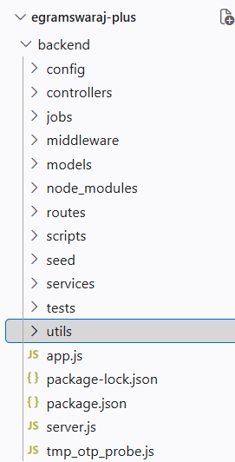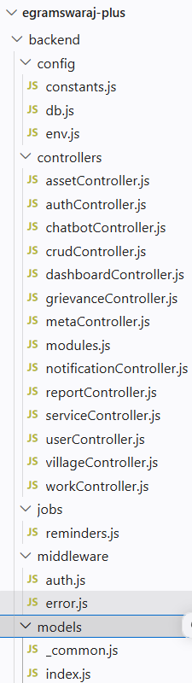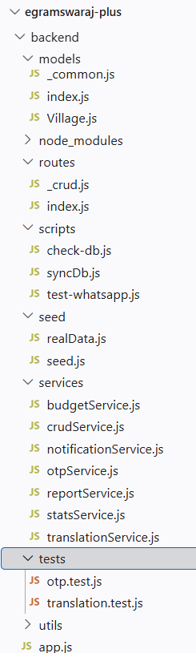
Fig 8.1 Structure of backend folder

Frontend Folder
The frontend repository contains React components, UI page views, custom context providers, and Axios service integrations.
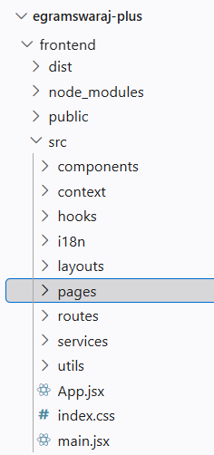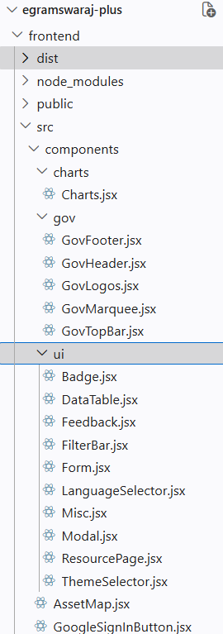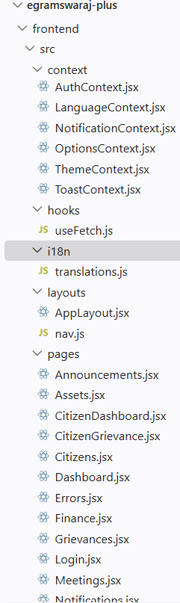
Fig 8.2 Structure of frontend folder
8.3 USER AUTHENTICATION & ACCESS CONTROL
Purpose & Scope
Provides account creation, sign-in, OTP validation, and role-based access control (RBAC) across administrative and citizen user accounts. It identifies every user with a signed JSON Web Token (JWT), separates citizens from officers, overseers, and administrators, and prevents unauthorized access to administrative functions.

Functional Requirements
What the module must do:
- A citizen can register with name, e-mail, phone, ward address, and password (minimum eight characters) with automated OTP verification.
- A user can log in with e-mail or phone number and password, receiving a signed 7-day JWT Bearer token.
- Role-based authorization enforces 5 distinct roles: ADMIN, PANCHAYAT_OFFICER, OVERSEER, WATER_OPERATOR, and CITIZEN.
- An administrator can view user accounts, update designations, or suspend inactive accounts from the administration panel.
Non-Functional Requirements
How well the module must do it:
- Security: Passwords are stored only as salted bcrypt hashes (cost factor 12) and are never returned by the API.
- Token lifetime: Server JWT tokens expire after 7 days to balance administrative security with usability.
- Rate limiting: Login attempts are rate-limited to 15 attempts per 15-minute window per IP.
- Consistency: E-mail addresses and phone numbers are trimmed, lower-cased, and unique.
API Design
Method | Endpoint | Purpose / contract
POST | /api/users/login | Body: email/phone, password. Authenticates credentials and returns signed JWT.
POST | /api/users/register | Body: name, email, phone, password, ward. Registers citizen profile & triggers OTP.
POST | /api/users/verify-otp | Body: userIdentifier, otp. Verifies OTP and activates user account.
GET | /api/users/me | Header: Bearer token. Returns authenticated user profile.

DB Design
Collection | Keys & indexes | Key fields
users | _id, unique email, unique phone | name, email, password (hash), role, villageId, phone, status
otpVerifications | _id, userIdentifier, purpose | userIdentifier, otpHash, purpose, expiresAt, verified

- The unique indexes on email and phone prevent duplicate registrations.
- The role field is an enum enforcing RBAC authorization across routes.

Screenshots
The screens below show the user login interface, citizen registration page, and OTP verification dialog.
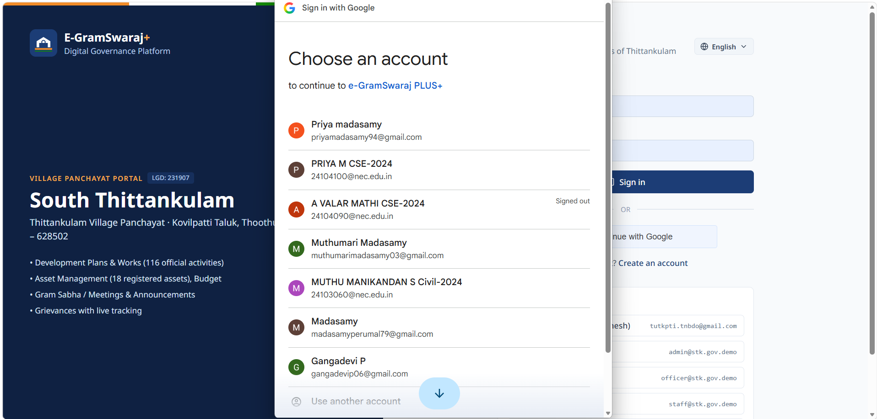
Fig 8.3 User login screen with role-based login options
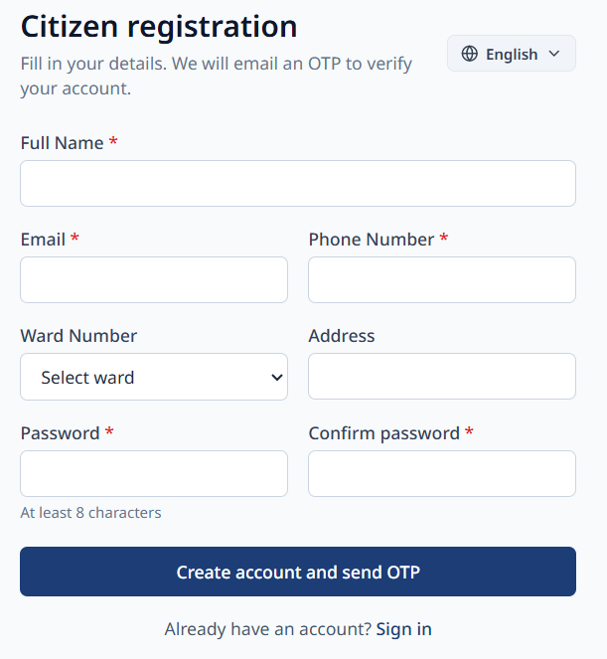
Fig 8.4 Citizen registration and profile creation screen
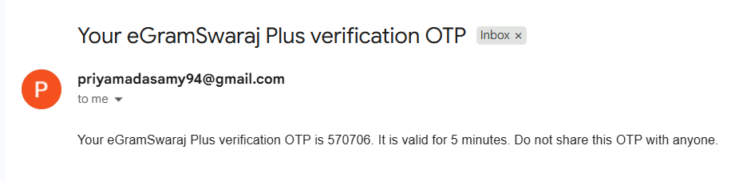Fig 8.5 OTP Verification dialog for citizen onboarding
8.4 VILLAGE PROFILE & MASTER DATA MANAGEMENT
Purpose & Scope
Centralizes foundational reference data for South Thittankulam Village Panchayat (LGD Code: 231907), including geography, population statistics, household counts, ward breakdowns, official contact directories, and village facility registries.

Functional Requirements
What the module must do:
- Maintain official village details: name, code ('STK'), LGD code (231907), block, taluk, district, state, and pincode.
- Record population, household counts, ward divisions, geographic boundary area, and local public amenities.
- Provide a facility registry detailing panchayat office, primary health center, schools, community halls, and water overhead tanks.
Non-Functional Requirements
How well the module must do it:
- Data Integrity: Enforce unique key constraints on villageCode and LGD code.
- Read Optimization: Village profile data is cached in client memory on startup to optimize load speed.
API Design
Method | Endpoint | Purpose / contract
GET | /api/villages | Lists all village panchayats in the system.
GET | /api/villages/:code | Fetches complete master profile & demographics for a village code.
PUT | /api/villages/:id | Admin/Officer only. Updates village statistics, contact officers, or amenities.

DB Design
Collection | Keys & indexes | Key fields
villages | _id, unique villageCode, lgdCode | name, villageCode, taluk, district, state, population, lgdCode
citizens | _id, villageId, userId | villageId, name, phone, email, address, ward, gender, status

Screenshots
The screens below show the village profile interface and demographic master data views.
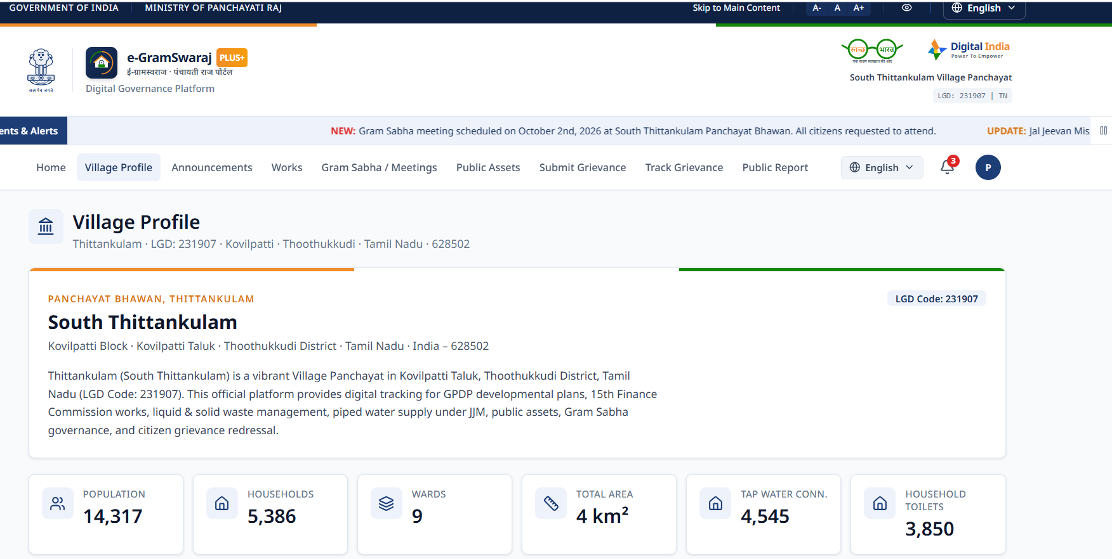
Fig 8.6 Village profile master data and demographics interface
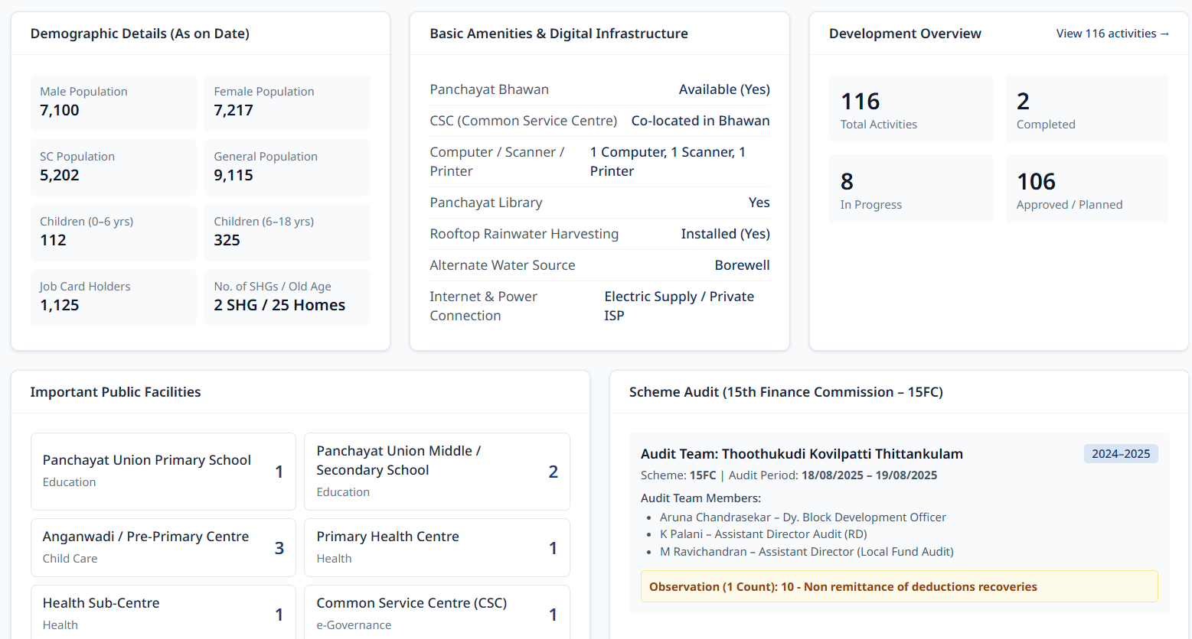
Fig 8.7 Village facility and public infrastructure directory

8.5 CITIZEN SERVICES & REQUISITIONS / GRIEVANCES MANAGEMENT
Purpose & Scope
Empowers citizens to submit civic requisitions and public complaints (water supply, street lighting, drainage, road repairs, garbage removal) online, track resolution workflows, and receive status updates.
Functional Requirements
What the module must do:
- A citizen can submit a grievance with category, subject, description, ward location, and priority level.
- Generates a unique tracking reference number (e.g. GRV-202610-XXXX) upon submission.
- Panchayat officers can assign grievances to field staff and update resolution status (Submitted, Acknowledged, In Progress, Resolved).
Non-Functional Requirements
How well the module must do it:
- Traceability: All status transitions are appended to an immutable audit history with timestamps.
- Responsiveness: Citizens can view real-time status changes from their personal portal.
API Design
Method | Endpoint | Purpose / contract
GET | /api/grievances | Lists grievances filtered by status, category, or citizen ID.
POST | /api/grievances | Creates a new civic complaint requisition and returns reference number.
PUT | /api/grievances/:id/status | Officer only. Updates grievance resolution status and appends remarks.

DB Design
Collection | Keys & indexes | Key fields
grievances | _id, unique referenceNumber, citizenId | referenceNumber, citizenId, category, subject, ward, status, history
serviceRequests | _id, unique applicationNumber | applicationNumber, serviceId, applicantName, status, assignedOfficer

Screenshots
The screens below show the grievance submission portal and issue tracking workflow.
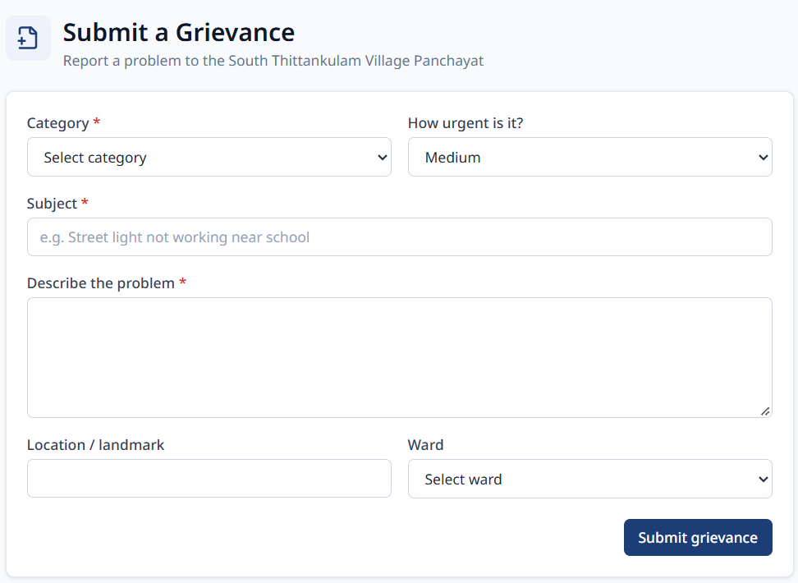
Fig 8.8 Citizen civic grievance submission portal
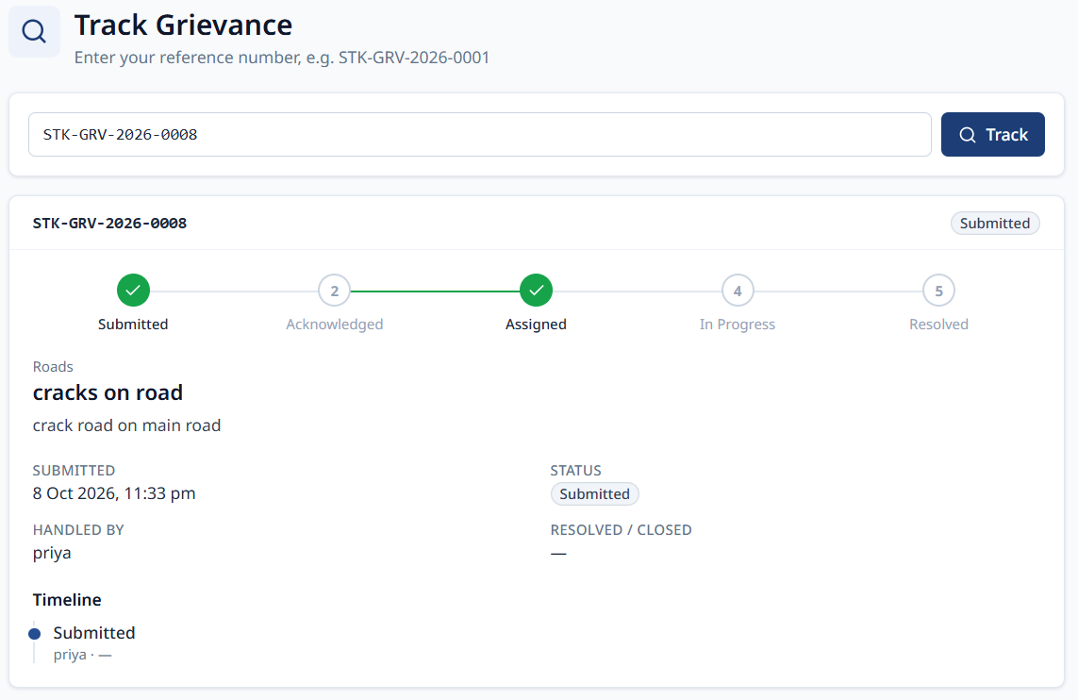
Fig 8.9 Grievance status tracking and resolution workflow
8.6 DEVELOPMENT PLANS & WORKS EXECUTION
Purpose & Scope
Orchestrates Gram Panchayat Development Plans (GPDP) and active civil infrastructure works from initial proposal to financial sanctioning, contractor assignment, and milestone completion.
Functional Requirements
What the module must do:
- Create multi-year development plans with categories (Infrastructure, Water, Sanitation, Roads), priority, and estimated cost.
- Track active civil works with activity codes, location coordinates, scheme allocations, and contractor assignments.
- Update physical progress (0-100%); auto-mark status COMPLETED when progress reaches 100%.
Non-Functional Requirements
How well the module must do it:
- Precision: All cost estimates and expenditure amounts are stored as DECIMAL(14,2).
- Automated Hook: Sequelize beforeSave hook auto-updates actualCompletionDate upon 100% progress.
API Design
Method | Endpoint | Purpose / contract
GET | /api/works | Lists civil works filtered by status, category, or financial year.
POST | /api/works | Officer only. Creates a new civil work under a sanctioned development plan.
PUT | /api/works/:id | Overseer/Officer. Updates physical progress percentage, spent amount, or status.

DB Design
Collection | Keys & indexes | Key fields
developmentPlans | _id, villageId, status | title, category, priority, estimatedCost, status, financialYear
works | _id, villageId, status | name, activityCode, category, location, estimatedCost, spentAmount, contractor, progress, status

Screenshots
The screens below show the development plan listing and civil works progress tracking.
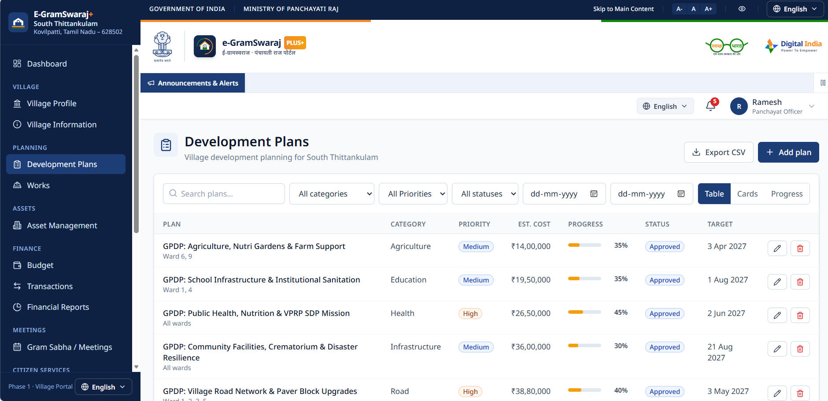
Fig 8.10 Gram Panchayat Development Plan (GPDP) listing
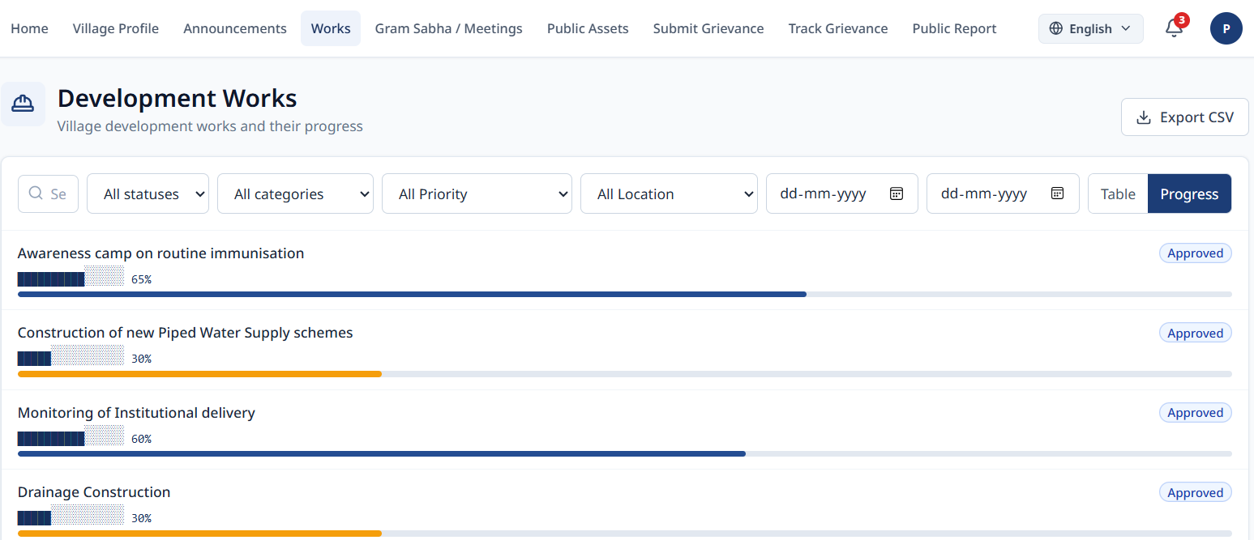
Fig 8.11 Civil works monitoring & progress tracking screen
8.7 PUBLIC ASSET & INFRASTRUCTURE TRACKING
Purpose & Scope
Manages public physical assets across the panchayat (water tanks, hand pumps, street lights, community halls, roads) with GIS coordinates and maintenance schedules.

Functional Requirements
What the module must do:
- Catalog assets by type (WATER_TANK, STREET_LIGHT, RO_PLANT, BUILDING, ROAD), ward location, asset code, and estimated value.
- Store latitude/longitude coordinates to render assets on interactive Leaflet maps.
- Track asset health condition (EXCELLENT, GOOD, POOR, NON_FUNCTIONAL) and log scheduled maintenance dates.
Non-Functional Requirements
How well the module must do it:
- Geo Validation: Latitude validated between -90 and 90; longitude validated between -180 and 180.
- Maintenance Alerts: Highlights assets whose maintenance interval days have elapsed.
API Design
Method | Endpoint | Purpose / contract
GET | /api/assets | Fetches asset catalog with optional type, ward, and condition filters.
POST | /api/assets | Officer only. Registers a new public asset with GPS location.
PUT | /api/assets/:id | Updates asset health condition or logs maintenance entry.

DB Design
Collection | Keys & indexes | Key fields
assets | _id, villageId, type, condition | name, assetCode, type, ward, latitude, longitude, condition, estimatedValue, maintenanceIntervalDays, status

Screenshots
The screens below show the GIS public asset mapping interface and asset registry.
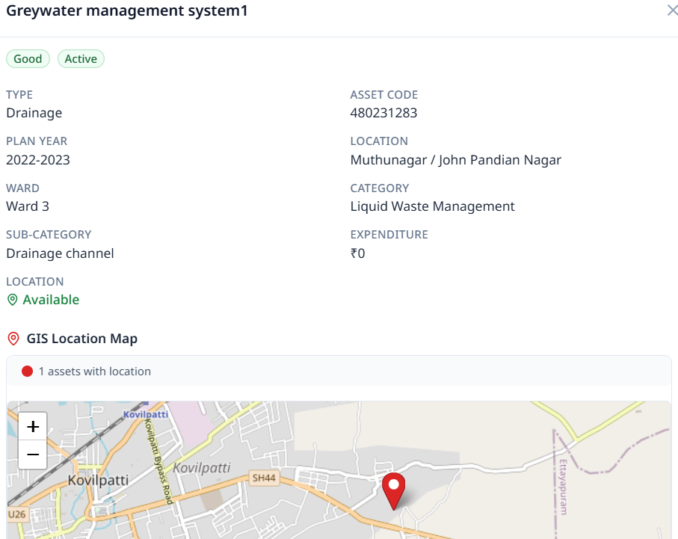
Fig 8.12 Interactive GIS public asset and infrastructure map
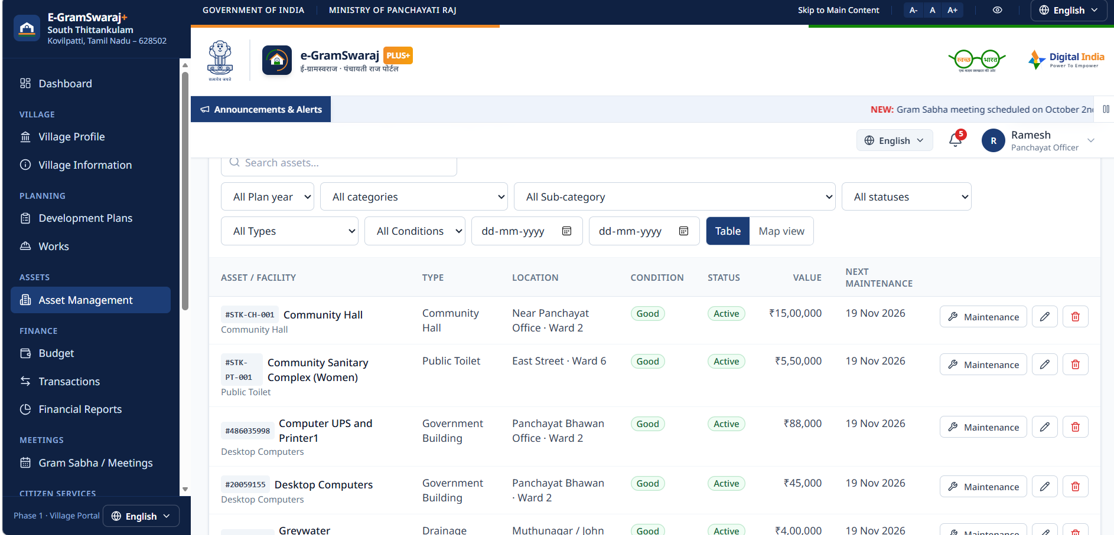Fig 8.13 Village asset registry and maintenance scheduler

8.8 FINANCIAL TRANSACTIONS & BUDGETARY CONTROL
Purpose & Scope
Enforces strict ledger accounting for village income receipts (government grants, local taxes) and expenditure payments against category-wise annual budgets.
Functional Requirements
What the module must do:
- Record receipts and expenditures with voucher reference numbers and descriptions.
- Define annual category budgets (e.g. 2026-2027) with allocated, utilized, and remaining amounts.
- Sequelize beforeSave hook auto-computes financial year from transaction date and recalculates remaining budget balances.
Non-Functional Requirements
How well the module must do it:
- Zero Floating Error: Strict DECIMAL(14,2) representation for all monetary amounts.
- Budget Guard: Prevents expenditure booking if category budget utilized amount exceeds allocated funds.
API Design
Method | Endpoint | Purpose / contract
GET | /api/financial-transactions | Fetches financial transactions for a given financial year.
POST | /api/financial-transactions | Officer only. Records a new receipt or expenditure voucher.
GET | /api/budgets | Views category-wise budget allocations and utilization status.

DB Design
Collection | Keys & indexes | Key fields
financialTransactions | _id, villageId, financialYear, type | type, category, amount, referenceNumber, date, financialYear, status
budgets | _id, unique (villageId, financialYear, category) | financialYear, category, allocatedAmount, utilizedAmount, remainingAmount

Screenshots
The screens below show the financial receipts/expenditures ledger and annual budget summary.
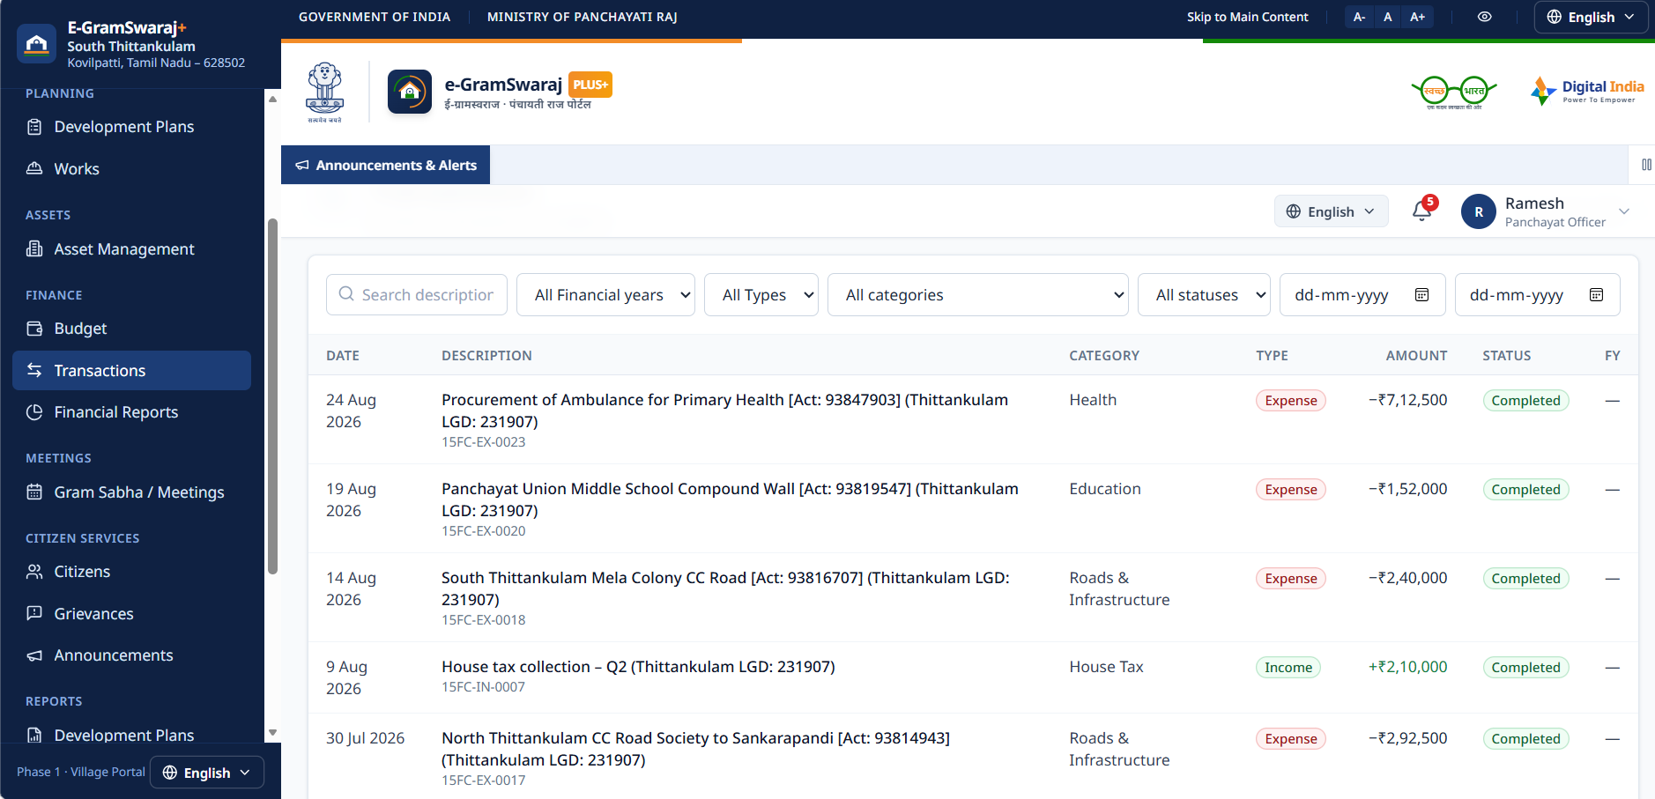
Fig 8.14 Public financial ledger (Receipts & Expenditures)
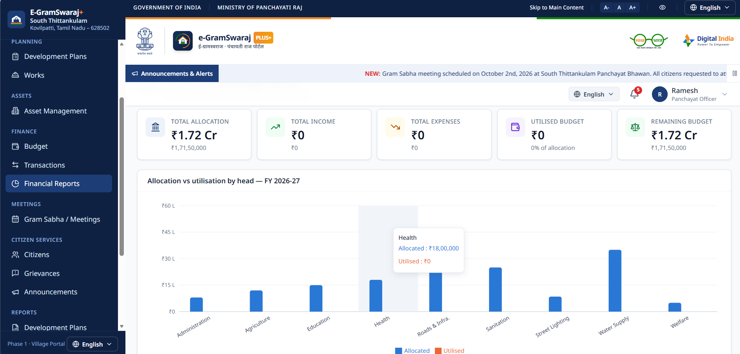
Fig 8.15 Annual budget allocation and utilization charts

8.9 GRAM SABHA MEETINGS & GOVERNANCE
Purpose & Scope
Facilitates democratic local governance by managing public meeting schedules, formal agendas, public attendance logging, and official resolutions.
Functional Requirements
What the module must do:
- Schedule Gram Sabha, Panchayat Board, and Ward Sabha meetings with date, location, and published agenda items.
- Document formal meeting minutes, passed resolutions, and gender-disaggregated public attendance counts (male/female/officials).
- Publish public meeting notices accessible on citizen portals without login requirement.
Non-Functional Requirements
How well the module must do it:
- Transparency: Meeting notices marked isPublic=true are publicly readable.
- Structured Data: Agenda items and meeting decisions are stored as structured JSON arrays.
API Design
Method | Endpoint | Purpose / contract
GET | /api/meetings | Fetches scheduled or completed meetings for the village.
POST | /api/meetings | Officer only. Schedules new Gram Sabha or Panchayat Board meeting.
PUT | /api/meetings/:id | Uploads meeting minutes, resolutions passed, and public attendance.

DB Design
Collection | Keys & indexes | Key fields
meetings | _id, villageId, type, status | title, type, date, location, agenda (JSON), minutes, decisions (JSON)

Screenshots
The screens below show the Gram Sabha meeting notice dashboard and attendance/minutes logger.
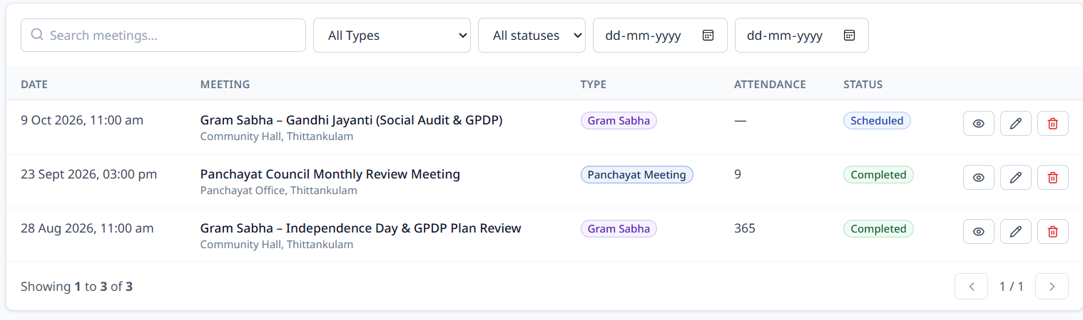
Fig 8.16 Gram Sabha meeting schedule & notice dashboard
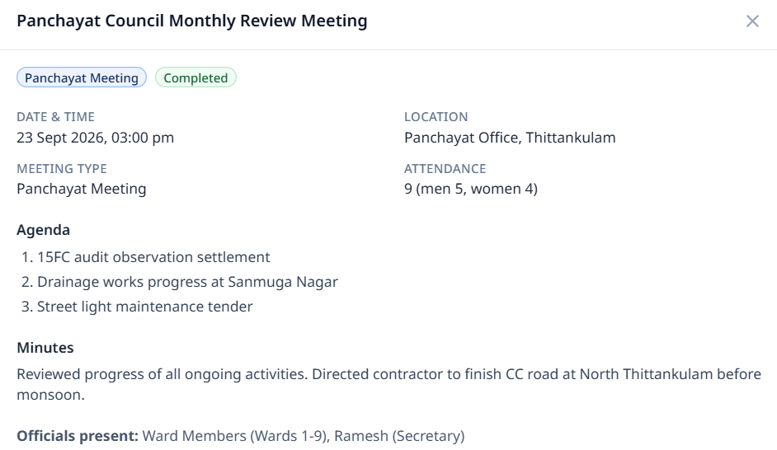
Fig 8.17 Gram Sabha meeting resolutions & attendance logged

8.10 EXECUTIVE DASHBOARD, ANALYTICS & LOCALIZATION
Purpose & Scope
Provides operational transparency through live KPI summary monitoring, Recharts analytics graphics, and dynamic 8-language localization powered by Google Cloud Translation API.
Functional Requirements
What the module must do:
- Display active summary counters: total population, total works count, active budget utilization, asset count, and pending grievances.
- Support dynamic UI translation across 8 Indian languages (English, Tamil, Hindi, Telugu, Kannada, Malayalam, Marathi, Bengali).
- Hash source strings (SHA-256) and cache translated text in translationCache to eliminate redundant Google API calls.
Non-Functional Requirements
How well the module must do it:
- Cache Latency: < 5 ms for cached translations vs ~300 ms for live API calls.
- Graceful Fallback: If translation API key is unconfigured, UI safely displays original source text.
API Design
Method | Endpoint | Purpose / contract
GET | /api/health | Public health check endpoint returning server & database status.
POST | /api/translate | Translates provided text or retrieves from DB cache for target language.

DB Design
Collection | Keys & indexes | Key fields
translationCache | _id, unique sourceHash | sourceHash, sourceText, sourceLanguage, targetLanguage, translatedText

Screenshots
The screens below show the executive analytics dashboard and dynamic multi-lingual interfaces.
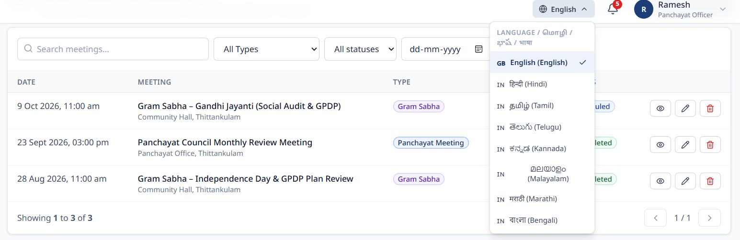Fig 8.18 Executive analytics dashboard with KPI metrics
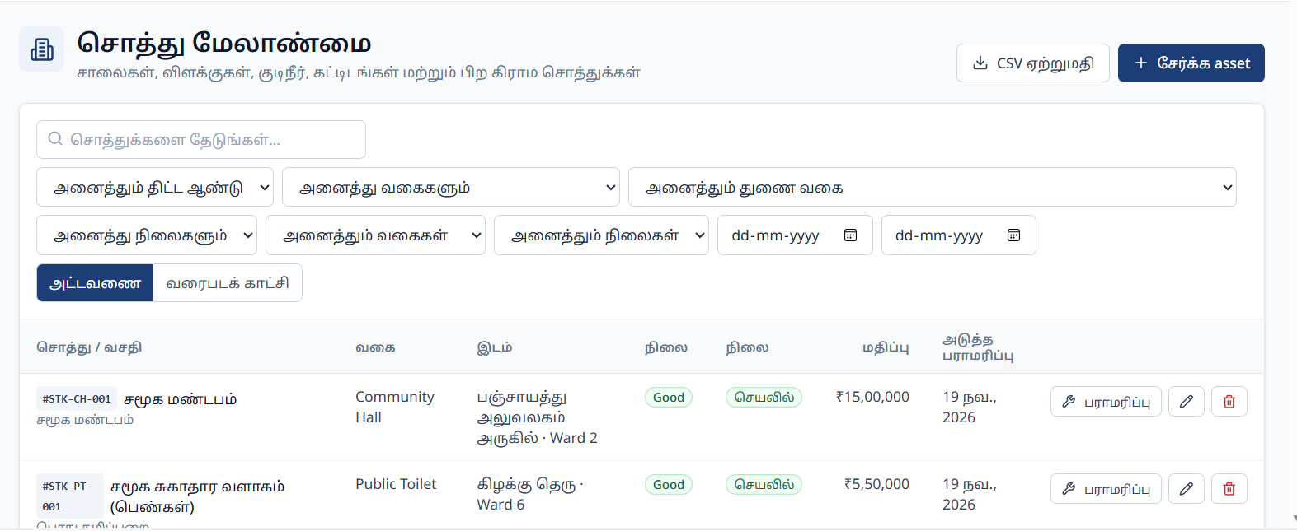
Fig 8.19 Dynamic interface localized in Tamil
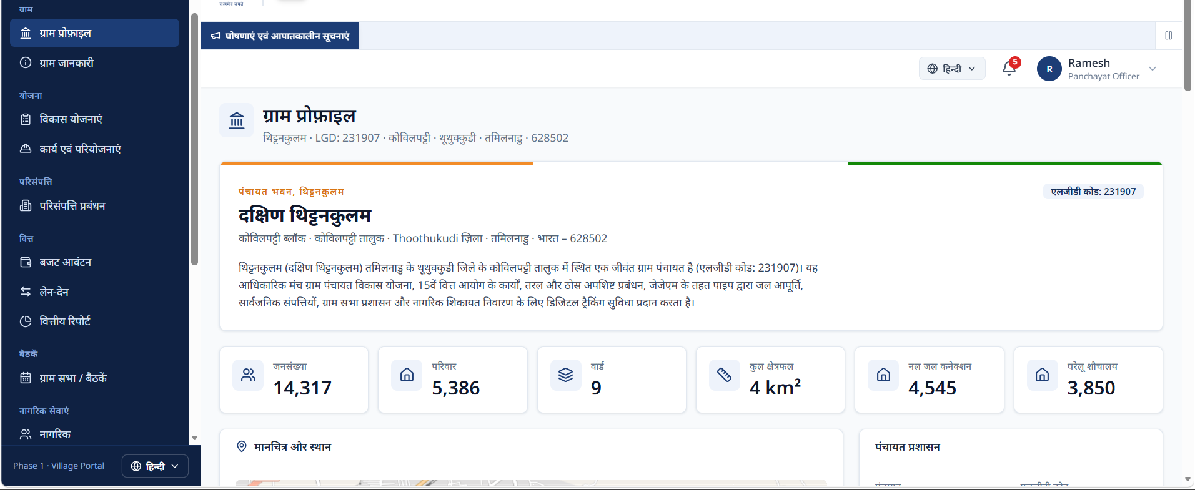
Fig 8.20 Dynamic interface localized in Hindi
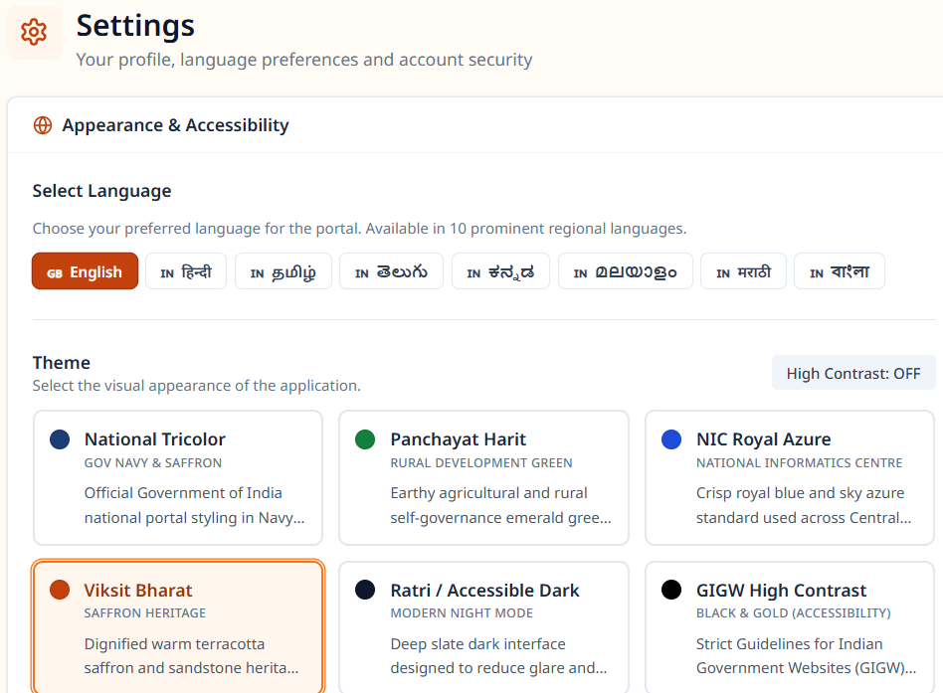
Fig 8.21 Dynamic user themes

CHAPTER 9
CONCLUSION
CONCLUSION
The E-GramSwaraj+ system provides a comprehensive, full-stack digital governance platform for automating and modernizing the core operations of South Thittankulam Village Panchayat. By unifying village profile administration, citizen service requisitions, multi-year development project lifecycle tracking, public physical asset management, financial budget accounting, and Gram Sabha governance within a single web application, the system successfully eliminates manual paper registers, minimizes recording errors, and significantly enhances public transparency.
Developed using React 18, Vite, Tailwind CSS, Recharts, and Leaflet on the client side, and Node.js, Express.js, Sequelize ORM, and MySQL 8 on the server side, the platform exhibits high architectural performance, modular maintainability, and enterprise-grade security. Secured through JWT token authentication, salted bcrypt password hashing, HTTP hardening via Helmet, CORS restrictions, and express rate limiting, the system guarantees role-based access control across administrative officers, staff, and citizens.
Furthermore, the integration of dynamic 8-language localization via Google Cloud Translation API backed by a high-speed SHA-256 database cache breaks down language barriers, enabling local villagers to interact seamlessly with their local panchayat portal in their native language.E-GramSwaraj demonstrates how modern web technologies can empower rural digital governance, providing a scalable model capable of extending to Panchayati Raj institutions across the nation.
FUTURE WORK
Future upgrades to E-GramSwaraj could include real-time SMS alerts for grievance updates and Gram Sabha meetings, while GIS-based automated boundary tools can support ward planning. Mobile apps can enable offline field data collection by village overseers, and AI with NLP can automatically categorize grievances. Finally, cloud-native deployment with auto-scaling databases can help scale the system across entire blocks and districts.

