**VEHICLE MANAGEMENT SYSTEM USING SALESFORCE**

**Project Report Template**

***1)Introduction***:

*● Vehicle management project is an application that is* ***used to manage the fleet of***

***vehicles****(****online****/****offline****).In this project sales and marketing strategy is executed to* ***sell***

***or rental*** *2-wheeler's and 4-wheeler's .Nowadays vehicle management is very much*

*needed in order to have a flourishing economy.*

***PURPOSE***

*Vehicle management helps to* ***improve service delivery and good governance of vehicle .***

***It is aimed at*** *-*

*● keeping driver records ,*

*● Vehicle details*

*and etc.*

*A customer who wishes to buy or rental vehicle can* ***approach us through the app or visit our***

***company*** *for a better approach.*

***Our service includes***

*1) Keeping records of every vehicle along with brand name , colour, condition and etc .*

*2) If a driver assistance is needed we also provide it with pleasure.*

***The following are the important features****:*

*1) More accountability to driver and officials assigned.*

*2) Security of customer is protected .*

*3) Manipulation of the data cannot be done by anyone.*

*Through our project Customer* ***satisfactory service*** *would be provided along with the facilities*

*and features mentioned above.*

**2) Problems Definition & Design Thinking:**

*•The screenshot of* ***Empathy map*** *of our project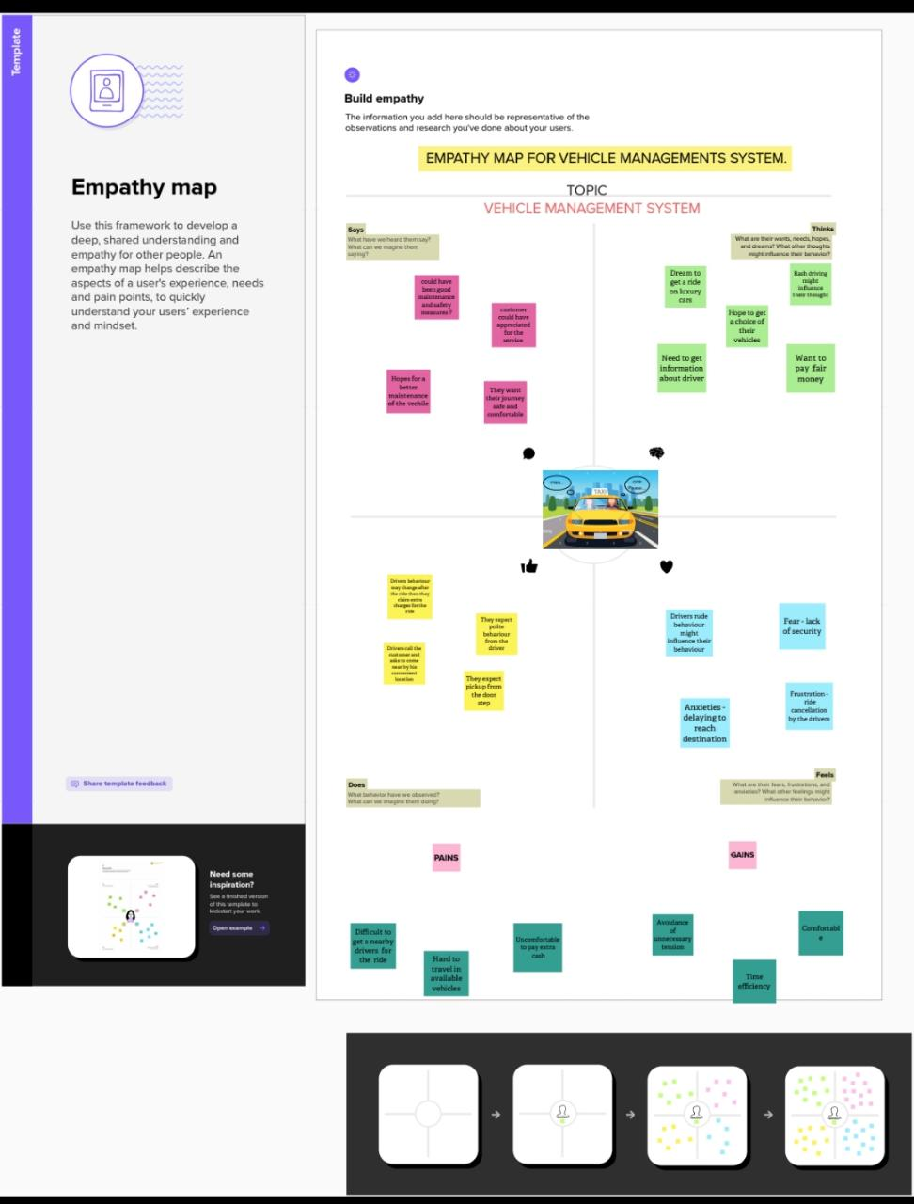*

*•The screenshot of* ***Brainstorming map*** *of our project*

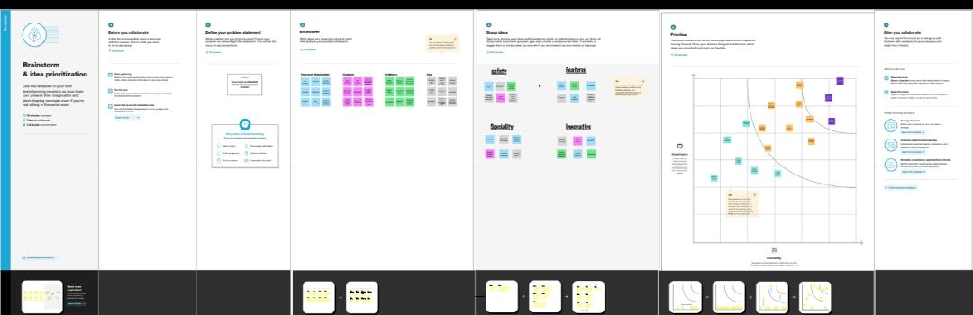

**3) Result:**

**Data Model**

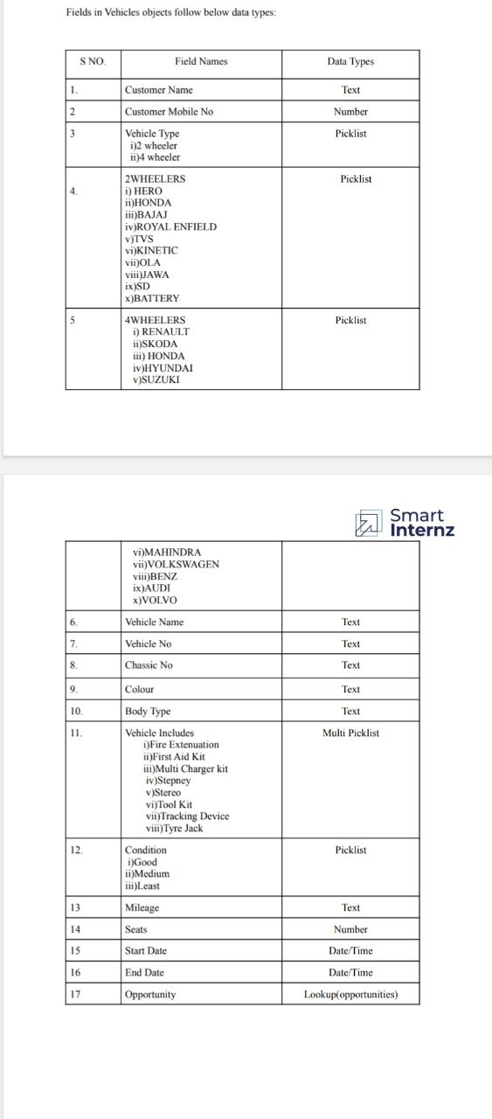

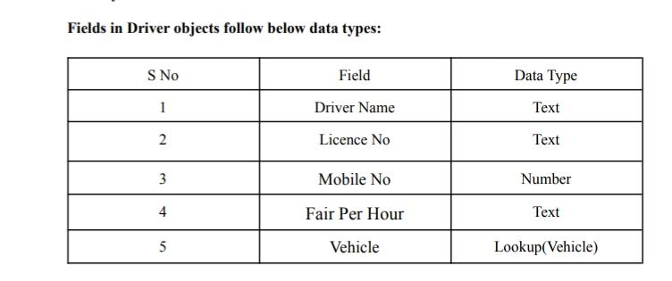

**Activity & Screenshot**

**OBJECTS:**

**Salesforce objects are database tables that permit you to store data that is specific to an organization. Salesforce objects are of two types: Standard Objects: Standard objects are the kind of objects that are provided by salesforce.com such as users, contracts, reports, dashboards, etc.**

**Standard Objects:**

**Account, Contact, Opportunity.**

**Custom objects:**

**Vehicles, Drivers.**

**STEP 1: CREATING CUSTOM OBJECTS**

**\*VEHICLE**

**\*DRIVER**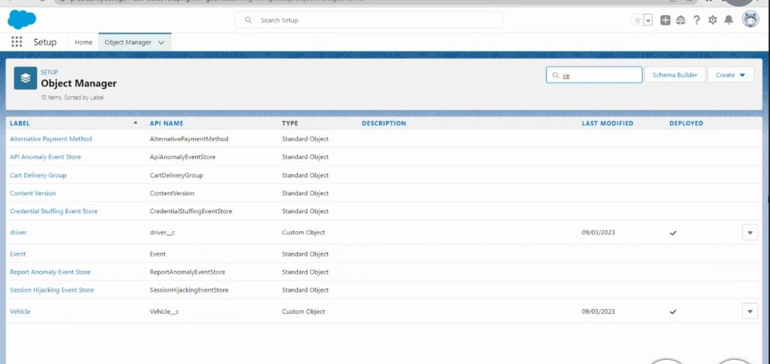

**FIELDS AND RELATIONSHIPS:**

**An object relationship in Salesforce is a two-way association between two objects. Relationships are created by creating custom relationship fields on an object. This is done so that when users view records, they can also see and access related data.**

**STEP 2: CREATING CUSTOM FIELDS FOR VEHICLE AND DRIVER OBJECT**

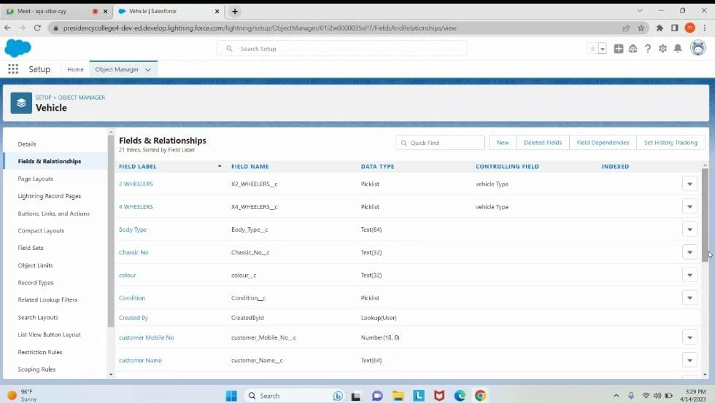

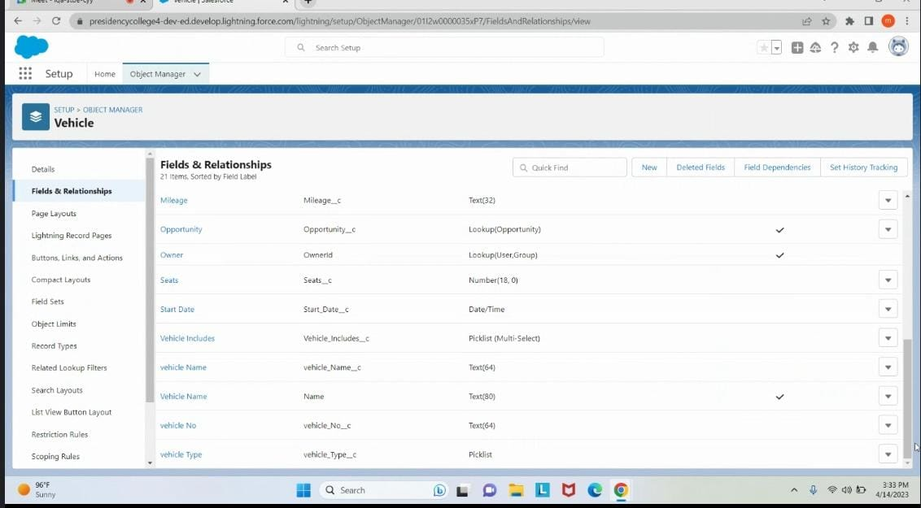

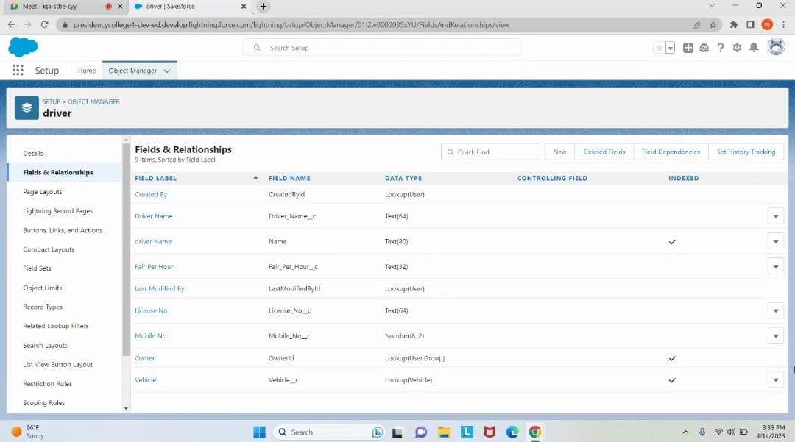

**STEP 3: CREATING FIELD DEPENDENCIES FOR VEHICLE OBJECT**

**Create a dependency between these two picklists, so that when a Vehicle type is selected, only respective 2Wheeler Brands are available in the 2Wheeler field,Similarly for 4-wheelers.**

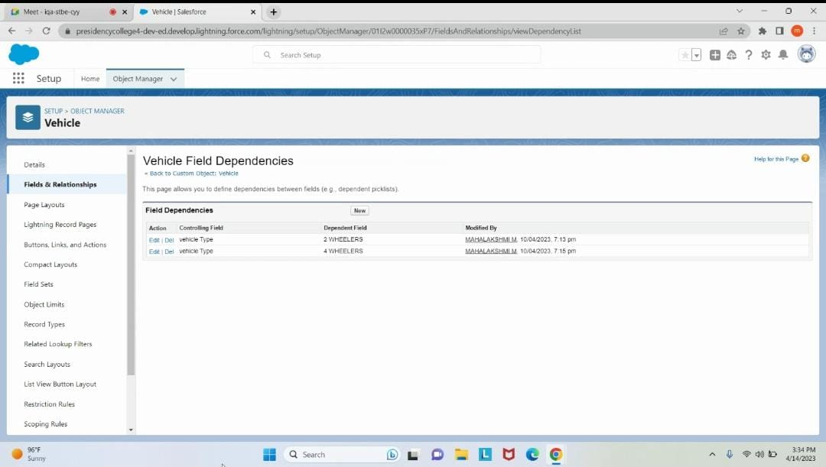

**STEP 4: CREATE A VEHICLE MANAGEMENT APP**

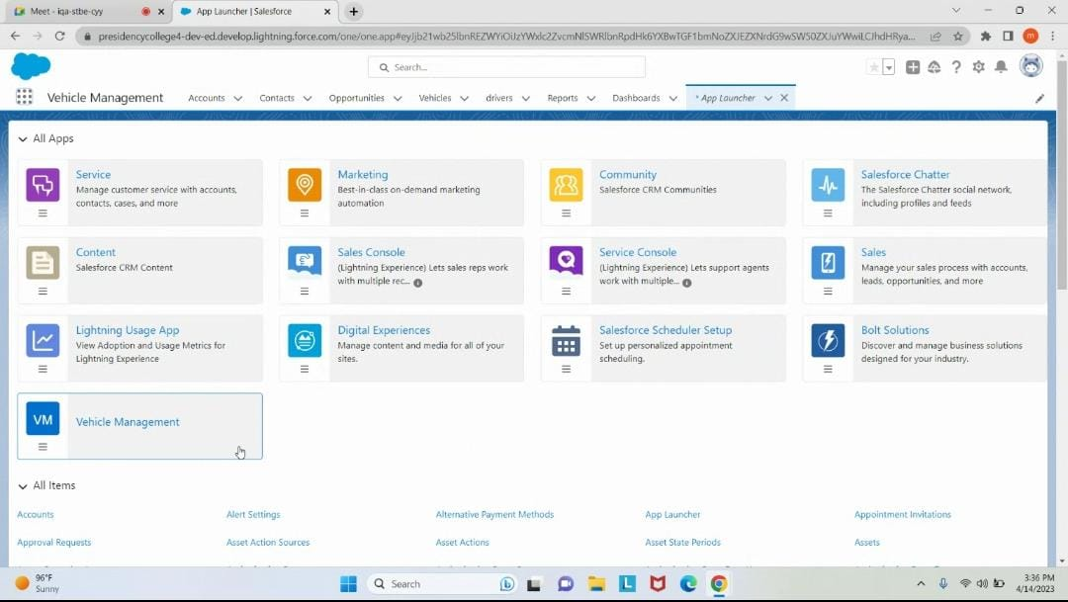

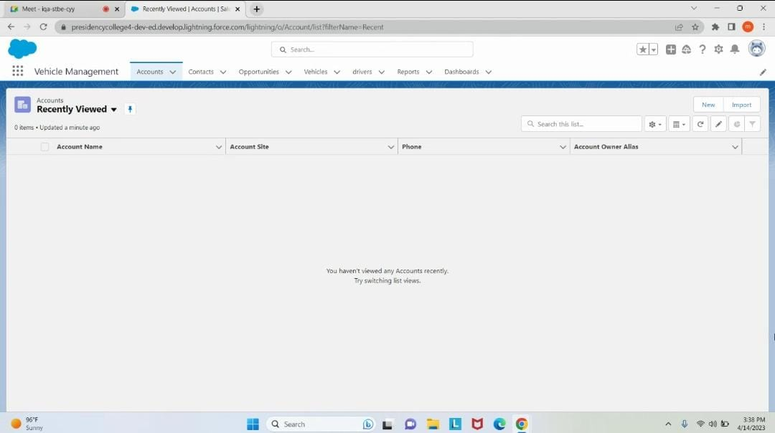

**STEP 5: CREATE A VEHICLE MANAGER AND OPERATOR PROFILE**

**A profile is a group/collection of settings and permissions that define what a user can do in Salesforce. A profile controls “Object permissions, Field permissions, User permissions, Tab settings, App settings, Apex class access, Visualforce page access, Page layouts, Record Types, Login hours & Login IP ranges**

**Create vehicle profile, Clone Standard user and Scroll down to Custom Object Permissions and give access for Create, Read, Edit, Delete ,View all and Modify all for Vehicle object and Drivers object.**

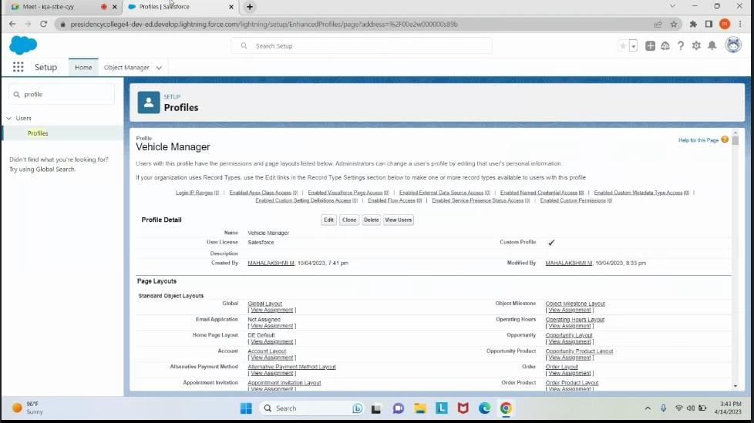

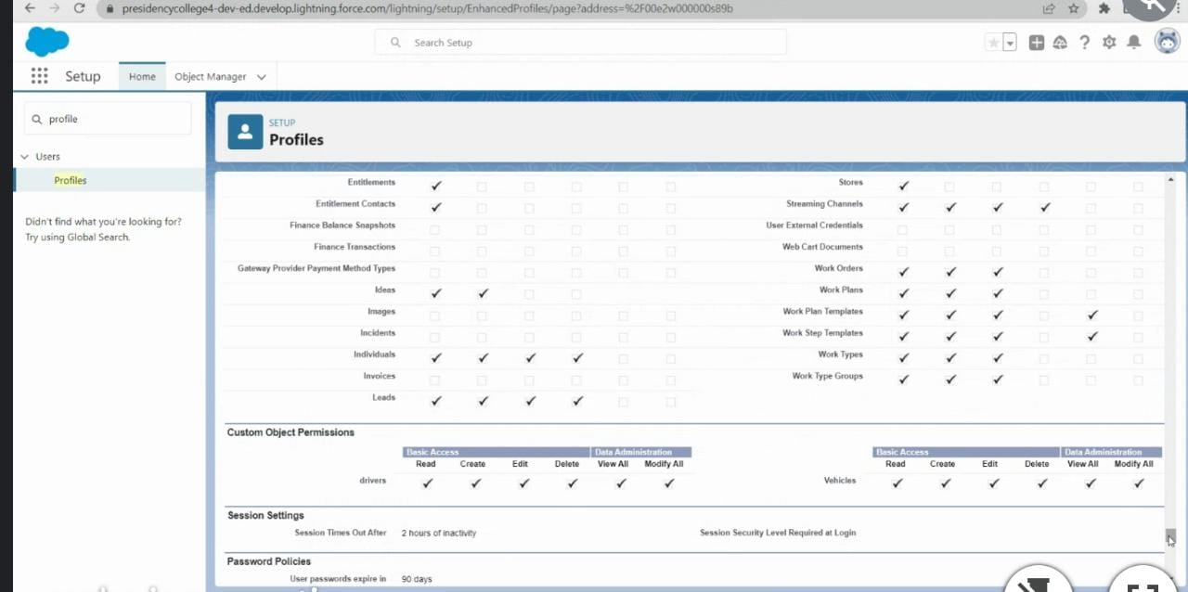

**CREATE OPERATOR PROFILE**

**Create operator profile:**

**Clone Salesforce Platform user and Scroll down to Custom Object Permissions and give access for Create, Read, Edit, Delete, View all, and Modify all only for Vehicle object**

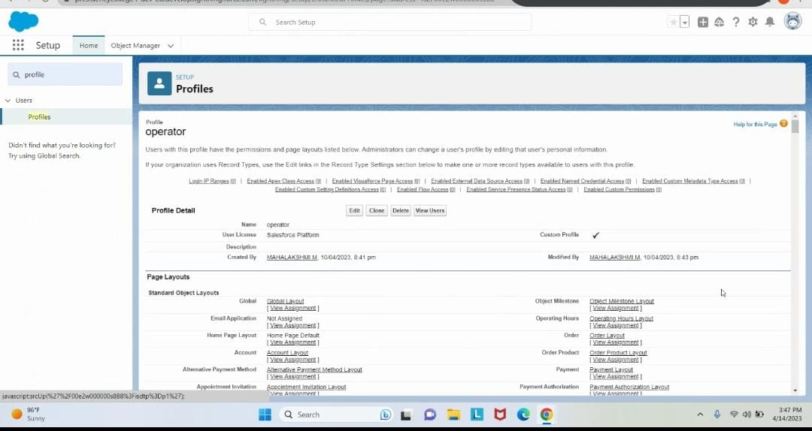

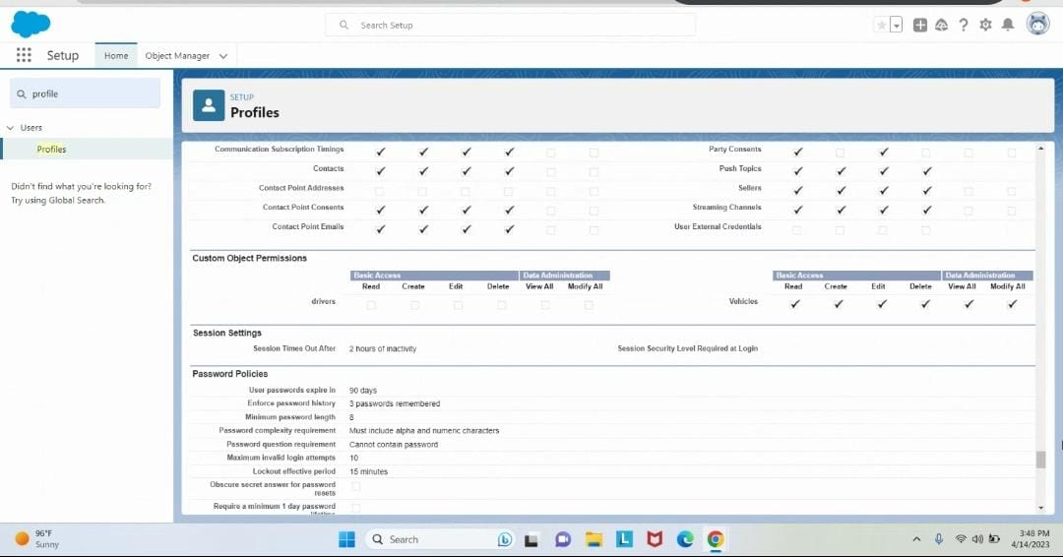

**STEP 6: ADD ROLE**

**UNDER THE CEO ADD THE ROLE – VEHICLE MANAGER**

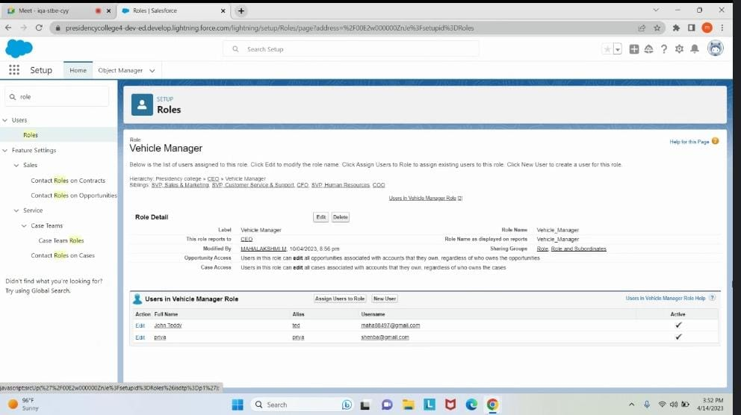

**UNDER THE VEHICLE MANAGER ADD THE ROLE OPERATOR 1 AND OPERATOR 2**

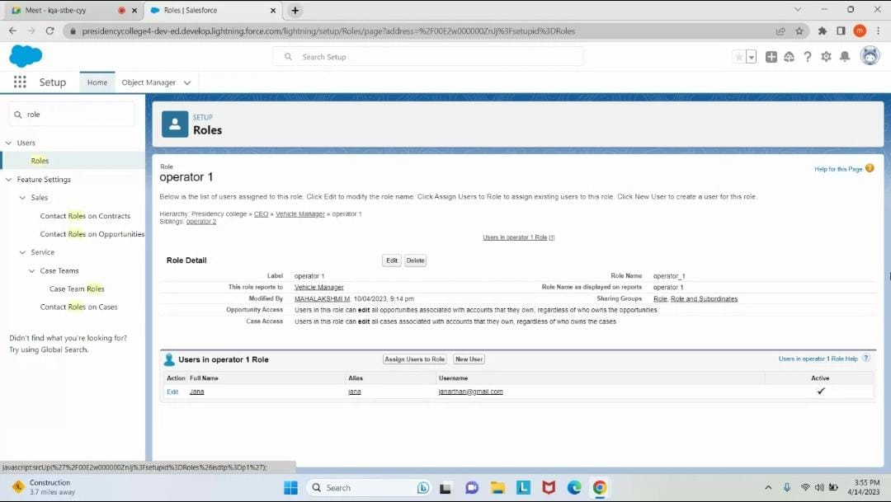

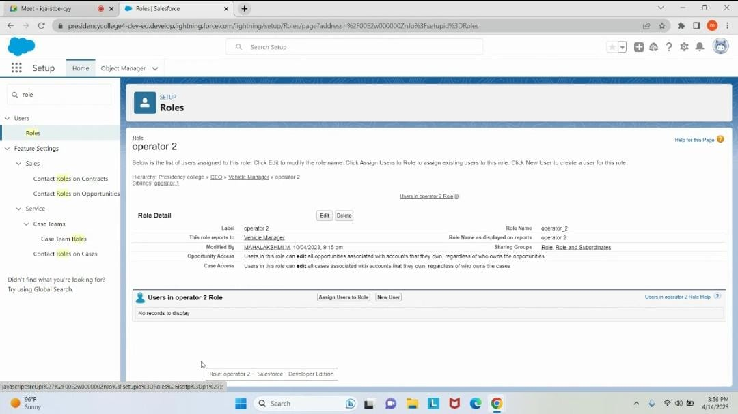

**STEP 7: CREATING THE USERS**

**A user is anyone who logs in to Salesforce. Users are employees at your company, such as sales reps, managers, and IT specialists, who need access to the company's records. Every user in Salesforce has a user account.**

**CREATE A USER "JOHN TEDDY" AND ASSIGN VEHICLE MANAGER AS ROLE AND PROFILE**

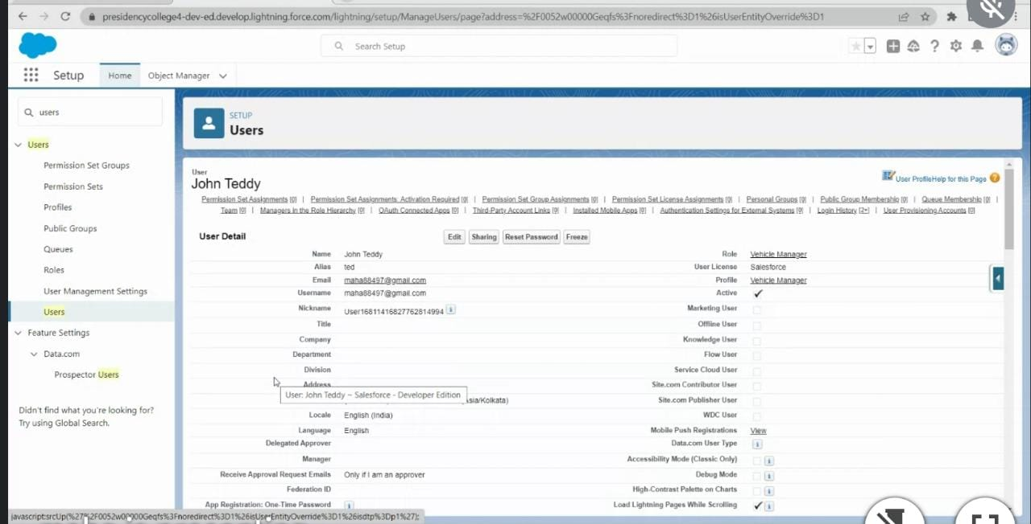

**CREATE OTHER TWO USERS AND ASSIGN OPERATOR 1 AND OPERATOR 2 ROLES ALONG WITH OPERATOR PROFILE**

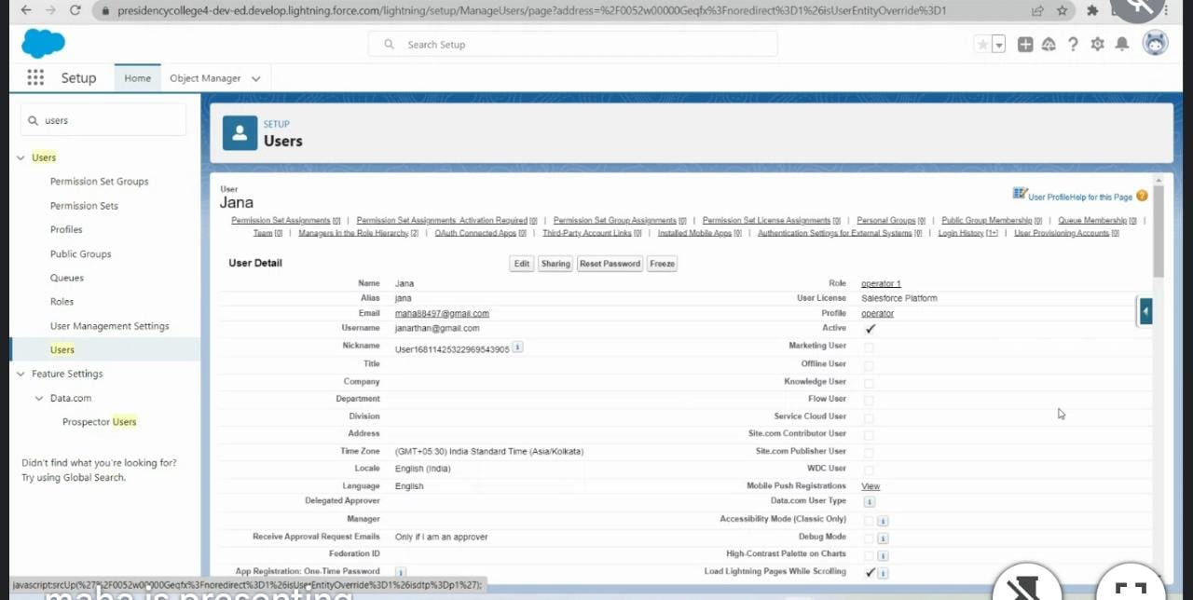

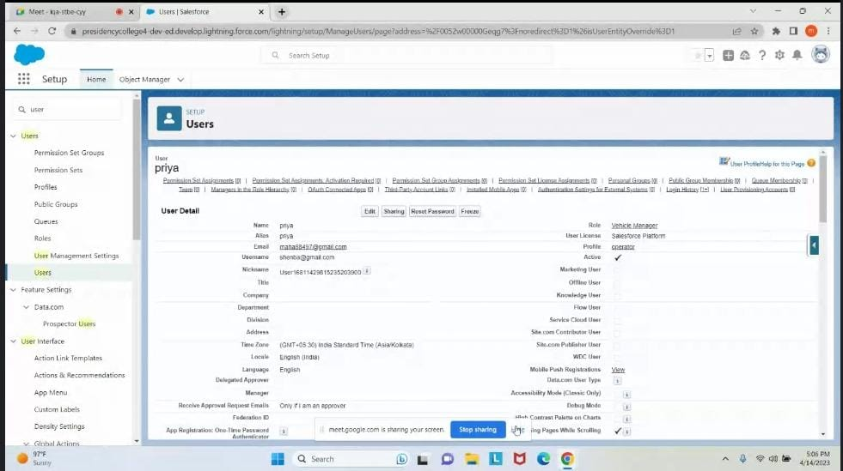

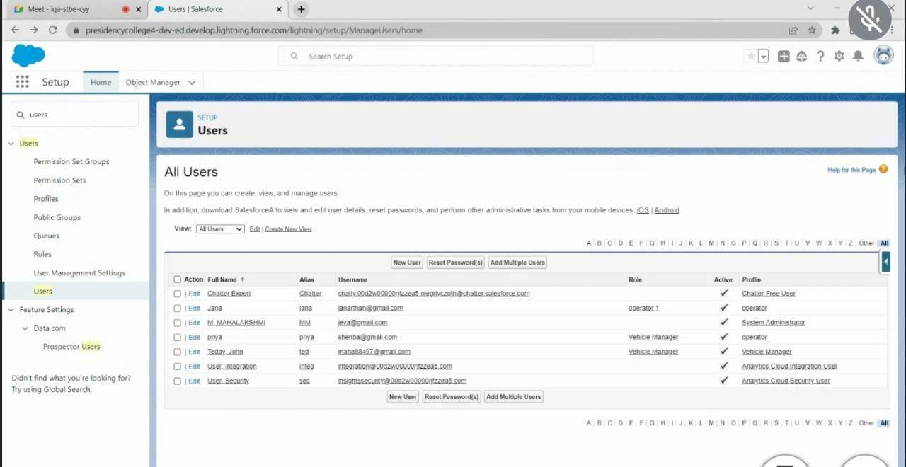

**STEP 8: CREATE THE REPORTS**

**A report is a list of records that meet the criteria you define. It's displayed in Salesforce in rows and columns, and can be filtered, grouped, or displayed in a graphical chart. Every report is stored in a folder. Folders can be public, hidden, or shared, and can be set to read-only or read/write.**

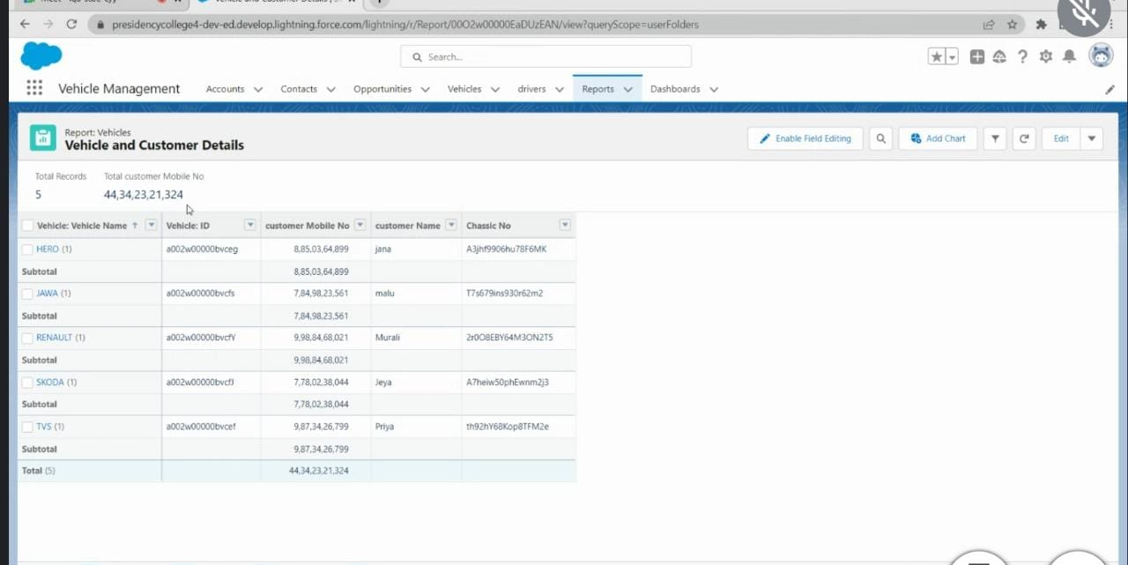

**STEP 9 :CREATING THR DASHBOARDS**

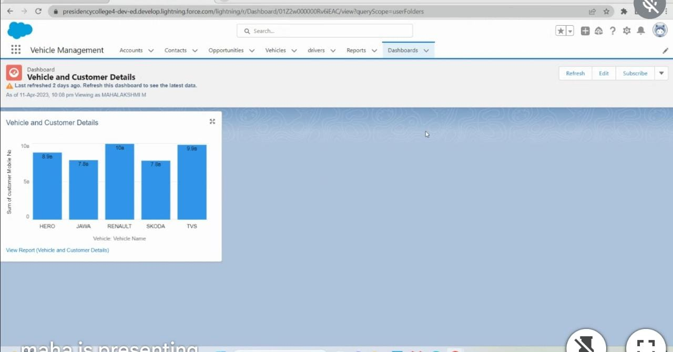

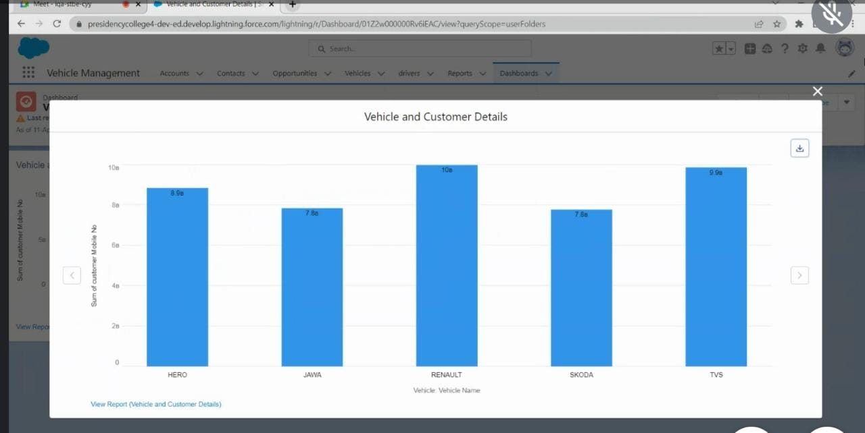

**4)Trailhead profile public URL**

Team leader - https://trailblazer.me/id/maham139

Team member 1 - https://trailblazer.me/id/elams4

Team member 2 - https://trailblazer.me/id/girsn

Team member 3 - https://trailblazer.me/id/ajaym71

**5) Advantage and disadvantage**

**Advantage**

*i) Easy management of fleet of vehicles*

*ii) Security of customer is well protected*

*iii) Accessing of desired vehicle becomes easy for*

*everyone*

**Disadvantage**

*i) Network issue may happen at the least …..*

*ii) Minutely damaged vehicle could be supplied at*

*the least….*

**6)Application:**

*●Management of vehicles is applied*

*in every fields like sales & services,*

*business processing units , dealers*

*in new and used vehicle sales and*

*etc….*

**7) Conclusion:**

*● At last , we conclude by*

*mentioning that Vehicle*

*management helps to*

*improve service delivery and*

*good governance of vehicle*

*which is much needed in*

*today's world.It is well*

*performed by our application*

*for vehicle management.*

**8)Future Scope:**

*In the future many feature like purified*

*water supply in vehicle, improved gps*

*facilities,security alarm in every vehicle*

*which informs cops and dear ones at*

*the emergency through screaming,well*

*equipped accident safety measures*

*and etc*