# State Diagram

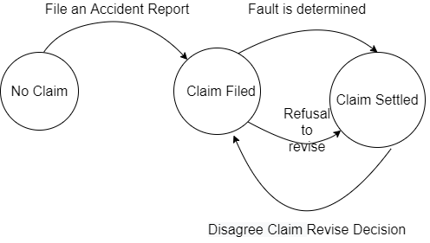

# State Data

1. States :
   1. No Claim
   2. Claim Filed
   3. Claim Settled
2. State: 0
3. Policy number: ‘’
4. Make: ‘’
5. Model: ‘’
6. Year: ‘’
7. Registration: ‘’
8. License Plate Number: ‘’
9. Date of Accident: ‘’
10. Time of Accident: ‘’
11. Location of Accident: ‘’
12. Extent of Injuries: ‘’
13. Accident Description: ‘’
14. Name of Accident Driver: ‘’
15. License of Accident Driver: ‘’

# Functions and Transitions

## Transitions

1. FileAccidentReport(above state data needed)
2. FaultDeterminationFunction()
3. DisagreeClaimReviseDecision()
4. RefusalToRevise()

## Functions

1. CheckClaim()
2. CheckStatus()

## Roles

1. FileAccidentReport(above state data needed) -> Claimant
2. FaultDeterminationFunction() -> Insurance Company
3. DisagreeClaimReviseDecision() -> Claimant
4. RefusalToRevise() -> Insurance Company