# Sequence Diagram Explanation

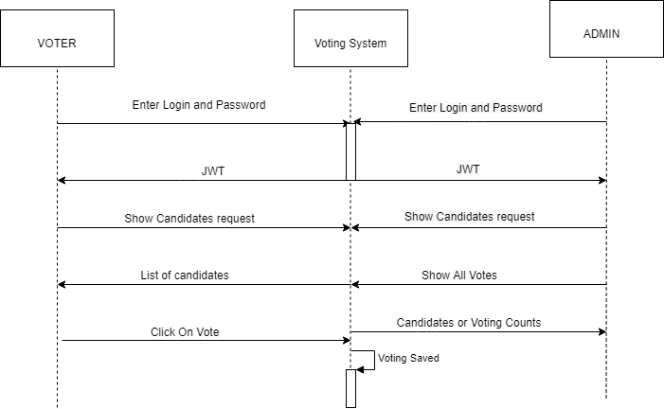

First or all there are two types of login: Admin and Voter. Admin can login the system to get the list of all candidates or get the list of all the votes. Voter can login the system which returns JWT to validate the user. Voter can view candidates and can vote on a candidate.