Step 1 : UI has two button as mentioned below

1. Reset Deck

2. Draw Card

**Landing Page :-**

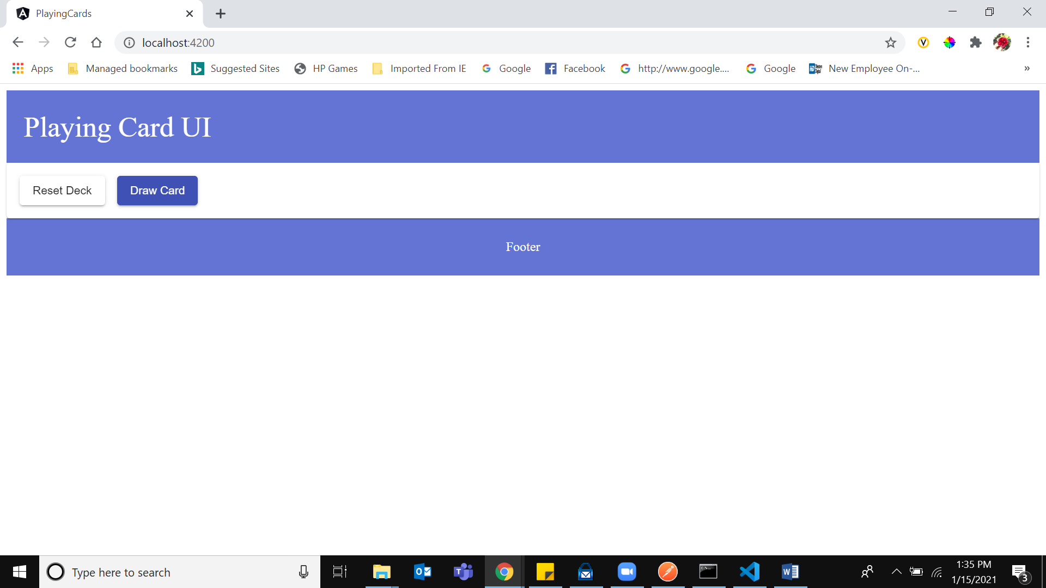

Step 2 : After Pressing Reset Deck, new deck is creating.

**New Deck Creation Page :-**

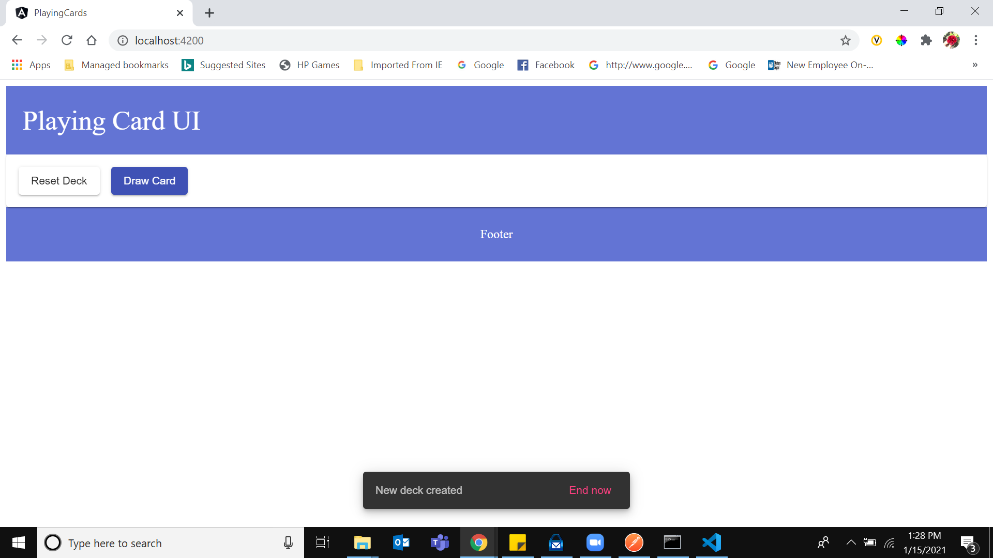

Step 2 : After pressing on Draw Card, new card is creating of that deck.

**Draw New Card Page:-**

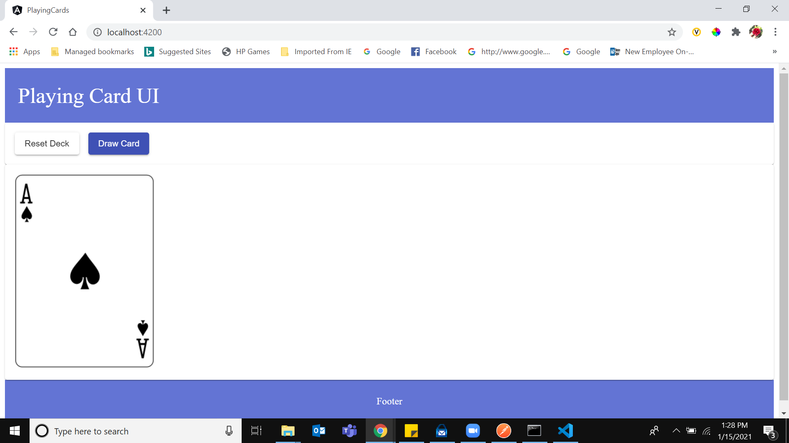

step 3 : Once deck is empty, showing message to reset deck.

**Empty Deck Page :-**

