SUPERSTORE SALES ANALYSIS
INTRODUCTION:
This project clearly demonstrates the role of analyzing data for business enhancements. The objective of the project is to analyze the sales trends and patterns by using power query, power pivot, dashboards and insights excel with an example of Superstore data set.
AIM:
The Aim of the project is to analyze the sales trends and workflow to enhance business profitability and reduce losses.
BUSINESS PROBLEM /CONTEXT:
The retail superstore sales fluctuate between profit and loss over certain categories. This analysis will find a strategical solution to fix the losses and retain their growth.
ABOUT SUPERSTORE DATA:
This data set is about Superstore sales which contains 9995 rows and 19 columns with its products and customers details on a different sheet through which meaningful insight is developed to help business decision making.

PROJECT WORKFLOW:
- RAW DATA:
Raw data is uncleaned and unprocessed data which is further cleaned and transformed to derive meaningful insights.
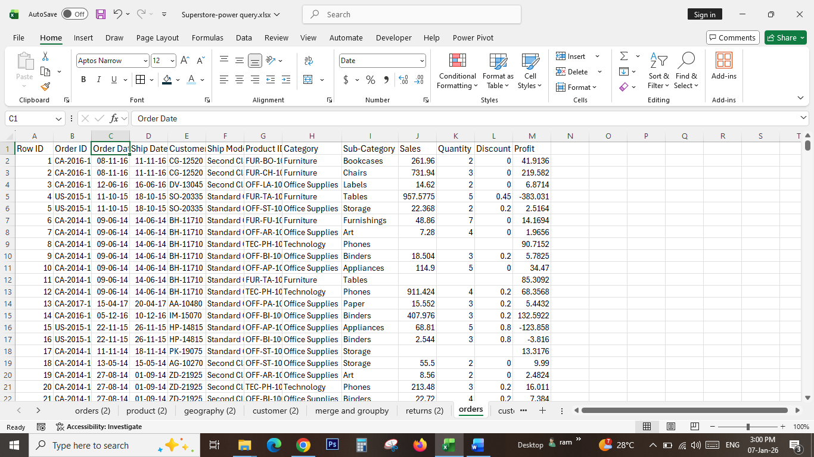
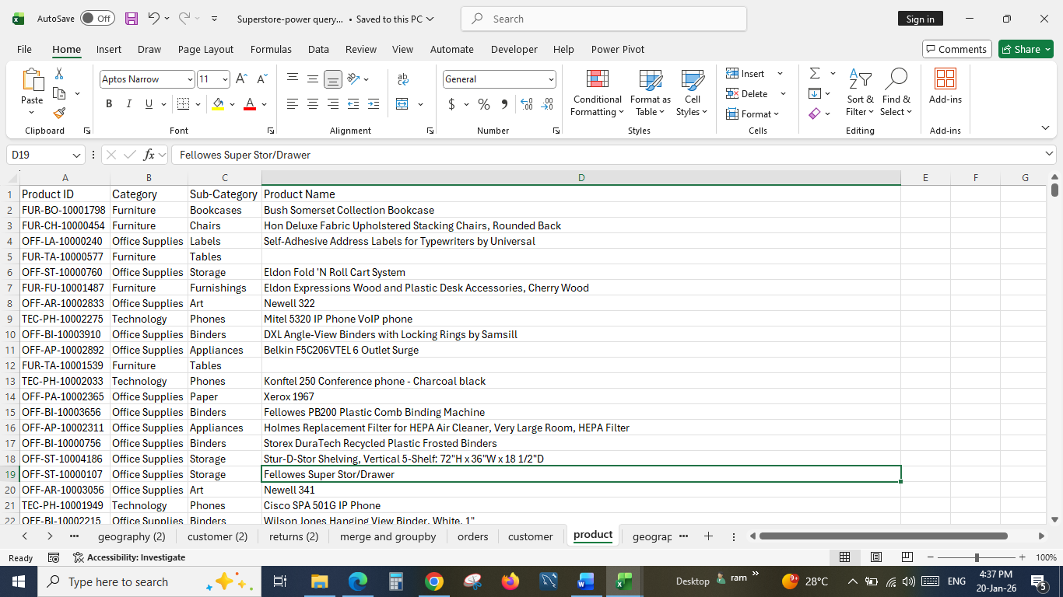
CLEANING AND PREPROCESSING:
Power query is an essential tool to clean data efficiently. The messy or raw data is imported to power query to transform it into a structured and processed data by changing its data types, removing duplicates and replacing null values.
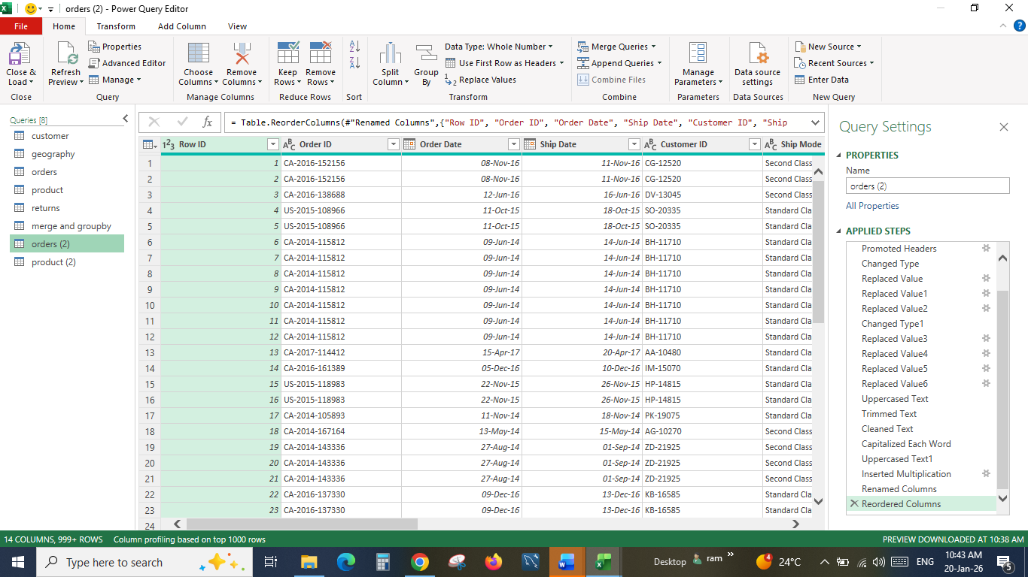
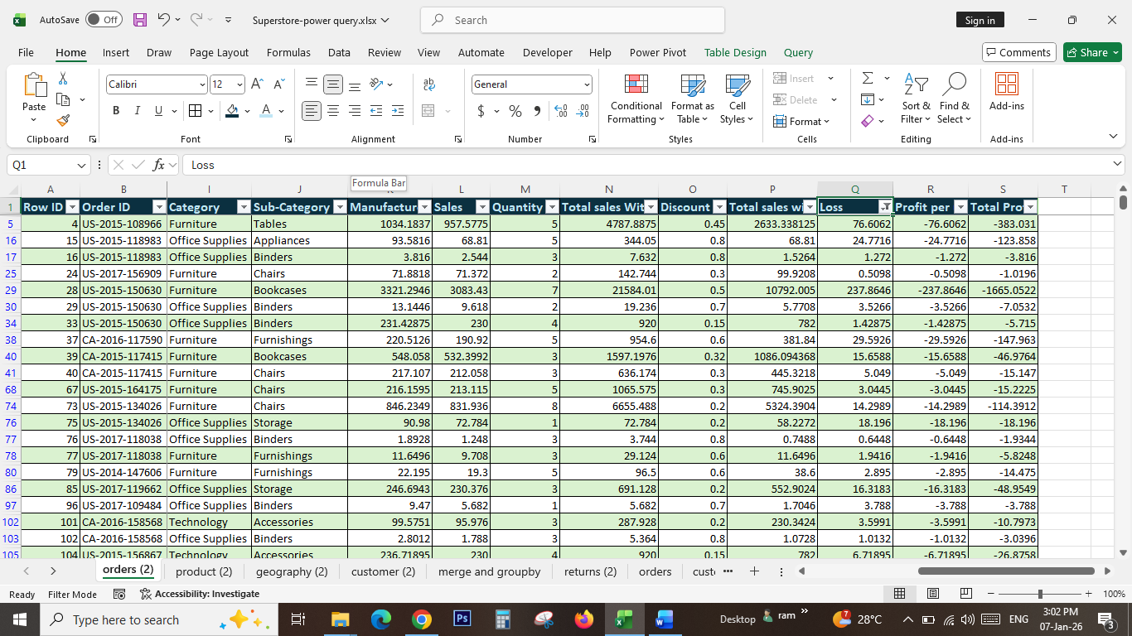
After pre-processing the data is loaded to excel file and profit, and loss calculations have been performed.

DERIVED METRICS:
IF ELSE, NESTED IFELSE, VLOOKUP, XLOOKUP and SUMIF functions are used to derive new metrics as pertaining to the data. Aggregate functions are used to derive max, min and average sales.

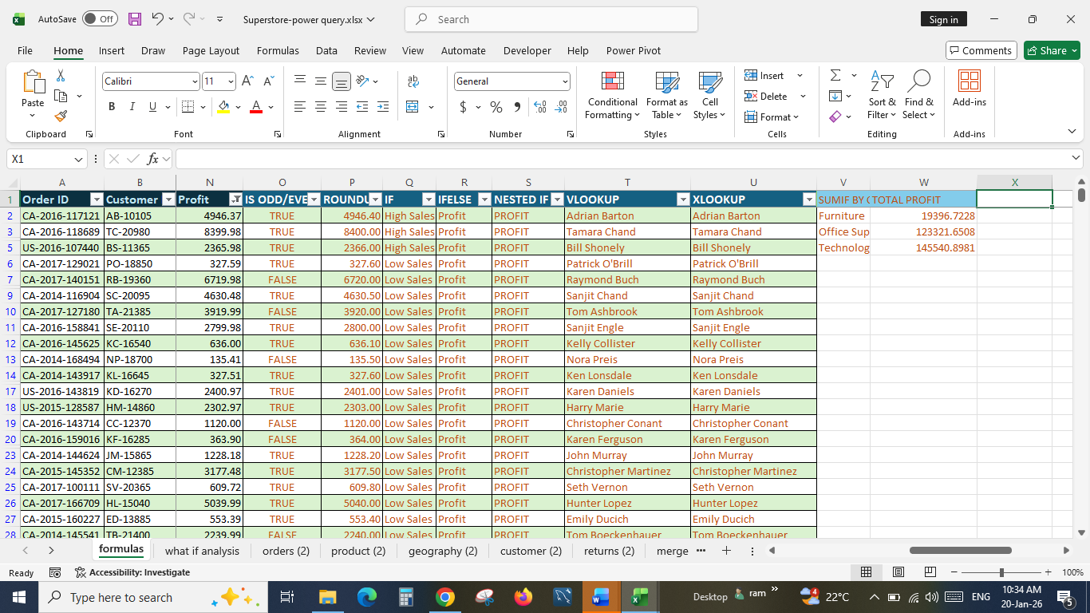

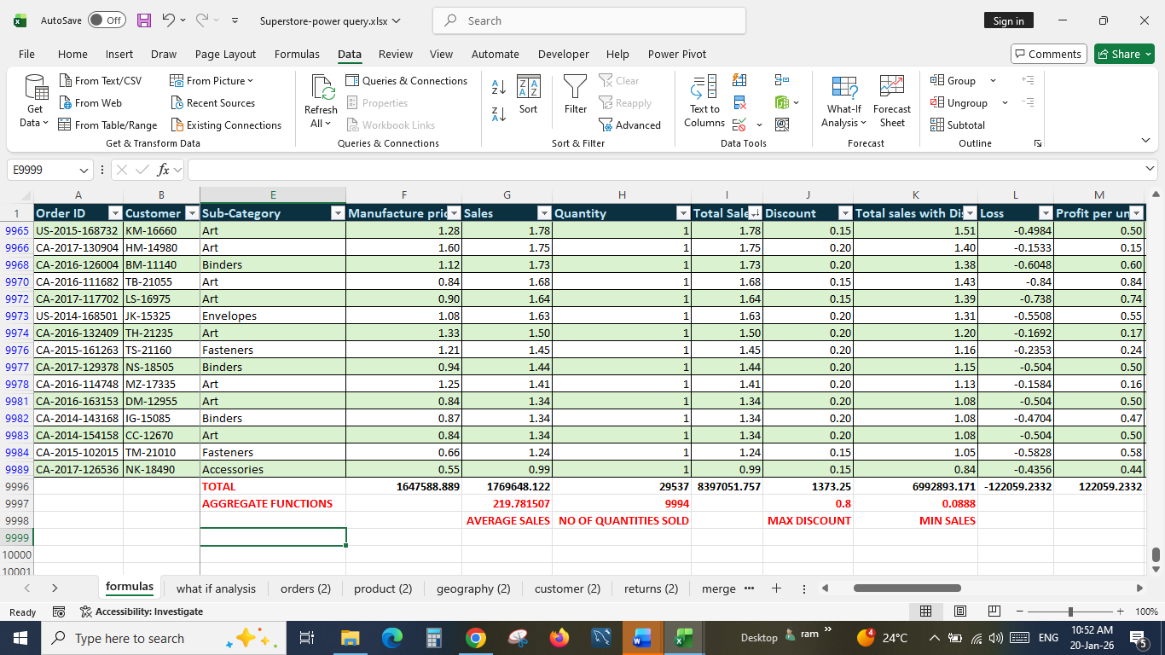
CONDITIONAL FORMATTING:
Total sales with discount column is applied with color bar formatting for easier way to identify the low and high sales. The Top 20 sales in Total sales without discount column are sorted in descending order and highlighted in red fill to view the top sales alone. And Filters are used to view the applied conditional formatting in orders (2) sheet.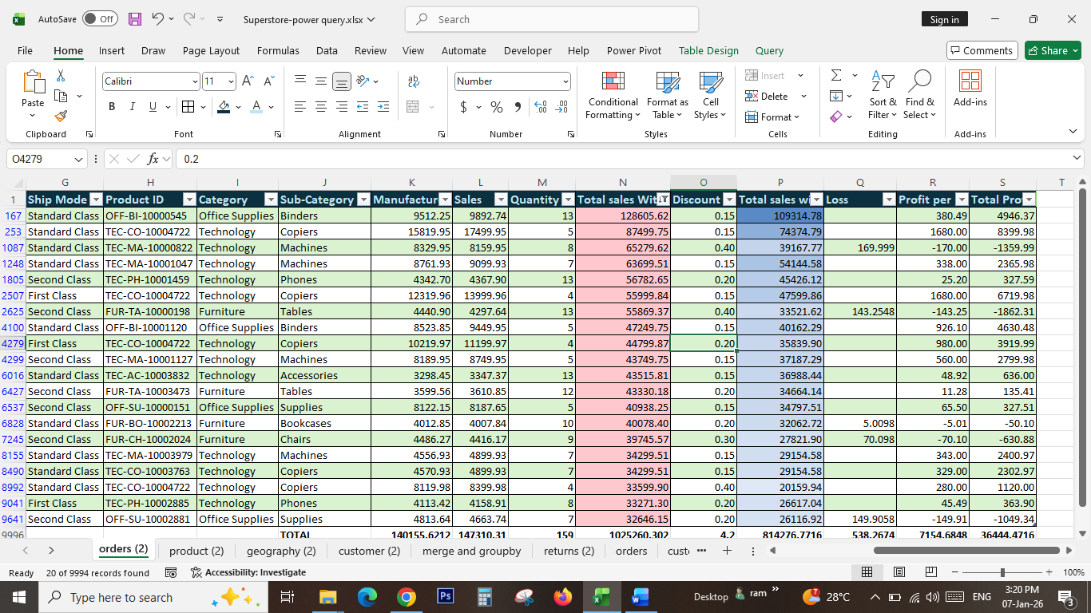
PIVOT TABLES:
Created Pivot table for the metrics derived data to summarize the overall performance of the business with inserted slicers and timelines for applying filters over pivot table.

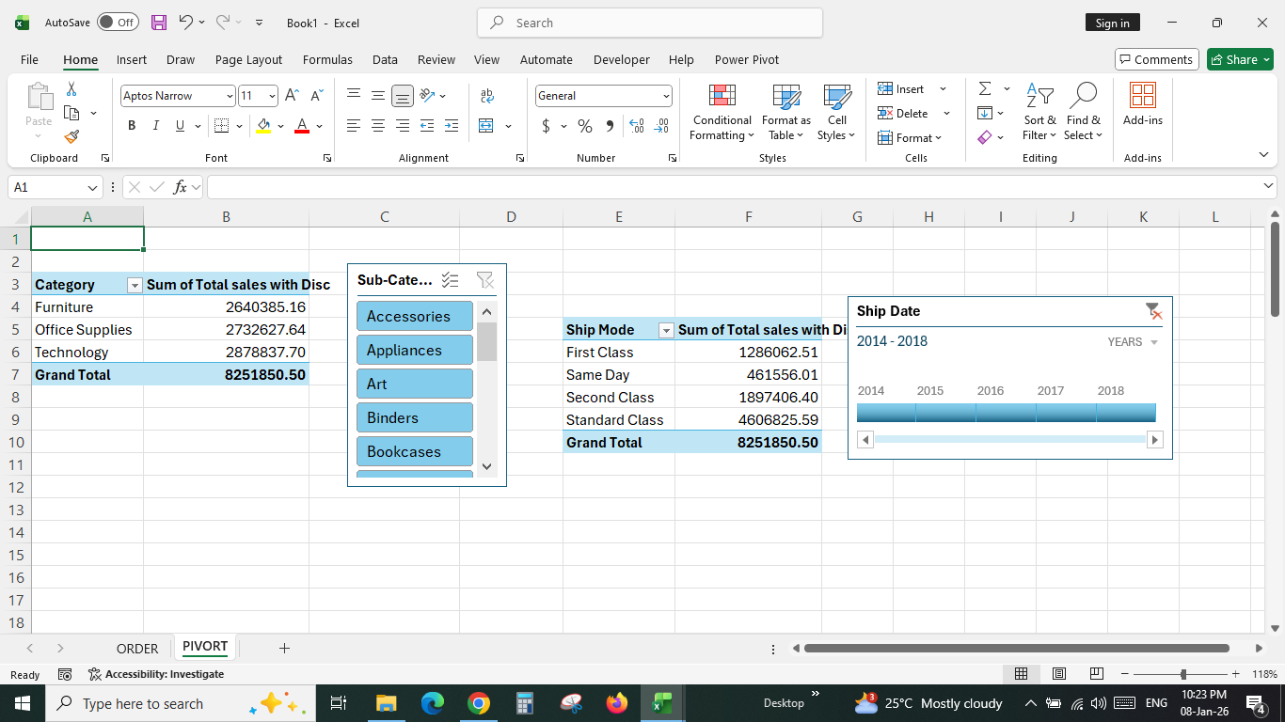
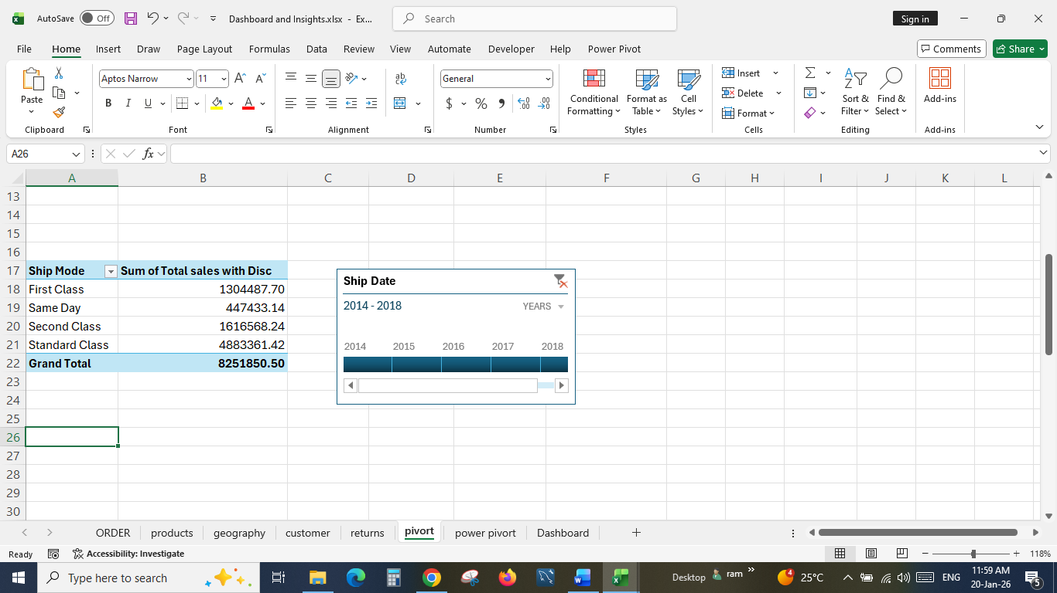
MACROS:
Macros are performed to reduce the work time and automate repetitive tasks like formatting and conditional formatting. This Macros can be run by ctl+shift+j.

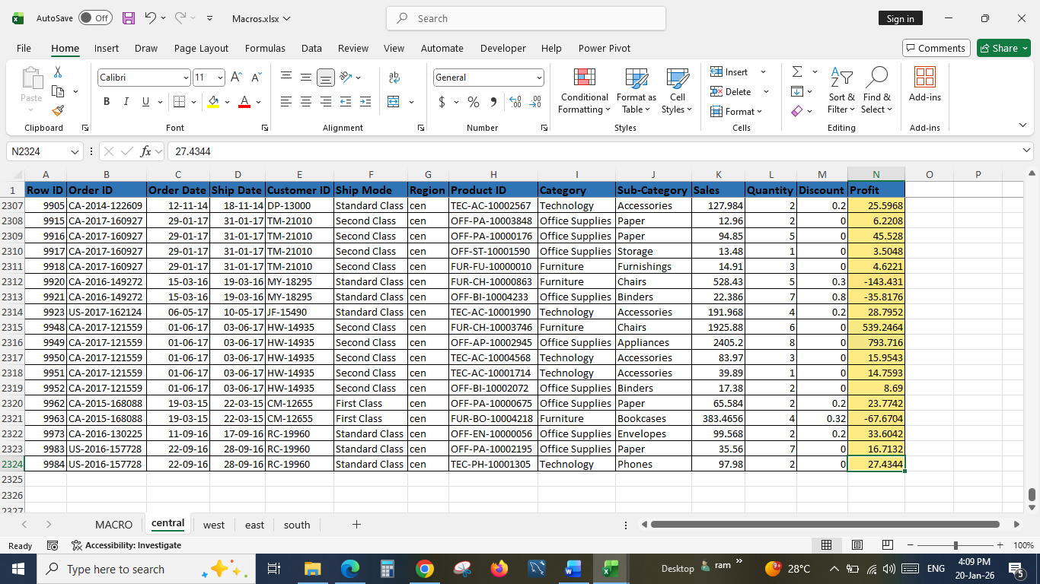
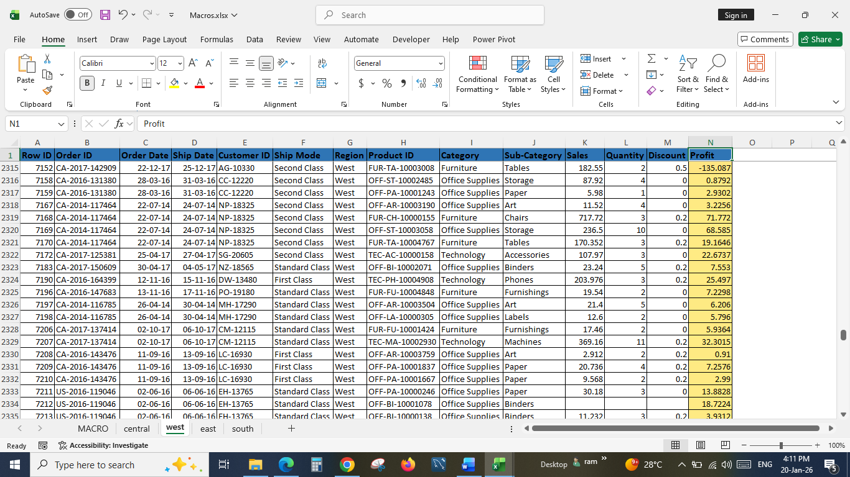
SCENARIO ANALYSIS:
Data table, Goal seek and Scenario manager are performed to derive outputs based on different scenarios.
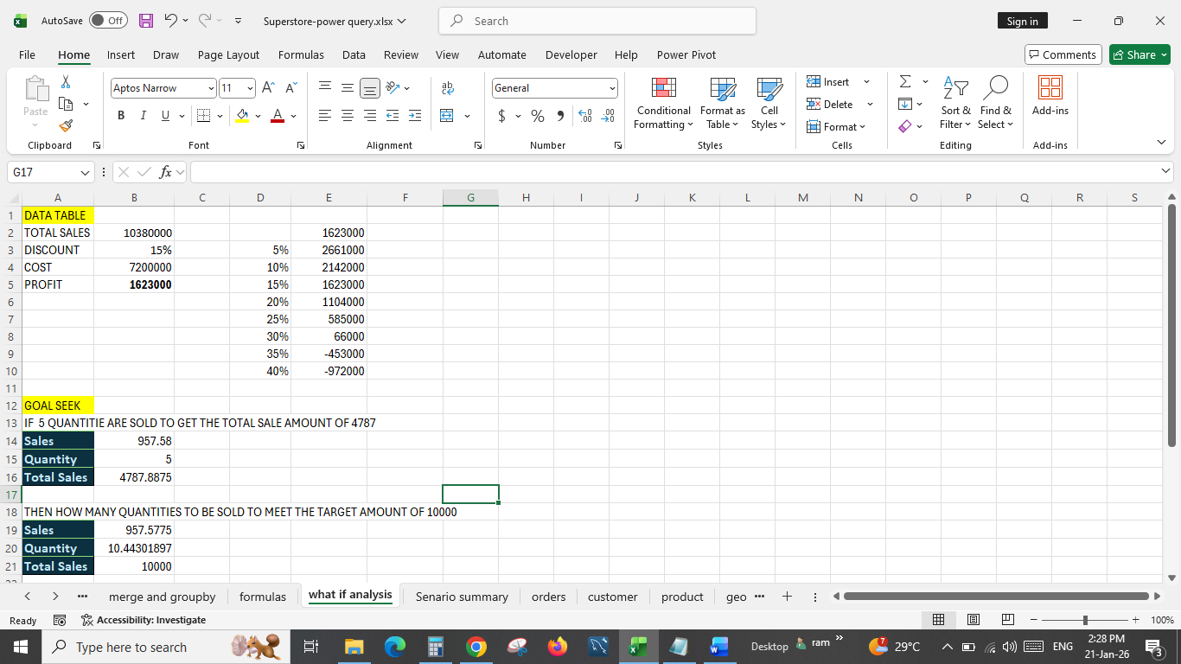
Current Values column represents values of changing cells at time Scenario Summary Report was created. Changing cells for each scenario are highlighted in gray.
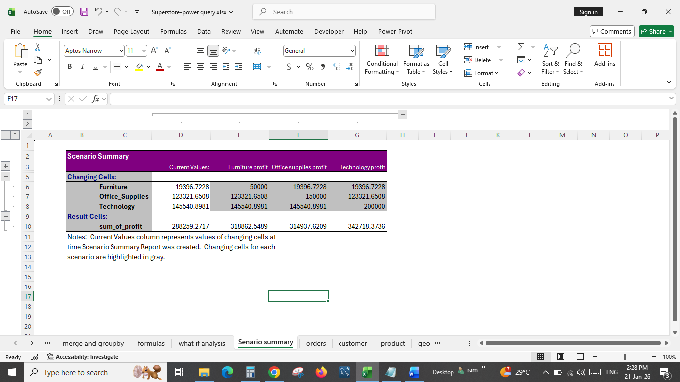
DATA MODELING:
After cleaning and preprocessing data, Data modeling is performed for advanced analysis by making connections with the different workbooks.
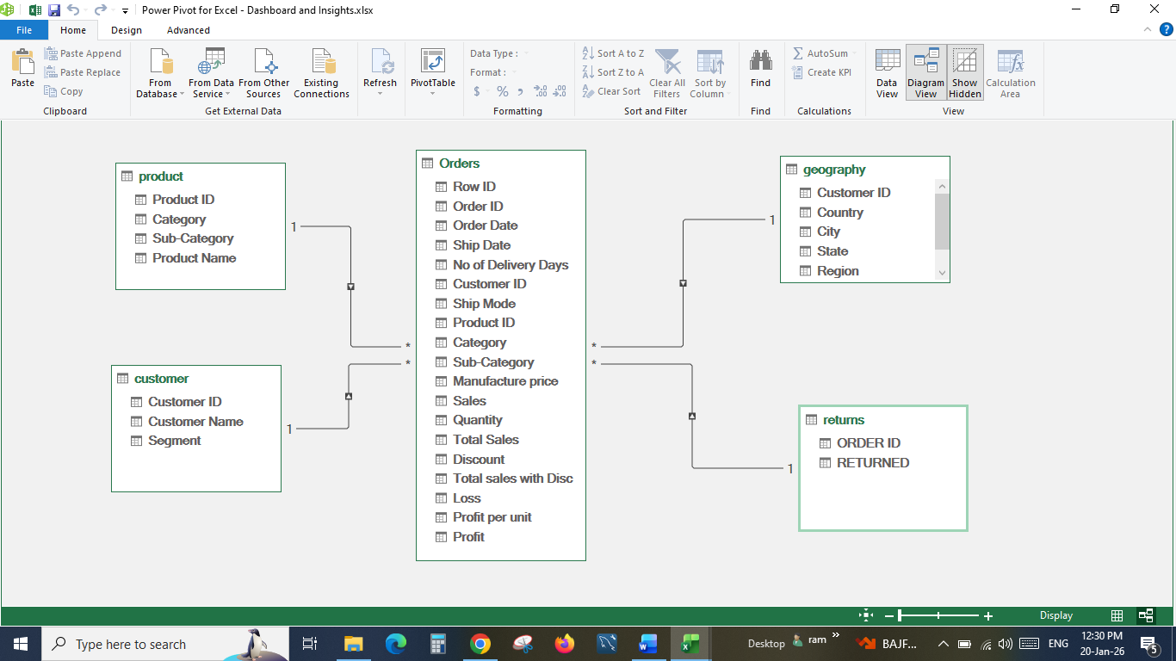
After connecting it can be created as pivot table using power pivot.
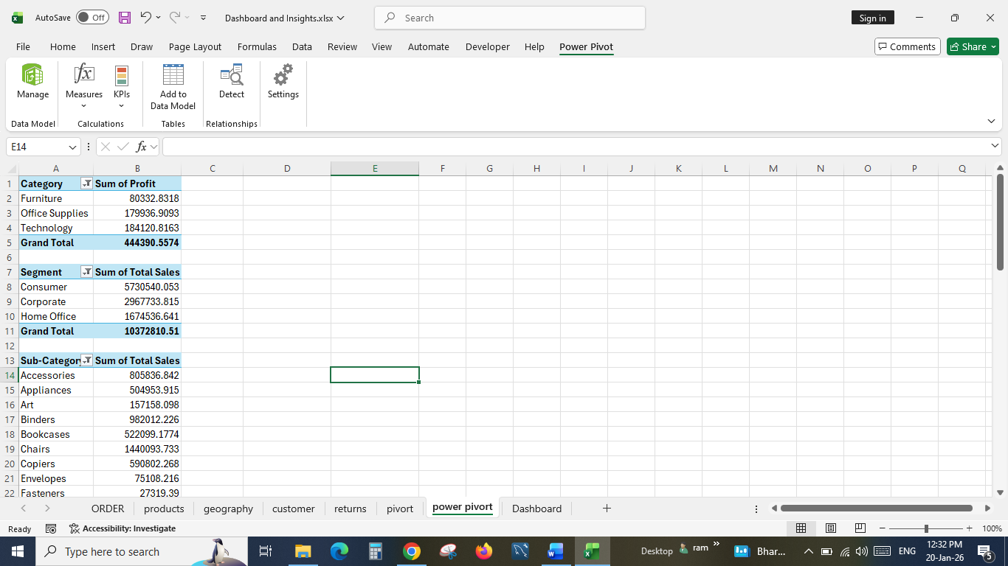
DATA VISUALISATIONS:
After creating pivot table univariate and bivariate charts are created to visualize the trends and relationships through dashboard.
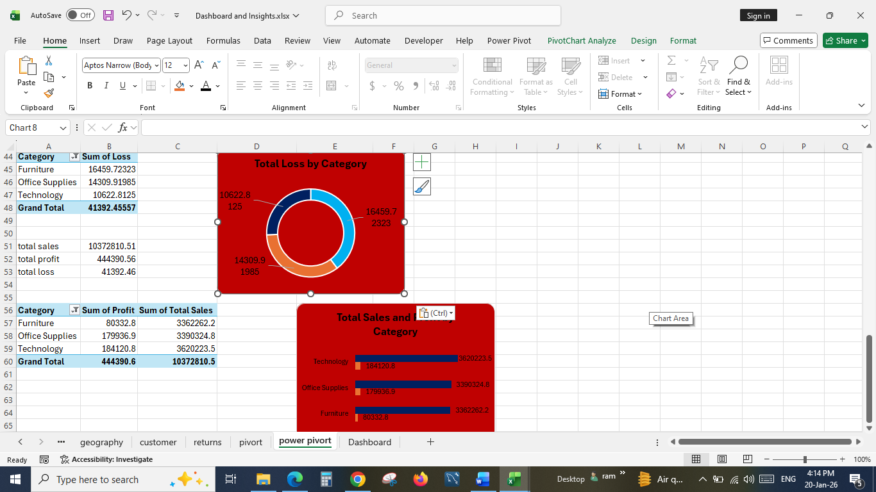
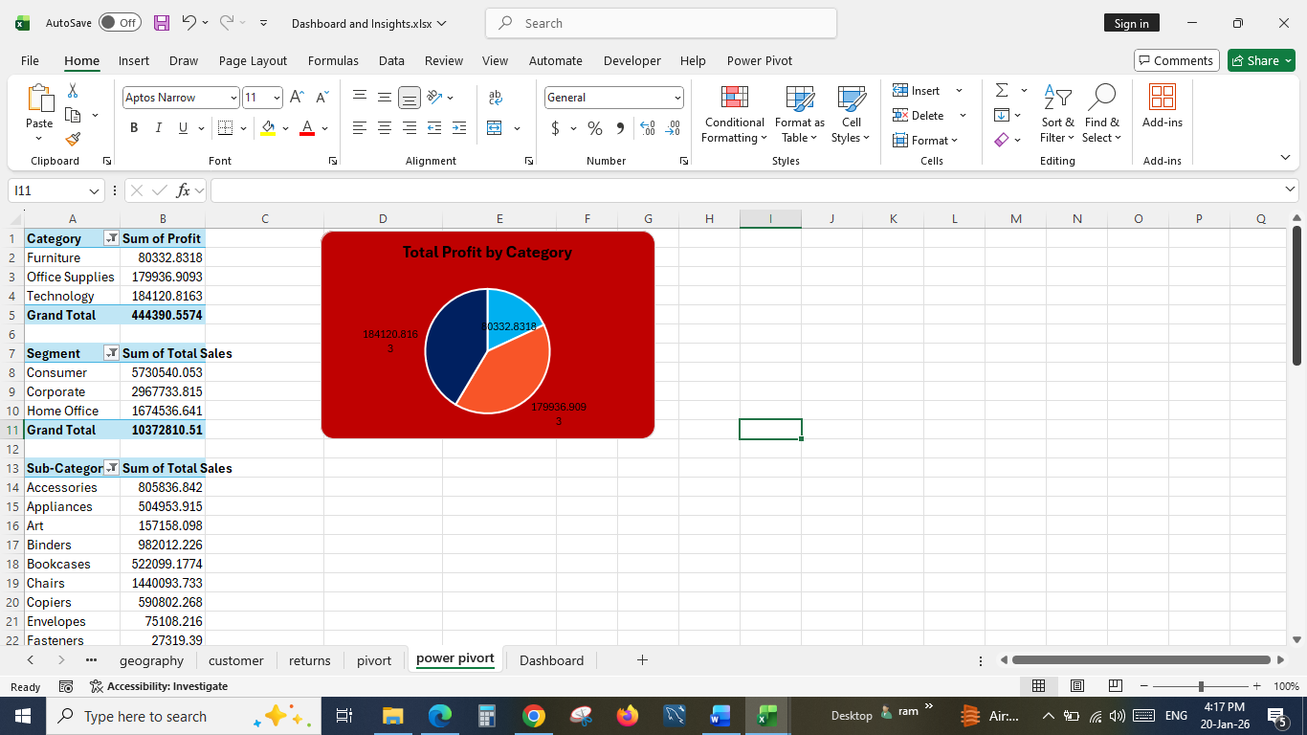

DASHBOARD:
A Dashboard is created to visually present the data and key insights in one place. It is used for quick monitoring and decision making

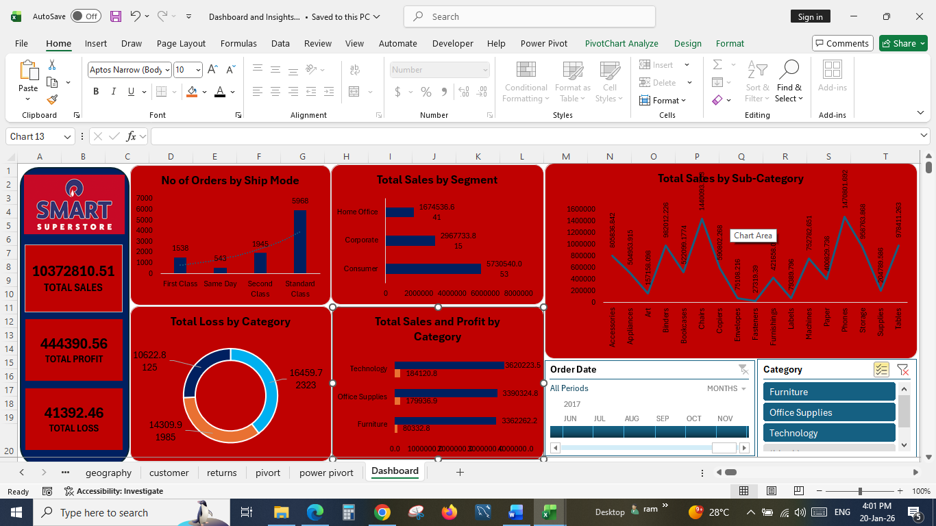

INSIGHTS:
Furniture and Office supplies sales can be improved by decreasing discounts since these two categories are facing heavy losses of 40% and 34% respectively
Optimized proper margin setting is necessary for profitable business. By resetting margin, further losses can be reduced.
People highly prefer standard shipment mode than any other modes. Shipping costs can be reduced for the first, and second-class shipping mode to enhance overall sales.

CONCLUSION AND RECOMMENDATIONS:
Furniture and Office supplies categories are having low sales and huge losses compared to Technology. Reducing discounts on non-festive times can have a great impact on low sales.
Setting a proper margin for the products is an essential duty in a business, failing in this can lead to a great loss. Margin should be balanceable even If lots of discounts and offers are launched. Resetting margins can help in reducing upcoming losses.
More than any shipment mode Standard shipment mode is mainly utilized by the customers since there are mainly no shipping or low shipping charges. First class, second class and Same day delivery charges may be reduced, or delivery time can be cut so that many customers can purchase easily with low delivery timeline with low delivery charge as well.

