Motherboard

A motherboard (sometimes alternatively known as the mainboard, system board, baseboard, planar board or logic board, or colloquially, a mobo) is the main [printed circuit board](https://en.wikipedia.org/wiki/Printed_circuit_board) (PCB) found in general purpose [microcomputers](https://en.wikipedia.org/wiki/Microcomputer) and other expandable systems. It holds and allows communication between many of the crucial electronic components of a system, such as the [central processing unit](https://en.wikipedia.org/wiki/Central_processing_unit) (CPU) and [memory](https://en.wikipedia.org/wiki/Computer_memory), and provides connectors for other [peripherals](https://en.wikipedia.org/wiki/Peripherals). Unlike a [backplane](https://en.wikipedia.org/wiki/Backplane), a motherboard usually contains significant sub-systems such as the central processor, the chipset's input/output and memory controllers, interface connectors, and other components integrated for general purpose use.

Motherboard specifically refers to a [PCB](https://en.wikipedia.org/wiki/Printed_circuit_board) with expansion capability and as the name suggests, this board is often referred to as the "mother" of all components attached to it, which often include [peripherals](https://en.wikipedia.org/wiki/Peripheral), interface cards, and [daughtercards](https://en.wikipedia.org/wiki/Daughtercard" \o "Daughtercard): [sound cards](https://en.wikipedia.org/wiki/Sound_card), [video cards](https://en.wikipedia.org/wiki/Video_card), [network cards](https://en.wikipedia.org/wiki/Network_card), [hard drives](https://en.wikipedia.org/wiki/Hard_drive), or other forms of persistent storage; [TV tuner cards](https://en.wikipedia.org/wiki/TV_tuner_card), cards providing extra [USB](https://en.wikipedia.org/wiki/USB) or [FireWire](https://en.wikipedia.org/wiki/Firewire) slots and a variety of other custom components.

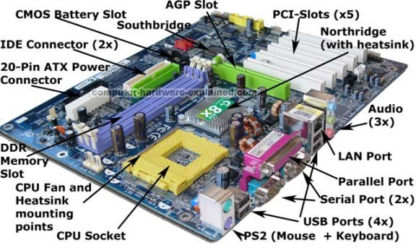

The components of Motherboard are as follows:

1. CPU Socket(Processor):

Motherboards are subcategorized by the type of processor socket they have. The processor socket (also called a CPU socket) is the connector on the motherboard that houses a CPU and forms the electrical interface and contact with the CPU. Processor sockets use a pin grid array (PGA) where pins on the underside of the processor connect to holes in the processor socket. Computers based on the Intel x86 architecture include socket processors.It is used to install the processor on the motherboard. The processor socket helps determine what computer processors your computer&#39;s motherboard is capable of accepting  because of the varied in layouts and the technological differences.

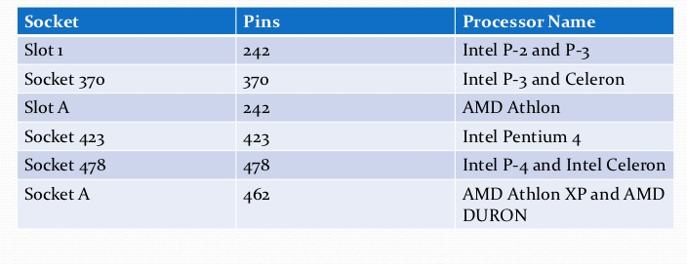

1. RAM Slots:

A memory slot, memory socket, or RAM slot is what allows computer memory (RAM) to beinserted into the computer. Depending on the motherboard, there may be two to four memoryslots (sometimes more on high-end motherboards) and are what determine the type of RAM used with the computer. The most common types of RAM are SDRAM and DDR for desktop computers and SODIMM for laptop computers, each having various types and speeds.

**SIMM slots.**

The full form is a single in-line memory module. These slots were found in older motherboards, up to 486 boards. The SIMM supports 32-bit bus.SIMM is a memory module with 72 or 30 pins.SIMMs with 72 pins can support 32-bit transfer rates and 32-pin SIMMs can support 16-bit transfer rates.

**DIMM slots.**

The full form of DIMM is a Double inline memory module. These are the latest RAM slots which run on a faster 64-bit bus. The DIMM used on Laptop boards are called SO-DIMM.DIMM is a memory module with 168 pins as shown in Figure . DIMMs are commonly used today and support 64-bit transfer.

DIMM is preferred over SIMM because of the increased width which replaces two SIMM ports for one DIMM port.

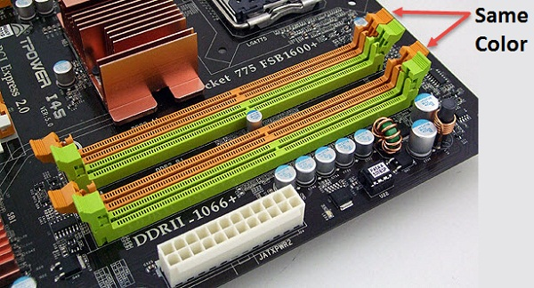

1. Chipsets:

In a computer system, a chipset is a set of electronic components in an integrated circuit that manages the data flow between the processor, memory and peripherals. It is usually found on the motherboard. Chipsets are usually designed to work with a specific family of microprocessors. Because it controls communications between the processor and external devices, the chipset plays a crucial role in determining system performance .A chipset is a group of small circuits that coordinate the flow of data to and from a PC&#39;s key components. These key components include the CPU itself, the main memory, the secondary cache, and any devices situated on the buses. A chipset also controls data flow to and from hard disks and other devices connected to the IDE channels.

A computer has got two main chipsets:

**NorthBridge:**

The NorthBridge (also called the memory controller) is in charge of controlling transfers between the processor and the RAM, which is why it is located physically near the processor. It is sometimes called the GMCH, for Graphic and Memory Controller Hub. The northbridge connects directly to the processor via the front side bus (FSB). A memory controller is located on the northbridge, which gives the CPU fast access to the memory. The northbridge also connects to the AGP or PCI Express bus and to the memory itself.

**SouthBridge:**

The SouthBridge (also called the input/output controller or expansion controller) handles communications between slower peripheral devices. It is also called the ICH (I/O Controller Hub). The term &quot;bridge&quot; is generally used to designate a component which connects two buses. The southbridge is slower than the northbridge, and information from the CPU has to go through the northbridge before reaching the southbridge. Other busses connect the southbridge to the PCI bus, the USB ports and the IDE or SATA hard disk connections.

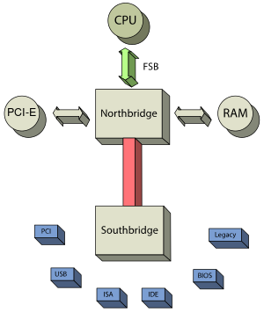

1. Power Connectors:

In order to receive power from SMPS, there are connectors mounted on the motherboards.

**AT connector**.: It consists of 2 number of 6 pin male connectors and is found on old types of motherboards.

**ATX connector :** The latest in the series of power connectors, they are either 20 or 24 pin female connectors. Found in all the latest types of motherboards.

**IDE connector:**IDE, an acronym for Integrated Drive Electronics, is a standard type of connection for storagedevices in a computer. Generally, IDE it refers to the types of cables and ports used to connect some hard drives and optical drives to each other and to the motherboard.

These are used to interface disk drives. The 40-pin male connector is used to connect IDE hard disk drives and the 34-pin male connector connects to Floppy Disk Drive.

**SATA connector :**

Latest in the series, the connectors, Serial Advance Technology Attachment(SATA) are 7-pin connectors to interface latest SATA hard disks. connecting devices like optical drives and harddrives to the motherboard.

They are much faster than IDE interface.

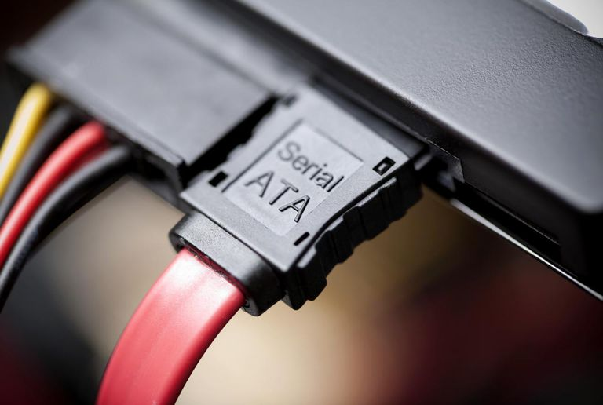

1. Expansion Slots:

Alternatively referred to as a bus slot or expansion port, an expansion slot is a connection or port located inside a computer on the motherboard or riser board that allows acomputer hardware expansion card to be connected. For example, if you wanted to install anew video card in the computer, you&#39;d purchase a video expansion card and install that cardinto the compatible expansion slot.

The different expansion slots are as follows :

* AGP - Video card
* AMR - Modem, Sound card
* CNR - Modem, Network card, Sound card
* EISA - SCSI, Network card, Video card
* ISA - Network card, Sound card, Video card
* PCI - Network card, SCSI, Sound card, Video card
* PCI Express - Video card, Modem, Sound Card, Network Card
* VESA - Video card

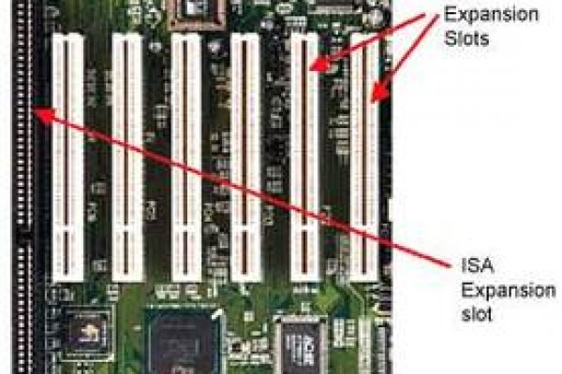

1. BIOS :

BIOS, which stands for Basic Input Output System, is software stored on a small memory chip on the [motherboard](https://www.lifewire.com/motherboards-system-boards-and-mainboards-2618154). You might need to access BIOS to change how the device works or to assist in troubleshooting a problem.It's BIOS that's responsible for the [POST](https://www.lifewire.com/what-is-post-2625953) and therefore makes it the very first software to run when a computer is started.The BIOS [firmware](https://www.lifewire.com/what-is-firmware-2625881) is non-volatile, meaning that its settings are saved and recoverable even after power has been removed from the device.

BIOS instructs the computer on how to perform a number of basic functions such as [booting](https://www.lifewire.com/what-does-booting-mean-2625799) and [keyboard](https://www.lifewire.com/what-is-a-keyboard-2618153) control.BIOS is also used to identify and configure the [hardware](https://www.lifewire.com/computer-hardware-2625895) in a computer such as the [hard drive](https://www.lifewire.com/what-is-a-hard-disk-drive-2618152), [floppy drive](https://www.lifewire.com/what-is-a-floppy-drive-2618151), [optical drive](https://www.lifewire.com/what-is-an-optical-disc-drive-2618157), [CPU](https://www.lifewire.com/what-is-a-cpu-2618150), [memory](https://www.lifewire.com/what-is-random-access-memory-ram-2618159), etc.

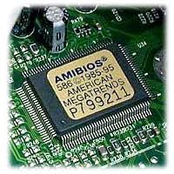

A particular bios setup screen looks as follows :

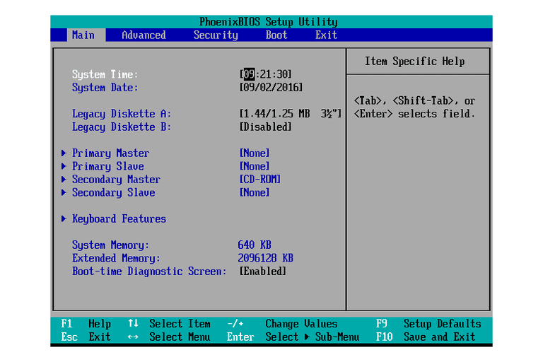

1. CMOS :

Alternatively referred to as a Real-Time Clock (RTC), Non-Volatile RAM (NVRAM) or CMOS RAM, CMOS is short for Complementary Metal-Oxide Semiconductor. CMOS is an on-board, battery powered semiconductor chip inside computers that stores information. This information ranges from the system time and date to system hardware settings for your computer. The picture shows an example of the most common CMOS coin cell battery (Panasonic CR 2032 3V) used to power the CMOS memory.

When the computer first boots up, BIOS pulls information from the CMOS chip to understand the hardware settings, time, and anything else that&#39;s stored in it.

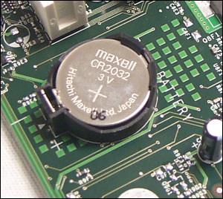

The CMOS RAM is used to store basic Information about the PC’s configuration for instance:-

* Floppy disk and hard disk drive types
* Information about CPU
* RAM size
* Date and time
* Serial and parallel port information
* Plug and Play information
* Power Saving settings

Also the time and date data is stored and updated by the cmos battery which is updated by a Real time clock.