**The space complexity of Iterative Binary Search:**

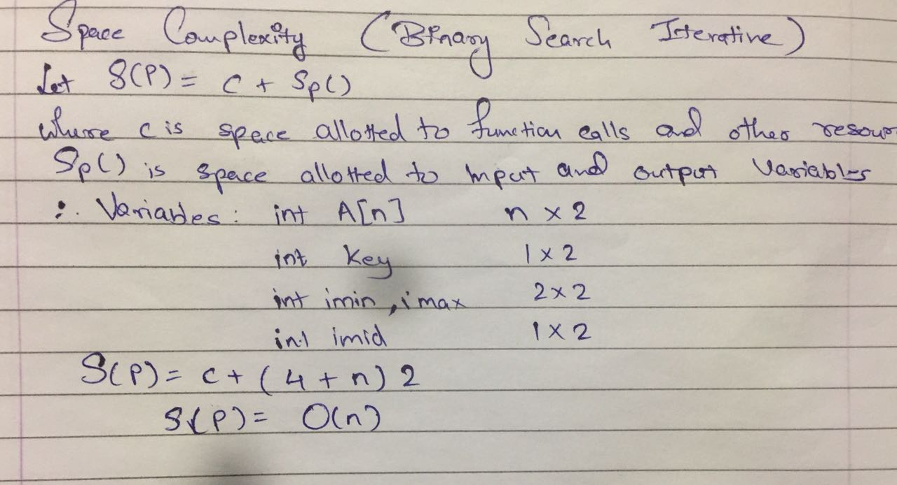

**The space complexity of Recursive Binary Search:**

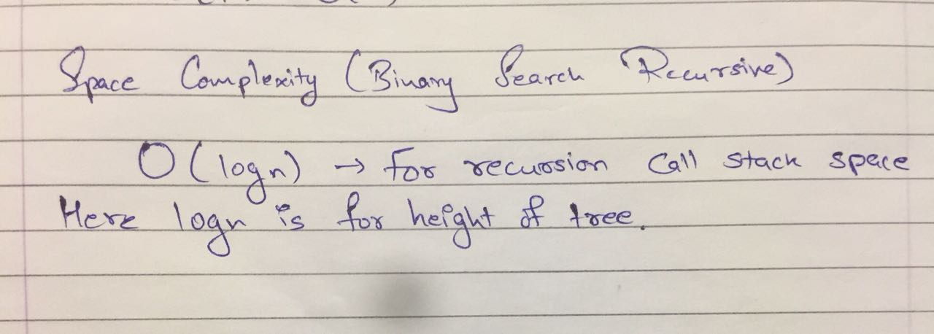

**The Time complexity of Binary Search:**

