

|  |
| --- |
| **Title: Implementation of selection sort/ Insertion sort** |



**Objective:** To analyse performance of sorting methods



**CO to be achieved:**

|  |  |
| --- | --- |
| Sr. No | Objective |
| CO 1 | Compare and demonstrate the efficiency of algorithms using asymptotic complexity notations. |
| CO 2 | Analyze and solve problems for divide and conquer strategy, greedy method, dynamic programming approach and backtracking and branch & bound policies. |
| CO 3 | Analyze and solve problems for   different string matching algorithms. |



**Books/ Journals/ Websites referred:**

1. **Ellis horowitz, Sarataj Sahni, S.Rajsekaran,” Fundamentals of computer algorithm”, University Press**
2. **T.H.Cormen ,C.E.Leiserson,R.L.Rivest and C.Stein,” Introduction to algortihtms”,2nd Edition ,MIT press/McGraw Hill,2001**
3. [**http://en.wikipedia.org/wiki/Insertion_sort**](http://en.wikipedia.org/wiki/Insertion_sort)
4. [**http://www.sorting-algorithms.com/insertion-sort**](http://www.sorting-algorithms.com/insertion-sort)
5. [**http://www.princeton.edu/~achaney/tmve/wiki100k/docs/Insertion_sort.html**](http://www.princeton.edu/~achaney/tmve/wiki100k/docs/Insertion_sort.html)
6. [**http://www.personal.kent.edu/~rmuhamma/Algorithms/MyAlgorithms/Sorting/insertionSort.htm**](http://www.personal.kent.edu/~rmuhamma/Algorithms/MyAlgorithms/Sorting/insertionSort.htm)
7. [**http://en.wikipedia.org/wiki/Selection_sort**](http://en.wikipedia.org/wiki/Selection_sort)
8. [**http://www.sorting-algorithms.com/selection-sort**](http://www.sorting-algorithms.com/selection-sort)
9. [**http://www.personal.kent.edu/~rmuhamma/Algorithms/MyAlgorithms/Sorting/selectionSort.htm**](http://www.personal.kent.edu/~rmuhamma/Algorithms/MyAlgorithms/Sorting/selectionSort.htm)
10. **http://courses.cs.vt.edu/~csonline/Algorithms/Lessons/SelectionCardSort/selectioncardsort.html**



**Pre Lab/ Prior Concepts:**

Data structures, sorting techniques



**Historical Profile:**

There are various methods to sort the given list. As the size of input changes, the performance of these strategies tends to differ from each other. In such case, the priori analysis can helps the engineer to choose the best algorithm.



**New Concepts to be learned:**

Space complexity, time complexity, size of input, order of growth.



**Algorithm InsertionSort**

INSERTION_SORT (*A,n*)

//The algorithm takes as parameters an array *A*[1.. *n*] and the length *n* of the array.

//The array *A* is sorted in place: the numbers are rearranged within the array

// A[1..n] of eletype, n: integer

**FOR** j ← 2 **TO** length[*A*]   
             **DO**  key ← *A*[*j*]      
                   {Put *A*[*j*] into the sorted sequence *A*[1 . . *j* − 1]}     
                    *i* ← *j* − 1      
                    **WHILE** *i* > 0 and *A*[*i*] > key  
                                 **DO** *A*[*i* +1] ← *A*[*i*]              
                                         *i* ← *i* − 1       
                     *A*[*i* + 1] ← key

**Algorithm SelectionSort**

SELECTION_SORT (A,n)

//The algorithm takes as parameters an array *A*[1.. *n*] and the length *n* of the array.

//The array *A* is sorted in place: the numbers are rearranged within the array

// A[1..n] of eletype, n: integer

**FOR** *i* ← 1 **TO** *n*-1 **DO**    
    min *j* ← *i*;  
    min *x* ← A[*i*]  
   **FOR** *j* ← *i* + 1 to n do  
        **IF** A[*j*] < min x then  
            min *j* ← *j*  
            min *x* ← A[j]  
    A[min *j*] ← A [*i*]  
    A[*i*] ← min *x*

**The space complexity of Insertion sort:**

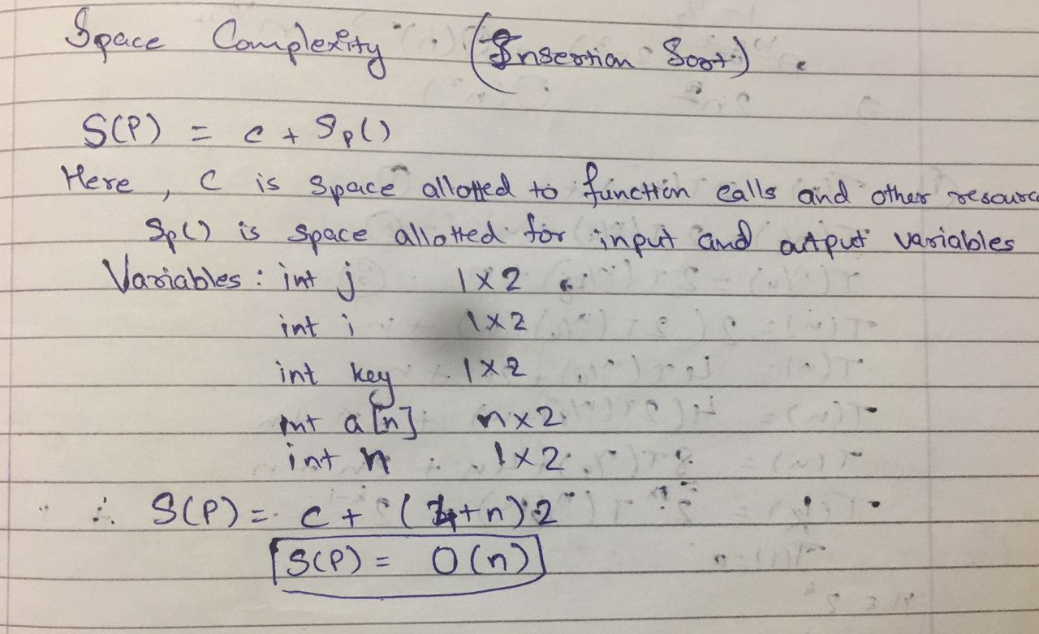

**The space complexity of Selection sort:**

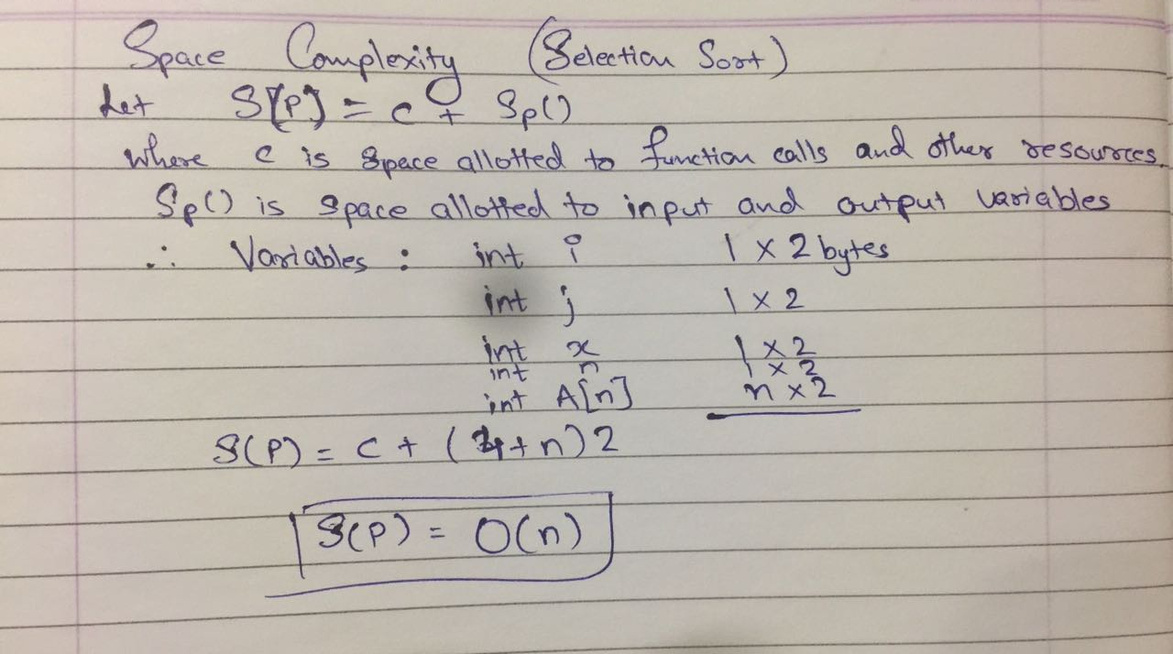

**Time complexity for Insertion sort:**

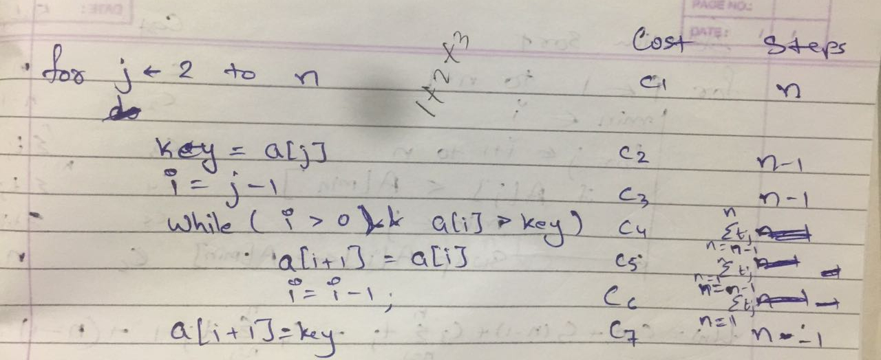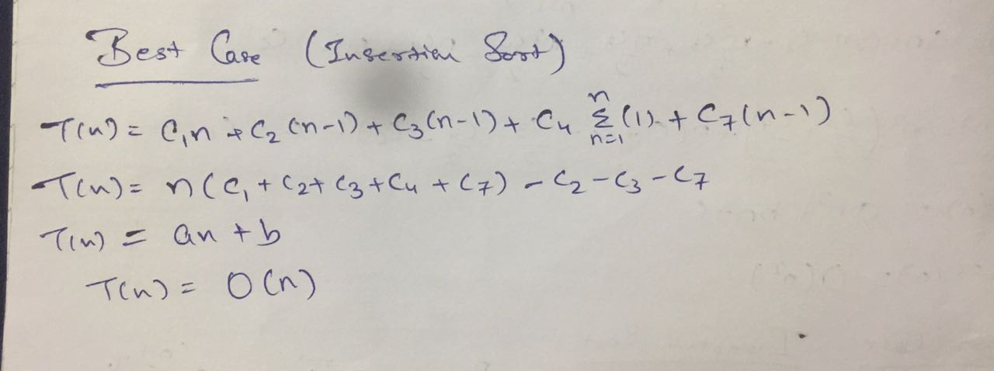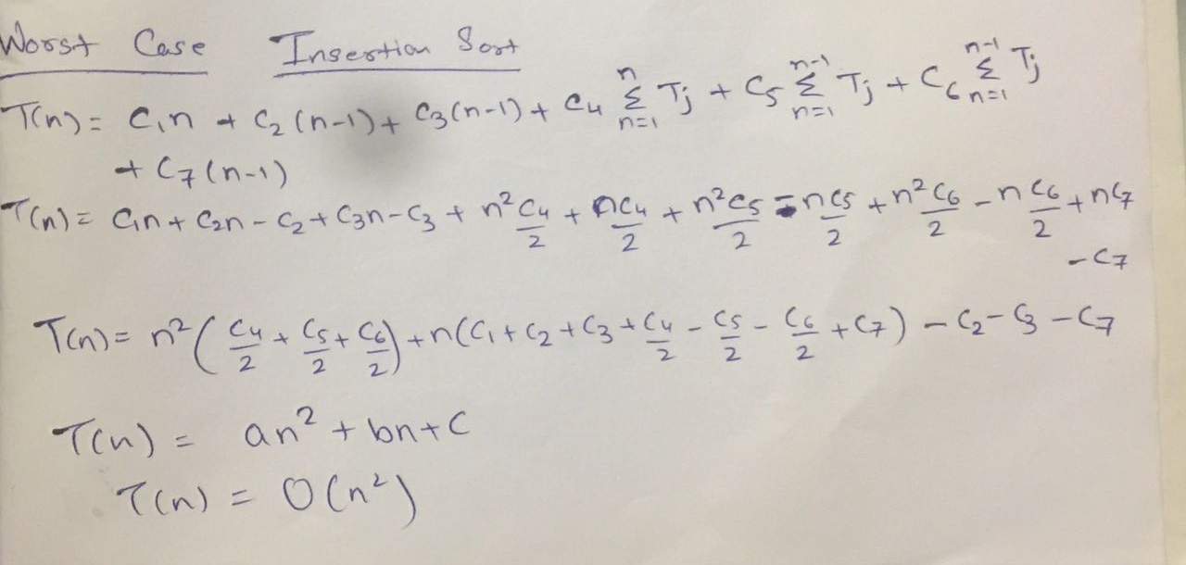

**Time complexity for selection sort:**

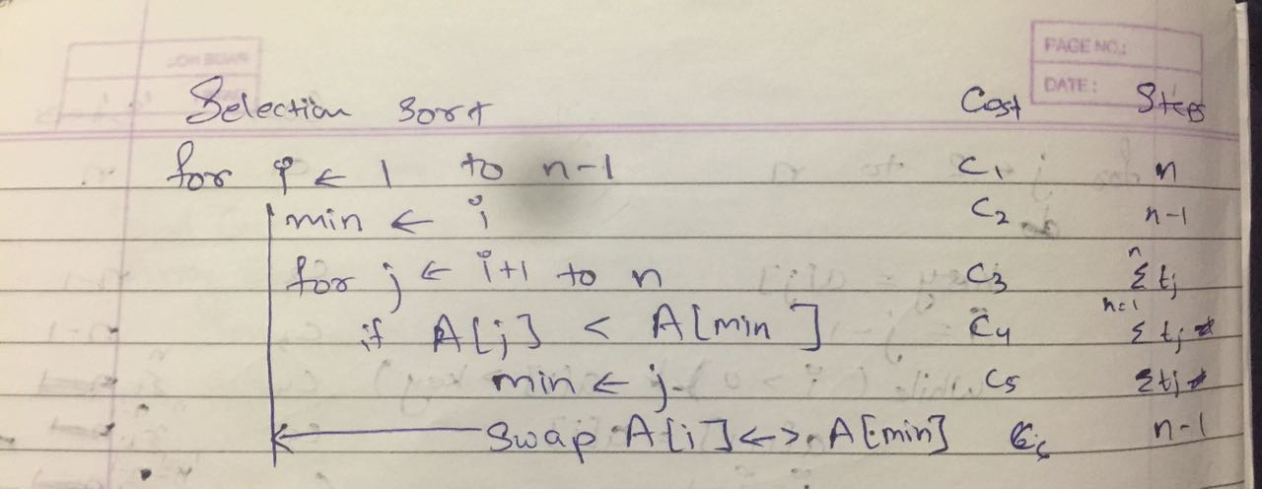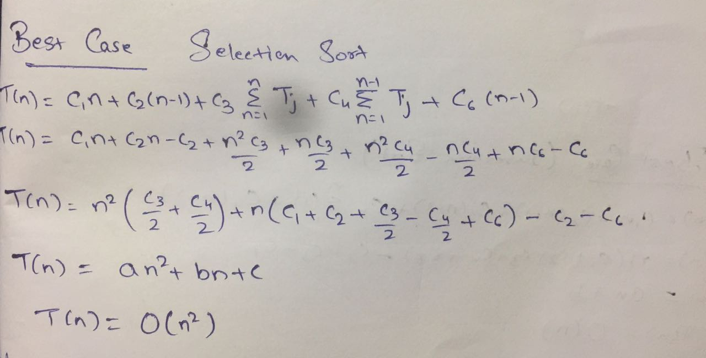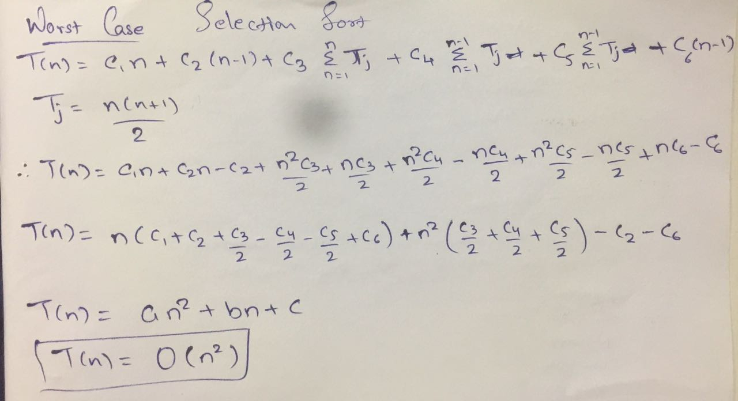

Graphs for varying input sizes: (Insertion Sort & Selection sort)

**CONCLUSION:**

Time and Space Complexity of Insertion and Selection Sort has been studied.