# K. J. Somaiya College of Engineering, Mumbai-77



(Autonomous College Affiliated to University of Mumbai)

# Batch:B3 Roll No.:1611107

**Experiment / assignment / tutorial No. 1 Grade: AA / AB / BB / BC / CC / CD /DD**

**Signature of the Staff In-charge with date**

**Title:** Problem Definition and Design of Extended-Entity-Relationship diagram

**Objective:** To define a Database Problem and Design an EER diagram for a business domain.

# Expected Outcome of Experiment:

**CO 1:** Design entity-relationship diagrams to represent different database application scenarios.

# Books/ Journals/ Websites referred:

1. G. K. Gupta :”*Database Management Systems*”, McGraw – Hill
2. Korth, Slberchatz, Sudarshan : “Database Systems Concept”, 6th Edition , McGraw Hill
3. Elmasri and Navathe, “Fundamentals *of Database Systems*”, 5thEdition, PEARSON Education.

**Dia Software: A software to Design ER Model**

Dia is one of the convenient open source tool which runs on multiple platforms including Linux, Windows and MacOS.Dia has a number of "sheets" each of which includes diagram objects for different modeling tools, such as UML, ER diagrams, flowcharts, etc.

1

# Department of Computer Engineering

RDBMS-2018

# K. J. Somaiya College of Engineering, Mumbai-77

(Autonomous College Affiliated to University of Mumbai)

The ER tool has objects for entities, relationships, attributes (using the oval notation), edges, and so on. The properties boxes for each of these elements allow you to specify cardinality constraints, total participation, identifying relationship, etc.

It supports many common formats to store diagrams such as jpeg, png, eps, etc.

# Pre Lab/ Prior Concepts:

The ER data model was developed to facilitate the database design by allowing specification of an enterprise schema that represents the overall logical structure of the database. The ER model is one of the several data models. The semantic aspect of the model lies in its representation of the meaning of the data. The ER model is very useful many database design tools drawn on concepts from the ER model. The ER model employs 3 basic notations: entity set, relationship set and attributes.

# Symbols Used in ER Notation

1.

Entity

**Entity set:** An entity is a set of entities of the same type that share the properties or attributes.



2.

Entity Name **Weak entity set:** An entity set may not have sufficient attributes to form a primary key. Such an entity set is termed as weak entity set.

3.

R **Realtionship Set:** A relationship is an association among several entities. A relationship set is a set of relationship

of the same type.

2

# Department of Computer Engineering

RDBMS-2018

# K. J. Somaiya College of Engineering, Mumbai-77

(Autonomous College Affiliated to University of Mumbai)

1. **Identification relationship set for weak entity set:** The relationship associating the weak entity set with the

R

identifying entity set is called the identifying relationship.

5.

**Primary key:** The primary key is used to denote a

**A** candidate key that is chosen by the database designers as the principal means of identifying entities within an entity set.

# 6. Many to Many relationship

R

7.

R

# One to One relationship

1. **Attribute**

**A**

9.

# . A Multi valued Attribute

3

# Department of Computer Engineering

RDBMS-2018

# K. J. Somaiya College of Engineering, Mumbai-77

(Autonomous College Affiliated to University of Mumbai)

**Extended Entity Relationship Diagram:**

The EER model includes all of the concepts introduced by the ER model. Additionally it includes the concepts of a [subclass](https://en.wikipedia.org/wiki/Subclass_(computer_science)) and [superclass](https://en.wikipedia.org/wiki/Superclass_(computer_science)) ([Is-a](https://en.wikipedia.org/wiki/Is-a)), along with the concepts of [specialization](https://en.wikipedia.org/wiki/Inheritance_(computer_science)#Specialization) and [generalization](https://en.wikipedia.org/wiki/Generalization). Furthermore, it introduces the concept of a [union](https://en.wikipedia.org/wiki/Union_(computer_science)) type or category, which is used to represent a collection of objects that is the union of objects of different [entity](https://en.wikipedia.org/wiki/Entity) types. EER model also includes EER diagrams that are conceptual models that accurately represent the requirements of complex databases.

**Example Case Study**: List the data requirements for the database of the company which keeps track of the company employee, department and projects. The database designers provide the following description

* 1. The company is organized into departments. Each department has unique name, unique number, and particular employee to manage the department. We keep track of the start date and the employee begins managing the department. The department has several locations.
  2. The department controls a number of projects each of which has a unique name, unique number and a single location.
  3. We store each employee names social security number, address, salary, sex and dob. An employee is assigned one department but may work on several projects which are not necessarily controlled by the same department. We keep track of the department of each employee works on each project and for insurance purpose. We keep each dependents first name, sex, dob and relation.

# Procedure for doing the ER diagram experiment

1. Identifying the Entities (Strong and weak entities)
2. Identify attributes of the Entity (keys, partial key, simple, composite, multivalued, derived)
3. Identify relationship(recursive)
4. Identify the structural constraints of the relationship (cardinality ratio, participation constraints**)**

4

# K. J. Somaiya College of Engineering, Mumbai-77

(Autonomous College Affiliated to University of Mumbai)

# ER- Diagram for company Case Study Database:

5

# Department of Computer Engineering

RDBMS-2018

# K. J. Somaiya College of Engineering, Mumbai-77

(Autonomous College Affiliated to University of Mumbai)

**Problem Definition: REAL ESTATE MANAGEMENT SYSTEM**

**Statement:**

* This project is aimed to provide the seller facility to sell his property with predictive rate decider based on size of property and buyer with facility to buy a property also various searching facility will be available with buyer based upon property type such as Flat, Plot and Bungalow ,max and min budget , location.
* This system provides facilities like Selling a property, Updating details of property, Buying a property, Contacting the property owner ,Creating Buyer/Seller account.
* Admin can use the system to insert and delete data(eg. Property details)which will update the webpage(webpage are dynamic, changing according to data in database)Admin can also check statistic information from the system

**Design of ER:**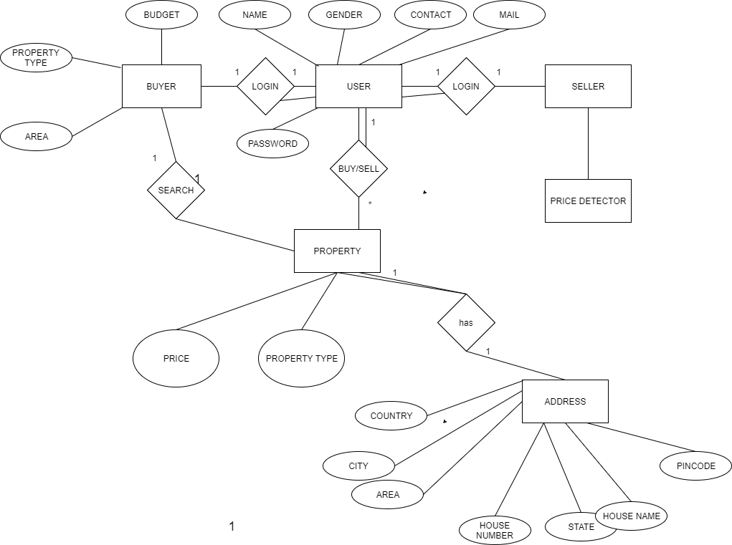

# K. J. Somaiya College of Engineering, Mumbai-77

 (Autonomous College Affiliated to University of Mumbai)

# Post Lab Descriptive Questions (Add questions from examination point view)

* 1. Define following terms with examples:-

1. Entity and Subentity
2. Participation
3. Specialization ,generalization and its types
4. Union
5. Inheritance and Lattice

**1.Entity:**

An entity can be a real-world object, either animate or inanimate, that can be easily identifiable. For example, in a school database, students, teachers, classes, and courses offered can be considered as entities. All these entities have some attributes or properties that give them their identity.

An entity set is a collection of similar types of entities. An entity set may contain entities with attribute sharing similar values. For example, a Students set may contain all the students of a school; likewise a Teachers set may contain all the teachers of a school from all faculties. Entity sets need not be disjoint.

Entities in a school database

ii.

**1.Total Participation**:

Each entity is involved in the relationship. Total participation is represented by double lines.

**2.Partial participation:**

Not all entities are involved in the relationship. Partial participation is represented by single lines.

iii.

**1. Specialization:**

Specialization is the opposite of generalization. In specialization, a group of entities is divided into sub-groups based on their characteristics. Take a group ‘Person’ for example. A person has name, date of birth, gender, etc. These properties are common in all persons, human beings. But in a company, persons can be identified as employee, employer, customer, or vendor, based on what role they play in the company.

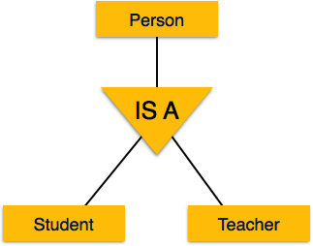

Similarly, in a school database, persons can be specialized as teacher, student, or a staff, based on what role they play in school as entities.

2. **Generalization:**

The ER Model has the power of expressing database entities in a conceptual hierarchical manner. As the hierarchy goes up, it generalizes the view of entities, and as we go deep in the hierarchy, it gives us the detail of every entity included.

Going up in this structure is called **generalization**, where entities are clubbed together to represent a more generalized view. For example, a particular student named Mira can be generalized along with all the students. The entity shall be a student, and further, the student is a person. The reverse is called **specialization** where a person is a student, and that student is Mira.

As mentioned above, the process of generalizing entities, where the generalized entities contain the properties of all the generalized entities, is called generalization. In generalization, a number of entities are brought together into one generalized entity based on their similar characteristics. For example, pigeon, house sparrow, crow and dove can all be generalized as Birds.

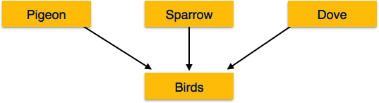

iv. **Union:**

Whenthe subclass will represent a collection of objects that is a subset of the UNION of distinct entity types we call such a subclass a union type or a category.

e.g.Suppose that we have three entity types: PERSON, BANK, and COMPANY. In a database for vehicle registration, an owner of a vehicle can be a person, a bank (holding a lien on a vehicle), or a company. We need to create a class (collection of entities) that includes entities of all three types to play the role of vehicle owner. A category OWNER that is a subclass of the UNION of the three entity sets of COMPANY, BANK, and PERSON is created for this purpose.

UNION is used to combine the results of two or more Select statements. However it will eliminate duplicate rows from its result set. In case of union, number of columns and datatype must be same in both the tables.

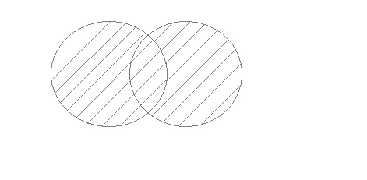

v.

**1.Lattice:**

If an entity set is a lower level entity set in more than one ISA relationship ,then the entity set has multiple inheritance, and the resulting set is said to a lattice.

**2.Inheritance:**

We use all the above features of ER-Model in order to create classes of objects in object-oriented programming. The details of entities are generally hidden from the user; this process known as abstraction.

Inheritance is an important feature of Generalization and Specialization. It allows lower-level entities to inherit the attributes of higher-level entities.

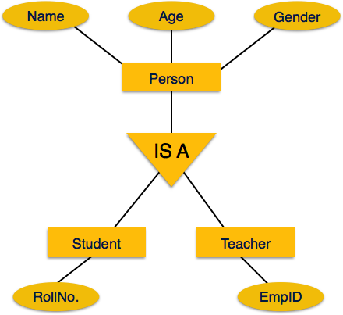

For example, the attributes of a Person class such as name, age, and gender can be inherited by lower-level entities such as Student or Teacher