Project Topic: Evidence-enhanced disinformation detection for Crypto News

Motivation: The crypto market space is 1.78T and is forecasted to grow higher[1]. The space is dynamically changing and there is new news being spread across the world to influence the market. Our research aims to help users assess the crypto news based on the evidence from knowledge bases available like google with truth-value between 0.0 to 1.0. The research can then be extended with additional modifications for general news categories and algorithms.

Proposed Solution: The driver function takes an input string as test_article and passes through four phases to get the desired results. In phase 1 the input string is passed through filter functions to get a cleaned string. There are four filter functions a) converting string to lowercase, b) removing non-alphanumeric characters, c) checking crypto space words available in the string so that we can categorize it as news for crypto niche, and d) word count being greater than 6 as a guess-estimation for further processing.

In phase 2 we’re searching recent articles from google search to create an evidence list. We’re passing the input as a query to google and receiving the top URLs as an output. We then parse through individual article content in those URLs to form a summarized document list of all evidence. The list of evidence and links are then filtered for removing empty or response error texts. In phase 3, we pass this evidence list for pre-processing before tf-idf calculation.
After calculating tf-idf values for the evidence list, the input query is tokenized and vectorized for cosine similarity calculation.

Cosine angles are calculated for query vector and individual evidence document vector. In phase 4 while printing the final results, the evidence is sorted based on higher similarity values and an average value is calculated to classify the article as true, false, or un-predictable. The threshold for classification is 0.05 cosine angle which is a guess-estimate based on sample testing of the algorithm on 100 news articles.

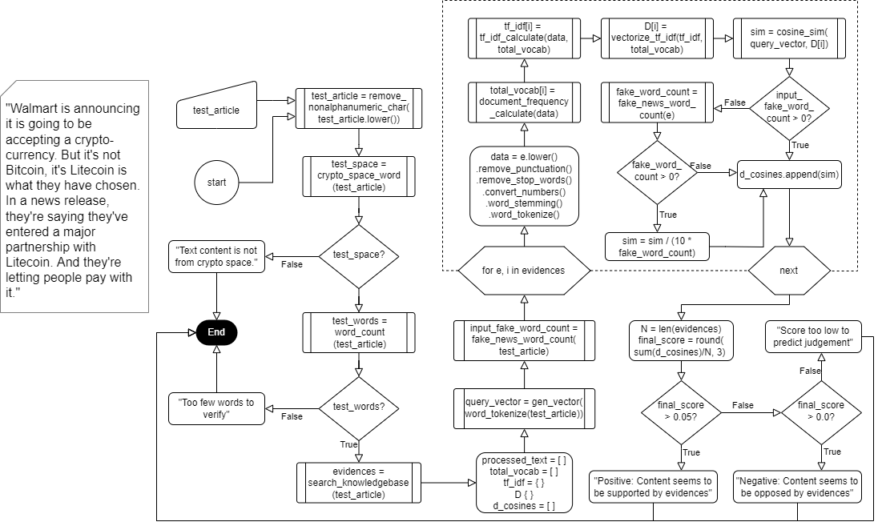
Flowchart of the algorithm

Results:
We tested our algorithm over 100 articles that were found over the internet from known sources and were tagged with actual results being True, False, or Unpredictable for general news articles. The accuracy of the algorithm was found to be 73%. The results led us to conclude that there is a need for a weighted approach in scoring with additional filter layers for source verification, time period and history checks, etc.

A sample result for a single simulation is shown below
Query Text : a crypto entrepreneur bought an nft of jack dorseys first tweet for nearly 3 million and tried to sell it for 48 million the top bid is less than 7000
~~~~~~~~~~~~~~~~~~~~~~~~~~~~Finalresults~~~~~~~~~~~~~~~~~~~~~~~~~~~~~~~~~~~~~~
Evidence 0 : Twitter co-founder and Square CEO Jack Dorsey.AP Photo / Jose Luis MaganaCryptocurrency entrepreneurs are stuck with a $ 3 million NFT purchase of Jack Dorsey's first tweet.He has put up an NFT for sale at a price of $ 48 million, but the highest bid he has received so far is about $ 6,800.Cryptographic entrepreneur Sina Estavi struggles to sell Twitter co-founder NFT Jack Dorsey's first tweet After shooting millions to buy tokens in the first place."A few years later, I think people will realize the true value of this tweet, like the Mona Lisa picture," he said at the time.After posting the tokens on the NFT marketplace OpenSea, Estavi found that the highest bid wasn't even close to what he paid, but much less than he wanted.NFT, or non-fungible token Is a unique certificate that proves ownership of digital assets such as trading cards, music, images and even tweets like Dorsey.The total sales volume of NFT is $ 25 billion Over the past year, artists, investors and entrepreneurs have been trying to take advantage of the seemingly thriving Web3 space.Some experts say that rushing to take advantage of the NFT boom is at the expense of user security and hacking is rampant throughout the market.Estavi, the founder of two Malaysia-based crypto companies, Tweet Last week he planned to donate 50% of his earnings to poverty alleviation efforts in Africa.
Url: https://godzillabtc.com/a-crypto-entrepreneur-bought-an-nft-of-jack-dorseys-first-tweet-for-nearly-3-million-and-tried-to-sell-it-for-48-million-the-top-bid-is-less-than-7000/
Cosine Value: 0.21846754268031832
Evidence 1 : A crypto entrepreneur is stuck with his $3 million NFT purchase of Jack Dorsey's first tweet.He listed the NFT for sale at a price of $48 million, but the highest bid he's received so far is about $6,800.Crypto entrepreneur Sina Estavi is struggling to sell an NFT of Twitter cofounder Jack Dorsey's first tweet after having shelled out millions to buy the token in the first place."I think years later people will realize the true value of this tweet, like the Mona Lisa painting," he said then.He told CoinDesk and the BBC that although the deadline he set was over, he might either accept a "good offer" or may never sell it.NFTs, or non-fungible tokens , are unique certificates that prove ownership of digital assets like trading cards, music, images, or even tweets like Dorsey's.Total NFT sales volume has ballooned to $25 billion over the past year as artists, investors, and entrepreneurs seek to capitalize on the seemingly-prosperous Web3 space.Some experts say the rush to capitalize off the NFT boom has come at the expense of user security, with hacks rampant across marketplaces.Although Estavi owns the digital right to Dorsey's tweet, it is still publicly accessible to anyone who can use the internet.Estavi, the founder of two Malaysia-based crypto companies, claimed in a tweet last week that he planned to donate 50% of the proceeds to poverty relief efforts in Africa.
Url: https://sports.yahoo.com/crypto-entrepreneur-bought-nft-jack-101420067.html
Cosine Value: 0.18977496947082823
Evidence 2 : A crypto entrepreneur is stuck with his $3 million NFT purchase of Jack Dorsey's first tweet.He listed the NFT for sale at a price of $48 million, but the highest bid he has ever received is about $6,800.Crypto Entrepreneur Sina Estavi Struggles to Sell Twitter Cofounder's NFTs Jack Dorsey's first tweet After spending lakhs of rupees to buy tokens in the first place."I think years later people will realize the true value of this tweet, like a Mona Lisa painting," he said then.He told CoinDesk and the BBC that although the deadline he set, he could either accept a "good offer" or never sell it.NFTs, or non-fungible tokens, are unique certificates that prove ownership of digital assets such as trading cards, music, pictures or even Dorsey-like tweets.As artists, investors, and entrepreneurs look to capitalize on the seemingly affluent Web3 space, total NFT sales volume has grown to $25 billion over the past year.Some experts say the rush to capitalize on the NFT boom has come at the cost of user security, with hacking rampant across the market.Estawi, founder of two Malaysia-based crypto companies claimed Tweet Last week he planned to donate 50% of the proceeds to poverty relief efforts in Africa.Read more: Bank of America's head of content breaks down the 8 investment mega-trends he's backing to rapidly accelerate and transform financial markets over the next decade.
Url: https://biz.crast.net/a-crypto-entrepreneur-bought-the-nft-of-jack-dorseys-first-tweet-for-about-3-million-and-tried-to-sell-it-for-48-million-the-top-bid-is-under-7000/
Cosine Value: 0.1590784540617042
Evidence 3 : A crypto entrepreneur is stuck with his $3 million NFT purchase of Jack Dorsey's first tweet.Crypto entrepreneur Sina Estavi is struggling to sell an NFT of Twitter cofounder Jack Dorsey's first tweet after having shelled out millions to buy the token in the first place.He told CoinDesk and the BBC that although the deadline he set was over, he might either accept a "good offer" or may never sell it.NFTs, or non-fungible tokens , are unique certificates that prove ownership of digital assets like trading cards, music, images, or even tweets like Dorsey's.Total NFT sales volume has ballooned to $25 billion over the past year as artists, investors, and entrepreneurs seek to capitalize on the seemingly-prosperous Web3 space.Some experts say the rush to capitalize off the NFT boom has come at the expense of user security, with hacks rampant across marketplaces.Although Estavi owns the digital right to Dorsey's tweet, it is still publicly accessible to anyone who can use the internet.Estavi, the founder of two Malaysia-based crypto companies, claimed in a tweet last week that he planned to donate 50% of the proceeds to poverty relief efforts in Africa.Stablecoin issuer Circle nets $400 million in funding from backers including investment giants Fidelity and BlackRockBitcoin could fall another 33% if it breaks below its key $40,000 support level, Fairlead's Katie Stockton says
Url: https://www.businessinsider.in/cryptocurrency/news/a-crypto-entrepreneur-bought-an-nft-of-jack-dorseys-first-tweet-for-nearly-3-million-and-tried-to-sell-it-for-48-million-the-top-bid-is-less-than-7000-/articleshow/90845945.cms
Cosine Value: 0.1529721945937469
Evidence 4 : The tweet, which says, "just setting up my twttr," was first posted by Dorsey on March 21, 2006.And since they run on blockchain, a decentralized digital ledger that documents transactions, ownership and validity of each can be tracked."[B]y bidding on Jack Dorsey's first tweet of history and Elon Musk's NFT, I wanted to emphasize the importance of NFTs on [the] future of crypto and tech sphere," Estavi recently told CNBC Make It .In addition, "I wanted to encourage involving in charities in the crypto space."In March, Dorsey said that all proceeds from his NFT sale would be converted to bitcoin and donated to GiveDirectly, a charity giving cash to people living in poverty.Dorsey's gift will specifically go to its Africa Covid-19 response."Sent to @GiveDirectly Africa fund," Dorsey tweeted on Monday .Dorsey has long been a supporter of the crypto space - in February, his financial services company Square bought an additional $170 million worth of bitcoin, and consistently, Dorsey has been an advocate for bitcoin.Today, Dorsey is worth $13 billion , according to Forbes.This story has been updated to add more information about GiveDirectly.
Url: https://www.15minutenews.com/article/2022/04/14/214228405/a-crypto-entrepreneur-bought-an-nft-of-jack-dorseys-first-tweet-for-nearly-3-million-and-tried-to/
Cosine Value: 0.1419365979890849
Evidence 5 : An October 21, 2021, report based on a "long-running, massive-scale randomized experiment" that analyzed "millions of tweets sent between 1 April and 15 August 2020", found that Twitter's machine learning algorithm amplified right-leaning politics on personalized user Home timelines.Trending topics are sometimes the result of concerted efforts and manipulations by fans of certain celebrities or cultural phenomena, particularly musicians like Lady Gaga (known as Little Monsters), Justin Bieber (Beliebers), Rihanna (Rih Navy) and One Direction (Directioners), and novel series Twilight (Twihards) and Harry Potter (Potterheads).The origin of the worm is unclear, but Pearce H. Delphin (known on Twitter as @zzap) and a Scandinavian developer, Magnus Holm, both claim to have modified a related exploit found by another user (possibly Masato Kinugawa) who was using it to create colored Tweets.In January 2016, Twitter was sued by the widow of a U.S. man killed in the 2015 Amman shooting attack , claiming that allowing the Islamic State of Iraq and the Levant (ISIL) to continually use the platform, including direct messages in particular, constituted the provision of material support to a terrorist organization , which is illegal under U.S. federal law.[472] The same day, Twitter, along with Facebook , Google , and Microsoft , jointly agreed to a European Union code of conduct obligating them to review "[the] majority of valid notifications for removal of illegal hate speech " posted on their services within 24 hours.In March 2021, Twitter suspended around 3,500 fake accounts that were running a campaign to influence the American audience, after the US intelligence officials concluded that the assassination of The Washington Post journalist, Jamal Khashoggi was "approved" by the Saudi Crown Prince Mohammed bin Salman .[554] In September 2008, the journalist Clive Thompson mused in a New York Times Magazine editorial that the service had expanded narcissism into "a new, supermetabolic extreme--the ultimate expression of a generation of celebrity-addled youths who believe their every utterance is fascinating and ought to be shared with the world".[555] One of the earliest documented forms of celebrity-related Twitter-like disclosures dates from 1980, when real estate mogul William Desmond Ryan made round-the-clock press releases about his relationship with comedian Phyllis Diller , even revealing what she was making him for dinner on a nightly basis.[558] In that same vein, and with Sigmund Freud in mind, political communications expert Matthew Auer observed that well-crafted tweets by public figures often deliberately mix trivial and serious information so as to appeal to all three parts of the reader's personality: the id, ego, and superego.Two days later, on May 28, 2020, Trump signed "Executive Order on Preventing Online Censorship" [625] aimed to impact the protections of Section 230 of the Communications Decency Act which Twitter and other social media sites have to avoid liability for dealing with moderation of user content on their platforms.
Url: https://www.cnbc.com/2021/03/22/jack-dorsey-sells-his-first-tweet-ever-as-an-nft-for-over-2point9-million.html
Cosine Value: 0.093259306319362
Evidence 6 : The buyer of a non-fungible token (NFT) of Twitter co-founder Jack Dorsey's first tweet says he "may never sell it" after receiving a series of low bids.Mr Estavi has compared the digital asset to Leonardo da Vinci's Mona Lisa.The tweet, which says "just setting up my twttr," was first posted in March 2006 and was auctioned off last year by Mr Dorsey for charity.However, they have no tangible form of their own, and experts have warned about risks in the market.Last week, Mr Estavi announced that the tweet was up for sale on NFT marketplace OpenSea.Mr Estavi, who is the chief executive of blockchain company Bridge Oracle, had earlier claimed that he had been offered $10m for the tweet.Earlier in the day, Mr Estavi told the BBC he "may never sell" the tweet unless he received a "high bid", without saying what that was.The data includes information such as the time the tweet was posted and its text contents.NFTs that are"one of a kind assets" have often been sold for thousands - and even millions - of dollars.Media caption, Will digital-only trading cards replace physical ones?
Url: https://www.bbc.com/news/business-61102759
Cosine Value: 0.07128251837897615
Evidence 7 : "Someone like Elon Musk" deserves to own Jack Dorsey's first tweet as an NFT, the struggling seller said.
Url: https://www.onenewspage.com/n/Business/1zobamt8xo/crypto-entrepreneur-bought-an-NFT-of-Jack.htm
Cosine Value: 0.0314388063167124
Evidence 8 : Cryptocurrency A digital asset maintained by a decentralized system that records and verifies transactions using cryptographyTransactions are verified by network nodes through cryptography and recorded in a public distributed ledger called a blockchain.The cryptocurrency was invented in 2008 by an unknown person or group of people using the name Satoshi Nakamoto.Bitcoin has been criticized for its use in illegal transactions, the large amount of electricity used by mining, price volatility, and thefts from exchanges.A few local and national governments are officially using Bitcoin in some capacity, with one country, El Salvador, adopting it as a legal tender.U.S. banknotes are issued in the form of Federal Reserve Notes, popularly called greenbacks due to their predominantly green color.The monetary policy of the United States is conducted by the Federal Reserve System, which acts as the nation's central bank.You may be interested in info This list is generated from recent searches, followed securities, and other activity.Learn more All data and information is provided "as is" for personal informational purposes only, and is not intended to be financial advice nor is it for trading purposes or investment, tax, legal, accounting or other advice.Please consult your broker or financial representative to verify pricing before executing any trades.
Url: https://www.google.com/finance/quote/BTC-USD?hl=en
Cosine Value: 0.010877718012238925
Evidence 9 : To continue, please click the box below to let us know you're not a robot.
Url: https://www.bloomberg.com/news/articles/2022-04-13/dorsey-s-tweet-nft-fails-by-millions-in-resale-attempt-coindesk
Cosine Value: 0.0
Average cosine similarity value for query and evidences is 0.107
Content seems to be supported by evidences

References:
- Coin Market Cap: https://coinmarketcap.com/, accessed Mar 2022.
- Priyam Shah, Mihir Shah, and Amit Bhujbal. Automation in the Interview Assessment Process, IRJET, Dec 2021.
- Hamdi T., Slimi H., Bounhas I., Slimani Y. (2020) A Hybrid Approach for Fake News Detection in Twitter Based on User Features and Graph Embedding. In: Hung D., D´Souza M. (eds) Distributed Computing and Internet Technology. ICDCIT 2020. Lecture Notes in Computer Science, vol 11969. Springer, Cham. https://doi.org/10.1007/978-3-030-36987-3_17
- Bharadwaj, Pranav and Shao, Zongru, Fake News Detection with Semantic Features and Text Mining (July 24, 2019). International Journal on Natural Language Computing (IJNLC) Vol.8, No.3, June 2019, Available at SSRN: https://ssrn.com/abstract=3425828.
- Z. Shahbazi and Y. -C. Byun, "Fake Media Detection Based on Natural Language Processing and Blockchain Approaches," in IEEE Access, vol. 9, pp. 128442-128453, 2021, doi: 10.1109/ACCESS.2021.3112607.
- Sanglap Sarkar, Venkateshwar Rao Madasu, Baala Mithra SM, Subrahmanya VRK Rao. NLP Algorithm Based Question and Answering System. Seventh International Conference on Computational Intelligence, Modelling and Simulation, 2015
- Soares, Marco Antonio Calijorne, and Fernando Silva Parreiras. "A literature review on question answering techniques, paradigms and systems." Journal of King Saud University-Computer and Information Sciences 32, no. 6 (2020): 635-646.

Future Scope:
- Adding more knowledge bases, such as Twitter and Etherscan, as we only got around to using Google search to find evidence.
- Using transactional data based on user requested query as a weighted parameter.
- Extending further to use expert-based suggestions as a weighted parameter for the results.
- Applying machine learning models to filter evidence.

