**Prime number challenge:**

Here in the case if one of the number in the range in negative, then I am giving an error message saying “Range cannot have negative numbers” as shown in the image below.

OUTPUT:

Range: -10 to 20

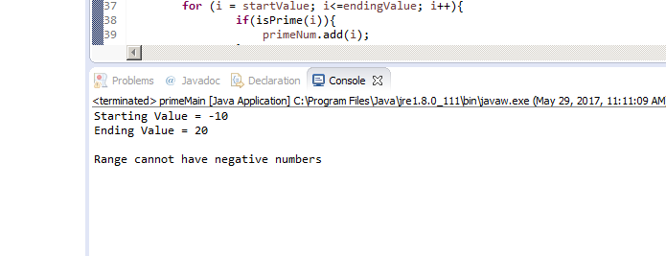

Range: 0 to 20

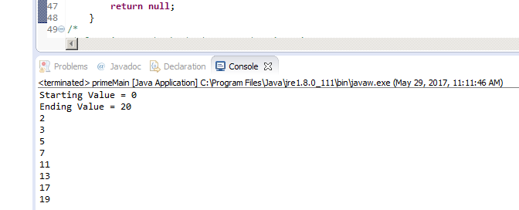

Range: 7920 to 7900

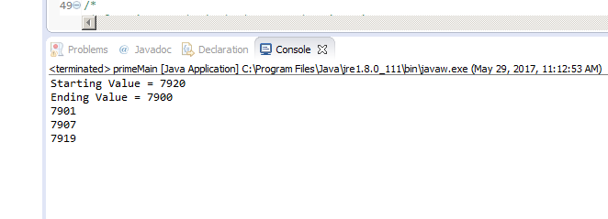

Range: 20 to 0

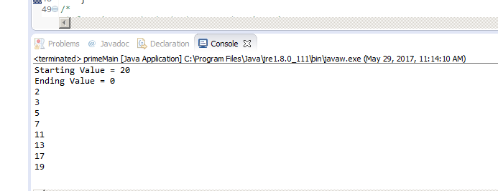

**UI Challenge:**

In this challenge I could not implement type ahead search. For sorting, instead of drop down menu, I have implemented sorting by clicking on the table headings.

Here I first started with JavaScript. But once I was left with the sorting part, I figured it out but the output behavior was not as expected. The sorting is working but if I sort the list first and then delete any entry I was getting the previous list of entries with the existing once on the display. Therefore I tried doing it with AngularJs.

In AngularJs version everything thing is working but I could not improve the styling as I stared working on this with HTML and script. I did not apply css in the beginning. Once I was done with the functionality, then I started applying css.