
Operating Document
Standard Operating Procedure and User Operations Manual
Closing the Screening-to-Care Loop
Hack2skill Future Health Digital Innovation Challenge (FHDIC) · Challenge 05
Version | 1.1
Date | 28 October 2026
Prepared by | Priyam Singh
Applies to | KareShafaa v0.1 (code at master aac2f3d), production mode
Service | https://kareshafaa.onrender.com (web and installable app)
Status | Issued for the FHDIC Challenge 05 submission

Important notices
Prototype software, not a certified medical device. Clinical decisions remain with the treating clinician.
Patient messages are simulated. SMS and WhatsApp messages are recorded in the case but not delivered to phones until a messaging provider is connected.
Sample records only. All patients are fictional and carry SYN- medical record numbers. No real person's data is used.
Clinical targets marked CONFIRM in the rules engine are awaiting clinical-lead sign-off before any real use.

Document control
Table 1. Document details
Item | Detail
Document title | KareShafaa Operating Document (SOP and User Operations Manual)
Document owner | Priyam Singh (KareShafaa)
Version / date | 1.1 / 28 October 2026
Software covered | KareShafaa v0.1, state machine v1.1.0, repository master at commit aac2f3d
Sources | Application code and documentation (README, DEPLOY, docs/), and the Challenge 05 solution design. Where they differ, this document follows the code.
Audience | Care coordinators, family doctors, specialists, clinical leads, programme analysts, system administrators, medical translators and the patients they serve (Section 1.3)
Distribution | FHDIC Challenge 05 submission; programme staff
Review cycle | Review on every release that changes roles, states, deadlines or rules, and at least every 6 months

Table 2. Revision history
Version | Date | Author | Change
1.0 | 24 Oct 2026 | Priyam Singh | First issue.
1.1 | 28 Oct 2026 | Priyam Singh | Separated clinical lead and system administrator duties to match the code (aac2f3d). Updated the permissions matrix, RACI and role sections. Applied the official logo and navy brand colours. Replaced every screenshot and redrew the diagrams.

Table 3. Review and approval
Role | Name | Status
Author | Priyam Singh | Complete
Clinical review (clinical lead) | To be named by the programme | Pending
Technical review (system administrator) | To be named by the programme | Pending
Approval for pilot use | Programme sponsor | Pending

How to read this document: Sections 1–3 explain the service and the end-to-end flow for everyone. Section 4 has one part per role; read your own role first. Sections 5–6 cover safety, governance, exceptions and support. Section 7 holds reference tables.

Contents
1. Purpose, scope and audience 4
1.1 Purpose 4
1.2 Scope 4
1.3 Audience 4
1.4 Definitions and abbreviations 4
2. System overview and access 6
2.1 What KareShafaa does 6
2.2 Accessing the service 6
2.3 Installing the app (PWA) 6
2.4 Signing in, passwords and sessions 7
2.5 Languages 7
2.6 Screen layout and navigation 8
3. End-to-end flow 9
3.1 Flow diagram 9
3.2 Case states 9
3.3 Step-by-step procedure 10
3.4 Stage-by-stage procedures 11
4. Roles and responsibilities 16
4.1 Role summary 16
4.2 Permissions matrix 16
4.3 RACI for the core flow 18
4.4 Care coordinator 18
4.5 Family doctor (GP) 20
4.6 Specialist doctor 21
4.7 Clinical lead 23
4.8 Programme analyst 25
4.9 System administrator 26
4.10 Medical translator 28
4.11 Patient 29
5. Safety and governance 31
5.1 Human decisions and the limits of ML 31
5.2 Clinical rules safety 31
5.3 Actions that need a named person's sign-off 31
5.4 Closure guard 32
5.5 Audit log 32
5.6 Data protection 32
5.7 What patients can see, and the answer lock 32
5.8 Patient wording governance 33
5.9 Separation of clinical and system duties 34
6. Exceptions, escalation and support 35
6.1 Exception handling 35
6.2 Escalation contacts and incident reporting 35
6.3 Administration and support operations 36
7. Appendices 38
Appendix A. Urgency tiers 38
Appendix B. Step deadlines (SLA) 38
Appendix C. Pathways and targets 39
Appendix D. Reason codes 39
Appendix E. Glossary 40

1. Purpose, scope and audience

1.1 Purpose
This document is the Standard Operating Procedure (SOP) and user operations manual for KareShafaa. KareShafaa turns every actionable screening result into a tracked case and carries it to care: one accountable owner at every step, a deadline for every step, escalation when a deadline is missed, and closure only with evidence or an authorised human decision.
It explains the end-to-end flow from result to closure, what each user role does at each step, and how the service is kept safe, governed and supported.

1.2 Scope
Table 4. Scope of this document
In scope | Out of scope
Four screening programmes: bowel (FIT), cervical (HPV and cytology), breast (mammography) and diabetes (HbA1c and fasting glucose).  The case lifecycle from result to closure, including side states (unreachable, no-show, declined).  Eight user roles: seven staff roles and the patient.  Safety, governance, exceptions, escalation, administration and support. | The clinical guidelines themselves (they are summarised in the rules and in the code documentation).  Real patient data: the service runs on fictional sample records (SYN- MRNs).  Delivery of SMS and WhatsApp messages: these are simulated until a messaging provider is connected.  Hosting, contracts and certification needed for a real pilot (Section 6.3).

1.3 Audience
Table 5. Who should read what
Reader | Role in KareShafaa | Read first
Care coordinator (navigator) | coordinator | Sections 3 and 4.4
Family doctor (GP) | gp | Sections 3 and 4.5
Specialist doctor | specialist | Sections 3 and 4.6
Clinical lead (also medical director for L4) | clinical_lead | Sections 3, 4.7 and 5
Programme analyst | analyst | Sections 4.8 and 5.1
System administrator | admin | Sections 4.9 and 6.3
Medical translator | translator | Sections 4.10 and 5.8
Patient (through staff and the patient page) | patient | Section 4.11

1.4 Definitions and abbreviations
Table 6. Definitions and abbreviations
Term | Meaning
Case | One actionable screening result followed from issue to closure. It always has exactly one accountable owner.
Accountable owner | The named person (or the programme team pool) responsible for the current step.
State / step | Where the case is on the care pathway, for example Patient notified (Section 3.2).
Tier (T0–T3) | Urgency: T0 Critical, T1 Urgent, T2 Soon, T3 Routine (Appendix A).
SLA / step deadline | Time allowed for the current step, by state and tier (Appendix B).
Pathway target | End-to-end deadline from the result to reaching care, set by the clinical rule (Appendix C).
Escalation (L1–L4) | Alerts raised as a step deadline passes 50 %, 100 %, 150 % and 200 % (Section 3.4.14).
Teach-back | Three questions that check the patient understood the result, the next step and the timeframe.
Channel ladder | Order of patient contact: app, then SMS, then WhatsApp, then a navigator phone call.
Closure guard | Code rule that allows closure only with evidence or an authorised decision with a reason.
Clinical review (flag) | A result the rules cannot handle safely; a clinician must review it before anything else happens.
e-consult | A clinician-to-clinician question (Ask a specialist) with a response deadline.
Team pool | Programme-level owner used when no named person is available; listed as No named owner.
Working day (wd) | UAE working day, excluding weekends and public holidays; used for T2 and T3 clocks.
HL7 v2 ORU^R01 / FHIR R4 | Laboratory result message standards accepted by the Results inbox and the API.
ACK AA / AE | HL7 acknowledgement: accepted, or error (message not processed).
MRN | Medical record number. Every sample record starts with SYN-.
PWA | Progressive web app: the site can be installed on a phone or computer like an app.
RACI | Responsible, Accountable, Consulted, Informed.
RBAC | Role-based access control: permissions are fixed per role and checked on the server.

2. System overview and access

2.1 What KareShafaa does
- Receives results as HL7 v2 ORU^R01 or FHIR R4 messages, or as results entered in the Results inbox, and matches them to a patient.
- Applies deterministic clinical rules (no machine learning) to set the urgency tier, the pathway, the pathway target and the reason. Anything uncertain goes to clinical review.
- Creates a case with exactly one accountable owner and a deadline for every step, then follows it to closure.
- Contacts the patient in English, Arabic, Hindi or Urdu, checks understanding with a teach-back, and falls back to a navigator phone call.
- Escalates missed deadlines to named people, and records everything in an append-only, tamper-evident audit log.
- Uses an ML model only to order outreach within the same urgency. It never moves, triages or closes a case.
Table 7. Screening programmes covered
Programme | Screening test | Confirmatory step | Specialist service
Bowel (colorectal) – FIT | Faecal immunochemical test (µg/g) | None (direct to colonoscopy) | Gastroenterology (colonoscopy)
Cervical – HPV | High-risk HPV DNA, reflex cytology | Cervical cytology (reflex) | Gynaecology (colposcopy)
Breast – mammography | Screening mammogram (BI-RADS) | Diagnostic imaging / biopsy | Breast clinic (breast surgery)
Diabetes – HbA1c / fasting glucose | HbA1c (% or mmol/mol), FPG | Repeat HbA1c / fasting glucose | Diabetes clinic (endocrinology)

2.2 Accessing the service
Table 8. Access details
Item | Detail
Web address | https://kareshafaa.onrender.com
Mode | Production mode: full workflows, password sign-in only, approval gates, a limit of 300 writes per minute per user, data never reset.
Devices | Any modern browser on a laptop, tablet or phone. Screens adapt to phone width; buttons have 44-pixel tap targets.
Accounts | Issued by the system administrator. Staff in clinical roles are linked to a staff directory record. Patient accounts are created from the patient record.
First start | On the free hosting tier the service sleeps after 15 minutes without use; the first page after that takes about a minute to load.

2.3 Installing the app (PWA)
Table 9. Installing KareShafaa as an app
Device | How to install
Android (Chrome) | Open the web address → menu (⋮) → Install app or Add to Home screen.
iPhone / iPad (Safari) | Open the web address → Share → Add to Home Screen.
Windows / macOS (Chrome or Edge) | Open the web address → install icon in the address bar → Install.

What the installed app stores
The installed app caches only static files (styles, scripts, icons) and the offline page. It never stores patient data, API responses or signed-in pages on the device. Without a connection it shows an offline page; nothing is saved until the connection returns.

2.4 Signing in, passwords and sessions
Table 10. Sign-in rules
Rule | Detail
Sign-in | Username and password. Error messages are generic and do not reveal whether the username exists.
Passwords | At least 12 characters; not a common password; no repeated patterns or keyboard sequences; must not contain your name or username. Stored only as argon2id hashes.
Temporary passwords | A new account or an administrator reset gives a temporary password; you must change it at the next sign-in.
Sessions | End after 30 minutes without activity and after 8 hours in total. Signing out ends the session at once.
Lockout | 5 failed attempts in 15 minutes lock the account for 15 minutes; 20 failures from one network address in 15 minutes pause that address.
Protection | Every change needs a per-session security (CSRF) token. Each user can make at most 300 changes per minute.
Audit | Sign-in, failed sign-in, sign-out and every account change are recorded in the audit log.

Never share a password or write it in a case note, message or this document. If you think a password is known to someone else, change it at once (account menu → Change password) and tell the system administrator.
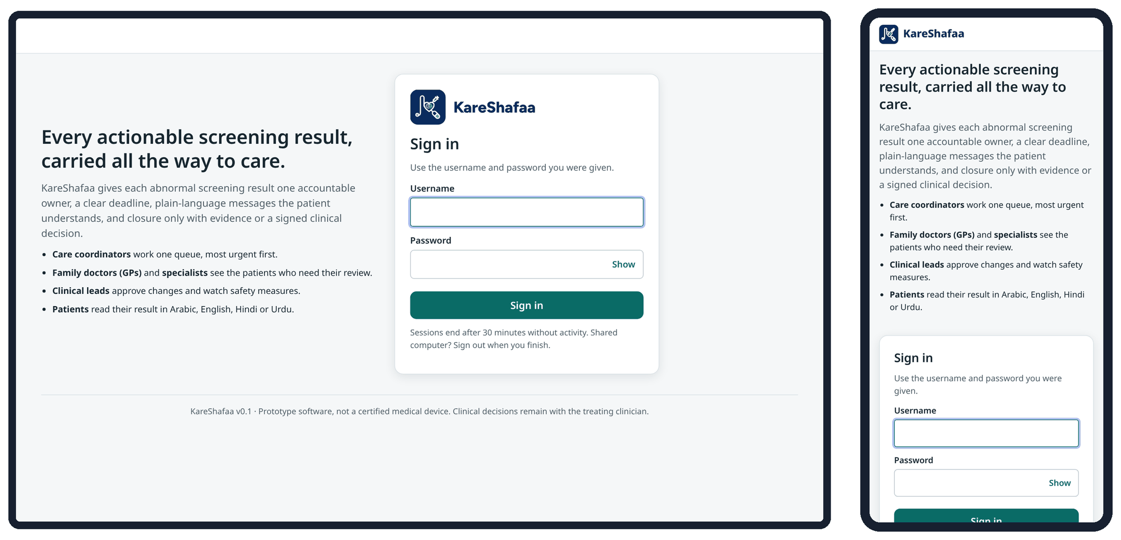
Figure 1. Sign-in page on a laptop (left) and on a phone (right).

2.5 Languages
- Staff screens are in English.
- The patient page and patient messages are available in English, Arabic, Hindi and Urdu. Arabic and Urdu are shown right to left. The patient can switch the page language at the top of the page; the choice is saved for the page and does not change the language recorded for clinical messages.
- Other languages: Tagalog and Malayalam speakers receive English text plus a notice in their own language, and the system creates an interpreter-supported navigator phone call.
- The brand name KareShafaa is never translated.
- Translated patient text goes live only after a clinical sign-off and a translation sign-off by different people (Section 5.8).

2.6 Screen layout and navigation
After sign-in each role lands on its own main task. The menu is on the left on a laptop and at the bottom on a phone. Your name and role are shown at the top right; the account menu has Change password and Sign out.
Table 11. Landing page and menu by role
Role | Lands on | Menu items
Care coordinator | Today's queue | Today's queue · Results inbox
Family doctor (GP) | Needs review | Needs review · All my cases · Ask a specialist
Specialist doctor | Needs review | Needs review · My cases · Consult requests
Clinical lead | Overview | Overview · Work queue · Approvals · Outcomes · Audit trail
Programme analyst | Outcomes | Outcomes · Models & rules
System administrator | Users | Users · System · Outcomes · Advanced
Medical translator | Content sign-off | Content sign-off
Patient | My results | My results

Opening another role's page is refused by the server, even if the address is typed directly. The footer of every page carries the prototype notice.

3. End-to-end flow
This section describes the flow of a case from the moment a result arrives to its closure. Section 3.1 shows the flow as a diagram, Section 3.3 gives the procedure as a 17-step table, and Section 3.4 gives the instructions for each stage. The numbers in the diagram match the step numbers in the table.

3.1 Flow diagram
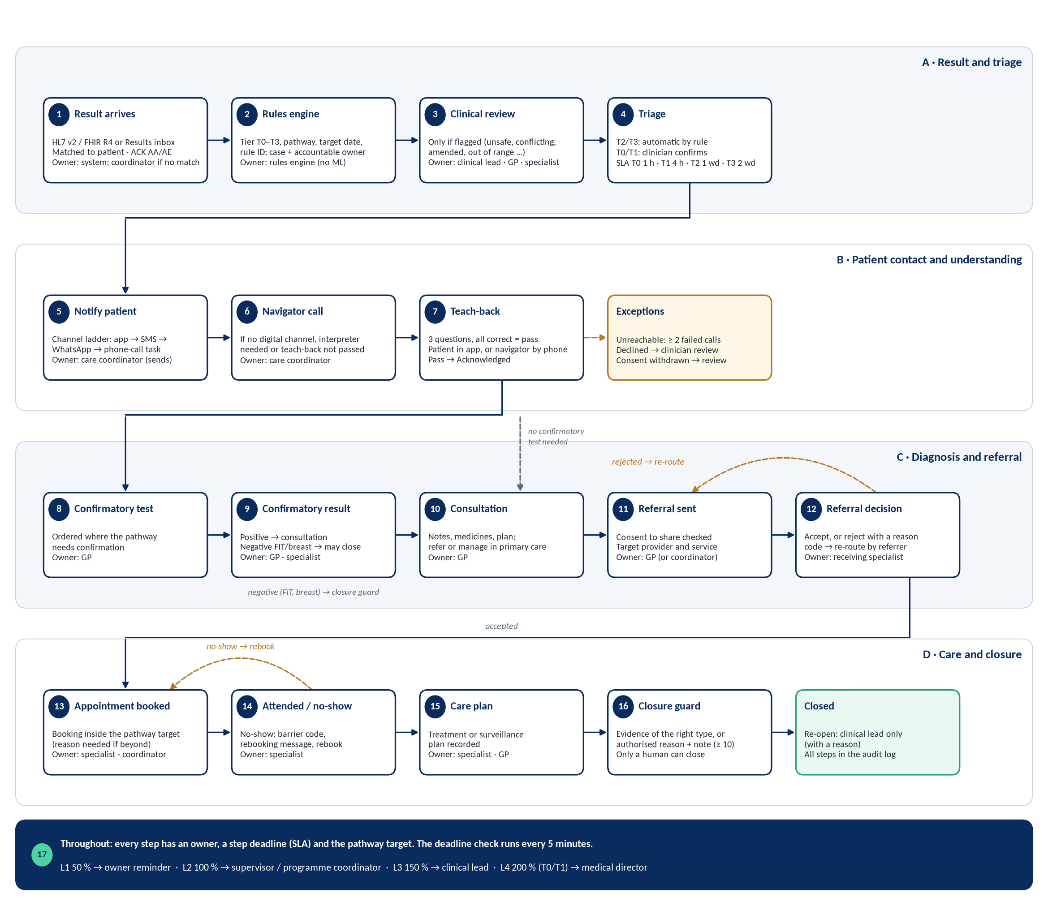
Figure 2. End-to-end flow of a KareShafaa case. Solid arrows are the main path; dashed amber arrows are exception loops.

3.2 Case states
A case is always in exactly one state. The state machine (version 1.1.0) allows only the moves listed below; closure goes through the closure guard. The default owner is set by the code when the case enters the state.
Table 12. Case states and default owners
State shown on screen | Meaning | Default owner
Result issued | Result received; waiting for triage (or for clinical review if flagged) | Programme care coordinator; clinical lead if flagged
Triaged | Urgency confirmed; patient to be told | Programme care coordinator
Patient notified | Message delivered; waiting for the teach-back | Programme care coordinator
Acknowledged (teach-back passed) | Patient understood; next clinical step due | Patient's family doctor (GP)
Confirmatory test | Confirmatory test ordered; waiting for the result | Family doctor (GP)
Consultation | Clinician consultation and decision on referral | Family doctor (GP)
Referral sent | Waiting for the receiving service to decide | Family doctor (GP)
Referral rejected | Rejected with a reason; to be re-routed | The referring clinician
Referral accepted | Appointment to be booked | Accepting specialist
Appointment booked | Waiting for the appointment | Accepting specialist
Appointment attended | Care plan to be recorded | Accepting specialist
Treatment / surveillance started | Care plan in place; closure to be documented | Accepting specialist (else GP)
Closed | Closed with evidence or an authorised decision | –
Unreachable (side state) | Patient not reached after the full contact ladder | Programme care coordinator
No-show (side state) | Patient missed the appointment; to be rebooked | Programme care coordinator
Declined – clinician review (side state) | Patient declined; a clinician must review | Family doctor (GP)

If the default owner is inactive or missing, the case goes to the programme team pool and appears under No named owner until someone is assigned.

3.3 Step-by-step procedure
Deadlines are the default step SLAs for T0 / T1 / T2 / T3 (h = hours, d = days, wd = UAE working days). The pathway target also applies (Appendix C), and a step deadline never runs past it.
Table 13. Step-by-step procedure (17 steps)
# | Step | Who owns it | System action | Deadline | What is recorded
1 | Result received and matched | System; care coordinator or GP for unmatched messages | Parses HL7 v2 / FHIR R4; answers ACK AA or AE; ignores exact duplicates; holds uncertain matches in the Results inbox | On arrival | Inbound message, result, patient match, ACK
2 | Rules applied, case created | Rules engine | Sets tier, pathway, target date and rule ID; flags anything unsafe for review; assigns the owner | On arrival | Case, tier, rule ID, pathway, target, owner
3 | Clinical review of a flagged result | Clinical lead, GP or specialist | Blocks every other step and all patient messages until resolved; the tier can only be lowered by a clinician with a note | As step 4 | Review decision and note (review log), new tier
4 | Triage | T2/T3: rules engine; T0/T1: GP or clinical lead | T2/T3 move to Triaged automatically; T0/T1 need a clinician | 1 h / 4 h / 1 wd / 2 wd | Triage step, actor, note
5 | Patient notified | Care coordinator | Runs the channel ladder (app → SMS → WhatsApp) within consent; creates a phone-call task if no channel works | 4 h / 24 h / 2 wd / 5 wd | Each message attempt, channel, language, delivery status (simulated)
6 | Navigator phone call | Care coordinator | Call task for no digital channel, interpreter need or a failed teach-back | Within the step 5 / 7 deadline | Call outcome (reached, no answer, wrong number) and note
7 | Teach-back and acknowledgement | Patient (app) or care coordinator (phone) | Scores 3 questions; a pass moves the case to Acknowledged; a fail creates a call task; answers lock after sending | 24 h / 48 h / 5 wd / 10 wd | Answers, score, confidence (1–5), language, any changed answers
8 | Confirmatory test ordered | GP | Offered only where the pathway needs confirmation | 24 h / 72 h / 7 wd / 14 wd (from acknowledgement) | Test order (service request)
9 | Confirmatory result | GP or specialist | Positive → consultation; negative → closure (FIT, breast) or surveillance plan (cervical, diabetes) | 48 h / 7 d / 14 wd / 28 wd | Result on the test order
10 | Consultation | GP | Clinical record with consultation notes and medicines | 24 h / 72 h / 7 wd / 14 wd | Consultation note, medicines, step note
11 | Referral sent | GP (care coordinator or clinical lead may also send) | Checks consent to share; offers only valid providers | 24 h / 48 h / 5 wd / 10 wd (for the decision) | Referral: organisation, specialist, summary
12 | Referral decision | Receiving specialist | Accept, or reject with a reason code; rejection returns the case to the referrer | Rejected: re-route in 8 h / 24 h / 2 wd / 5 wd | Decision, reason code, note
13 | Appointment booked | Specialist or care coordinator | Sends the appointment message (app, SMS, WhatsApp); asks for a reason if the date is beyond the pathway target | Book in 24 h / 72 h / 10 wd / 20 wd | Appointment time, booking note
14 | Attendance or no-show | Specialist (care coordinator may record) | No-show sends a rebooking message and opens the No-show step | Attend in 7 d / 14 d / 30 wd / 60 wd | Attendance, barrier code
15 | Treatment or surveillance plan | Specialist or GP | Records the care plan; care is now reached | 48 h / 5 d / 10 wd / 20 wd | Care plan type and description
16 | Closure | Any clinical role with evidence; GP, specialist or clinical lead for an authorised decision | Closure guard checks the evidence or the reason code and note | 48 h / 72 h / 7 wd / 14 wd | Closure type, evidence or reason, note, actor
17 | Deadline check and escalation | System; then owner, supervisor, clinical lead, medical director | Every 5 minutes: updates clocks, raises L1–L4 alerts, sends due patient reminders, moves cases of inactive owners to the team pool | Continuous | Escalations, reminders, acknowledgements

3.4 Stage-by-stage procedures

3.4.1 Result intake (steps 1–2)
- Laboratory systems post HL7 v2 ORU^R01 or FHIR R4 Bundles to the ingest interface. Care coordinators and GPs can paste an HL7 message in the Results inbox (/ingest).
- Each message is answered with ACK AA (accepted) or AE (error). A message with the same control ID and the same content is ignored as a duplicate; the same ID with different content is never silently treated as a replay.
- Patients are matched deterministically by identifier and birth year. If the match is uncertain the message waits in Waiting for a patient match; a coordinator or GP resolves it.
- The rules engine then creates the case (Appendix C) or, for a negative result, returns the person to routine screening without a case.
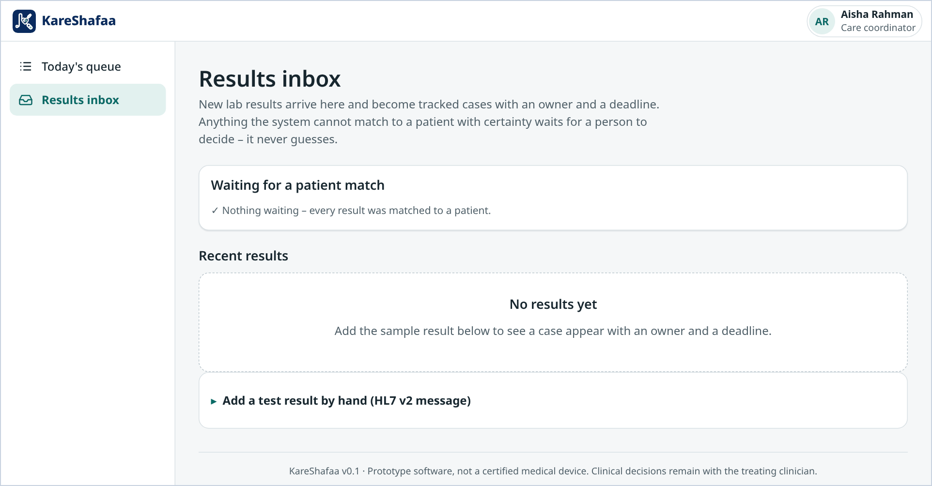
Figure 3. Results inbox: messages waiting for a patient match and recent results (care coordinator, laptop).

3.4.2 Clinical review of flagged results (step 3)
A result is flagged when it is unknown, malformed, out of range, conflicting, amended, duplicated, outside the screening age, or when the patient is pregnant, deceased or already under specialist care, or the programme was closed in the last 180 days. A flagged case is placed at the safest plausible tier, owned by the clinical lead, and nothing else happens until a GP, specialist or clinical lead chooses Resolve clinical review and records a decision and note. Every review note is kept on the case and shown in the timeline.

3.4.3 Triage (step 4)
T2 and T3 results are triaged automatically by the deterministic rule. T0 and T1 results must be confirmed by a clinician: open the case and choose Confirm triage (clinician). The T0 first-action deadline is 1 hour, day or night.

3.4.4 Notifying the patient (step 5)
1. Open the case in Triaged and choose Send result notification (channel ladder).
2. The system tries the app, then SMS, then WhatsApp, in the order configured for the patient's language and only on channels the patient consented to.
3. If no digital channel succeeds, or an interpreter is needed, a phone-call task is created for the care coordinator.
4. When a message is delivered the case moves to Patient notified.
Messages are simulated
SMS and WhatsApp messages are recorded in the case but not sent to phones until a messaging provider is connected. Each recorded message is marked as simulated. Do not rely on these messages to reach real patients.

3.4.5 Navigator calls (step 6)
Work the Phone calls to make filter. Record each call as reached, no answer or wrong number with a note. Use an interpreter when the case shows the interpreter flag. After at least two failed calls, and when the digital ladder has failed, mark the case Unreachable (Section 6.1).

3.4.6 Teach-back and acknowledgement (step 7)
- The patient answers three questions on the patient page (what the result means, the next step, how soon) and rates confidence from 1 to 5. All three must be correct to pass.
- A pass moves the case to Acknowledged. A fail creates a navigator call task; the coordinator explains the result and can record a navigator teach-back by phone.
- Once sent, the patient's answers are locked. To change them the patient must choose Change my answers, confirm, and send again within 30 minutes (Section 5.7).

3.4.7 Confirmatory test (steps 8–9)
If the pathway needs confirmation (for example a repeat HbA1c), the GP chooses Order confirmatory test. When the result arrives, a GP or specialist chooses Record confirmatory result. A positive result moves to consultation. A negative FIT or breast result may be closed with evidence; a negative cervical or diabetes result needs a surveillance care plan. If no confirmation is needed the case goes straight to consultation.

3.4.8 Consultation (step 10)
The GP reviews the full clinical record on the case page: patient summary, tests and investigations, consultations, medicines, referrals and appointments, and outreach. Use Add consultation note and Add medicine to record the consultation; then refer, or record a treatment or surveillance plan in primary care.

3.4.9 Referral (steps 11–12)
1. Choose Send referral, select the organisation and specialist, and write a clinical summary. A referral to an outside organisation needs the patient's consent to share.
2. The receiving specialist chooses Accept / reject referral. A rejection needs a reason code and a note.
3. A rejected referral returns to the referrer, who re-routes it to another provider, completes the missing information, or chooses Alternative plan: back to consultation.

3.4.10 Appointment and attendance (steps 13–14)
Book the appointment inside the pathway target; a later date needs a reason, which is stored as the booking note. The patient receives the appointment message. After the appointment record attended or no-show with a barrier code (for example transport, work, cost, language, Ramadan hours). A no-show sends a rebooking message and opens the No-show step for rebooking.

3.4.11 Care plan and closure (steps 15–16)
Table 14. Closure guard
Closure type | Allowed when | Who
Evidence: appointment fulfilled | Appointment attended, or treatment / surveillance started | Any clinical role (coordinator, GP, specialist, clinical lead)
Evidence: care plan | Treatment / surveillance started, or appointment attended | Any clinical role
Evidence: negative confirmatory result | Confirmatory test, FIT and breast programmes only | Any clinical role
Authorised decision | Any open state; reason code + note of at least 10 characters | GP, specialist or clinical lead

Only a human can close a case. Evidence recorded before a re-open belongs to the earlier episode and cannot close the re-opened case.

3.4.12 Re-opening
Only a clinical lead can re-open a closed case (Re-open case, note of at least 10 characters). The case returns to Triaged. If the original pathway target has already passed, the case is overdue at once.

3.4.13 Ownership, reassignment and transfer
- Reassign owner (coordinator, GP, clinical lead) with a reason of at least 3 characters.
- Transfer to another provider (two-key) (coordinator, GP, specialist, clinical lead): the receiver must accept. Until then the current owner stays accountable; the case shows Transfer waiting. A declined transfer needs a reason.

3.4.14 Deadlines and escalation (step 17)
Every open step has a deadline. The deadline check runs every 5 minutes and raises alerts on the ladder shown below. Once the pathway target is missed, the pathway clock raises one consolidated alert per case per level, from L2. Patient reminders are sent only between 08:00 and 21:00 UAE time. A case whose owner is inactive moves to the team pool automatically.
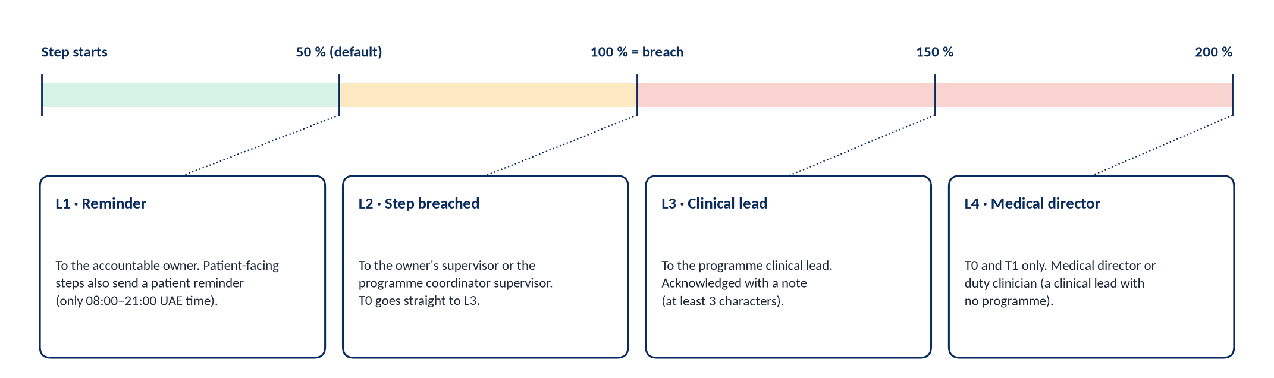
Figure 4. Escalation ladder for a step deadline. L1 uses the reminder point set per state and tier (default 50 %).
Acknowledge each escalation on the case with what you did. The system administrator can also run the deadline check by hand (Advanced → Run the check now); due reminders are then sent as the rules engine and the request is audited.

3.4.15 The case page
Every case page shows the patient's clinical record first, then the current step: the step, accountable owner, step deadline and urgency, a step tracker, the clinical rule and pathway target, and the Next step card with the main action and More actions. The tabs below show the timeline, messages and events, and the case audit.
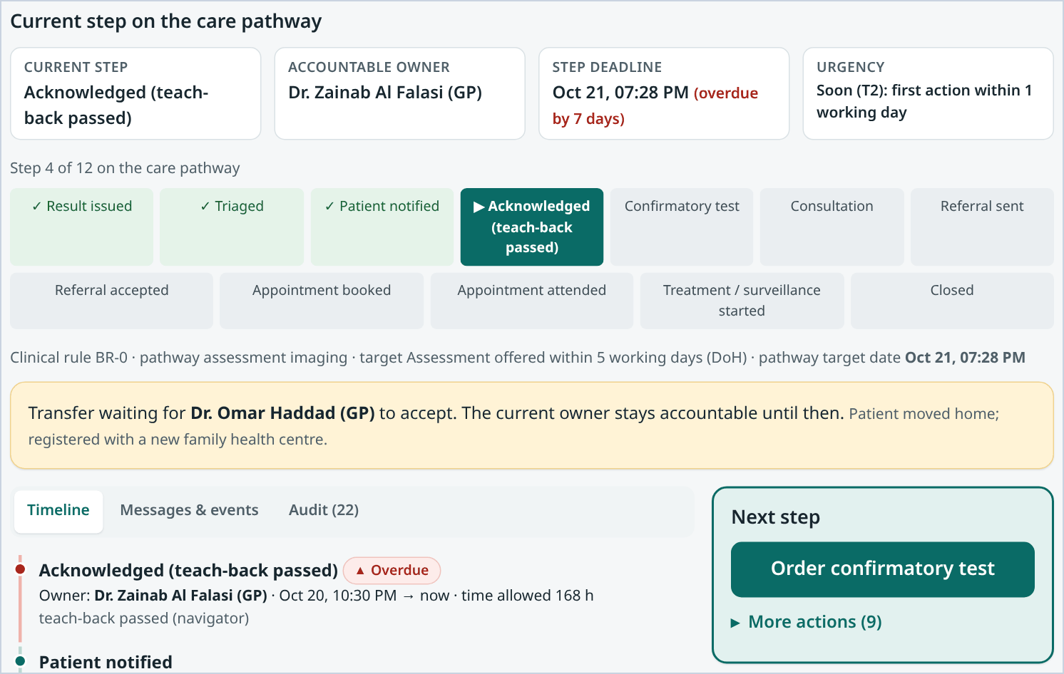
Figure 5. Current step and Next step card on a case (family doctor, laptop).

4. Roles and responsibilities
KareShafaa has seven staff roles and a patient role. Each role has a fixed set of permissions in the code. Every action is checked on the server, and page access is checked as well, so a role cannot open another role's screens even by typing the address. Clinical decisions and system administration are deliberately separated: the clinical lead makes clinical approvals, the system administrator runs the system and makes no clinical decisions.

4.1 Role summary
Table 15. Roles at a glance
Role | Purpose | Which cases are visible
Care coordinator | Keeps every case moving: queue, results inbox, patient contact and calls, bookings, re-routing | All cases in the programme
Family doctor (GP) | Clinical review, triage of urgent results, confirmatory tests, consultation, referral, care plans, authorised closure; results inbox | Cases their organisation is involved in
Specialist doctor | Referral decisions, appointments, attendance, care plans, e-consult answers, authorised closure | Cases their organisation is involved in
Clinical lead | Owns flagged results; approves models, rule and deadline changes and patient wording; escalations and overdue oversight; re-opening; read-only audit trail | All cases in the programme
Programme analyst | Monitors outcomes and fairness; read-only view of models, rules and content | No individual cases: aggregates only, groups below 5 hidden
System administrator | User accounts, system status, audit-chain check, deadline-check runner, model retraining, proposal engine, simulation runs | No cases: queue and case pages are refused
Medical translator | Attests that translated patient wording says the same as the signed-off English | No cases
Patient | Reads their result, completes the teach-back, asks questions, declines or changes consent | Their own case only

Involved means the organisation manages the patient, owns the case, receives a referral or appointment, is asked an e-consult question, or is the target of a pending transfer. Organisations other than the managing organisation also need the patient's consent to share.

4.2 Permissions matrix
✓ = allowed; – = not allowed. Coord = care coordinator, Spec = specialist, Lead = clinical lead, Admin = system administrator, Transl = medical translator. Numbers refer to the notes below the table.
Table 16. Permissions matrix (code at aac2f3d)
Action | Coord | GP | Spec | Lead | Analyst | Admin | Transl | Patient
Open the work queue and case pages | ✓ | ✓ | ✓ | ✓ | – | – | – | Own case
Results inbox: load an HL7 / FHIR result, resolve a patient match | ✓ | ✓ | – | – | – | – | – | –
Confirm triage of a T2/T3 result | ✓ | ✓ | – | ✓ | – | – | – | –
Confirm triage of a T0/T1 result | – | ✓ | – ¹ | ✓ | – | – | – | –
Resolve a clinical review (flagged result) | – | ✓ | ✓ | ✓ | – | – | – | –
Send result notification or reminder (channel ladder) | ✓ | ✓ | ✓ ² | ✓ | – | – | – | –
Record call outcome, navigator teach-back, mark unreachable | ✓ | ✓ | – | ✓ | – | – | – | –
Order a confirmatory test | – | ✓ | – | ✓ | – | – | – | –
Record a confirmatory result | – | ✓ | ✓ | ✓ | – | – | – | –
Move to consultation; record a decline; resume after reconsidering | ✓ | ✓ | ✓ | ✓ | – | – | – | Decline own
Consultation notes and medicines (clinical record) | – | ✓ | ✓ | ✓ | – | – | – | –
Send or re-route a referral | ✓ | ✓ | – | ✓ | – | – | – | –
Accept or reject a referral (own organisation) | – | – | ✓ | ✓ | – | – | – | –
Book appointment; record attendance or no-show | ✓ | ✓ | ✓ | ✓ | – | – | – | –
Record a treatment or surveillance plan | – | ✓ | ✓ | ✓ | – | – | – | –
Close a case with evidence | ✓ | ✓ | ✓ | ✓ | – | – | – | –
Authorised closure; record a death | – | ✓ | ✓ | ✓ | – | – | – | –
Re-open a case; correct a death recorded in error | – | – | – | ✓ | – | – | – | –
Reassign owner | ✓ | ✓ | – | ✓ | – | – | – | –
Request a two-key transfer | ✓ | ✓ | ✓ | ✓ | – | – | – | –
Record consent | ✓ | ✓ | ✓ | ✓ | – | – | – | Own
Ask a specialist (e-consult) | ✓ | ✓ | ✓ | ✓ | – | – | – | Ask care team
Answer an e-consult | ✓ ³ | ✓ ³ | ✓ ³ | ✓ | – | – | – | –
Acknowledge escalation; record delay reason; export FHIR | ✓ | ✓ | ✓ | ✓ | – | – | – | –
Outcomes dashboard (aggregates) | – | – | – | ✓ | ✓ | ✓ | – | –
View models, lessons, deadlines and settings | – | – | – | ✓ | ✓ | ✓ | – | –
Approve, reject or roll back a model; decide rule and deadline changes | – | – | – | ✓ | – | – | – | –
Train a candidate model; run the proposal engine; run simulations | – | – | – | – | – | ✓ | – | –
Clinical sign-off of patient wording | – | – | – | ✓ | – | – | – | –
Translation sign-off | – | – | – | – | – | – | ✓ | –
View patient wording and sign-off status | – | – | – | ✓ | ✓ | – | ✓ | –
Read the audit trail | – | – | – | ✓ ⁴ | – | ✓ | – | –
Check the audit chain is intact | – | – | – | – | – | ✓ | – | –
Advanced tools page; run the deadline check now | – ⁵ | – | – | – | – | ✓ | – | –
Manage users; System page | – | – | – | – | – | ✓ | – | –
Own result, teach-back, questions, page language | – | – | – | – | – | – | – | ✓

Notes. ¹ The specialist holds the urgent-triage permission and the screen offers Confirm triage (clinician), but the server also requires the general triage permission, which the specialist does not have, so the action is refused. ² A specialist can send messages, but moving a case from Triaged to Patient notified needs the call-recording permission, so a specialist-sent result notification is refused at that step. ³ Only the clinician the question is addressed to, or a clinical lead, can answer. ⁴ Read-only: the lead's audit page has no chain check and no link to Advanced. ⁵ The coordinator role still holds the deadline-check permission in the code, but the Advanced page that has the button is open only to the system administrator.

4.3 RACI for the core flow
R = does the work; A = accountable (default owner in the code); C = consulted; I = informed. Derived from the default owner of each state and the permissions above. The analyst is informed through Outcomes. The system administrator supports accounts and the system and has no clinical part.
Table 17. RACI for the core flow
Activity | Coord | GP | Spec | Lead | Admin | Patient | System
Result intake and patient match | A / R | R | – | I | – | – | R
Clinical review of flagged results | I | R | R | A / R | – | – | R (flag)
Triage | A / R (T2/T3) | R | – | R | – | – | R (T2/T3)
Notify patient and outreach | A / R | R | C | C | – | I | R (ladder)
Teach-back | R (phone) | I | – | – | – | R | R (scoring)
Confirmatory test and consultation | I | A / R | R (result) | C | – | I | –
Referral sent / re-routed | R | A / R | I | C | – | I | –
Referral decision | I | I | A / R | R | – | – | –
Appointment and attendance | R | R | A / R | – | – | I | R (messages)
Treatment or surveillance plan | – | R | A / R | R | – | I | –
Closure with evidence | R | R | A / R | C | – | – | R (guard)
Authorised closure | – | R | R | A / R | – | – | R (guard)
Re-open | I | I | I | A / R | – | – | –
Escalation response | R (L2) | R | R | A (L3/L4) | – | – | R (alerts)
Deadline check run by hand | – | – | – | I | A / R | – | R
Patient wording sign-off | – | – | – | A / R | – | – | R (checks)
Model and rule changes | – | – | – | A (approve) | R (train, propose) | – | R (gates)
User accounts and audit-chain check | – | – | – | I | A / R | – | –

4.4 Care coordinator

Responsibilities
- Keep every case in the programme moving and inside its deadline; you are the default owner from result to notification, and for unreachable and no-show cases.
- Contact patients: run the channel ladder, make navigator calls (with an interpreter where flagged), record call outcomes and navigator teach-backs.
- Resolve patient matches and load results in the Results inbox.
- Book appointments, record attendance and no-shows, and re-route rejected referrals.
- Act on L2 escalations as programme coordinator or supervisor.

What you see
- Today's queue: most urgent first – overdue and due-soon steps, then tier T0 to T3, then flagged results, then outreach priority, then deadline. Counters for Overdue, Need review, No named owner and Escalated; a programme filter and a search by name, MRN or case number.
- Queue views: All open cases, Overdue, Needs clinical review, Assigned to me, No named owner, Escalated, Referral rejected, Phone calls to make, Transfers waiting, Open consultations.
- Results inbox: messages waiting for a patient match, recent results, and an HL7 v2 entry box.
- Case page: clinical record, current step, owner, deadline, urgency, timeline, messages and events, case audit, and the Next step card.
You can | You cannot
Confirm triage of T2/T3 results; send notifications and reminders; record calls, navigator teach-backs and unreachable; send and re-route referrals; book appointments and record attendance; close with evidence; reassign; request transfers; record consent or a decline on the patient's behalf; ask a specialist; acknowledge escalations; record delay reasons; export FHIR. | Confirm T0/T1 triage or resolve a clinical review; order or record confirmatory tests; decide referrals; write consultation notes, medicines or care plans; authorised closure or record a death; re-open; open Outcomes, Approvals, the audit trail or Advanced.

Daily checklist
☐ Open Today's queue and press Open the most urgent case; work down from the red (overdue) items.
☐ Check No named owner and assign every pooled case.
☐ Work Phone calls to make and record each outcome the same day.
☐ Check Referral rejected and re-route each case.
☐ Check Results inbox for messages waiting for a patient match.
☐ Acknowledge your Escalated cases with what you did.
☐ Before leaving, check Transfers waiting and amber items due overnight.

Key procedures
Notify a patient
1. Open the case in Triaged.
2. Press Send result notification (channel ladder).
3. Read the outcome: the delivered channel, or a phone-call task if no digital channel succeeded.
4. If a call task was created, call the patient (with an interpreter if flagged) and record the outcome.
Record a navigator teach-back during a call
1. Open the case in Patient notified.
2. Choose Record navigator teach-back; ask the three questions in the patient's language.
3. Record the answers and the patient's confidence (1–5). A pass moves the case to Acknowledged.
Resolve a patient match
1. Open Results inbox → Waiting for a patient match.
2. Compare identifier, name and birth year with the patient record.
3. Choose the correct patient. The result then creates or updates the case as normal.
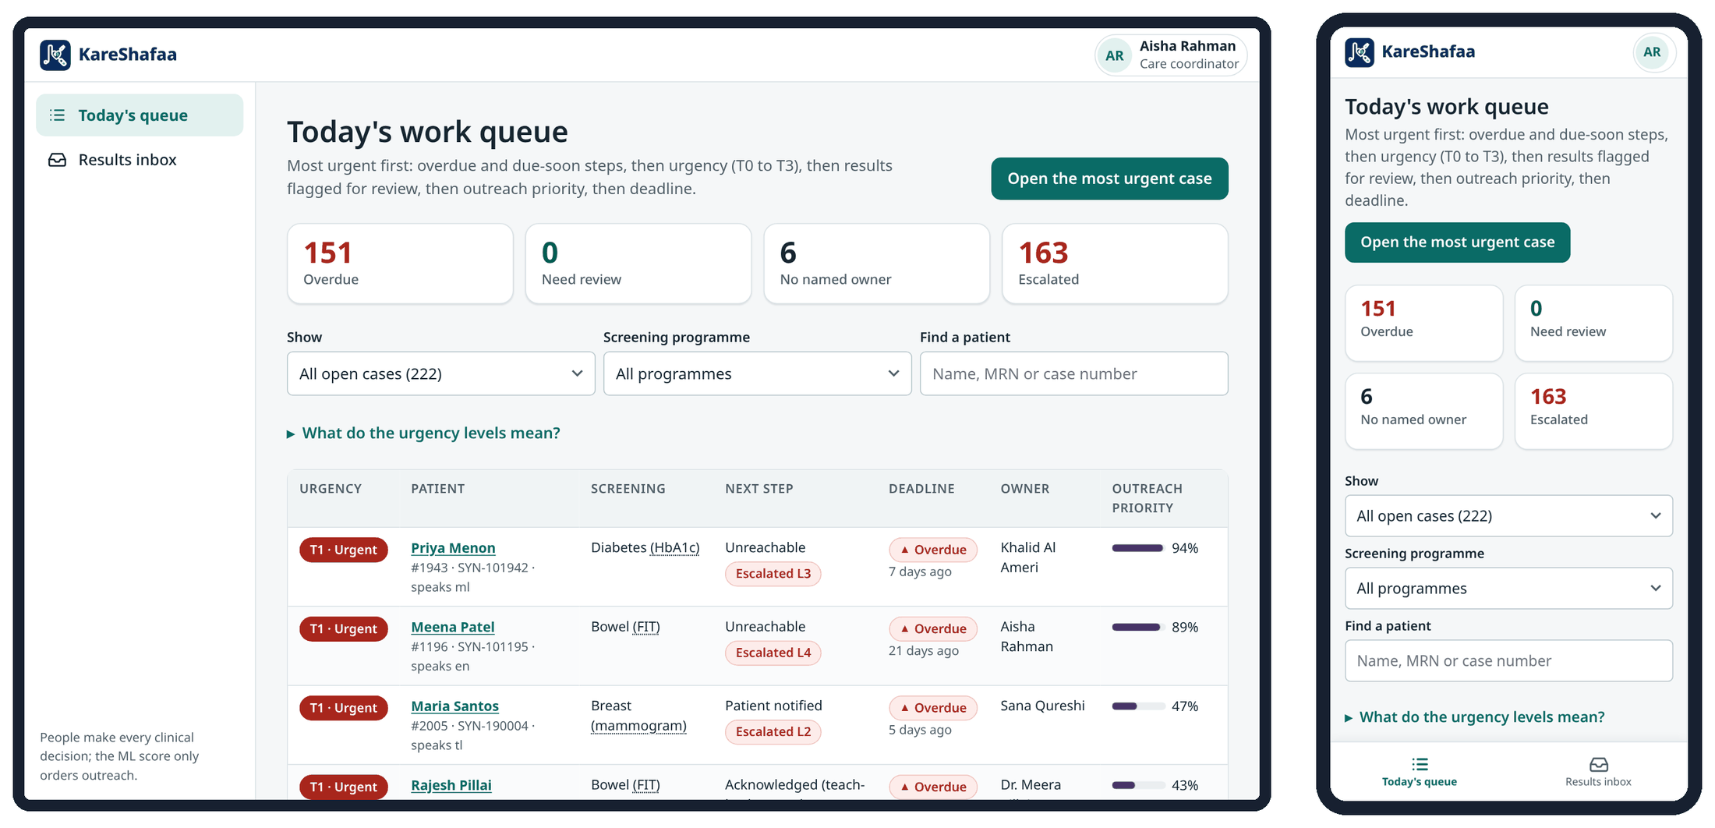
Figure 6. Care coordinator: Today's queue on a laptop (left) and a phone (right).

4.5 Family doctor (GP)

Responsibilities
- Review flagged results and confirm the urgency of T0/T1 results.
- Order and record confirmatory tests; hold the consultation; refer, or manage in primary care.
- Record consultation notes, medicines and care plans in the clinical record.
- Sign off authorised closures; record a death when confirmed.
- Use the Results inbox for results that arrive at the practice; answer patient questions routed to you.

What you see
- Needs review: your patients whose results need a clinician.
- All my cases: open cases your organisation is involved in.
- Ask a specialist: your e-consults and questions addressed to you.
- Case page: patient summary (MRN, age, sex, language, contact preference, family doctor, allergies, key conditions), tests and investigations, consultations and encounters, medicines, referrals and appointments, outreach and patient responses.
You can | You cannot
Confirm triage including T0/T1; resolve clinical reviews; order and record confirmatory tests; consultation notes and medicines; send referrals; book appointments; record care plans; close with evidence or by authorised decision; record a death; reassign; transfer; ask a specialist; results inbox. | Decide referrals (specialist or clinical lead); re-open closed cases or correct a death record (clinical lead); approve models, rules or patient wording; see Outcomes or the audit trail.

Daily checklist
☐ Open Needs review and resolve every flagged result, T0 first.
☐ Check Ask a specialist for answers and patient questions.
☐ Review cases in Acknowledged, Confirmatory test and Consultation in All my cases.
☐ Act on declined cases: talk to the patient and document an informed decline or a new plan.
☐ Acknowledge escalations on your cases.

Key procedures
Confirm and act on a T1 result
1. Open the case from Needs review.
2. Check the rule, pathway and target shown on the case.
3. Choose Confirm triage (clinician), or resolve the review with a decision and note.
4. Send the result notification, or leave it to the coordinator, who owns the next step.
Authorised closure
1. Open the case → More actions → Authorised closure (reason required).
2. Choose the reason code and write the rationale (at least 10 characters).
3. Confirm. The guard checks the reason against the case, for example two failed calls for unable to contact.
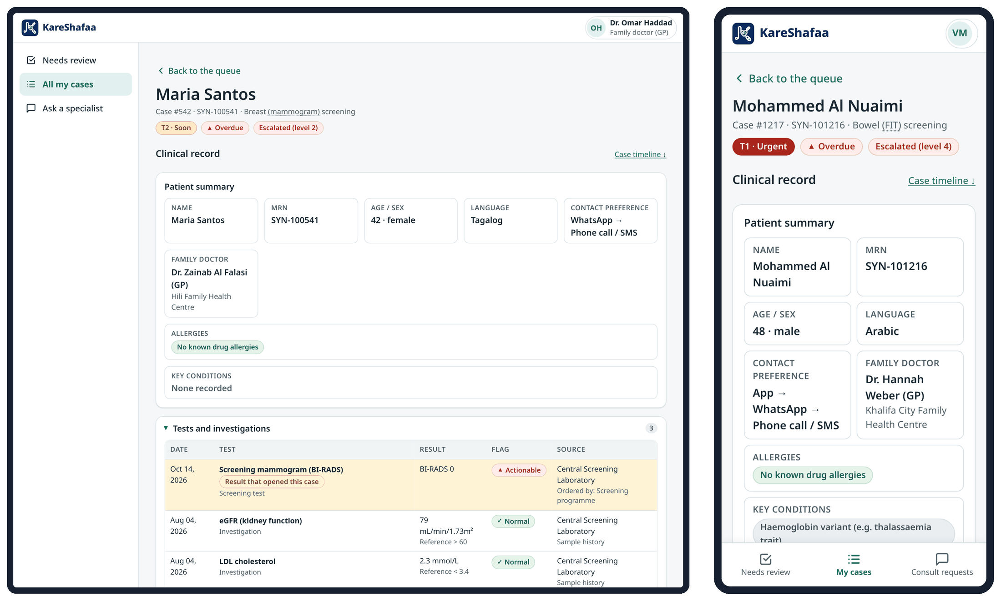
Figure 7. Clinician case view: family doctor on a laptop (left) and specialist on a phone (right). The clinical record is shown above the current step.

4.6 Specialist doctor

Responsibilities
- Accept or reject referrals sent to your organisation, with reasons.
- Book appointments and record attendance and no-shows.
- Record confirmatory results, consultation notes, medicines and care plans; sign off authorised closures.
- Resolve clinical reviews on your cases; answer e-consult questions addressed to you.

What you see
- Needs review: cases needing your review.
- My cases: cases your organisation is involved in.
- Consult requests: questions from GPs and patients addressed to you, with the time to answer.
You can | You cannot
Resolve clinical reviews; decide referrals for your organisation; book appointments and record attendance; record confirmatory results and care plans; consultation notes and medicines; close with evidence or by authorised decision; record a death; request transfers; answer e-consults addressed to you. | Triage results (see note ¹ to the matrix); record call outcomes; reassign owners or send referrals; order confirmatory tests; decide referrals addressed to another organisation; re-open cases; governance, Outcomes or the audit trail.

Daily checklist
☐ Decide every referral in Referral sent for your organisation.
☐ Book accepted referrals inside the pathway target.
☐ Record attendance or no-show after each clinic.
☐ Record care plans after attended appointments.
☐ Answer Consult requests within the response time (T0 1 h, T1 4 h, T2 24 h, T3 72 h).

Key procedures
Reject a referral
1. Open the case in Referral sent → Accept / reject referral.
2. Choose Reject, pick the reason code (wrong service, capacity, incomplete information, out of network, not clinically indicated) and write a note.
3. Save. The case returns to the referring clinician for re-routing.
Record a no-show
1. After the appointment time, open the case → Record attendance / no-show → No-show.
2. Choose the barrier code.
3. Save. The patient receives a rebooking message and the case moves to No-show for rebooking.
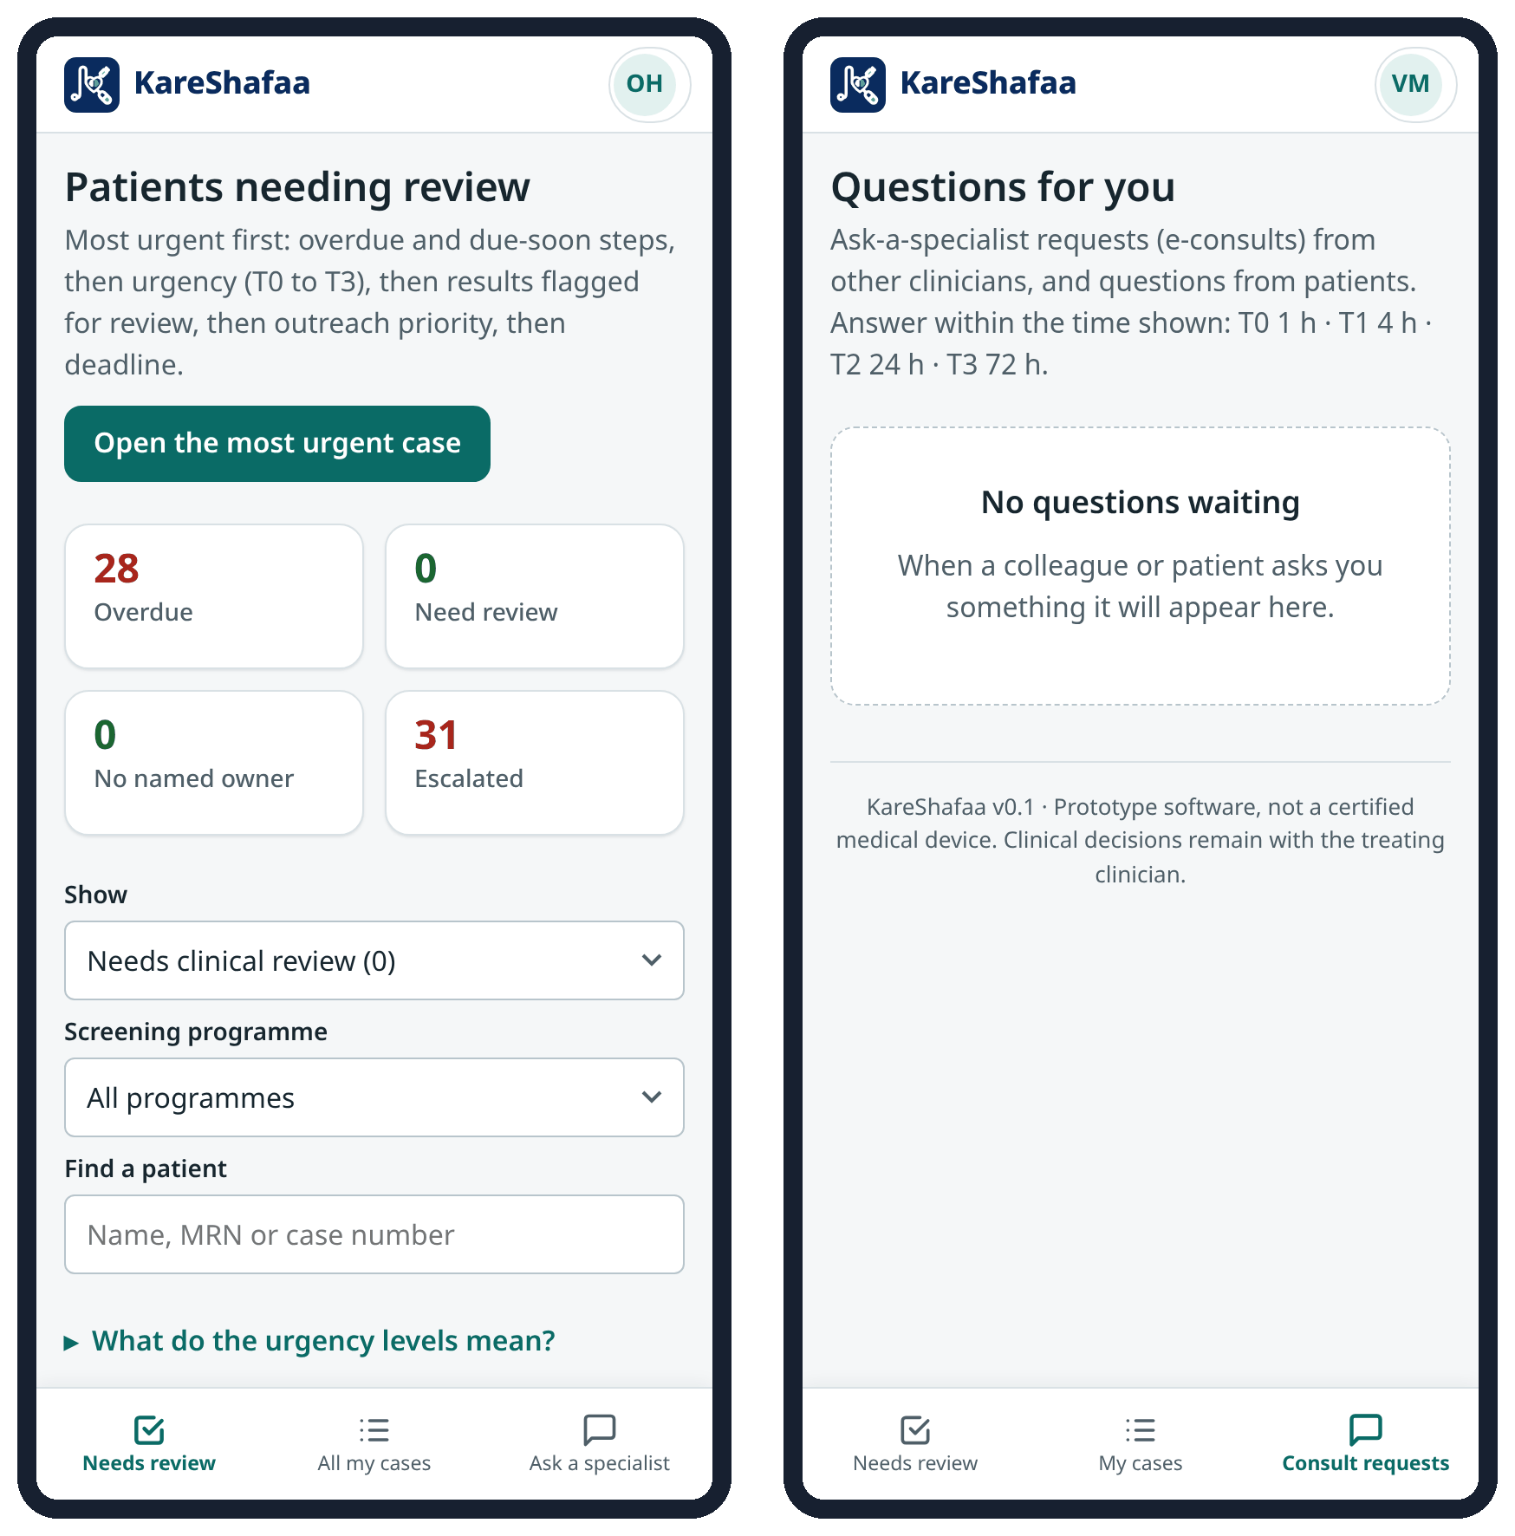
Figure 8. Family doctor's Needs review list (left) and specialist's Questions for you (right), on phones.

4.7 Clinical lead

Responsibilities
- Own and resolve flagged results for the programme.
- Approve or reject candidate outreach models with a note, and roll back; decide proposed rule and deadline changes.
- Give the clinical sign-off for patient wording.
- Respond to L3 escalations and watch overdue cases; lead accounts without a programme act as medical director for L4.
- Re-open closed cases and correct death records recorded in error.
- Review clinical governance with the read-only Audit trail and Outcomes.

What you see
- Overview: decisions waiting (outreach model updates, rule and deadline changes, patient texts), patient safety (overdue, escalations not acknowledged, needs clinical review, referrals rejected) and programme results.
- Work queue and case pages for the whole programme.
- Approvals: tabs Outreach model, Proposed rule changes, Lessons learned, Deadlines & settings and Patient texts.
- Outcomes (aggregate KPIs and fairness) and Audit trail (read-only: search events; no chain check).
You can | You cannot
Everything a GP can do in a case, plus: decide referrals, re-open cases, correct a death record, answer any e-consult, approve or reject models and roll back, decide rule and deadline proposals, clinical sign-off of patient wording, Outcomes, read-only audit trail. | Run the deadline check by hand, retrain models, run the proposal engine or simulations, use the Results inbox, verify the audit chain, open Advanced or the guided walkthrough, manage users (all system administrator or front-line tasks); give the translation sign-off.

Daily checklist
☐ Open Overview and clear Waiting for your decision.
☐ Review Patient safety: unacknowledged escalations, overdue cases, flagged results and rejected referrals.
☐ Resolve flagged results you own.
☐ Weekly: review T2/T3 cases past 200 % of their deadline and the lessons-learned list.

Key procedures
Approve or reject a candidate model
1. Open Approvals → Outreach model; read the gate results (AUC, calibration, fairness) and the model card.
2. Approve only if the candidate passed every gate and is better than the current model.
3. Write a decision note (at least 5 characters) and confirm. Roll back production model returns to the previous approved version, also with a note.
Decide a rule or deadline change
1. Open Approvals → Proposed rule changes; read the evidence from lessons learned.
2. Check the current values in Deadlines & settings.
3. Approve or reject with a note. Only approved proposals change the configuration.
Re-open a closed case
1. Open the closed case → Re-open case.
2. Write the reason (at least 10 characters) and confirm.
3. Check the step deadline: if the original target has passed, the case is overdue at once.
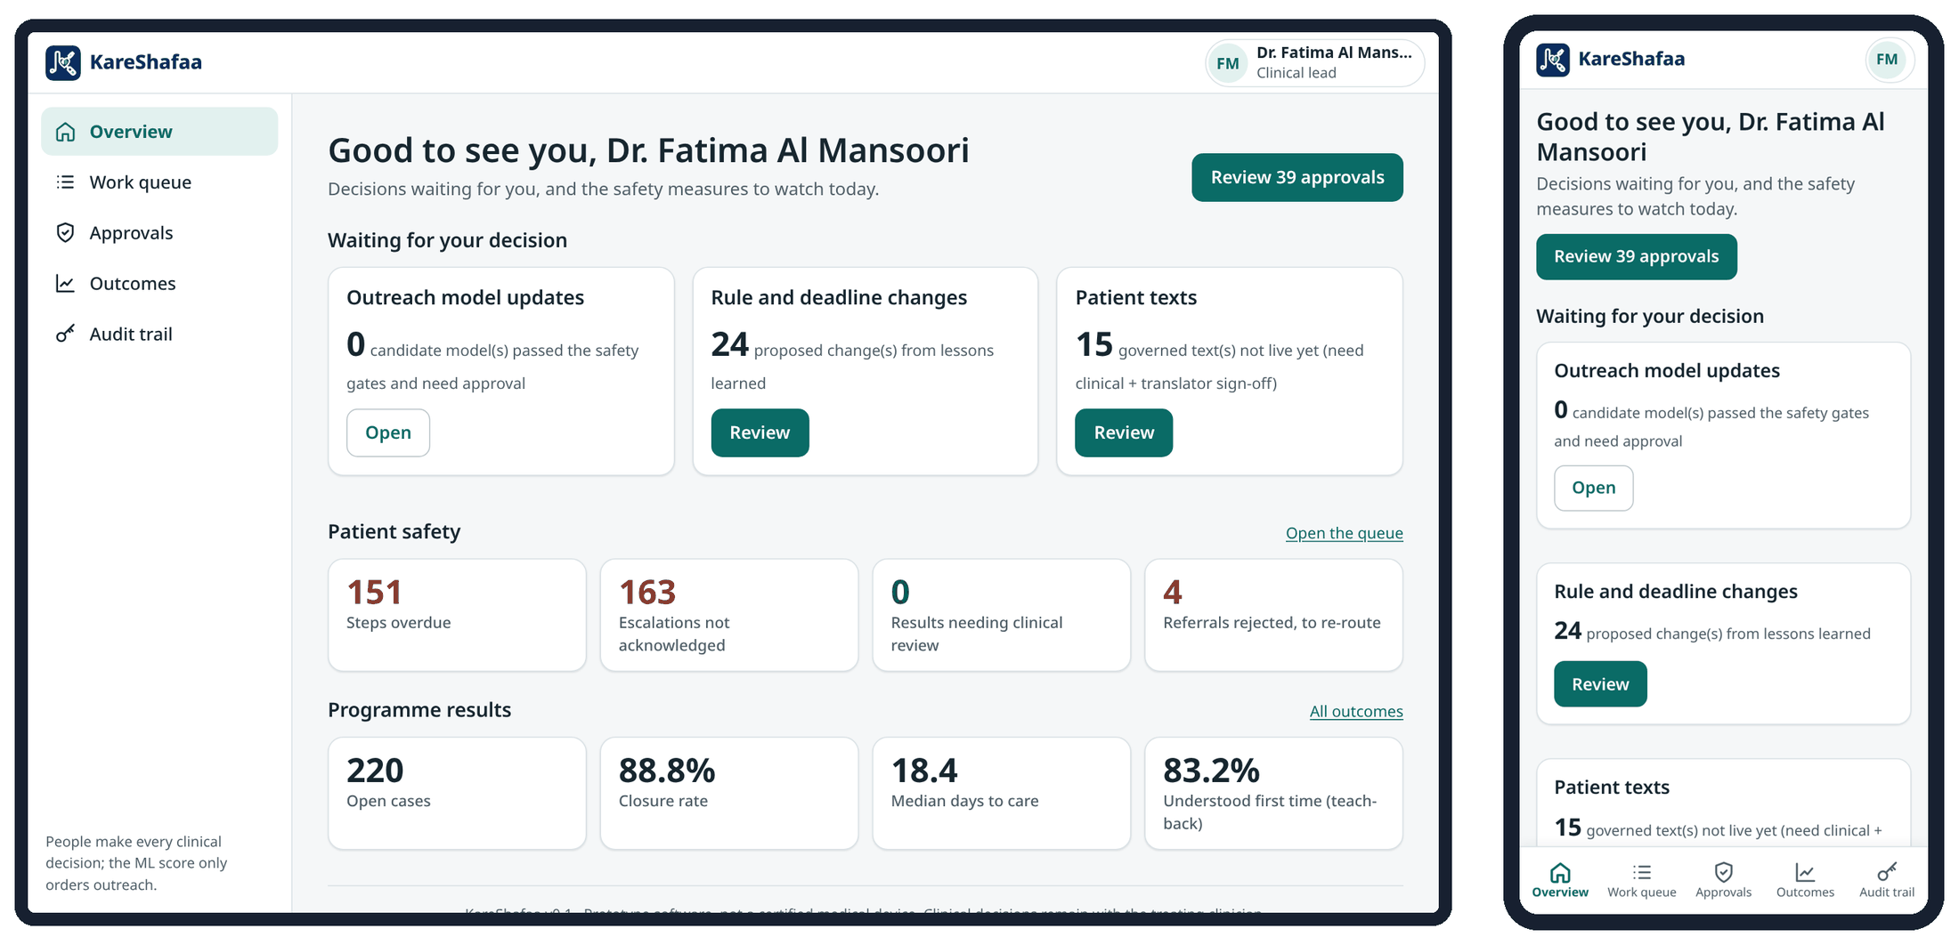
Figure 9. Clinical lead: Overview on a laptop (left) and a phone (right).
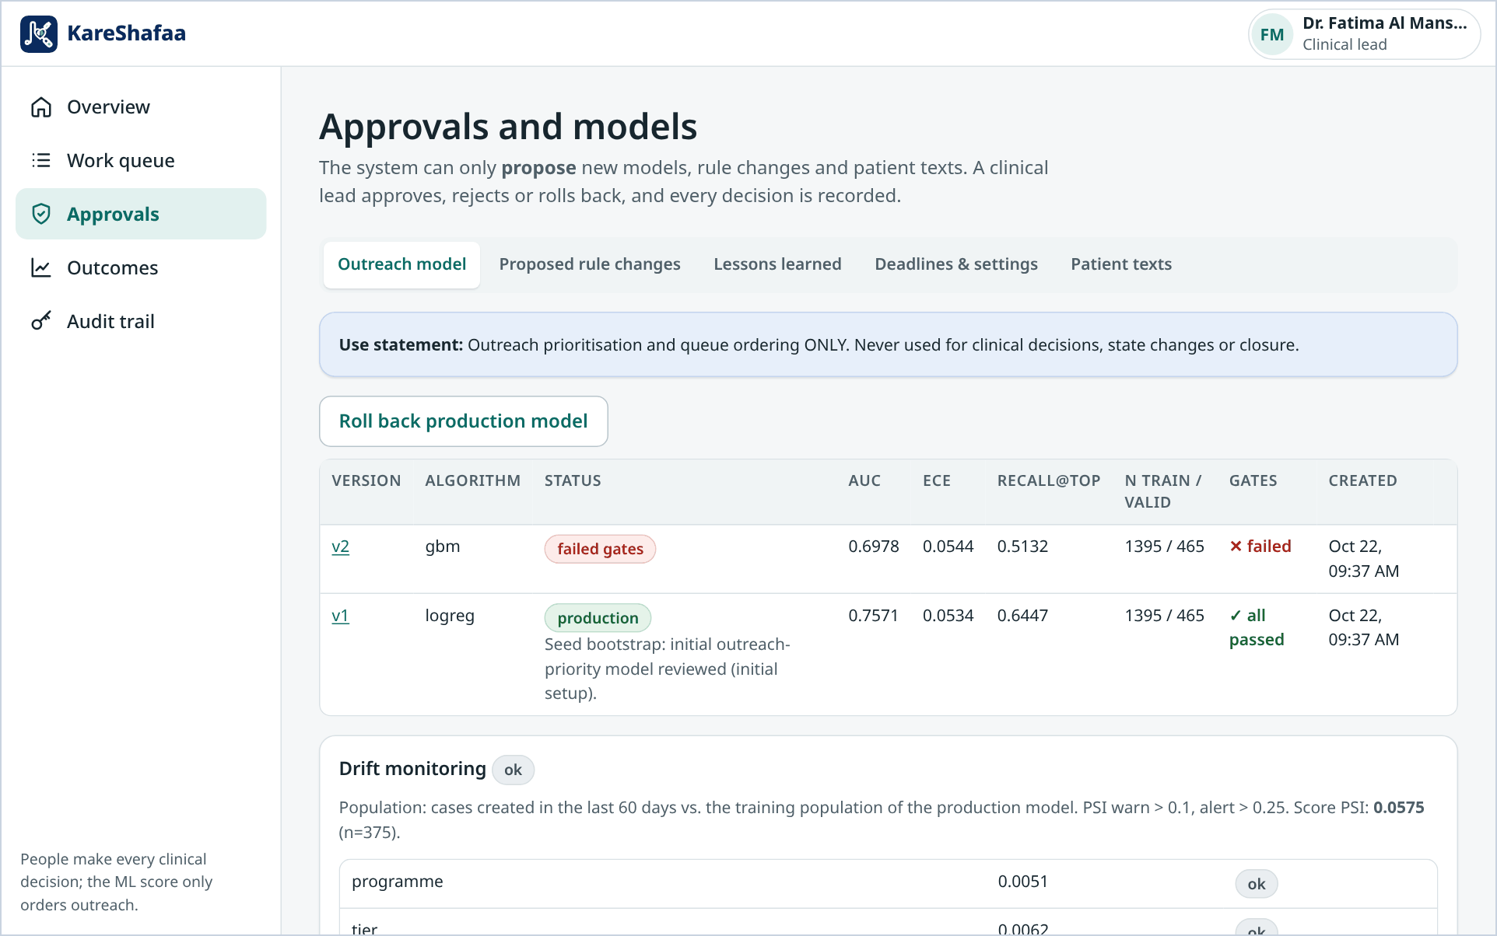
Figure 10. Approvals → Outreach model: candidate models with gate results, and rollback (clinical lead, laptop).
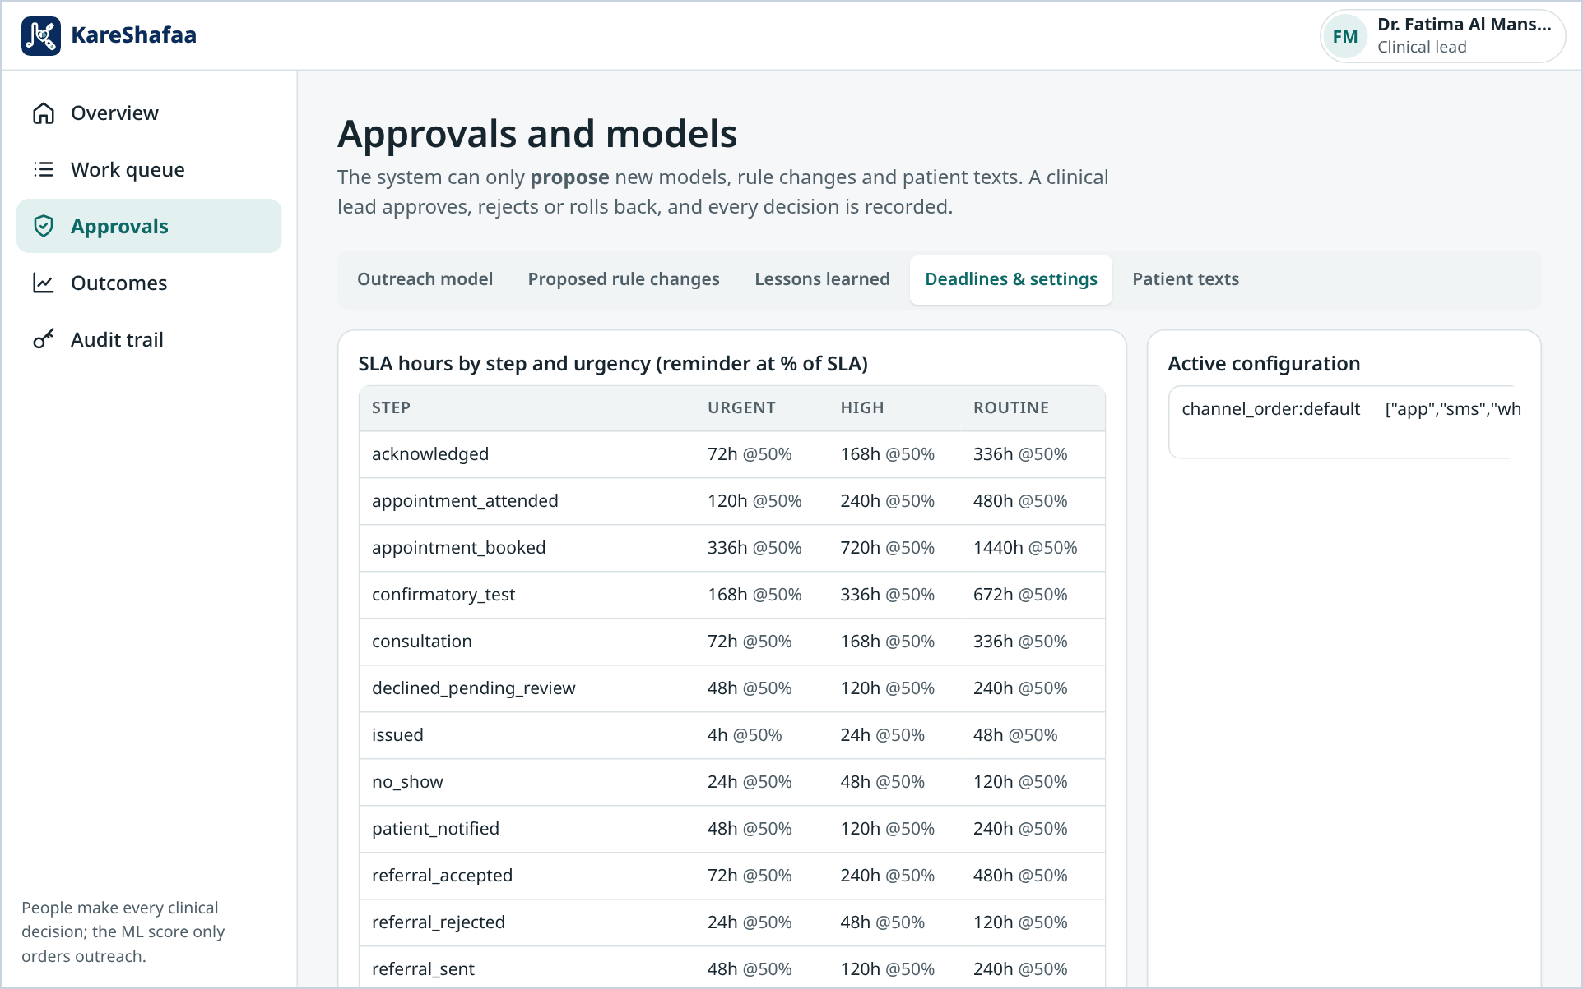
Figure 11. Approvals → Deadlines & settings: step deadlines by state and tier with the reminder point (clinical lead, laptop).

4.8 Programme analyst

Responsibilities
- Monitor programme performance and equity: time to notification and to care, closure, teach-back, drop-off reasons and fairness slices.
- Review model, rule and content information (read-only) and share findings with the clinical lead.

What you see
- Outcomes: KPI dashboard with Before / after, Live figures and Equity by group. The before and with-KareShafaa comparison comes from a simulation with stated assumptions and is not real-world evidence.
- Models & rules: model registry, lessons learned, deadlines and settings, and patient text status (read-only).
You can | You cannot
Read aggregate outcomes, fairness, lessons, models, deadlines and settings, and patient texts. | Open any case or patient record; change anything (no data-changing controls are offered). Groups with fewer than 5 people are hidden.

Daily checklist
☐ Check outcome trends and fairness gaps by language, region and nationality.
☐ Share findings with the clinical lead before any change proposal.
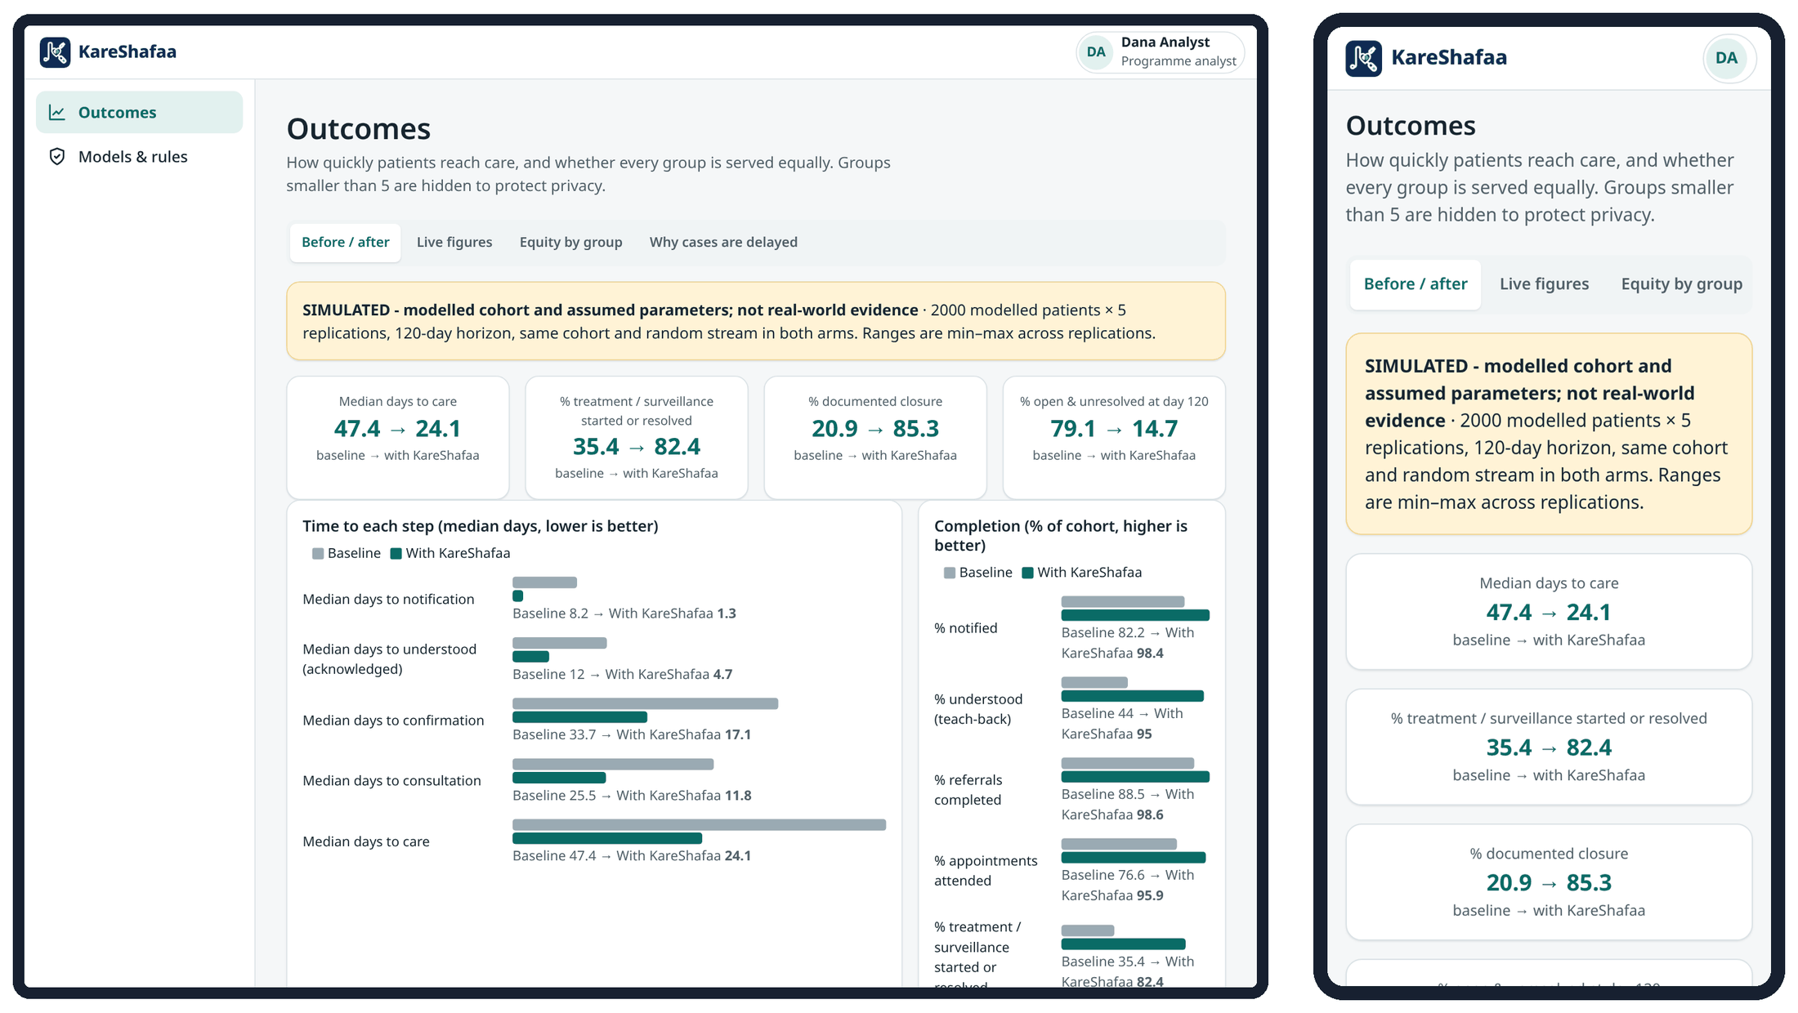
Figure 12. Outcomes dashboard for the programme analyst on a laptop (left) and a phone (right); aggregates only.

4.9 System administrator

Responsibilities
- Create and manage user accounts; reset passwords; deactivate leavers.
- Check system status and storage.
- Verify the audit chain (Check the log is intact) and investigate with the audit trail.
- Run the technical tools: deadline check now, model retraining (candidates go to the clinical lead for approval), proposal engine, simulation runs.
- Support users with sign-in problems.

What you see
- Users (/admin/users): list, search, filter by role and status; add a user; change role, site and team; reset password; deactivate and reactivate.
- System (/admin/system): version, mode, database, whether data is stored permanently, number of accounts, patients and cases, write limit and session timeout.
- Outcomes, and Advanced: audit trail with chain check, outreach model internals (registry, retraining), deadline check (Run the check now), interoperability samples, API reference, load-test notes and a health check.
You can | You cannot
Manage accounts; read the audit trail and verify the chain; Outcomes; view and retrain models; run the proposal engine, simulations and the deadline check (reminders are then sent as the rules engine). | Open the work queue or case pages (refused by the server); approve, reject or roll back models; decide proposals; sign off patient wording; acknowledge escalations; use the Results inbox; change your own role or deactivate your own account; delete any account (accounts are never deleted).

Daily checklist
☐ Check System shows Data is stored permanently (PostgreSQL).
☐ Process joiners, movers and leavers the same day.
☐ Run Check the log is intact in the audit trail weekly and after any incident.
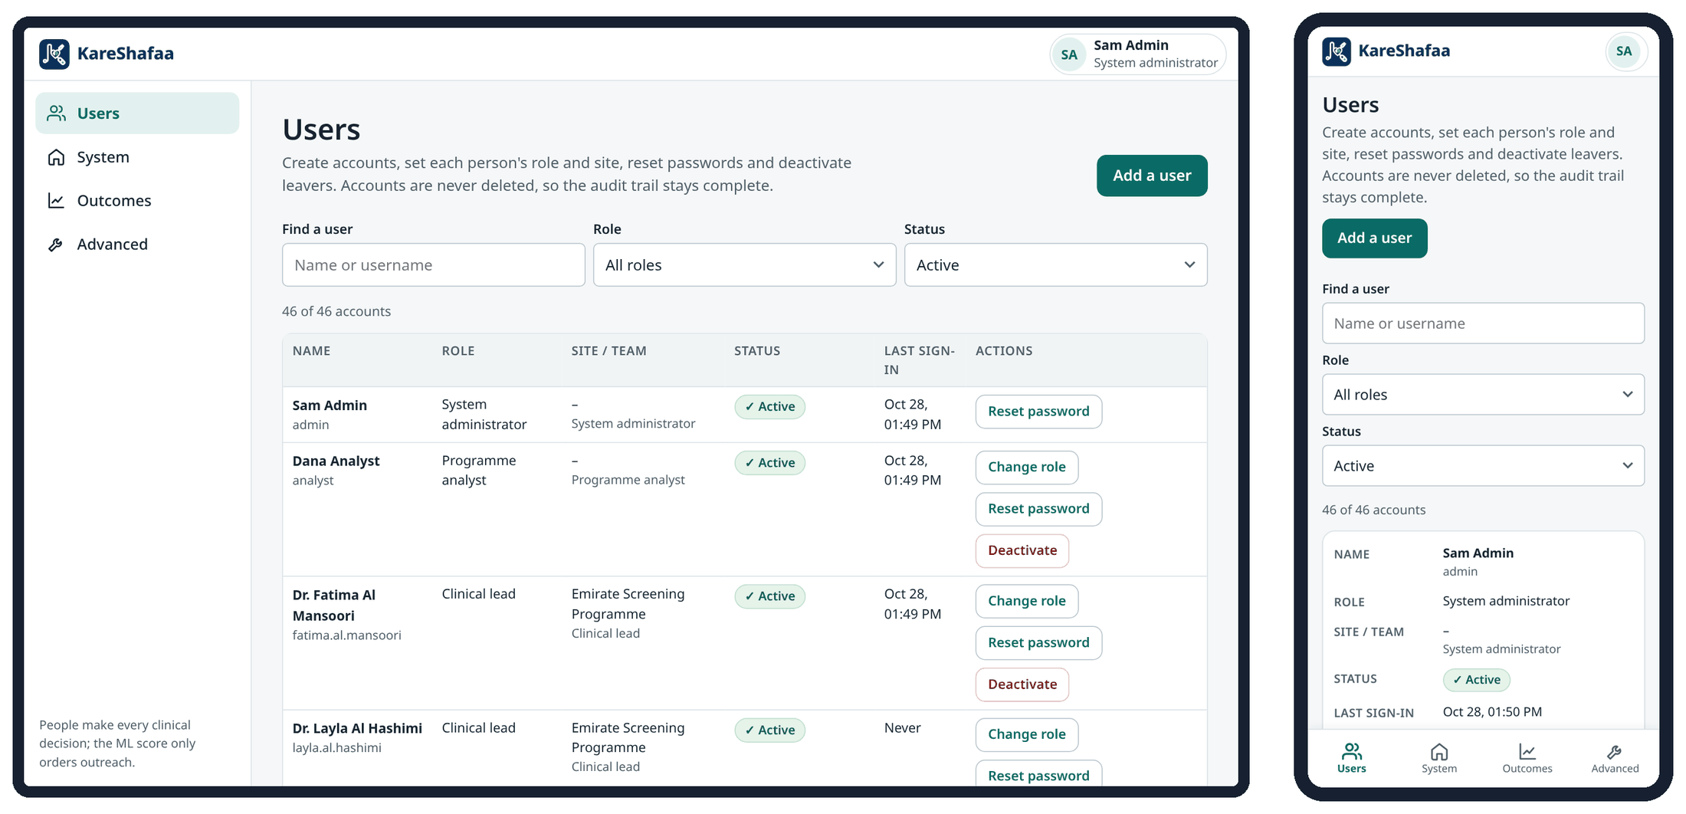
Figure 13. System administrator: Users page on a laptop (left) and a phone (right).
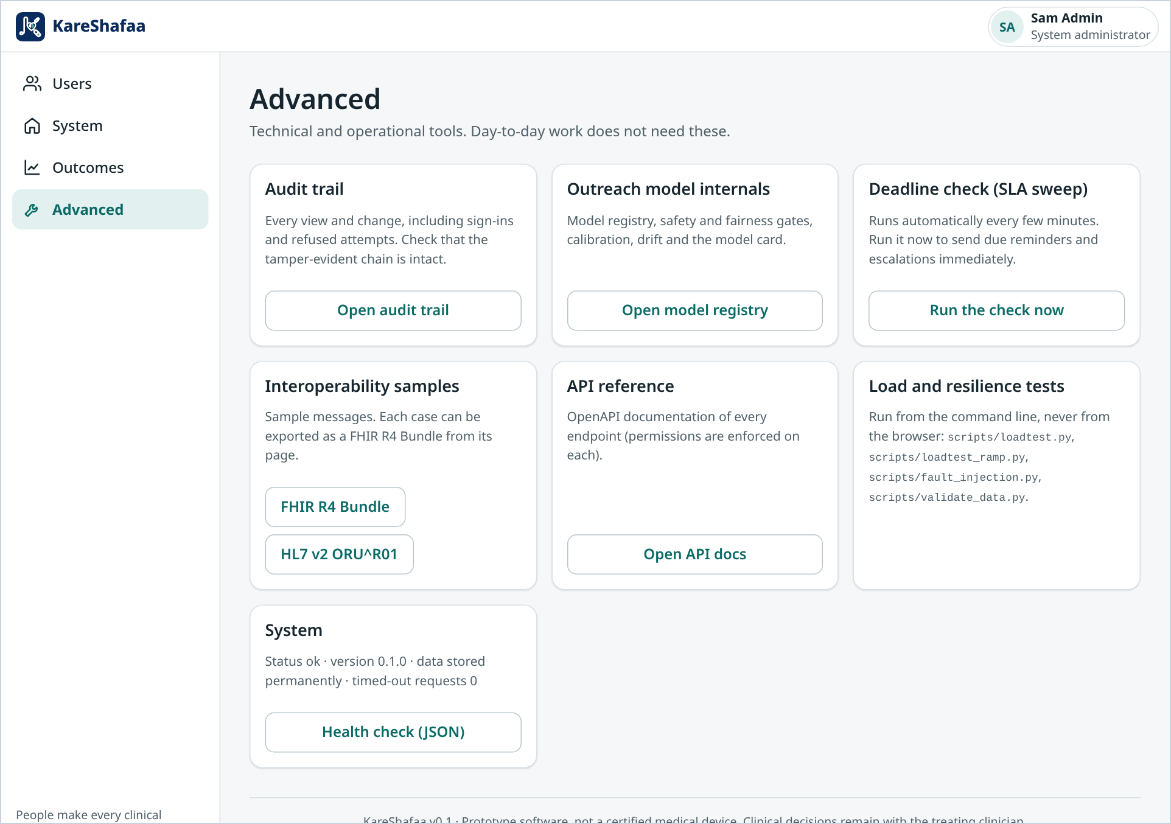
Figure 14. Advanced tools page, open only to the system administrator (laptop).
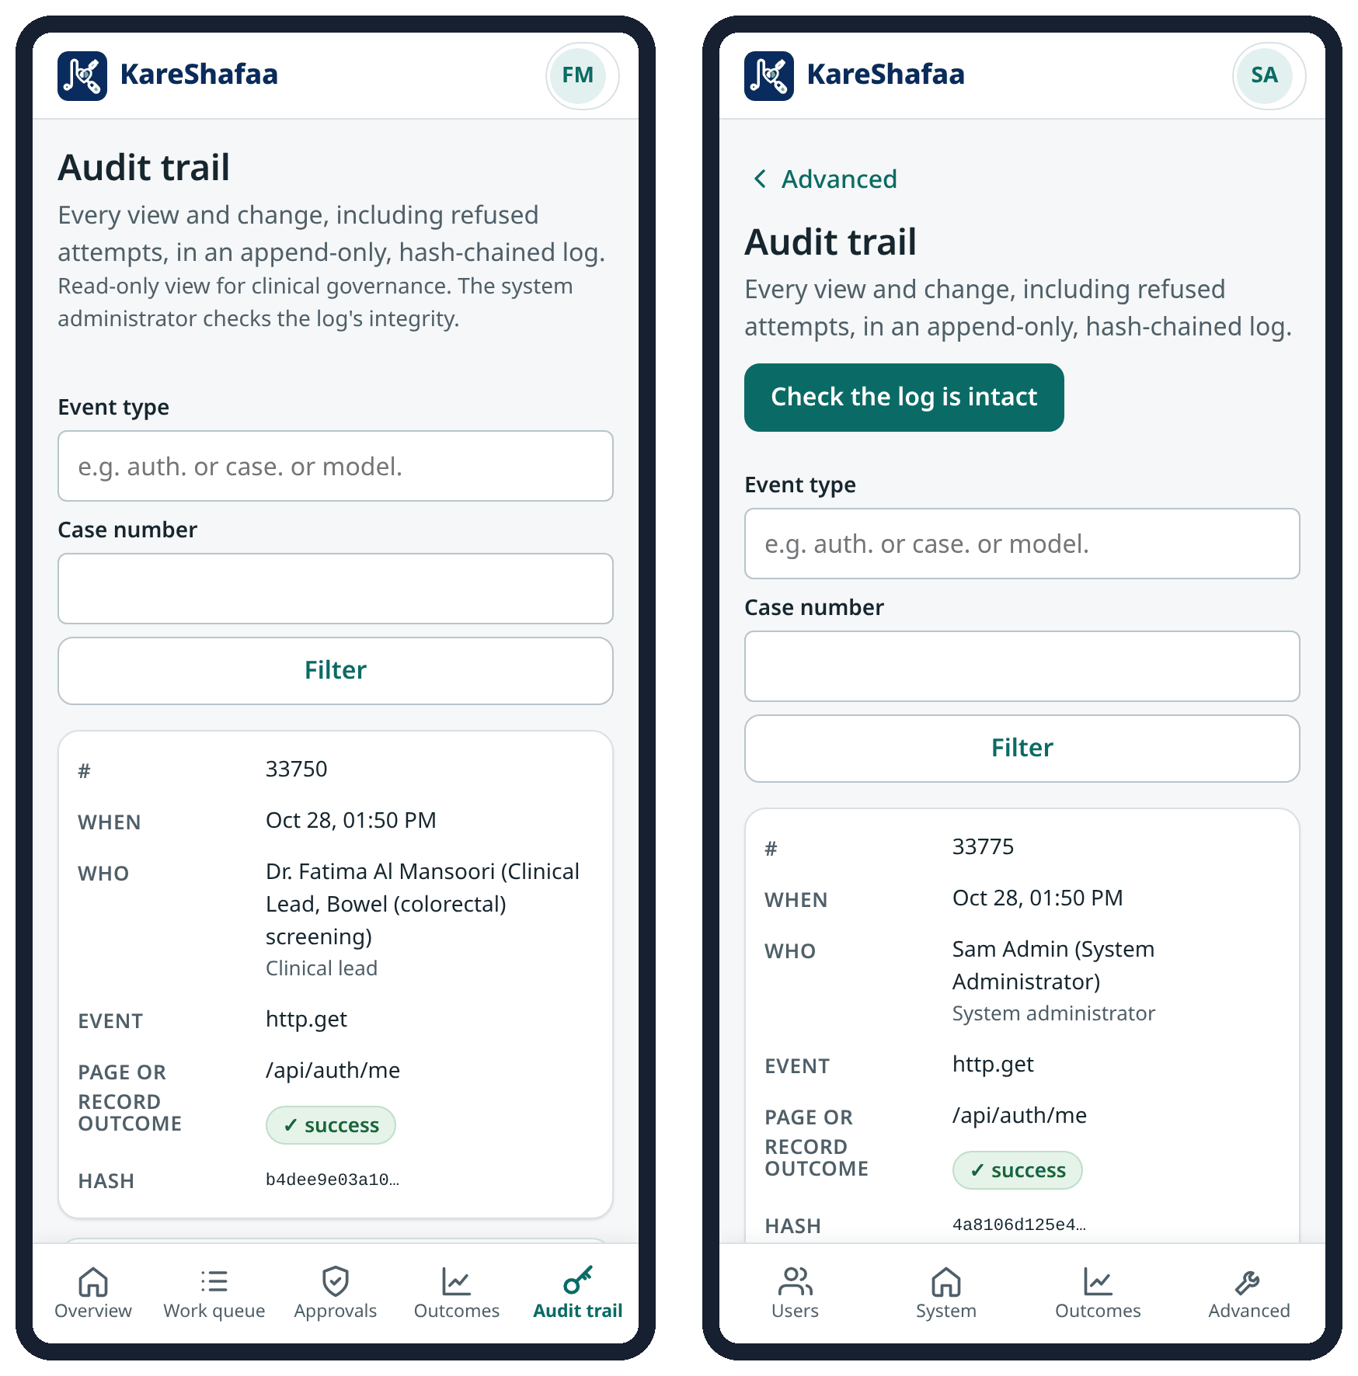
Figure 15. Audit trail on a phone: clinical lead's read-only view (left) and administrator's view with Check the log is intact (right).

4.10 Medical translator

Responsibilities
- Attest that each Arabic, Hindi or Urdu text says the same as the signed-off English source.

What you see
- Content sign-off: every patient-facing text with its language, reading-level and tone checks, and its clinical and translation sign-off status.
You can | You cannot
Give the translation sign-off with a note of what was checked (at least 5 characters). | Sign off English source text; give the clinical sign-off; sign a translation you also signed clinically; open cases.

Daily checklist
☐ Review new or changed translations in Content sign-off.
☐ Compare against the current English source before signing.
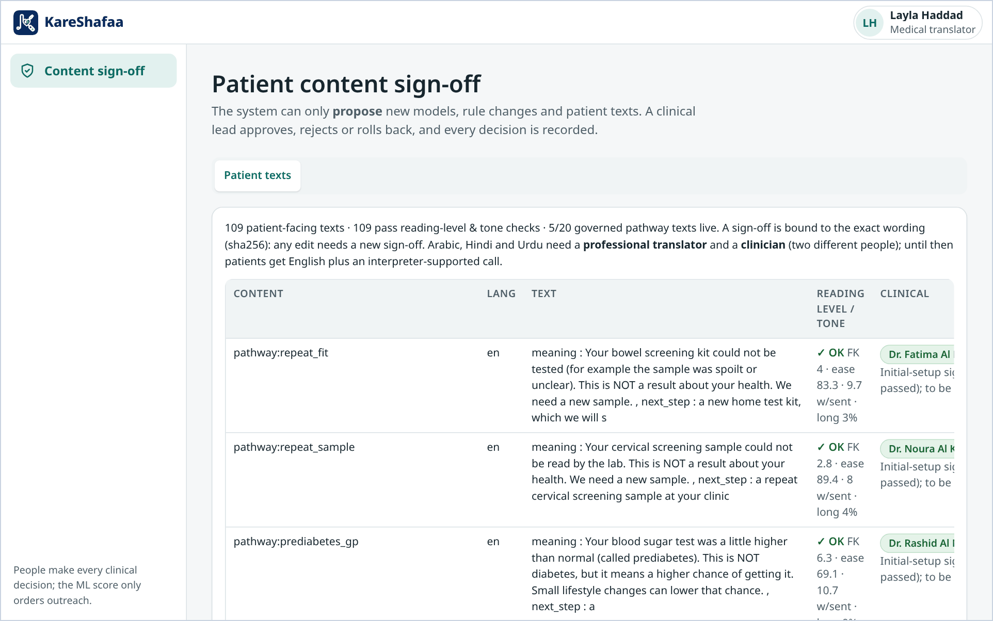
Figure 16. Patient content sign-off page used by the medical translator (laptop).

4.11 Patient

Responsibilities
- Read the result, complete the understanding check, ask questions and take the next step within the timeframe.

What you see
- My results: what the result means, how urgent it is, the next step and timeframe, who is looking after you, the understanding check, a journey tracker, a question box and recent messages.
- A language switch (English, Arabic, Hindi, Urdu) at the top. The page is labelled as a prototype and asks the patient to check anything important with the care team.
You can | You cannot
Answer the teach-back once (change only through Change my answers); ask the care team a question; decline the follow-up with an optional reason; record consent; choose the page language. | See clinician notes or other patients' data; move a case other than by acknowledging or declining; close a case.

Daily checklist
☐ Open My results when a message arrives.
☐ Answer the three questions and rate your confidence.
☐ Use I'd like to talk to a clinician if anything is unclear.

Key procedures
Change answers already sent
1. Choose Change my answers and confirm.
2. Answer again within 30 minutes and send. Earlier answers stay in the record.
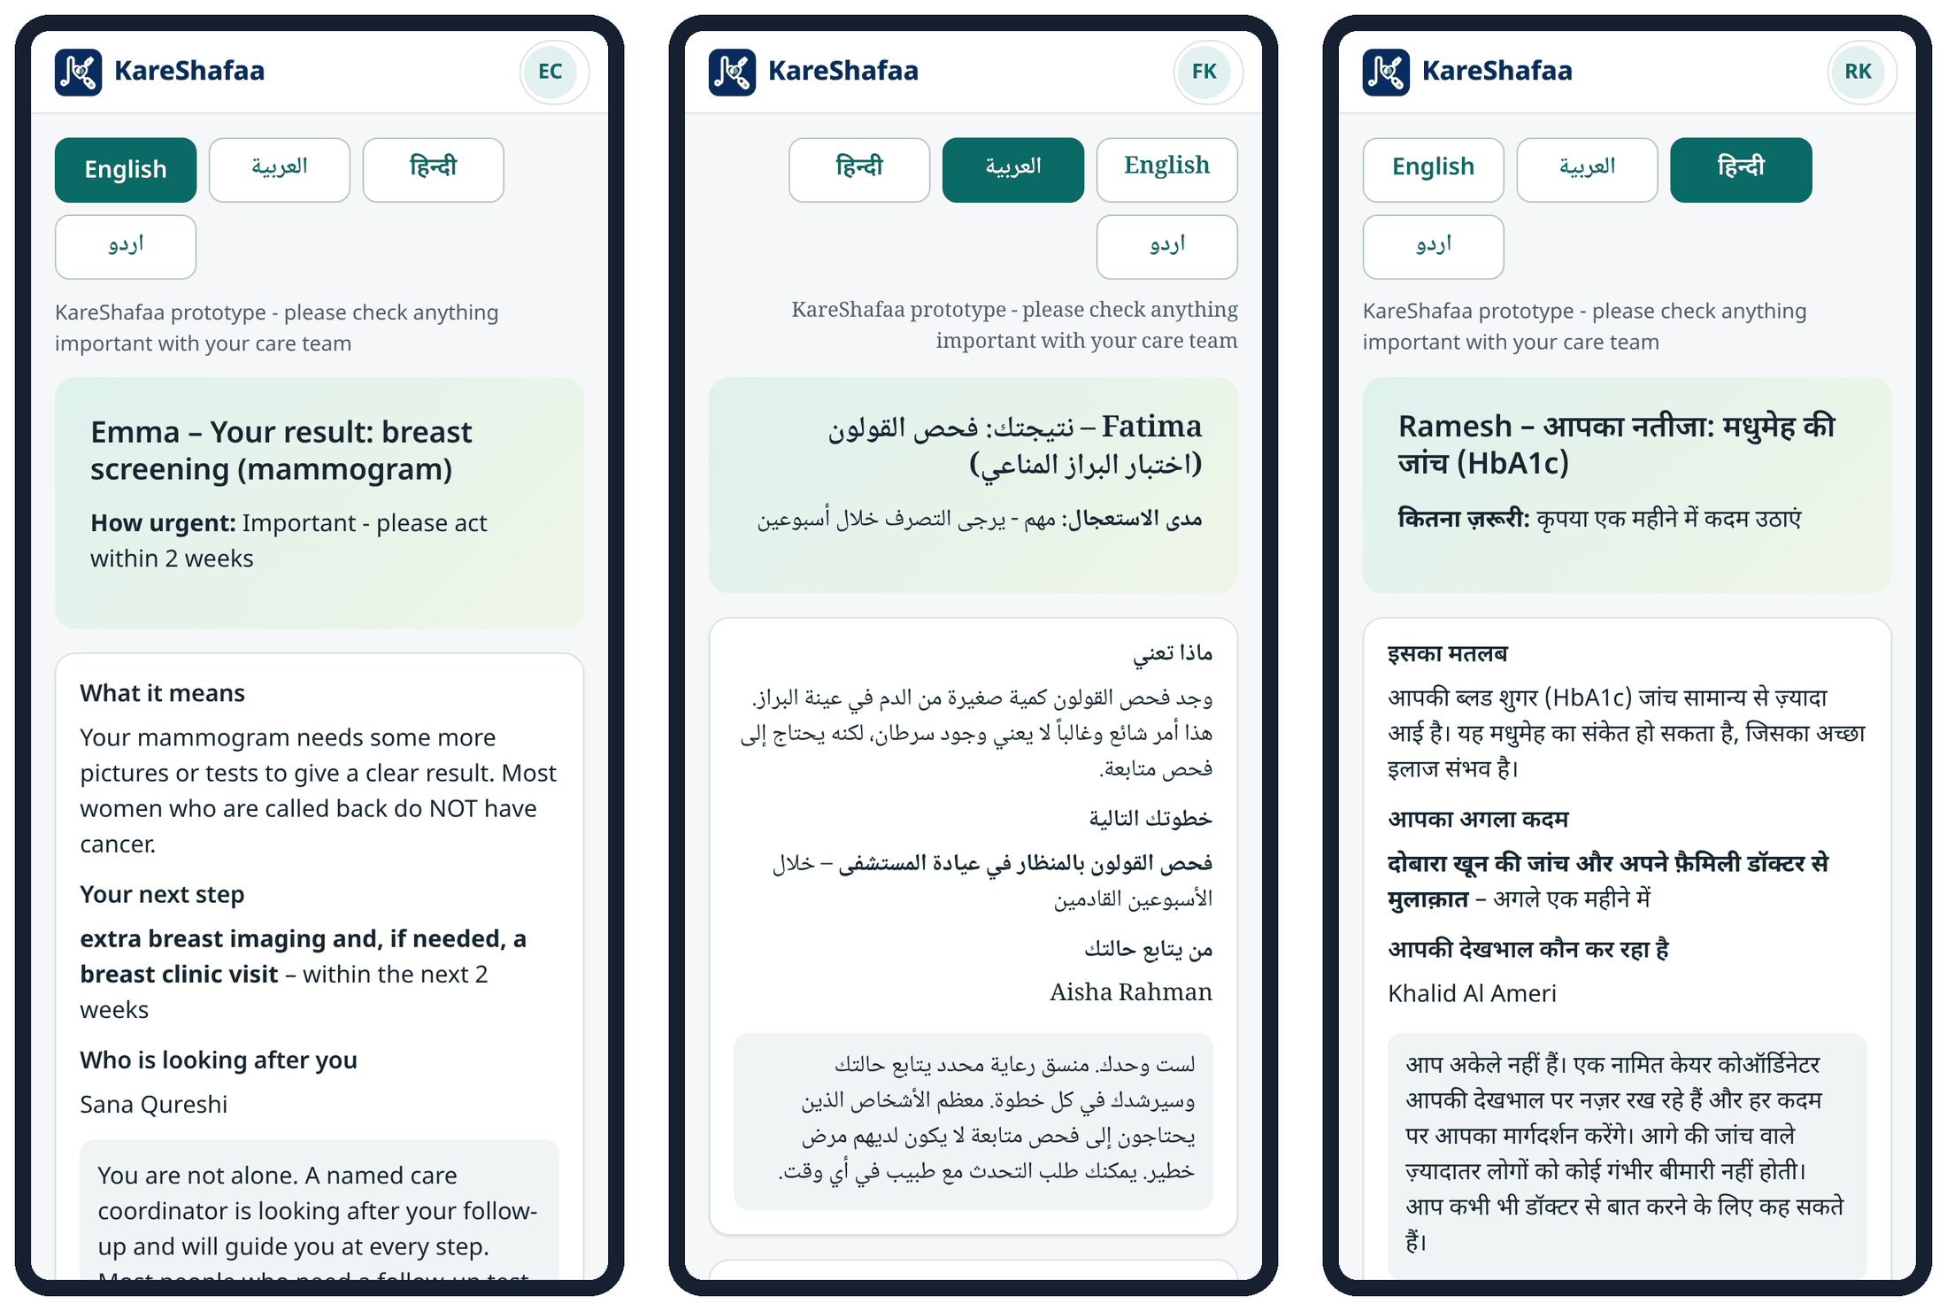
Figure 17. Patient page on phones in English, Arabic (right to left) and Hindi.

5. Safety and governance

5.1 Human decisions and the limits of ML
- The ML model (scikit-learn) estimates the chance that a patient misses the next step and is used only to order outreach. The queue sorts by deadline status first, then tier, then review flag, and only then by the ML score; the score can never move a case across tiers.
- The ML score is never read by the state machine, triage or closure. The case page labels it “Outreach priority (ordering only)” with a Why this estimate explanation.
- Gender, nationality, age band and language are monitored for fairness and are never model inputs; the need for an interpreter is an input.
- The system administrator trains candidate models. A candidate is promoted only if it passes the gates (AUC of at least 0.60 and better than the current model, calibration error at most 0.10, calibration slope 0.7–1.3, calibration-in-the-large within 0.05, and the fairness gates) and a clinical lead approves it with a note. Rollback needs a previous approved version.
- The lessons-learned engine (run by the system administrator) only proposes changes to deadlines, reminder timing, message variants or channel order; a clinical lead must approve each one before it applies.

5.2 Clinical rules safety
- Rules are deterministic and versioned, with a rule ID on every case. Where a guideline is ambiguous the safer option is used and marked CONFIRM for clinical-lead sign-off.
- Fail-safe: uncertain results become review cases at the most urgent plausible tier; tiers only go up automatically (a data-layer interlock refuses any downgrade that is not an authorised clinician decision); a review case cannot progress or message the patient before a clinician resolves it.
- T0 and T1 cases need clinician-confirmed triage.

5.3 Actions that need a named person's sign-off
Table 18. High-impact actions. Automated actors (rules engine, deadline check, ML service) are always refused.
Action | Who | Written rationale
Authorised closure | GP, specialist, clinical lead | Reason code and at least 10 characters
Close with evidence | Coordinator, GP, specialist, clinical lead | Evidence checked against the case state
Re-open a case | Clinical lead | At least 10 characters
Resolve a clinical review (may lower the tier) | GP, specialist, clinical lead | At least 10 characters
Reassign owner | Coordinator, GP, clinical lead | At least 3 characters
Request / decide a transfer | Coordinator, GP, specialist, clinical lead / the receiver | At least 5 characters; a reason to decline
Decide a referral | Specialist (own organisation), clinical lead | Rejection: reason code and note
Start a care plan | GP, specialist, clinical lead | At least 5 characters
Acknowledge an escalation | Coordinator, GP, specialist, clinical lead | At least 3 characters
Record a death | GP, specialist, clinical lead | At least 10 characters
Correct a death record | Clinical lead | At least 20 characters
Record consent or a decline on the patient's behalf | Coordinator, GP, specialist, clinical lead | At least 10 characters
Resolve a patient match | Coordinator, GP | Patient chosen from the record
Approve, reject or roll back a model; decide a proposal | Clinical lead | At least 5 characters
Patient wording sign-off (clinical / translation) | Clinical lead / medical translator | At least 5 characters
Deactivate or reactivate a user | System administrator | Reason recorded

5.4 Closure guard
A case closes only with recorded evidence of the right type for its state, or an authorised human decision with a reason code and a note (Section 3.4.11). Only a human can close a case. A flagged case can be closed only by an authorised clinician decision, which also resolves the flag.

5.5 Audit log
- Every read and write, sign-in, failed sign-in, sign-out, refused attempt and account change is recorded with the actor, role, time, action, record and outcome.
- The log is append-only (database triggers and an application guard) and tamper-evident: each event's SHA-256 hash includes the previous event's hash.
- The clinical lead has a read-only Audit trail for clinical governance. The system administrator has the same search plus Check the log is intact, which verifies the whole chain.
- If a request cannot be logged it is refused rather than served unlogged.

5.6 Data protection
- Least-privilege access by role and organisation, plus the patient's consent to share outside the managing organisation. The system administrator has no access to cases.
- Consent is checked before every message and channel. Withdrawal of care-coordination consent stops automated messaging and sends open cases to review.
- Analysts receive aggregates only; any group smaller than 5 is suppressed.
- The installable app never caches patient data or signed-in pages. Sessions expire after 30 minutes without activity.
- Passwords are stored as argon2id hashes; they are never shown on the site or kept in the code.
- All records are fictional (SYN- MRNs). The free hosting tier is not suitable for real health data: a pilot needs hosting inside the UAE, an agreement with the health authority, backups and monitoring.

5.7 What patients can see, and the answer lock
- Patients see only their own case, in plain language: meaning, urgency, next step, timeframe, care-team name, journey, their messages and their own questions with answers. Clinician notes are never shown.
- The teach-back form is locked once answers are sent. Sending again without Change my answers is refused and nothing is saved.
- Change my answers must be confirmed by the same patient login, lasts 30 minutes and is used by one submission only. Every version stays in the record; the request, any cancellation and the new answers are audited with the previous answers.
- Teach-backs recorded by a navigator do not lock the patient's form.
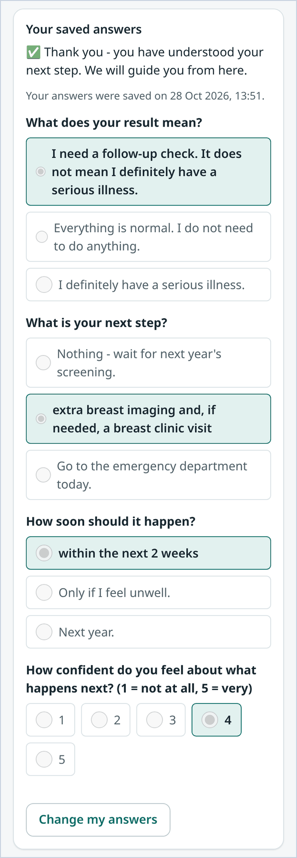
Figure 18. Patient page after answers are sent: the saved answers are shown locked, with Change my answers (phone).

5.8 Patient wording governance
- Patient text goes live only after a clinical sign-off by a clinical lead and, for Arabic, Hindi and Urdu, a translation sign-off by a medical translator: two different people. The English source must itself be signed off in its current wording.
- Each text passes automatic reading-level and tone checks before clinical sign-off. A sign-off is bound to the exact wording (hash); any edit needs a new sign-off.

5.9 Separation of clinical and system duties
Table 19. Who does what since the role separation (code aea0d72 and aac2f3d)
Clinical lead (clinical approvals and oversight) | System administrator (system operation)
Approve, reject or roll back outreach models  Decide rule and deadline change proposals  Clinical sign-off of patient texts  L3 escalations and overdue oversight  Case actions, re-open, death-record correction  Answer any e-consult  Outcomes and Deadlines & settings (read)  Read-only audit trail | User accounts, roles, password resets, deactivation  System status and storage  Audit trail with the chain check  Advanced tools page and health check  Run the deadline check now (as the rules engine)  Train candidate models (approval stays with the lead)  Run the proposal engine and simulations  No queue, case pages, approvals or escalations

Both rules are enforced on the server (the API refuses the action) and in the screens (the menu and page access); automated tests check every rule.

6. Exceptions, escalation and support

6.1 Exception handling
Table 20. Exceptions and what to do
Exception | How it is detected | What to do | Who
Overdue step | Step clock red; Overdue view; L2–L4 alerts | Act on the step, then acknowledge the escalation with what was done | Owner; supervisor (L2); clinical lead (L3); medical director (L4, T0/T1)
Pathway target missed | Consolidated pathway alert from L2 | Expedite care; any booking beyond the target needs a reason | Owner; clinical lead
Unreachable patient | Digital ladder fails; call task; at least 2 failed calls | Mark Unreachable (with confirmation). When reached, record the call: the case returns to Patient notified. Otherwise a clinician may close as unable to contact | Coordinator; GP or clinical lead for closure
Teach-back not passed | Not all 3 answers correct | Call the patient (interpreter if flagged) and record a navigator teach-back | Coordinator
Patient declines care | Patient presses decline, or staff record it (at least 10 characters) | A clinician talks to the patient and documents an informed decline (authorised closure), or chooses Patient reconsidered – resume | GP
No-show | Attendance recorded as no-show with a barrier | Address the barrier and rebook | Coordinator or specialist
Referral rejected | Referral rejected view | Re-route to another provider, complete the information, or go back to consultation | Referring clinician; coordinator
Death recorded | A clinician records the death (at least 10 characters) | All messaging stops; call tasks and queued reminders are cancelled; open cases go to review. Close each with the authorised reason deceased | GP, specialist or clinical lead
Death recorded in error | Wrong patient identified | Clinical lead corrects the record (at least 20 characters); open cases are flagged for review and cases closed as deceased are listed for re-opening | Clinical lead
Consent withdrawn | Patient or staff record a withdrawal | Automated outreach stops; a clinician documents an informed decline or agrees another route | GP
New result on an open case | Linked result; review flag (duplicate, conflicting or more urgent) | Clinician reviews; the tier is never lowered automatically | GP or clinical lead
Result after closure (within 180 days) | New case flagged for review | Clinician reviews with the earlier history | Clinical lead
Unmatched or unreadable message | Results inbox; ACK AE | Resolve the match, or check the message with the laboratory | Coordinator or GP
Owner deactivated or inactive | Detected by the deadline check | Case moves to the team pool automatically; the coordinator assigns a named owner | Coordinator
Transfer declined | Receiver declines with a reason | The original owner stays accountable and agrees another route | Original owner
Service busy or offline | Busy message or offline page | Nothing was saved; repeat the action | Any user

6.2 Escalation contacts and incident reporting
Table 21. Escalation contacts
Level | Raised to | Expected response
L1 (reminder point, default 50 %) | Accountable owner | Complete the step
L2 (100 %, breach) | Owner's supervisor, or the programme coordinator supervisor | Unblock or reassign; acknowledge with a note
L3 (150 %; T0 at breach) | Programme clinical lead | Clinical decision; acknowledge with a note
L4 (200 %, T0/T1 only) | Medical director or duty clinician (a clinical lead without a programme) | Direct intervention; acknowledge with a note

Each alert is recorded on the case and as an internal message (delivery simulated). Report any safety concern to the programme clinical lead and record it on the case as a lesson of type Incident / near miss. Technical incidents (sign-in, storage, errors) go to the system administrator.

6.3 Administration and support operations
All procedures in this section are for the system administrator unless stated otherwise.
Create a user
1. Open Users → Add a user.
2. Enter username, full name, role, site and team. Clinical roles (coordinator, GP, specialist, clinical lead) must be linked to a staff directory record, and each record can have only one account.
3. Set a temporary password that meets the policy, or leave it blank for a generated 16-character password shown once. The user must change it at first sign-in.
4. Save. The creation is audited (user.create). Patient accounts are created from the patient record, not from this page.
Change role, site or team
1. Open Users, find the person and choose Change role.
2. Select the new role, site and team and save (user.role_change). You cannot change your own role.
Reset a password or unlock an account
1. Find the user and choose Reset password.
2. Enter a temporary password, or leave it blank to let the system generate a 16-character one that is shown once.
3. Give it to the user through a separate, secure channel. Their sessions end, any lockout is cleared and they must change it at the next sign-in (user.password_reset).
4. A lockout also clears by itself after 15 minutes.
Deactivate or reactivate a user
1. Find the user and choose Deactivate; enter the reason (for example left the organisation).
2. All their sessions end at once. Their open cases move to the programme team pool at the next deadline check, so the coordinator can assign a named owner.
3. Accounts are never deleted, so the audit trail stays complete. Activate restores access, also with a reason. You cannot deactivate your own account.
Check system status
1. Open System. Check version, mode (production), database and the storage line: it must read Data is stored permanently (PostgreSQL) with the database host.
2. If it says data is not stored permanently, the database connection is missing and data would be lost on restart. Raise it with the system owner at once.
3. For a quick technical check use the health check on the Advanced page; it reports status, version, storage and timed-out requests.
Run the deadline check now
1. Open Advanced → Deadline check (SLA sweep) → Run the check now, and confirm.
2. The check runs as the rules engine: due reminders and escalations are raised for every open case. The result shows the number of cases checked, reminders and escalations.
3. Your request is audited as sla.sweep_requested. The check also runs automatically every 5 minutes, so use this only after an outage or a configuration change.
Train a candidate outreach model
1. Open Advanced → Outreach model internals → Open model registry, and choose Retrain candidate (gradient boosting or logistic regression). The proposal engine has a similar button, Run proposal engine now, on the Proposed rule changes tab.
2. Read the gate results. A candidate never goes live by itself: tell the clinical lead, who approves or rejects it in Approvals.
Verify the audit chain
1. Open Advanced → Audit trail (or the audit page) and press Check the log is intact.
2. If the check fails, do not change anything; record the time and result and report it to the system owner and the clinical lead as an incident.
Hosting notes
- The service runs as one container on Render (free web service) with permanent data in PostgreSQL on Neon. Restarts and redeploys never reset or overwrite data.
- Staff accounts receive a first password from a hosting secret only if they have no password yet; a password changed by a user or administrator is never overwritten. Passwords are never in the code or on the site.
- Neon Free keeps 6 hours of restore history. Take a regular database dump to storage you control for anything important.

7. Appendices

Appendix A. Urgency tiers
Table 22. Urgency tiers. The default target applies when a pathway has none, or when a case was escalated above its clinical tier.
Tier | Meaning | First action (triage) | Clock | Triage by | Default target | Patient wording
T0 Critical | Same-day clinician action | 1 hour | 24/7 | Clinician | 1 day | Please contact us today
T1 Urgent | Suspected cancer, high-grade abnormality or unsafe data | 4 hours | 24/7 | Clinician | 14 days | Please act soon
T2 Soon | Positive screen needing a diagnostic test | 1 working day | UAE working days | Rule (automatic) | 31 days | Important – please act within 2 weeks
T3 Routine | Surveillance, prevention, repeat sample | 2 working days | UAE working days | Rule (automatic) | 90 days | Please act within a month

Examples from the rules: T0 – HbA1c of 15 % or more, or FPG of 500 mg/dL or more; T1 – BI-RADS 4 or 5, FIT of 400 µg/g or more, high-grade cervical cytology; T2 – FIT positive, HPV 16/18, BI-RADS 0, HbA1c of 10 % or more; T3 – HbA1c in the diabetes or prediabetes range, repeat samples.

Appendix B. Step deadlines (SLA)
Table 23. Default step deadlines (wd = UAE working day; configuration, not clinical guidance)
Step (state) | T0 | T1 | T2 | T3
Result issued (to triage) | 1 h | 4 h | 1 wd | 2 wd
Triaged (to patient notified) | 4 h | 24 h | 2 wd | 5 wd
Patient notified (to teach-back) | 24 h | 48 h | 5 wd | 10 wd
Acknowledged (to next step) | 24 h | 72 h | 7 wd | 14 wd
Confirmatory test | 48 h | 7 days | 14 wd | 28 wd
Consultation | 24 h | 72 h | 7 wd | 14 wd
Referral sent (to decision) | 24 h | 48 h | 5 wd | 10 wd
Referral rejected (to re-route) | 8 h | 24 h | 2 wd | 5 wd
Referral accepted (to booking) | 24 h | 72 h | 10 wd | 20 wd
Appointment booked (to attendance) | 7 days | 14 days | 30 wd | 60 wd
Appointment attended (to care plan) | 48 h | 5 days | 10 wd | 20 wd
Treatment / surveillance started (to closure) | 48 h | 72 h | 7 wd | 14 wd
No-show (to rebooking) | 8 h | 24 h | 2 wd | 5 wd
Unreachable (to review) | 24 h | 72 h | 7 wd | 14 wd
Declined – clinician review | 24 h | 48 h | 5 wd | 10 wd

Deadlines are stored as configuration (visible in Deadlines & settings) and change only through a proposal approved by a clinical lead. A step's deadline never runs past the pathway target. UAE working days exclude weekends and public holidays; Islamic holiday and Ramadan dates are approximate.

Appendix C. Pathways and targets
Table 24. Pathways and end-to-end targets in the rules engine (targets marked CONFIRM await clinical-lead sign-off)
Pathway | Rule IDs (examples, tier) | Next step | Target (calendar days from result)
colonoscopy | CRC-FIT-POS (T2); CRC-FIT-URGENT (T1) | Colonoscopy | 31 (FIT of 400 µg/g or more: 14)
repeat_fit | CRC-FIT-REPEAT (T3) | New FIT kit | 28
colposcopy | CX-HPV1618, CX-HPVOTHER-LG (T2) | Colposcopy with biopsy | 42
colposcopy_urgent | CX-HIGH-GRADE, CX-SUSP-INVASIVE (T1) | Urgent colposcopy or gynae-oncology | 14
reflex_cytology | CX-HPVOTHER-REFLEX (T3) | Reflex cytology on the same sample | 14
reflex_hpv | CX-CYTO-LG-NOHPV (T3) | Reflex HPV test | 14
surveillance_1y | CX-HPVOTHER-NILM (T3) | Surveillance plan; repeat HPV at 12 months | 28 (plan documented)
repeat_sample | CX-UNSAT (T3) | Repeat sample | 120
assessment_imaging | BR-0 (T2) | Recall for assessment | 7
biopsy | BR-4, BR-4A/B/C, BR-5 (T1) | Triple assessment and core biopsy | 7
same_day_review | DM-A1C-CRIT, DM-FPG-CRIT (T0) | Same-day clinician contact | 1
confirm_then_gp | DM-A1C-DIAB, DM-FPG-DIAB (T3); DM-A1C-HIGH, DM-FPG-HIGH (T2) | Confirmatory test, then GP visit and care plan | 28 (high range: 14)
prediabetes_gp | DM-A1C-PRE, DM-FPG-PRE (T3) | GP advice; retest within 12 months | 90
human_review | Any review reason (for example CRC-ERR, BR-3, CX-ERR) | Clinician review | Tier default (Appendix A)
routine_recall | Negative results | No case; routine screening | –

When a case is escalated above its clinical tier (for example by a review floor), the more urgent of the pathway target and the tier default applies.

Appendix D. Reason codes
Table 25. Reason codes used in forms
List | Codes
Authorised closure reasons | informed_decline · unable_to_contact · deceased · moved_abroad · care_elsewhere_verified · clinically_not_indicated · duplicate
Closure evidence types | appointment_fulfilled · care_plan · negative_confirmatory_result
Referral rejection reasons | wrong_service · capacity · incomplete_info · out_of_network · not_clinically_indicated
No-show barriers | transport · work · fear_anxiety · cost · language · forgot · childcare · ramadan_hours · unknown
Delay reasons (lessons) | patient_not_responding · contact_details_wrong · language_barrier · capacity · referral_incomplete · awaiting_result · patient_travel · patient_anxiety · staff_absence · system_issue · other
Call outcomes | reached · no_answer · wrong_number
Lesson types | overdue · drop_off · incident · no_show · rejected_referral · unreachable · declined

Appendix E. Glossary
Table 26. Glossary
Term | Meaning
Advanced | System administrator page with the audit trail and chain check, model internals, the deadline check, interoperability samples, the API reference, load-test notes and a health check.
Approvals | Clinical lead page (analyst: Models & rules, read-only) with the outreach model, proposed rule changes, lessons learned, deadlines and settings, and patient texts.
Channel ladder | App, then SMS, then WhatsApp, then a navigator phone call; reminders, appointment and no-show messages use at most the first three rungs.
Closure guard | Code rule that blocks closure without evidence or an authorised, reasoned human decision.
Deadline check (SLA sweep) | Background job, every 5 minutes, that updates clocks, raises escalations and sends due reminders; the system administrator can also run it by hand.
E-consult (Ask a specialist) | A clinician-to-clinician question about a case, answered by the addressed clinician or a clinical lead, with a response time by urgency.
Escalation | A named alert raised when a step or pathway clock passes a ladder threshold.
Hash chain | Each audit event's hash covers the previous event, so any edit or deletion is detectable.
Lesson | A recorded delay, drop-off, no-show, rejection, decline or incident reason that feeds outcome analysis and change proposals.
Model card | Summary of a model version: intended and prohibited use, gate results, fairness and approval history.
Navigator | The staff member (normally the care coordinator) who calls patients and records calls and teach-backs.
Outreach priority | ML estimate of the chance of missing the next step; orders work only within the same deadline status and tier.
Pathway | The care route chosen by the rule, for example colonoscopy or confirm_then_gp.
Production mode | Operating mode of the hosted service: full workflows, password sign-in only, approval gates, write limit, data never reset.
Review reasons | Codes explaining why a result needs a clinician, for example amended_result, missing_unit, sex_mismatch, pregnant, stale_result.
Team pool | Programme-level owner used when no named owner is available; listed under No named owner.
Two-key transfer | Ownership hand-over that completes only when the receiving side accepts.

