Infosys Springboard Virtual Internship 7.0
Internship Completion Report
Team Name: Team C | Batch 1 | Group 1
Team Members: Siddhant Singh, Priyam Sinha, Ponnuru Nithiin
Mentor Name: Ms. Nithyasri S J
Internship Duration: 8 weeks
Year: 2026

Table of Contents
Team Details 3
1. Project Title 3
2. Project Objective 3
3. Project Description 3
3.1 Overview · 3.2 Approach · 3.3 Technology · 3.4 Insights · 3.5 Real-World Impact 3
4. Timeline Overview 5
5a. Key Milestones 6
5b. Project Execution Details 6
Execution Workflow · Dashboards 1–7 6
6. Snapshots / Screenshots 10
7. Challenges Faced (Milestone 3) 11
8. Learnings & Skills Acquired 11
8.1 Technical · 8.2 Analytical · 8.3 Future · 8.4 Soft Skills · 8.5 Domain 11
9. Testimonials from Team 12
10. Conclusion 12
11. Acknowledgement …………………..………………………………………………………………………… 13

1. Project Title
Cyber Threat Analytics Platform with Incident Visualization System

2. Project Objective
The objective of this project is to design and deliver an interactive, end-to-end business-intelligence solution in Microsoft Power BI that consolidates large-scale cybersecurity incident data into a single, coherent analytical framework. The framework enables security analysts, decision-makers and communication teams to detect and quantify attack patterns, assess threat severity, monitor network and user behaviour, and convert 40,000 raw security events into clear, visually communicated and actionable intelligence that supports faster, evidence-based security decisions.

3. Project Description

▍ 3.1 Overview
This project delivers an Advanced Threat Incident Analytics and Security Visualization Framework built entirely in Microsoft Power BI. It is based on a publicly available cybersecurity dataset of 40,000 incident records sourced from Kaggle, spanning January 2020 to October 2023 and covering 28 states across India. The raw data captures rich detail for every event - source and destination IP addresses and ports, protocol, packet type and length, traffic type, malware indicators, anomaly scores, attack type and signature, severity level, action taken, device, operating system, browser, network segment and geography.
The solution transforms this raw log data into seven themed, interconnected dashboards - Cyber Security Attacks Analysis, Threat Detection and Anomaly Analysis, Network Traffic Analysis, User Behavior Analytics, Threat Profile and Severity Breakdown, Security Alert Monitoring, and Attack Trends & Response Effectiveness. Together they provide a 360-degree view of the threat landscape, moving the reader from high-level KPIs down to granular, drill-able detail.

▍ 3.2 Project Approach
The project was executed through a structured nine-step Power BI workflow. Each step is summarised below and elaborated in Section 5b.
- Step 1 - Problem Definition: framed the security questions and defined the KPIs and target audience.
- Step 2 - Data Collection: sourced a 40,000-record cybersecurity dataset from Kaggle.
- Step 3 - Data Cleaning & Preprocessing: shaped the data in Power Query (types, nulls, date/time split, category standardisation).
- Step 4 - Data Modeling: built a marked Date table and established relationships.
- Step 5 - DAX Measures & Calculated Columns: authored KPIs and the Anomaly Score Band logic.
- Step 6 - Dashboard Design & Visualization: designed seven themed report pages.
- Step 7 - Interactivity & Advanced Analytics: added slicers, cross-filtering, decomposition tree and drill-through.
- Step 8 - Insight Generation & Interpretation: derived and validated the findings.
- Step 9 - Reporting, Documentation & Publishing: produced the report, PPT, GitHub repository and mentor reviews.

▍ 3.3 Technology Used
The following tools and technologies were used across the internship:
- Microsoft Power BI Desktop - primary tool for data modeling, DAX and building all seven interactive dashboards.
- Power Query Editor - data cleaning, transformation and shaping (ETL): type conversion, null handling, date/time splitting and category standardisation.
- DAX (Data Analysis Expressions) - authoring measures and calculated columns such as Attack, High Severity, % High Severity, Malware Detected, Avg Anomaly Score, Block Rate % and Anomaly Score Band.
- Microsoft Teams - team collaboration, milestone meetings, screen-sharing and mentor reviews.
- Microsoft PowerPoint - milestone presentations and progress walkthroughs.
- Microsoft Word - project documentation and this milestone report.
- GitHub - version control and a central repository for the .pbix file and supporting artefacts.
- Power BI Service (publishing) - sharing dashboards for review and stakeholder access.

▍ 3.4 Insights from the Dashboard
Analysing the 40,000-record dataset across the seven dashboards surfaced the following key findings:
40,000  Total Attacks | 33.5%  High Severity | 33.8%  Block Rate | 50%  Malware (IoC)

- The dataset spans 40,000 incidents across 2020–2023, with attack volume peaking in 2022 (10,750) and a lower 2023 figure (8,139) reflecting a partial year captured only to October.
- Attack types are almost evenly distributed, with DDoS marginally leading (33.6%), followed by Malware (33.3%) and Intrusion (33.2%) - indicating a broad, multi-vector threat environment rather than a single dominant attack.
- Severity is balanced across High (33.5%), Medium (33.6%) and Low (33.0%), meaning roughly one in three incidents is high-severity and warrants priority response.
- Only about 33.8% of attacks were actively Blocked, while the remainder were Ignored (33.2%) or merely Logged (33.0%) - a notable response gap and a clear improvement opportunity.
- Windows is by far the most-targeted operating system (~45% of incidents), followed by Linux (17.9%), Mac OS (14.5%), iOS (14.4%) and Android (8.2%).
- Mozilla accounts for roughly 80% of browser-associated activity, with Opera making up the remainder.
- The average anomaly score is 50.1 on a 0–100 scale, with incidents spread fairly evenly across all anomaly bands - the 51–75 band is the largest.
- Malware indicators (IoC Detected) are present in exactly half of all records (20,000), underscoring the prevalence of malware-linked activity.
- ICMP is the most common protocol (33.6%), and Control packets slightly outnumber Data packets (50.6% vs 49.4%).
- Incidents are widely distributed across 28 states - led by Manipur, Uttar Pradesh, Gujarat, Maharashtra and Arunachal Pradesh - showing a nationwide footprint rather than a few hotspots.

▍ 3.5 Real-World Impact for Media and Public Communication

Beyond the security operations centre, a framework of this kind has direct value for media and public communication. Cybersecurity data is often technical and intimidating; by distilling 40,000 raw events into clear KPIs, trends and geographic views, the dashboards make the threat landscape understandable to journalists, spokespeople, policymakers and the general public.
For communication teams, the visuals provide accurate, ready-to-use evidence for public advisories, awareness campaigns and executive briefings - for example, highlighting that roughly one in three incidents is high-severity, that malware indicators appear in half of all events, or that only a third of attacks are actively blocked. Presenting such figures visually builds credibility, counters misinformation, and helps citizens and organisations make informed decisions about their own digital safety. The state-level view further supports regionally targeted awareness messaging.

4. Timeline Overview
The eight-week internship progressed as follows, culminating in the Milestone 3 submission.

Week | Activities Planned | Activities Completed
Week 1 | On boarding, problem understanding, dataset exploration | Kick off call; requirements defined; Kaggle dataset (40,000 records) finalised
Week 2 | Data cleaning & pre-processing in Power Query | Cleaned data, corrected types, handled nulls, split date/time, standardised categories
Week 3 | Data modelling & base DAX measures | Built & marked Date table, set relationships, created core measures (Attack, High Severity)
Week 4 | First dashboards | Built Cyber Security Attacks & Network Traffic dashboards with KPI cards
Week 5 | Anomaly & user-behaviour analytics | Anomaly Score Band, gauge, OS & browser analysis, user/device cards
Week 6 | Two Final Dashboards | Security alert monitoring, Attack Trends & Response Effectiveness
Week 7 | Testing validation and refinement | Refining final reports and documentation
Week 8 | Documentation and Final presentation | Deploying report on gitlab and github

5a. Key Milestones

Milestone | Description | Date Achieved
Project Kickoff | Kick-off call completed; project requirements were defined and the 40,000-record Kaggle dataset was finalised. | 02/07/2026
Prototype/First Draft | Initial dashboards were developed, including Cyber Security Attacks Analysis and Network Traffic Analysis with KPI cards. | 16/07/2026
Mid-Term Review | Core analytical work was reviewed, including data modelling, DAX measures, anomaly analysis and user-behaviour dashboards. | 06/08/2026
Final Submission | Final dashboards were validated and the report, PowerPoint presentation and GitHub repository were consolidated and prepared for submission. | 20/08/2026
Presentation | Final project presentation and walkthrough were completed as part of Week 8 activities. | 21/08/2026

The project was organised around three key milestones, each building on the previous one.
Milestone | Focus | Start Date
Milestone 1 | Data Foundation & Understanding - dataset acquisition, cleaning, modelling and base KPIs | 02/07/2026
Milestone 2 | Core Dashboards & Behavioural Analytics - attack, traffic, anomaly and user-behaviour dashboards | 16/07/2026
Milestone 3 | Advanced Threat Profiling, Insights & Reporting - decomposition, severity profiling, insight synthesis and documentation | 06/08/2026
Milestone 4 | Security alert monitoring, Attack Trends & Response Effectiveness | 13/08/2026

During this phase of the project ,our team successfully transitioned from raw data acquisition to a fully functional ,seven phase visualization framework across 4 distinct milestone ,each building directly on deliverables of the one before it:

MILESTONE 1 - Data Foundation & Understanding

Focus
Dataset Acquisition → Data Cleaning → Data Transformation → Data Modelling → Base KPIs

Activities Completed
1. Data Collection
- Imported the Cyber Security Attacks dataset from Kaggle.
- Dataset contained approximately 40,000 network-activity records.
- Covered 25 features and the period January 2020 – October 2023.
- Included fields such as Timestamp, Source/Destination IP, Protocol, Attack Type, Severity Level and Action Taken.
2. Data Pre-processing
- Performed 19 recorded Power Query transformation steps.
- Promoted headers and separated composite fields.
- Corrected data types, including Timestamp → Date/Time.
- Renamed columns for clarity.
- Standardised inconsistent and placeholder values.
- Removed redundant columns.
- Removed duplicate records.
- Removed rows containing conversion errors.

Outcome
A clean, consistent and fully analysis-ready cybersecurity dataset was created and loaded for the next phase.

MILESTONE 2 - Core Dashboards & Behavioural Analytics

Focus
Dashboard Development → Threat Analysis → Network Analysis → Anomaly Analysis → User Behaviour

Dashboard 1 - Cyber Security Attacks Analysis
Purpose: Provide a high-level overview of the complete attack landscape.
Key components:
- Total Attack KPI
- Low Severity KPI
- High Severity KPI
- Geographic Spread
- Attacks by Attack Type
- Action Taken over Attacks
- Severity by Attack Type
- Traffic Breakdown
- Attacks over Time

Dashboard 2 - Threat Detection & Anomaly Analysis
Purpose: Provide an interactive investigation view focused on anomaly behaviour.
Key components:
- Anomaly Score Band
- Average Anomaly Score
- Attacks by Browser
- Attacks by State
- Date, City, Severity, Protocol and Attack Type slicers
- Cross-filtering
- Back-navigation between dashboards

Additional Milestone 2 Analytics
The report's complete Milestone 2 work also covers:
- Network Traffic Analysis
- User Behaviour Analytics
- Protocol and packet-type analysis
- Operating-system analysis
- Browser analysis
- User/device analysis
- Source-IP analysis
- Interactive slicers and cross-filtering
The overall objective was to convert the prepared dataset into interactive analytical dashboards for understanding attacks, traffic, anomalies and user behaviour.

Outcome
Interactive Power BI dashboards providing a comprehensive view of cybersecurity attacks, network activity, anomalies and user/device behaviour.

MILESTONE 3 - Advanced Threat Profiling, Insights & Reporting

Focus
Advanced Analytics → Threat Profiling → Insight Generation → Validation → Documentation

Activities Completed
1. Advanced Threat Profiling
- Developed the Threat Profile & Severity Breakdown dashboard.
- Analysed relationships between:
  - Attack Type
  - Severity
  - Network Segment
  - Anomaly Score Bands
  - Threat Signatures
2. Advanced Visual Analytics
- Used Decomposition Tree
- Ribbon Chart
- Treemap
- Severity Matrix
- Interactive filtering and drill-down analysis
3. Advanced KPI Development
Created and analysed measures including:
- % High Severity
- Malware Detected
- Block Rate %
- Average Anomaly Score
- Anomaly Score Bands
4. Insight Synthesis
The project consolidated findings relating to:
- High-severity incidents
- Malware indicators
- Attack-response behaviour
- Network protocols
- Geographic distribution
- Anomaly patterns
- User/device characteristics
5. Reporting & Documentation
- Validated findings across dashboards.
- Consolidated analytical findings into the Milestone 3 report.
- Prepared the PowerPoint presentation.
- Maintained project artefacts through GitHub.
- Reviewed project progress and deliverables with the mentor.

Outcome
A complete cybersecurity analytics framework with advanced threat profiling, validated insights and documented project deliverables.

MILESTONE 4 - Future Enhancements & Deployment
Focus: Transforming the existing cybersecurity analytics framework into a more advanced, predictive and operational security intelligence platform.
Building on the dashboards and analytical capabilities developed in the earlier milestones, Milestone 4 focuses on near-real-time data integration, predictive anomaly and risk analysis, role-based access through Row-Level Security, automated security alerts using Power Automate, detailed incident drill-through and enhanced geographic visualization. The proposed phase also includes wider deployment through Power BI Service and App Workspace, enabling broader stakeholder access and more operational use of the framework.
Outcome: A scalable, predictive and more automated cybersecurity intelligence platform capable of supporting real-time monitoring, proactive threat detection and secure stakeholder-level decision-making.

5b. Project Execution Details
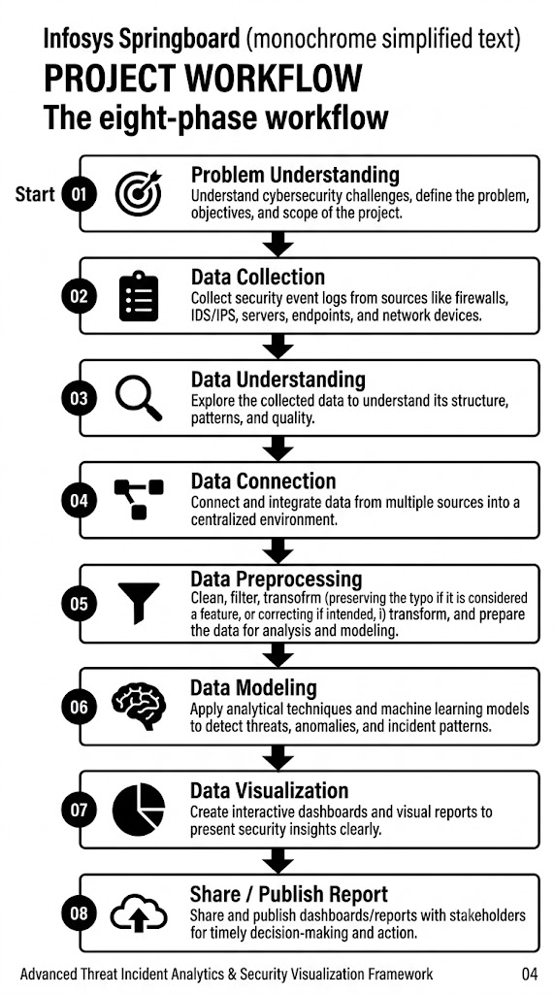
This section details how the framework was executed end-to-end. The project followed a structured nine-stage Power BI workflow, after which each of the seven dashboards was assembled, formatted and validated. The workflow below summarises the pipeline from problem definition to publishing.

Figure 1 - End-to-end Power BI execution workflow (nine stages).

Execution Workflow -

Step 1 - Problem Definition & Requirement Understanding. We began by framing the core security questions the framework needed to answer - how many attacks occur, of what type and severity, how the network and users behave, and how effectively threats are handled. From these questions we defined the KPIs (total attacks, high-severity share, block rate, average anomaly score, malware detections) and identified the target audience.
Step 2 - Data Collection. A publicly available cybersecurity dataset of 40,000 incident records was sourced from Kaggle. It was chosen for its breadth - over thirty attributes per event covering network, threat, user and geographic dimensions - making it well-suited to a multi-dashboard analytical framework.
Step 3 - Data Cleaning & Preprocessing. Using the Power Query Editor, the raw data was cleaned and shaped through nineteen individual transformation steps, grouped below into eleven logical stages, so that the dataset was fully analysis-ready before modeling began.
1. Removed Duplicate Records - removed duplicate rows to eliminate redundant data and improve data accuracy.
2. Changed Timestamp Data Type - converted the Timestamp column from Text to Date/Time format for time-based analysis.
3. Created Date, Hour & Day Columns - extracted Date, Hour, and Day Name from the Timestamp column for trend analysis.
4. Handled Missing Values - replaced null values in Malware Indicators, Alerts/Warnings, Proxy Information, Firewall Logs, and IDS/IPS Alerts with "No".
5. Split Geo-location Column - split the Geo-location column into two separate columns, City and State, using a comma delimiter.
6. Renamed Columns - renamed the newly created columns to City and State for better readability and consistency.
7. Extracted Browser Information - created a new Browser column by extracting browser names from the Device Information column using conditional logic.
8. Removed Payload Data Column - deleted the Payload Data column because it contained unnecessary placeholder text and did not contribute to analysis.
9. Created Severity Sort Key - added a Severity Sort column (Low = 1, Medium = 2, High = 3) to ensure the severity levels are displayed in the correct order.
10. Changed Data Types - assigned appropriate data types to the transformed columns (Date/Time, Whole Number, Text, etc.) to improve data consistency.
11. Created Anomaly Score Bands - grouped Anomaly Score values into ranges (0–25, 25–50, 50–75, 75–100) for easier visualization and analysis.
Step 4 - Data Modeling. A dedicated Date table was created and marked as the model's date table to enable time-based analysis, and relationships were established so that all visuals respond consistently to slicers and cross-filtering.
Step 5 - DAX Measures & Calculated Columns. Core DAX logic was authored, including Attack = COUNTROWS('cybersecurity_attacks'), High Severity and % High Severity, Malware Detected, Avg Anomaly Score, Block Rate %, and the Anomaly Score Band calculated column that buckets scores into 0–25, 26–50, 51–75 and 76–100.
Step 6 - Dashboard Design & Visualization. Seven themed report pages were designed with a consistent dark security aesthetic, KPI cards and a clear visual hierarchy, so each page tells a focused story.
Step 7 - Interactivity & Advanced Analytics. Slicers (date, severity, attack type), cross-highlighting, tooltips and advanced visuals - the decomposition tree, ribbon charts, treemaps and matrices - were added so users can explore the data interactively and drill from summary to detail.
Step 8 - Insight Generation & Interpretation. The completed dashboards were analysed to extract the findings documented in Section 3.4, validating figures across visuals for consistency.
Step 9 - Reporting, Documentation & Publishing. Findings were consolidated into this Word report and a PowerPoint walkthrough; the .pbix file and artefacts were version-controlled on GitHub; progress was reviewed with the mentor on Microsoft Teams; and the report was prepared for the Milestone 4 submission.

▍ Dashboard 1 - Cyber Security Attacks Analysis

Key Performance Indicators (KPIs)
Located at the very top, these three text boxes provide a high-level summary of the attack volume:
- Total Attack: Shows a total of 40K recorded cybersecurity incidents.
- High Severity: Indicates that 13382 of those attacks were classified as having a high severity level.
- Low Severity: Shows that 13183 of the attacks were classified as low severity. (The remaining balance accounts for medium-severity attacks).
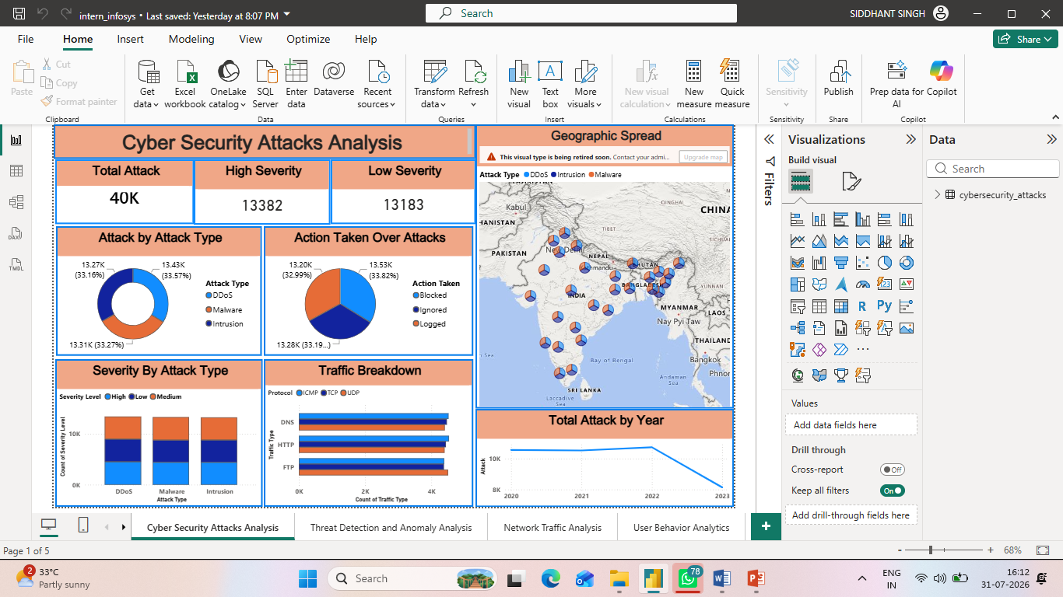

Attack by Attack Type
This donut chart on the middle-left breaks down the total attacks into three specific categories, showing a nearly equal distribution among them:
- DDoS: 13.43K (33.57%)
- Malware: 13.31K (33.27%)
- Intrusion: 13.27K (33.16%)


Action Taken Over Attacks
Located in the center, this pie chart illustrates the system's or security team's response to the detected incidents. Similar to the attack types, the actions are evenly distributed:
- Blocked: 13.53K (33.82%)
- Logged: 13.28K (33.19%)
- Ignored: 13.20K (32.99%)


Severity By Attack Type
This stacked column chart in the bottom-left corner provides a deeper look into the attack types (DDoS, Malware, Intrusion) by segmenting each column into three severity levels:
- High (Light Blue)
- Low (Dark Blue)
- Medium (Orange) The chart reveals that the proportion of high, low, and medium severity incidents is highly consistent regardless of the attack type.


Traffic Breakdown
Found in the bottom-middle section, this clustered horizontal bar chart categorizes network traffic involved in the attacks:
- Traffic Types: DNS, HTTP, and FTP.
- Protocols: Each traffic type is further broken down by ICMP (Light Blue), TCP (Dark Blue), and UDP (Orange).
- The data displays a uniform distribution, with each protocol type accounting for roughly 4K incidents across all three traffic categories.
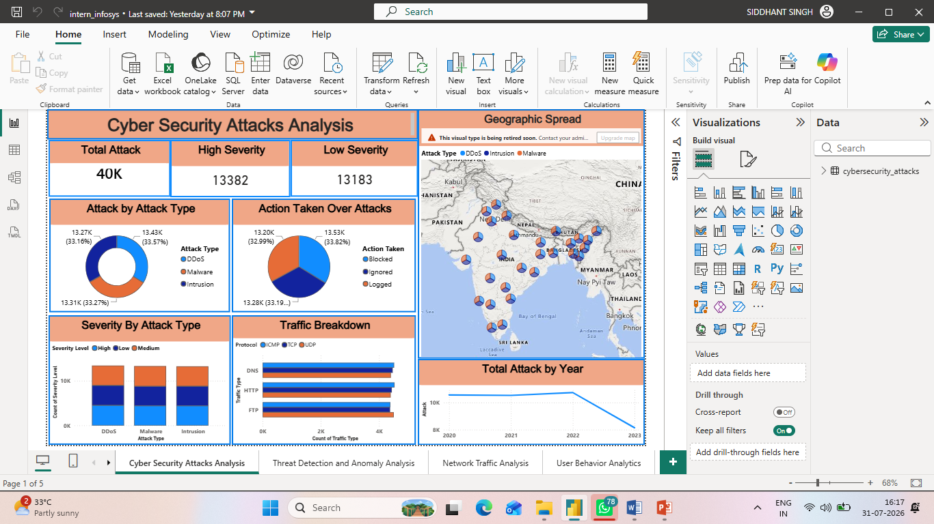

Geographic Spread
Taking up the top right section, this map visualizes the physical origins or targeted nodes of the attacks:
- The map focuses on India and neighboring countries.
- It uses multi-colored circular markers at various geographic points. The colors within these markers correspond to the Attack Type (DDoS, Intrusion, Malware), indicating the mix of attacks hitting each specific location.
- Note: There is an administrative warning banner at the top of this chart stating, "This visual type is being retired soon."


Total Attack by Year
Located in the bottom right, this line graph tracks the volume of attacks over a four-year timeline:
- 2020 to 2022: The number of attacks remains stable, tracking steadily just above the 10K mark.
- 2023: The trend line shows a sharp, noticeable decline in total attacks dropping below the 8K mark.



This landing dashboard gives a portfolio-level overview of the entire threat environment. A Total Attack card headlines the volume at 40,000 events, flanked by High Severity and Low Severity KPI indicators. The Total Attacks by Year line chart tracks volume over 2020–2023, revealing a peak in 2022 and a tapering 2023 (partial year). The Severity by Attack Type clustered column chart compares High, Medium and Low counts across DDoS, Intrusion and Malware, while the Attack Type donut shows their near-equal split. The Action Taken over Attacks pie exposes the response mix (Blocked / Ignored / Logged), the Traffic Breakdown bar chart cross-tabulates Protocol against Traffic Type (DNS / HTTP / FTP), and the Geographic Spread map plots attack types across Indian states.

▍ Dashboard 2 - Threat Detection and Anomaly Analysis

Dashboard Filters
Located at the top left, these three dropdowns and date pickers indicate that the data currently displayed on the dashboard is filtered for specific criteria:
- Severity Level: Currently set to filter for High severity incidents.
- Attack type: Currently set to filter for DDoS attacks.
- Date: The date range is restricted from 03-01-2020 to 05-10-2023.
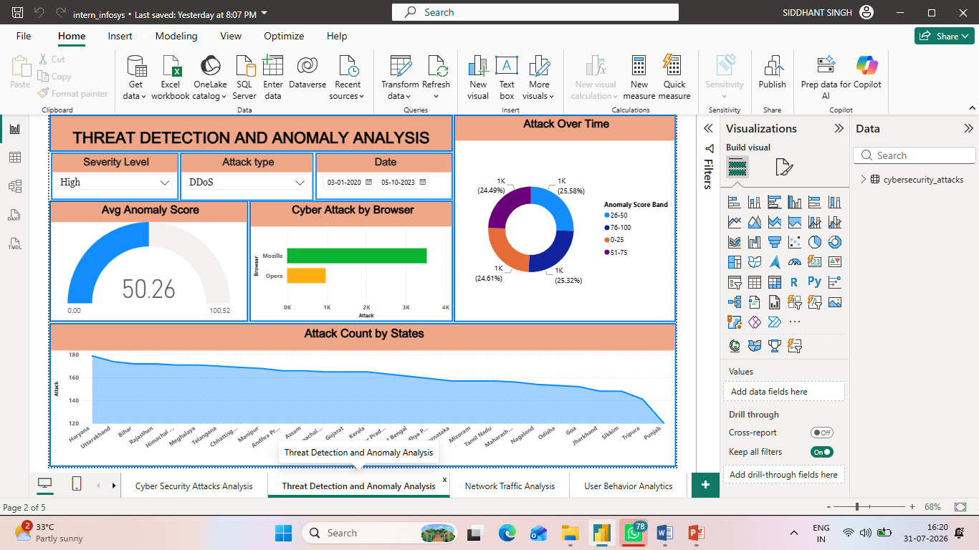

Avg Anomaly Score
This gauge chart on the middle-left displays the average anomaly score based on the applied filters:
- Score: The central number indicates an average score of 50.26.
- Scale: The gauge ranges from a minimum of 0.00 to a maximum of 100.52. The blue fill represents the score sitting precisely at the halfway point of the scale.


Cyber Attack by Browser
Positioned in the middle center, this horizontal bar chart compares the volume of attacks originating from or targeting specific web browsers:
- Mozilla: The green bar shows a significantly higher attack count, reaching approximately 3.5K.
- Opera: The yellow bar indicates a lower attack count, sitting right at the 1K mark.


Attack Over Time (Anomaly Score Band)
Located on the right side, there is a notable discrepancy in this visual: the title says "Attack Over Time," but the visual is actually a donut chart representing Anomaly Score Bands. It shows an almost perfectly even distribution across four quartiles:
- 26-50 (Light Blue): 1K (25.58%)
- 76-100 (Dark Blue): 1K (25.32%)
- 0-25 (Orange): 1K (24.61%)
- 51-75 (Purple): 1K (24.49%)



Attack Count by States
Taking up the entire bottom section, this filled area chart visualizes the distribution of attacks across various Indian states:
- X-Axis: Lists numerous Indian states, starting with Haryana on the left and ending with Punjab on the right.
- Y-Axis: Represents the count of attacks, scaled from 120 up to 180.
- Trend: The chart displays a smooth, gradual downward slope. Haryana records the highest number of attacks (approaching 180), while the volume steadily decreases across the listed states, with Punjab recording the lowest count (dropping down to 120).



This page focuses on anomaly-based detection and is driven by Date, Severity Level and Attack Type slicers for interactive filtering. The Avg Anomaly Score gauge summarises detection risk at 50.1 out of 100. The Attacks by Anomaly Band donut distributes events across the four score bands; the Cyber Attacks by Browser bar chart contrasts Mozilla and Opera exposure; and the Attack Count by State area/column chart shows the geographic concentration of incidents. Together these visuals help analysts isolate high-anomaly, high-severity segments quickly.

▍ Dashboard 3 - Network Traffic Analysis

Protocol vs Action Taken
Located in the top-left corner, this stacked column chart illustrates how the security system responded to attacks across different network protocols:
- X-Axis (Protocol): ICMP, UDP, and TCP.
- Y-Axis (Attack): Measures the volume of attacks, reaching just under 14K for each column.
- Categories: Each protocol's column is evenly split into three actions taken: Blocked (Light Blue), Ignored (Dark Blue), and Logged (Orange).
- Trend: The distribution of attacks and the subsequent actions taken are virtually identical across all three protocols.
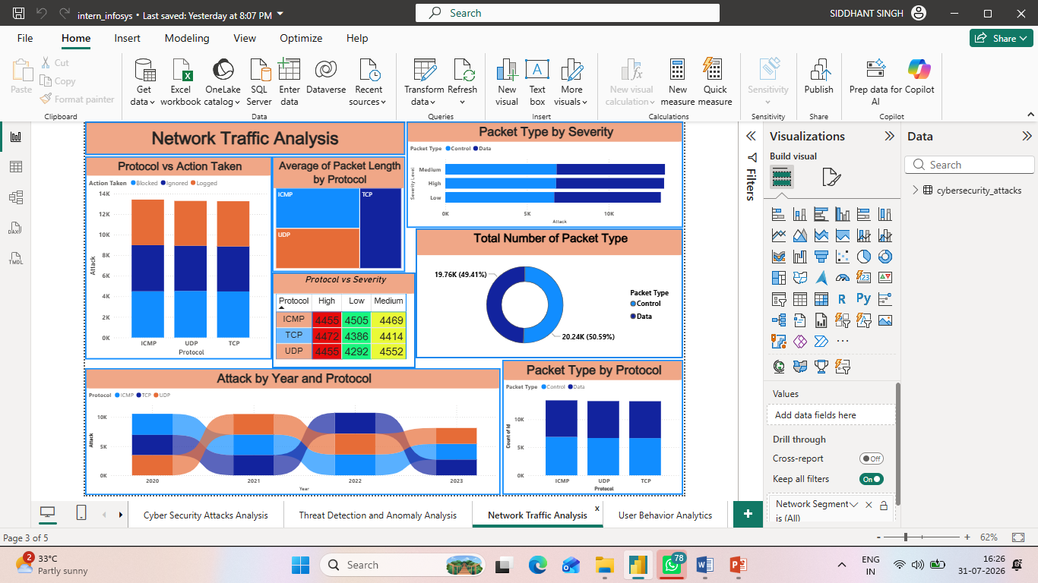

Average of Packet Length by Protocol
Positioned in the top-middle, this treemap visualizes the proportion of the average packet length associated with each protocol:
- TCP (Dark Blue) occupies the entire right half of the visual, indicating a significant portion of the average packet length.
- ICMP (Light Blue) and UDP (Orange) share the left half, with ICMP situated at the top and UDP at the bottom.


Protocol vs Severity
Found directly below the treemap, this table acts as a heatmap detailing the exact count of attacks by protocol and severity level:
- Rows: ICMP, TCP, UDP.
- Columns: High (Red), Low (Green), Medium (Yellow).
- Data: The attack counts are highly uniform across all intersections, ranging narrowly from 4292 (UDP - Low) to 4552 (UDP - Medium), indicating no single protocol is disproportionately favored for high-severity attacks.
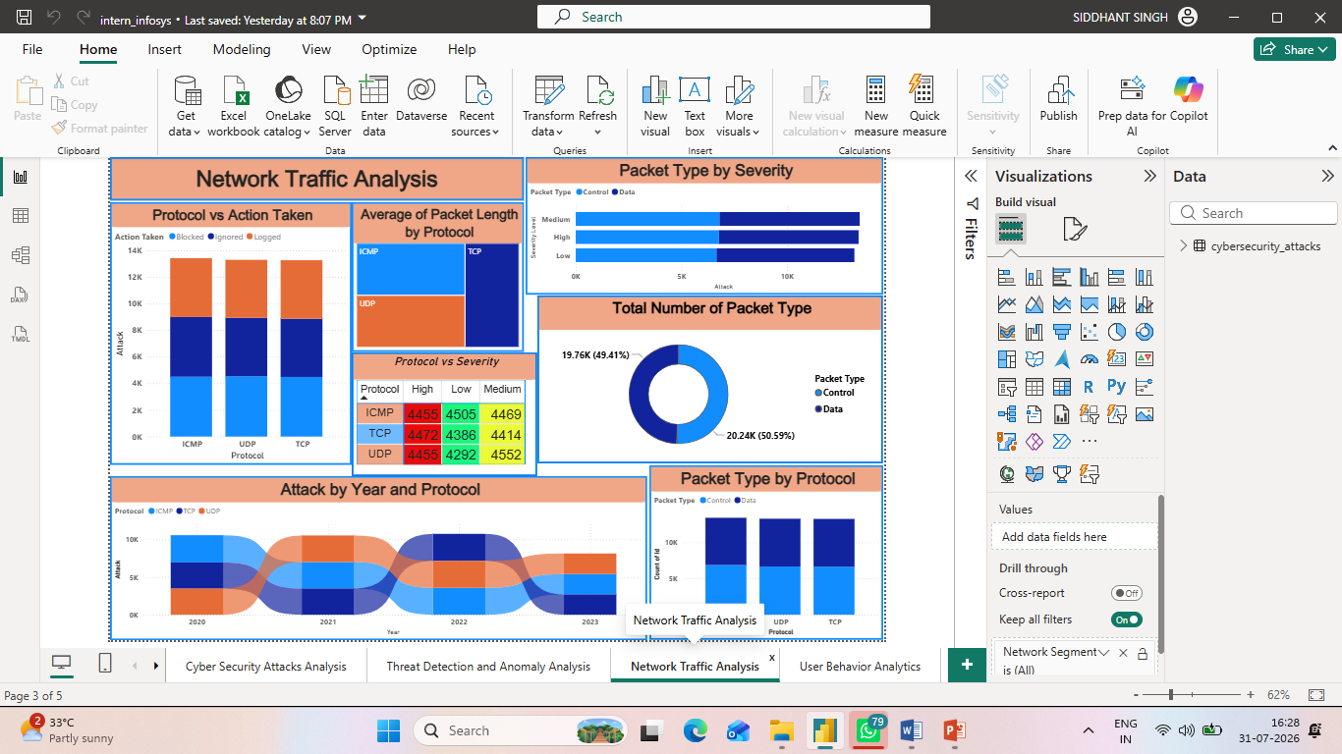

Packet Type by Severity
Located in the top-right, this stacked horizontal bar chart breaks down severity levels by the type of network packet involved:
- Y-Axis: Severity Level (Medium, High, Low).
- X-Axis: Total attack count, reaching just above 10K per severity level.
- Categories: Each severity bar is split into Control packets (Light Blue) and Data packets (Dark Blue). The split is perfectly even (approximately 50/50) across all three severity levels.


Total Number of Packet Type
Positioned in the middle-right, this donut chart provides a straightforward summary of the overall packet types involved in the recorded attacks:
- Control (Light Blue): 20.24K packets, representing 50.59% of the total.
- Data (Dark Blue): 19.76K packets, representing 49.41% of the total.
- This confirms an almost equal distribution between control and data packets overall.


Attack by Year and Protocol
Taking up the bottom-left section, this ribbon chart (or smoothed stacked area chart) illustrates how the volume and composition of attacks have shifted over time:
- X-Axis: Years 2020 to 2023.
- Y-Axis: Attack volume (0K to slightly above 10K).
- Trend: While the overall volume stays relatively stable from 2020 to 2022, the prominence of each protocol (ICMP in Light Blue, TCP in Dark Blue, UDP in Orange) fluctuates. For example, ICMP drops in rank during 2021, while UDP rises. Consistent with other dashboard views, there is a distinct drop in overall attack volume in 2023.


Packet Type by Protocol
Located in the bottom-right corner, this stacked column chart shows the composition of packet types within each specific protocol:
- X-Axis (Protocol): ICMP, UDP, TCP.
- Y-Axis (Count of Id): Total counts reaching roughly 13K per protocol.
- Categories: Just like the "Packet Type by Severity" visual, every column here is divided into a near-perfect 50/50 split between Control (Light Blue) and Data (Dark Blue) packets, showing high uniformity across the network protocols.
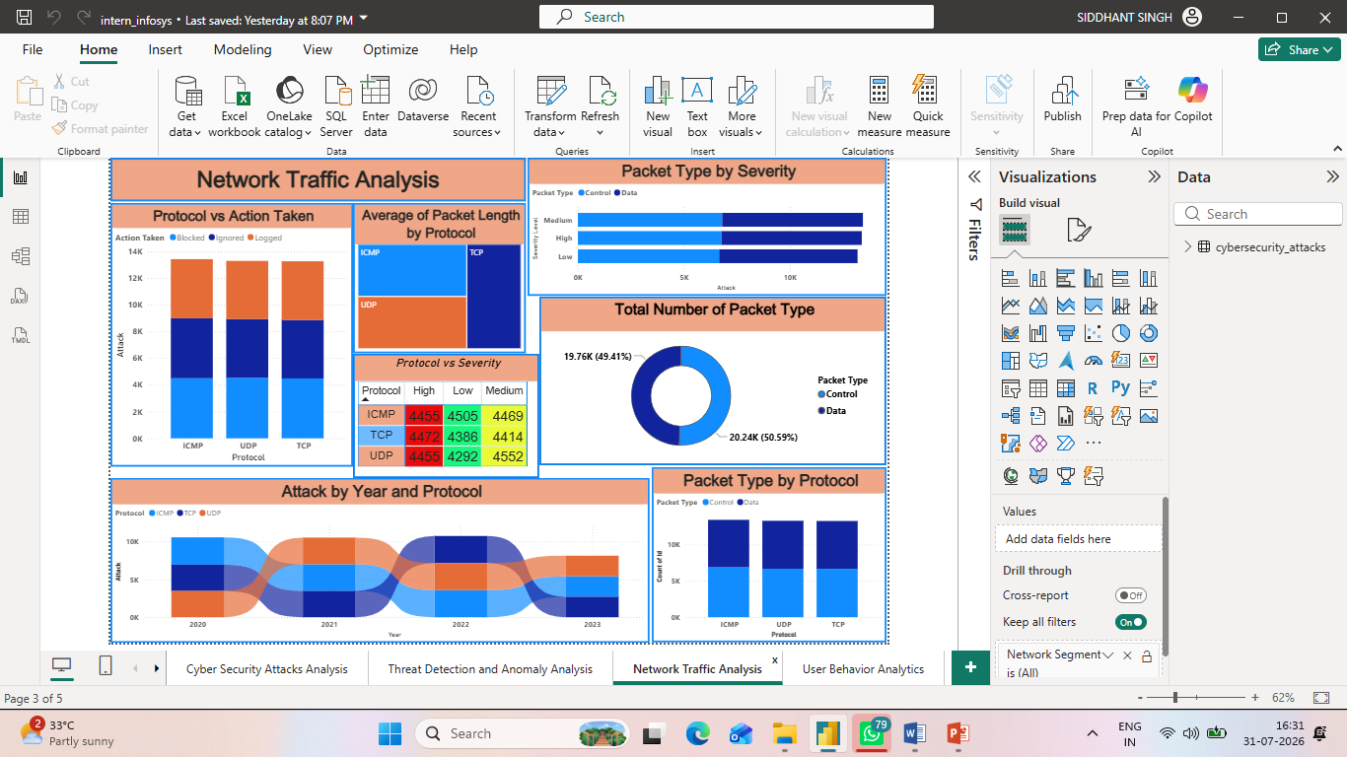

This dashboard dissects network-level behaviour. Packet Type by Protocol and Protocol vs Action Taken columns show how Control/Data packets and response actions distribute across ICMP, TCP and UDP. Packet Type by Severity relates packet composition to threat severity, while the Protocol vs Severity matrix provides exact counts. A Total Packet Type donut summarises the Control-versus-Data split (50.6% vs 49.4%), a ribbon chart ranks protocols by attack volume, and an Avg Packet Length by Protocol view profiles packet size - giving a complete picture of traffic characteristics.

▍ Dashboard 4 - User Behaviour Analytics

Monthly Attack matrix
Located in the top-left corner, this table acts as a heatmap showing the volume of attacks broken down by month and attack type:
- Rows & Columns: The rows display the months of the year (January to December), and the columns are split by attack type (DDoS, Intrusion, Malware).
- Color Gradient: The cells are color-coded from green (lowest volume) to red (highest volume).
- Trend: The highest concentration of attacks (in red and orange) occurs in the spring and summer months, notably March and June. The lowest volume of attacks (in bright green) consistently appears at the end of the year in November and December, dropping into the 800-900 range.

Key Performance Indicators (KPIs)
Located top-center, these two summary cards display overall user and device metrics:
- Total Users: 32.389K
- Total devices: 32.104K
- This indicates a nearly 1:1 ratio of users to devices being monitored within this dataset.
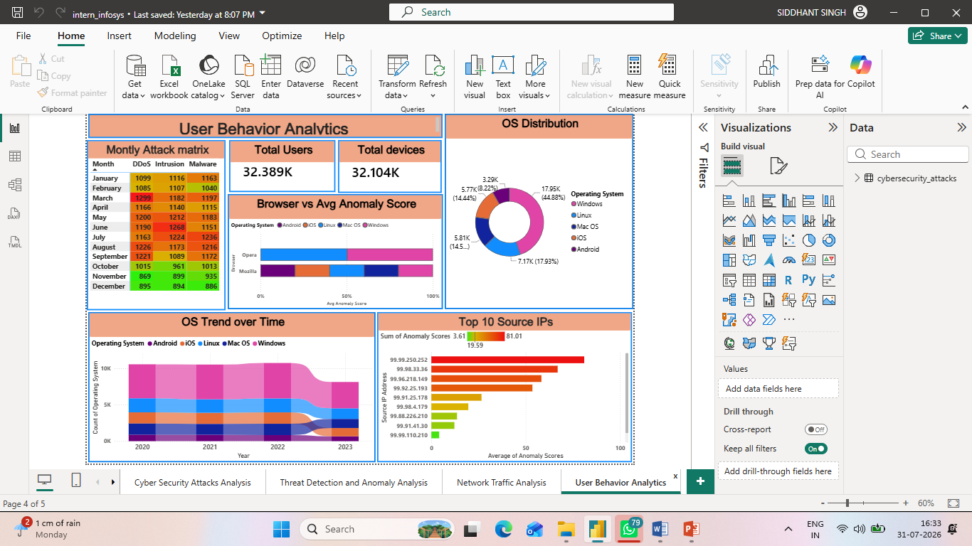

Browser vs Avg Anomaly Score
Positioned in the middle of the dashboard, this 100% stacked horizontal bar chart illustrates how anomaly scores are distributed across operating systems for two specific browsers:
- Opera: The anomaly score distribution is split cleanly and evenly between just two operating systems: Linux (Light Blue) and Windows (Pink).
- Mozilla: The anomaly score distribution is spread across all five tracked operating systems (Android, iOS, Linux, Mac OS, Windows) in relatively even proportions.


OS Distribution
Found in the top-right corner, this donut chart breaks down the total count of operating systems involved in the data:
- Windows (Pink): Represents the largest segment by a significant margin at 17.95K (44.88%).
- Linux (Light Blue): The second largest at 7.17K (17.93%).
- Mac OS (Dark Blue): Accounts for 5.81K (~14.5%).
- iOS (Orange): Accounts for 5.77K (14.44%).
- Android (Purple): The smallest segment at 3.29K (8.22%).


OS Trend over Time
Located in the bottom-left, this stacked area chart tracks the volume of operating systems recorded from 2020 to 2023:
- Distribution: It visually mirrors the "OS Distribution" donut chart, with Windows (Pink) taking up the largest top band, followed by the other operating systems stacked below it.
- Timeline Trend: The total volume remains stable and flat from 2020 through 2022. Consistent with the other dashboard tabs, there is a sharp and noticeable decline in overall volume in 2023.


Top 10 Source IPs
Taking up the bottom-right section, this horizontal bar chart ranks the specific IP addresses responsible for the highest anomaly scores:
- X-Axis: Measures the Average of Anomaly Scores (0 to 100).
- Color Gradient: The bars are colored based on the Sum of Anomaly Scores, ranging from Green (3.61) to Red (81.01).
- Top Threat: The top IP address (99.99.250.252) stands out with a significantly higher average anomaly score (and a deep red color) compared to the rest of the list. As you move down the top 10, the bars get progressively shorter and shift toward yellow and green, indicating lower anomaly severity.



This page profiles the human and device dimension. Total Users (32,389) and Total Devices (32,104) cards quantify the affected population. The OS Distribution donut shows Windows dominating at roughly 45%; the Browser vs Avg Anomaly Score visual compares risk across browsers and operating systems; and the OS Trend over time and Monthly Attack Matrix reveal temporal patterns by attack type. The Top 10 Source IPs chart surfaces the highest-anomaly source addresses for investigation.

▍ Dashboard 5 - Threat Profile and Severity Breakdown

Attacks by Attack Type x Severity
Located in the top-left corner, this cross-tabulation table provides a precise numerical breakdown of attacks:
- Rows: Represents the Attack Type (DDoS, Intrusion, Malware).
- Columns: Represents the Severity Level (High, Low, Medium).
- Data: It displays the exact count of incidents for each intersection, culminating in total counts. The grand total of all attacks is exactly 40000. The data shows a remarkably even spread, though DDoS has a marginally higher total (13428) compared to the others.
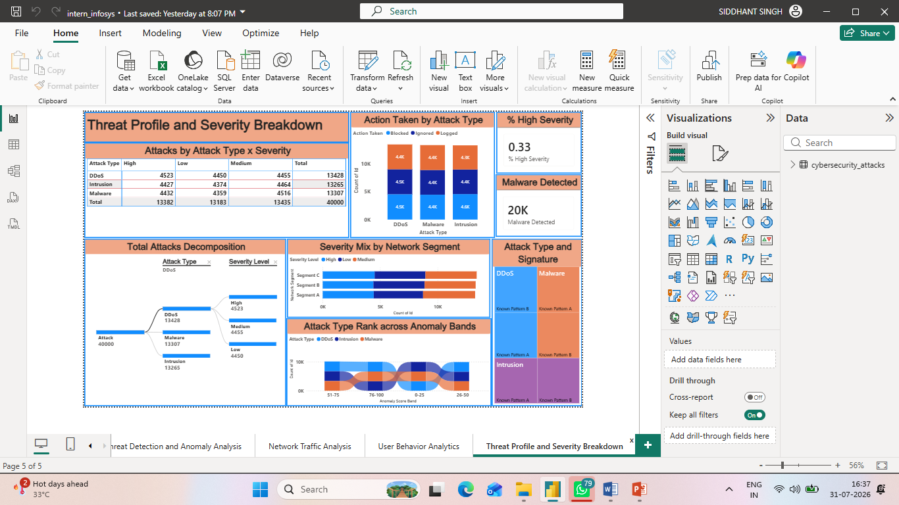

Action Taken by Attack Type
Positioned in the top-middle, this stacked column chart illustrates the security system's response to different threats:
- X-Axis: Attack Type (DDoS, Malware, Intrusion).
- Y-Axis: Count of Id (Attack volume).
- Categories: Each column is segmented into the action taken: Blocked (Light Blue), Ignored (Dark Blue), and Logged (Orange).
- Trend: The distribution of the actions taken is highly uniform across all three attack types, with each action segment accounting for roughly 4.3K to 4.6K incidents.


Key Performance Indicators (KPIs)
Found in the top-right corner, these two standalone cards highlight specific top-level metrics:
- % High Severity: Displays a value of 0.33 (representing 33%), indicating the proportion of the total attacks that were classified with a high severity level.
- Malware Detected: Displays a count of 20K, indicating the total volume of malware incidents detected in this specific context.


Total Attacks Decomposition
Taking up the bottom-left section, this decomposition tree visualizes the hierarchical breakdown of the attack data:
- Root: Starts with the total attack volume of 40000.
- First Branch (Attack Type): Splits the total into DDoS (13428), Malware (13307), and Intrusion (13265).
- Second Branch (Severity Level): The visual specifically expands the DDoS branch to show its composition by severity: High (4523), Medium (4455), and Low (4450).


Severity Mix by Network Segment
Located in the middle-right area, this stacked horizontal bar chart shows how attack severities are distributed across different parts of the network:
- Y-Axis: Network Segments (Segment C, Segment B, Segment A).
- X-Axis: Count of Id.
- Categories: High (Light Blue), Low (Dark Blue), and Medium (Orange) severity levels.
- Trend: The chart reveals that every network segment experiences a virtually identical volume and proportional mix of high, low, and medium severity attacks.



Attack Type Rank across Anomaly Bands
Positioned in the bottom-middle, this ribbon chart tracks the flow and ranking of attack types across different scoring buckets:
- X-Axis: Anomaly Score Bands (non-sequential: 51-75, 76-100, 0-25, 26-50).
- Categories: DDoS (Light Blue), Intrusion (Dark Blue), and Malware (Orange).
- Trend: The twisting ribbons illustrate how the relative rank and volume of each attack type fluctuate depending on the specific anomaly score band they fall into.


Attack Type and Signature
Located in the far bottom-right corner, this treemap visualizes the composition of specific threat signatures within the broader attack categories:
- Primary Categories: The map is divided into three main color blocks representing DDoS (Light Blue), Malware (Orange), and Intrusion (Purple).
- Sub-categories: Each of these primary blocks is further subdivided to show the proportion of specific signatures, labeled as Known Pattern A and Known Pattern B, indicating the makeup of recognized threats within each main attack type.



The final dashboard delivers the deepest threat profiling. A Total Attacks Decomposition tree lets analysts break attacks down by Attack Type and Severity interactively, supported by % High Severity (33.5%) and Malware Detected (20,000) cards. The Severity Mix by Network Segment and Action Taken by Attack Type charts relate severity and response to network structure and threat class, while the Attack Type & Signature treemap and the Attack Type across Anomaly Bands ribbon expose signature and anomaly patterns. A final Attacks by Attack Type × Severity matrix consolidates the numbers.

▍ Dashboard 6 - Security Alert Monitoring

% Alert Rate
Positioned at the top of the left-hand KPI rail, this single-value card reports the % Alert Rate - the share of all 40,000 incidents that raised an alert or warning (Alerts/Warnings = “Alert Triggered”), calculated as DIVIDE([Total Alerts Triggered], [Attack]) × 100.
Value displayed: 49.83% (19,933 of 40,000 incidents triggered an alert).
Because almost exactly half of every incident generates an alert, the card confirms that the alerting layer is highly active and, on its own, cannot be used to prioritise - roughly one in two events would surface. This makes the severity- and response-based filtering elsewhere on the page essential for separating genuine signal from noise.
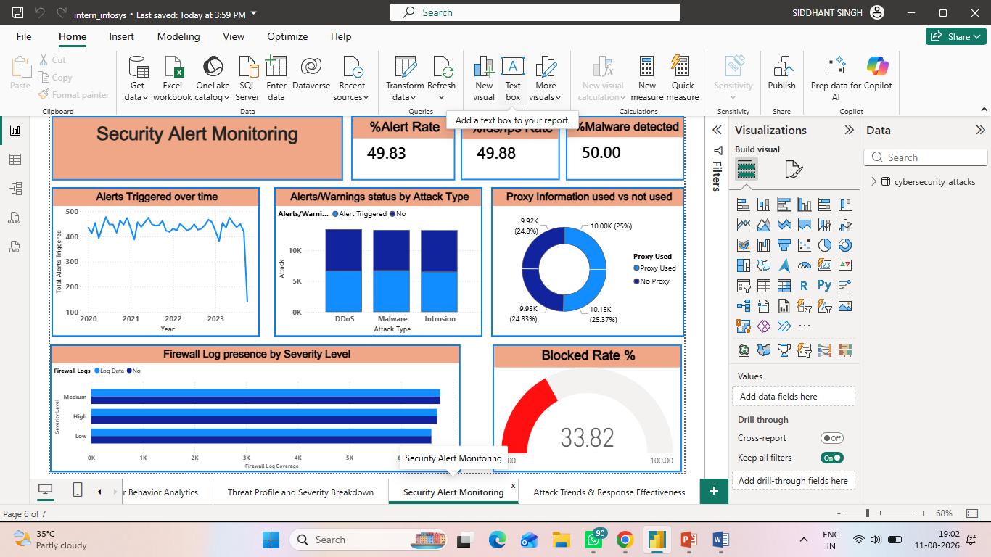

% IDS/IPS Rate
The second card on the KPI rail shows the % IDS/IPS Alert Rate - the proportion of incidents for which the intrusion-detection / intrusion-prevention system produced alert data (IDS/IPS Alerts = “Alert Data”), i.e. DIVIDE([IDS/IPS Alert Count], [Attack]) × 100.
Value displayed: 49.88% (19,950 of 40,000 incidents carried an IDS/IPS alert).
The IDS/IPS layer fires on almost exactly half of all traffic, closely mirroring the general alert rate. The near-identical coverage suggests the two alerting mechanisms trigger largely in parallel rather than catching different populations of events - useful context when judging whether the sensors add independent value.
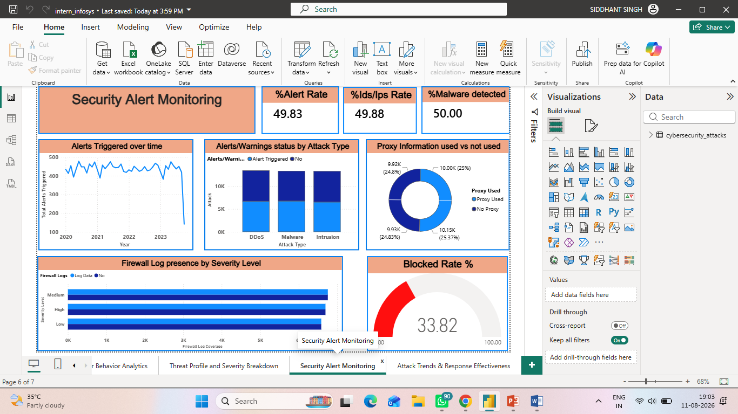

% Malware Detected
The third KPI card reports the % Malware Indicator Rate - the share of incidents flagged with a malware indicator of compromise (Malware Indicators = “IoC Detected”), DIVIDE([Malware Detected], [Attack]) × 100.
Value displayed: 50.00% (exactly 20,000 of 40,000 incidents carry a malware IoC).
Malware indicators are present in precisely half of all records - the single largest risk signal on the page and consistent with the Milestone 3 finding of 20,000 IoC-positive incidents. It establishes that malware is not a niche threat in this environment but effectively a coin-flip on every event, which justifies the emphasis on blocking and firewall coverage across the rest of the dashboard.


Blocked Rate %
Anchoring the foot of the KPI rail, this gauge visual plots the Blocked Rate % - the percentage of incidents that were actively Blocked (Action Taken = “Blocked”), DIVIDE(Blocked, Total) × 100 - against a 0-100 scale.
Needle value: 33.82% (13,529 of 40,000 incidents blocked).
Only about a third of incidents are actually stopped at the point of detection, matching the 33.8% block rate reported in Milestone 3. Placing this gauge beside the ~50% alert and malware cards makes the central operational gap explicit: alerts fire on half of all events, yet only a third are blocked, so a large share of flagged - and potentially malicious - activity is still merely logged or ignored rather than prevented.
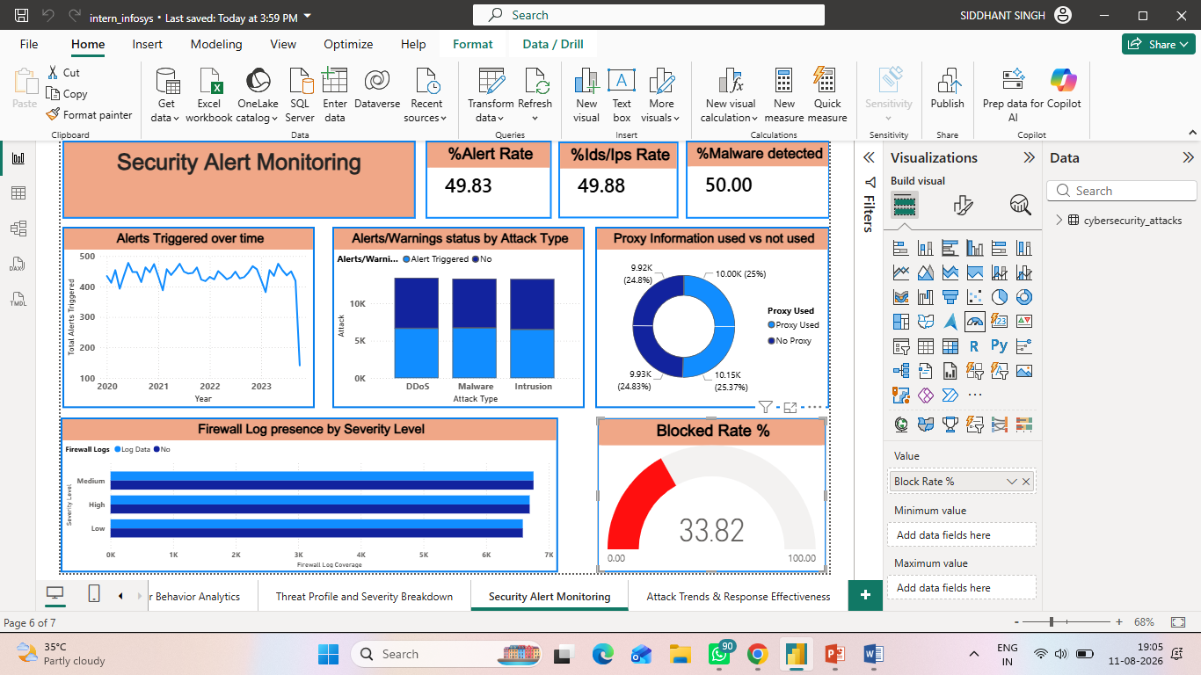

Alerts/Warnings Status by Attack Type
This clustered column chart sits at the top-centre of the page. It plots the Attack count on the Y-axis, grouped along the X-axis by Attack Type (DDoS, Intrusion, Malware) and split within each group by Alerts/Warnings status (Alert Triggered vs No).
DDoS - Alert Triggered: 6,673 · No alert: 6,755 (13,428 total)
Intrusion - Alert Triggered: 6,525 · No alert: 6,740 (13,265 total)
Malware - Alert Triggered: 6,735 · No alert: 6,572 (13,307 total)
Alert coverage is close to a 50/50 split within every attack type, with Malware the only class where alerts slightly outnumber non-alerts (6,735 vs 6,572). The near-uniformity shows the alerting system is essentially attack-type agnostic - it is not tuned to fire more aggressively on any one threat class - which is important when assessing whether high-risk malware is being surfaced often enough.


Alerts Triggered over Time
Running across the top-right, this line chart trends Total Alerts Triggered along a Year → Month date hierarchy, showing how alert volume has evolved from 2020 to 2023.
2020: 5,304 alerts · 2021: 5,286 · 2022: 5,277 · 2023: 4,066
Alert volume is essentially flat at roughly 5,300 per year across 2020-2022 before dropping to about 4,066 in 2023. As with the attack-volume trend seen in earlier dashboards, the 2023 decline reflects partial-year data rather than a genuine fall in threat activity, and the drill-down to month lets an analyst pinpoint exactly where coverage tapers off.


Proxy Information Used vs Not Used
This donut chart, lower-centre, breaks the total Attack count by whether a proxy was involved (Proxy Used vs No Proxy), with each arc further segmented by Alerts/Warnings status.
Proxy Used: 20,149 incidents (50.4%) - of which 10,000 triggered an alert
No Proxy: 19,851 incidents (49.6%) - of which 9,933 triggered an alert
Proxy usage is split almost evenly across the dataset, and the alert rate is virtually identical whether or not a proxy was used (~49-50% in both arcs). This tells the SOC that attackers’ use of proxies is not materially changing whether an event gets alerted on - proxy presence is a useful forensic attribute but not, by itself, a reliable trigger for escalation.


Firewall Log Presence by Severity Level
The clustered bar chart at the lower-right measures Firewall Log Coverage (the count of incidents where Firewall Logs = “Log Data”) down each Severity Level (High, Medium, Low), split by whether a firewall log was present.
High severity - Log Data: 6,696 · No log: 6,686
Medium severity - Log Data: 6,757 · No log: 6,678
Low severity - Log Data: 6,586 · No log: 6,597
Total firewall-log coverage: 20,039 of 40,000 incidents (~50%).
Firewall logging covers almost exactly half of incidents at every severity level - critically, High-severity events are logged no more often (6,696 of 13,382) than Low-severity ones. The absence of severity-weighted logging is a genuine operational gap: the most dangerous incidents are just as likely to be missing firewall evidence as the least dangerous, with direct implications for forensic readiness.

Dashboard 6 shifts the analysis from what the attacks are to how well the monitoring and alerting stack is performing. Four headline KPIs - % Alert Rate (49.83%), % IDS/IPS Rate (49.88%), % Malware Detected (50.00%) and a Blocked Rate % gauge (33.82%) - frame a consistent story: detection signals fire on roughly half of all traffic, yet only a third of incidents are actively blocked. The surrounding visuals decompose that headline by dimension - alert status across attack types, alert volume over time, proxy involvement, and firewall-log coverage by severity - and together they expose where monitoring is strong (broad, even alert coverage) and where it is weak (blocking and severity-weighted firewall logging), giving the security operations centre a clear, evidence-based view of alert-handling effectiveness.

▍ Dashboard 7 - Attack Trends & Response Effectiveness

Total Alert
This KPI card in the top-right reports Total Alerts Triggered - the raw count of incidents whose Alerts/Warnings field equals “Alert Triggered” (CALCULATE([Attack], Alerts/Warnings = “Alert Triggered”)).
Value displayed: 19,933 alerts.
Just under 20,000 of the 40,000 incidents raised an alert, providing the absolute baseline that the rest of this page evaluates responses against. It anchors the effectiveness story: with roughly 20k alerts in play, the central question the dashboard answers is how consistently those alerts convert into a “Blocked” outcome.
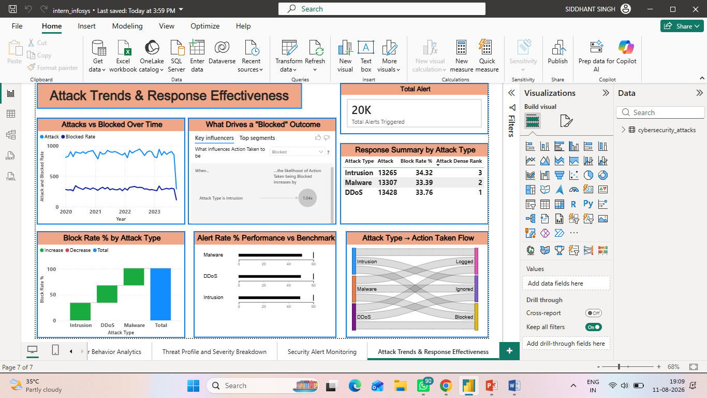

Attacks vs Blocked Over Time
Occupying the top-left, this dual-measure line chart trends two series on a Year → Month hierarchy: total Attack volume and the Blocked Rate, letting the reader see whether response effectiveness holds up as attack volume changes.
2020: 10,573 attacks · 33.86% blocked
2021: 10,538 attacks · 33.32% blocked
2022: 10,750 attacks · 34.16% blocked (peak year)
2023: 8,139 attacks · 33.98% blocked (partial year)
Attack volume is stable at ~10,500-10,750 per year through 2022 before the partial-2023 dip, while the block rate stays in a remarkably narrow 33.3-34.2% band throughout. That flat block-rate line is the key finding: response effectiveness has neither improved nor degraded over four years and appears independent of how many attacks arrive.


What Drives a “Blocked” Outcome
This Key Influencers visual, top-centre, uses Power BI’s built-in analytics to rank which factors most increase the likelihood that Action Taken = “Blocked”. The target is Action Taken and the model explains it using Attack Type, Severity Level, Protocol and Proxy Used.
Because the underlying categories are near-uniformly distributed (each attack type ≈33%, each severity ≈33%, block rate ≈33-34% everywhere), the visual surfaces only marginal influencers rather than a dominant driver.
The absence of a strong driver is itself the insight: no single attack type, severity, protocol or proxy state meaningfully changes the odds of an incident being blocked. This confirms that blocking in this dataset is effectively uniform and not risk-weighted - a finding that would prompt a real SOC to introduce severity-aware blocking rules.


Response Summary by Attack Type
This table on the right-hand side summarises response performance per Attack Type, with columns for Attack (volume), Block Rate % and an Attack Dense Rank (RANKX over attack types by volume, dense/descending).
DDoS - 13,428 attacks · 33.76% blocked · rank 1
Malware - 13,307 attacks · 33.39% blocked · rank 2
Intrusion - 13,265 attacks · 34.32% blocked · rank 3
DDoS is the most frequent attack type (rank 1) yet has almost the lowest block rate (33.76%), while Intrusion - the least frequent - is blocked most often (34.32%). The spread is well under one percentage point, reinforcing that response is even-handed across threat classes rather than concentrated on the highest-volume one.


Block Rate % by Attack Type
This waterfall chart, bottom-left, decomposes Block Rate % across the three Attack Types, showing each type’s contribution as a step and its cumulative position.
DDoS: 33.76% · Malware: 33.39% · Intrusion: 34.32%
The waterfall makes the near-equality visually explicit - the steps are almost the same height, so no attack type stands out as being blocked substantially more or less than the others. It is the graphical companion to the response table and drives home that block-rate parity, not variation, is the defining characteristic of the response profile.


Attack Type → Action Taken Flow
This Sankey diagram, bottom-centre, visualises the flow from each Attack Type (source) to each Action Taken (destination), with ribbon width weighted by Attack count - a single view of how every threat class is dispositioned into Blocked, Ignored or Logged.
DDoS → Blocked 4,533 · Ignored 4,459 · Logged 4,436
Intrusion → Blocked 4,553 · Ignored 4,401 · Logged 4,311
Malware → Blocked 4,443 · Ignored 4,416 · Logged 4,448
Column totals: Blocked 13,529 · Ignored 13,276 · Logged 13,195
Every attack type splits into the three actions in almost equal thirds, so the ribbons are of near-identical width. The operationally important flows are the ~13,276 Ignored and ~13,195 Logged incidents: two-thirds of all activity - including roughly 8,900 malware-carrying events - is not being blocked, which is the single clearest efficiency concern the response analysis raises.


Alert Rate % Performance vs Benchmark
The bullet chart in the bottom-right compares each Attack Type’s % Alert Rate against a common benchmark band, giving a compact “actual vs target” read on alerting performance by threat class.
DDoS: 49.69% · Intrusion: 49.19% · Malware: 50.61% (overall 49.83%)
All three attack types cluster tightly around the ~50% alert-rate benchmark, with Malware marginally ahead (50.61%) and Intrusion marginally behind (49.19%). The tight grouping confirms alerting is applied consistently regardless of threat type; the small Malware lead is the only positive signal that the most dangerous class is being surfaced slightly more often than average.


Dashboard 7 is the capstone of the framework, pivoting from monitoring coverage to response effectiveness and trend. A Total Alert card (19,933) sets the baseline, while the Attacks vs Blocked Over Time line shows attack volume peaking in 2022 (10,750) against a block rate that never leaves a narrow 33-34% band. The Key Influencers visual, the Response Summary table, the Block Rate % waterfall and the Attack Type → Action Taken Sankey all converge on the same conclusion: response is uniform - every attack type is blocked, ignored and logged in near-equal thirds, with no risk-weighting - while the Alert Rate bullet chart confirms alerting is applied evenly across threat classes. Taken together the page tells a clear operational story: the environment reliably detects and consistently responds, but blocks only about a third of incidents, leaving a two-thirds tail of ignored and logged activity that is the primary target for future tuning.

6. Snapshots / Screenshots
The interactive dashboard captures are embedded alongside their explanations in Section 5b as Pic 1.1 to Pic 1.7. The table below indexes each snapshot for quick reference. High-resolution screenshots exported directly from Power BI can be inserted in an appendix if a raw-capture set is required

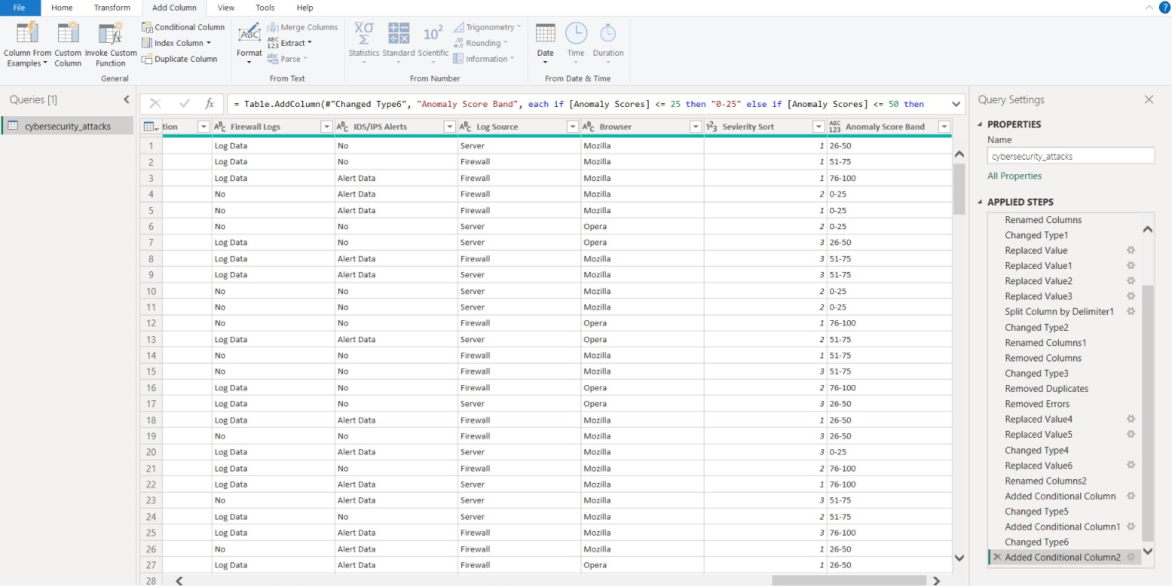
▍ Data Transformation Steps

▍ Dashboard 1 - Cyber Security Attacks Analysis

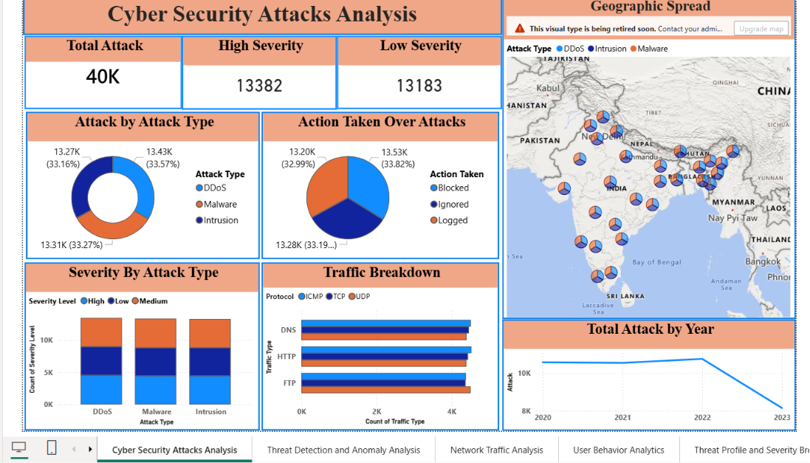

Dashboard 2 - Threat Detection and Anomaly Analysis

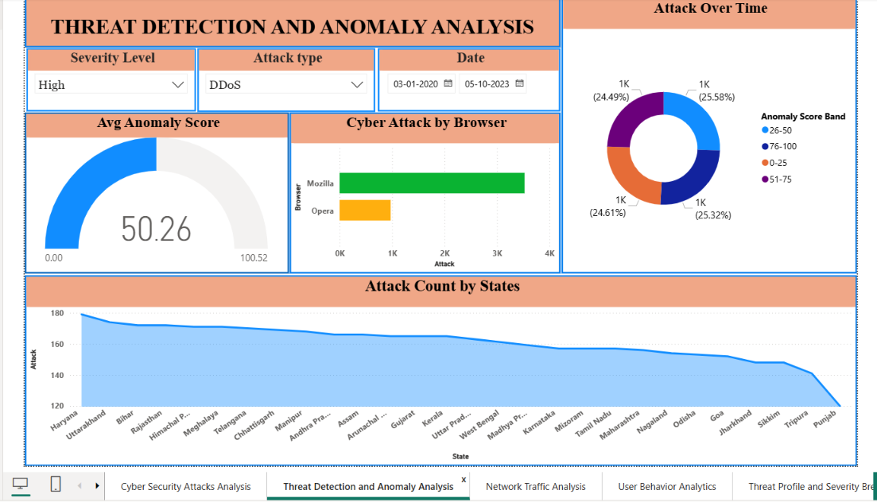

Dashboard 3 - Network Traffic Analysis

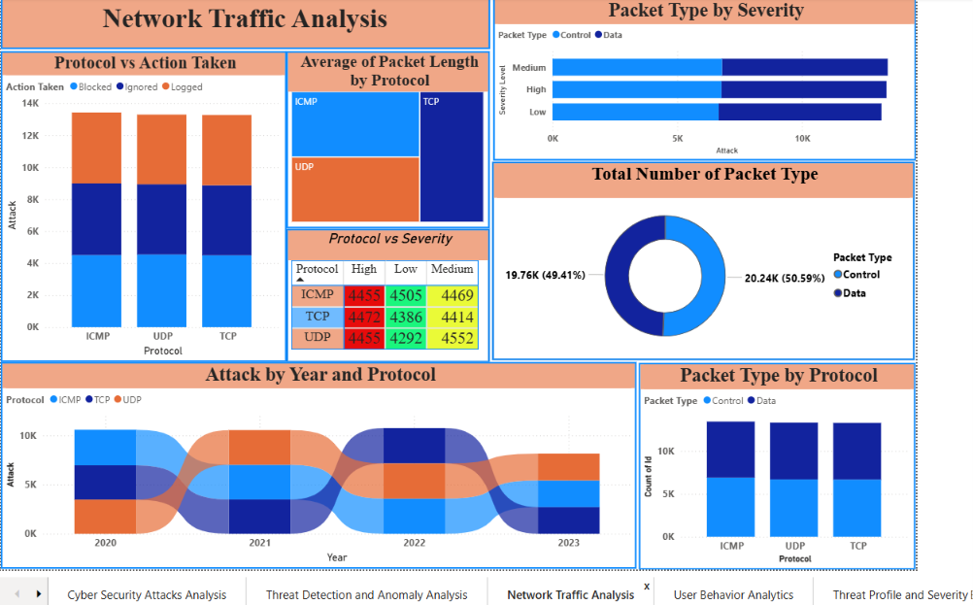

▍ Dashboard 4 - User Behaviour Analytics

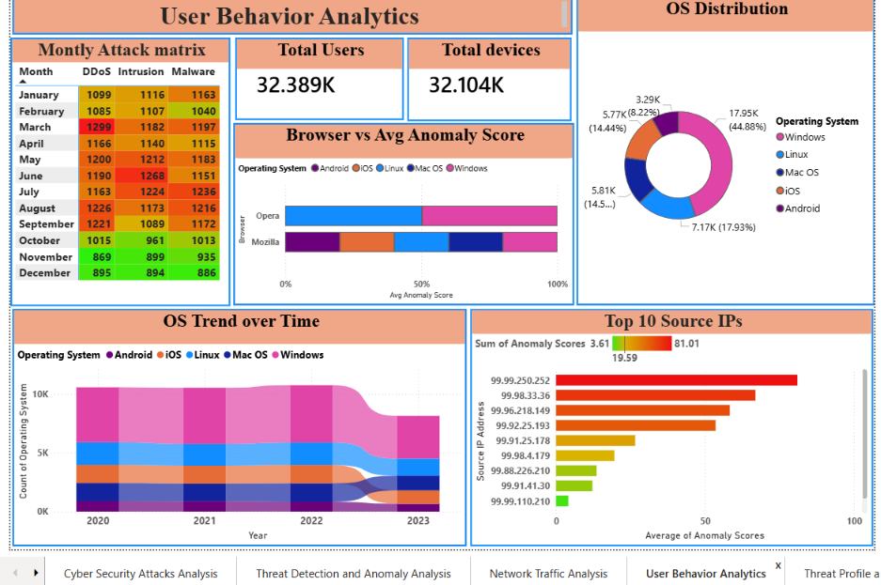

▍ Dashboard 5 - Threat Profile and Severity Breakdown

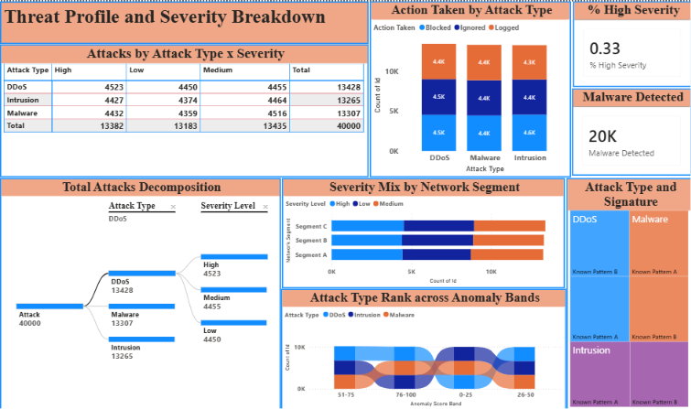

▍ Dashboard 6 - Security Alert Monitoring
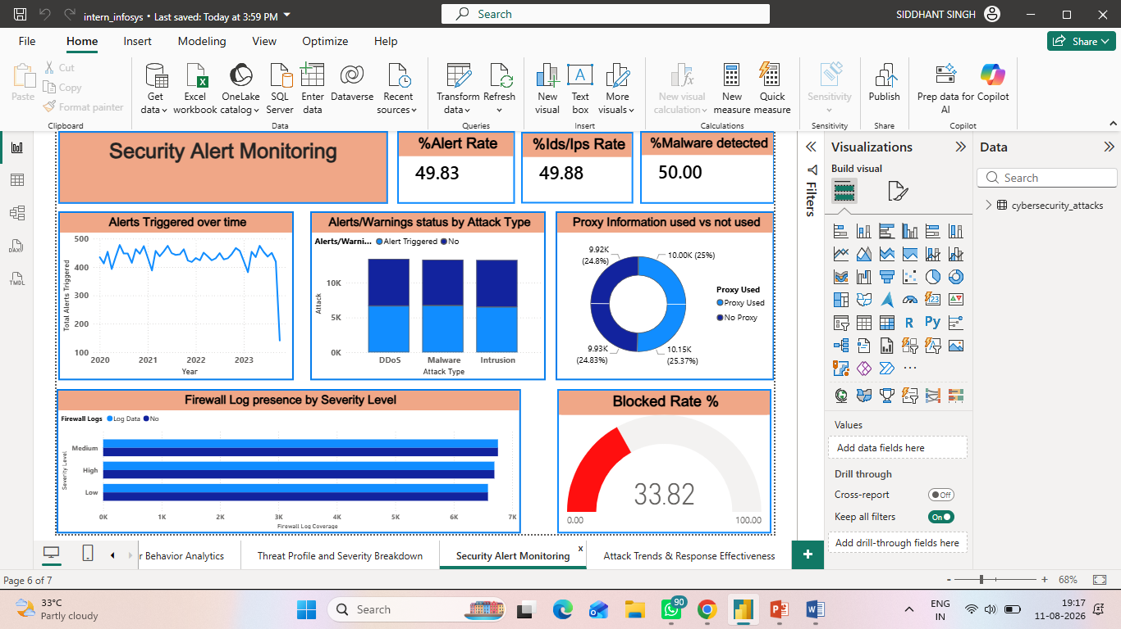

▍ Dashboard 7 - Attack Trends & Response Effectiveness
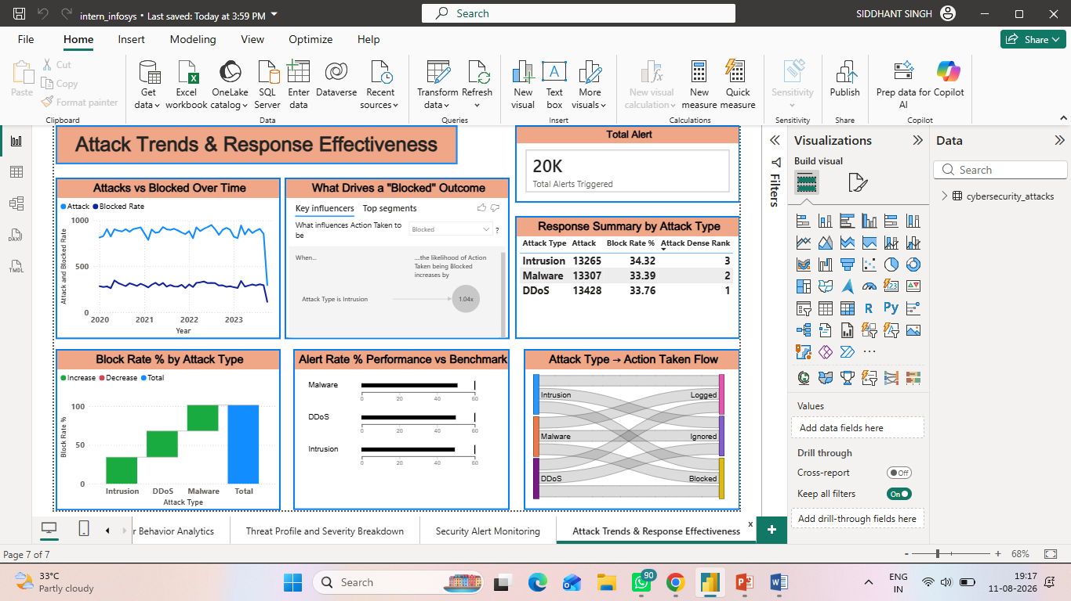

7. Challenges Faced
The advanced-analytics and reporting phase of Milestone 3 presented several challenges, each of which was resolved through iteration and collaboration:
- Handling a 40,000-row model while keeping visuals responsive - this required efficient DAX and disabling unnecessary auto date/time tables.
- Designing meaningful DAX for derived metrics (% High Severity, Block Rate %, Anomaly Score Band bucketing) so that KPIs stayed accurate under all slicer interactions and filter contexts.
- Configuring the decomposition tree and ribbon charts to reveal hierarchy (Attack Type → Severity) without overwhelming the reader.
- Maintaining a consistent visual language - colours, fonts and severity encoding - across seven dashboards contributed to by different members.
- Representing geography meaningfully across 28 states without producing a cluttered or misleading map.
- Balancing dashboard density - showing all key visuals on each page while preserving readability.
- Coordinating remotely via Microsoft Teams and merging individual work through GitHub with minimal conflicts.
- Interpreting a near-uniformly distributed dataset - deriving genuine, defensible insights rather than over-reading statistical noise.

8. Learnings & Skills Acquired

▍ 8.1 Technical Skills
- End-to-end Power BI Desktop: data import, Power Query ETL, modeling, visualization and publishing.
- Writing DAX measures and calculated columns (CALCULATE, DIVIDE, COUNTROWS, AVERAGE and conditional banding).
- Building a date table and managing relationships for time-based analysis.
- Using advanced visuals: decomposition tree, ribbon chart, treemap, gauge, matrix, KPI cards and maps.
- Report theming, slicers, cross-filtering and drill-through.
- Version control with GitHub for the .pbix and documentation artefacts.

▍ 8.2 Analytical and Problem-Solving Skills
- Translating a business/security question into measurable KPIs.
- Selecting the most appropriate visual for each analytical intent.
- Reading distributions, proportions and trends to form defensible conclusions.
- Debugging DAX and filter-context issues.
- Validating numbers across visuals to ensure consistency.

▍ 8.3 Future Enhancements
- Integrate near-real-time data via scheduled refresh or DirectQuery.
- Add predictive analytics (anomaly forecasting, risk scoring) using Python/R or Azure ML.
- Implement row-level security for role-based dashboards (SOC analyst vs manager).
- Automate alerting on threshold breaches with Power Automate.
- Enable drill-through to raw incident detail and add a true India choropleth map.
- Publish to the Power BI Service within an app workspace for wider stakeholder access.

▍ 8.4 Soft Skills and Team Collaboration
- Task distribution, ownership and accountability within the team.
- Communicating analytical findings clearly to non-technical audiences.
- Structured collaboration and a regular review cadence via Microsoft Teams.
- Time management against milestone deadlines.
- Giving and receiving constructive feedback and iterating on it.

▍ 8.5 Domain Knowledge and Application
- Core cybersecurity concepts: attack types (DDoS, Malware, Intrusion), severity levels, protocols, packet types, malware indicators (IoC), anomaly scoring, network segments and response actions (Blocked / Ignored / Logged).
- How security operations teams triage and respond to incidents.
- How business intelligence supports security monitoring, reporting and executive decision-making.

9. Testimonials from Team
Siddhant
Siddhant played a pivotal role throughout this project and particularly during Milestone 3. He led the data-modeling and DAX layer of the framework (Steps 4 and 5), building and marking the Date table, establishing the model relationships, and authoring the key measures - including % High Severity, Block Rate %, Malware Detected and the Anomaly Score Band bucketing logic - that power the KPIs across every dashboard. He also designed the Threat Profile and Severity Breakdown dashboard, configuring the decomposition tree and the severity matrices that give the report its analytical depth. Beyond his technical contribution, Siddhant coordinated task allocation on Microsoft Teams, reviewed team members' visuals to keep the colour and severity encoding consistent, resolved GitHub merge conflicts when individual work was combined, and patiently helped his peers understand filter context and visual selection. His ownership, clear communication and willingness to support the team were instrumental in delivering this milestone on time..
Priyam Sinha
Priyam Sinha played a key role in framing the project and translating its analysis into a finished, communicable product. He led the problem-definition stage (Step 1), helping shape the security questions and KPIs the framework needed to answer, and later drove the insight-generation and reporting stages (Steps 8 and 9). Priyam built the Threat Detection and Anomaly Analysis and User Behaviour Analytics dashboards - designing the anomaly-score gauge, the anomaly-band and OS-distribution visuals, and the top source-IP and user/device views - and worked closely with the team to interpret the results and validate figures across dashboards for consistency. He also took ownership of the documentation effort, consolidating findings into the project report and PowerPoint walkthrough and maintaining the GitHub repository. Priyam's structured thinking, strong communication and eye for presentation gave the final deliverables their clarity and polish.
Ponnuru Nithin
Ponnuru Nithin was central to the data-engineering backbone of the project, owning the data-collection and preparation stages (Steps 2 and 3). He sourced and validated the 40,000-record cybersecurity dataset from Kaggle, then shaped it in the Power Query Editor - correcting data types, handling null and inconsistent values, splitting the date and time fields, standardising categorical values such as protocol, packet type and action taken, and adding the Severity Sort column that controls ordering across the visuals. Building on this clean foundation, he designed and built the Network Traffic Analysis dashboard, crafting the packet-type, protocol and severity visuals along with the Protocol vs Severity matrix. Nithin also contributed to overall dashboard interactivity (Step 7) by configuring slicers and cross-filtering, and was quick to troubleshoot data-refresh and query issues for the rest of the team. His attention to data quality and his reliability under deadline pressure ensured that every downstream analysis rested on trustworthy, well-structured data.

10. Conclusion

This project successfully transformed a large, raw cybersecurity dataset of 40,000 incidents into an Advanced Threat Incident Analytics and Security Visualization Framework comprising seven interactive Power BI dashboards. From attack overview to anomaly detection, network traffic, user behaviour and deep threat profiling, the framework provides a complete, drill-able view of the threat landscape and converts complex log data into intelligence that both technical and non-technical audiences can act on.
The analysis showed a broad, multi-vector threat environment: attack types and severity levels are almost evenly distributed, Windows is the most-targeted operating system at around 45%, malware indicators appear in half of all events, and only about a third of attacks are actively blocked - a clear, quantified opportunity to strengthen response. More importantly, the project reinforced the value of data-driven decision-making and gave the team hands-on mastery of Power BI, DAX, data modelling and analytical storytelling, alongside the collaboration and communication skills essential to professional project delivery. Milestone 3 marks a meaningful step in the team's academic and professional journey and a strong foundation for the future enhancements outlined in Section 8.3.

11. Acknowledgements

We would like to express our sincere gratitude to the Infosys Springboard Team for organizing this highly enriching virtual internship program and for providing a structured, industry-aligned learning platform. The well-designed modules, milestone-based framework, and practical orientation of the internship enabled us to gain meaningful exposure to real-world business intelligence applications.
We extend our heartfelt appreciation to our mentor, Ms. Nityasree, for her consistent guidance, valuable feedback, and continuous encouragement throughout the project lifecycle. Her insights and structured direction played a significant role in shaping the analytical depth and professional quality of this project. We would also like to acknowledge our team members for their strong collaboration, accountability, and shared commitment toward achieving project objectives. The coordinated distribution of responsibilities, open communication, and collective problem-solving approach significantly contributed to the successful execution of this project.
In addition, we extend our appreciation to the creators and maintainers of Microsoft Power BI documentation and community resources, which served as essential references during dashboard development and KPI implementation. We are also grateful to Kaggle for providing access to publicly available datasets that facilitated practical, hands-on analytical experience.
The structured learning resources and practical exposure provided through this internship have significantly strengthened our analytical thinking, technical proficiency, and business interpretation skills. This experience has enhanced our ability to approach data with a strategic mindset, collaborate effectively within a team environment, and execute projects with professional discipline. Overall, this internship has been a meaningful milestone in our academic and professional journey, reinforcing the value of data-driven decision-making and structured analytical execution in modern business environments.

