Supplemental Figure 1
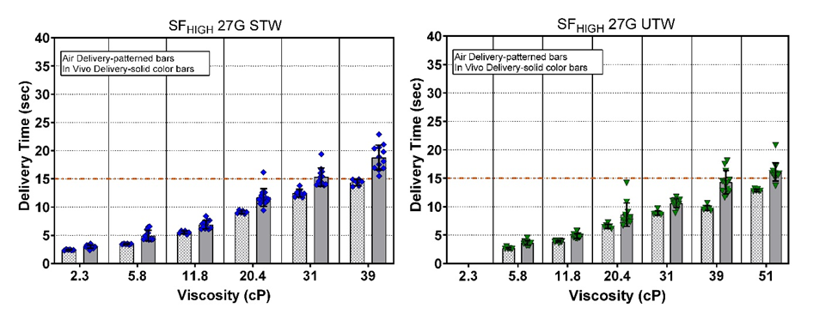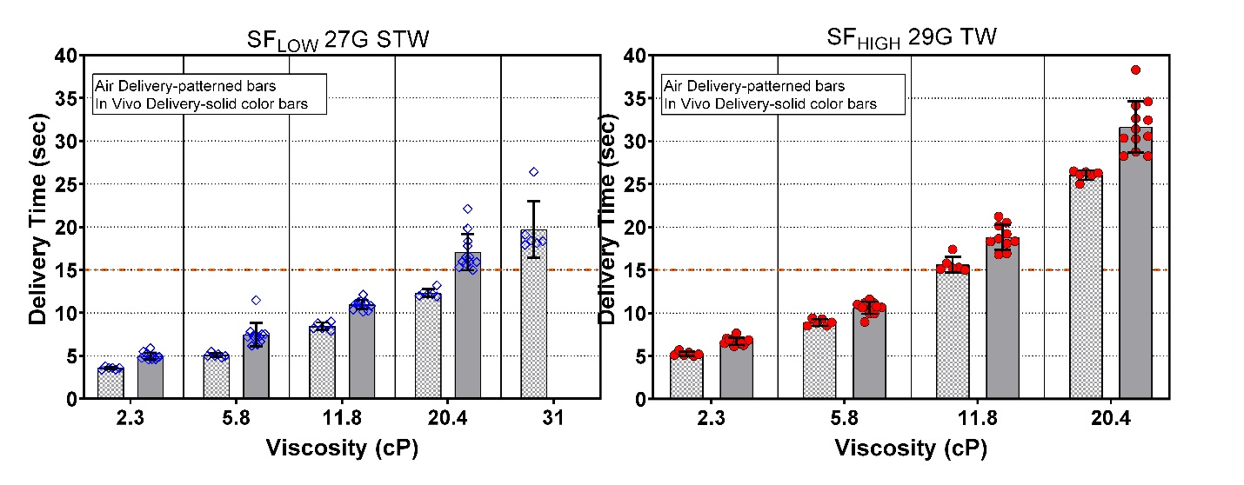
Supplemental Figure 1: Average (±SD) delivery time in air versus average delivery time in vivo for all injections per viscosity: SF_{HIGH} 27G STW and UTW (top), SF_{LOW} 27G STW, SF_{HIGH} 29G TW (bottom) device configurations. Dotted red line represents nominal 15 second injection duration. G = gauge; SF_{LOW} = Low Spring Force; SF_{HIGH} = High Spring Force; TW = thin wall; STW = special thin wall; UTW = ultra-thin wall.

Supplemental Figure 2

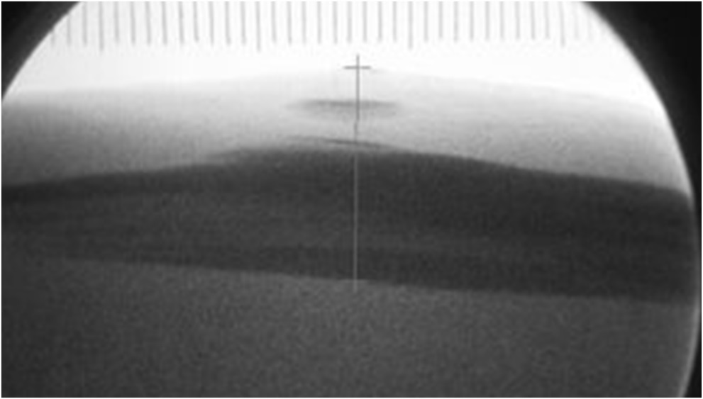
Supplemental Figure 2: A single injection case (SF_{High} 27G STW, 5 cP) which showed predominant SC deposition with an observation of nominal intradermal injectate (blue circle). CP = centipoise; G = gauge; SC = subcutaneous; SF_{HIGH} = High Spring Force; STW = special thin wall.

Supplemental Figure 3
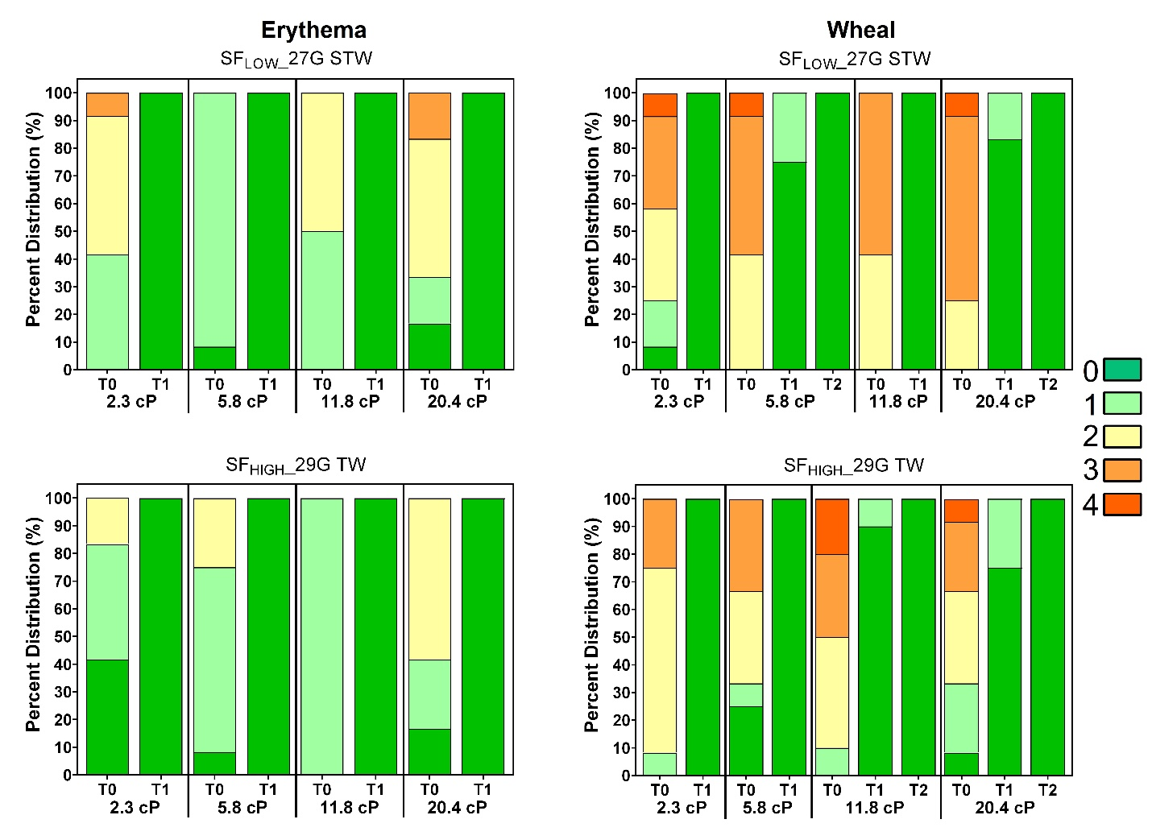
Supplemental Figure 3: Observed erythema (left) and wheal (right) scores (0-4) by viscosity over time expressed as a percentage of total injections for LVAI SF_{LOW} 27G STW (top) and SF_{HIGH} 29G TW device configurations (bottom) immediately after injection (T0) and through resolution by viscosity. Regardless of injection test condition, all erythema resolved to non-detectable levels (Score=0; dark green) by T-60 minutes (T1) post-injection; all wheal scores resolved within 2 hours (T2) post injection. G = gauge; LVAI = large volume autoinjector; SF_{LOW} = Low Spring Force; SF_{HIGH} = High Spring Force; TW = thin wall; STW = special thin wall; UTW = ultra-thin wall.

