PROJECT TITLE
College Name: L.R.GArts College, Tirupur
College Code: bru07

TEAM ID: NM2025TMID28014
TEAM MEMBERS:
Team LeaderName: Priyavarshinisree.S
Email: santhakumarpriya47@gmail.com
Team Memberl: Divya.M
Email: divyamsv2006@gmail.com
Team Member: Karthiyayini.S
Email: sureshmohana45@gmail.com
Team Member: Vanmathi.D
Email: vanmathiv902@gmail.com

I.INTRODUCTION

1.1 Project Overview
The Lease Management System is a Salesforce-based application designed to streamline the processes associated with leasing real estate properties. It handles tenant management, lease contracts, payments, and communication with automation features such as flows, approval processes, and email alerts.
LEASE | PAYMENT
ABSTRACTING | PROCESSING
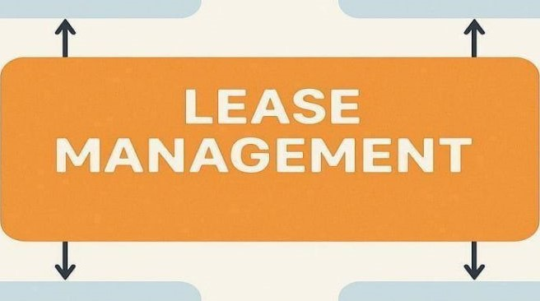
DOCUMENT | PROPERTY
MANAGEMENT | MAINTENANCE
1.2 Purpose
The main objective of the project is to enable organizations to efficiently manage properties, tenants, and lease-related activities. It reduces manual intervention, improves accuracy, and ensures better compliance and communication.

DEVELOPMENT PHASE
Creating Developer Account:
By using this URL - https://www.salesforce.com/form/developer-signup/?d=pb
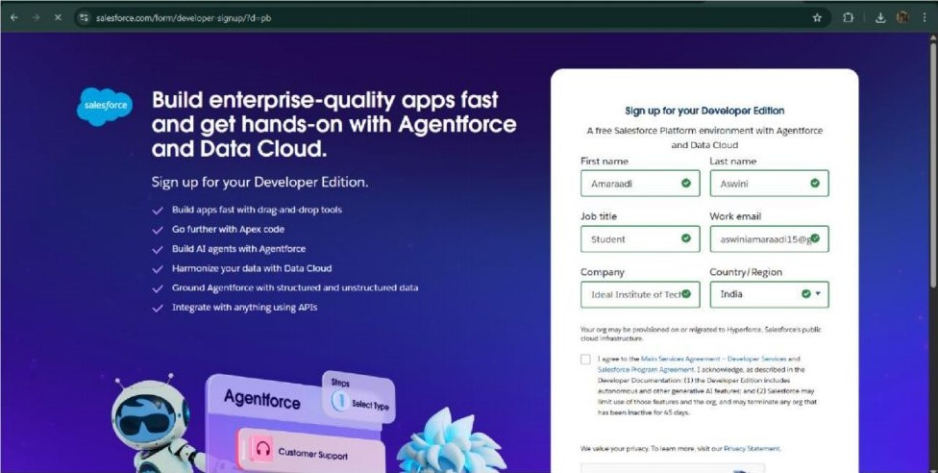
- Created objects: Property, Tenant, Lease, Payment
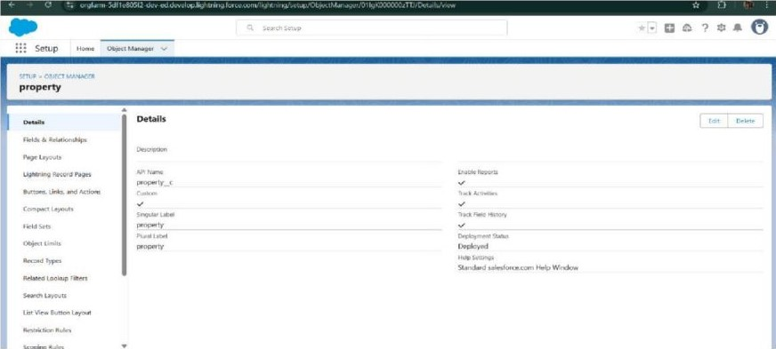
Tenant
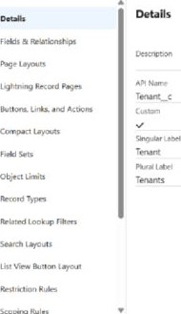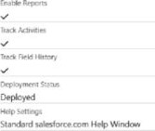
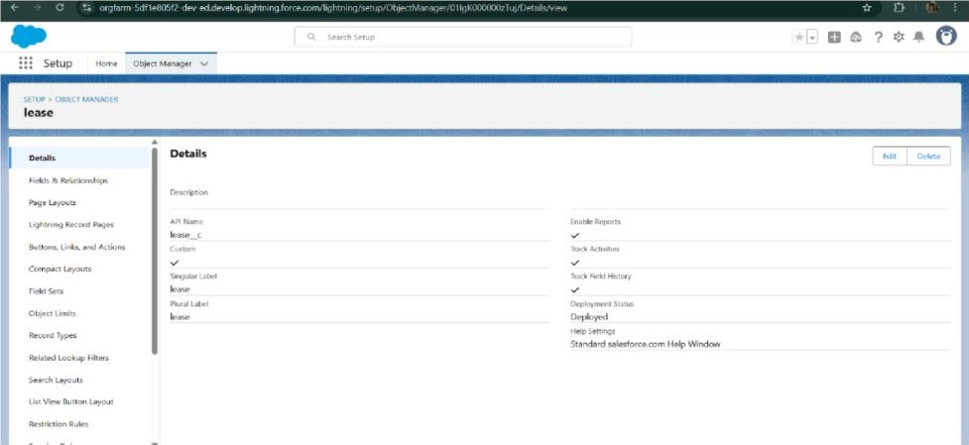
Payment for tenanat
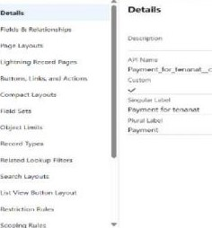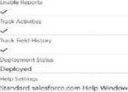
- Configured fields and relationships
property
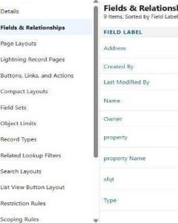  Relationships | 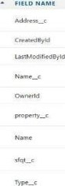 | 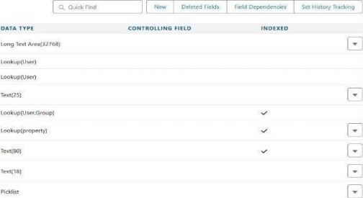
Setup
Payment for tenanat
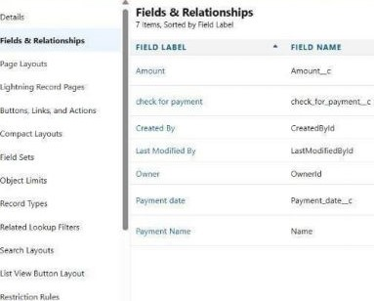 | DATA Type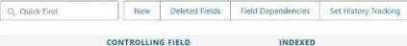  co  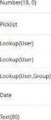
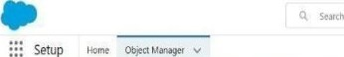Setup
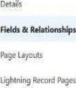  Buttons. Links. and Actions  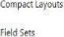  Obi«t Linirs  Rea rd Types  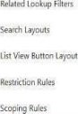 | 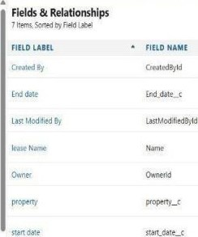 | 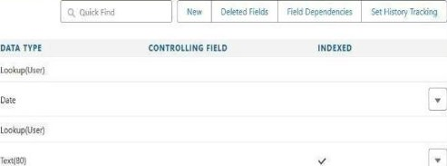
Lcokupvser. Grow)
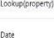
• Setup
s oe."EcT
Tenant
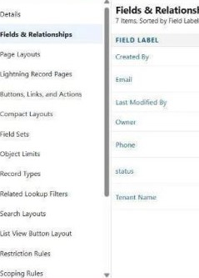  Relationships | 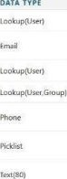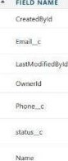 | CONTROLLING
- Developed Lightning App with relevant tabs
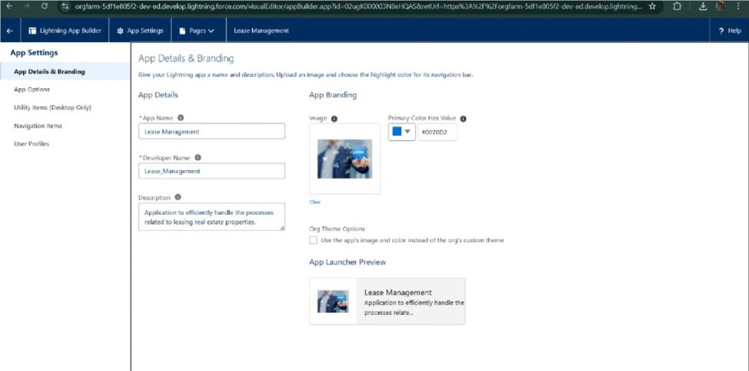
Navhgaticn Items
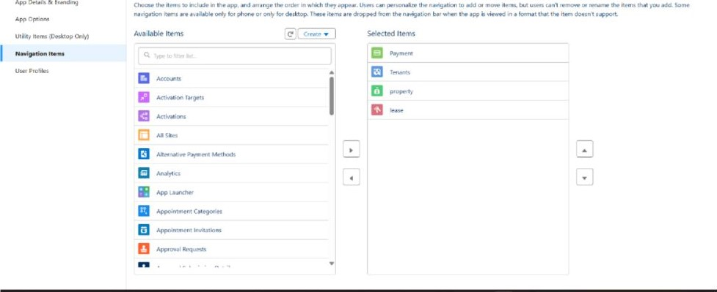
卯
~
User ProfEs
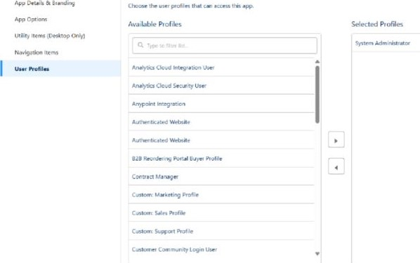
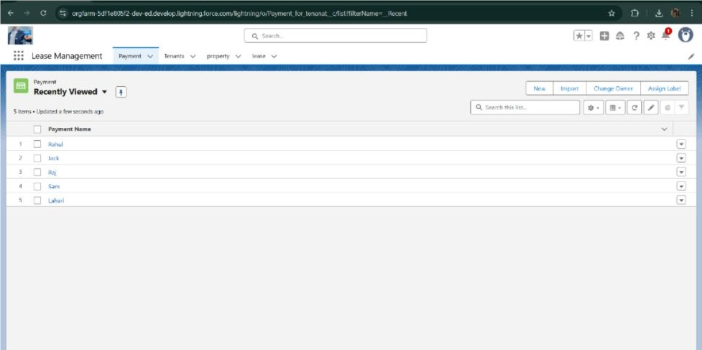
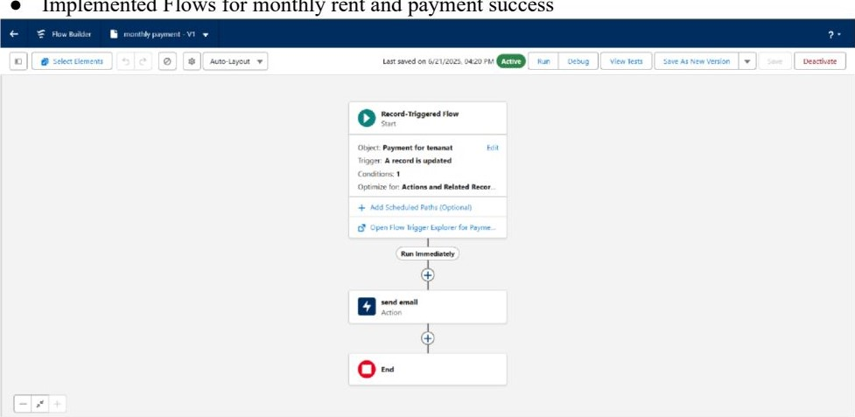
Implemented
Flows
for
monthly
rent
and
payment
success
- To create a validation rule to a Lease Object
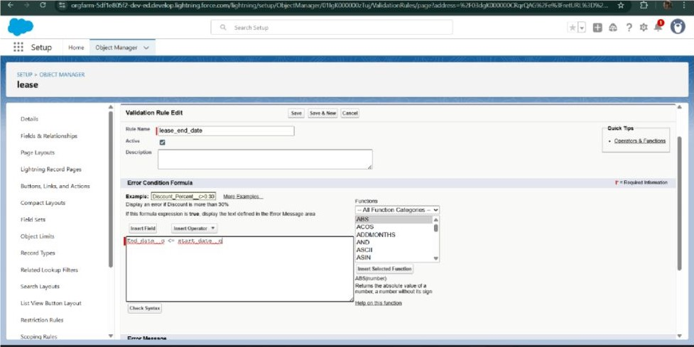
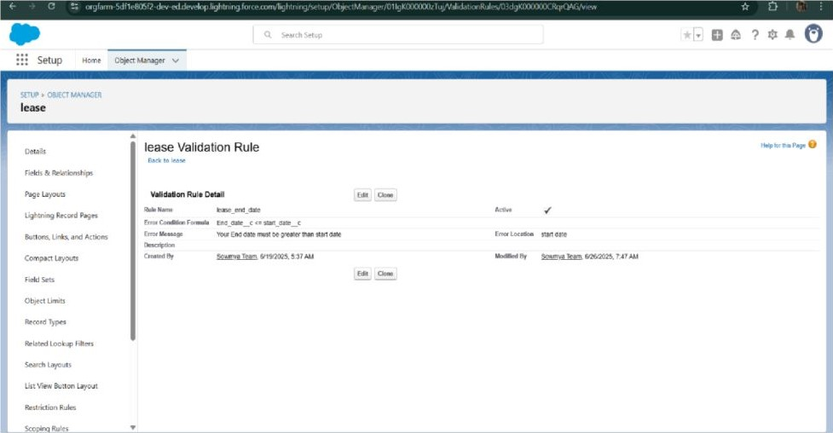
- Added Apex trigger to restrict multiple tenants per property
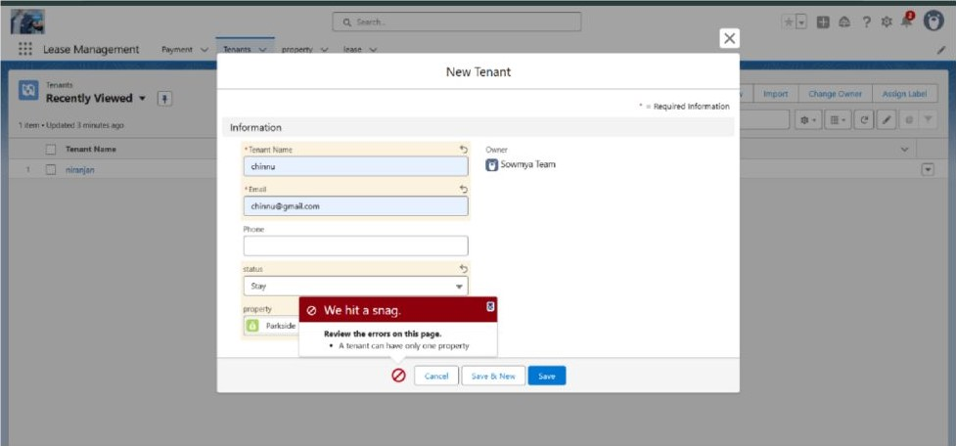
- Scheduled monthly reminder emails using Apex class
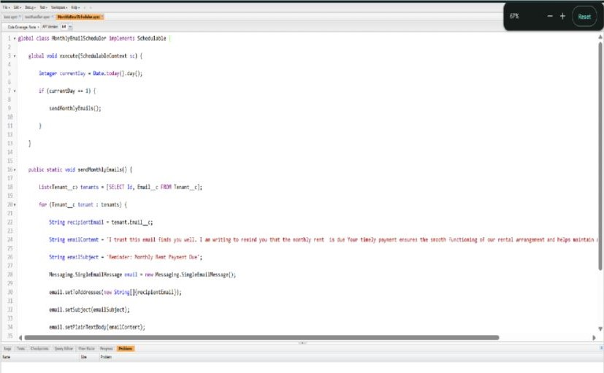
- Built and tested email templates for leave request, approval, rejection, payment, and reminders
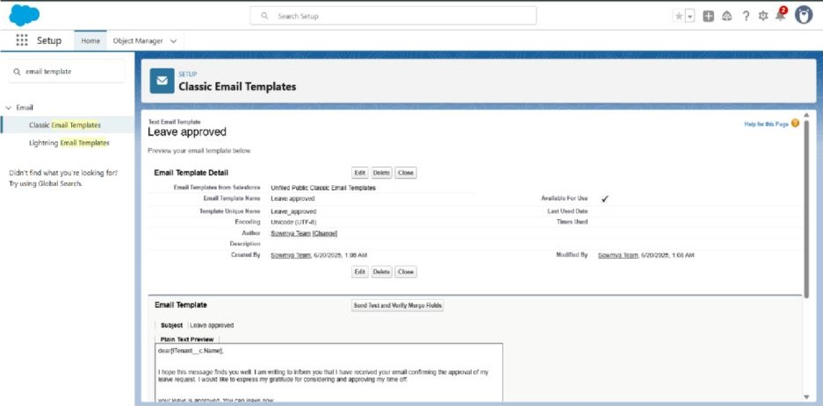
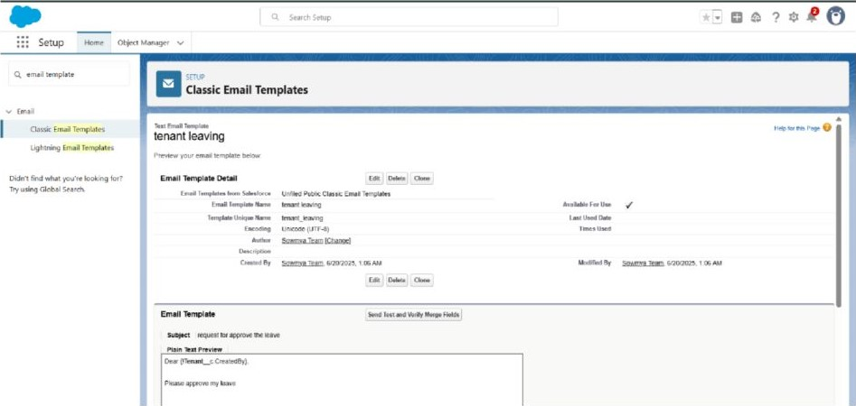
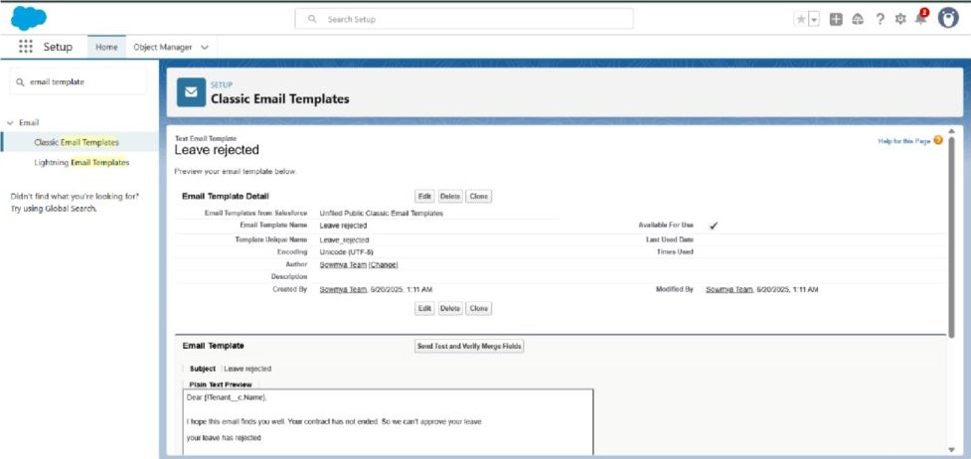
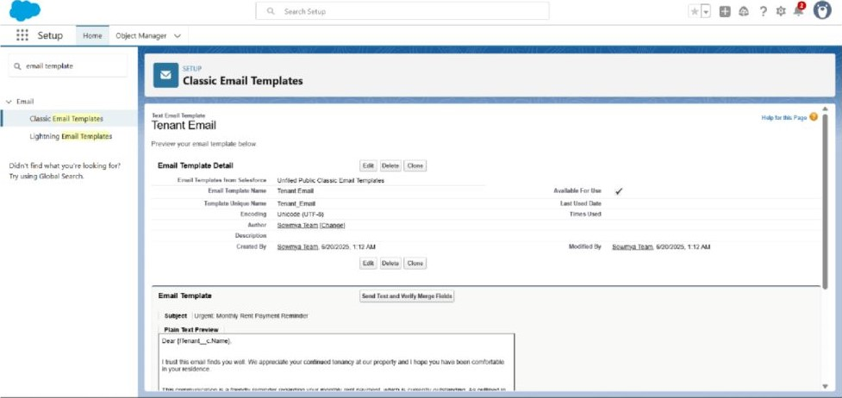
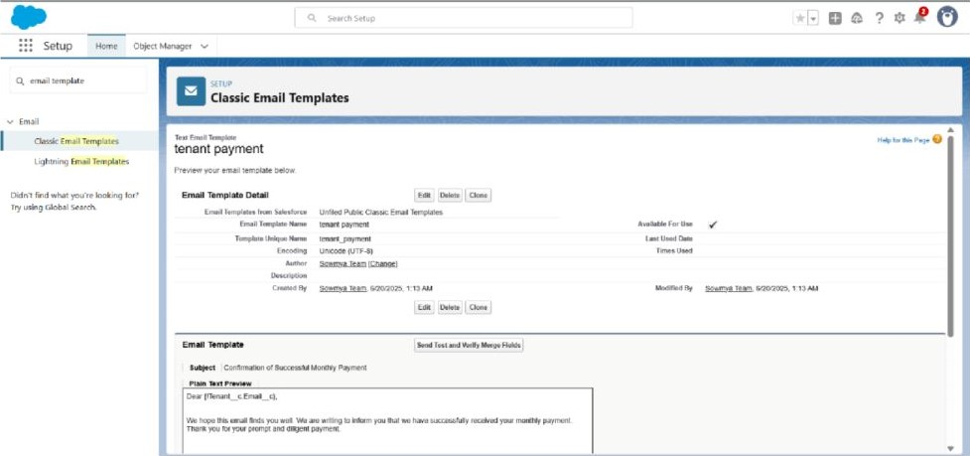
- Approval Process creation
For Tenant Leaving:
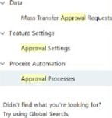 | Approval Processes
 | 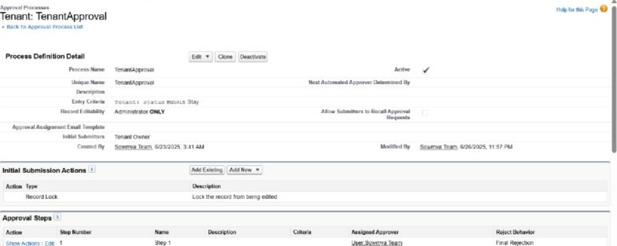
For Check for Vacant:
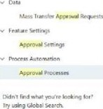 | Approval processes
 | 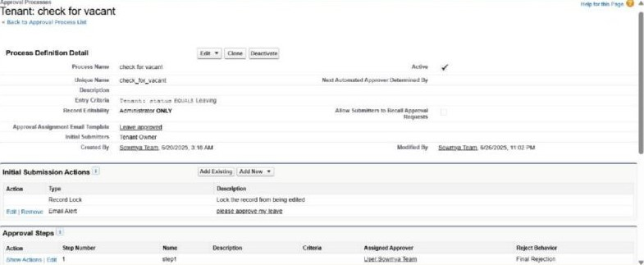
- Apex Trigger
Create an Apex Trigger
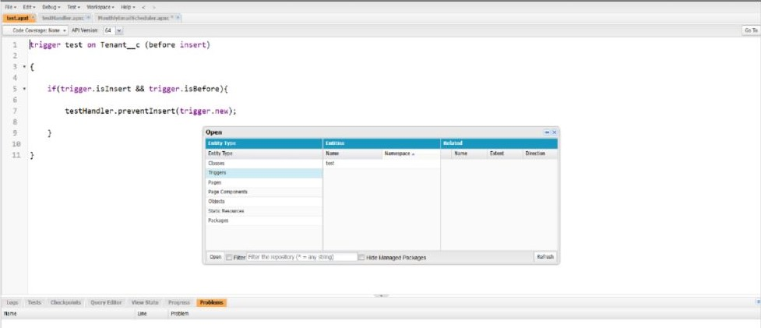
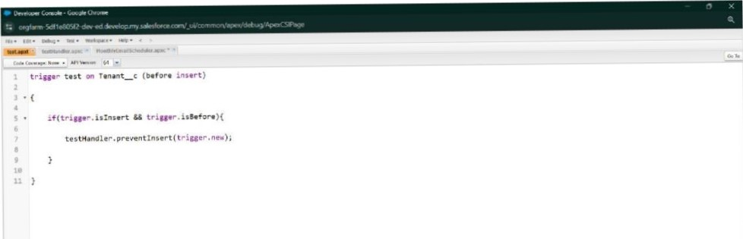
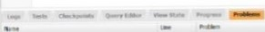
Create an Apex Handler class
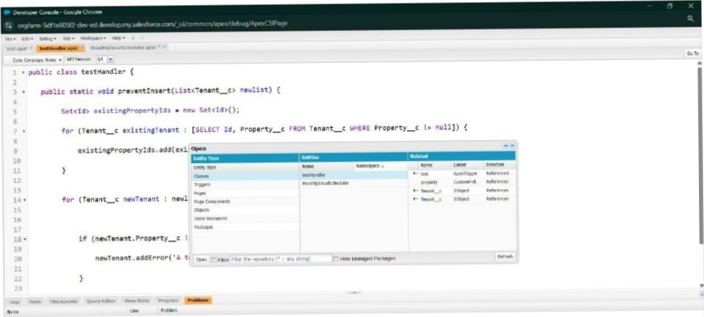
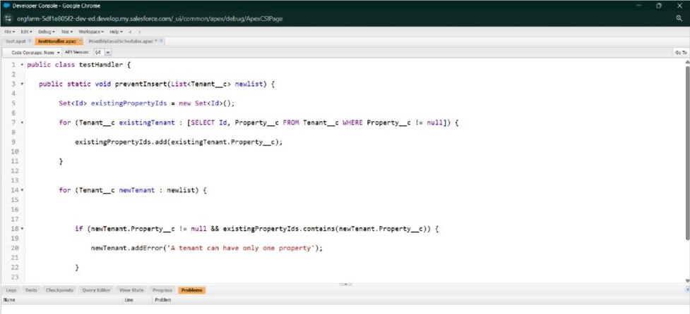
- FLOWS
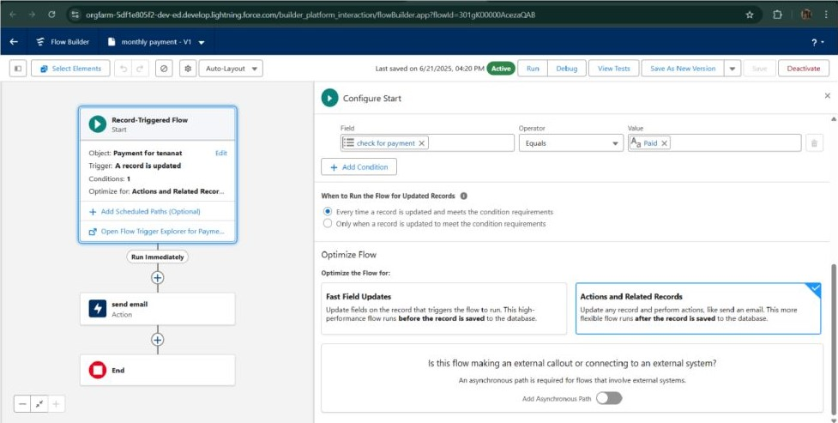
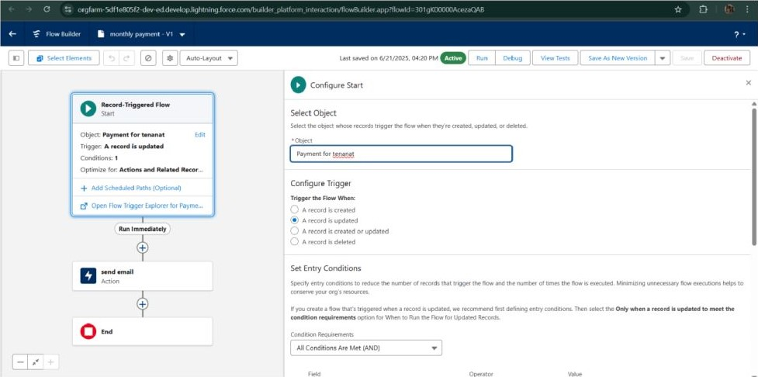
- Schedule class: Create an Apex Class
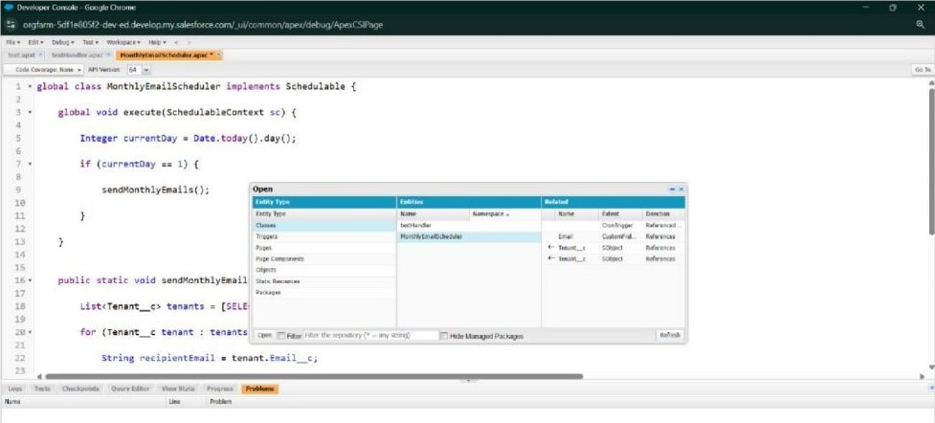
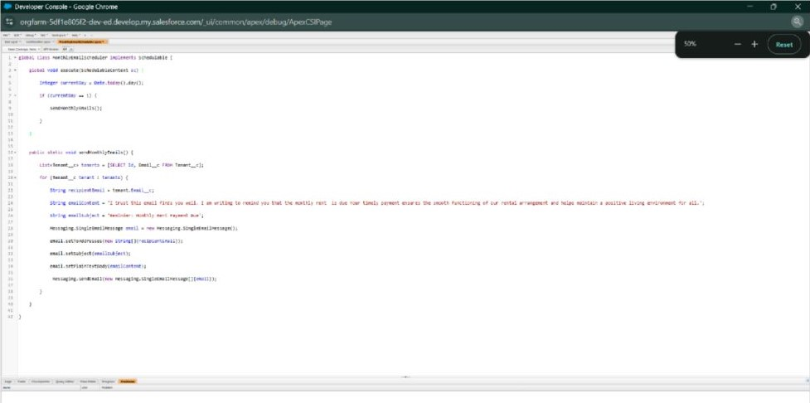
Schedule Apex class
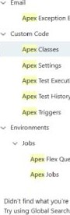  k»king | Apex Classes
 | 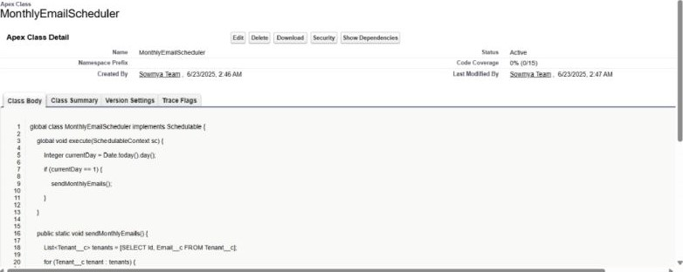
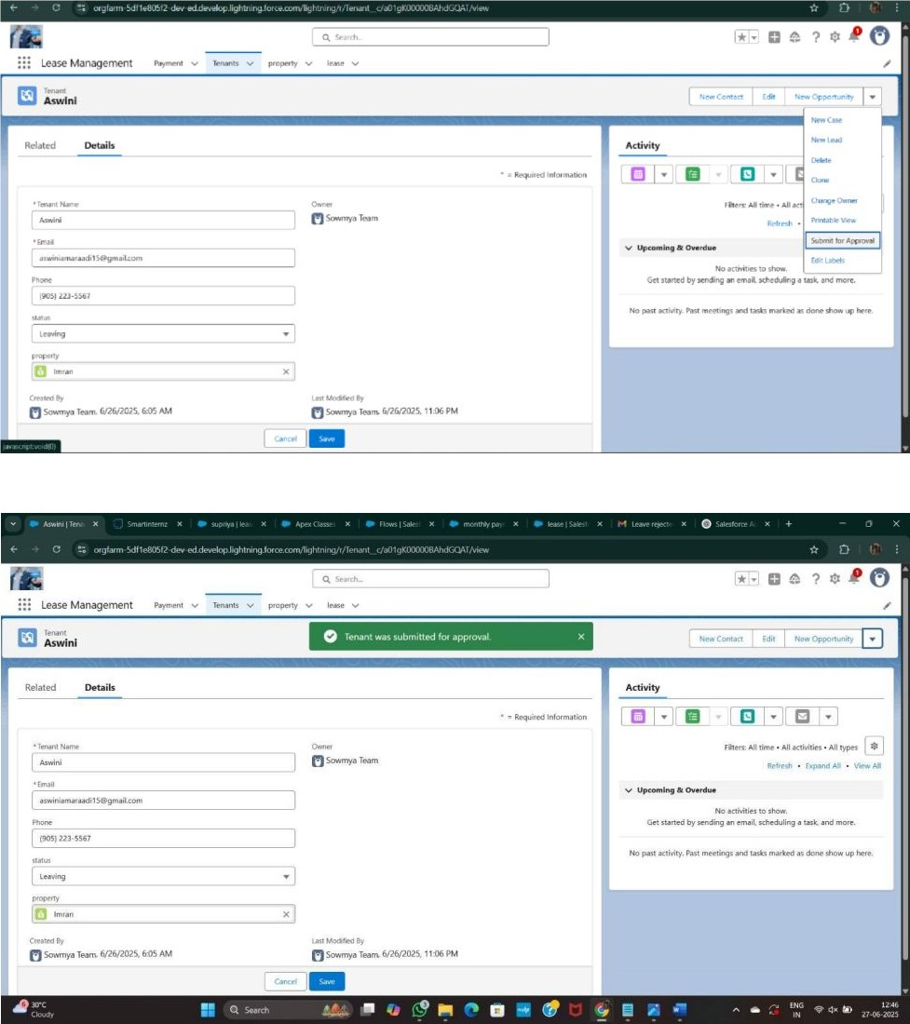
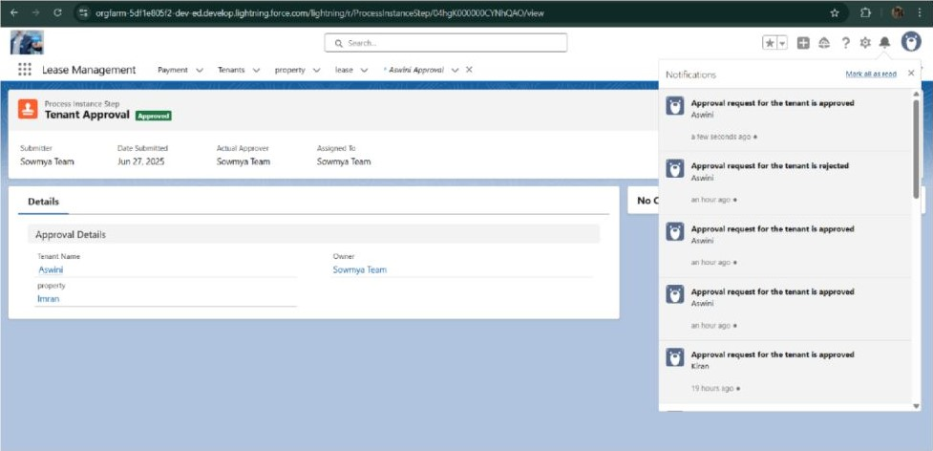

FUNCTIONAL AND PERFORMANCE TESTING
Performance Testing
- Trigger validation by entering duplicate tenant-property records
 |  |  |  | 
 | Lease | New Tenant  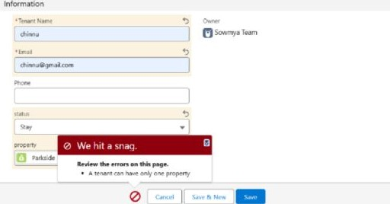
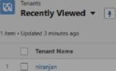
- Validation Rule checking
Lease Management 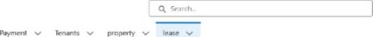 |  |  | 
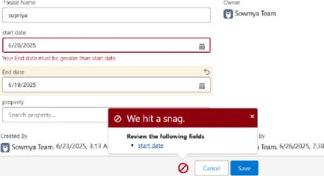AM |  |  | 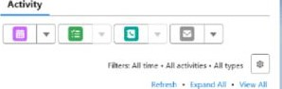  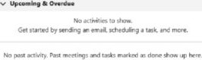
 | Management | 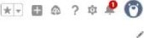
 | 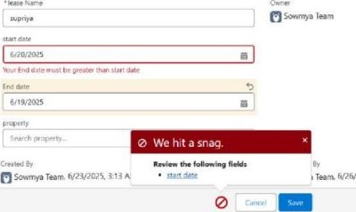 AM |  |  | 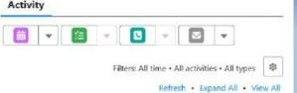  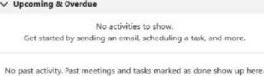
- Test flows on payment update
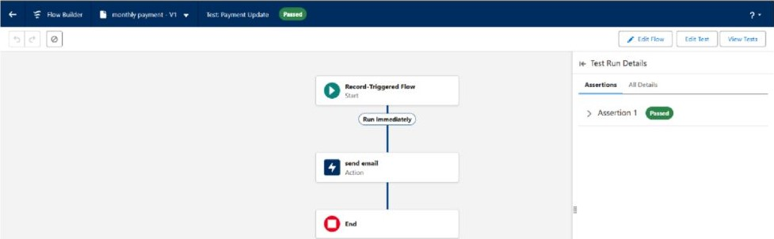
- Approval process validated through email alerts and status updates

Lease Management 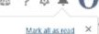
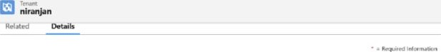  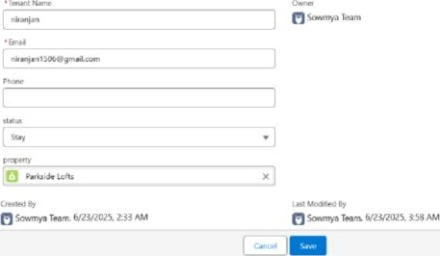 | 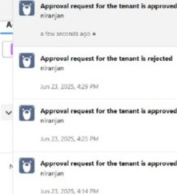
 | 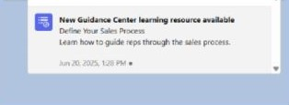
Lea Management  P | ? o
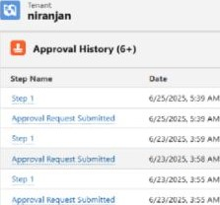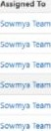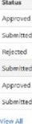  o灬4 | 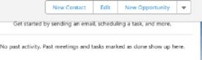

RESULTS
Output Screenshots
- Tabs for Property, Tenant, Lease, Payment
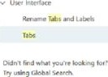 | Tabs
 | 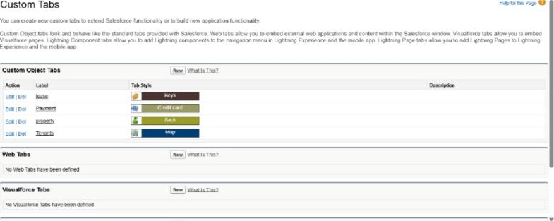
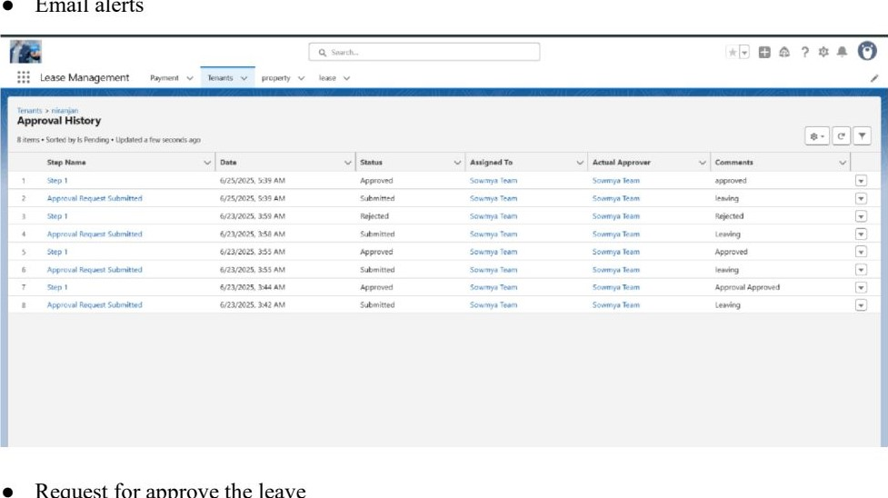
Email
alerts
Request
for
approve
the
leave
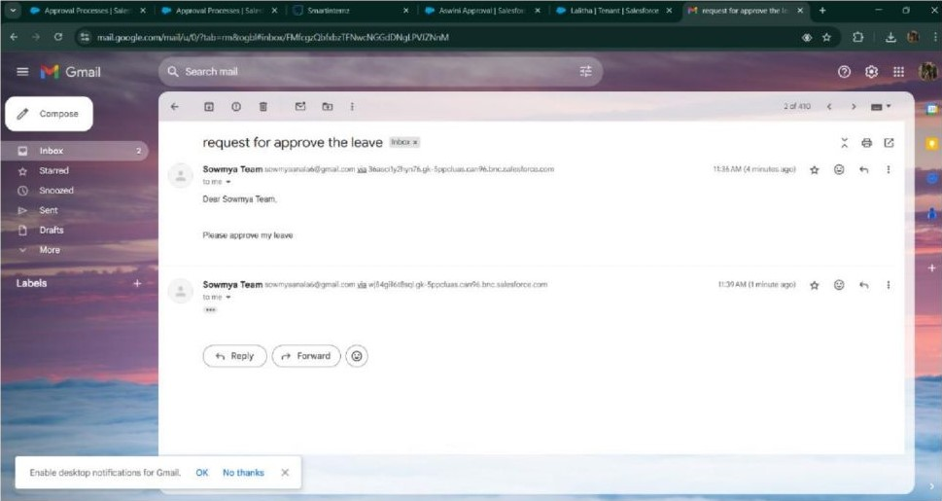
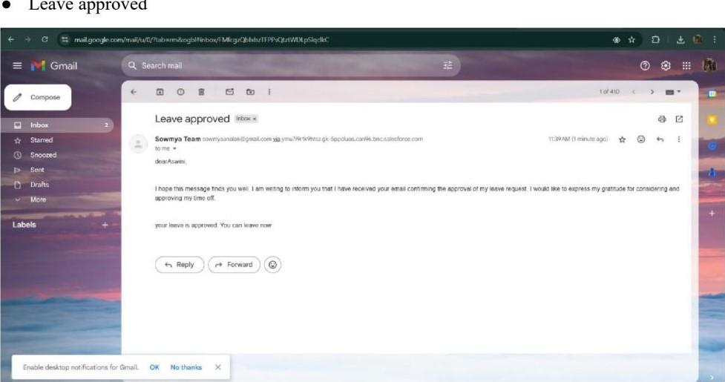
Leave
approved
- Leave rejected
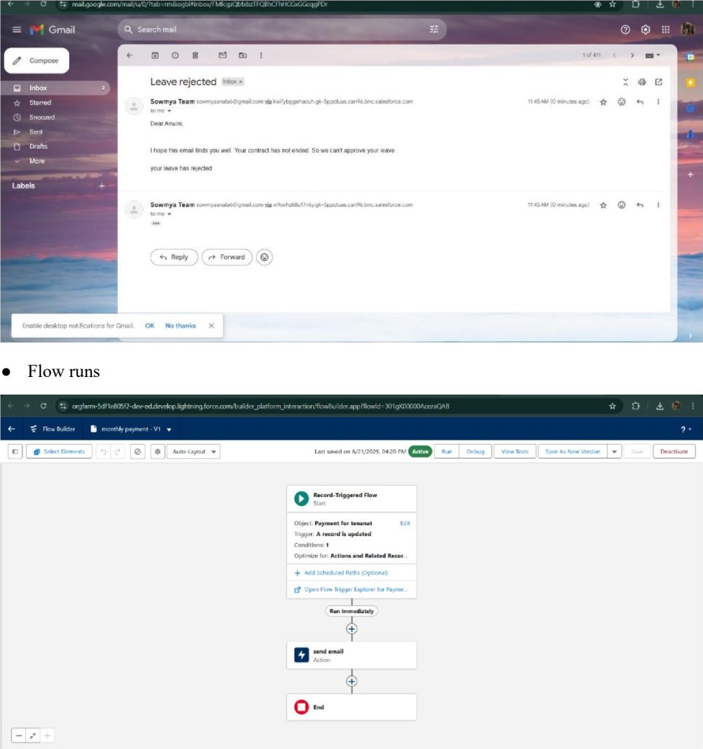
- Trigger error messages
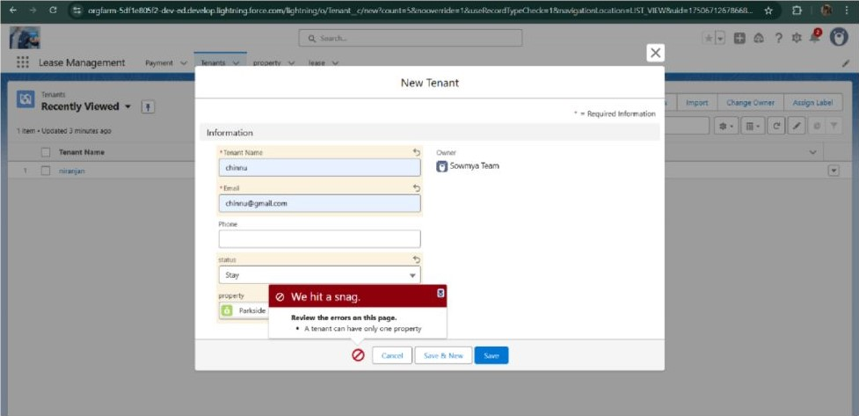
- Approval process notifications
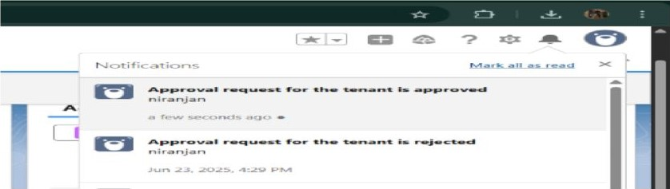

ADVANTAGES & DISADVANTAGES

CONCLUSION
The Lease Management System successfully streamlines the operations of leasing through a structured, automated Salesforce application. It improves efficiency, communication, and data accuracy for both admins and tenants.

APPENDIX
• Source Code: Provided in Apex Classes and Triggers
Test.apxt:
trigger test on Tenant c (before insert) { if
(trigger.islnsert && trigger.isBefore) { testHandler.preventInsert(trigger.new);
testHandler.apxc:
public class testHandler { public static void preventInsert(List< Tenant_c> newlist)
existingPropertyIds
= new Set<ld>()
for (Tenant c existingTenant : [SELECT Id, Property c FROM Tenant c
WHERE Property_c null]) { existingPropertyIds.add(existingTenant.Property c;
} for (Tenant_c newTenant :
newlist) {
if (newTenant.Property_c != null && existingPropertyIds.contains(newTenant.Propertyc)) { newTenant.addError('A tenant can have only one property');
MothlyEmailScheduler.apxc:
global class MonthlyEmailScheduler implements Schedulable { global void execute(SchedulableContext sc) { Integer currentDay Date.today().day(); if (currentDay — l) { sendMonthlyEmails();
} public static void sendMonthlyEmails() { List<Tenant_c> tenants = [SELECT Id, Email c FROM Tenant c]; for (Tenant_c tenant :
tenants) {
String recipientEmail = tenant.Email c;
String emailContent = 'I trust this email finds you well. I am writing to remind you that the monthly rent is due Your timely payment ensures the smooth functioning of our rental arrangement and helps maintain a positive living environment for all.'; String emailSubject — 'Reminder: Monthly Rent Payment Due';
Messaging.SingleEmailMessage email new
Messaging.SingleEmailMessage(); email.setToAddresses(new String[] {recipientEmail}); email.setSubject(emailSubject); email.setPlainTextBody(emailContent);
Messaging.sendEmail(new Messaging.SingleEmailMessage[] {email} );

