PromptBench: A Smart Framework for Prompt Testing and Response Evaluation

P. Bindu
dept. of [CSIT]
[KL University]
Hyderabad, India
Roll No. 2420090092
[2420090092@klh.edu.in]
K. Druvitha
dept. of [CSE]
[KL University]
Hyderabad, India
Roll No. 2420030557
[2420030557@klh.edu.in]
B. Priyamvada
dept. of [CSE]
[KL University]
Hyderabad, India
Roll No. 2420030495
[2420030495@klh.edu.in]

Abstract — Developers building on large language models (LLMs) often need to know which provider works best for a given prompt in terms of quality, speed and cost. Today that usually means pasting the prompt into several provider consoles by hand, which is messy, hard to repeat and does not scale. In this paper we present PromptBench, a full-stack, object-oriented web application built with TypeScript and Next.js. It sends one prompt to several providers, currently Google Gemini and Groq-hosted Llama models, and records each response along with its token usage, latency and estimated cost, which are shown side by side in an interactive dashboard. Provider-specific details are hidden behind a single polymorphic calling interface, so a new provider can be added by implementing a small contract and leaving the calling code untouched. Shared TypeScript interfaces keep the data format consistent across the frontend, backend and evaluation layers. To judge quality, PromptBench uses an LLM-as-judge grader with a general rubric, and a reference-based factuality grader that computes accuracy over a batch dataset of question–answer pairs. Every run, score and batch result is saved in a structured local store so that evaluations can be compared over time. The whole system runs on free API tiers, which makes it easy to reproduce, and it shows how object-oriented principles apply to multi-provider AI development.
Keywords — large language models, prompt evaluation, LLM-as-judge, object-oriented design, polymorphism, model comparison, Next.js, TypeScript

I. INTRODUCTION
Large language models (LLMs) like GPT-3 [1], Gemini [2] and Llama [3] are now part of a lot of everyday software. People use them for question answering, summarizing text, writing code and building chatbots. The trouble is that no two providers behave the same way. Their answers differ in quality, they respond at different speeds, they charge different prices, and their APIs look nothing alike. Even for a single model, rewording a prompt a little can change the output a lot [4], [5]. So when a developer has to pick a provider for a task, the honest answer is usually “try it and see.”
Trying it properly is harder than it sounds. Most developers paste the same prompt into several provider dashboards one after another and compare the answers by eye. That is slow, easy to get wrong and impossible to repeat later. The tools built for serious evaluation are not much better for this job: some are heavy, command-line benchmark frameworks meant for large offline studies [6], [7], and others are one-off scripts that keep no history and have no dashboard.
In this paper we present PromptBench, a full-stack web application built with TypeScript and Next.js that tries to fill this gap. Our contributions are as follows: (1) an object-oriented design that puts several LLM provider APIs behind one common interface; (2) a dashboard that shows each model’s response, token usage, latency and cost side by side; (3) an LLM-as-judge evaluator that scores response quality, plus a reference-based grader that measures factual accuracy over a whole dataset; (4) saved test and batch history, so results can be compared over time; and (5) a setup that runs only on free API tiers, so anyone can reproduce it.
The paper is organized as follows. Section II covers related work, Section III explains the design and methodology, Section IV describes the environment and evaluation setup, Section V talks about limitations, and Section VI concludes.

II. RELATED WORK
Evaluation frameworks. HELM evaluates language models across a broad range of scenarios and metrics [6], and the Language Model Evaluation Harness lets users run a model through many academic benchmarks from the command line [7]. A project with a similar name is the PromptBench library by Zhu et al., which began as a study of how robust LLMs are to adversarial prompts and has grown into a general Python library for evaluation [8]. Our system is a different thing. It is a web application for developers who want to compare providers on their own prompts, rather than a research library for robustness testing. Frameworks like these are very useful, but they are designed for large offline studies, not for quickly checking one prompt and looking at the results.
LLM-as-judge. Having people grade model outputs is expensive and slow, so a growing body of work asks a strong LLM to do the grading. Zheng et al. found that a judge model can agree with human preferences about as often as humans agree with each other, but they also point out biases, such as favoring longer answers, favoring the first answer shown, and favoring its own outputs [9]. G-Eval takes a related route: it gives the LLM task-specific criteria and gets scores that track human judgments better than older automatic metrics [10]. We use the same idea for general quality scoring, and for factual checks we add a reference answer so the judge does not have to rely only on its own knowledge.
Provider abstraction and object-oriented design. Hiding differences behind a stable interface is an old idea in object-oriented design. The Strategy and Adapter patterns [11] and the open–closed principle [12] both describe how to add new implementations without touching the code that uses them. The Vercel AI SDK [13] applies this to LLM providers by giving them one calling interface. We build on that, and add our own typed data contracts, evaluation layer and storage. We also treat the object-oriented structure as a goal of the project in its own right.

III. METHODOLOGY

A. System Design
PromptBench has the layered structure shown in Fig. 1. At the top is a React dashboard with five screens: New Test, Results, Compare Prompts, Batch Evaluation and History. These screens talk to Next.js API routes (App Router) that handle submitting a test, comparing prompts, running a batch dataset, and fetching history and statistics. The routes only know about the common model-calling interface and the evaluation layer. They never deal with a specific provider directly. Everything is saved in a local data store, and a set of shared TypeScript interfaces keeps the data format the same across all layers.
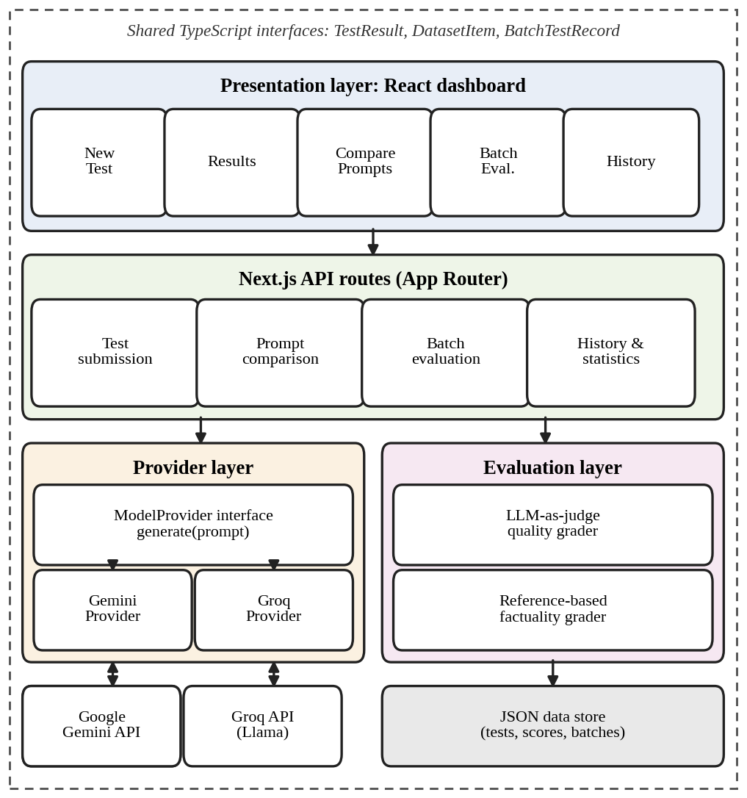
Fig. 1. Layered architecture of PromptBench.
We built the system in six phases. First, we defined the core interfaces and types (TestResult, DatasetItem and BatchTestRecord). Second, we wrote the Gemini and Groq calling code behind one polymorphic interface. Third, we created the API routes, and fourth, the dashboard out of reusable React components. Fifth, we added the LLM-as-judge evaluator, which has a general quality-rubric grader and a reference-based factuality grader. Finally, we tested everything end to end with real API calls to both providers and checked the batch accuracy scoring against a question–answer dataset that we curated by hand.

B. Object-Oriented Architecture
Encapsulation. Gemini and Groq expect different requests and return different responses. We keep all of that provider-specific work, such as building the request, parsing the reply and counting tokens, inside one module per provider. The rest of the application only sees a uniform interface, so nothing else depends on how a particular provider works.
Abstraction. A few shared TypeScript interfaces (TestResult, DatasetItem and BatchTestRecord) act as the data contract between the frontend, the backend and the evaluation layer. Listing 1 shows a simplified version. Because of this, the dashboard can display results without caring which provider produced them.
Polymorphism. Every provider is called with the same method signature, whatever happens inside it. The routing layer picks the right implementation at run time. To add a new provider, a developer only has to implement the small interface in Listing 1. None of the calling code needs to change.
interface TestResult {
model: string; response: string;
tokens: number; latencyMs: number;
cost: number; score?: number;
}
interface ModelProvider {
readonly id: string;
generate(prompt: string): Promise<TestResult>;
}
class GeminiProvider implements ModelProvider {...}
class GroqProvider implements ModelProvider {...}
Listing 1. Simplified data contract and provider interface (illustrative).

C. Test and Comparison Pipeline
When a prompt is submitted, the routing layer sends it to each selected provider and records the response, token usage, latency and cost. We measure latency on the server as the time between sending the request and receiving the full response:
L = t_{end} − t_{start} (1)
The cost of a call is estimated from the number of prompt and completion tokens and a price table that can be configured:
C = (n_{in}·p_{in} + n_{out}·p_{out}) / 10⁶ (2)
Here n stands for the token counts and p for the price per million tokens. Since we only use free tiers, C is what the same call would cost on a paid plan, not an amount we were actually charged. The Compare Prompts screen applies the same pipeline to several versions of a prompt, so you can see how rewording affects each model.

D. LLM-as-Judge Evaluation

1) General quality grader
A second LLM call is given the original prompt, the response and a scoring rubric, and it returns a numeric quality score. We ask for structured output so the score can be read reliably and saved with the test result.

2) Reference-based factuality grader
If a reference answer is available, the judge gets the question, the reference and the model’s response, and decides whether the response agrees with the reference factually. Checking against a reference instead of the judge’s own knowledge keeps the verdict grounded and reduces the effect of judge mistakes [9]. The result is a simple 0 or 1, written as c ∈ {0, 1}, which is used for the batch accuracy score.

E. Batch Evaluation
The Batch Evaluation screen runs a whole dataset of DatasetItem records (each a question with a reference answer) against the chosen models. For a model m and a dataset with N items, accuracy is
Acc_{m} = (100 / N) Σ c_{m,i} (3)
The accuracy of each model, along with its average latency and cost, is saved as a BatchTestRecord. That makes it easy to compare models, prompts or dates later. Fig. 2 gives an overview of the flow.
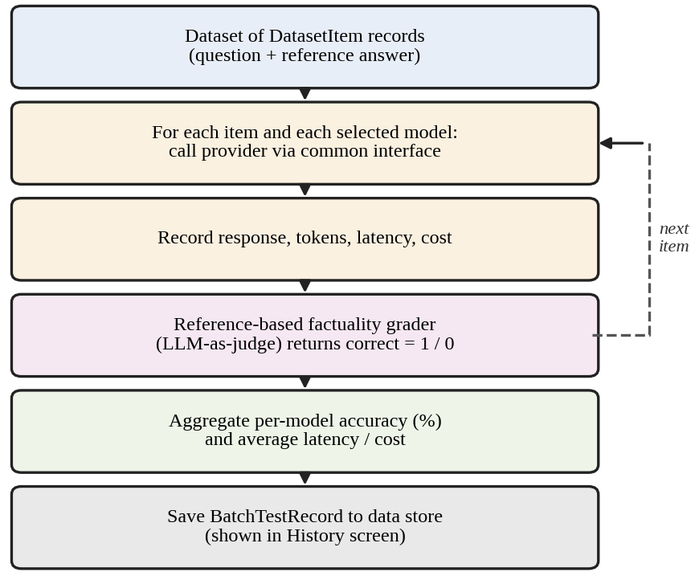
Fig. 2. Batch evaluation flow.

F. Persistence
Test runs, judge scores and batch results are all saved in a local data store made of JSON files. This keeps the project free of extra dependencies and simple to reproduce, and it can be upgraded to SQL or PostgreSQL later. The History screen reads from the store, so past evaluations can be reviewed, filtered and compared.

IV. EXPERIMENTAL SETUP AND RESULTS

A. Software and Hardware Environment
We built and ran PromptBench with the software and hardware listed in Table I. Both providers are used through their free API tiers, and the Vercel AI SDK [13] handles provider abstraction. The machine requirements are modest because the models run on the providers’ servers, but an internet connection is needed for the API calls.
TABLE I
Development and Runtime Environment
Component | Specification
Runtime | Node.js 18+ and TypeScript
Framework | Next.js (React, App Router)
LLM providers | Google Gemini API and Groq API (free tiers)
Abstraction | Vercel AI SDK
Storage | JSON files (upgradeable to SQL/PostgreSQL)
Editor | VS Code or equivalent IDE
Memory | Minimum 4 GB RAM
Processor | Intel i3 or above
Disk space | 500 MB for project and dependencies
Network | Internet connection required

B. Dashboard Implementation
Each of the five screens is made from reusable React components. On New Test, the user enters a prompt and picks the providers. Results shows the responses side by side along with the fields in Table II. Compare Prompts puts several prompt variants next to each other. Batch Evaluation runs a dataset and reports accuracy for each model, and History lists the saved runs so they can be reviewed and filtered.
TABLE II
Data Recorded for Each Test Run
Field | Description
Response | Full text returned by the model
Token usage | Prompt and completion token counts
Latency | Server-side wall-clock time, Eq. (1)
Cost | Estimated cost from token counts, Eq. (2)
Quality score | Score from the LLM-as-judge grader

C. Evaluation Protocol
We judge quality in two ways. For open-ended prompts we use the LLM-as-judge quality score. For batch mode we use our hand-curated question–answer dataset, whose reference answers let the factuality grader produce accuracy as in Eq. (3). Latency and cost are recorded for every call. Table III compares PromptBench with the two kinds of approaches described in Section I, and Table IV lists what we report for each model in the batch run.
TABLE III
Qualitative Comparison of Evaluation Approaches
Capability | Manual consoles | Benchmark frameworks | PromptBench
Side-by-side providers | No | Varies | Yes
Interactive dashboard | No | Rarely | Yes
Persistent history | No | Varies | Yes
Pluggable provider interface | N/A | Yes | Yes
Batch reference scoring | No | Yes | Yes
Free-tier operation | Varies | Varies | Yes

TABLE IV
Batch Evaluation Results per Model
Model | Accuracy (%) | Avg. latency (ms) | Avg. cost
Gemini | [value] | [value] | [value]
Groq / Llama | [value] | [value] | [value]

One practical benefit of this design is that adding another provider to Table IV only means registering one more implementation of the provider interface. The API routes and the dashboard stay as they are. Results from every provider are stored in the same format, so they can be compared directly across runs and dates.

V. DISCUSSION
The main thing PromptBench does is turn a messy, manual habit (trying a prompt on a few models and judging the answers by eye) into something structured and repeatable. Because the differences between providers are kept inside one module each, extending the system is cheap, and a new provider automatically gets the dashboard, the judge and the history. Staying within free API tiers also means students and small teams can reproduce the whole workflow without paying for anything.
There are some limitations we should be upfront about. First, LLM-as-judge scores carry the biases of the judging model, such as a liking for longer answers or for its own style [9]. Using a reference answer helps but does not remove this, so a person should still spot-check the verdicts. Second, the latency we measure is end to end. It includes network delay and free-tier queuing, so it shows what a user would experience, not how fast the model itself is. Third, free tiers have rate limits that cap the size of batch runs, and our hand-made dataset is small, so the accuracy numbers should not be over-generalized. Last, a JSON-file store works for one user but not for many users at once.
In future work we would like to add more providers, move the store to PostgreSQL, use more than one judge model to lessen single-judge bias, repeat each call to report variation in latency and quality, and add significance tests to the comparison views.

VI. CONCLUSION
We presented PromptBench, an object-oriented, full-stack web application for evaluating prompts across several LLM providers. Hiding provider details behind one interface, sharing typed data contracts and calling every provider polymorphically make the system easy to extend. The dashboard, LLM-as-judge evaluator, batch accuracy scoring and saved history together help developers choose a model based on evidence while they work on their prompts. The project also shows that ordinary object-oriented ideas carry over well to a modern problem like working with several AI providers at once.

ACKNOWLEDGMENT
The authors would like to thank P. SriLakshmi, Assistant Professor, for her guidance throughout this project, which was done as part of the course Applied Machine Learning for Text Analysis (24ALT3101).

REFERENCES
[1] T. B. Brown et al., “Language models are few-shot learners,” in Proc. Adv. Neural Inf. Process. Syst. (NeurIPS), vol. 33, 2020, pp. 1877–1901.
[2] Gemini Team, Google, “Gemini: A family of highly capable multimodal models,” arXiv:2312.11805, 2023.
[3] A. Grattafiori et al., “The Llama 3 herd of models,” arXiv:2407.21783, 2024.
[4] J. Wei et al., “Chain-of-thought prompting elicits reasoning in large language models,” in Proc. Adv. Neural Inf. Process. Syst. (NeurIPS), vol. 35, 2022, pp. 24824–24837.
[5] P. Liu et al., “Pre-train, prompt, and predict: A systematic survey of prompting methods in natural language processing,” ACM Comput. Surv., vol. 55, no. 9, Art. no. 195, 2023.
[6] P. Liang et al., “Holistic evaluation of language models,” Trans. Mach. Learn. Res., 2023.
[7] L. Gao et al., “A framework for few-shot language model evaluation,” Zenodo, 2021.
[8] K. Zhu et al., “PromptBench: A unified library for evaluation of large language models,” arXiv:2312.07910, 2023.
[9] L. Zheng et al., “Judging LLM-as-a-judge with MT-Bench and Chatbot Arena,” in Proc. Adv. Neural Inf. Process. Syst. (NeurIPS) Datasets and Benchmarks Track, vol. 36, 2023.
[10] Y. Liu et al., “G-Eval: NLG evaluation using GPT-4 with better human alignment,” in Proc. Conf. Empirical Methods Nat. Lang. Process. (EMNLP), Singapore, 2023.
[11] E. Gamma, R. Helm, R. Johnson, and J. Vlissides, Design Patterns: Elements of Reusable Object-Oriented Software. Reading, MA, USA: Addison-Wesley, 1994.
[12] B. Meyer, Object-Oriented Software Construction, 2nd ed. Upper Saddle River, NJ, USA: Prentice Hall, 1997.
[13] Vercel Inc., “AI SDK documentation,” [Online]. Available: https://ai-sdk.dev/docs. [Accessed: Oct. 26, 2026].

