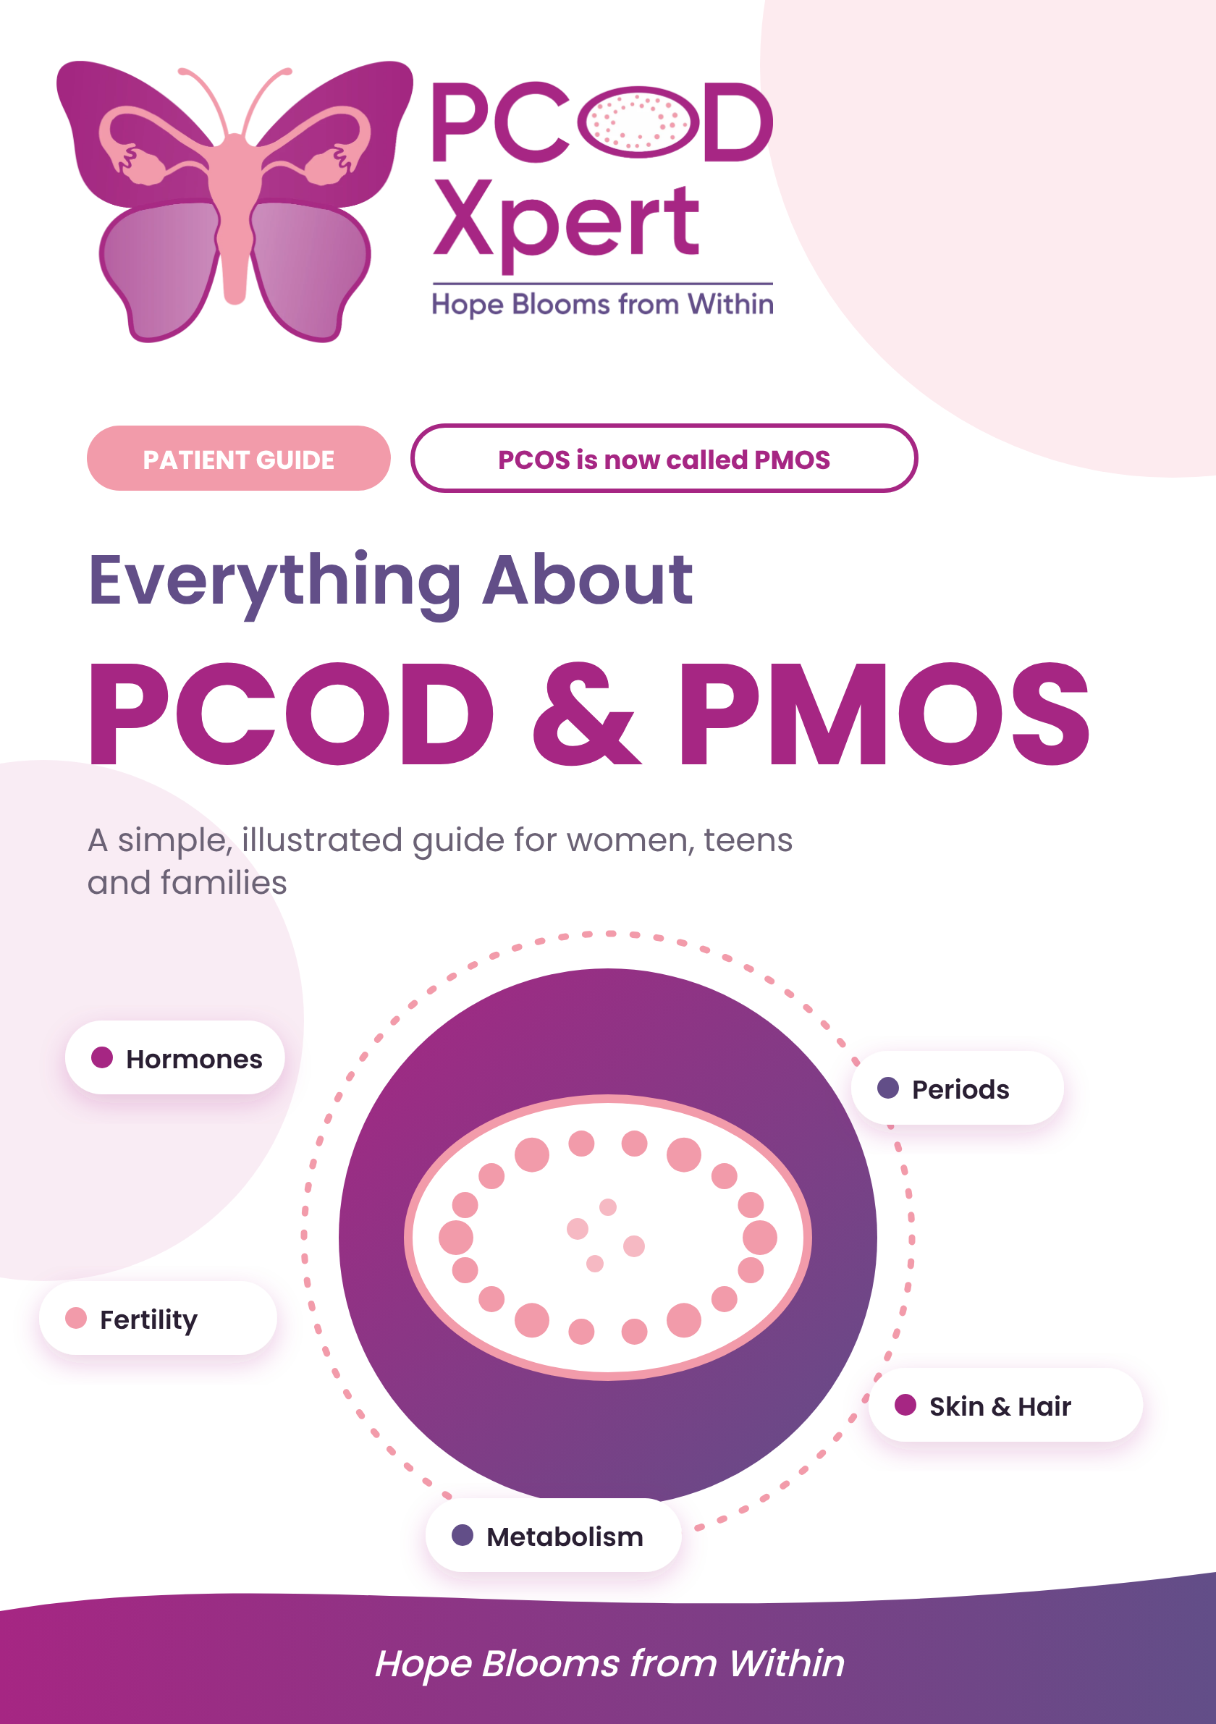

START HERE
Welcome

If you have been told you have PCOD or PCOS, you are not alone. About 1 in 5 women of reproductive age lives with it. It is common, it is manageable, and understanding it is the first step.
How to use this booklet
- Read one page at a time. Each page explains one idea with a picture.
- Use the symptom decoder (page 14) to understand what your body is telling you.
- Fill in the tracker (page 26) and bring it to your appointment.

For teens and parents
Irregular periods are common in the first 2 to 3 years after the first period. A doctor can check whether it is simply your body settling in, or something that needs care.

In this booklet
3 | What are PCOM, PCOD, PCOS, PMOS? | 4 | The spectrum and the new name
5 | Your monthly cycle | 6 | The hormones
7 | Why it happens | 8 | Symptoms to watch for
9 | Periods: normal or not? | 10 | Hair, acne and hair fall
11 | Insulin and metabolic syndrome | 12 | Fertility and pregnancy
13 | How it is diagnosed | 14 | Symptom decoder
15 | Eating well | 16 | Your 5-phase eating roadmap
17 | Move, sleep, calm | 18 | Treatment options
19 | How we treat: periods, skin, hair | 20 | How we treat: weight, sleep, womb
21 | Mind and long-term health | 22 | Our PCOD Xpert team
23 | 3 and 6 month programmes | 24 | Myths and facts
25 | Questions and answers | 26 | My tracker
27 | Patient stories | 28 | Contact us

THE BASICS
What are PCOM, PCOD, PCOS and PMOS?

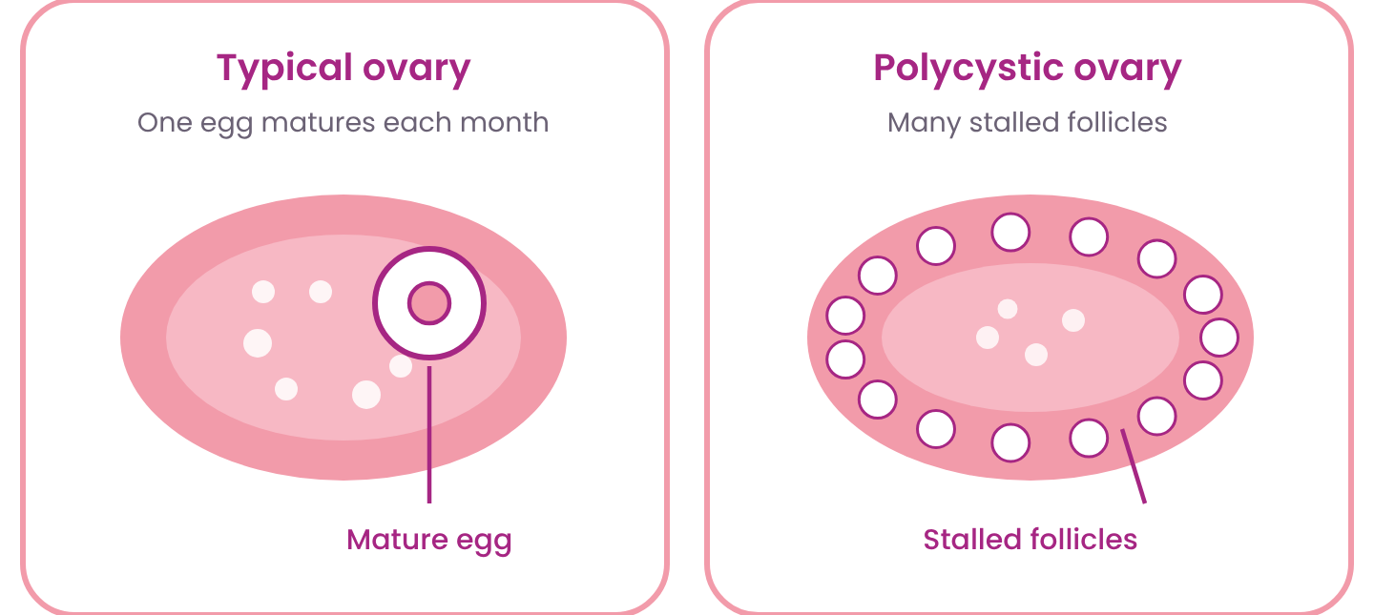
Your ovaries store eggs inside tiny fluid-filled sacs called follicles. Each month one follicle usually grows, matures and releases an egg. In this family of conditions, many follicles start growing but stall, so the egg is not released on time.
Not "cysts" you need to remove
The small dots seen on a scan are stalled follicles, not harmful cysts. They do not turn into cancer and usually do not need surgery.

Four names you may hear
PCOM | Polycystic Ovarian Morphology. Small follicles seen on a scan only.
PCOD | Polycystic Ovarian Disorder. A mild hormone and cell imbalance.
PCOS | Polycystic Ovary Syndrome. A whole-body hormone and metabolic condition.
PMOS | Polyendocrine Metabolic Ovarian Syndrome. The new official name for PCOS.
Good to know
- Not your fault. Genes, hormones and insulin all play a part.
- Manageable. Most symptoms improve with the right care.

THE NEW NAME
The spectrum and the new name

Doctors now see these as steps on one spectrum. Your doctor decides where you are after your history, tests and scan.
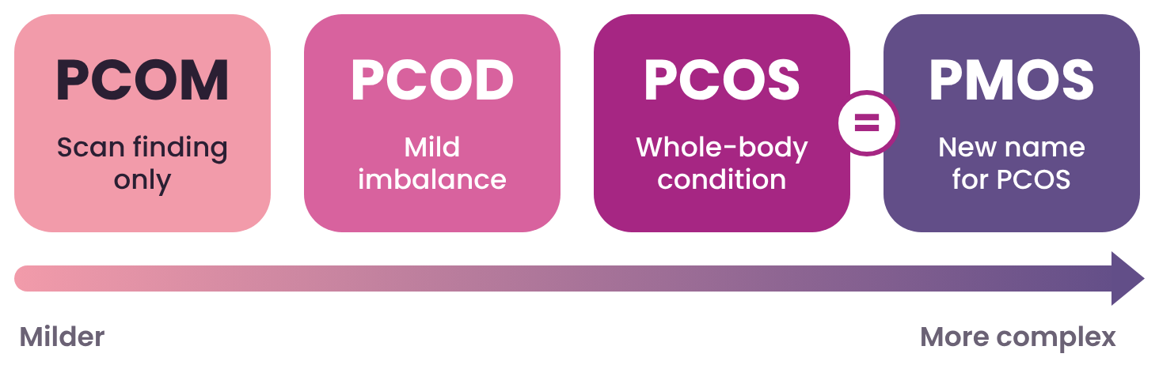
Name | What it means | Usual plan
PCOM | Small follicles seen on the scan only. Not hormonal. Periods are regular, conceiving is easy and there are no symptoms. | 1 to 2 months of a targeted diet
PCOD | A mild hormone and cell imbalance. Signalling between the ovary's two cell types breaks down, so immature eggs may be released. Irregular periods, weight gain and acne can appear. | 3 to 4 months: targeted diet, activity, lifestyle changes and some medicines
PCOS | A more complex, whole-body hormone and metabolic condition. High androgens disrupt ovulation and raise the risk of insulin resistance, diabetes and heart problems. | 3 to 6 month structured plan, then regular reviews
PMOS | The new official name for PCOS. It stresses the whole-body hormone and metabolic nature, not just the ovaries. | Same care as PCOS

Why PCOS became PMOS
The old name made it sound like an ovary problem with "cysts". In truth it involves insulin, many hormones and metabolism across the whole body. PMOS is the new official name for PCOS, agreed by international medical bodies and expert groups.

YOUR BODY
Your monthly cycle

A typical cycle is a dance of hormones between your brain, ovaries and womb. Day 1 is the first day of bleeding.
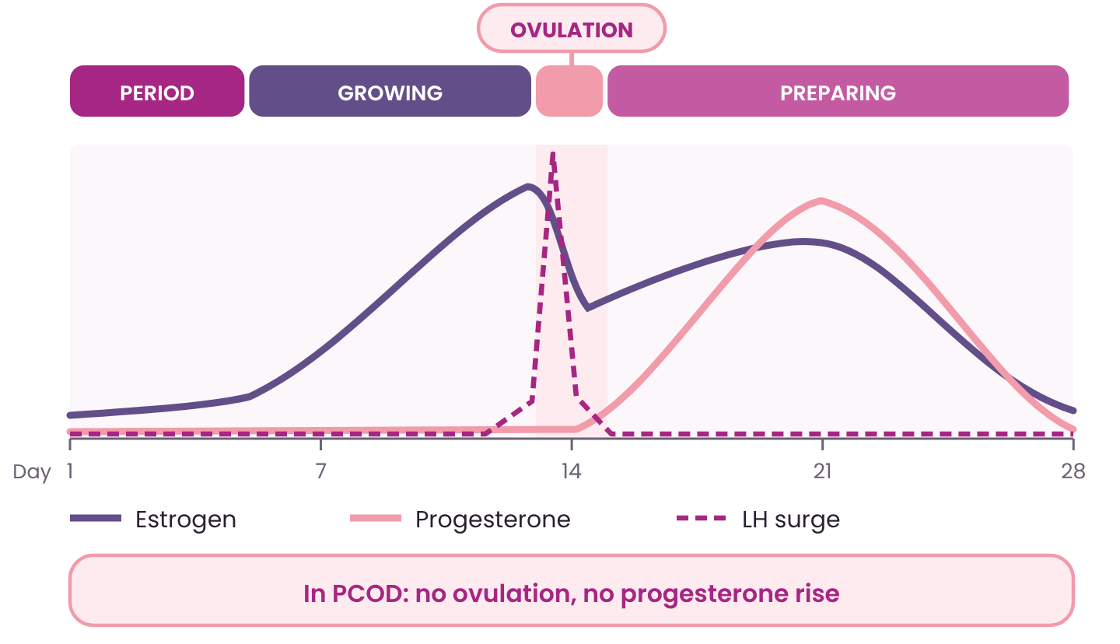
Period  Day 1-5  The womb lining sheds as bleeding. | Growing  Day 1-13  Egg sacs grow. Estrogen rises and rebuilds the lining. | Ovulation  About day 14  A surge of LH releases the egg. | Preparing  Day 15-28  Progesterone prepares the womb. No pregnancy? Period starts.

What changes in PCOD?
The egg often does not release. Without ovulation there is no progesterone rise, so periods become late, missed or heavy, and getting pregnant takes longer.

YOUR BODY
The hormones

Hormones are chemical messengers. The brain sends signals to the ovaries, and the ovaries send signals back. In PCOD this conversation gets out of balance.
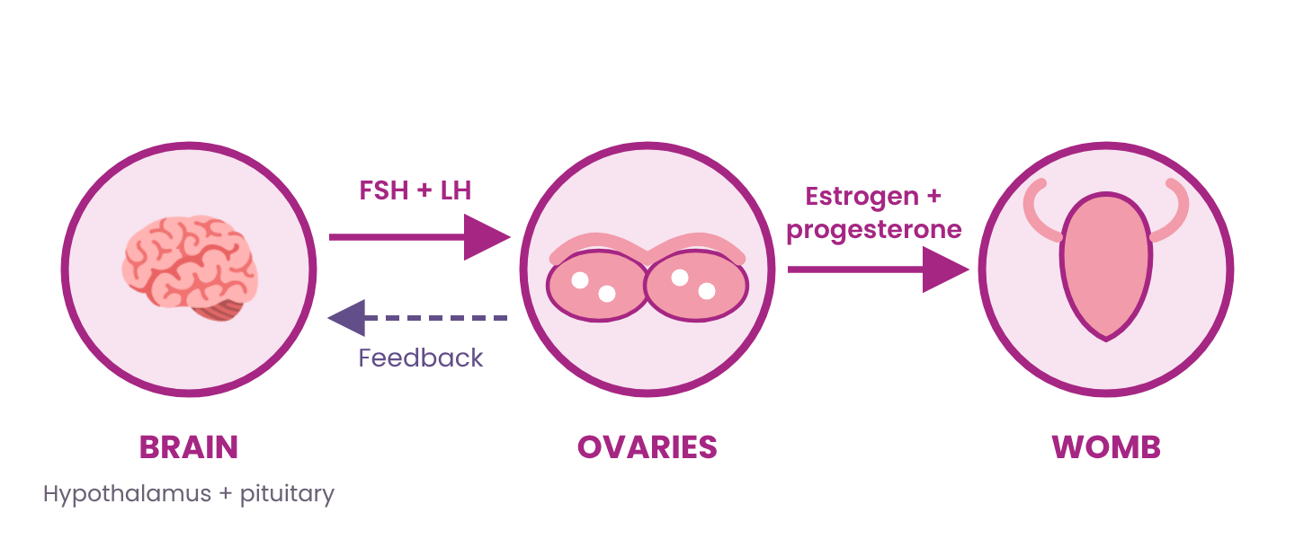
FSH  Grows the egg sac each month. | LH  Triggers egg release. Often higher in PCOD. | Estrogen  Builds the womb lining. Supports skin and bones.
Progesterone  Prepares the womb after ovulation. Low in PCOD. | Androgens  Hormones every woman makes in small amounts. Higher in PCOD: acne, hair. | Insulin  Moves sugar into cells. Often high in PCOD.

Thyroid and prolactin problems can look like PCOD. That is why we always test them too.

THE CAUSE
Why does PCOD happen?

There is no single cause. Several things add up and keep each other going, like a circle.
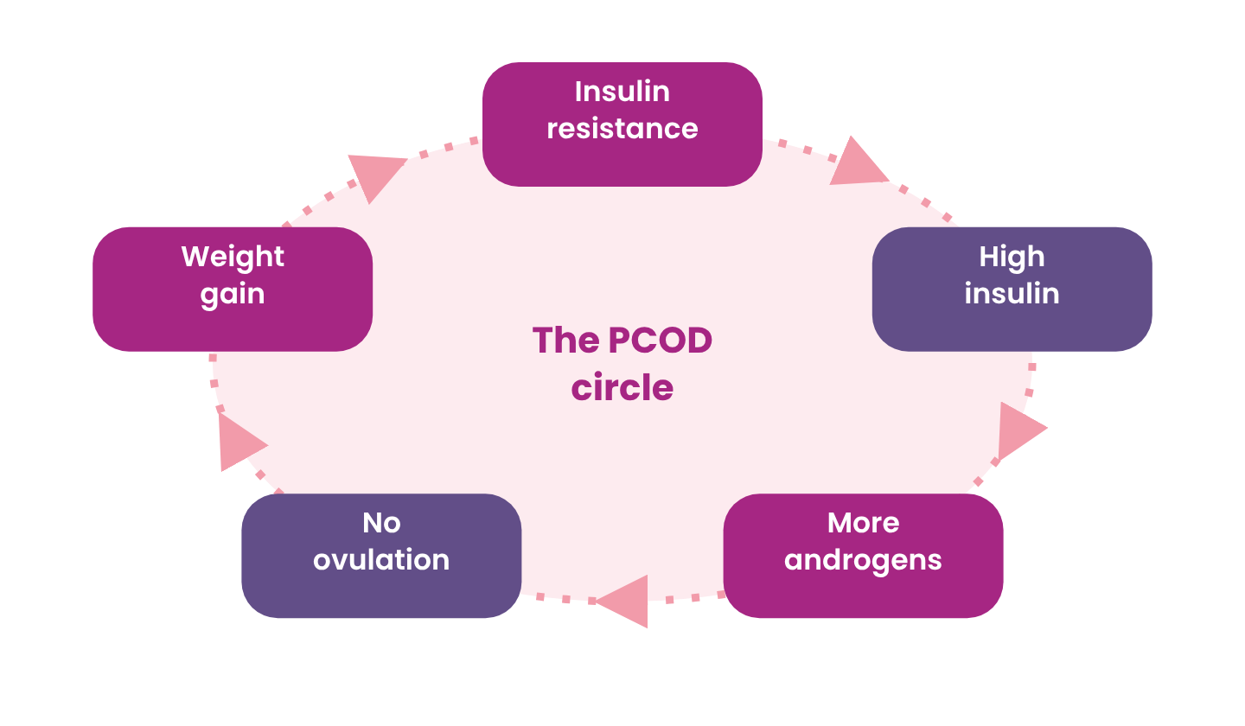
What adds up
- Family history: mother, sister or aunt with PCOD or diabetes.
- Insulin resistance: cells respond poorly to insulin.
- Extra androgens: ovaries and adrenal glands make more.
- Low-grade inflammation in the body keeps insulin resistance going.
- Lifestyle: low activity, poor sleep, stress and extra weight can make it worse.

The good news
You can break the circle at any point. If you carry extra weight, losing even 5 to 10% of your body weight can bring back regular ovulation and periods.

SYMPTOMS
Symptoms to watch for

You may have only a few of these. Every woman is different. Numbers match the picture.
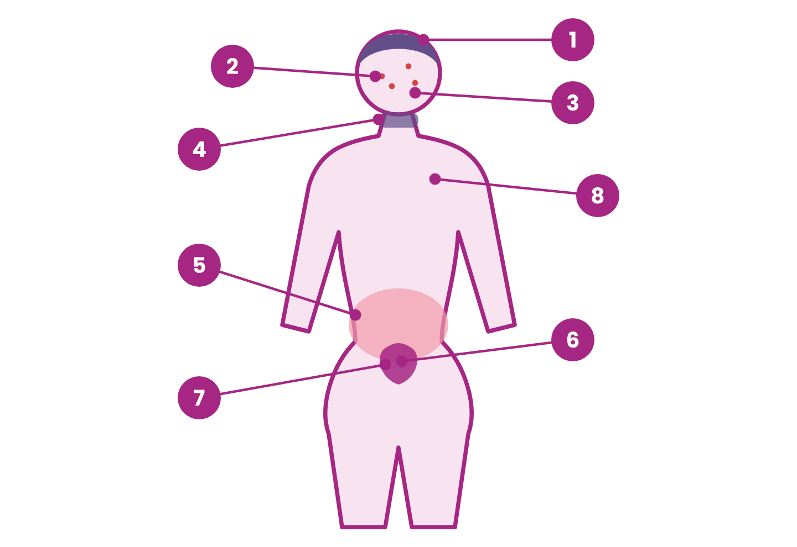
1 | Hair thinning at the parting | 2 | Acne and oily skin
3 | Extra dark hair on chin, upper lip | 4 | Dark, velvety patches on neck, underarms
5 | Weight gain, especially around the belly | 6 | Irregular, missed or heavy periods
7 | Difficulty getting pregnant | 8 | Low mood, anxiety, tiredness, poor sleep

See a doctor if you notice two or more of these, or if one is bothering you.

SYMPTOMS
Periods: normal or not?

Periods are a monthly report card of your hormones. Here is how to read it.
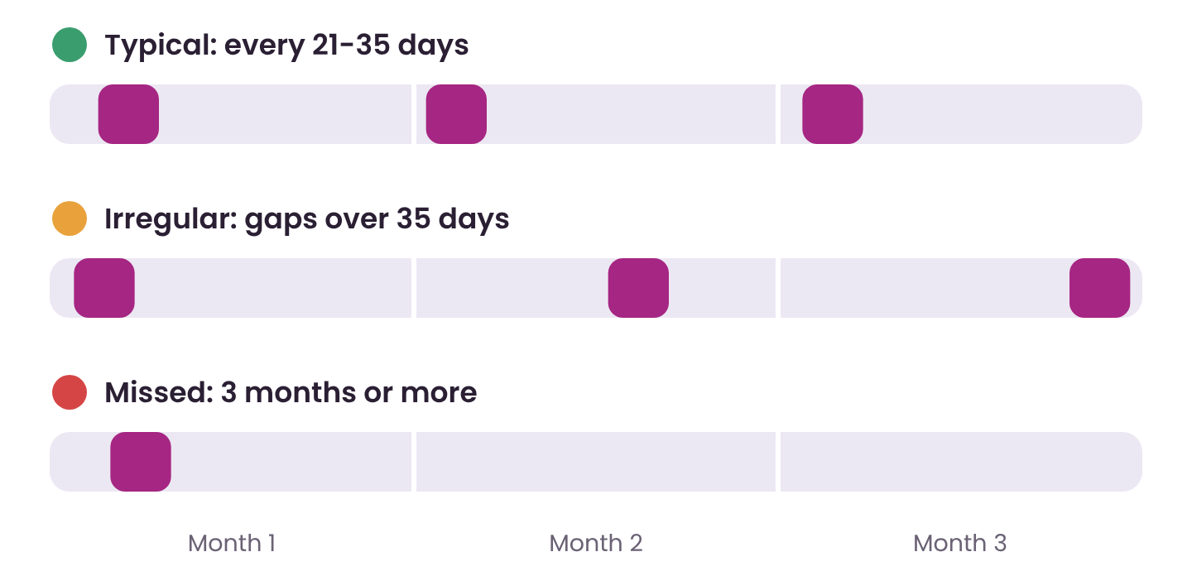
Typical | A period every 21 to 35 days. Bleeding lasts 2 to 7 days. A pad changes every 3 to 4 hours or less often.
Worth checking | Cycles longer than 35 days, fewer than 8 periods a year, skipping months, spotting between periods.
See a doctor soon | No period for 3 months (and not pregnant). Soaking a pad every hour for 2 hours. Large clots. Bleeding over 7 days. Severe pain.

Why skipped periods matter
If periods are missed for many months, the womb lining can keep thickening. Over the years this can cause heavy bleeding and, rarely, serious lining changes. A doctor can give a simple treatment to protect it.

For teens
See a doctor if there is no period by age 15, or more than 3 years after breast growth began.

SYMPTOMS
Hair, acne and hair fall

Androgens make some hair follicles grow thick, dark hair and make oil glands more active. Others, on the scalp, shrink.
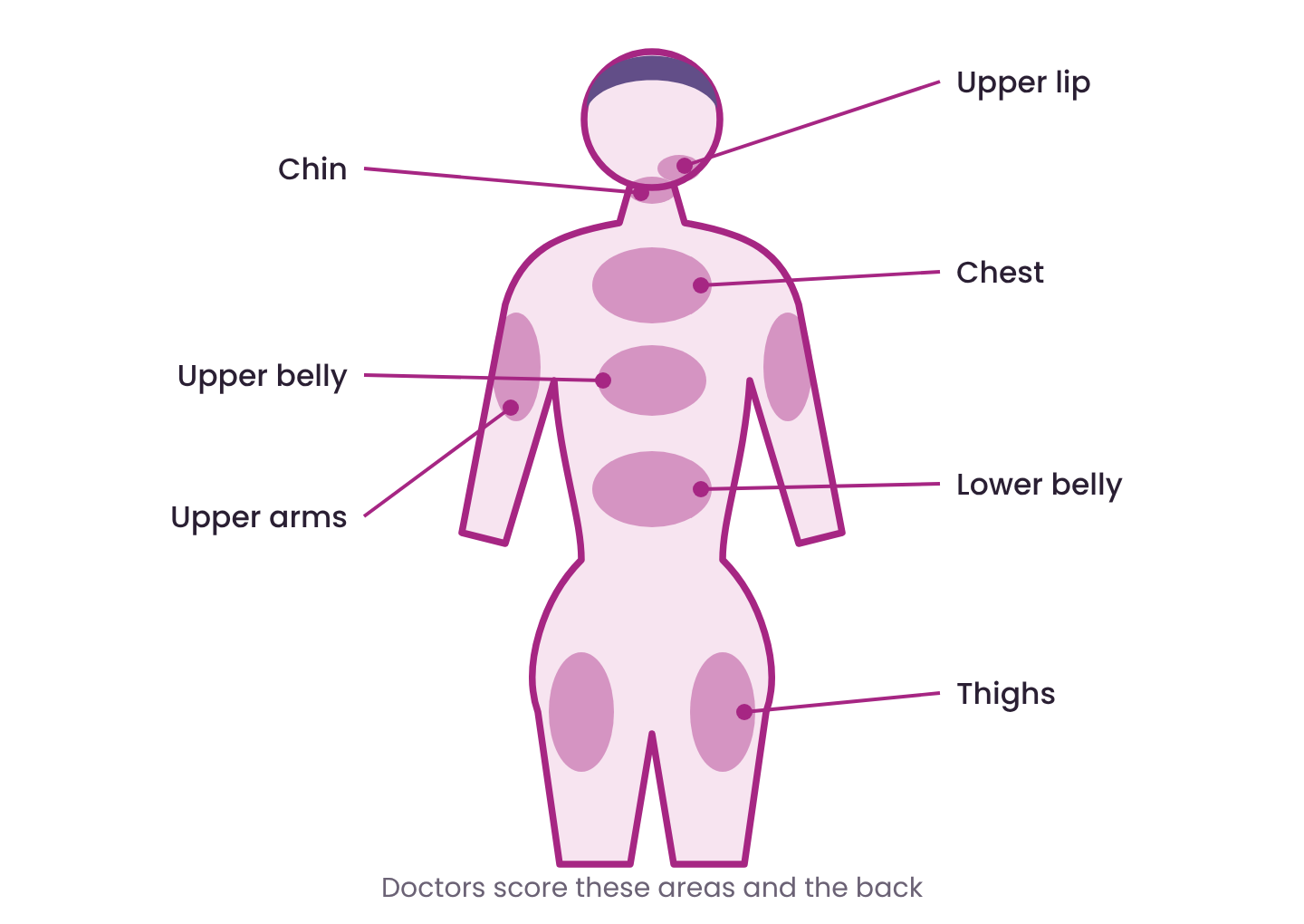
Extra hair  Hirsutism  Coarse, dark hair on the upper lip, chin, chest, belly, back or thighs. Different from light, fine facial fuzz that most women have. | Acne  Painful pimples on the jawline, chin and lower face. Often flare before periods and may leave marks. | Hair fall  The centre parting gets wider and hair feels thinner on top. The hairline at the front usually stays.

What helps
- Treatment takes 3 to 6 months to show. Hair grows slowly.
- Medicines reduce new hair and acne. Laser or electrolysis removes existing hair.
- Shaving or threading does not make hair thicker.
- Check iron, thyroid and vitamin D. Low levels also cause hair fall.

METABOLISM
Insulin and metabolic syndrome

Insulin resistance
Insulin is a key that lets sugar into your cells for energy. When the lock gets stiff, the body makes more keys. High insulin tells the ovaries to make more androgens.
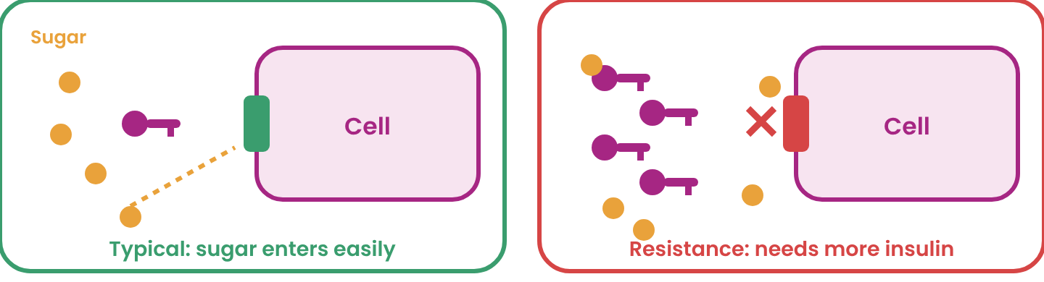
Signs: dark neck patches, skin tags, sugar cravings, belly fat, sleepy after meals. Lean women can have it too.
Metabolic syndrome
This means 3 or more of these 5 are present. It raises the risk of diabetes and heart disease.
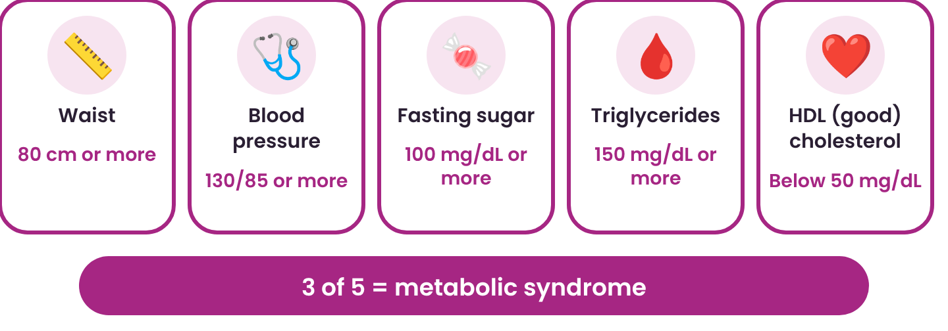
A simple blood test and a tape measure are enough to check. Early action can reverse it.

FERTILITY
PCOD and getting pregnant

PCOD is the most common cause of ovulation problems. It does not mean you cannot have a baby. Most women with PCOD do conceive, sometimes with medical help.
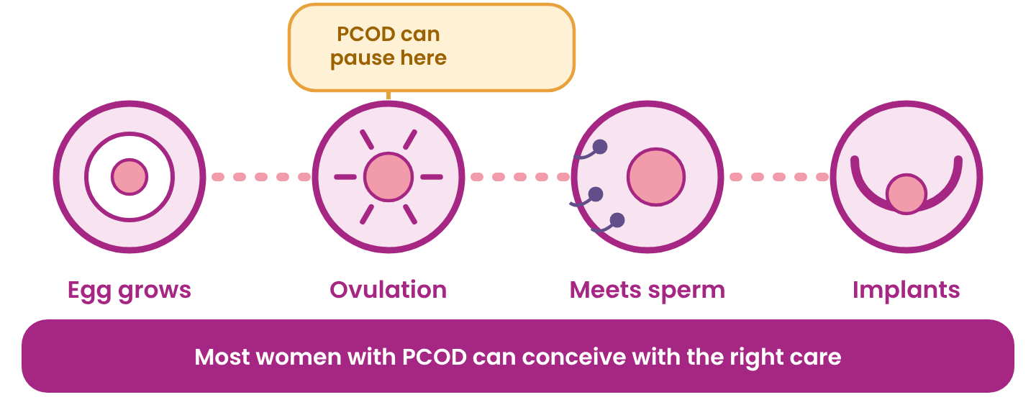
Why it can take longer  - The egg may not mature or release regularly.  - High insulin and androgens disturb the cycle.  - Other causes (tubes, womb, partner's semen) are checked at the same time. | When to ask for help  - Trying for 12 months (under 35 years).  - Trying for 6 months (35 years or older).  - Sooner if periods are very irregular or absent.

Before and during pregnancy
Start folic acid as advised, aim for a healthy weight, stop smoking and alcohol. Women with PCOD have a higher chance of gestational diabetes and high blood pressure, so early antenatal care matters.

DIAGNOSIS
How PCOD is diagnosed

There is no single test. Doctors use the Rotterdam criteria: any 2 of these 3 signs, after ruling out other conditions.
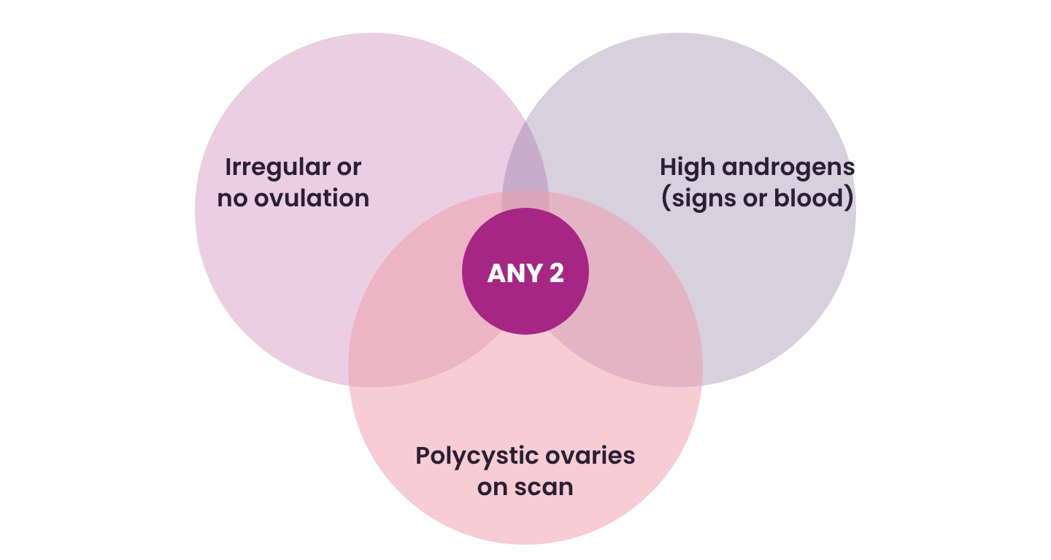
Tests you may be advised
Hormones | LH-FSH, AMH, prolactin, TSH, free testosterone, SHBG, DHEA-S | Sugar | HbA1c, fasting sugar and insulin, OGTT, HOMA-IR
Heart | Lipid profile, blood pressure, hs-CRP, ECG or ECHO if needed | Vitamins | Vitamin D, B12, iron, liver tests
Scan | Pelvic ultrasound of ovaries and womb lining | Body | Weight, waist, body composition, skin and hair analysis

Teens: a scan alone is not used to diagnose PCOD in the first 8 years after periods start.

SYMPTOM DECODER
What does it mean?

You notice | It may mean | What to do
Periods over 35 days apart, or skipped | Ovulation is not happening regularly | Track dates, see a doctor
Very heavy periods with clots | Thick lining, fibroids or thyroid issue | Doctor visit soon
Acne on jaw and chin | High androgens | Hormone and skin review
New dark hair on chin or chest | High androgens | Hormone tests
Thinning at the parting | Androgens, low iron, thyroid | Blood tests
Dark velvety neck patches | Insulin resistance | Sugar and insulin tests
Belly weight, sugar cravings | Insulin resistance | Diet and activity plan
Tired, snoring, poor sleep | Sleep apnoea, thyroid, anaemia | Doctor check
Low mood, constant worry | Common in PCOD | Talk to someone, counselling
No pregnancy after 6 to 12 months | Ovulation problem | Fertility consultation

Get help urgently if you have
Severe lower tummy pain, fainting, very heavy bleeding, chest pain or breathlessness, or sudden deepening of voice with rapid hair growth.

LIFESTYLE
Eating well with PCOD

There is no one "PCOD diet". The goal is steady sugar and less inflammation. Use the plate below at lunch and dinner. The step-by-step roadmap is on the next page.
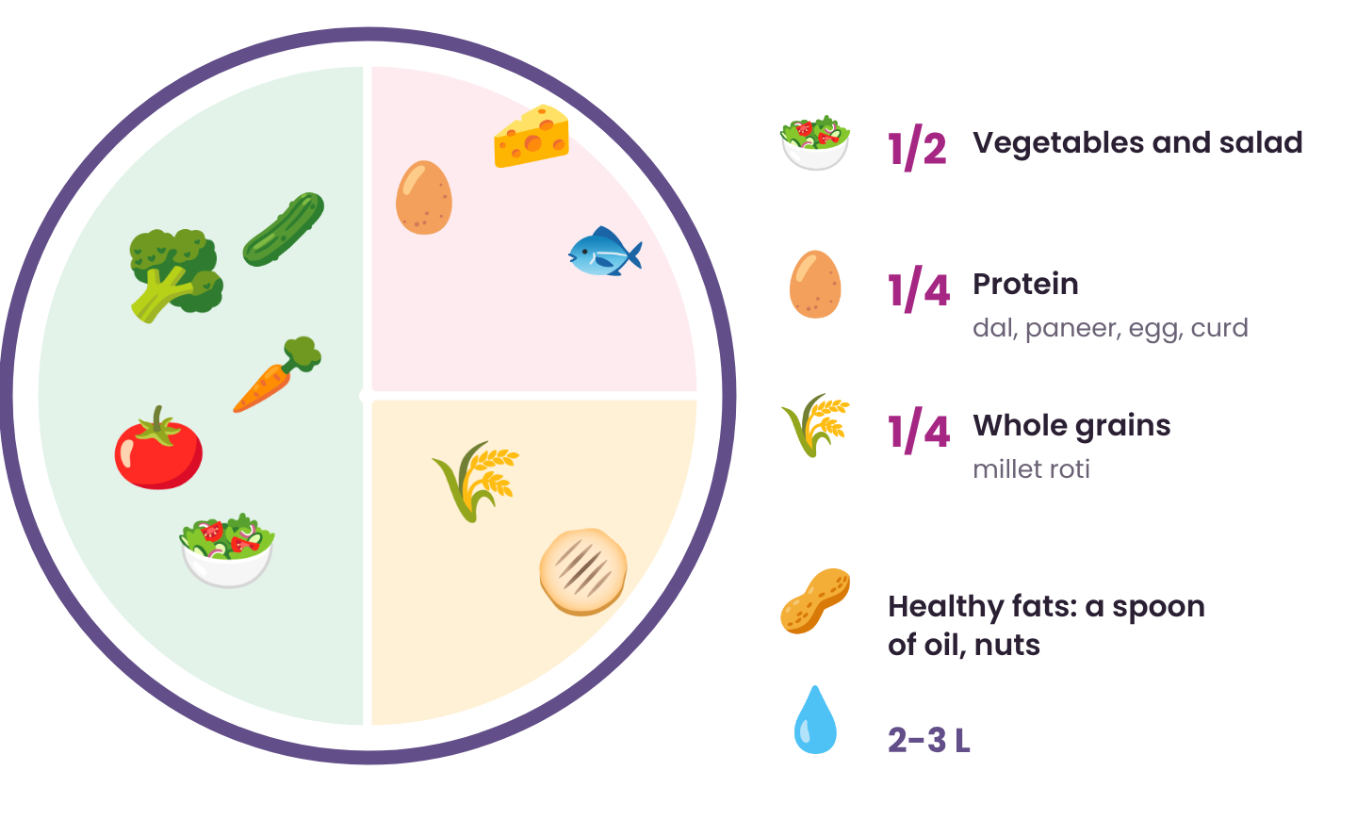
Eat more  - Millets: jowar, bajra, ragi  - Dals, sprouts, chana, rajma  - Vegetables and salads  - Curd, paneer, eggs, fish  - Nuts, seeds, berries, guava | Eat less  - Maida, biscuits, white bread  - Sugar, sweets, cold drinks, sweeteners  - Packaged and deep-fried snacks  - Large portions of white rice  - Late-night heavy meals

Small habits that help
- Protein with every meal, especially breakfast.
- Eat vegetables first, then protein, and carbs last.
- Avoid crash diets. They backfire.

EATING ROADMAP
Your 5-phase eating roadmap

A step-by-step plan for insulin resistance, inflammation, high androgens and gut health. "Detox" here does not mean juice cleanses or starving. It means less refined sugar and processed food, and more whole foods.
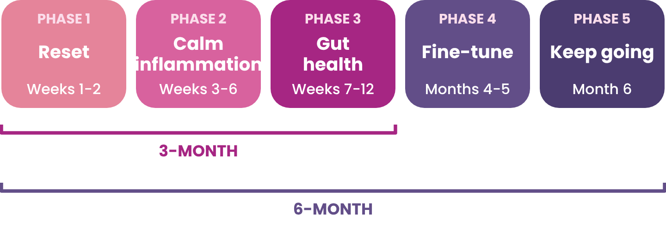
Phase | What you do | Night gap
Phase 1  Weeks 1-2 | Reset. Cut refined sugar, sweeteners, packaged food and extra seed oils. Dairy or gluten only if they trigger you. Add broccoli, cauliflower, cabbage. Fibre 30 g/day; roughly a third each protein, smart carbs, healthy fats. | 9-10 h
Phase 2  Weeks 3-6 | Calm inflammation. Mediterranean style: olive oil, fatty fish 2-3 times a week (flaxseed or spirulina if vegetarian), berries, turmeric with black pepper, cinnamon. Protein 25-30%, carbs 35-40%, fats 35%. HBOT if advised. | 11-12 h
Phase 3  Weeks 7-12 | Gut health. Fibre 35 g or more: dals, chana, chia, flaxseed, pumpkin seeds, cooled potato. Gut-healing drinks. Optional seed cycling. Review at end of month 3. | 11-12 h
Phase 4  Months 4-5 | Fine-tune. Eat vegetables first, then protein and fats, carbs last. No late-night eating. Add ancient grains: quinoa, khapli wheat, buckwheat. | 12-14 h
Phase 5  Month 6 | Keep going. The 80/20 rule: 80% anti-inflammatory, 20% flexible. Re-introduce foods one at a time to test tolerance. 25-30 g protein per meal. | -

Seed cycling (optional): Days 1-14: 1 tbsp pumpkin seeds + 1 tbsp ground flaxseed daily. Days 15-28: 1 tbsp sesame + 1 tbsp sunflower seeds daily. Evidence is limited, so it is optional.

LIFESTYLE
Move, sleep, calm

Movement makes your cells listen to insulin again. Good sleep and calm balance hunger and stress hormones.
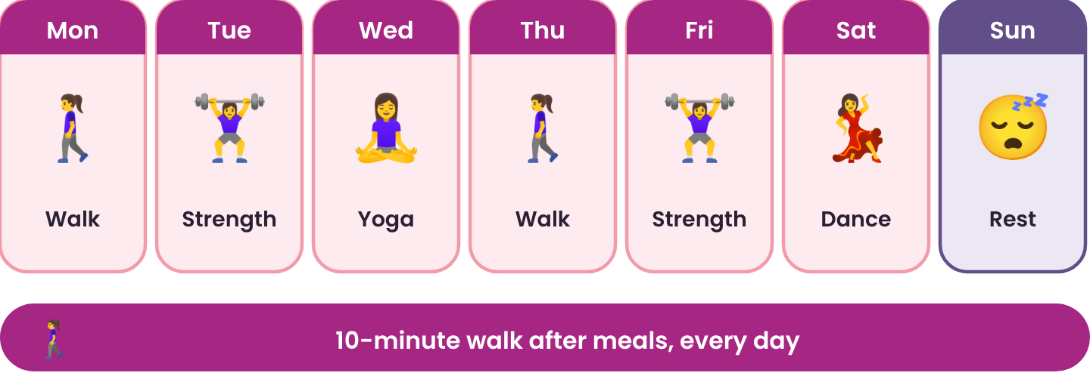
Move  150 minutes a week of brisk walking, cycling, swimming or dance, plus 2 days of strength. Even 10 minutes counts. | Sleep  7 to 9 hours, same time each night. Screens off 1 hour before bed. Dark, cool room. | Calm  10 minutes of yoga, pranayama or meditation daily. Time for a hobby or friends.

Start small. Pick one habit this week. Small steps you can keep beat big plans you drop.

This week I will:
1.
2.
3.

TREATMENT
Treatment options

Treatment depends on what you want: regular periods, clearer skin, less hair, or a baby. Your doctor will build your plan. Pages 19 and 20 show how we treat each symptom.
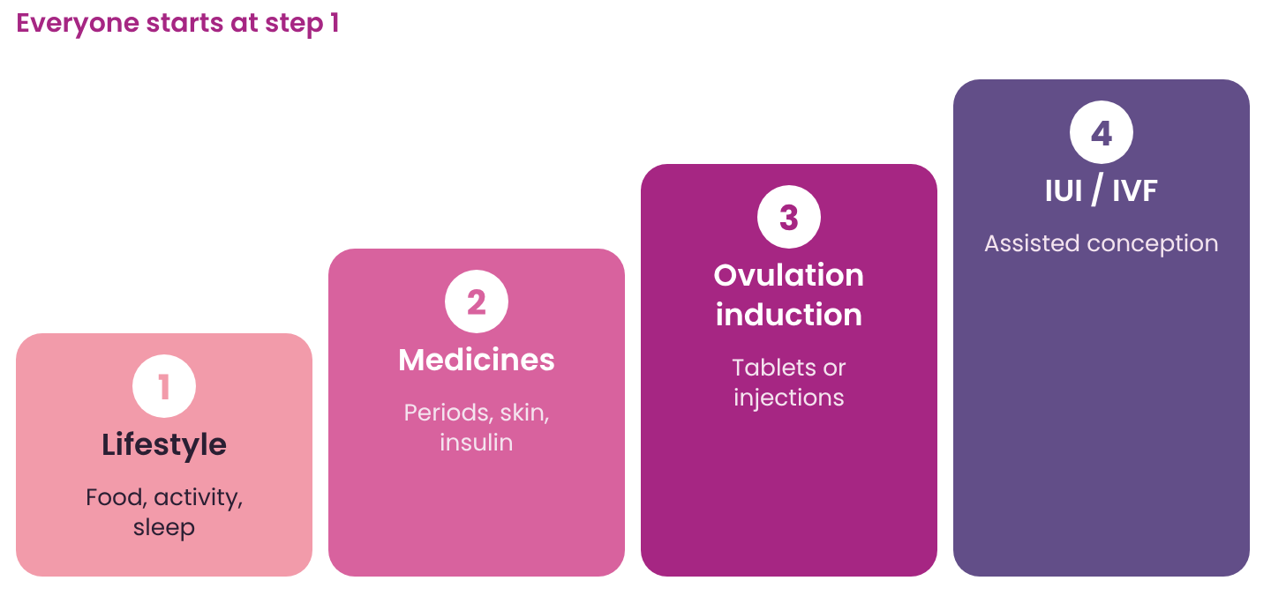
- Regular periods, protect the womb: Hormonal pills or progestins to regulate cycles and lower androgens
- Insulin resistance, weight: Nutrition plan, activity, metformin and other medicines as advised
- Acne, extra hair, hair fall: Anti-androgen medicines, skin treatments, laser

If pregnancy is the goal
Ovulation medicines | Tablets early in the cycle, or injections, help an egg grow and release. Often the first step. Scans watch the egg growth.
IUI | Prepared sperm are placed in the womb around the time of ovulation.
IVF / ICSI | Eggs are collected, fertilised in the lab, and the embryo is placed in the womb. Used if earlier steps fail or other factors exist.
LOD | A small keyhole surgery on the ovaries, used rarely when other steps fail.

Important: take medicines and supplements (including inositol, vitamin D) only on your doctor's advice.

HOW WE TREAT
How we treat each symptom

Every symptom has its own tests and options. Your doctor chooses only what suits you.
Irregular or painful periods, no periods, trouble conceiving
Tests | Pelvic ultrasound, LH-FSH, AMH, prolactin, TSH
Medical | Hormonal pills, ovulation-induction medicines
Nutrition | Targeted diet, inositol (myo and D-chiro), CoQ10
Advanced | HBOT, pelvic chair
Ayurveda | Shatavari, Ashwagandha, Kanchnar guggulu; medicated enema, Uttar basti, Yoni prakshalana

Acne, excess hair, hair fall
Tests | Free testosterone, SHBG, FAI, DHEA-S, androstenedione; skin and hair analysis
Medical | Anti-androgen medicines, retinoids
Nutrition | Targeted diet, NAC, curcumin, zinc
Advanced | Laser hair reduction, Q-switch laser, chemical peels, hydra and medicated facials, microneedling, PRP, exosomes, ozone
Ayurveda | Raktashodhana, Raktamokshana, Virechana, Mukhalepa; Nasya, Abhyanga, Shiro pichu

Advanced and Ayurvedic options are supportive, and are offered only as your doctor advises. They do not replace medical care.

HOW WE TREAT
How we treat each symptom (2)

Weight gain, appetite and insulin resistance (also heart health)
Tests | Fasting sugar and insulin, HbA1c, OGTT, HOMA-IR, lipid profile, hs-CRP, body composition analysis, ECG and ECHO
Medical | Metformin; newer weight-loss medicines (GLP-1 type) or orlistat, only if your doctor advises
Nutrition | Low-GI, anti-inflammatory or Mediterranean plan; about 500 kcal below daily needs; gut drinks; berberine, magnesium, chromium, vitamins (as advised)
Advanced | Body contouring (cryolipolysis, RF, muscle stimulation, microwave), HBOT, ozone
Ayurveda | Triphala, Trikatu, Arjuna, Guggulu; Udvartana, Swedana, Vamana

Tiredness, sleep and mood
Tests | Cortisol curve, B12, folate, ferritin and iron, vitamin D3, sleep apnoea screening, liver tests
Medical | Sleep and mood evaluation, counselling and CBT, hormonal medicines or spironolactone when suitable, CPAP for sleep apnoea
Nutrition | Vitamin D, omega-3, sleep-supporting foods
Ayurveda | Brahmi, Jatamansi; Shirodhara, Abhyanga

Protecting the womb lining
Tests | Ultrasound for lining thickness, endometrial biopsy, hysteroscopy; CA-125 and MRI only if needed
Medical | Cyclic progestin, progestin-releasing IUD, hormonal pills
Nutrition | Inositol, curcumin, cruciferous vegetables
Advanced | Pelvic chair, acupuncture, Panchakarma
Ayurveda | Ashoka, Shatavari

Always talk to your doctor before starting any medicine, supplement or therapy.

WELLBEING
Mind and long-term health

Your feelings are real
Anxiety, low mood and worry about body image are 2 to 3 times more common in PCOD. It is not weakness. Hormones and insulin play a role. Talking helps. Ask us about counselling.

When to ask for help
Sadness or worry lasting more than 2 weeks, panic attacks, losing interest in daily life, or trouble with sleep or appetite. If you ever think of harming yourself, tell someone and get help right away. Free helpline: Tele-MANAS 14416 (24x7).

Possible long-term risks
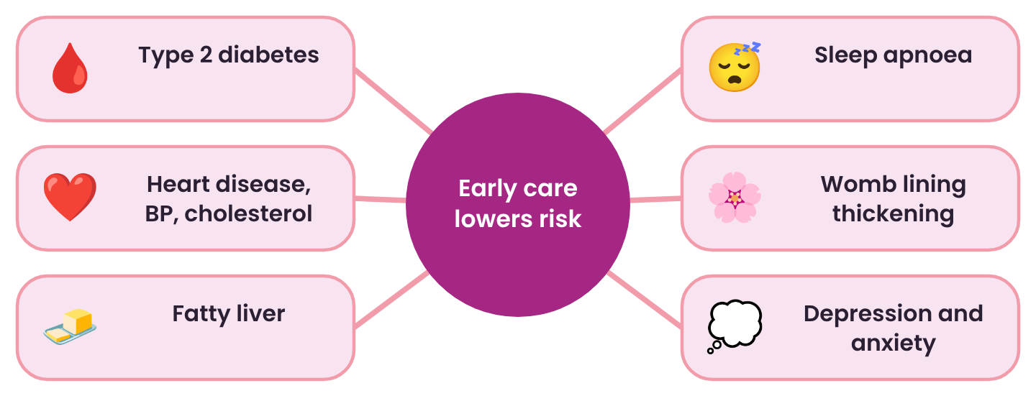
Protect yourself
- Check blood pressure, sugar and cholesterol every year.
- Aim for a period at least every 3 months.
- Keep active, eat well, sleep well.
- Early care greatly lowers these risks.

OUR TEAM
Everything under one roof

PCOD touches many parts of the body, so one doctor is rarely enough. At PCOD Xpert, a multidisciplinary team works together on your plan, from consultation to tests, in one campus.
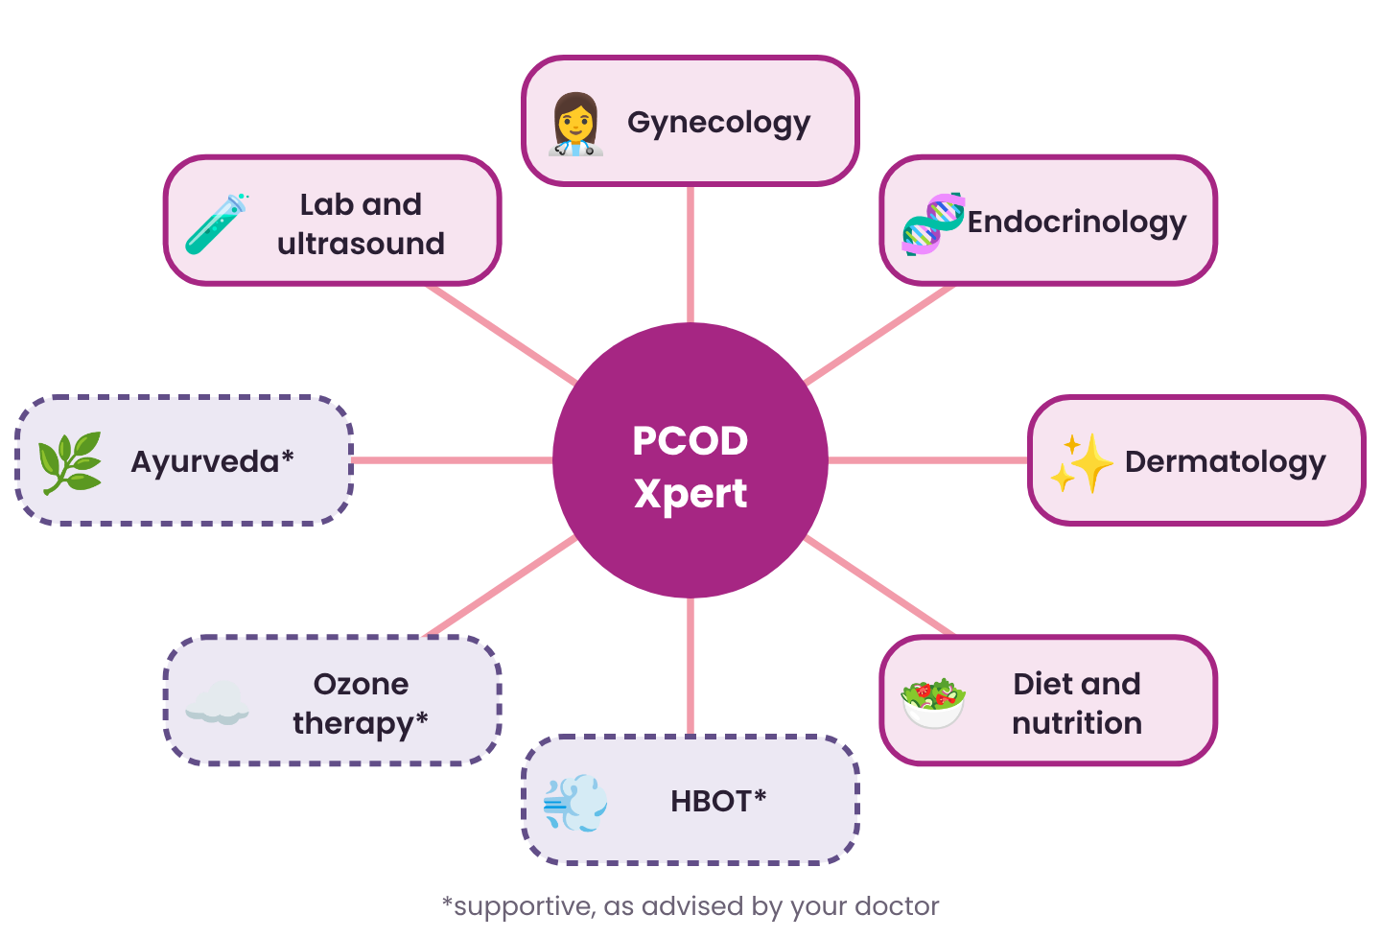
Why one roof helps
- One plan shared by all your specialists.
- Tests and scans on the same campus.
- Fewer visits, clear follow-up and one team to call.

Supportive therapies
HBOT, ozone therapy and Ayurveda are offered as additional supportive options only when your doctor advises. Research on the role of HBOT and ozone in PCOS is still developing. They do not replace lifestyle, medicines or fertility care.

OUR PROGRAMMES
3 and 6 month programmes

A structured journey with regular reviews, built on the 5-phase eating roadmap, so you are never managing PCOD alone.
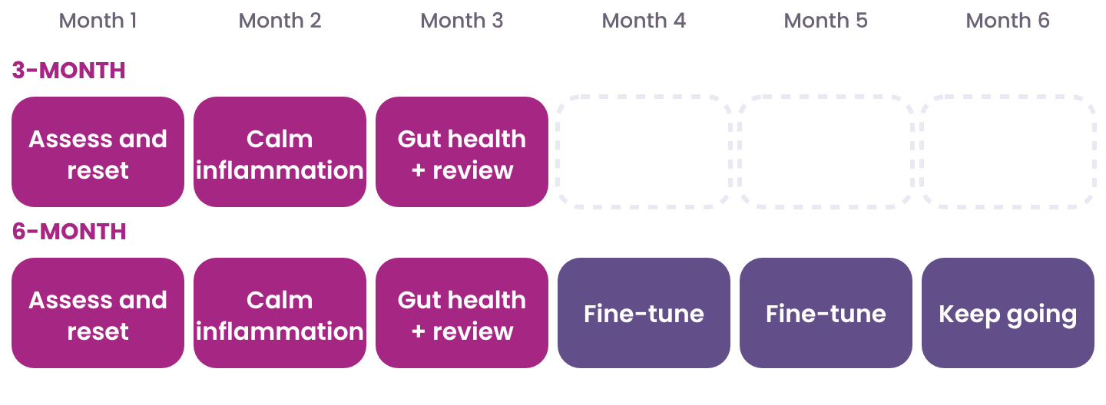
3-MONTH PROGRAMME
Month 1 | Assess and reset  Gynecology, endocrine, skin and diet consults. Blood tests and ultrasound. Eating phases 1 and 2 begin.
Month 2 | Calm inflammation  Mediterranean-style eating. Medicines and skin or hair care as needed. Supportive therapy as advised. Follow-up.
Month 3 | Gut health and review  High-fibre, gut-friendly eating (phase 3). Repeat tests and measurements. Progress check and a plan to keep going.

6-MONTH PROGRAMME
Everything in the 3-month programme, plus months 4 to 6: advanced eating habits (phase 4), a flexible long-term routine (phase 5), monthly check-ins, fine-tuning of medicines, fertility planning if you wish, and a full review of your tests and long-term health plan.
Ask our team what is included in each programme for your needs.

MYTHS AND FACTS
Myths and facts

MYTH | FACT
PCOD means I can never have a baby. | Most women with PCOD conceive, sometimes with treatment.
Only overweight women get PCOD. | Lean women can have PCOD and insulin resistance too.
PCOD is caused by junk food. | Genes and hormones come first. Lifestyle helps control it.
Regular periods mean no PCOD. | You can have PCOD with regular periods. Tests tell.
Shaving makes hair grow thicker. | It does not. Hair only looks blunt when it regrows.
I must give up rice and ghee forever. | Portions and balance matter. Crash diets do not work.
PCOD goes away after marriage or a baby. | It may ease for a while, but needs ongoing care.
Pills are the only treatment. | Lifestyle is the base. Medicines are chosen for your goal.

QUESTIONS
Questions and answers

Is PCOD hereditary?  Often it runs in families, but having a relative with PCOD does not mean you will definitely have it. | Will I need medicines forever?  Not always. Many women improve with lifestyle and need medicines only for certain goals or periods of time.
Can PCOD cause cancer?  If periods are very rare for years, the womb lining can overgrow. Treating this early protects you. | Why was PCOS renamed PMOS?  PMOS stresses that the condition affects hormones and metabolism across the whole body, not only the ovaries. Your doctor may use either name.
Can I get pregnant without treatment?  Some women with PCOD ovulate now and then and conceive naturally. If it has not happened in 6 to 12 months, ask for help. | Can stress make PCOD worse?  Yes. Stress hormones affect insulin and ovulation. Sleep, movement and talking to someone all help.

Questions to ask your doctor
What type of PCOD do I have?

Which tests do I need, and how often?

What are my goals for the next 3 months?

Which medicines, and for how long?

When should I plan a pregnancy?

MY TRACKER
My tracker

Write down the first day of every period. Bring this page to your appointment.
Period start | Days | Flow L/M/H | Pain 0-10 | Weight | Notes
My medicines and supplements:
Next appointment:

PATIENT STORIES
Hope blooms from within

Real stories from women who took the first step.
PHOTO | “  Add the patient's own words here (with written consent).  Patient name, age  Years with PCOD / months with PCOD Xpert

PHOTO | “  Add the patient's own words here (with written consent).  Patient name, age  Years with PCOD / months with PCOD Xpert



Don't ignore PCOD.
Connect with us.
Call or WhatsApp us  +91 82230 87999  WhatsApp | Call |   Scan to chat on WhatsApp

PCOD, PCOS & PMOS care under one roof
Gynecology | Endocrinology | Dermatology | Diet & Nutrition | Ayurveda | Lab & Ultrasound

Visit us
Sahaj Hospital Campus
15/2 South Tukoganj, Near Manas Bhavan,
Behind Hotel Surya, Indore,
Madhya Pradesh 452005

MEDICAL DISCLAIMER
This booklet is for educational purposes only and is not a substitute for professional medical advice, diagnosis or treatment. Individual results vary. Always consult your doctor before starting or stopping any treatment. Programme details are decided by your treating doctor. Advanced and Ayurvedic therapies are supportive and offered only as advised.

