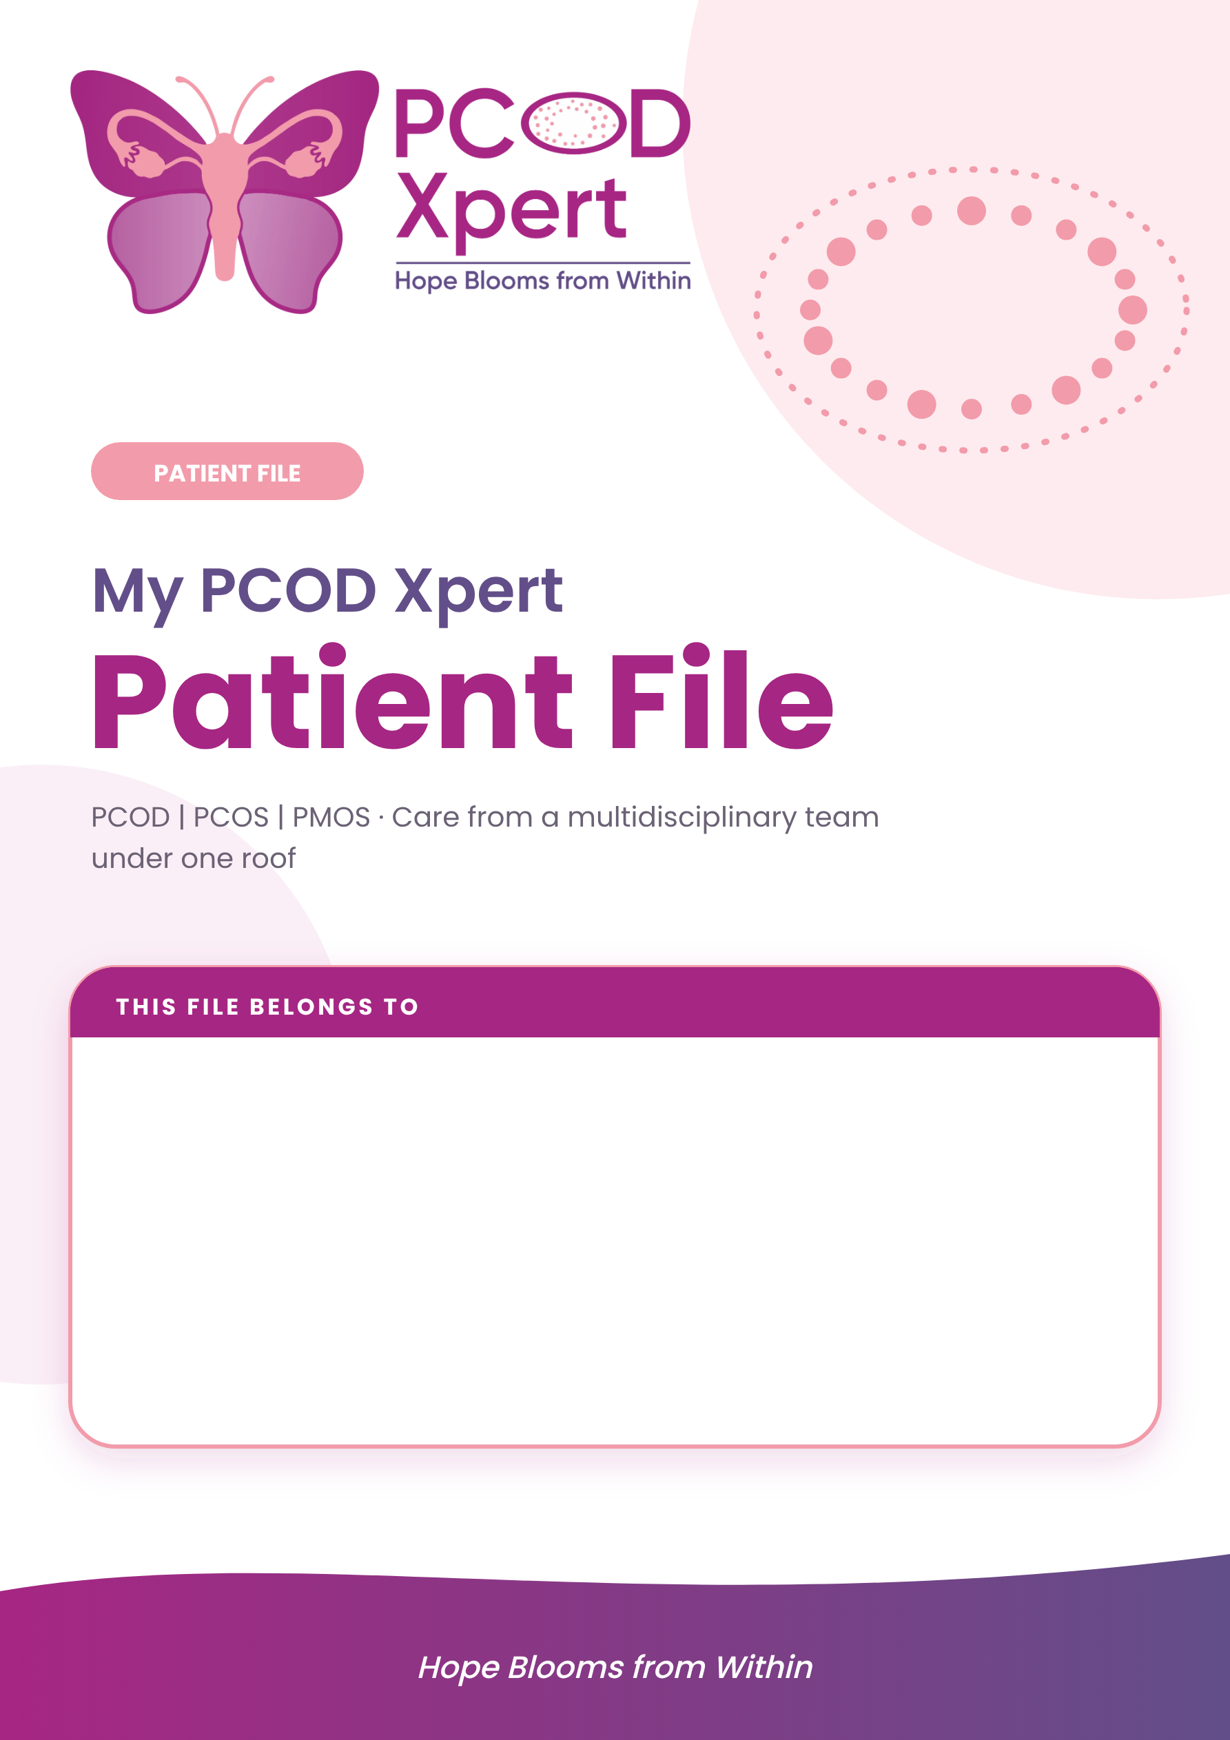

PATIENT NAME | PATIENT ID
DATE OF BIRTH / AGE | MOBILE / WHATSAPP
PRIMARY DOCTOR | PROGRAMME (3-month / 6-month) AND START DATE
EMERGENCY CONTACT (NAME AND PHONE) | KNOWN ALLERGIES / CONDITIONS

01 | Welcome to your file  One place for your history, tests, plan and progress | BOTH

This file is yours. It travels with you to every visit, so every doctor on your team sees the same full picture. The more completely it is filled in, the better your plan can be.
How to use this file
1  Fill in the pink-tagged pages at home before your first visit. | 2  Your doctors complete the purple-tagged pages during visits. | 3  Bring it back to every visit and update the logs and diary.
What is inside
3 | Patient details | 4 | Health history
5 | Symptoms and goals | 6 | Doctor’s assessment
7 | Investigations tracker | 8 | My treatment plan
9 | Medicines and supplements | 10 | Eating roadmap
11 | Move, sleep, calm log | 12 | Cycle and symptom diary
13 | Visit and follow-up log | 14 | Progress review
15 | Consents and documents | 16 | Contacts and warning signs
My care team
Role | Name | Days / how to reach
Gynecologist
Endocrinologist
Dermatologist
Dietitian
Ayurveda physician
Counsellor
Programme coordinator

Keep it safe
This file holds private health information. Share it only with your care team. Keep a photo or scan of it on your phone, in case the paper copy is lost.

02 | Patient details  Registration and contact information | PATIENT FILLS

About me
FULL NAME | PATIENT ID | DATE
DATE OF BIRTH | AGE | HEIGHT (cm) | WEIGHT (kg) | BLOOD GROUP
OCCUPATION | MARITAL STATUS | LANGUAGE I PREFER
How to reach me
MOBILE / WHATSAPP | ALTERNATE NUMBER | EMAIL
ADDRESS

CITY / PIN CODE | BEST TIME TO CALL | ID PROOF TYPE / NUMBER
Emergency contact
NAME | RELATIONSHIP | PHONE
Referral
☐ Self / walk-in | ☐ Doctor referral | ☐ Family or friend
☐ Social media | ☐ Online search | ☐ Other hospital
REFERRED BY / NOTES

How we may contact me
☐ Phone call | ☐ WhatsApp message | ☐ SMS
☐ Email | ☐ Reports may be sent on WhatsApp | ☐ Reminders for appointments

For teens (under 18)
A parent or guardian fills in and signs the consent page. Add their name and phone number above as emergency contact.

03 | Health history  Your story, in your own words. Tick what applies | PATIENT FILLS

Periods
AGE AT FIRST PERIOD | USUAL CYCLE LENGTH (days) | BLEEDING DAYS | LAST PERIOD (LMP)
☐ Regular | ☐ Irregular | ☐ Missed for 3 months or more
☐ Heavy bleeding | ☐ Painful periods | ☐ Spotting between periods
Pregnancy and fertility
PREGNANCIES | LIVE BIRTHS | MISCARRIAGES | TRYING TO CONCEIVE SINCE | CONTRACEPTION USED
☐ I want to get pregnant now | ☐ Pregnancy later
☐ Not planning pregnancy | ☐ Earlier fertility treatment taken
Medical conditions (me)
☐ Thyroid problem | ☐ Diabetes / high sugar | ☐ High blood pressure
☐ High cholesterol | ☐ Fatty liver | ☐ Sleep apnoea / snoring
☐ Depression / anxiety | ☐ Anaemia | ☐ Asthma / allergies
OTHER CONDITIONS, SURGERIES, HOSPITAL STAYS

Family history
☐ PCOD / PCOS | ☐ Diabetes | ☐ Thyroid problem
☐ High blood pressure | ☐ Heart disease | ☐ Cancer (type: ______)
Allergies and current medicines
ALLERGIES (medicines, food, other)

MEDICINES AND SUPPLEMENTS I TAKE NOW

Daily life
DIET (veg / non-veg / egg / other) | MEALS PER DAY | EXERCISE (type, minutes per week)
SLEEP (hours per night) | WATER (glasses per day) | STRESS LEVEL (0-10) | SMOKING / ALCOHOL / TOBACCO

04 | My symptoms and goals  Tick one circle for each line. Be honest, there are no wrong answers | PATIENT FILLS

How much does it bother me?
Symptom | None | Mild | Moderate | Severe
Irregular or missed periods | ○ | ○ | ○ | ○
Painful or heavy periods | ○ | ○ | ○ | ○
Acne or oily skin | ○ | ○ | ○ | ○
Extra hair on face or body | ○ | ○ | ○ | ○
Hair thinning or hair fall | ○ | ○ | ○ | ○
Dark velvety skin patches (neck, underarms) | ○ | ○ | ○ | ○
Weight gain, hard to lose weight | ○ | ○ | ○ | ○
Sugar cravings, tired after meals | ○ | ○ | ○ | ○
Tiredness, poor sleep, snoring | ○ | ○ | ○ | ○
Low mood, anxiety, mood swings | ○ | ○ | ○ | ○
Trouble getting pregnant | ○ | ○ | ○ | ○

SINCE WHEN HAVE I HAD THESE SYMPTOMS? | WHAT MAKES IT BETTER / WORSE?
What I want from treatment
☐ Regular periods | ☐ Clearer skin | ☐ Less unwanted hair
☐ Stop hair fall | ☐ Lose weight | ☐ Steady energy and mood
☐ Better sleep | ☐ Plan a pregnancy | ☐ Protect my long-term health
What matters most to me
MY TOP 3 GOALS (in my own words)

1.

2.

3.

My worries and questions for the doctor

05 | Doctor’s assessment  Measurements, diagnosis and classification | DOCTOR FILLS

Measurements
Measure | Baseline | Month 1 | Month 3 | Month 6 | Target
Weight (kg)
BMI
Waist (cm)
Hip (cm)
Blood pressure
Pulse
Hirsutism score (mFG)
Acne grade
Skin and hair analysis
Body composition (fat %, muscle)
Rotterdam criteria: any 2 of 3
☐ Irregular or no ovulation | ☐ High androgens (signs or blood tests) | ☐ Polycystic ovaries on ultrasound
Other causes ruled out
☐ Thyroid disorder | ☐ High prolactin | ☐ Non-classic CAH (17-OHP)
☐ Cushing’s / adrenal cause | ☐ Other: ____________
Classification
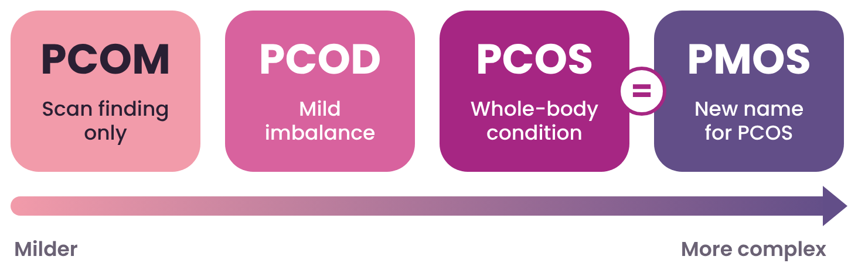
☐ PCOM (scan finding only) | ☐ PCOD (mild imbalance) | ☐ PCOS / PMOS (whole-body condition)
Doctor’s notes
DIAGNOSIS AND KEY FINDINGS

DOCTOR NAME AND SIGNATURE | DATE

06 | Investigations tracker  Write the date and the result. Compare at each review | DOCTOR FILLS

Test | Date | Result | Date (review) | Result (review) | Remarks
HORMONES
LH and FSH (LH-FSH ratio)
AMH
TSH
Prolactin
Free / total testosterone
SHBG and FAI
DHEA-S
17-OH progesterone / androstenedione
Cortisol (if advised)
SUGAR, FATS AND INFLAMMATION
Fasting glucose and insulin
HbA1c
OGTT (2-hour) / HOMA-IR
Cholesterol: total, LDL, HDL
Triglycerides
hs-CRP
VITAMINS, IRON AND ORGANS
Vitamin D3
Vitamin B12 and folate
Ferritin / iron panel
Liver tests (SGOT, SGPT)
SCANS AND OTHER TESTS
Pelvic ultrasound (ovaries, lining)
ECG / ECHO (if needed)
Sleep apnoea screening

Lab reference ranges differ between labs. Your doctor will explain each result and mark it against the range printed on your report.

07 | My treatment plan  Chosen together by you and your doctors | DOCTOR FILLS

Programme
☐ 3-month programme | ☐ 6-month programme | ☐ Consultation only | ☐ Fertility plan
START DATE | REVIEW DATES | PROGRAMME COORDINATOR
My care team
Specialty | Focus | Doctor / start date
Gynecology | Periods, fertility, womb
Endocrinology | Hormones, insulin, thyroid
Dermatology | Skin, hair, acne
Diet and nutrition | Eating roadmap
Ayurveda (supportive) | As advised
Counselling | Mood, stress, sleep
Treatment components
Lifestyle
☐ Eating roadmap (5 phases) | ☐ Exercise plan | ☐ Sleep and stress plan | ☐ Weight target
Medical
☐ Hormonal pills / progestin | ☐ Metformin / insulin sensitiser | ☐ Anti-androgen medicines | ☐ Ovulation induction
☐ Weight-loss medicine | ☐ Vitamins and supplements | ☐ Skin treatment (topical) | ☐ Other: ________
Advanced and supportive (only as advised)
☐ HBOT | ☐ Ozone therapy | ☐ Laser hair reduction | ☐ Chemical peel / facials
☐ Microneedling / PRP | ☐ Body contouring | ☐ Pelvic chair | ☐ Ayurveda therapies
Fertility
☐ Cycle and ovulation tracking | ☐ IUI | ☐ IVF / ICSI | ☐ LOD
Plan notes and special instructions

08 | Medicines and supplements  Doctor writes the dose. I tick when I take it as advised | BOTH

Medicine / supplement | Dose and timing | Why | Start | Stop | Prescribed by

Remember
Take medicines and supplements only as your doctor advises. Do not start, stop or change anything without asking. Tell your doctor about any other medicine you take, including Ayurvedic and over-the-counter ones.

09 | Eating roadmap  Track your 5 phases. Your dietitian guides each step | BOTH

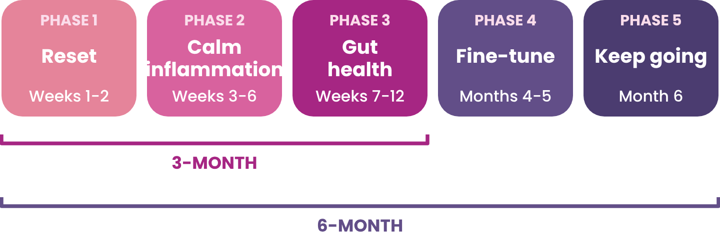
Phase | Focus | What I do | Planned dates | Done
Phase 1 | Reset | Cut refined sugar, sweeteners, packaged food, extra seed oils. Add cruciferous vegetables. Fibre 30 g/day. Night gap 9-10 h. |  | ☐
Phase 2 | Calm inflammation | Mediterranean style: olive oil, fatty fish or flaxseed, berries, turmeric, cinnamon. Night gap 11-12 h. |  | ☐
Phase 3 | Gut health | Fibre 35 g or more: dals, chana, seeds. Gut-healing drinks. Review at end of month 3. |  | ☐
Phase 4 | Fine-tune | Vegetables first, then protein, carbs last. No late-night eating. Ancient grains. Night gap 12-14 h. |  | ☐
Phase 5 | Keep going | 80/20 rule. Re-introduce foods one at a time. 25-30 g protein per meal. |  | ☐
A day on my plate
Meal | Time | What I plan to eat | Notes
Early morning
Breakfast
Mid-morning
Lunch
Evening snack
Dinner
Water (glasses)

Plate reminder: half vegetables and salad, a quarter protein, a quarter whole grains, plus a spoon of healthy fat.

10 | Move, sleep, calm log  Small steps, written down. Aim: 150 minutes a week plus 2 strength days | PATIENT FILLS

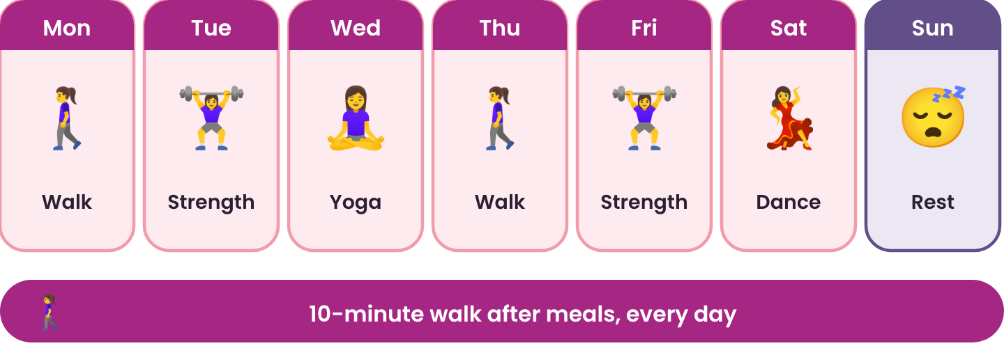
Week 1
Day | Activity and minutes | Steps | Strength (Y/N) | Sleep (hours) | Stress (0-10) | Mood / notes
Mon
Tue
Wed
Thu
Fri
Sat
Sun
Week 2
Day | Activity and minutes | Steps | Strength (Y/N) | Sleep (hours) | Stress (0-10) | Mood / notes
Mon
Tue
Wed
Thu
Fri
Sat
Sun
Week 3
Day | Activity and minutes | Steps | Strength (Y/N) | Sleep (hours) | Stress (0-10) | Mood / notes
Mon
Tue
Wed
Thu
Fri
Sat
Sun

Tip: a 10-minute walk after meals helps sugar levels. Sleep 7 to 9 hours at the same time each night.

11 | Cycle and symptom diary  Write the first day of every period. Rate symptoms 0 (none) to 3 (severe) | PATIENT FILLS

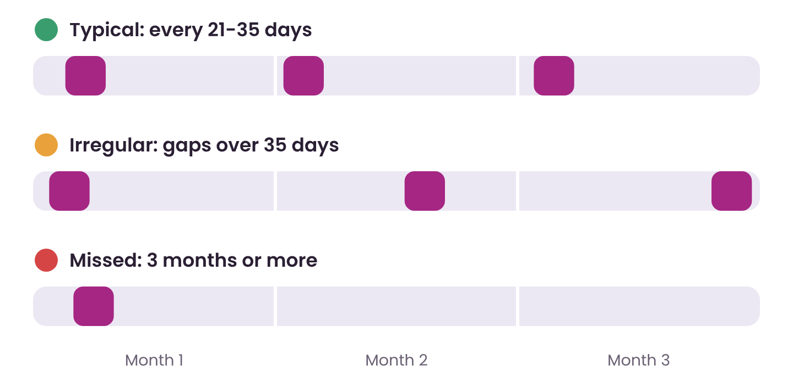
# | Start date | End date | Cycle days | Flow L / M / H | Pain 0-10 | Clots Y/N | Acne | Hair | Mood | Weight / notes

Typical: a period every 21 to 35 days, lasting 2 to 7 days. See a doctor if there is no period for 3 months, or bleeding soaks a pad every hour for 2 hours.

12 | Visit and follow-up log  One line for every visit, call or message | DOCTOR FILLS

Date | With (doctor / team) | What we discussed | Changes to my plan | Next visit

13 | Progress review  Compare yourself with where you started | BOTH

Measure | Baseline | Month 1 | Month 3 | Month 6
HOW I FEEL (0 = very bad, 10 = very good)
Regularity of periods
Acne
Unwanted hair growth
Hair fall
Energy
Mood
Sleep quality
Sugar cravings and appetite
Confidence
NUMBERS
Weight (kg)
Waist (cm)
Blood pressure
Progress photos (optional)
Baseline  Attach photo (with consent) | Month 3  Attach photo (with consent) | Month 6  Attach photo (with consent)
My wins so far
My goals for the next 3 months

14 | Consents and documents  Keep every paper in one place | BOTH

Consent / form | Done | Date | Patient or guardian signature
Consent for treatment and programme | ☐
Consent for progress photographs | ☐
Consent for advanced / supportive therapies (HBOT, ozone, laser) | ☐
Consent to share reports by WhatsApp or email | ☐
Privacy and confidentiality notice read | ☐
Programme enrolment form | ☐
Reports and papers in my file
☐ Blood reports | ☐ Ultrasound reports | ☐ Prescriptions
☐ Diet chart | ☐ Exercise plan | ☐ Receipts and invoices
☐ Other hospital records | ☐ Insurance papers | ☐ Discharge summaries
Signatures
PATIENT / GUARDIAN NAME AND SIGNATURE | DATE
TREATING DOCTOR NAME AND SIGNATURE | DATE

Pocket for loose papers
Slip printed reports, prescriptions and receipts behind this page, or take a clear photo and save it on your phone in a folder named "My PCOD file".



15 | Contacts and warning signs  Keep this page easy to find | BOTH

Call or WhatsApp us  +91 82230 87999  WhatsApp | Call |   Scan to chat on WhatsApp

Get help urgently if you have  - Severe lower tummy pain or fainting  - Very heavy bleeding (a pad soaked every hour for 2 hours)  - Chest pain or breathlessness  - Sudden deepening of voice with rapid hair growth  - Thoughts of harming yourself (Tele-MANAS 14416, 24x7) | Visit us  PCOD Xpert by Hope  Sahaj Hospital Campus  15/2 South Tukoganj, Near Manas Bhavan,  Behind Hotel Surya, Indore,  Madhya Pradesh 452005

Between visits
Questions about your plan? Message the programme coordinator on WhatsApp. Include your name and patient ID. | Before every visit: update your diary, log and medicine list, and bring this file with all your reports. | Running low on medicines? Call before they finish, not after. Never stop a medicine suddenly on your own.

CONFIDENTIALITY
This file contains your private health information and belongs to you. PCOD Xpert by Hope uses it only to look after you and shares it only with your treating team. Please keep it safe and share it only with people you trust. This file is a record and a guide. It is not a substitute for professional medical advice. Individual results vary.

