Project Details and Design

Part 2

Design of the File System

To start with, NEOFS views the secondary storage as an array of BLOCKS, which are of, fixed size (4 * 1024 bytes in implementation). This is something like unwinding the tracks of device and viewing them as a single strand of blocks. The minimal amount of data read or written to the storage unit is a BLOCK. By doing so we ease the problem of addressing, now instead of specifying the head, cylinder, track and sector to read or write we just specify the logical number of the block. We call such a logical address of block as LOGICAL BLOCK ADDRESS, LBA .We then internally do the conversion from LBA to actual address, which enables us to change block size easily.

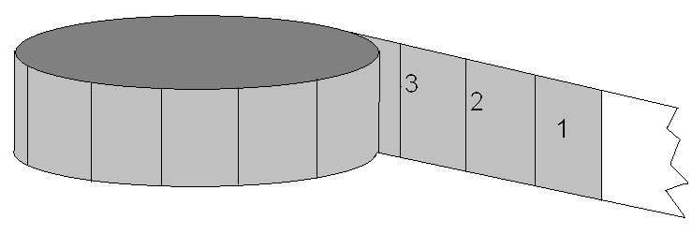

Any file system for that matter has to store the address of data blocks of a file in the disk, so that it can read data back. This information can be stored in the form of linked list distributed over disk, or in the form of list packed and stored at one location as in FAT system. Both of these methods do not provide a good performance in case of direct read, since it has to traverse the list to determine the location. Though the latter is better than former in direct access, the latter is static, i.e. irrespective of number of files, a certain fixed percentage of disk space is used for storing information about file system, so it is a compromise between space and performance.

One way to achieve a better direct access performance is to pullout all data links into a single block so that direct access to any location is guaranteed to be in very few seek. This method is used in file systems of UNIX and Linux platforms. It is bounded and has good performance. This design does have some problems carried from earlier ones via:

a) Even this design is static as described earlier.
b) We need at least two disk access to get data from disk, one to the
Inode block where all collected links are stored ordered by files, and then to actual data. Even if the file is small and can be read in single seek this needs two accesses that are more often actual seeks.

Our file system tries to overcome these two drawbacks and with it uses the advantages UNIX filesystem. Our perspective towards solving this problem was to place the collection of links or typical INODE next to the first data block so that they can be read in a single seek to disk but we came out with a better design towards it where we place the inode EMBEDED into the first data block itself. This method, along with ensuring implementation of our view, solved problems like non-availability of two successive blocks.
Since the inode is now a part of files itself we call it as FNODE or file node. This enables us to get both inode and first block of data not only in a single seek but also in a single read. This system distributes the FNODES of files through out the disk along with their first data block. Dynamic behavior is obtained by allocating fnode and first data block when a file is created unlike in UNIX where all inodes are allocated statically when filesystem is created. So the minimal space requirement of our filesystem is the minimal accessible unit that is one block.
Benefit of our system certainly does not come with an illusionary free of cost, there are some brickbats to be caught. The penalty is that we need to read redundant data when we just need an Fnode. In some cases like if you are just trying to get attributes of a number of files, our system may have a limping performance against that of UNIX, but we assume that when you access a file you want to read/write it. In file systems like that of UNIX, even though the redundant data is read, it contains the inode of different file which may be saved and may be used to prevent a seek for other files. The data of a file read redundantly in our file system is unlikely to be used for any other purpose. So if only inode of a file is required, then we read redundant data, which cannot be avoided.

The location or LBA of the fnode is obtained from the directory entry of the file, which contains the file name and its LBA. There is also an identifier to indicate whether the entry in it is a file or directory. The read and write operations are always processed through buffers, which implement the approximation of LRU (Least Recently Used), buffer replacement algorithm. The files that were opened are ordered separately and we use ordered buffering there. Maintaining a bit vector does the free space management on secondary storage. Unlike windows systems where every write operation to disk is expected to write immediately, your system stores it in buffer as long as possible so that each modification does not need a separate write. This is done to enhance performance, but requires the device be unmounted before removal to ensure consistency. It also needs to mount a device before using it.

Other features of file system include support for multiple users, where in they can set privileges for each file they own. Since the operating system is currently based on floppy and we want to enable users to use their floppies, the user security is implemented at disk level. One of the user can claim ownership over floppy, and has privileges to add other users. This user is determined at the time of creation of file system. Each user is provided with a home directory where he can do his job. Operations required to change the ownership and the permissions of the file are provided. We have tried to cover all basic operations given by a file system. Some of the operations we give are
File operations like opening, closing, seeking, reading, writing, linking, unlinking, renaming, getting info and changing permission, owner of a file.
Directory operations include opening, closing, reading, seeking, removing, getting info, changing ownership and permissions of directory.

IMPLEMENTATION OF FILE SYSTEM
The file system is implemented in several layers. The lowest layer provides function to read and write from the diskette and also functions to allocate and free blocks of disk. The functions of this layer are Read, Write, alloc_bit(), free_bit() etc
The next layer is concerned with buffer management. All disk operations go through these buffers. Approximation of LRU algorithm is used for its implementation. The layers above this use functions like get block, free_block() to use the buffers. Contents of buffer are written to disk only when all buffers are used and a new one is required. Buffer contents are written back only if it is dirty. The LBA based addressing helps in reading the contents of disk to buffer easier.
The details of a file are in a structure called fnode. Fnode also has links to the data blocks of the file. Fnode contains details like file size owner, permission and so on. It is embedded into the first data block of the file. The structure is shown below.

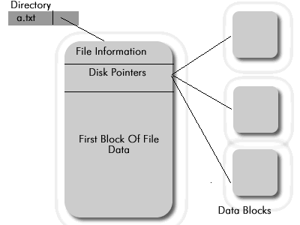

The NEOFS was designed to improve the direct access to the contents of the file. If we have only direct pointers to the data block in the fnode, the maximum size of the file will be extremely constrained. The NEOFS is designed to be easily ported to hard disk as well, so we give first and second level in indexing the lba, which enable us to address huge secondary memory. The data block links in fnode are as shown below 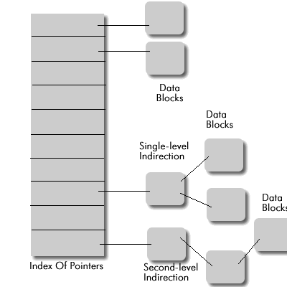

The LBA of the first data block of the file, which also contains the Fnode, is retrieved from the directory entry, which is collection of names and LBA.
The next layer is concerned with marinating the open file table. All the files opened are kept in this layer and operated upon. Over this layer we give all the operations like read, write, seek etc. Over this functionality layer we give a shell, which uses them to provide the commands. The multiple users and user privileges are implemented at this layer.

