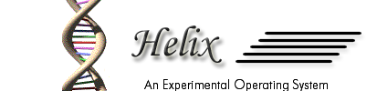

Name Of the Project | Design and Implementation of an experimental operating system ( Helix )
Undertaken By | - MuraliRaja M (Project Leader)  - Harish J P  - Naveen B N  - Priyananda Shenoy P
Semester / Branch | VI Semester / Information Science
Institution | R V College Of Engineering
Project Guide | Kaylan Chakravarthy C P S



Department Of Information Science and Engineering,
R V College Of Engineering,
Bangalore – 560059.
Index

- Abstract about the project
  - Project Goals
  - Project Objectives
- Detailed List of Features
  - General Features
  - Memory-related features
  - I/O related features
  - File related features
  - Programming interface related features
  - Protection and Security features
  - Shell and User Interface Features
- Detailed Design
  - General Overview
  - Subsystems Design
- Design of Boot-up programs
- Design of Memory System
- Design of the I/O Systems
  - Keyboard Drivers
  - Video drivers
  - Floppy Disk Drivers
- Design of the File System
- Design of the System-call interface
- Data Dictionary
  - Explanation for common terms
  - Structures used
  - Functions and modules
  - Constants and file organization
- Tools Used
- Brief Introduction to i386+ architecture
- Scope for development
- Acknowledgement
- Bibliography

Abstract

The operating system is the software, which forms the interface between the computer and the user. It interacts with the hardware and takes care of the basic operations required for the user’s computational activities. It provides an environment for the user to carry out his tasks. The operating system insulates the user from the inner details of the working of the computer and simplifies the usage of the computer for the user.
Helix is an experimental operating system that aims to provide the basic features of an operating system. Helix is a general-purpose operating system that provides the user a wide variety of functionalities, ranging from Disk management to Process management. Helix aims to make efficient usage of the computer’s resources while providing the user a simple interface to carry out his tasks.

The goals of Helix Project are:

- To develop and deploy a general purpose operating system for Intel 80x86+ based PCs.
- To provide the user an interface to achieve his/her computational needs.
- To hide the intricacies and complexities of the hardware system by insulating the user with a layer of abstraction.
- To integrate various different components of a computer system as a single co-operative unit.
- To provide a programming environment for developers to write complex programs to achieve their desired results.
- To provide security for user and his data against accidental or deliberate damage.

The objectives of the Helix Project are:

- To understand the working of an Intel 80386 or compatible PC.
- To understand and successfully make use of advanced features of modern 32-bit processors
- To understand the low-level details of Device - I/O and develop device drivers for these devices
- To design and develop a Operating System kernel which integrates the device drivers and builds upon them
- To achieve a necessary level of abstraction in order to develop applications which makes use of the Operating System functionality
Detailed List Of features

General Features

- Helix can run on any IBM PC or compatible systems with Intel 80386 or higher microprocessor.
- Can boot from a fat 12 floppy diskette.
- Helix requires a PC/XT or compatible BIOS.
- Helix can only boot from a system that contains a 1.44M 3.5’ floppy.
- Helix is a stand-alone operating system.
- Helix requires minimum of 4MB of RAM for running processes.
- It has a customized highly efficient file system called NE0FS.

Memory Related Features:

- The Helix Memory model is built for completely 32-bit protected mode operations.
- Each process has a 4 GB (2 ³²) virtual address space.
- Helix uses segmentation for virtual addressing, but does not use paging.
- Well configured GDT and IDT to handle 32 bit segments in 32 bit protected mode and to handle 32 bit interrupts.

I/O Related Features:

The various I/O devices supported are:
- Keyboard – generic keyboards with US Layout are supported by Helix
- Video – standard VGA or SVGA monitors are supported
- Floppy Drive – Helix supports standard 1.44 MB 3.5” floppy disks

File Related Features:

Helix is ported with a new custom file system called NEOFS. NEOFS is an efficient file system for floppies and with minor changes can support other IDE devices.

The File system model followed is similar to the UNIX inode-block structure. Multilevel directories are supported. The directory structure is an acyclic-graph based structure. Basic file operations like open, close, read and write are supported.

Programming interface related features

Helix comes with libraries for common operations which include I/O and console related functions like printf() and scanf() , string manipulation functions like strlen(),strcpy() , other c-library functions like atoi().The programming libraries form an interface for the programmer to write programs .

Protection and Security Features

Helix supports simple authentication and security. Helix supports multiple users with separate privileges and security configurations. The protection is ensured at floppy level, as the media is removable.
The security is for individual files and folders. Each file/Directory has an owner and a specified set of permissions for the owners and others . The ownership of a file as well as the permissions for the file can be changed dynamically .

Shell and User Interface features

Helix has a customized console based interactive shell called QSH (Quick Shell). It has common commands to read and write files, display other information like usage of commands. It also has extensive help for all command provided.

Detailed Design

Overall Design

The Design of Helix follows a layered architecture. The system functionality is divided into separate functional layers. Each layer abstracts the higher layers from the complexities of the lower layers. The Helix operating system consists of the following layers:

- Device Interface Layer – This is the lowest layer of the System. This layer is the one which interacts with the hardware of the system. It consists of low level I/O manipulation functions which are subsequently used by the upper layers

- System Implementation layer – This is the layer which implements most of the Operating system functionality. This layer has functions which work on top of device drivers and provide an interface ( System Call Interface ) for Operating System Services

- User Interface Layer – This is the part of Helix which is visible to the user . This layer includes the shell which is the primary interface between the user and the system . This also includes the common libraries and wrappers for system calls for application programs.

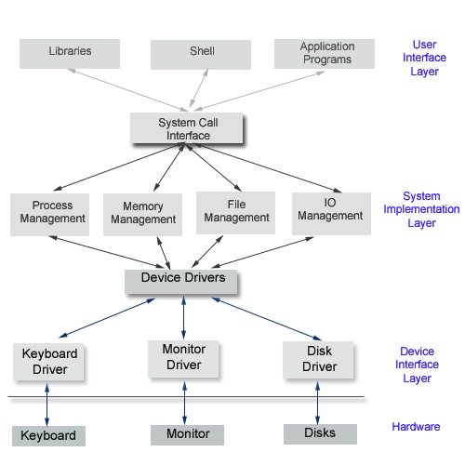
Kernel

Fig 1 : Helix System Architecture

Helix Kernel

The Kernel is the core part of the operating system. The kernel performs all operations of the operating system. Almost all modern operating systems separate the core operating system ( kernel ) from the user-interface part ( shell ).

The system model followed is the Linux Kernel-Shell model. The Kernel is a monolithic non-preemptible program which runs in Ring 0 (Supervisor mode).

Design of Boot-up programs

Design of Memory System
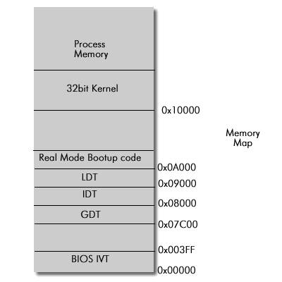

Helix is designed to make optimal use of the large memories that are supported by modern systems . Helix works in completely 32bit environment with security and protection features enabled . It makes use of protected mode features of i386 systems to ensure that accidental or deliberate memory references do not destroy the system.
Keyboard Drivers

Video drivers

Floppy Disk Drivers

Design of the File System

To start with, NEOFS views the secondary storage as an array of BLOCKS which are of fixed size (4 * 1024 bytes in implementation) .This is something like unwinding the tracks of device and viewing them as a single strand of blocks. The minimal amount of data read or written to the storage unit is a BLOCK. By doing so we ease the problem of addressing, now instead of specifying the head, cylinder, and track, sector to read or write we just specify the logical number of the block. We call such a logical address of block as LOGICAL BLOCK ADDRESS, LBA .We then internally do the conversion from LBA to actual address which enables us to change block size easily.

Any filesystem for that matter has to store the address of data blocks of a file in the disk, so that it can read data back. This information can be stored in the form of linked list distributed over disk, or in the form of list packed and stored at one location as in FAT system. Both of these methods do not provide a good performance in case of direct read, since it has to traverse the list to determine the location .Though the latter is better than former in direct access, the latter is static, i.e. irrespective of number of files, a certain fixed percentage of disk space is used for storing information about file system, so it is a compromise between space and performance.

One way to achieve a better direct access performance is to pullout all data links into a single block so that direct access to any location is guaranteed to be in very few seek. This method is used in file systems of UNIX and Linux platforms. It is bounded and has good performance. This design does have some problems carried from earlier ones via:

a) Even this design is static as described earlier.
b) We need at least two disk access to get data from disk, one to the
Inode block where all collected links are stored ordered by files, and then to actual data. Even if the file is small and can be read in single seek this needs two accesses which are more often actual seek.

Our filesystem tries to cover up these two draw backs and with it use the advantages UNIX filesystem. Our perspective towards solving this problem was to place to the collection of links or typical INODE next to the first data block so that they can be read in a single seek to disk but we came out with a better design towards it where we place the inode EMBEDED into the first data block itself. This method along with ensuring implementation of our view, solved problems like non availability of two successive blocks.
Since the inode is now a part of file itself we call it as FNODE or file node .This enables us to get both inode and first block of data not only in a single seek but also in a single read. This system distribute the FNODES through out the disk along with the first data block .Dynamic behavior is obtained by allocating fnode and first data block only when a file is created unlike in UNIX where all inodes are allocated statically when filesystem is created. So the minimal space requirement of our filesystem is that super block to be stored to make it work. So we can skip allocation of initial static space required for storing the inode block which allocates disk space for all inode whether file is created or not.

Benefit of our system certainly does not come with an illusionary free of cost. The penalty is that we need to read redundant data when we just need an inode. In some cases like if you are just trying to get attributes of a number of files our system may have a limping performance against that of UNIX, but we assume that when you access a file you want to read/write it. In file systems like that of UNIX, even though the redundant data is read , it contains the inode of different file which may be saved and may be used to prevent a seek for other file.The data of a file read redundant is unlikely to be used for any other purpose. So if only inode of a file is required , then we read redundant data which cannot be avoided.

The location or LBA of the fnode is obtained from the directory entry of the file which contains the file name , its LBA and also a hash value based on file name to improve the performance of search in directory. The read and write operations are always processed through buffers which implement the approximation of LRU buffer replacement algorithm . The files that were opened are ordered separately and we use ordered buffering there. The free space management on secondary storage is done by maintaining a bit vector. Unlike windows systems where every write operation to disk is expected to write immediately, your system stores it buffer as long as possible so that modification do not need a separate write. This is done to enhance performance, but requires that the device is unmounted before removal to ensure write to it. It also needs to mount a device before using it.

Other features of file system include support for multiple users, where in they can set privileges for each file. We have tried to cover all basic operations given by a file system. Some of the operations we give are
file operations like opening, closing , seeking ,reading ,writing, linking, unlinking ,changing permission, owner of a file

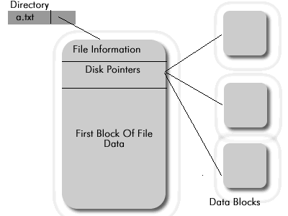

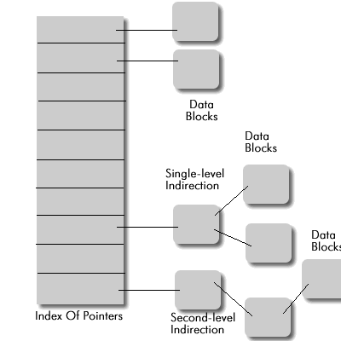
Initialization of the Global Descriptor Table

The global descriptor table contains the descriptor of each segment selector that may be used in the protected mode. In Helix we have 9 segment descriptors in the GDT Table. The structure of each GDT entry is given below.

63 62 61 60 59 58 57 56 55 54 53 52 51 50 49 48 47 46 45 44 43 42 41 40 39 38 37 36 35 34 33 32
LIMIT
BASE (24 – 31) G B 0 1 (16 – 19) 1 DPL S TYPE BASE (16-23)

BASE (0 – 15) LIMIT (0 – 15)

31 30 29 28 27 26 25 24 23 22 21 20 19 18 17 16 15 14 13 12 11 10 9 8 7 6 5 4 3 2 1 0

The descriptors used and the role they play are as follows: ( Described in gdt.asm )

NULL_GDT : The first descriptor in the GDT table must be a null entry as it is made mandatory by Intel . (All the 8 bytes are 0’s).

LINEAR_SEL : This descriptor is a data segment descriptor that starts from base 0 and has the limit 4GB . It is a data segment that is writable at DPL 0.

VIDEO_SEL : This descriptor is used by the video driver to write into the video memory. The base of this descriptor is set to 0xb8000 and the limit is set to 0xfff and Granularity bit off. It is a data segment that is writable at DPL 0.

KERNEL_DATA_SEL : This descriptor is a data segment descriptor used by the Kernel when executing in 32 Bit mode . It has the base 0 and limit set to 0xffff and Granularity bit on.

KERNEL_CODE_SEL : This descriptor is an executable , read-only segment with the base 0 and the limit set to 0xffff and Granularity bit on.

KERNEL_STACK_SEL : This descriptor is same as KERNEL_DATA_SEL but sp is initialized before the stack is made use of.

LDT_SEL : This contains the LDT table entry for a given process that will be executing in the 32bit DPL 3 mode.

REAL_CODE_SEL : This descriptor is a segment that starts at 0x10000 base address and the limit is 0xffff with the Granularity bit off. This is mainly used to execute interrupt 13h by switching to real mode.

REAL_DATA_SEL : This descriptor contains the necessary segment descriptor that will be used when switching from protected to real mode to execute interrupt 13h

All the above descriptors are loaded at physical address 0x7c00 when the Boot1 finishes executing . It is a must that you must create a GDT table before you jump to 32 bit protected mode and load the GDTR register with its appropriate address.

The way the logical addresses are translated into linear addresses using the Selector and descriptor is shown in the following diagram.

Linear Address
gdt or ldt
Descriptor

gdtr or ldtr
Index | T1
8
:

Selector Offset

Initialization of the Interrupt Descriptor table

After switching to the 32 bit protected mode the interrupt descriptor table has to be reinitialized to contain appropriate 32 bit handlers. The dummy interrupt vector would be loaded at physical address 0x8000 after the boot1 stage of helix. All the interrupt table vector entries has to be reinitialized to an appropriate interrupt handler .The Programmable interrupt controller is programmed to send all the interrupts it generates to interrupts 32 to 48 .

The way the two PIC’s are cascaded are shown below and the corresponding interrupt number they generate are given in the table below

INT

8259 Slave
8259 Master

8 9 10 11 12 13 14 15 0 1 2 3 4 5 6 7

IRQ IRQ

IRQ Assignment to I/O Devices

IRQ INT Hardware Device
0 | 32 | Timer
1 | 33 | Keyboard
2 | 34 | PIC Cascading
3 | 35 | Second Serial Port
4 | 36 | First Serial Port
6 | 38 | Floppy Disk
8 | 40 | System Clock
11 | 43 | Network Interface
12 | 44 | PS/2 Mouse
13 | 45 | Mathematical coprocessor
14 | 46 | EIDE disk controller’s first chain
15 | 47 | EIDE disk controller’s second chain

In helix all the interrupt descriptors are interrupt gates .The structure of each interrupt date is as follows .

63 62 61 60 59 58 57 56 55 54 53 52 51 50 49 48 47 46 45 44 43 42 41 40 39 38 37 36 35 34 33 32

OFFSET ( 16 – 31 ) P DPL 0 1 1 1 0 0 0 0 RESERVED

SEGMENT SELECTOR OFFSET (0 – 15)

31 30 29 28 27 26 25 24 23 22 21 20 19 18 17 16 15 14 13 12 11 10 9 8 7 6 5 4 3 2 1 0

The IDTR register is initialized to point to the IVT of 32 bit mode before any interrupts are called.

Acknowledgments

We wish to sincerely thank the following people for their invaluable contribution to the Helix cause:

Mr. N K Srinath , HOD , Department Of Information Science and Engineering , R V College Of Engineering. He has been a great source of inspiration for all of us.

Mr. Kalyan Chakravarthy , our project guide who gave us the original idea for Helix. Now you know whom to blame for all bugs.

All Lecturers of ISE Dept, for their co-operation and great help. Also for sacrificing their precious floppies for the sake of Helix

All the Technical Staff at ISE Dept for their patience with us. They have gone into great troubles for our sake.

Our parents , who allowed us to work on Helix even late at night .

We also would like to make a mention about the system numbered COM37, which has undergone about 561 reboots till now while testing Helix.

We also thank Andrew S Tanenbaum for the providing us guidance indirectly.

Last but by no means the least , all the students of 6th SEM ISE for their motivation.

