Section : YEFP/sched/3.1

Objective : To monitor apache process load and quantify the average load of the server

Rationale :

This section deals with a specific process ie Apache Web server and the measurement of the load on the process and the average time taken by apache to respond to a user request. The program under consideration is Apache version 1.3.2 running on Linux 2.4.18 kernel.

Apache structure:

The Apache structure is based on a single parent process and a group of reusable children. The parent reads the configuration and manages the pool of children. Each child at any time is either serving a single request or sleeping. Apache 1.3 automatically regulates the size of the pool of children so that there are enough to cope with spikes in load without using too many resources to maintain idle processes. Busy children serve one request at a time on a single socket.
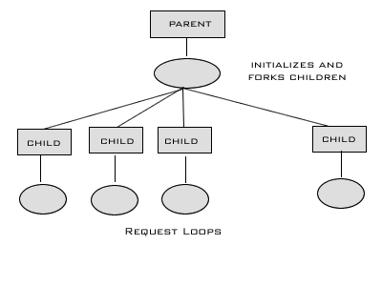
( Apache 2.0 has a different architecture. It uses Multiple Process Modules (MPM) to optimize the server. It can run with a hybrid model of pre-forked processes and threads which take advantage of the underlying system architecture. However , in Linux where forking and switching is cheap , a pre-forked model is optimal.Hence I use 1.3.2)

Measurement of Apache must therefore measure each of the children processes and how they are loaded. We do this by monitoring the parent process (httpd) and all children of httpd (whose ppid is httpd’s pid).The percentage of CPU consumed by each of the processes is measured over a period of time.

Implementation:

The proc file system is used to get the values of the amount of time spent by the process in the last intervals.The load measurement is done once in the range 200-500 ms (Anything lesser than 200ms is not necessarily accurate )

/**
- Reads the times ( utime , stime , cutime , cstime )
- For a process whose pid is given
*/

void read_proc( char * pid , four_t * time )
{
int itemp,a,b,c,d,e,f, fd;
unsigned long ltemp , m , n , o , p , q;
char ctemp[100],ch;
char buff[512];

sprintf(ctemp,"/proc/%s/stat" , pid );
fd = open ( ctemp , O_RDONLY );
itemp = read( fd , buff,511 );
buff[itemp] = 0;
sscanf( buff,
"%d (%[^)]) %c %d %d %d %d %d %lu %lu %lu %lu %lu %lu"
" %lu %ld %ld" ,
&itemp,
ctemp,

//. . .
ime->u,
&time->s,
&time->cu,
&time->cs );
close(fd);
}

/**
- The following macros help in getting the number of seconds
- Taken by the process and the total number of second passed
*/

#define tv2double(tv) \
(double)tv.tv_sec + \
(double)tv.tv_usec / 1000000.0;

#define read_time(tv,dval) \
do{ \
gettimeofday(&tv,NULL); \
dval = tv2double(tv); \
}while(0)

#define read_ptime(str,four,dval) \
do{ \
read_proc(str,&four); \
dval = ((double)four.u + (double)four.s + \
(double)four.cu + (double)four.cs) \
/ 100.0f; \
}while(0)

int main(int argc , char * argv[]){
struct timeval tv ;
four_t time = { 0 };
double total_ticks = 0.0f , told_ticks = 0.0f;
double proc_ticks[10] = {0.0f};
double pold_ticks[10] = {0.0f};
read_time(tv,told_ticks);
for( int i = 0 ; i < argc ; ++i )
read_ptime(argv[i],time,pold_ticks[i]);

setbuf(stdout,NULL);
while(1){
read_time(tv,total_ticks);
for( int i = 1 ; i < argc ; ++i ){
read_ptime(argv[i],time,proc_ticks[i]);
printf("%lf " ,
(proc_ticks[i] - pold_ticks[i])
/ (total_ticks - told_ticks)
);
pold_ticks[i] = proc_ticks[i];
}
told_ticks = total_ticks;
puts(" ");
usleep(500000);// 500 ms
}

return 0;
}

Results:
The load monitoring was carried out for two sets of cases:

- Non-concurrent clients – here the clients send requests one after the other.The next request comes only if the previos request is completely processed

- Concurrent clients – here the client spawns multiple children or threads which simultaneously send requests to the server.This was done by a program called “http_load” which can be configured to exactly send requests at pre-determined number , concurrency count and other parameters
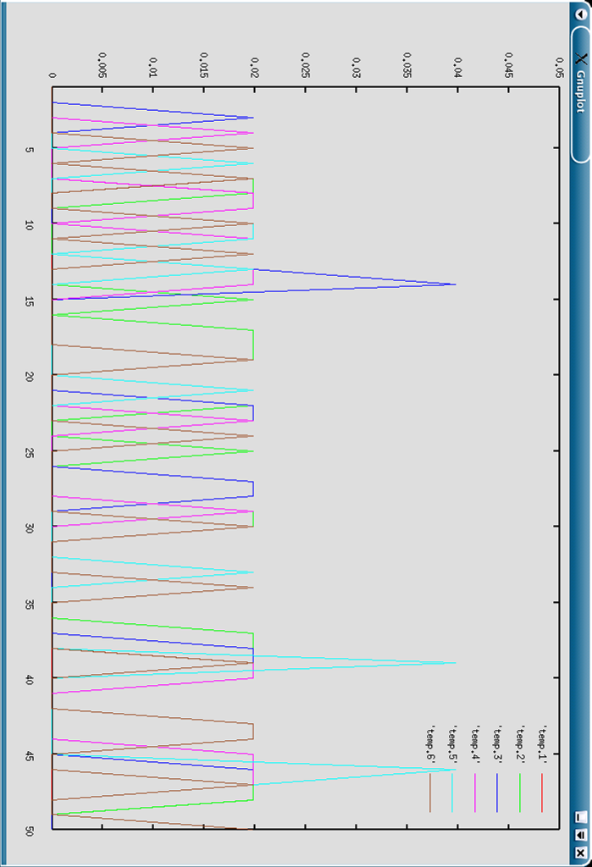

This graph gives the CPU % used by 6 child processes of Apache.
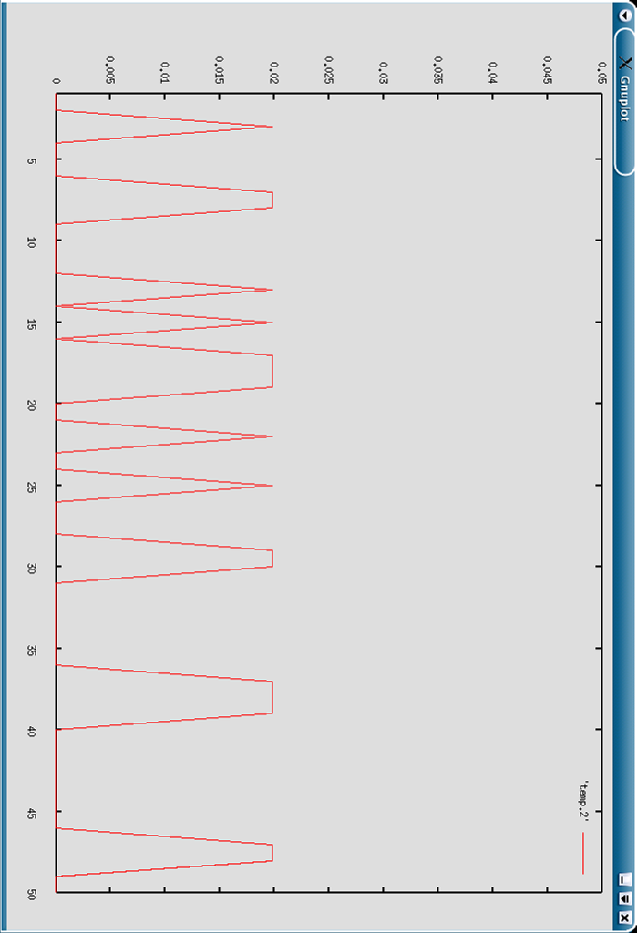

This graph gives the CPU utilization by one Apache child.

