Section : YEFP/sched/3.3

Objective : Load based Apache priority increments

Rationale :

Apache children generally run at default nice priority. This is to ensure fairness in a general environment. If the load is low, then all of the children are not active at the same time, then there is little point in changing the priority of the processes. If the load reaches a threshold, then the server is under heavy load. At this time we may dynamically increase the priority of the process to match the load. The idea to give larger priorities (and hence more of the CPU) to the children when the load is high. This assumes that the child processes are essentially CPU bound. If the child processes are I/O bound, then this mechanism is useless but doesn’t cause any harm.

Implementation:

The implementation out-lined below is not in general a good idea. It actually hard-codes specific process related methods inside the Linux kernel. A better way would be to use a specific interface either as a module or a system-call based user-space process, so that the actual details are abstracted out of the kernel. But because of paucity of time, this mechanism is done.
We keep track of the Apache process ( assumed to be execed from /sbin/httpd )and all its children (whose ppid equals the apache parent’s pid). We use the load calculation system of Ingo Molnar’s 2.4.18 scheduler to keep track of all the children’s current loads. We monitor the children and when the load reaches a pre-calculated threshold, we switch on the priority increment mechanism. The mechanism checks every 4 seconds, the amount of load each child had and depending on the load changes the effective priority of the child by an amount (0…PROF_APACHE_LOAD_PRIORITY)
PROF_APACHE_LOAD_PRIORITY is set to 10.This quite a large increment and can cause other processes to get lesser time slices and hence starve. Hence the increment is given slowly and only if the server is highly loaded, is the maximum increment given.
We store the httpd parent process pid in a global variable pp_apache_pid. This is done in the exec system call.
During schedule, if ppid of a task equals pp_apache_pid , then it’s effective priority is calculated using the function pp_calc_prio

/* based on Ingo Molnars interactivity function */
static inline int pp_calc_prio( task_t * p ){
int prio_bonus;

prio_bonus = MAX_USER_PRIO*PRIO_BONUS_RATIO*
p->sleep_avg/MAX_SLEEP_AVG/100 -
MAX_USER_PRIO*PRIO_BONUS_RATIO/100/2;

//…
prio = p->static_prio + SCALE_TO_RANGE(prio_bonus);
return prio;
}

Depending on effective priority, the bonus is calculated. The macro SCALE_TO_RANGE is used to scale the bonus in the range (0… PROF_APACHE_LOAD_PRIORITY). The effective priority is used to assign the process to one of the priority queues.

Results:

The apache process is monitored on the normal 2.4.18 kernel and then on the modified kernel with dynamic priority calculation added. The average response times are measured and compared. What we find that there is a slight overall decrease in the response times. The difference seems to be slight. The load calculation parameter in this case was probably too high because the highest reached bonus priority is 5 even when the server was heavily loaded. Empirical study of bonus calculation parameter can be helpful in determining the actually optimal load calculation which gives the right amount of throughput.

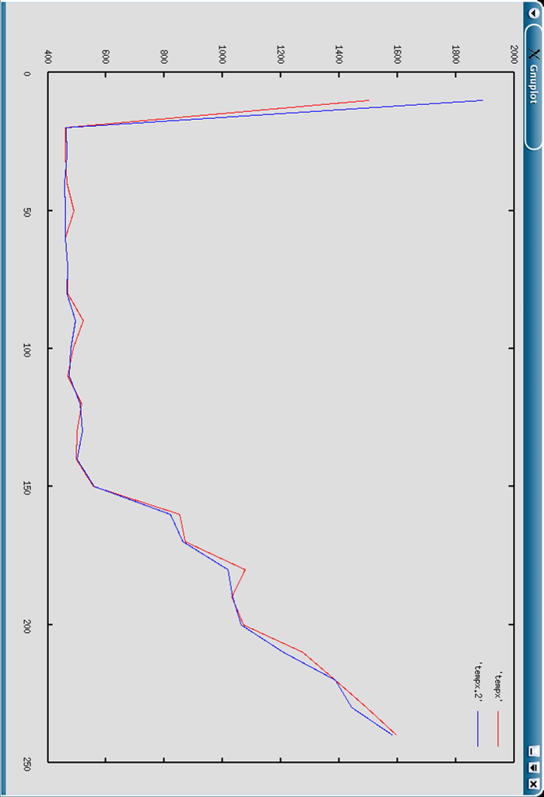

This compares average response time on standard 2.4.18 kernel and the modified kernel with load based priority bonus. The average response time is slightly lower than the normal one.
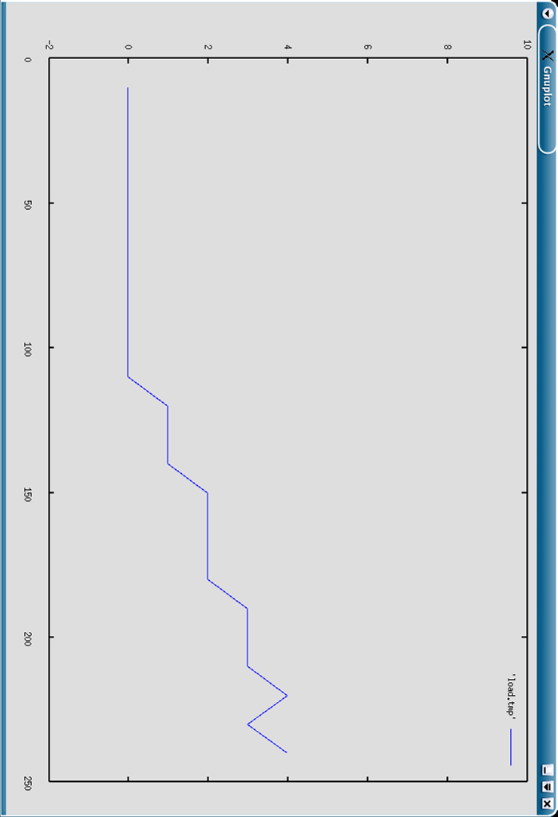

This shows the calculated bonus value using load as the parameter. The parameter is very slow to rise and hence the maximum load measured is around 4.

