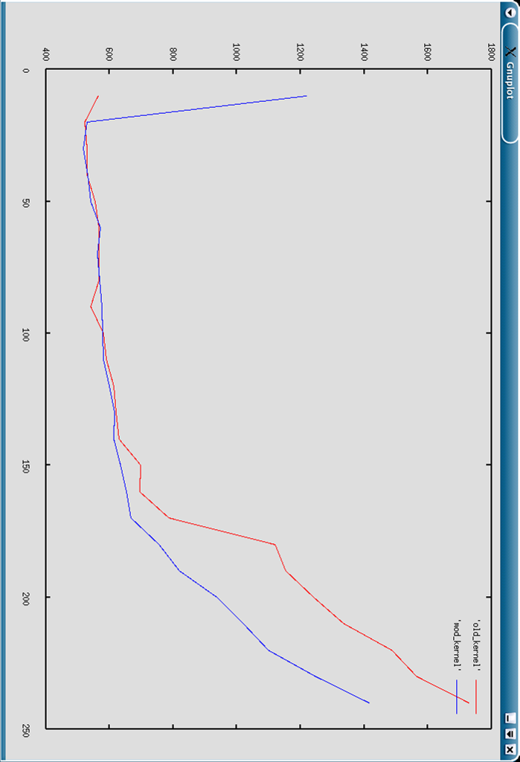

The comparison of response times for Apache on the standard 2.4.18 kernel and the kernel modified to give priority increments is as shown below.

Y Axis: average response time in microseconds
X Axis: concurrency count in http_load – number of concurrent requests
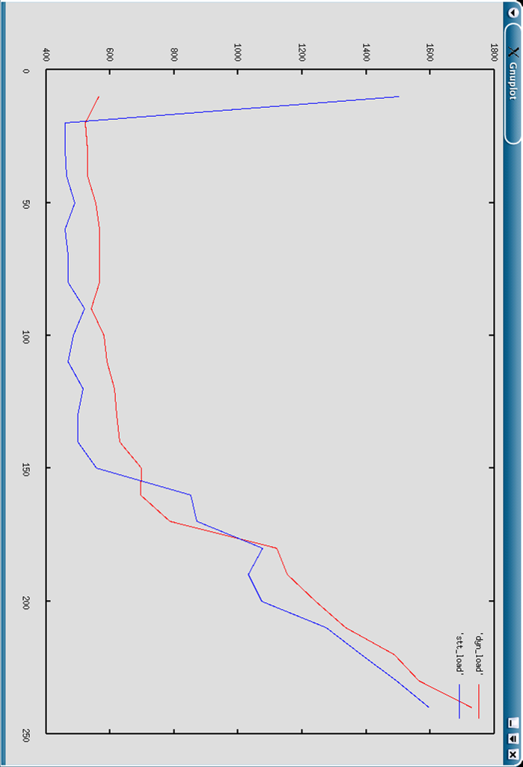

The comparison for response times of static html pages ( url_count = 8 ) and dynamic page ( gd.php ) on Apache 1.3.2 on unmodified 2.4.18 kernel

Y Axis: average response time in microseconds
X Axis: concurrency count in http_load – number of concurrent requests

