Section : YEFP/sched/3.2

Objective : Measurement of average response time of Apache Web service

Rationale :

We can define response time of a server as the amount of time taken to give the first output , measuring from the moment we send a request. The response time is an important parameter. It determines the time a process ahs to wait for the initial response.
If we measure response time , the time we obtain is compose of the following parts:

- The network delay for sending the request to the server
- The processing time taken to retrieve the file and respond to the request
- The network delay of the response packets reaching from the server to the client.

The network delays are assumed to be constant (because this program uses the loop-back interface). Hence the response time gives us an estimate of the processing time itself.

The processing time in turn consists of the following components:

- The time taken to process the HTTP request headers
- The time taken to retrieve the file requested
- The time taken to create a response and write it to the network stream

By measuring the average time taken for a response, we can analyze the processing time required.

To measure non concurrent request response time , we use a program which uses libcurl to requests and receive a 1-byte file from the HTTP server. The timing measurement is taken over a large number of sequential requests. The average

Implementation:

We use multithreaded request dispatching using pthread library to send and measure requests to the server concurrently. The average time is measured over a period of time. The initial requests must be ignored because the first few times the page is accessed, the overhead in loading the file is far greater thatn any processing operation. Further accesses are cached, so there is no I/O overhead.

volatile int cum_times = 0 , number = 0;
pthread_mutex_t lock = PTHREAD_MUTEX_INITIALIZER;
volatile int thread_count = 0;

/**
Atomically update process times. Possible race condition
*/
void update_times( int time ){
pthread_mutex_lock( &lock );
{
cum_times += time;
number ++;
}
pthread_mutex_unlock( &lock );
}

void * send_request(void * gg){
Socket s = Socket("localhost",80);
StringWriter sw ( s.getOutputStream() );
StringReader sr ( s.getInputStream() );
struct timeval start,end;
static char request[255];
sprintf( request ,
"GET %s HTTP/1.1\n"
"Host: oink\n\n" , get_random_page() );
gettimeofday( &start , NULL );
sw.write( request );
sr.readLine();
gettimeofday( &end , NULL );
long long val =
(long long)
( end.tv_sec - start.tv_sec) * 1000000L +
( end.tv_usec - start.tv_usec);
update_times( (int) val);
--thread_count;
}

void delegate_task(){
pthread_t tid;
static char ch = 1;
++thread_count;
pthread_create( &tid , NULL , send_request , &ch );
}
int main( int argc , char * argv[]){
for ( int step = 100 ; step < 1010 ; step += 10 )
{
thread_count = 0;
for( int i = 0 ;i < step ; ++i )
delegate_task();
while(thread_count);
printf("%d %f\n", step,
(double) cum_times / (double) number);
cum_times = number = 0;
}
}

Results:

The average response time is measured over a large range of concurrency counts. The results are plotted on to a graph. The trend observed shows that depending on Apache configuration, until a particular threshold, the average response time is fairly constant. When the number of concurrent requests reaches the threshold value, the average response time increases rapidly. This happens when all the pre-forked children are busy. Until this point, the server is fairly unused. The threshold can be used to deduce when the server is loaded and hence requires some additional tuning.
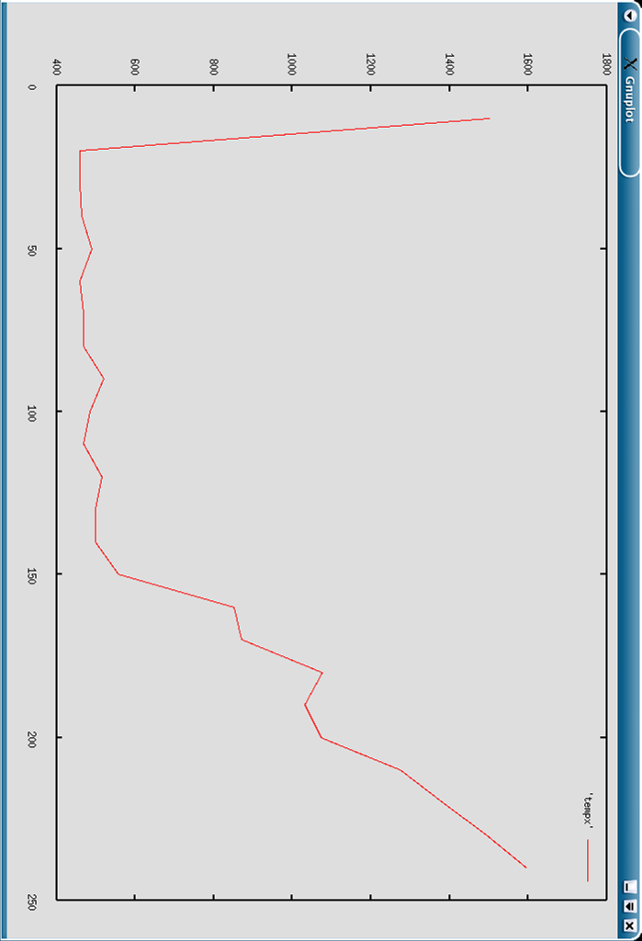

This shows the average response time taken vs. the number of concurrent requests.It increases rapidly after it reaches the threshold.( Time is in microseconds)

