Section : YEFP/sched/2.3

Objective : Empirical analysis of various load calculation parameters and their effect on the load penalty

Rationale :
In Section 2.2 , a load penalty calculation scheme was shown. The load was calculated using a function

load = 0.8 * x + 0.2 * y;
where
x = ratio of CPU utilized by User to total CPU usage
y = ratio of number of Runnable tasks to total number of tasks

It is interesting to note that the weights were given arbitrarily. The next logical step would be to try to obtain an optimal or correct weight distribution. But no theoretical basis exists in general on what could be considered an optimal weight allocation.
Also why those two parameters are taken to be used in the load function is debatable. The justification for chosing the parameters are given below :

- Ratio of CPU utilized to total CPU time – The question comes up as to what do we mean by “load”. We can define load as the measure of how much supply is available according to the demand.Consider a system where the CPU is not being utilized even though there are a large number of processes ( possibly all are I/O bound and are sleeping ) . It is not right to call that system loaded. So how much the current CPU is being utilized can be a measure of system-load

- Ratio of Running processes to total number of processes – The current length of the Run Queue is an important measure of the system load. The higher the ratio, the more the number of processes contending for CPU, and according to our definition, the higher the system loads.

The calculation is a little naïve in its simplicity. Obviously more parameters can be used to determine system load. The calculation would become more complex.
Another issue is the scale factor. In the algorithm, the load was scaled to a -2...0...+2 range.This limits the penalty in a small region. Again the interval was chosen arbitrarily. Chosing a small interval reduces the effect of load on the counter values. On the other hand, a very large penalty can radically change the dynamic priority. In chosing a small value, I decided to be conservative and not deviate too much from the standard priority ranges. It is an entirely different excersice to try and optimize the results for a particular system using different load intervals.

Implementation:
Implementing this is very straight forward. The code in Section 2.2 is modified slightly as shown below (kernel/shenoy.c)

#define PROF_WEIGHT 0.8f

void pp_calc_load(void){
float x = (float)
( kstat.cpu_user + kstat.cpu_system ) /
(float) jiffies;
float y = (float ) nr_running / (float) nr_tasks ;
float load = x * ( 1 – PROF_WEIGHT ) + y * PROF_WEIGHT;
pp_load = PROF_SCALE(load);
}

The kernel is recompiled and run many times with different weigths by changing the value of the PROF_WEIGHT macro. The load calculation and measurement is done as in Section 2.2 using the same set of processes. The value of load is measured every 10 seconds.

Results:
The results are tabulated and examined. The following graph is obtained. The measurements are made for values of PROF_WEIGHT as 0.8, 0.5 and 0.3.
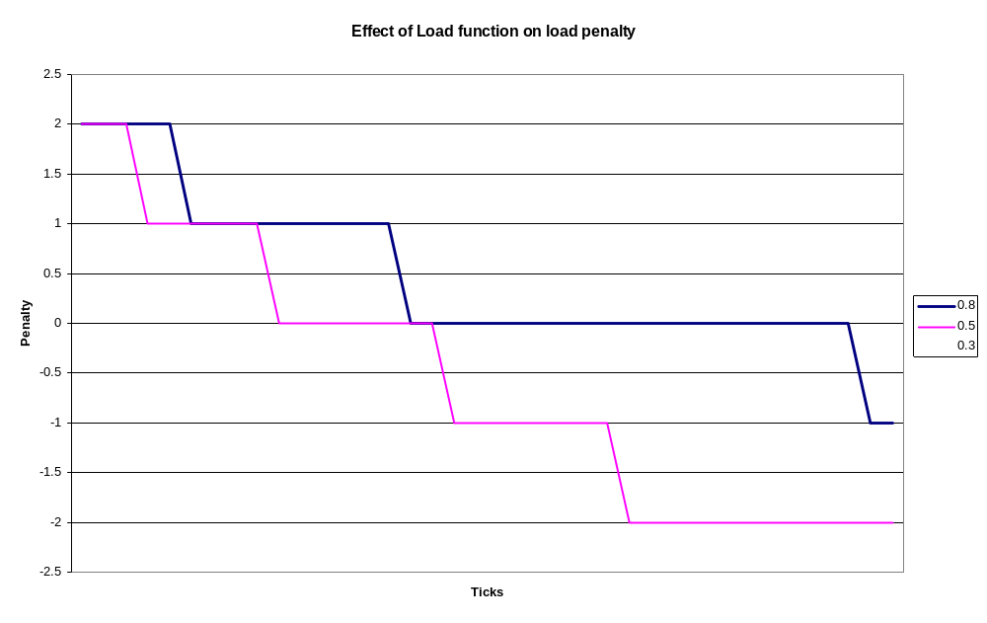
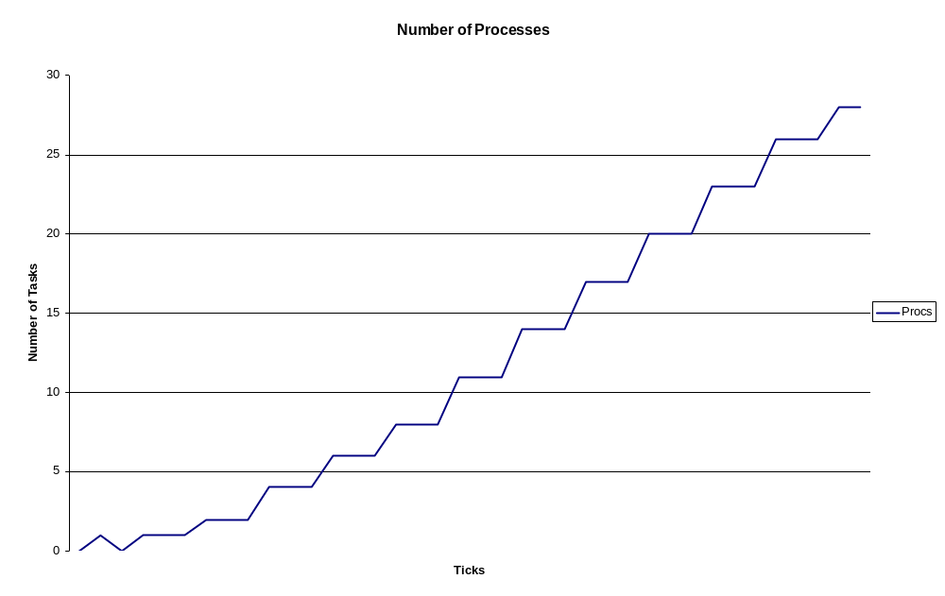

Figure 2 shows the number of processes runnig in the system. The analysis of these graphs gives the following patterns:
The load weight determines the quickness with which the load penalty changes. Actually it determines the definition of load. For example, the 0.5 line starts to decrease the load penalty later than 0.3 line.Also the 0.5 line stays at 0 penalty for a longer time than the 0.3 line. To be able to say that a particular value is optimal, it is necessary to define what is considered to be a normal load. For example, for the 0.5 penalty line has normal range (i.e. when penalty is 0) from 10-20 processes. The 0.8 line actually makes penalty lowest quite early.

