Section: YEFP/sched/2.4

Objective: Implementing a dynamic proportional fair share scheduling approach using the lottery algorithm

Rationale:
Conventional scheduling algorithms often must follow different conflicting policies for various types of service requests. Scarce resources must be multiplexed to service requests of varying importance, and the policy chosen to manage this multiplexing can have an enormous impact on throughput and response time. Accurate control over the quality of service provided to users and applications requires support for specifying relative computation rates.
Fairness is a criterion which schedulers struggle to maintain, because this directly conflicts with efficiency. In conventional schedulers, fairness is considered at the process level. That is, every process will eventually get a slice of the CPU, and all processes at the same priority level will get an equal share of the CPU. But higher applications may not require fairness at the process level. The application policy may not directly correspond to per-process fairness. So a scheduler which takes into consideration other factors while making the scheduling decision is required. One such scheduling approach is dynamic proportional fair share algorithm. It is dynamic because the allocation of a resource is not done statically. It is fair-share because the policy-based fairness is incorporated. It is proportional because the resource consumption rates of active computations are proportional to the relative shares that they are allocated.
One such policy based fairness may be per-user fairness. That is, all users get a proportional share of the CPU, irrespective of the number of processes the user has. As an example, consider a system with user A having 8 processes and B having 2 processes. Each process may get the same time slice. But user A has got 80% of the CPU utilized while B has 20% share. This is restrictive because the user has no control over the allocation of resource.
One such approach is lottery scheduling, a recently introduced randomized mechanism by Waldspurger et al. that provides responsive control over the relative execution rates of computations. Lottery scheduling efficiently implements proportional-share resource management. The resource management framework developed for lottery scheduling provides a means for resource allocation to be more flexible and responsive. In addition, lottery scheduling provides a currency abstraction that allows processes to be grouped together and insulated from other processes.

Detailed explanation for Lottery algorithm

Lottery scheduling is a randomized resource allocation mechanism. Resource rights are represented by lottery tickets. Each allocation is determined by holding a lottery; the resource is granted to the client with the winning ticket.
In the introductory paragraph, I mentioned the need for policy-based scheduling. The user must have a mechanism to dynamically create policy criterion which the scheduler uses in allocating the resource (CPU). This necessitates a flexible method by which the higher level policies can be reflected in scheduling decisions. Lottery tickets encapsulate resource rights that are abstract, relative, and uniform. They are abstract because they quantify resource rights independently of machine details. Lottery tickets are relative, since the fraction of a resource that they represent varies dynamically in proportion to the contention for that resource. Thus, a client will obtain more of a lightly contended resource than one that is highly contended.
The lottery algorithm is probabilistically fair. The expected allocation of resources to clients is proportional to the number of tickets that they hold. Since the scheduling algorithm is randomized, the actual allocated proportions are not guaranteed to match the expected proportions exactly. However, the disparity between them decreases as the number of allocations increases.

The main algorithm is given below:
- Allocate a number of tickets to a process
- Generate a random number in the range of the tickets allocated
- Iterate though the process list increasing the count by the number of tickets allocated to the processes
- Stop when the count becomes greater or equal to the random ticket number
An example illustrates this
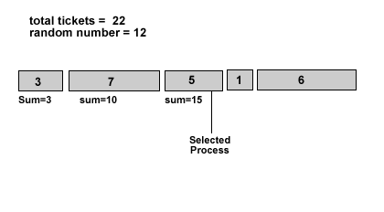
Several issues arise when considering this algorithm. Allocating tickets to any process is dependent on the policy followed. This is what gives the algorithm its dynamic nature. Another important consideration is the matter of starvation. Even though random number generations are statistically fair, they don’t guarantee that the process will eventually win the lottery. So to overcome that problem, compensation tickets are given to consistently unlucky processes. When a process reaches a predefined maximum number of tickets, it is unconditionally executed. So starvation doesn’t occur.
As an example, suppose that per-user share allocation was the policy required. That is, some criterion is used to allocate relative shares between users. Then the concepts of user-ticket and process-ticket currencies come into picture. Each user is given a number of system-wide base tickets. Each process is given a number of tickets which are set by the user on the relative importance of the process. The tickets given to the process are in the user-currency i.e. they are relative to the base-currency of the user as well. This makes sure no one user can hog the CPU. If a user A is given 20 out of 100 tickets, then irrespective of the number of processes A creates, A gets a 20% share of the CPU. Based on the user-tickets that each of A’s processes have, that 20% is proportionally shared between the processes of the user.
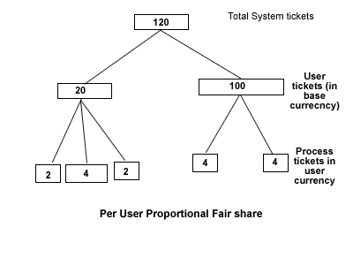

Implementation:

The implementation of lottery algorithm carried out here is highly simplified. Per-user ticket-allocation is done in an entirely ad-hoc manner. Users with uids less than 100 are taken to be system users and daemon users. All others are supposed to be usermode processes. Alternatively, only the root (uid=0) might be taken as privileged user. The system users are given a ticket share of 100, while normal users are given 50. Further analysis may give better methods of allocating tickets.
Per-process ticket allocation is done on the basis of priority. Along with the static priority, other factors can be taken into consideration for calculating the ticket allocation. Again, further analysis is required to come to an effective calculation method.
The following change is made to the task structure (include/linux/sched.h). The pp_tickets field holds the number of tickets the process has in user currency.

struct task_struct{
...
unsigned long policy;
unsigned long pp_tickets;
...
};
To implement user-tickets, the structure user_struct is modified as follows. The tickets are in base currency. The pp_given_tickets takes care of the total number of tickets that all processes of that user have got.

struct user_struct{
...
unsigned long policy;
unsigned long pp_tickets;
unsigned long pp_given_tickets;
...
};

To initialize the tickets when a process is started, the following code in do_fork() (kernel/fork.h) is modified.

pid_t do_fork(){
// …
/** p is the process just created **/
p->pp_tickets = p->priority;
//…
}

When a new user logs in an entry is made in the system wide user-table. This is done by the function alloc_uid. (kernel/fork.c) That is changed as below

#define PP_SYSTEM_UID 100
#define PP_SYSTEM_TICKETS 100
#define PP_USER_TICKETS 50

int alloc_uid(struct task_struct *p)
{
//…
if( p->uid > PP_SYSTEM_UID)
p->user->pp_tickets = PP_USER_TICKETS;
else
p->user->pp_tickets = PP_SYSTEM_TICKETS;
up->pp_tickets_given = p->pp_tickets;
}

The p->pp_tickets_given has to be incremented in fork() (kernel/fork.c) and decremented in sys_exit() (kernel/exit.c).A global variable pp_base_tickets give the total number of tickets allocated to all users.
A prerequisite for lottery algorithm is a random number generator. An implementation for pseudo-random numbers was used by me. The random number is then scaled to the range [1...pp_base_tickets].
The scheduling criteria is done in the goodness() function (kernel/sched.h). The calculation is changed to find the process which has the winning lottery.

count =0;
r = pp_random( pp_base_tickets );
for ( p = &init_task->next_run , p != &init_task ;
p = p->next_run )
{
real_tickets = p->pp_tickets * p->user->pp_tickets;
real_tickets /= p->user->pp_tickets_given;
count += real_tickets;
if ( real_tickets > PP_COMPENSATION_MAX )
{
next = p;
p->pp_tickets = p->priority;
break;
}
p->pp_tickets ++; // Compensation

if (count > r)
{
next = p;
p->pp_tickets = p->priority;
break;
}
}

The tickets each process has are in user-currency. This is converted into base-currency by proportionally taking the ratio of user-currency to total tickets given. The process where the sum reaches the random number that process is chosen to run next. Its tickets are reset back to initial value. All other processes are given a compensation ticket.
This implementation is far from good, but gives a basic architecture for modeling fair share scheduling.

Performance:

The first thing that must be noted is the scheduling overhead. The scheduler uses a random number generator that takes some time for calculating the random number. This adds to the overhead. The actual scheduling algorithm traverses the process list once, similar to normal scheduler. So no extra overhead is incurred. The direct effect of the scheduling overhead is felt in the context switch times. Hence a comparison of context switch times can describe the overhead of lottery algorithm.

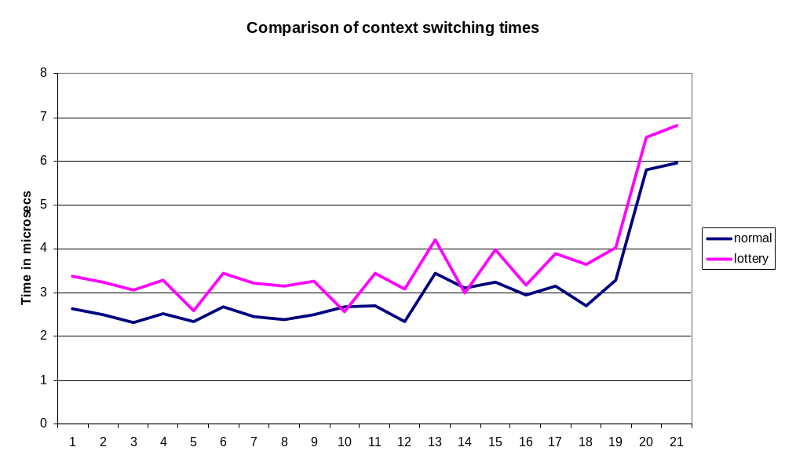

We see that the overhead is fairly constant because of my fairly simple implementation of the random number generation. The overhead is slightly higher but is not significantly more.
Another direct consequence of the implementation is the percentage of schedules which were done on the basis of the tickets reaching the maximum. If the percentage is high, then the randomizing algorithm is bad in its distribution. Having high percentages of compensation schedules can also indicate that some processes are starved to an extent.
A count of total number of schedules and the number of schedules because of compensation tickets is made in the algorithm.The cumulative counts are measured every 10 seconds and the results are tabulated and the following graph is obtained.
The average compensation-schedules were around 38% (This is not statistically accurate, but gives a rough estimate). This is a very high percentage and indicates that the random number generator did not distribute the values evenly.
