Design and Implementation of Code Import Tool
PROJECT REPORT
(FEB-JUN 2004)
SUBJECT CODE: IS8P2

Submitted in partial fulfillment of the requirements for
VIII Semester B.E.
Information Science And Engineering,
Visweshwariah Technological University

Submitted by,
Priyananda Shenoy P,
(1RV00IS021)

Guided By,
Internal Guide | External Guide
Ms Hema | Mr BT Narasimha
Dept Of Information Science, | Development Manager
R V College Of Engineering | SAP Labs India Pvt Lmt.


Department of Information Science And Engineering,
R V College of Engineering,
Bangalore – 560059.
Department of Information Science and Engineering,
R V College of Engineering,
Mysore Road,
Bangalore -560059.

CERTIFICATE

This is to certify that the project titled “Design and Implementation of Code Import Tool” is a bonafide work carried out by Priyananda Shenoy P in partial fulfillment of the award of the degree of Bachelor of Engineering in Information Science and Engineering of the Vishweshwaraih Technological University, Belgaum during the year 2004. It is certified that all corrections/suggestions indicated for internal assessment have been incorporated in the report deposited in the department library. The project report has been approved as it satisfies the academic requirements in respect of Project work prescribed for the Bachelor of Engineering degree.

________________________  Signature of the Project Guide |  | ___________________________  Signature of the HOD,  Department of Information Science,  R V C E
Signature Of External Guides | ____________________________________
 | ____________________________________

Acknowledgements
I consider my privilege to express my gratitude and respect to all those who guided me in the completion of my project
I extend my gratitude to Dr. SC Sharma for providing good library facilities
I am grateful to our HOD, Prof N K Srinath for his valuable suggestions and encouragement.
I am also grateful to my project guide, Ms Hema for her wholehearted help.
A special word of thanks to all the faculty members of Information Science department in helping me in this project.
My thanks also to the very co-operative people at SAP Labs India, Bangalore. This would not have been successful if not for their help. Special Thanks to Sultan Kasim, Narasimha BT, Vasudevan Kesavaprakash for their invaluable help.
Last but not the least, special thanks to my parents who have supported me wholeheartedly in all my ventures.
Abstract

Application Reuse is an emerging trend in software engineering. Large companies often use application databases to store and organize their code base in a manner which allows for efficient usage of reusable objects. These object databases often contain millions of lines of code and are invaluable to the organization.
In the fast moving technology sector, newer and better technologies emerge at a rapid rate. The problem with this is that the code objects stored in object databases would be rendered useless by new technology because generally the new technology is not compatible with the older one.
In such a scenario, there is a need for tools which automatically convert these object databases into newer technologies. This project is a part of one such effort which deals with automated conversion of an object database from the older VB 6 to the current state-of-the-art VB.Net language.
Contents
1 Introduction 7
1.1 Project Scenario 7
1.2 Project Overview 11
2 Concepts and Architecture 12
2.1 Introduction to Object Management System (OMS) 12
2.2 Object Management system services 13
2.2.1 Transaction Service 14
2.2.2 Concurrency Service 14
2.2.3 Persistence Service 15
2.2.4 Versioning Service 15
2.2.5 User Control Service 16
2.2.6 Internationalization Service 17
2.3 The OMS Code Object Architecture 18
3 Analysis 20
3.1 Requirements Description 20
3.1.1 Functional Requirements 20
3.1.2 Non-Functional Requirements 21
4 Design 23
4.1 System placement 23
4.2 Abstract Design 23
4.2.1 System Architecture 23
4.2.2 Object Extractor 24
4.2.3 OMSUpdater 25
4.2.4 Object Store 25
4.2.5 System Interaction 26
4.3 Sub system Design 27
4.3.1 Object Extractor subsystem 27
4.3.2 OMS Updater subsystem 28
4.3.3 Control subsystem 30
4.3.4 Sub system interactions 31
4.4 Design of Error handling subsystem 33
4.5 Design Description 34
4.5.1 Object Extractor sub system 34
4.5.2 OMS Updater sub system 36
4.5.3 Control Sub system 38
4.6 Design Specification 40
4.6.1 Complete Class Diagram 40
4.6.2 Sequence Diagrams 41
4.6.3 Data flow diagram 43
5 Implementation 46
5.1 Implementation choices 46
5.1.1 Choice of Language 46
5.1.2 Choice of File processing technique 46
5.1.3 Choice of Libraries to use 47
5.2 Algorithm and Data-structure design 47
5.2.1 Design of Object Store 47
5.2.2 Design of File Extractor 49
5.3 Class Responsibilities and functions 51
5.3.1 Class CITController 51
5.3.2 Class CITObject 51
5.3.3 class CITObjectStore 52
5.3.4 Class CITProjectExtractor 53
5.3.5 Class CITFileExtractor 54
5.3.6 Class CITInputComponent 54
5.3.7 Class CITObjectUpdater 55
5.3.8 Class CITLogger 55
5.3.9 Class CITOMSClient 56
5.3.10 Class CITException 57
5.3.11 Class CITProjectUpdater 57
5.3.12 Class CITFileUpdater 58
6 Testing 59
6.1 Testing strategy 59
6.2 Unit Testing 60
6.2.1 Preparation of Test Cases 60
6.2.2 Preparation of Test Data 61
6.3 Module Integration Testing 62
7 Deployment 64
7.1 Program Interfaces 64
7.1.1 Command Line arguments 64
7.1.2 Configuration Files Structure 65
7.2 System requirements 67
8 Conclusion 68
9 Further Improvements 69
10 Appendices 70
10.1 Appendix A: Introduction to COM technologies 70
10.1.1 COM Client/Server Architecture 70
11 Glossary 77
12 References 79

Introduction
To enable reuse of code and business logic, an Object database is used to store and maintain code objects which are used in multiple applications. The Object Management System (OMS) manages the database. Each code object is given a unique identifier with which forms a handle to the object. Currently all the code objects are in Visual Basic 6.0 code. With DOTNET emerging as the technology of choice, the code base must be converted into DOTNET code so that future applications would make use of new technologies.
The Language Converter is the component which actually converts code from VB 6 to VB.NET. It converts a VB application into a VB.NET application. After the migration, the OMS must be updated with the DOTNET versions of the code.
The Code Import Tool (CIT) is responsible for updating the OMS database using the migrated projects. The Code import tool must extract the code objects from the project sources and update the database.

Project Scenario
To understand the necessity of the Code Import Tool, we must first understand what the need for such a tool is. To reuse code objects across multiple applications, we must store the object in some data storage. Also to be able to use these objects, we must have a system which organizes the object data in an efficient and accessible manner. The Object management system (OMS) is such a service which manages and organizes code objects. The OMS maintains a layer of abstraction over database operations and provide the end user additional services like transaction management, version management etc.
The Object Database contains a number of code objects, each of which could be a function, event handler or any other structure. Currently all the code objects are coded in Visual Basic 6. VB 6 was the primary development platform for developing applications for a long time.
But with the emergence of .Net technologies from Microsoft, future development will be done in VB .NET. VB.NET is syntactically and semantically different from VB 6. Hence a large amount of code and application logic becomes useless, because they cannot be directly used in VB.NET applications.
The solution to this would be to automate the process of converting the objects into VB.NET equivalents. This is the goal of the entire project. Because the granularity of the code objects is low, they are not independent and cannot be converted on its own. The project is the smallest possible unit which could be converted from VB 6 to VB.NET. Hence the project is the unit which is processed.
The entire process of converting an object database from VB 6 to VB.NET is as shown in the diagram (Fig 1)
The steps involved in converting a database are:
- From the Object Database, the VB 6 code objects are extracted and added to one or more VB projects. To completely convert a database, we need to create the smallest set of projects which contain all the objects. Sometimes this is not possible.
- The VB 6 Project file is given as input to the Language Converter. For each object the Language converter creates an equivalent VB.NET code object. The output is a VB.NET project.
- The VB.NET project is given as input to the Code Import Tool. The CIT is responsible for finding the object and updating the OMS Object Database with the new Code Object.
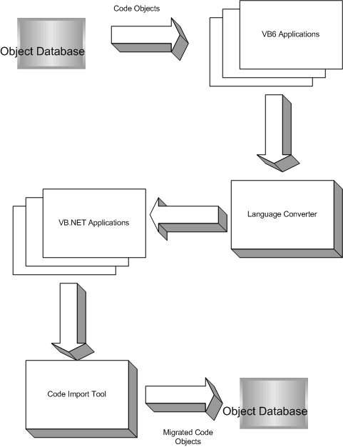
Fig 1: Overview of the Conversion process

Project Overview
The overall picture of the database conversion process was described in the previous section. The need of the Code Import Tool is to process the VB.NET project to extract the code objects and then use the Object Management system and update the database with the new converted code objects.
The Code Import tool is not designed to run as an independent unit but as part of the Conversion Process. The Code Import tool needs to co-ordinate with the other components. The input to the Code Import Tool is given by the language converter unit in terms of VB.NET projects. The main responsibility of the CIT is to identify and extract the code objects from the source files, validate them and create a new version of the code object in the Object Database. It has also got to manage errors, manage versioning and transaction management.

Concepts and Architecture

Introduction to Object Management System (OMS)
An Object Database is a store of all the components that make up an application. Generally this constitutes code and some extra information which is required to connect and relate different objects into coherent units.
The Design of such object databases must be such that database matches the requirements in terms of maintainability, extensibility and usability. Many factors are to be considered while designing such databases. Starting from a single user to multiple users and multiple locations of development, the issues that need to be addressed encompass the following:
- How and when to store/present data
- How to maintain Multiple versions
- How to achieve distributed development consistently
- When to synchronize distributed databases
- How to convert the database entities into actual deployable entities.

Object Management System (OMS) is a sophisticated data management application designed to support the complexities of a distributed deployable design environment. OMS defines an Object database that supports multi-user versioned development, where the development can distributed across different physical locations. To address the various aspects of the design environment, OMS is designed as a collection of services. The services are implemented as interfaces. Objects that support a certain service indicate so by implementing the corresponding interfaces. Taking this a step further, OMS provides a collection of predefined object types that have such services implemented.

For distributed development, OMS has repository synchronization mechanisms. The database is deployable and so naturally supports for customization, which allows clients to modify the objects in the repository to suit their requirements. The built-in versioning mechanisms allow for detection and adoption of changes during distributed development and/or while upgrading the application.

The continuous enhancement to the functionality provided in the application ensures the longer lifetime for the application. This means that the object model can undergo changes along the lifetime of the application. OMS is a designed object database, which means that the designer provides an object model of the participating object types in the application.

Object Management system services
As mentioned earlier, the OMS is modeled as a set of services. The services provide basic functionality to the developer to manage and organize the object is the Object Database in a efficient, reliable and consistent manner

Transaction Service
Transaction management is a very important responsibility of the OMS. In a distributed, multi-user system it is essential that changes are atomic. The Transaction service of OMS provides a transaction context which can be made as a unit, i.e. the operations either executes completely or not at all. The properties that the OMS Transaction are:
- Atomic: until the transaction is committed, the changes are not permanently added to the database. The user can rollback the changes without any effect to the database.
- Consistent: A transaction is consistent if the changes made in the transaction are reflected in the subsequent operations in the same transaction.
- Isolation: Any change made in an incomplete transaction is invisible to other users
- Durability: Once the transaction is committed, all changes are persisted to the database.

Concurrency Service
When multiple users use the same object in different physical locations, concurrency management comes into picture. Maintaining consistency while dealing with multiple concurrent users is the main concern of the OMS Concurrency Service.
Concurrency is maintained using a set of locks. To change an object, it is required that the user obtain a lock on that object. The OMS maintains different kinds of locks. Some of the types are:
- Read Locks – These can be held by many users concurrently. Only operations that don’t change the object are allowed.
- Edit Locks – These locks can be held only by one user at one time. All operations that require change in the object must use this.

Persistence Service
The persistence service is the most important duty of the OMS system. Persistence Service takes care of efficiently storing and retrieving code objects and metadata in the database. This service must manage the internal structure of the database and isolate the changes in the database from the user. It also provides a layer of abstraction between data storage and the data consumers.

Versioning Service
In scenarios where objects are concurrently modified by many users, it is necessary to maintain multiple versions of the object. Different versions of the object must be maintained separately because it may be required to revert some changes made. Version management is done by the Versioning Service.
Having multiple versions enables you to maintain the revision history of an object. You can track the changes being made on each object (via versions) during the process of development. In a distributed development environment, this methodology is essential, and is implemented using the branching concept.
To edit an object, we have to first create a new version of the object. Multiple users can simultaneously get versions of an object concurrently. The new version is private and not reflected in other users objects. After making all the changes the user can submit this new version. The OMS maintains the latest stable version of the object.
If more than one change is submitted together, then this is termed as a conflict. A conflict can be resolved using various techniques. Some of them are:
- Discard all the changes except one. This is done by assigning priorities to users and submitting the change with the highest priority.
- Combine the effects of the changes

User Control Service
This is a controlled way of accessing a database. OMS users cannot directly view or modify objects stored in the database. This concept is introduced to fulfill the following requirements:
- Security – The users of OMS can view or modify objects stored in the database only through OMS. The user passwords are encrypted, and it is easy to change these passwords for security reasons.
- Decentralized maintenance of users – The users are now maintained in the database
OMS defines a number of roles which are used to create users. Depending on their roles, the users can use certain operations. The common roles are
- Administrator
- Developer
- User

Internationalization Service
In modern international scenarios, applications need to have localization involved. This is done by the Internationalization component which maintains locale specific information in a separate structure. The service must also allow application developers to build applications independent of localization. The service takes care of handling locale-dependent components depending on the deployment.
This is done by having a language object for each supported locale. This would contain specific information like date format, currency, language etc. When the application is deployed the actual required language object is chosen.

The OMS Code Object Architecture
The fundamental component of the OMS is the Code Object. It is represented in code as the ICodeObject interface. The Code Object provides the basic functions to manipulate the object, such as object persistence, load and navigation. It maintains the minimum set of information required to persist an object. The object retrieval and navigation depends on the relationships that are defined on the development objects.
OMS defines an object uniquely in memory as well as in the database by providing repository object ID (OID) and type. The developer uses object names as identifiers. The namespace mechanism in OMS enforces the uniqueness of object names across different repositories in a distributed development environment.
The caching of code objects in the memory is handled to:
- Minimize the database access to enhance performance
- Return the same object instance on multiple requests on another object when a relationship is navigated
The functions provided by the OMS Code Objects are:

Operation | Function call/Method | Purpose
Persist | Persist | Saves the Object into the database
Remove | Remove | Deletes an object from the database.
Lock | Lock | Obtains an edit lock on the object.
Unlock | UnLock | Removes the lock

The properties of CodeObject are

Property | Purpose
Name | Locally unique identifier
OID | Globally unique identifier
Type | The type of Object
Parent | OID of the parent

The versioning functions provided by the OMS Code Objects are:
Function call/Method | Purpose
CreateNewVersion | Creates a new editable object version
Rollback | Reverts changes and discards it
Commit | Submits the change
CollisionPriority | Takes care of collision

Analysis
Analysis is the first step towards completion of the project. Given the problem description the domain of the problem is analyzed to find what is required by the tool. This is usually done by analyzing the potential users of the application and deriving requirements from the needs of the user.
The following user scenario was found out by consulting domain experts and end users. The user scenario is analyzed further to obtain functional and non-functional requirements.
User Scenario:
The user has an object database with VB 6 code objects. As further application development is in VB .NET technology, the large code base and business logic in the database would become useless. The user doesn’t want to rewrite his entire code base manually. The user can use the Language Converter to automate the process of converting VB6 to VB.NET projects. After the conversion however there is no tool to automate updating the OMS Object Database with the VB.NET Code Objects.

Requirements Description

Functional Requirements
Based on the analysis of the scenario, the following functional requirements were identified:
- The tool should take a VB project file as input and extract the code objects from the source files.
- The tool should find the code object in the OMS database, create a new version of it and update it with the updated code.
- The tool should take care of obtaining versions in case of remote objects and hence deal with collisions etc.
- The Tool must provide an error recovery and error handling interface. The tool must also be take care of logging the process so as to enable debugging in case or error.
- The Tool should provide an interface for reading input from either configuration files or command line.
- The Tool should be able to handle multiple projects using the tool. Also
the tool should ensure consistency, i.e. if one project fails, it should not affect the others.

Non-Functional Requirements
Along with the functional requirements, there are a set of non functional requirements that need to be satisfied. Some of them are:
Reliability: This is one of the important requirements of the CIT. Reliability of the system must be ensured even in the face of error. The tool must provide means to recover from error.
Low Processing Time: As the tool has to do with large projects, it is desirable that the CIT takes as less time as possible. The tool must ensure optimal utilization of the CPU and memory.
Maintainability: The tool should be designed in such a way that maintainable. Also further extensibility must be possible.
Adherence to COM programming paradigm: As the OMS layer is modeled as a COM component, the tool must adhere to COM programming methodology.
After the requirements are collected, we can proceed to the design phase. During the design phase, the requirements collected during analysis are modeled into concrete components.

Design

System placement
The position of the system in the overall structure of the conversion process is as shown in Fig 2. The system interfaces with two components. It takes its input from the Language Converter Unit and the output goes to the OMS Database. The system must therefore interact with the Language Converter and OMS Database.
Language Converter.
Object database
Code Import Tool
VB Project Files
OMS interface
Fig 2: System placement

Abstract Design

System Architecture
The external input to the component is a list of applications and their details which are migrated using the CMT. The CIT takes this list of applications (VB.NET Projects) and then proceeds to extract Code Objects from the files of the projects. After extracting, the component updates the OMS with the newer objects.
Hence the two major responsibilities of the CIT are:
- Extract the code object from source files
- Update the OMS Database with new objects

The design given above naturally leads to the following Subcomponents:
- Object Extractor
- OMS Updater
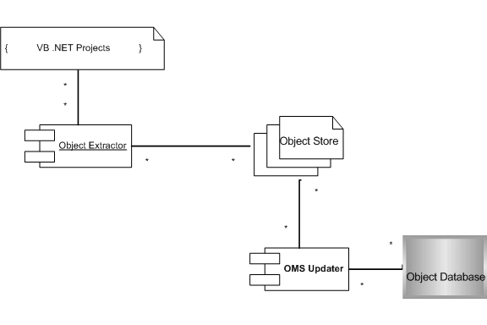
Fig 3: System Architecture

Object Extractor
The Object Extractors main responsibility is to process the VB.NET project and obtain Collection of Code Objects which is then passed on to the OMS Updater. To be able to do that, the Object Extractor must do the following:
- Read the VB.NET project files and obtain the names of the source files which can potentially contain CodeObjects
- Process each file and extract the Code Objects from the files
- Create an Object Store and populate it with the extracted objects
The Object Store forms the link between the Object Extractor and the OMS Updater.

OMSUpdater
The OMSUpdater is the component which interfaces to the OMS. The OMSUpdater gets an ObjectStore as an input and must update the OMS with the newer version of the Code Objects. The OMSUpdater’s main responsibilities are:
- Obtaining Open versions of Code Objects and updating it with newer code.
- Maintaining consistency using Transactions
- Handling any errors in a graceful manner

Object Store
The Design of the ObjectStore has important consequences for both OMSUpdater and ObjectExtractor. Since random access is not required, the in-memory representation can be a simple linked list. Because a project contains potentially large number of objects, the ObjecStore at one time has only those objects corresponding to one SourceFile. After every SourceFile is parsed, the ObjectStore is flushed.

System Interaction
The interaction between the ObjectExtractor and OMSUpdater is modeled using peer based design. Here the communicating agents between the two subsystems are one-to-one classes which communicate with each other. Each subsystem is hierarchically divided into many classes and modules. At every level in the hierarchy, we have a pair of peer classes in different subsystems. Each agent communicates only with its peer in the other sub-system. This form of design has many advantages. It maintains a level of abstraction over the low level functionality. Each class knows just what it deals with, and nothing about the classes above or below it in the hierarchy.
The principal interaction occurs at the object level, where the actual functionality is present. Also at the higher levels, there are peers established to maintain consistence and logical coherence.
Once we have identified the sub-systems, we can proceed to design each sub-system in detail.

Sub system Design

Object Extractor subsystem
If we look at the responsibility of the Object Extractor subsystem, the main functionality is processing of files in a project. In this scenario, we can make a generalization that what we get as input is set of one or more projects. Each project is a set of one or more source files. Each source may contain one or more code objects. This leads to a set of classes which are shown in the class diagram (Fig 4).
Because of the way the input is structured, we obtain a hierarchy of classes as shown. CITProject models a VB.NET project and is processed by CITProjectExtractor. CITProject is an aggregation of CITSourceFiles which is processed by CITFileExtractor and uses the CITObjectStore for storing the objects, The CITObject is the in-memory representation of the Code Object and the ObjectStore contains one or more CITObjects.

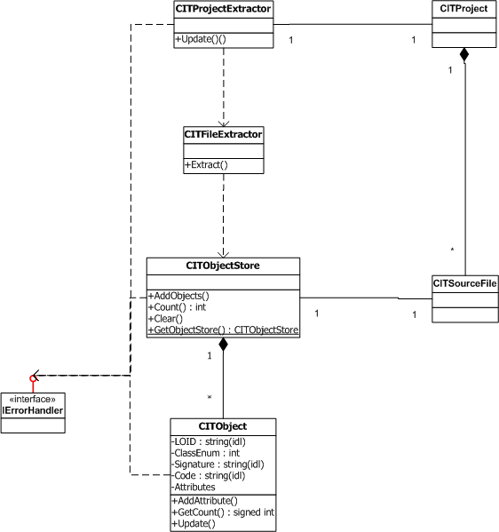

Fig 4: Design of Object Extractor Subsystem

OMS Updater subsystem
The OMS Updater subsystem deals with the OMS Database. The OMS Updater’s main responsibility is to update the OMS database with the code objects. The OMS Updater must also provide primitives to ensure consistency of the database. The hierarchical division of responsibility in the Object Extractor subsystem is followed in the OMS Updater sub system also. The peer of the CITProjectExtractor is the CITProjectUpdater, which gives transaction capabilities to project processing. On similar lines we have CITFileUpdater which gives roll-back for file operations in case of errors. The actual work of updating the object is given to the CITObjectUpdater. The CITObjectUpdater is responsible for taking a CITObject, finding its database counterpart, getting an open version of the object and update it with the new Code Objects.
To keep the design fairly abstract and independent to OMS database changes, the OMS state is maintained by a Façade class called CITOMSClient. This class maintains the OMS state information and gives a simple and functional interface to the OMS services.
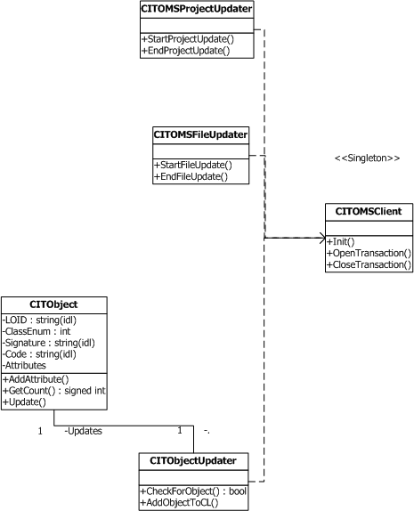

Fig 5: Design of OMS Updater subsystem.

Control subsystem
Apart from the functional subsystems, the overall control of the application is governed by the Control subsystem. The Control subsystem interacts with the external world, manages input and state information and takes care of external messages. The Control subsystem also provides a framework with which the error handling subsystem woks with. This is required to transmit the decision made to different sub when an error happens.
The Control Subsystem consists of the governing class CITController which acts as a mediator between the subsystems. The CITController is only the initiator, further interaction between the subsystems occur without the interference of the CITController. The class CITInputComponent provides input to the rest of the application. It abstracts out how the input is derived and how options are set. This allows the external interface of the tool to be independent of the internal architecture of the application. The CITInterfaceComponent manages interfacing with external entities and triggers events in the system based on these external signals.
Apart from these; there are some other classes which constitute the control subsystem. CITLogger takes care of persisting the debug and error messages into a file. The internal messages and events are processed through the CITEventManager class. The events are delegated to classes that implement the IEventHandler interface.

Sub system interactions
The interactions between the subsystems happen through the peer based structure mentioned earlier. There are three levels at which the processing takes place.
- The Project Level
- The File level
- The Object level
To model this, we have peer classes CITProjectUpdater and CITProjectExtractor at the project level, CITFileUpdater and CITFileExtractor and CITFileUpdater at the file level and the CITObject and CITObjectUpdater at the object level. These peer classes communicate only with their peers in the other sub system, not with any other classes. The peer based design is well suited for instances where a particular operation must be done with some parts of the actions being done in different subsystems.
The peer classes have a 1...1 relationship with each other. The functionality they provide are different from each other but are related. The peer classes establish an interface with which they communicate with each other. Note that the higher level peers abstract out the functionality of the classes lower down the hierarchy.
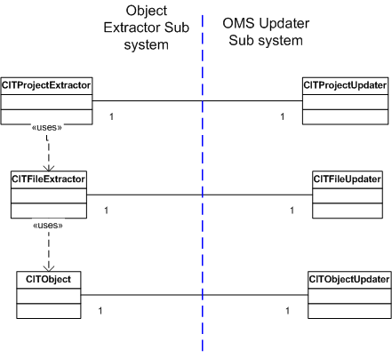
Fig 6: Sub system Interactions

Design of Error handling subsystem
The base class of all exceptions must be CITException. This class or its children must be used for error-handling. The Error handling must be done as said below:
- Clean up the error and bring the tool in a consistent state. That may be achieved using OMS Sessions and transactions.
- Report the error to the Central Error-Handler. The Error Handler makes the decision whether to stop or continue.
- If an error doesn’t come under the purview of the component or class where it arises, it is thrown back to its parent. Thus a chain-of-responsibility is maintained.
- The class gives the error-handler a number indicating the severity of error. The central component is not concerned with the type of errors but only about the severity.
The error handling mechanism is made using the IErrorHandler interface. The global error handler is an instance of this. All errors are reported to global error handler. The global error handler makes the final decision on how to handle the error. The possible options are:
- Ignore the error and continue.
- Discard the current unit and proceed with the other units.
- Remember the error, continue with the other units and restart the process after all other units are completed.
- Revert the entire operation.
How to handle a particular error is a decision which must be taken care by the system as a whole. Each component along with the central global error handler make a decision on how to correct or recover from the error.

Design Description
The design description is a textual explanation of the roles and responsibilities of the classes obtained in the classes. The design description should give a clear picture of the classes, what they do, what data they take as input and what output they give out. The description should give how an operation is done, rather what should be done. The design description is generally expressed in structured semi-formal natural language. It should be concise and unambiguous.

Object Extractor sub system
Class | CITProjectExtractor
Responsibility | The class mainly processes the VB.NET project files to extract the files which can potentially contain Code Objects.
Input | Path of the Project File
Output | A List of file paths which can potentially contain code objects

Class | CITObject
Responsibility | This class represents the in-memory representation of the Code Object. It is a data structure which also has functions to transform from in-memory representation to OMS representation
Input | -
Output | -

Class | CITObjectStore
Responsibility | The class stores Code objects in the same file. The class takes care of rolling back all the objects in case of error.
Input | -
Output | -

Class | CITFileExtractor
Responsibility | This class parses the VB.NET source files to extract the code objects.
Input | CITSourceFile
Output | CITObjectStore containing code objects of that file

Class | CITSourceFile
Responsibility | This class models a source file which contains code objects. This file may or may not correspond to an actual file on the filesystem
Input | Path of the Project File / Contents of a file
Output | -

Class | CITProject
Responsibility | This class models a VB.NET project which is given as input to CITProjectExtractor
Input | Path of the Project File / Contents of the project file
Output | -

OMS Updater sub system
Class | CITProjectUpdater
Responsibility | This class provides a context for project processing
Input | -
Output | -

Class | CITFileUpdater
Responsibility | This class provides a context for file processing
Input | -
Output | -

Class | CITObjectUpdater
Responsibility | This class is the main functional class for actually updating the OMS with the new Code Object.
Input | CITObject
Output | -

Class | CITOMSClient
Responsibility | This class provides an interface for the system to use the OMS services by providing a simplified Façade.
Input | OMS Connection Informaton
Output | -

Control Sub system
Class | CITController
Responsibility | The main controller class of the entire operation which initiates the sub systems.
Input | -
Output | -

Class | CITInputComponent
Responsibility | This class takes care of obtaining input and options from external entities.
Input | Configuration files, Command line
Output | -

Class | CITInterfaceComponent
Responsibility | This class deals with catching external messages and converting them into internal events
Input | Extarnal messages
Output | Internal messages
Class | CITEventManager
Responsibility | This class manages the internal messages and provides a base for communication and event processing
Input | Internal messages
Output | -

Class | CITLogger
Responsibility | This class is used to log debug and error messages
Input | Path of the log file
Output | Log file

Interface | IErrorHandler
Responsibility | The interface models the centralized global error handler. The implementation of this interface is the class which decides on what to do when error occurs
Input | -
Output | -

Interface | IEventHandler
Responsibility | The IEventHandler is the component which is invoked in response to events. The Event Handlers must be registered with the event manager
Input | -
Output | -

Design Specification
The design specification is the formal representation of the design obtained. The design must be expressed in unambiguous clear terms; otherwise the design and the implementation will be considerably different. The design specification is usually in the form of UML design diagrams. The design specification should clearly convey the desired information about the structure and behavior of the components so that this can be carried over to the implementation phase.

Complete Class Diagram
This diagram consolidates all the classes designed in the various sub systems. Some of the classes are left out of the main design to simplify the design. The interactions and relationships between the classes are shown.
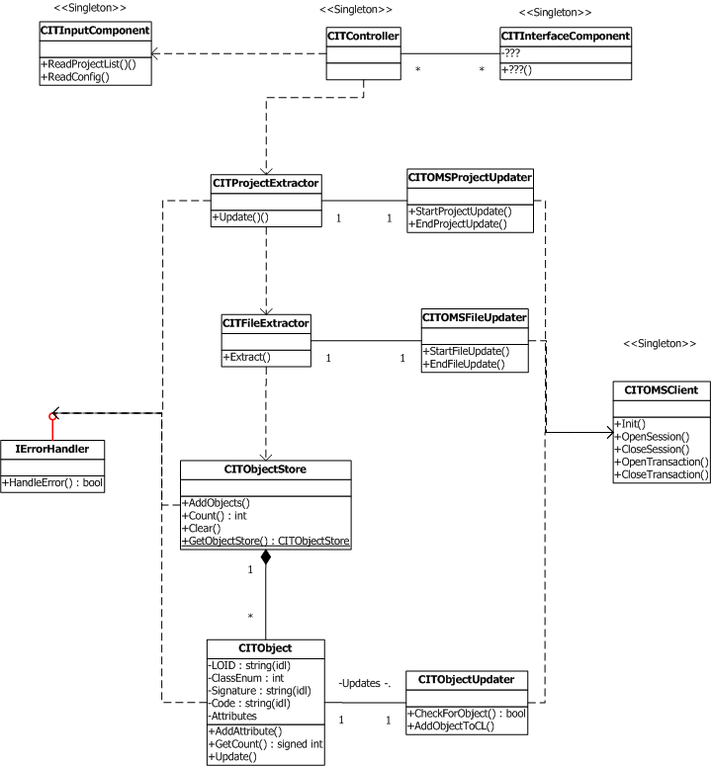

Fig 7: Consolidated Class Diagram

Sequence Diagrams
The following diagram shows part of the operational sequence which occurs when the Object Extraction occurs. The CITProjectExtractor, when initialized, will first send a message StartProjectUpdate to CITProjectExtractor which in turns sends message OpenSession to CITOMSClient. The client starts a context within which the project extraction takes place.
The CITProjectExtractor then instantiates the CITFileExtractor for each source file and sends a Extract message to it. After all the files are processed. The CITProjectExtractor sends a message EndProjectUpdate to CITProjectUpdater to commit the session.

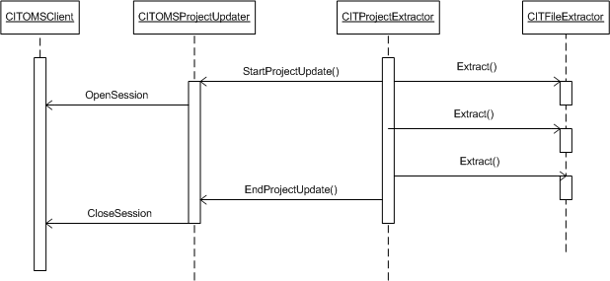
Fig 8: Sequence diagram for project processing

The following diagram shows part of the operational sequence which occurs when the File processing occurs. The CITFileExtractor, when initialized for each source file, will first send a message StartFileUpdate to CITFileExtractor which in turns sends message OpenTransaction to CITOMSClient. The client starts a transaction within which processing takes place.
The CITFileExtractor processes the file, extracting Coe Objects. For each Code Object it creates a CITObject and sends it a Update message. The CITObject in turn communicates with CITObjectUpdater to actually update the object.

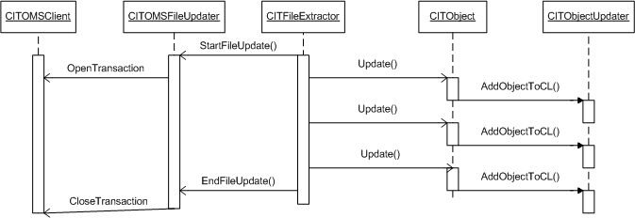
Fig 9 Sequence diagram for object Updation

Data flow diagram
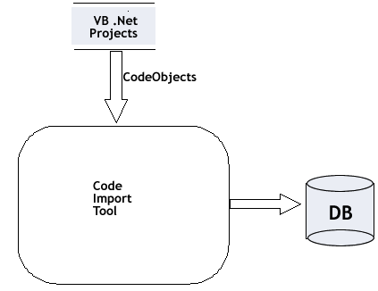
Fig 10 : Context Level DFD.
The Data flow diagrams for the application are given in Fig 10 and Fig 11. Fig 10 gives the Context DFD of the system as a unit. The primary data source of the Code Import Tool is the VB.Net project files created by the language converter. The primary data sink of the application is the OMS database which should be updated.
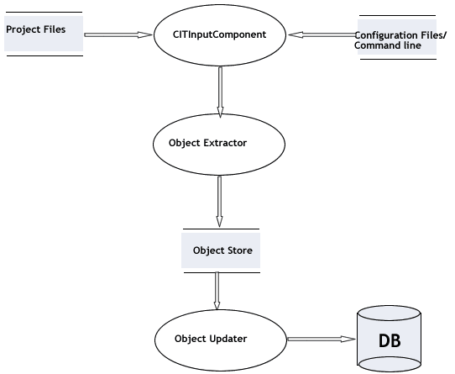
Fig 11: Data Flow Diagram for processing

Fig 11 shows the Level-1 data flow diagram for the application. The data source for the application, along with VB .Net project files is the set of configuration options which can be obtained from either configuration files or command line. These options are processed by the Control sub system and it initializes the processing of the projects by invoking the Object Extractor sub system. The Object Extractor sub system processes the source files and populates an Object Store which is an aggregation of code objects. The OMS Updater sub system then takes the code objects and updates the database with these objects

Implementation

Implementation choices
Based on the requirements of the project the following choices regarding technologies and techniques to use were made. The rationale behind making these decisions are also given

Choice of Language
The OMS component is a COM component. Hence the language used should be a COM ware language. Also because It has to interact with VB.Net projects, it should also be .NET aware language. It should also be fast and efficient.
The Language chosen was C++. A mixture of managed and unmanaged C++ was used to interact with .NET and COM components respectively.C++ has the advantage of being both compatible with COM and .NET framewiorks and also small and efficient.

Choice of File processing technique
The file processing technique was an important decision to be made. The file processing could be done using either of the following:
- Using lexer-parser combination to extract code objects from file.
  - Advantages: standard, simple way of doing it.
  - Disadvantages: must have complete grammar, inefficient
- Handwritten extractor using Regular expressions
  - Advantages: no need to go into great syntactic depth, fast
  - Disadvantages: difficult to extend, modify
Keeping these things in mind, the decision was made finally to use a handwritten parser. The main reason was that we had no need to go into great syntactic depth. Also efficiency considerations contributed to the decision.

Choice of Libraries to use
The following libraries were decided to be used
- Standard Template Library for string, hashtable etc
- The .NET Regular Expression library( System.Text.RegularExpression )
- The .NET XML Parsing library ( System.Xml namespace )
- Standard I/O Streams library for file processing

Algorithm and Data-structure design

Design of Object Store
The Object Store is a crucial element of the application. Because it is the primary data source of the application, the Object store has to be designed with care. The Object store must satisfy the following requirements:
- The Object Stores holds a large number of objects. Hence rather than the objects itself, it should hold the pointers to the objects. This prevents unnecessary copying.
- The Object Store must provide sequential access to the objects in the store. The Object store must publish an interface like the iterator interface to allow sequential access
- The Object Store must also have individual access using the Object Identifier as primary key.
- The Object Store must implement an efficient containment check function.
Considering all these factors, the data structure chosen was the STL hash table. The hashtable allows for O(1) lookups on objects and is ideal for random access. The hash table also provides an iterator function which could be used for sequential access.
The next consideration is the hash function. The hash table’s performance depends very much on the hash function. The hash function should be as close as possible to be a perfect hash function. The hash function for the Code Objects can be created from the fact that the objects have globally unique Object Identifiers and locally unique names. This could be used to generate a generally unique address.

Design of File Extractor
As explained earlier the File Extractor is chosen to be implemented using a hand written processor. The semi-formal grammar for the structure of the Code Object in the source code is given below:
<code-object> := “<object ” <attribute-list> “>” <code-snippet>
<attribute-list> := <attribute> | <attribute> <attribute-list> | <null>
<attribute> := <id> “=” <id>
<code-snippet> := <sub> | <function> | <event>
<sub> := <modifier> “SUB” <id> ( <param-list> ) <code> “End Sub”
<function> := <modifier> “FUNCTION” <id> ( <param-list> ) AS <data-type>
<code>
“End Function”
<event> := <modifier> “EVENT” <id> ( <param-list> )
<modifier> := “PUBLIC” | “PRIVATE” | “FRIEND” | <null>

This is not the complete grammar and is only given as reference. To extract an object, a state machine is constructed which parses the object. It is not a pure Deterministic Finite acceptor because the states remember some information.
The processor is initially in NORMAL state. When it encounters an object tag, it moves into GOT_OBJECT state. From there on depending on the next token the state may become SUB, FUNCTION or EVENT states. For each state the corresponding end state is reached when the appropriate token Is found.
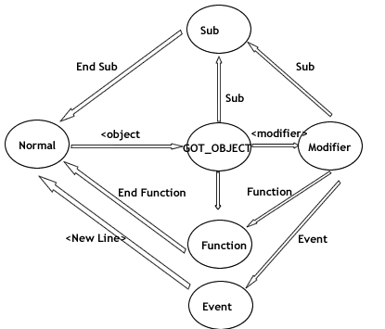
Fig 12: State machine for Object extraction from source file

Class Responsibilities and functions

Class CITController
This is the actual interface of the component. The external clients use this interface as shown above to update the OMS. The main responsibility of this class is to delegate responsibility to other classes and control the overall operations of the component. When an error occurs, it is propagated to this component which makes a decision to continue or abort.
+ SetLogFile( String fileName );
Sets the Log File path. The old log file will be flushed and closed. All new activities will be logged in the new file. If file already exists, it will append to it.
+ Start ()
Starts the process by initializing the object extractor subsystem

Class CITObject
The CITObject is the actual code Object which must be updated. It acts as a structure to store code and attributes
+ [ property(g/s) ] ObjectID : String
The Object ID – used to identify objects in OMS
+ [ property(g) ] Attributes : Map
Set of attributes. Representation is to be decided. Some of them are name-value pairs. Some are only names.
+ [ property (g/s)] Code : String
Aggregation of lines of code. Textual ,not processed in any way.
+ AddAttribute( String name , String val = "" )
Adds a new attribute to the map. If it already exists , it will fail.
+ SetAttribute( String name , String val );
Sets the value of an existing attribute. If it doesnot exist it fails.
+ GetAttribute( String name ):String
Gets the value of an attribute. If no value exists it fails.
+ ExistsAttribute( String name ) : bool
Checks if an attribute exists
+ AddCode( String line )
Adds a line of code to the Code.

class CITObjectStore
An object store is a collection of Objects which provides an interface to iterate over the objects.
+ [ property(g) ] Count : long
The number of Objects in the store
+ Clear()
CleOMS all the elements of the store.

+ AddObject( CITObject * );
Adds an object to the store. No claim is made for preserving the relative order of the objects.
+ Update()
Updates all objects of the store
+ GetObject( string name )
Gets a single object with the name or OID given as input

Class CITProjectExtractor
This is the in-memory representation of the VBProj file. It loads the XML file into memory and extracts all files of the Project. It uses the .NET XML Parser to do that. The list may be iterate over as it is, or using a Specialized FileFilter.

+ CITProjectExtractor( String path );
Reads a project file and extracts the file names form it
+ Update();
Gets all objects from various source files and updates the OMS

Class CITFileExtractor
This file reads a VB source file and extracts all the objects from the file. The
+ FileExtractor( String filename );
Creates a Extractor for the specified file
+Update( CITObjectStore * store );
Extracts all the objects from a SourceFile into the ObjectStore

Class CITInputComponent
It is responsible to connect to the OMS with required parameters. It may read some configuration files and obtain OMS Connection parameters. Also it reads the input XML file list of all the application paths. The CITController makes use of these data to carry out the operation.
+ GeConnectionInfo(): CITOMSInfo *
Reads a configuration file and gets the DSN, Username, password and the ChangeList Name/CLID.
+ GetProjectList(): list<String>
Gets a list of projects and their paths. This is obtained by reading an XML file given as input from the Language Converter

Class CITObjectUpdater
It deals with actually updating the object in the database. To do so it must interpret the various fields of the Updatable Object. Both the CITObject and CITObjectUpdater together collaborate to carry out the updation.

+ CheckForObject( CITObject * ): bool
Check whether the Object already has been migrated. If it has been, then no further operation is carried out.
+ Update(CITObject *)
Adds the object to the database. Some internal conversions may be done to the object to convert it from the in-memory representation to the OMS-compatible one.

Class CITLogger
The logger maintains a log-file and writes all messages to the log file. In case of Critical/Serious messages, it makes sure that the file buffer is flushed. The logger also has functions to interpret a log file and filter out the irrelevant messages.
+ SetLogFile(String filename)
Sets the log file’s name. The older log file is closed and flushed. All subsequent logs will go into the new file. The default log file is log.txt .
+ ConvertToHTML( String input , String output )
Formats the data. The data is formatted according to the error entry and type.
+ Filter( String inputFile , String outputFile , int filter )
Creates a new file with only some entries. The unwanted entries can be filtered out.

Class CITOMSClient
The OMSClient is a high-level wrapper over OMS code. This insulates the rest of the application from the OMS and takes care of internally taking care of OMS specifics. It provides an interface to CITOMSUpdater / CITObjectUpdater to carry out operations.
+ ConnectToOMS( CITOMSInfo* );
Uses the information to obtain a connection to the OMS Database.
+ GetChangeList( String ChangeListName )
Gets the changelist and sets the active context to the changelist.
+ StartTransaction()
Starts a transaction which can be rolled-back
+ CloseTransaction( bool commit )
Commits or rollbacks a transaction
+ StartSession()
Starts a session which can be rolled-back
+ CloseSession( bool commit )
Commits or rollbacks a session

Class CITException
Encapsulates the error which occurs in the application. This must be the only exception thrown and caught. The class contains an error-number and an optional error-message which is helpful for logging.
+ [property(g/s)] ErrorNumber: long
+ [property(g/s)] ErrrorMessage: String

Class CITProjectUpdater
This is the class which takes care of creating a context for project updation. The CITProjectUpdater maintains a session which can be used to commit or rollback changes. Any error will cause the project to be discarded.
+ StartProjectUpdate()
Starts a session in which all project processing occurs
+EndProjectUpdate(bool commit)
Commits or rolls-back a session in which all project processing occured

Class CITFileUpdater
This class is the peer of FileExtractor. This takes care of all OMS related activities with respect to updating all objects in a file. It maintains a transaction for the file which can be rolled back in case of errors.
+ StartFileUpdate()
Starts a session in which all project processing occurs
+EndFileUpdate(bool commit)
Commits or rolls-back a session in which all project processing occured.

Testing

Testing strategy
Any medium to large project requires well planned testing phases. The testing must occur at all levels and at all phases of the software development process. The tests are conducted to validate and verify the working of the application against requirements of the user.
Testing can be broadly divided into divided into two categories:
- Unit testing
  - Testing of individual program components
  - Usually the responsibility of the component developer (except sometimes for critical systems)
  - Tests are derived from the developer’s experience
- Integration testing
  - Testing of groups of components integrated to create a system or sub-system
  - The responsibility of an independent testing team
  - Tests are based on a system specification

Unit Testing
The general processes involved in component (unit) testing are illustrated in the diagram.
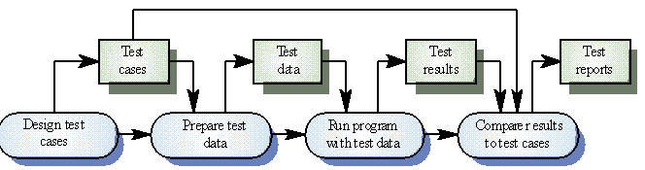
Fig 13: Sequence of Testing

Each sub system was independently tested with its own set of constraints. The methodology given above was followed to ensure correspondence between users needs and the functioning of the system.

Preparation of Test Cases
The preparation of the test cases is the most important part of the testing process. The test cases have to be representative of the actual input which is obtained by analysis of possible user inputs to the system. The following strategies are used to obtain test cases:
- Test cases based on Code coverage: One strategy is to use a code coverage analysis tool to find out those cases which will cover most parts of the application code. This reduces the chances of having a concealed defect in the system.
- Black Box Test Cases: Black box testing is done to verify the systems features from an external point of view. No knowledge of the systems inner working is assumed.
- Equivalence Partitioning: Input data and output results often fall into different classes where all members of a class are related. Each of these classes is an equivalence partition where the program behaves in an equivalent way for each class member. Test cases should be chosen from each partition
In practice, a hybrid of these techniques was used to prepare test cases.

Preparation of Test Data
Preparation of input data is important because the effectiveness of the test process depends of the input data. The test data should be obtained from the scenario of the application domain, rather than imaginary input. Rather than give a large set of inputs, we could reduce the number of inputs by looking for patterns in the data set.
Another testing strategy is to deliberately introduce wrong input. The application is expected to be consistent in finding errors as well as processing the correct data in the appropriate manner.
The test data created for testing had the following characteristics:
- The input was derived from a production repository which modeled real-world data.
- The input was ensured to have all possible kinds of input patterns
- Error was deliberately introduced in some cases to test the validation portion of the application
- The test data was designed such that the application covered maximum possible code paths.

Module Integration Testing
This is an important phase of testing after each individual component has been thoroughly tested. The components are now integrated as system. Integration Testing tests complete systems or subsystems composed of integrated components. Integration testing should be black-box testing with tests derived from the specification.
The Main difficulty in Integration is in localising errors. Incremental Integration testing can be used to reduce this problem.
There are two approaches to Integration Testing
- Top-down testing
  - Start with high-level system and integrate from the top-down replacing individual components by stubs where appropriate
- Bottom-up testing
  - Integrate individual components in levels until the complete system is created
In practice, most integration involves a combination of these strategies.In this case, the testing of components in each sub system was done in bottom-up manner and from then onwards top-down testing was used.

Deployment
Once the system is tested, it is ready to be deployed in the production environment. The deployment process has to be well planned and carefully thought out. The system deployment might cause unexpected problems when used in a different context than what it was developed on.
The first step in deployment is the specification of programs external interfaces. This may include the structure of input files, configuration files, permissions, libraries, command line arguments etc.

Program Interfaces

Command Line arguments
Option: -a<projectpath>
Description: adds a project for processing
Example: cit.exe –a”C:\test\a.vbproj”

Option: -d<database>
Description: sets the ODBC database DSN
Example: cit.exe –dtestdb

Option: -u<username>
Description: username for ODBC login
Example: cit.exe –usa

Option: -s<password>
Description: password for ODBC login
Example: cit.exe –spass

Option: -f<log-file-path>
Description: sets the path for log file
Example: cit.exe –f”C:\test\test.log”

Option: -p<project-list-path>
Description: sets path for input list file
Example: cit.exe –a”C:\test\a.txt”

Option: -c<db-config-file>
Description: sets the path for config file for ODBC
Example: cit.exe –a”C:\test\test.ini”

Configuration Files Structure
The input to the CIT consists of the following:
dbconfig.ini – This file consists of the parameters required to connect to the OMS Database. The information required are:
- Username
- Password
- DSN
The structure of a sample config file is as shown below
[DBCONFIG]
dsn=test
username=sa
password=

projectlist.txt – This file gives the list of project files. The project file path maybe complete or absolute. The file must contain the one project path in one line. The sample contents of projectlist.txt are as shown below.
C:\test\a.vbproj
C:\test\temp\a.vbproj

The output is a log file consisting of all the output information. The severity of the message is given by four types:
INFO - general information
DEBUG – debugging information
SERIOUS – messages for serious errors
CRITICAL – messages for critical errors.
Also a HTML file is created which displays the information in a readable format.

System requirements
The system requirements to run the Code Import Tool are:
- Operating System: Windows 2000 or better
- The OMS COM library must be installed in the client system
- The ODBC SQL Server drivers are required to be installed on the client
- The .NET Runtimes v1.0 or higher must be installed in the system
- The .NET libraries for Regular expressions and Xml processing should be installed
- The user must have write permission on the directories where the tool is installed
- The DSN used to update the database must be system DSN.

Conclusion
The Code Import Tool addresses an industry specific need for automating the task of migrating Code databases and updating them. The Code Import tool is an important component in the updating process. The Code Import tool strives to fulfill the need of a reliable, fast and efficient tool to convert the Code database into the future VB.NET code objects.
The application forms a part of an overall process of helping users migrate seamlessly from current technology to future technologies. The application has significant potential because the process of converting from one technology to another is a recurring occurrence in the ever changing field of Information Technology.
Though the application can be improved to a greater extent, it has satisfied its need of being a reliable, efficient and maintainable tool which performs its required task.

Further Improvements
The tool though useful as it is can be further improved. Some of the ways it can be improved are:
- The File processing can be made more efficient by using text parsing rather than regular expressions
- The redundant code objects which are already updated, can be discarded at the parsing level itself, increasing efficiency.
- The state machine could be further simplified to remove or merge redundant states
- The parser could be made more generic and can be made to handle more cases
- Error handling can be made more intelligent and some user errors can be corrected by the tool automatically.

Appendices

Appendix A: Introduction to COM technologies

The Component Object Model (COM) is an open architecture for cross-platform development of client/server applications. It is the cornerstone for ActiveX technology and OLE 2.0.
This appendix presents the fundamental concept of COM, such as COM client/server architecture, COM server, and COM client. A set of fundamental COM interfaces are also examined in detail to describe their roles in creating COM objects.
To illustrate the fundamental blocks and the concept of the COM architecture, serial examples are built step-by-step to demonstrate how to create various COM servers and corresponding COM client applications.

COM Client/Server Architecture
The Component Object Model (COM) is an open architecture for cross-platform development of client/server applications.
All ActiveX controls are COM objects. COM objects refer to any object that implements IUnknown interface.
COM provides a client/server architecture. The COM client uses COM server via the COM library

COM Server
A COM server is a component that implements one or more COM Class objects. A COM Class object is a COM object that is creatable via a COM Class Factory object. A COM Class object has a CLSID associated with it. A COM object is anything that implements IUnknown interface. It is different from an object in object-oriented programming. In Object-Oriented programming, an object called OO object here is an entity that has state, behavior and identity. The OO object's state is represented by the value of the attributes in the object. But a COM object's state is implied by the interface; the state is not explicitly stated, because there are no public attributes exposed in the interface. The Interface is just a set of functions without any attributes.
The OO object's behavior is a sequence of messages sent to the object, which is a sequence of methods called on this object. But for a COM object, the object's behavior is defined as the interface it supports.
The OO object's identity is a way to look at the object, whereas for a COM object, the identity is defined by moving between interfaces exposed by the COM object, this is done by invoking IUnknown::QueryInterface interface.
Each COM object provides functionality via exposing interfaces. An interface is a group of related functions and provides some specific service. For example, the COM server exposes two interfaces, one is IPrint, the other is IHelp. IPrint interface provides the print service, whereas IHelp supports the help service. Each interface groups its own functionality.
In order to uniquely identify the class object provided by the COM server, a class identifier (CLSID) is used, whereas to identify the interface, an interface identifier (IID) is used.
A COM server is usually a .DLL or .EXE file. A DLL based COM server is called an in-process (in-proc for short) server because it loads into the same address space as the client. The client can make direct call to the object, which is faster and more efficient. But the crash of the DLL can destroy the client's address space.
An EXE based COM server is called an out-process (out-proc for short), because it runs in its own separate process space.
An EXE based COM server isolates from the address space of the caller, which makes it more reliable. If the server crashes, it will not destroy the address space of the client. But because it is in a separate process, all interface calls must be marshaled across process (data gets copied), which affects the performance.

COM Client
A COM client (client for short) is an application that uses COM server. A COM client asks COM to instantiate object in exactly the same manner regardless of the COM server types. This is done by invoking the COM function CoCreateInstance. After COM client retrieves the first pointer to the COM object, it can not distinguish from the interface whether the COM server being used is an in-proc, or out-proc server.
COM Client is an executable (EXE) application as compared with COM server that can be DLL based.

COM Library

The COM library provides an implementation of the Application Programming Interface (API). The specification also defines a set of interfaces that will be used by different COM objects.
The component in COM also supports the communication establishment between the client and server. This component provides location transparency for the client. In other words, the client does not need to know where the server locates; all these are taken care of by the COM library.

COM Library APIs Functions
COM library API functions provide the functionality to the COM applications. COM applications are any application that uses COM. The following gives an example of API functions.
- CoInitialize: Initialize the COM library. The COM library must be initialized before calling its functions. This API should be called when the COM application starts.
- CoUninitialize: Uninitialize the COM library. This will free all the maintained COM resources and close all RPC connections. This API should be called when the COM application exits.
- CoCreateInstance: Create an instance of the object class. This API is a helper function. A helper function means a function that encapsulates other functions and interface methods defined in the COM specification. CoCreateInstance wraps the following sequence calls: COM API CoGetClassObject, IClassFactory method CreateInstance, and IClassFactory method Release.

COM Fundamental Interfaces
COM predefines a set of interfaces to be used by client/server applications. Among these, IUnknown and IClassFactory interfaces are the most fundamental ones. IUnknown interface is required for any COM object. The QueryInterface method in IUnknown interface allows the client to access the object's identity and move between interfaces.
A class factory object is required for every object identified by a given CLSID. A class factory object implements the IClassFactory interface.

IUnknown Interface

IUnknown is the interface that any other interfaces inherit from. In other words, every interface except IUnknown inherits from IUnknown. Listing 3.1 illustrates the IUnknown interface definition.

interface IUnknown

{

HRESULT QueryInterface([in] REFIID riid, [out] void **ppv);

ULONG AddRef();

ULONG Release();

}
COM object must implement this interface. COM client will invoke the methods in the interface implemented by the COM object.

IClassFactory Interface

IClassFactory is the interface that class factory object inherits from. In other words, class factory implements the IClassFactory interface. Class factory object is required in COM to create an instance of the object. It is a rule. For example, when the client application uses the CLowerStr object, CLowerStr object has to be created via its class factory.
COM server has a class factory, which creates an instance of the object.
IClassFactory interface has two fundamental methods shown in Listing 3.5.

interface IClassFactory : IUnknown

{

STDMETHODIMP CreateInstance(IUnknown *punkOuter, REFIID riid, void **ppv);

STDMETHODIMP LockServer(BOOL fLock);

}
The CreateInstance method creates an instance of the object class. It has to be implemented by the class factory object to instantiate the object. This method will be used inside the CoCreateInstance function call. CoCreateInstance will first return a pointer to the IClassFactory and then invoke IClassFactory's CreateInstance method to create an object's instance and returns an indirect pointer to the object's requested interface. This method only needs to be implemented but never needs to be invoked by the application itself.
punkOuter indicates whether the object is being created as part of the aggregate. If there is no aggregation in the COM server, NULL should be provided, otherwise, a pointer to the controlling IUnknown of the aggregate should be provided.
riid is the IID of the interface queried by the client. If the punkOuter is NULL, the IID of the initializing interface should be provided. Otherwise, riid must be IUnknown.
ppv is a pointer to the pointer of the requested interface. If the object does not support the interface specified in riid, ppv should be set as NULL, and E_NOINTERFACE should be returned as the method's return value.
LockServer locks the server in memory. The class factory will be revoked when the lock count is decremented to zero. LockServer(TRUE) will increment the lock count and ensure that the class factory will not be revoked.

Glossary
Code Import Tool (CIT):
The application which takes a visual basic .NET project and updates the OMS Database with the migrated code objects

Object Management System (OMS)
The OMS is a collection of services which is used to manage the Object Database. It provides services like persistence, versioning etc

Object database:
It is a database of Code Objects which can be reused in multiple applications and is organized in an efficient manner.

Code Object:
A Code Object is a piece of code which can be reused in many applications. The code object can be a method, function or event. It is uniquely identified by a name and a object identifier.

Component Object Modeling (COM):
COM is a Microsoft technology which provides standard way of communication between objects.

DOTNET:
This is Microsoft’s newest technology which proposes that all applications run on a common runtime platform called Common Language Runtimes (CLR)

Language Converter:
An application which takes one language source as input and gives a semantically equivalent output in some other language.

Transaction:
The transaction is a unit of operation which satisfies the ACID( Atomicity, Consistency, Isolation, Durability ) properties.

References
These are some of the books that I referred to while working on this project. They have been very helpful in guiding me.

- The OMS User Guide 4.0
© SAP Labs India Pvt. Lmtd.
- The Art of Programming – Sorting and Searching,
Donald Knuth.
- Software Engineering,
Ian Sommerville.
- Essential COM,
Don Box
- C# and the DOTNET platform,
Andrew Troelsen

