
Dept. Of Information Science and Engineering,
R V College Of Engineering,
Bangalore.

Abstract

As the digital age dawns upon mankind, computers are becoming ever important in their usage and applications in varied fields. With the increase in the extent of computer applications, the needs of the hour are reliable, secure and stable computer systems. This is especially true in the web and networking arenas, where security is a primary issue.
This paper looks at some of the issues concerning computer security and cryptography. This paper introduces the concepts of Quantum Cryptography and its role in the modern security scenario. The paper intends to give a broad overview of issues in cryptography and how the emerging quantum cryptography field deals with problems and limitations of existing systems.

1. Introduction

1.1 What is Cryptography and how is it related to computer security?

The Oxford Dictionary defines 'security' as 'being guarded against external attack’. The term Computer Security broadly encompasses all the techniques that secure a computer system from any kind of external infiltration or attack. It involves measures to prevent illegal access to resources of the system from users or programs without proper authorization. Computer Security also deals with reliable transfer of data in a communication channel without the data being accessed by external agents. The emergence of the Internet as a major communication tool has made it necessary to continuously develop and deploy more and more sophisticated security measures to counter the ever-increasing threat of intrusion. One of the major areas of current research in Computer Security is the field of Quantum Cryptography

1.2 What is Cryptography?

Before we venture into the world of Quantum Cryptography, let’s take a look at what is cryptography. Cryptography basically deals with encryption of data. Let’s take a look at some of the terms involved:

✓ Encryption of data is the term given to changing the form or structure in which data is stored or transmitted, so that an external agent cannot understand the data. An algorithm which encrypts the data is called an a Encryption Algorithm

✓ Decryption of data involves getting the data back from the encrypted form

✓ Cryptography is the branch of Computer Science which deals with formulating Encryption and Decryption methods

✓ Some extra information is used in the Encryption Algorithm to encrypt the data. This information is needed in order to decrypt the original data back. This information is generally called the ‘key’. Only the authorized user has access to this key. Hence , in principle , only the authorized user can decrypt the data

Most of the research on Cryptography is taking place on finding better algorithms to encrypt the data. The essential characteristic of a good cryptographic system is that it should be nearly impossible for an unauthorized person to gain access.

1.3 Classical cryptography and its classification

Classical cryptosystems are those which do not use quantum cryptographic methods. The general model of a classical cryptosystem is shown in the diagram:
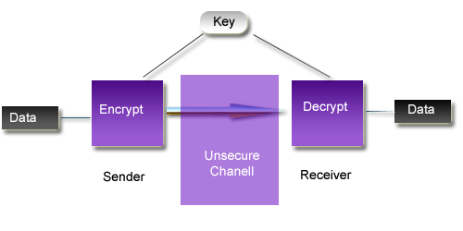
The sender and receiver of the message are connected by a possibly insecure communication channel. The data must not be accessible to any external agent who listens on that communication channel. In the general model, the sender and receiver agree upon a key which the sender uses to encrypt the data and the receiver uses to decrypt the data. There are two kinds of cryptography [7]:

✓ Secret (Asymmetric) Key Cryptography. Here the sender and receiver must secretly agree upon a key, which no external agent knows. But if the sender and receiver need to agree upon a key, they require a secure channel to communicate a key. Hence this is not implemented to a large extent in real world scenarios. The figure shows the basics of SKC.
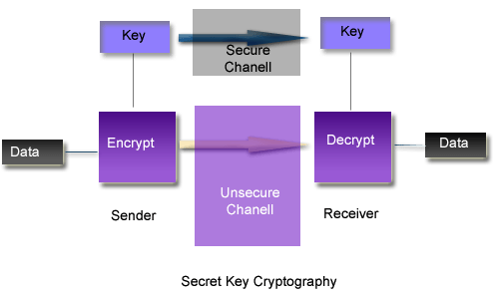

✓ Another way is called Public (Symmetric) Key Cryptography. In it each user has his/her own public key and private key. The public key is accessible to any user, i.e. it is distributed over an insecure channel. In general, the public key of the receiver is used by the sender to encrypt the data. This is possible because the public key of receiver is known to everybody. The receiver decrypts the data using his private key. The public and private keys are related in such a way that data encrypted using one key is decryptable by the other key. Hence anyone can encrypt the data but only the receiver can decrypt it. The figure shows simplified form of PKC.
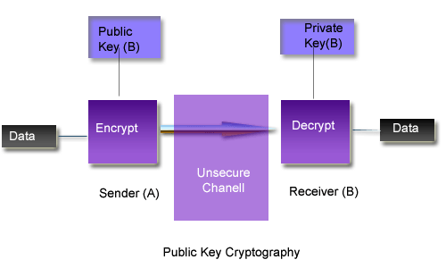

1.4 What are the limitations of Classical Cryptographic Methods?

A question which was not raised in the previous discussion was this - ' Knowing the public key of a receiver, what prevents illegal users from guessing the private key of the receiver? ' . The answer to this question is that the key-pairs and encryption algorithms are chosen in such a way that they cannot be guessed easily.
An excellent example of this is the famous RSA algorithm. The RSA algorithm by Rivest, Shamir and Adleman is very widely used encryption algorithm used in major systems worldwide including Microsoft Windows NT Operating system. The RSA algorithm works well in the Public Key Model. The RSA algorithm relies on the fact that factoring large numbers is very difficult. In theoretical terminology, it is a NP-hard problem. It is seen that the time for factoring large numbers increased hyper-exponentially with the number of digits of that number. In practice, a key of around 100 bits would take astronomical amounts of time to be factorized. A 129 bit number, to be factorized into 64, 65 bit prime factors, required more than 1000 powerful workstations computing for over 8 months. Considering that modern systems routinely use 256-bit keys, it seemed that RSA was the ultimate in encryption methods.
But in recent years, new developments on the theoretical fronts have radically changed our notions. The most important concept that has emerged in computer science is the concept of Quantum computer. A quantum computer is a computer built on quantum mechanical laws. But what does it have to do with Cryptography?
In 1994, Peter Shor devised an algorithm for the quantum computer, which could crack the factorization problem in polynomial time. Using this, factoring a 129 bit number on a quantum computer will take around 12 seconds! The implications of quantum computers on computer security are profound and far reaching [2].

2 Quantum Cryptography

2.1 What is a quantum computer ?

Simply put, a Quantum Computer is ; a computer built using the principles of Quantum Mechanics. A quantum computer is a computer in which a single atom or electron are computing units. Quantum Computers promise to do everything a modern computer can do, at a much very higher speed.
But quantum computers are not just improvement over classical computers. The quantum laws which govern the atomic interaction are essentially different than classical laws. The strange new properties of the quantum laws give these Quantum computers power far beyond the most powerful computers conceived today.

2.2 What is so special about Quantum Computers?

The smallest unit of computation in a classical computer is the binary-digit or bit. Each bit at a time can hold only one value, i.e. 0 or 1. Analogous to the bit, the smallest computational unit for the quantum computer is the quantum-bit or the Qubit. Unlike the classical bit, the qubit can simultaneously be in a superposition of states, i.e. it can hold more information than a normal bit.
The memory of a quantum computer is a quantum state, which can be in a superposition of many different numbers at once. A quantum computer can do an arbitrary reversible classical computation on all the numbers simultaneously and also has some ability to produce interference, constructive or destructive, between various different numbers. By doing a computation on many different numbers at once, then interfering the results to get a single answer, a quantum computer has the potential to be much more powerful than a classical computer of the same size. It can be shown that a set of L qubits can store up to 2*L numbers at once.
Once the register is prepared in a superposition of different numbers we can perform operations on all of them. For example, if Qubits are atoms then with suitably tuned laser pulses we can affect atomic electronic states and evolve initial superpositions of encoded numbers into different superpositions. During such evolution each number in the superposition is affected and as the result we generate a massive parallel computation albeit in one piece of quantum hardware. This means that a quantum computer can in only one computational step perform the same mathematical operation on 2*L different input numbers encoded in coherent superpositions of L Qubits. Thus a quantum computer offers an enormous gain in the use of computational resources such as time and memory.[1]

2.2 What is quantum cryptography?

Having some idea about quantum computers and cryptography , lets get to the central theme of this paper - Quantum Cryptography . Simply put , quantum cryptography is the branch of cryptography which uses quantum relations to encrypt the data . Quantum cryptography is an emerging technology in which two parties may simultaneously generate shared, secret cryptographic key material using the transmission of quantum states of light. The security of these transmissions is based on the inviolability of the laws of quantum mechanics and information-theoretically secure methods. An adversary can neither successfully tap the quantum transmissions, nor evade detection, owing to Heisenberg's uncertainty principle.[8]

2.3 A little Bit about Uncertainty principle . . .

The foundations of quantum mechanics are based on The Uncertainty principle by Hiesenberg, a German physicist. The Uncertainty principle says that measurement of a quantity in a quantum system necessarily brings about an uncertainty in measurement of another quantity of that system . These quantities form a conjugate pair. This characteristic of quantum mechanics makes quantum crypto-system a formidable system to break , even if the intruder has unlimited computational powers . This is because , the intruder cannot stay undetected while he is trying to access the data .

2.4 Quantum Key Distribution ( QKD )
PKC and Traditional symmetric cryptography both rely on the use of a key to encrypt and decrypt the plain text message they wish to conceal. In the case of PKC, no previously shared information is required; however, it is based on unproven mathematical difficulties.
Security provided by PKC is likely to be threatened by the completion of the first quantum computer in the not too distant future. Traditional symmetric cryptography relies on a shared key that has to be established in an out of band manner. Both these methods rely on a physical transformation, encryption of the plain text. The ciphered text can then be read and copied by any person, but only the intended recipients can decrypt and understand the message. Quantum cryptography is a completely different approach with this regard. Quantum information cannot be read unless some information is known beforehand about the state in which the information was prepared. Any attempt to read and hence copy the data with out the required information, disturbs the data in such away as to change its values.
Quantum key distribution aims to generate a truly random key between two principles wishing to communicate in a secure manner. The two principles require no prior shared information. Once a key of arbitrary length is shared, the secret information can be transmitted through public communication channels, having been encrypted using a symmetric encryption.
Current quantum key distribution uses one of these main cryptographic systems with encoding based on:
1. Two non-commuting observables
2. Quantum entanglement and Bells inequality/theorem
The protocols used in a system of the above type were originally proposed by Bennett and Brassard (The BB protocol). Another prototype, based on quantum entanglement, is currently being built. The protocols used for this system here originally developed by Ekert (Ekert protocol). [3]
2.5 BB Protocol
This protocol uses polarized photons as the information carriers. Photons can be polarized to many different angles. This algorithm makes use of 4 different polarizations to achieve secure communication. The four angles of polarization are 0, 45, 90 and 135 degrees. According to quantum physics, a photon can be measured to determine whether its polarization is at 0 or 90 degrees. With a slight reconfiguration of the apparatus, a photon can be measured to decide whether it is at a polarization of 45 or 135 degrees. The two configurations however cannot both be used to measure the polarization. T he process of measuring the polarization changes a photon’s polarization in a random manner. Attempting to measure a photon's polarization at the wrong angle produces truly random results. This means both parties in a communication must agree on the angle of polarization to use, for the correct information to be transferred.
The Brassard-Bennett protocol is explained below . Traditionally, in cryptography , the sender is named ‘Alice’ and the receiver ‘Bob’ . They must communicate secretly over an insecure communication channel . The channel is being monitored by the evil intruder ‘Eve’ . The objective is to secretly transfer messages without Eve deciphering it.

The BB protocol involves the following steps:
• The light source, often a light-emitting diode (LED) or laser, is filtered to produce a polarized beam in short bursts with a very low intensity. The polarization in each burst is then modulated randomly to one of four states (horizontal, vertical, left-circular, or right-circular) by the sender, Alice.
• The receiver, Bob, measures photon polarizations in a random sequence of bases (rectilinear or circular).
• Bob tells the sender publicly what sequences of bases were used.
• Alice tells the receiver publicly which bases were correctly chosen.
• Alice and Bob discard all observations not from these correctly-chosen bases.
• The observations are interpreted using a binary scheme: left-circular or horizontal is 0, and right-circular or vertical is 1.

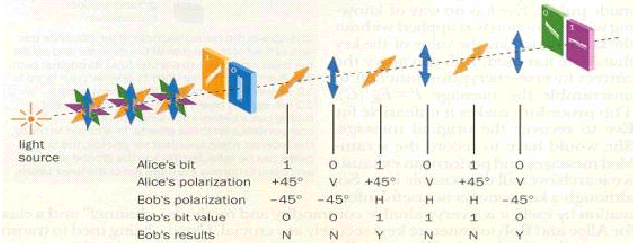

This is a simplified form of BB Protocol, which does not take into consideration the factor of noise , which may occur randomly or be introduced by the intruder . When noise exists, polarizations observed by the receiver may not correspond to those emitted by the sender. In order to deal with this possibility, Alice and Bob must ensure that they possess the same string of bits, removing any discrepancies. This is generally done using a binary search with parity checks to isolate differences; by discarding the last bit with each check, the public discussion of the parity is rendered harmless.

2.6 Ekert protocol
The Ekert Protocol is a Cryptographic system with encoding built upon quantum entanglement and Bells theorem. T his protocol takes advantage of quantum entanglement and the non-locality properties of quantum systems. Polarized photons are once again used as the information carriers. In this protocol the receiver is the initiator of the communication.
The Ekert protocol involves the following steps :
• The communication starts with Bob generating two co-related photons. Each particle is kept isolated from the environment to prevent any external quantum entanglement. Bob knows the quantum spin on the generated photons. He sends 1 of the photons to Alice, who wishes to transmit information.
• Alice performs one of 4 operations on the sent photon. The four operations Alice can perform are - to do nothing to rotate the photon by 180 degrees around one of the 3 axes (x, y, z). These are special operations, known as unitary operations, which can be applied the photon without destroying the coherence between the two entangled particles.
• Alice then sends the photon back to Bob who then recombines the 2 entangled particles.
• Bob then makes a measurement of the combined state using a quantum gate. The result can be used to determine which operation Alice performed on the photon.

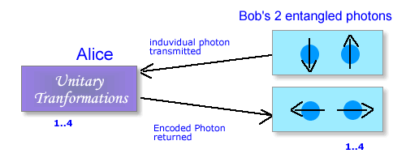
The quantum gates used by Alice to alter the state of the photon are available and have been so for quite some time. However the quantum gate used by Bob is still in development. Bob’s quantum device is performing an operation more commonly known as a "Bell measurement". This device is allowed by quantum mechanics, as it does not try to calculate the state of the individual photons, but rather their combined state. This gate is presently beyond our technology but the idea is being experimentally reviewed.

3 Applications , limitations and practicalities
3.1 How secure is quantum cryptography?
No Cryptographic system is viable unless it demonstrates it invulnerability against intrusion. Let us examine the possibility of intrusion in quantum cryptography. In classical physics - the theory of macroscopic bodies and phenomena such as paper documents, magnetic tapes and radio signals - allows all physical properties of an object to be measured without disturbing those properties. Since all information, including a cryptographic key is encoded in measurable physical properties of some object or signal, classical theory leaves open the possibility of passive eavesdropping, because it allows the eavesdropper in principle to measure physical properties without disturbing them.
This is not the case in quantum theory, which forms the basis for quantum cryptography. Quantum theory is believed to govern all objects, large and small, but its consequences are most conspicuous in microscopic systems such as individual atoms or subatomic particles. The act of measurement is an integral part of quantum mechanics, not just a passive, external process as in classical physics. So it is possible to design a quantum channel - one that carries signals based on quantum phenomena - in such a way that any effort to monitor the channel necessarily disturbs the signal in some detectable way. The effect arises because in quantum theory, certain pairs of physical properties are complementary in the sense that measuring one property necessarily disturbs the other.
3.2 Error Detection and correction
Since no medium is perfectly noise-free , we cannot neglect the error in transmitting data . So some means of reliable error-detection is required to verify the integrity of the system . This has to be done without compromising the security of the data . This can be done using either parity bits or checksums . A subset of the bits of the data is chosen and the parity for that subset is obtained . The parity of the sender and receiver are compared . It can be shown that if the sender’s and receiver’s data differ, comparing the parity of a random subset will detect that fact with a probability of 1/2, regardless of the number and location of errors. It suffices to repeat the test 20 times, with 20 different random subsets, to reduce the chance of an undetected error to less than one in a million.
3.3 Problems of Quantum Cryptography
There are some practical problems in implementing quantum cryptography. Some of them are listed below [1] :
1. Single photon generation
One of the practical limits of a quantum system is the difficulty in producing single photons. To illuminate this problem a series of pulses are generated. Unfortunately these pulses can easily be sampled using beamsplitting techniques by an eavesdropper, without detection. The eavesdropper would more than likely use this information to assist in crypto-analysis.
However, the error correction protocol just discussed changes the mapping between the original transmission and final key to such an extent that any of the partial information gained, will to all means and purposes be useless.
2. Distance Transmission
Transmission of photons over a long distance cannot be achieved as for every 10km 50% of the photons is lost. The maximum distance over which such information can be transmitted is 48km. For further transmission over longer distances can be achieved is amplification is done. But this cannot be done as it violates the basic Heisenbergs uncertainty principle and non-cloning theorem. Photons cannot be copied or replicated again. If this difficulty can be removed using further developments in quantum amplifiers, distant transmission can be possible.
3. Accuracy in photon generation and transmission
For the right information to be sent to Bob, Alice must generate the particular photons with a particular angle of polarization. If the angle of polarization is 87 degrees instead of 90 degrees, the information received by Bob will be different from what Alice wanted to send. And thus generation of the particular photons is very important. How ever, this is difficult. Also while the message is being transmitted through optical fibbers, due to the bi-refringence of fibre, the polarization of the photons could change, and hence once again the information received by Bob will be different from what Alice sent.

Conclusion
Quantum cryptography is the undoubtedly the future of cryptography. The vast potential of this new and exciting branch of cryptography is still to be tapped. Quantum Crypto-systems promise to deliver reliable and secure data transmission , without fear of any intrusion . But this area is still in its infancy and much research has to be done on various aspects of Quantum cryptography to make it usable in day-to-day life . The practical problems which the quantum cryptosystems are not insurmountable and it is only a matter of time before it will be solved .
References
This paper is a review paper on quantum cryptography . The authors donot claim that the material given here is original . Some of the sources which shed more light on the subject are given below
[1] Dipti Borkar , Raghav Shreyas Murthi “Quantum Cryptography “
[2] Shor,P.W. "Proceedings of the 35th Annual Symposium on the Foundations of Computer Science" IEEE Computer Society, Los Alamitos, CA, 1994
[3] CH. Bennett, G. Brassard, and A.K. Ekert, "Quantum cryptography", Scientific American, October 1992.
[4] R. Rivest, A. Shamir, and L. Adleman, "On Digital Signatures and Public-Key Cryptosystems", MIT Laboratory for Computer Science.
[5] Charles H. Bennett, François Bessette, Gilles Brassard, Louis Salvail, and John Smolin, ”Experimental Quantum Cryptography'', J. of Cryptology 5, 1992.
[6] Stallman , “ Cryptography and Network Security “
[7] Fruehauf .H. , “Encryption Fundamentals”
[8] Ekert . A . , “What is Quantum cryptography? http://www.qubit.org/index.html

