Efficient Space partitioning with height Balanced AVL Trees

By:
Priyananda Shenoy P,
Naveen B N ,
VII Sem, Information Science,
R V C E,
Bangalore.

Abstract

This paper looks at issues in Computer graphics, namely Binary Partitioned Spatial Organization using trees (BSP Trees) from a data structures point of view. The paper tries to improve upon the BSP organization by eliminating imbalance using AVL Trees. It tries to explain the pro’s and con’s of using AVL Trees for organizing polygons.

1 Introduction

1.1 What is a BSP Tree?

3D graphics is the art of visually representing a three Dimensional environment on a two dimensional screen. With the continuous emergence of 3D Computer Graphics as a major discipline of Computer Science, the need is for better and more complex applications of CG. As applications grow larger and more complex, the representation of the elements that make up the applications (generally polygons) become a major issue. Today's high end computer games talk in terms of millions of polygons. The question then is how do you represent these polygons?

Some of the characteristics of the representation required are:
- There must be some way to obtain fast access to any given node.
- Because of the sheer number of polygons, we cannot afford even linear time access. The access should be in sub-linear time , preferably in logarithmic time .[1]
- There must be some way to obtain a depth sorted ordering of the polygons. From an arbitrary viewpoint , it should be possible to accurately sort the polygons in the back-to-front order.[2]
- The structure must allow algorithms to efficiently carry out operations like collision detection , visible surface determination.[2]
- The algorithm should be simple!

An elegant and simple solution was discovered by Fuchs et al [3]. This solution is Binary Space Partitioning. A Binary Space Partitioning (BSP) tree represents a recursive, hierarchical partitioning or subdivision of n-dimensional space into convex subspaces [4]. In simple terms, BSP organization divides the given space into two sub-spaces through a plane called Partition Plane or Hyper Plane. Each of these sub-spaces is again recursively divided. The resultant hierarchy of sub-spaces is organized as a binary tree.

1.2 BSP tree construction

BSP Tree Construction is a process which takes a subspace and partitions it by a hyperplane that intersects the interior of that subspace. The pseudo code for construction is given below [2]:

Algorithm BuildTree( PolyList )
{
if ( PolyList is empty )
return NULL;
//PolyList is the current polygon list
SplittingPoly = SelectSplitter ( PolyList )
// Select one plane as Hyper Plane

for each Polygon in PolyList
side = PolySide( Polygon, SplittingPoly.Plane )
// which side of the Hyper Plane is the polygon ?
switch (side)
{
front:
FrontPolyList.Insert ( Polygon )
// polygon is in front of the HyperPlane
back:
BackPolyList.Insert ( Polygon )
// polygon is at the back of the
// HyperPlane
spanning:
// Oh Oh ! , the polygon intersects with
// the Partition Plane ,
// must be split
Poly FrontPart
Poly BackPart
SplitPoly( Polygon, Plane,
FrontPart , Back Part )
// Split polygons into two polygons ,
// Frontpart and BackPart
FrontPolyList.Insert( FrontPart )
BackPolyList.Insert( BackPart )
}

// Recursively apply algorithm
// to Front and Back sub-spaces
Node = new NODE;
Node->Poly = SplittingPoly;
Node->Front = BuildTree (FrontPolyList);
Node->Back = BuildTree (BackPolyList);

return Node;
// End of PCode

The BSP Algorithm takes a list of polygons and divides the polygons into two parts, depending on whether the polygon is in front of the Partition Plane or behind it. Each node of a BSP tree has the following structure:

struct BSP_tree {
plane Poly; // Splitting Plane
list PolyList; // List of Polygons
BSP_tree *Front, // Front and back Sub Trees
*Back;
};

The main algorithm can be summarized as:
- Choose a partition Plane
- Put all the polygons in front of the partition plane into the left sub-tree
- Put all the polygons behind the partition plane into the right sub-tree
- Recursively apply algorithm for left- and right- sub-trees

Consider a room with polygons a, b, c, d. To build a BSP Tree, the room is sub-divided into two parts by a partition plane passing through b. Hence b becomes the root of the BSP tree. Similarly, the steps are repeatedly carried out to get the final BSP tree.
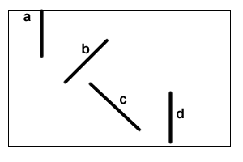
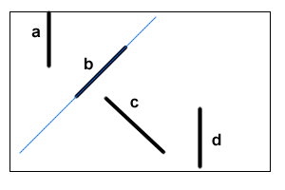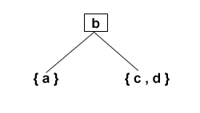
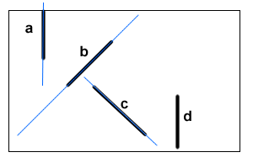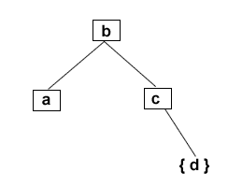
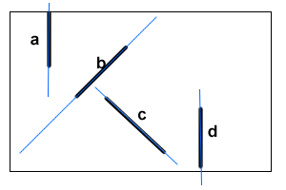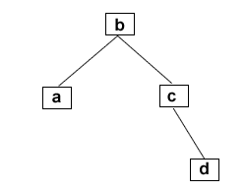
fig(1) Creating a BSP Tree

  - Choosing the Partition Plane

The efficiency of BSP algorithm depends mainly on the choice of partition planes. The partition planes dictate the structure of the BSP tree and hence are crucial to their working. Then how is the partition plane chosen?
We have to consider the following factors in choosing a partition plane:

    - Choosing a plane with least splits

If a polygon lies completely in one sub-space, then the action is straightforward. But what happens if a plane lies in both the sub-spaces? Well, then we split the tiresome polygon into two smaller polygons. The resulting smaller polygons can be inserted normally into FrontList and BackList of the Node.
It is easy to realize that polygon splitting is every graphics programmer’s nightmare. Increasing the number of polygons really causes a major increase in the computing time and space requirements of the application.
It is to be noted that in some cases, polygon splitting is inevitable. Sometimes two polygons overlap in such a way that the polygons cannot be sorted in back-to-front order. In such a case a split must occur. Decidedly, splitting too many polygons is prohibitively expensive. So we must choose a plane which minimizes the number of polygon splits.

1.3.2 Choosing a plane which balances the tree

As every Data Structures student knows, one of the disadvantages of Binary Trees is that they tend to become unbalanced. A Binary Tree is unbalanced if the height of left and right sub trees of the tree are different. Such imbalance robs the binary tree of its search efficiency. In the worst case, the search time can degrade to O (n) from O (log n). When we are dealing with millions of polygons, we cannot neglect the effect of unbalanced nodes in the tree. So the partition plane must be chosen to balance the tree. This is actually quite easily done. We must choose a plane such that the number of polygons in front of it is roughly equal to the number of polygons behind it.
So we have two contradictory factors to consider while choosing a partition plane. One way would be to choose the polygon with least splitting or one which balances the tree. The choice is often dictated by the nature of the application. It is shown that finding an optimal plane which satisfies both factors is a NP-hard problem and practically infeasible to carry out. Generally a compromise is adopted between the least polygon-splits and balancing of the tree. Because polygon splitting is very expensive, the solution leans more towards minimizing polygon-splits. But as applications grow larger, we cannot neglect balancing and its effects.

2. BSP Tree + AVL Tree = Efficient Space partitioning

2.1 What are AVL Trees?
The problems that we face, i.e. balancing of binary trees, were exactly the same problems researchers encountered in the 1960s. To balance a tree, we need the tree to have some intelligence. We need a self-adjusting tree which can retain its balance even on random insertions and deletions. In 1962, Russian mathematicians E. Landis and G.M. AdelSon-VelSkii invented the AVL Tree [9] which solved these problems. So what is this AVL Tree?

The properties of an AVL Tree are [9]:
- It is a binary tree
- It is a height balanced tree of order one {HB (1)}. A height balanced tree is one in which the height of a left sub tree differs from the height of right sub tree by not more that one level.
- Its worst case sort depth is in O (log n). Compare this with the worst case sort depth of binary tree O ( n )
- It maintains the balance even on random insertions and deletions

  - How is the balance maintained with random deletions and insertions?

Adelson-Velskii and Landis devised a set of four operations called rotations to counter the effect of random insertions and deletions. Associated with each node in the tree is a number called balance-factor which is the difference between heights of the left and right sub trees. For an AVL Tree, the balance-factor is always 1,0,-1.If the insertion of a new node violates this rule , then the following steps are carried out :
Let us assume the right subtree of p is higher than the left subtree of p. (The rotation algorithm you need to use if the left subtree is the higher subtree is analogous to the algorithm outlined in the following paragraphs, just that all occurrences of the word LEFT are replaced by the word RIGHT, and vice versa.)
Let us refer to the RIGHT child node of p as u, to the LEFT child node of u as v, and to the RIGHT child node of u as w. Note that v does not necessarily exist; i. e., that the left child node pointer of u may point to NULL.
To rotate, first check if the subtree whose root node is v is higher than the subtree whose root node is w.
- If yes, p is replaced by u (that is, the pointer previously pointing to p from now on points to u). Node p becomes the new LEFT child node of u, and v becomes the new RIGHT child node of p. (This operation is commonly referred to as single rotation to the LEFT).
- If no, p is replaced by v (that is, the pointer previously pointing to p from now on points to v). Node p becomes the new RIGHT child node of v, and node u becomes the new LEFT child node of v. What previously was the LEFT child node of v becomes the new RIGHT child node of p, and what previously was the RIGHT child node of v becomes the new LEFT child node of u. (This operation is commonly referred to as double rotation to the LEFT. It can be considered a two-step manipulation consisting of two consecutive single rotations: First, we perform a single rotation to the RIGHT on node u, and then we perform a single rotation to the LEFT on node p. Hence the adjective double.)
Similarly we have single and double rotations to the right. Deletion is conceptually similar.
The diagrams should make it clearer:

LL Rotation

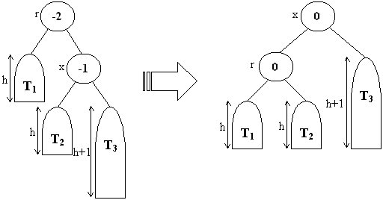

RR Rotation
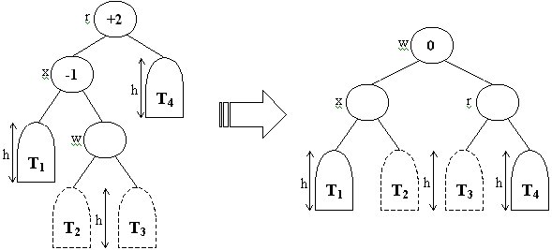

LR Rotation

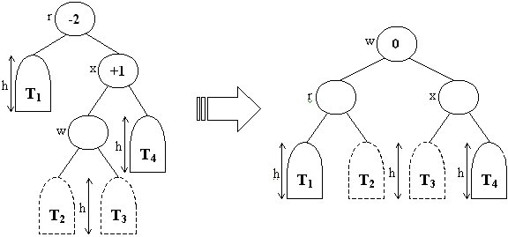

RL Rotation
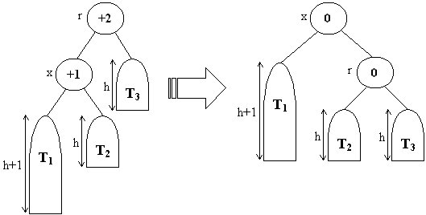
fig (2 ) : Rotation Operations
3. XSP Trees

3.1 Putting it all together
The main theme of the paper is in applying AVL Trees to BSP Trees. The construction is rather straightforward. When a BSP Tree is being constructed, balance is ignored. Only the polygon splitting is considered for obtaining the partitioning plane. Such a BSP Tree would be unbalanced. Once the BSP Tree is obtained, then it could be converted into an AVL Tree keeping the same ordering but re-structuring the tree. In such a tree, balance would be maintained to a large extent while retaining the optimal polygon-splitting.

3.2 Problems and shortcomings

XSP Trees are not without problems. One of the main problems is the increase in complexity. In the algorithm mentioned above, converting an existing BSP Tree into an AVL Tree is expensive. It can degenerate to O (n) if rotation has to be carried out at every node. The rotations themselves are pretty time consuming and hence take up valuable time to be carried out. A Sample run of an application which made use of normal BSP Tree and the modified BSP Tree [10], was run with sets on randomly generated polygons. The times taken for Tree creations are given below. Clearly there is a significant increase in the time taken for BSP Tree creation with XSP trees. Sometimes as much as 150% increase is seen.

3.3 Then why XSP Trees?

After seeing that XSP Trees are very slow to create, the logical question is to why XSP Trees should be used at all. The answer lies in the asymmetry of creation and usage of BSP Trees. BSP Trees in some applications are created only once and used many times. Such a create-only-use-many scenario is suitable for XSP Trees. Since the Trees are used frequently, the small time-saving due to balanced trees becomes significant. Some of the major CG applications, namely computer games, come under this category. Since the maps are created only one by the game-developers, and then subsequently

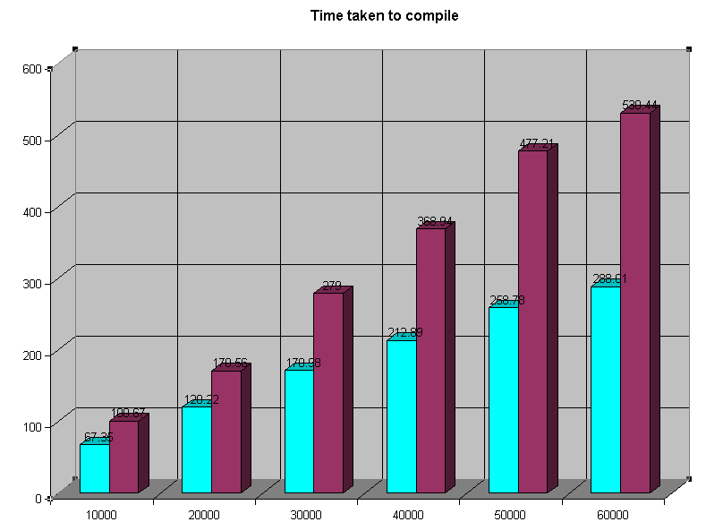
fig (3) Sample time taken to create a BSP Tree with and without using AVL Tree balancing

Accessed many times by end-users, using XSP Trees can have significant run-time benefits.
On the other hand, in applications where the world-creation is dynamic, XSP Trees are not suitable. The overhead of balancing using AVL Trees is much more than the performance-increase by using them. In such application, XSP Trees find no real use.
Conclusion

XSP Tree is a new idea which the authors believe has significance in today’s scenario of computer graphics applications. The authors believe that in spite of having many shortcomings, XSP trees can make applications more efficient.
References

The idea of using AVL Trees in BSP Tree Algorithm is considered by the author(s) to be their own. In that sense, this is an original paper. But it is such a simple concept that we are sure that many other people have probably got the same idea. Many of the concepts are taken from different sources, some of whom are mentioned below. Also, in writing this paper , the author(s) made use of many pictures , source code and other material from various sources. We acknowledge their contribution.

[1] Foley,Van Dam,Feiner,Hughes
"Computer Graphics - principles and practice "
(1999) (2/e) Addison Wesley
[2]Shavit
"BSP Tree - Accurate Depth Sorting"
http://www.cfxweb.net/~cfxamir/bsp1.html
[3]Fuchs,Kedem,Naylor
"On Visible Surface Generation by A Priori Tree Structures "
SIGGRAPH 80
[4]Wade
"Binary Space Partitioning FAQ"
ftp://rtfm.mit.edu/pub/usenet/news.answers/graphics/bsptree-faq
[5]Sahni
"Data Structures , Algorithms , Applications in C++"
(1998) Tata McGraw Hill
[6]Knuth
"The Art of Computer Programming : Sorting and Searching"
(1973) Addison Wesley
[7]Bayer,McCreight
"Organization and maintainance of Large Ordered Indexes " ( 1972 )
[9]Folk et al
"File Structures - An object Oriented approach with C++”
(1998) (3/e) Addison Wesley

