

Design and Implementation of an isometric tile-based game
Project Report
By
Harish J P
Reg. No: 1RV00IS008
&
Priyananda Shenoy P
Reg. No: 1RV00IS021



Department of Information Science and Engineering,
R V College of Engineering,
Bangalore – 560059.
Department Of Information Science and Engineering
RV College Of Engineering
Bangalore.

~ Certificate ~

This is to certify that the Project

Design and implementation of an Isometric Tile Based game

Submitted in partial fulfillment of Internet programming Laboratory subject of B.E. VII Semester, Information Science and Engineering Course of Visveswaraih Technological University is the result of bona fide work carried out by:
Harish J P 1RV00IS008
Priyananda Shenoy P 1RV00IS021

During the academic semester August 2003 – December 2003
Mr. Kalyan
Guide

Mr. N K Srinath
H O D
Dept of ISE

External Examiner 1:

External Examiner 2:

Table of Contents

Section | Page No
- General Introduction to Java | 5
- Graphics under Java | 6
- Isometric Rendering | 7
- Project Abstract | 8
- Design | 9
- Implementation | 10
- Testing | 13
- Appendices | 14
- Conclusion | 18
- Bibliography | 19

Acknowledgements

We would like to thank the following people:

- Prof N K Srinath – Words cannot describe what Mr. Srinath means to Information Science department. He is the person who shaped us into what we are today. We are eternally grateful for his constant support and encouragement, not to mention his friendly and positive attitude.

- Lecturers of ISE Dept – The lecturers make the department the fun place it is today. They are more our friends than our lecturers.

- Students of ISE Dept – We (naturally) believe that the bunch of guys and gals who constitute the VII SEM of ISE, RVCE are the BEST. Thanks for all the support (and criticism!).

- Our parents – for their support and general tolerance of our mischief.

Harish J P
Priyananda Shenoy P

Section I General introduction to Java

Java is an object-oriented programming language developed by Sun. It shares many superficial similarities with C, C++, and Objective C. Java was built initially to supersede C++ as it was found to be inadequate in some occasions.

Java is cross-platform not only in source form but also in binary compiled form Java is compiled to an intermediate byte-code which is interpreted on the fly by the Java interpreter. Java has the following features:

- Strong typing
- No unsafe constructs
- Language is small and easy to become fluent
- There are no undefined or architecture dependant constructs
- Java is object-oriented
- Java has concurrency

Difference between an Application and an Applet

An application is a stand-alone program, normally launched from the command line, and which has more or less unrestricted access to the host system.
An applet is a program which is run in the context of an applet viewer or web browser, and which has strictly limited access to the host system. For instance an applet can normally not read or write files on the host system whereas an application normally can.

Section II Graphics under Java

An interpreted high-level language doesn’t seem as the ideal choice for writing graphical applications. Then why chose Java? Java provides a variety of graphical features in a neat and object-oriented manner. What more, it can be run on different platforms. Also Java has wonderful features regarding sound and configuration files. This makes Java a suitable (if not ideal) language for writing graphical applications. Some of the graphical features that Java boasts of are:

- Double Buffering
- Antialiased fonts
- Affine Transforms - rotate , scale , shear
- Viewports and clipping
- Polygonal manipulation
- Texture mapping
- Alpha compositing
- Gradient Painting
- Multithreaded Animations

To make full utilization of the features of java, we made use of the standard Java Swing (JFC) and Java2D class libraries. These form a convenient and simple interface for accessing the low level features easily.
Though Java has numerous advantages, it has a few disadvantages. Some of them are:
- Java cannot make optimal use of system dependent resources without compromising on platform independence. That means it cannot use hardware tessellation and other features which can accelerate the graphics.
- Java clipping and transformation operations are carried out in software. This poses limits on the speed of operation and drastically decreases the frame rate.
All these make Java not suitable for large-scale graphics programming. Java is better suited at 2D graphics programming than 3D graphics. The standard Java package provides Java2D as an interface for 2D programming. Although Java3D exists, it is basically

Section III Isometric Rendering
To make a 2D world look approximately 3d, we make use of projection and transforms. Isometric Transforms are a way of displaying 2D maps in an approximately 3D manner. Isometric transform is explained with the help of a diagram below.

We chose isometric Rendering because it is easy to achieve, yet give a look which is three dimensional.

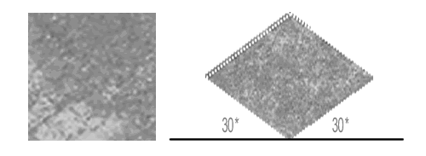

A square of width ‘w’ will be transformed into a polygon of height ‘w’ and width a * w , where a is a constants. If the tilting angle is 30*, the a = 1.73.As this is not easy to draw because of floating point approximations, we use the values of a as 2
Section IV Project Abstract
The requirement is for a Java project which makes optimal use of Java’s graphical properties. The obvious choice is a game written in Java. Because of the reasons given above, the game would have to be a 2D game rather than a 3D game. To achieve a 3D look we chose to make an isometric game. The game is a tile-based game in which the map is constructed out of tiles which are rendered isometrically and can take different properties.
Some of the features of the project are:
- The game comes with a Map Creator and a Game Player which can be used to create new maps and play them respectively.
- The map consists of a 2D array of tiles each of which could be of the following types – Lava, Grass, Wall, Water. Each tile type has its own properties.
- The game elements can be Health bonuses, Spells and Monsters. A human is the protagonist who must use the spells to destroy the monsters.
- Animated Monsters add to the visual feature of the game
- Spell animations are very attractive and are visually stunning.
- Sound has been incorporated to enhance the game play.
- Fully configurable Cheat Code support is present
- Fully configurable Key binding for movement is provided for customization
- The background music can be added by the user without changing the code.
- An in-game help manual assists the player in various manners. The help menu gives a complete description of Spell data and Monster information.
- A primitive support for player information exists.
- Extendible interface for enhancing or adding new feature
Section V Design
The game can be modeled in two views. When the map is being created, each tile must remember its properties independently because it can change. But at gametime, the Tile information cannot change. So a different view is required.
At a high level a Model-View-Controller (MVC) architecture was chosen. Here the representation of data is the Model. The View is the display or interface for the data. The controller transforms the Model into one or more views depending on the context.
Keeping this in mind, We designed the architecture to basically have 3 subsystems held in two packages :
j3a.graphics – The rendering and displaying sub-system
j3a.model – The Data Model Sub-system as well as the Controller Sub-
system.
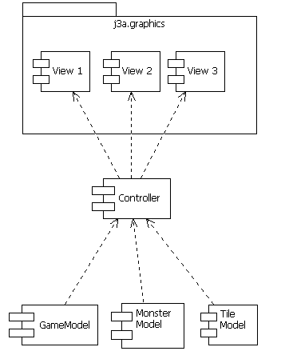
The game-time class diagram and the relationship of all the classes are shown in the class diagram below.

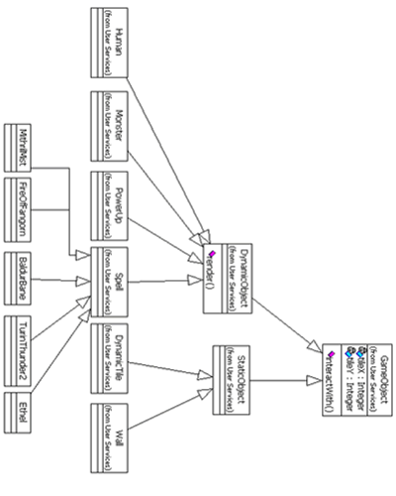
Section VI Implementation
Some of the important members of the packages and their functionality is explained here
Package j3a.graphics
Interface Summary
GameConstants | A set of misc game constants

Class Summary
AudioLoader | Cached Implementation of Audio Loading.
ChooserUI | The class for choosing the Map to play
GameIntro | Intro Screen for the Game
GameUI | The Top level container for game-time rendering
GoldenBorder | Nice Border
HelpDialog | In ganme help menu
HUDPanel | This class represents the HUD of the game Basically it is a hyped up JPanel
ImageLoader | A cached implementation of loading images
IsometricTransform | The model transform for isometric tile rendering
MapCreator | Class to create Maps
MediaPreloader | Preloads a few images and sounds with some fancy progress bars
NewMapDialog | Dialog to take New file information
PowerUp | A Health bonus
RenderableMap | The View component of a Map
SceneRenderer | The graphical counterpart of the Runtime Engine. Along with GameController renders and takes input for the game.
SplashScreen | Some flashy graphics
TextureFactory | Factory class to generate and cache textures
Tile | Static time tile representation

Package j3a.model
Interface Summary
EventObject | An event which is callable by the controller after some amount of time
HumanConstants | This is the stupidest named class in the project
MonsterConstants | What crap is this? Shenoy's example of meaningless interfaces.
SpellConstants | Is this fair? Using an interface as a enum ? Well , java does it , ( SwingConstants )

Class Summary
DynamicObject | Dynamic Object is an object which: 1> Can be drawn, 2> register an event with a controller 3> Possibly change state
DynamicTile | Represents a tile.Basically models the static tile properties Pretty easy to write.
GameController | The main class of the game runtime.
GameMap
GameObject | The fundamental class for modelling the objects in runtime
Human | Human is the only thing that can affect and be affected by other objects.
MapFileWriter | An abstraction over creating file representation of a Map
MapReader | An abstraction over reading a map file into GameMap
Monster | A class to represent a Monster dynamic Object
StaticObject | Static Object is an object which interacts with humans But no drawing takes place.It is stateless and unchanging
StaticSpell | This class is there partly because of bad design .This holds the Creation-time representation of a Spell
Triple | A structure to hold 3 objects - for Spell and Monster Pairs are held in Point structures

Section VII Testing
Testing was done on the game in a variety of ways to ascertain the behavior of the engine in various conditions. Some of the testing carried out was:

- Feature testing
- Exception testing

Feature testing
Some of the features checked were:

- Creation of maps of large size(Successfully tested for 30x40 maps)
- Running multiple animations at the same time
- Thread synchronization for multiple threads in case of shared objects – no race condition noticed
- All monster and spell animations work
- The tile properties are consistent
- Drawing is consistently back-to-front, no overlapping occurs in the wrong order.

Exception Testing
To ascertain the behavior of our game under exceptional conditions, we carried out a set of tests. Some of the test cases are:

No Maps are found: The game quits gracefully with a message.
No Players are found: The game quits gracefully with a message.
Textures are not found: Throws exception and quits.
Cheat codes are not present: Cheat support is disabled.
Key Binding files are not present: Default key bindings are used.
Section VIII Appendices
Appendix A: System requirements
The following software are required to compile and run “The Fall of Numenor”:
- Java 2 SE 1.4 or higher JDK and JRE
Because of Java’s portability, the game can run under any system which has Java.
No specific hardware requirements exist.

Appendix B: Compiling and installing
The game directories are listed briefly below:
audio/ The game audio files
conf/ has the cheat code file (cheat.cht) and key binding file (key.kdb)
images/ The game textures and sprites
j3a/* The class files in package order
manual/ The in-game help manual
players/ Player information
src/ Game Source files

To compile goto src directory and type the command

javac -d .. *.java

TO run the game type

java –cp . j3a.graphics.GameIntro

To run the map creator type

java –cp . j3a.graphics.MapCreator
Appendix C: Known Bugs / Limitations / Improvements

- The game has been known to flicker when the map sizes are high
- The game will crash when the tile count reaches 2000
- The Player support is still primitive. This could be improved further.
- A better interface for game-play creation must be there. The creator must specify which way the map must be played
- A multilayered map can be used to have more objects
- Monsters don’t move. That is probably the biggest limitation the game has.
- The Monster can have more AI and can be more dangerous
- Other game elements like trees, other humans etc can be introduced
- More spells can be added
- An interface for creating new monsters and new spells can be given.

Appendix D Unknown bugs
We don’t know them yet!!!

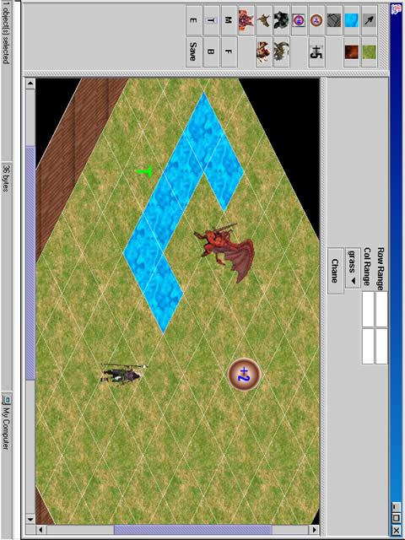
Some screen shots of the map Creator
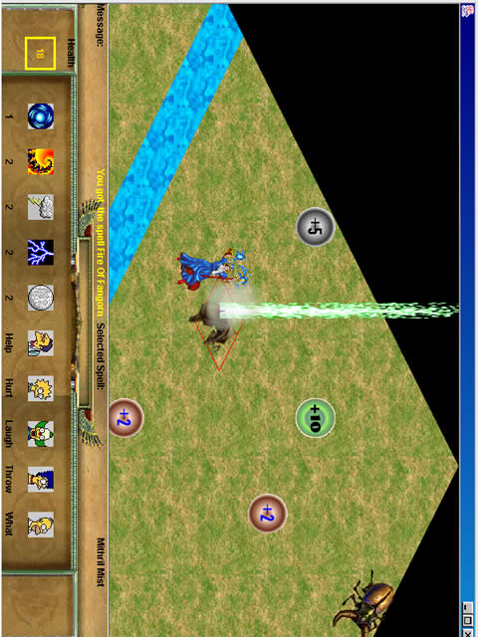
Some Screen shots of the game
Section IX Conclusion

Keeping in mind the requirement of a Java graphics application, the creators of the game tried to use as many advanced features of the game as possible. The result is a game which we like to play!! The game gave us more enjoyment than pain. We hope that others will also enjoy the game.
Though there is scope for improvement, the effort put in by the developers seems to have paid off. The experience would definitely help us in the future projects.

Harish J P
Priyananda Shenoy P
Section X Bibliography

We consulted some of these books and articles on Java for building the Java game.

[1] Java Tutorial
Sun Microsystems
http://java.sun.com/docs/books/tutorial/index.html

[2]Java Documentaion
Sun Microsystems
http://java.sun.com/j2se/1.4/docs

[3] Tile Based Games FAQ
by Chris Palmer and Greg Taylor
http://www.gamedev.net

We are extremely apologetic if we unintentionally left some of the books we referred out. We also thank them.

