3. DESIGN

3.1 Client-Server Architecture

When the program wishes to use TCP to exchange data, one of the programs should take the role of a client while the other must take the role of a server. The client application initiates what is called active open. It creates a socket and actively attempts to connect to server program. On the other hand, the server application creates a socket and passively listens for incoming connections from client, performing what is called passive open. When the client wants to connect a server, it sends a connection request. The server is notified that some process is trying to connect with it. By accepting the connection, the server completes what is called a virtual circuit, a logical communication pathway between the two programs. To review, there are five significant steps that a program that uses TCP must take to establish and complete a connection.

All communication protocols require certain Application Programming Interfaces (APIs). An API is an interface available to the programmer. The availability of an API depends on both the operating system being used and the programming language. The two most prevalent APIs for UNIX systems are:
      - Berkeley sockets
      - System V Transport Layer Interface (TLI).
Both these interface were developed for the C language.
The protocol being used to establish a connection between the client and the server can be either
1. Connection oriented, or
2. Connectionless.

The concept of Berkeley sockets is being used in this project to implement the Network File Search over an reliable, connection-oriented TCP.

3.2 Berkeley Sockets Overview:

A socket is a type of file used for network communication between processes. A socket can also be used for non-network communication between processes on a single host.

In Berkeley sockets, the notion of a socket allows a single computer to serve many different clients at once, as well as serving many different types of information. This feat is managed by the introduction of a port, which is a numbered socket on a particular machine. A server process is said to "listen" to a port until a client connects to it. A server is allowed to accept multiple clients connected to the same port number, although each session is unique.
To manage multiple client connections, a server process must be multithreaded or have some other means of multiplexing the simultaneous I/O.

3.3 Connection-oriented Service
The connection-oriented service is done using the Transmission Control Protocol (TCP).
To illustrate the role of TCP, it is instructive to follow a sample message between two machines. The processes are simplified at this stage, to be expanded on later today. The message originates from an application in an upper layer and is passed to TCP from the next higher layer in the architecture through some protocol (often referred to as an upper-layer protocol, or ULP, to indicate that it resides above TCP). The message is passed as a stream—a sequence of individual characters sent asynchronously. This is in contrast to most protocols, which use fixed blocks of data. This can pose some conversion problems with applications that handle only formally constructed blocks of data or insist on fixed-size messages.
TCP receives the stream of bytes and assembles them into TCP segments, or packets. In the process of assembling the segment, header information is attached at the front of the data. Each segment has a checksum calculated and embedded within the header, as well as a sequence number if there is more than one segment in the entire message. The length of the segment is usually determined by TCP or by a system value set by the system administrator. (The length of TCP segments has nothing to do with the IP datagram length, although there is sometimes a relationship between the two.)
If two-way communications are required (such as with Telnet or FTP), a connection (virtual circuit) between the sending and receiving machines is established prior to passing the segment to IP for routing. This process starts with the sending TCP software issuing a request for a TCP connection with the receiving machine. In the message is a unique number (called a socket number) that identifies the sending machine's connection. The receiving TCP software assigns its own unique socket number and sends it back to the original machine. The two unique numbers then define the connection between the two machines until the virtual circuit is terminated. (I look at sockets in a little more detail in a moment.)
After the virtual circuit is established, TCP sends the segment to the IP software, which then issues the message over the network as a datagram. IP can perform any of the changes to the segment that you saw in yesterday's material, such as fragmenting it and reassembling it at the destination machine. These steps are completely transparent to the TCP layers, however. After winding its way over the network, the receiving machine's IP passes the received segment up to the recipient machine's TCP layer, where it is processed and passed up to the applications above it using an upper-layer protocol.
If the message was more than one TCP segment long (not IP datagrams), the receiving TCP software reassembles the message using the sequence numbers contained in each segment's header. If a segment is missing or corrupt (which can be determined from the checksum), TCP returns a message with the faulty sequence number in the body. The originating TCP software can then resend the bad segment.
If only one segment is used for the entire message, after comparing the segment's checksum with a newly calculated value, the receiving TCP software can generate either a positive acknowledgment (ACK) or a request to resend the segment and route the request back to the sending layer.
The receiving machine's TCP implementation can perform a simple flow control to prevent buffer overload. It does this by sending a buffer size called a window value to the sending machine, following which the sender can send only enough bytes to fill the window. After that, the sender must wait for another window value to be received. This provides a handshaking protocol between the two machines, although it slows down the transmission time and slightly increases network traffic.
As with most connection-based protocols, timers are an important aspect of TCP. The use of a timer ensures that an undue wait is not involved while waiting for an ACK or an error message. If the timers expire, an incomplete transmission is assumed. Usually an expiring timer before the sending of an acknowledgment message causes a retransmission of the datagram from the originating machine.
Timers can cause some problems with TCP. The specifications for TCP provide for the acknowledgment of only the highest datagram number that has been received without error, but this cannot properly handle fragmentary reception. If a message is composed of several datagrams that arrive out of order, the specification states that TCP cannot acknowledge the reception of the message until all the datagrams have been received. So even if all but one datagram in the middle of the sequence have been successfully received, a timer might expire and cause all the datagrams to be resent. With large messages, this can cause an increase in network traffic.
If the receiving TCP software receives duplicate datagrams (as can occur with a retransmission after a timeout or due to a duplicate transmission from IP), the receiving version of TCP discards any duplicate datagrams, without bothering with an error message. After all, the sending system cares only that the message was received—not how many copies were received.
TCP does not have a negative acknowledgment (NAK) function; it relies on a timer to indicate lack of acknowledgment. If the timer has expired after sending the datagram without receiving an acknowledgment of receipt, the datagram is assumed to have been lost and is retransmitted. The sending TCP software keeps copies of all unacknowledged datagrams in a buffer until they have been properly acknowledged. When this happens, the retransmission timer is stopped, and the datagram is removed from the buffer.
TCP supports a push function from the upper-layer protocols. A push is used when an application wants to send data immediately and confirm that a message passed to TCP has been successfully transmitted. To do this, a push flag is set in the ULP connection, instructing TCP to forward any buffered information from the application to the destination as soon as possible (as opposed to holding it in the buffer until it is ready to transmit it).
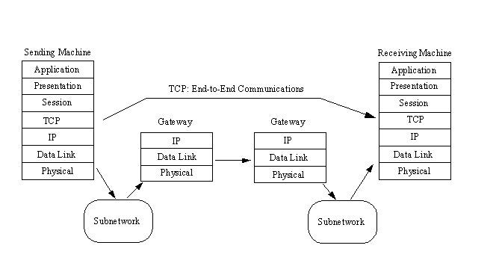
Figure 3.1 The TCP Model

3.4 Socket Addresses
Many of the BSD networking system calls require a pointer to a socket address as an argument. The definition of this structure is in <sys/socket.h>:

struct sockaddr
{
u_short sa_family; /* Address family : AF_xxx value */
char sa_data[14]; /* Up to 14 bytes of protocol-specific addresses */
};

The contents of the 14 bytes of protocol specific addresses are interpreted according to the type of address. For the Internet family, the following structures are defined in <netinet/in.h>:

struct in_addr
{
u_long s_addr; /* 32-bit netid/hostid */
/* network byte ordered */
};

struct sockaddr_in
{
short sin_family; /* AF_INET */
u_short sin_port; /* 16 bit port number */
struct in_addr sin_addr; /* 32 bit netid/hostid */
/* network byte ordered */
char sin_zero[8]; /* unused */
};

The header file <sys/types.h> provides C definitions and datatype definitions (typedefs) that are used throughout the system. We will mainly use the names defined for the four unsigned integer datatypes, as shown below.

C Data type 4.3BSD System V

unsigned char u_char unchar
unsigned short u_short ushort
unsigned int u_int uint
unsigned long u_long ulong

3.5 Socket System Calls Used

In this section, we describe the elementary system calls required to perform network programming.

1. socket System Call:

To do network I/O, the first thing a process must do is call the socket system call, specifying the type of communication protocol desired (Internet TCP, Internet UDP, etc.)

# include <sys/types.h>
# include <sys/socket.h>

int socket (int family , int type , int protocol );

family - Specifies the protocol to be used
.
Type - Specifies the socket type to be used.

Protocol - Specifies a particular protocol.

2. bind System Call:

The bind system call assigns a name to an unnamed socket.

# include <sys/types.h>
# include <sys/socket.h>

int bind (int sockfd , struct sockaddr *myaddr , int addrlen);

sockfd - is the socket file descriptor
myaddr - is a pointer a protocol-specific address
addrelen - is the size of the address structure.

Uses of bind system call:
- Servers register their well known address with the system. It tells the system “this is my address and any messages received for this address are to be given to me.” Both connection oriented and connectionless servers need to do this before accepting client requests.
- A client can register a specific address for itself.
- A connectionless client needs to assume that the system assigns it some unique address, so that the other end (the server) has a valid return address to send its responses to. This corresponds to making certain an envelope has a valid return address, if we expect to get a reply from the person we send the letter to.
The bind system call fills in the local-addr and local-process elements of the association 5-tuple.

3. send System Call:

The send system call is used to make a request or send a reply over a connected socket.

# include <sys/types.h>
# include <sys/socket.h>

int send (int sockfd , char *buff , int nbytes , int flags);

sockfd - is the socket file descriptor
buff - is a temporary buffer
nbytes - is th length of path of the filename
flags - is formed by ORing one of the following constants
- MSG_OOB - send or receive out of band data
- MSG_PEEK - peek at incoming message
- MSG_DONTROUTE - bypass routing

4. recv System Call:

The recv system call is used to receive data from a particular sender over a connected socket.

# include <sys/types.h>
# include <sys/socket.h>

int recvfrom ( int sockfd , char *buff , int nbytes , int flags );

sockfd - is the socket file descriptor
buff - is a temporary buffer
nbytes - is th length of path of the filename
flags - is formed by ORing one of the following constants

- MSG_OOB - send or receive out of band data
- MSG_PEEK - peek at incoming message
- MSG_DONTROUTE - bypass routing

3.6.System Design

The basic design of Mail Transfer Kit can be presented through the data-flow diagram, which shows how data is processed by a system. The notion used in these models represents functional processing, data stores and data movements between functions.

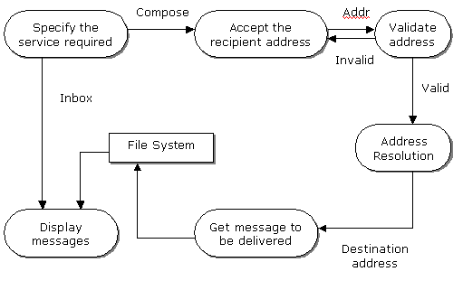

The model above shows how data (recipient address and the message to be delivered, in case of MTS and the message number and the message to be displayed, in case of MRS) flows through a sequence of processing steps. The data is transformed at each step before moving on to the next stage. The different processes like validation of the address, accepting of the message and their corresponding outputs like the valid address, message etc. are shown in the diagram.

