# ****TATA Forage Virtual Traineeship****

## ****Business Data Analysis Report****

### **Executive Summary**

As part of the **TATA Forage Virtual Traineeship**, I worked as a **Business Data Analyst** to extract strategic insights for an online retail company.

The project aimed to evaluate company performance from both **marketing** and **operational** perspectives and assist C-level leaders in making informed expansion decisions.  
The dataset was relatively clean, which allowed me to focus more on **business logic**, **visual strategy**, and **real-world critical thinking**—just like a professional analyst.

### **Tools Used**

* Power BI
* Microsoft Excel (supportive classification)
* Business reasoning + visualization design

### **Business Case**

The online retail store needed guidance on its performance across markets, customer behavior, and product demand to plan next year’s strategy.

The **CEO** was focused on operations and expansion.  
The **CMO** wanted to understand customer segments and country performance.

## ****Analysis & Insights****

### **1. Monthly Revenue Trends (2011)**

**Stakeholder:** CEO  
**Goal:** Spot seasonal patterns for forecasting.

📊 Visual used: Line chart  
💡 Insight: November showed peak revenue — a strong seasonal pattern likely driven by holiday demand. This supports boosting stock and logistics in that period.

🖼️ 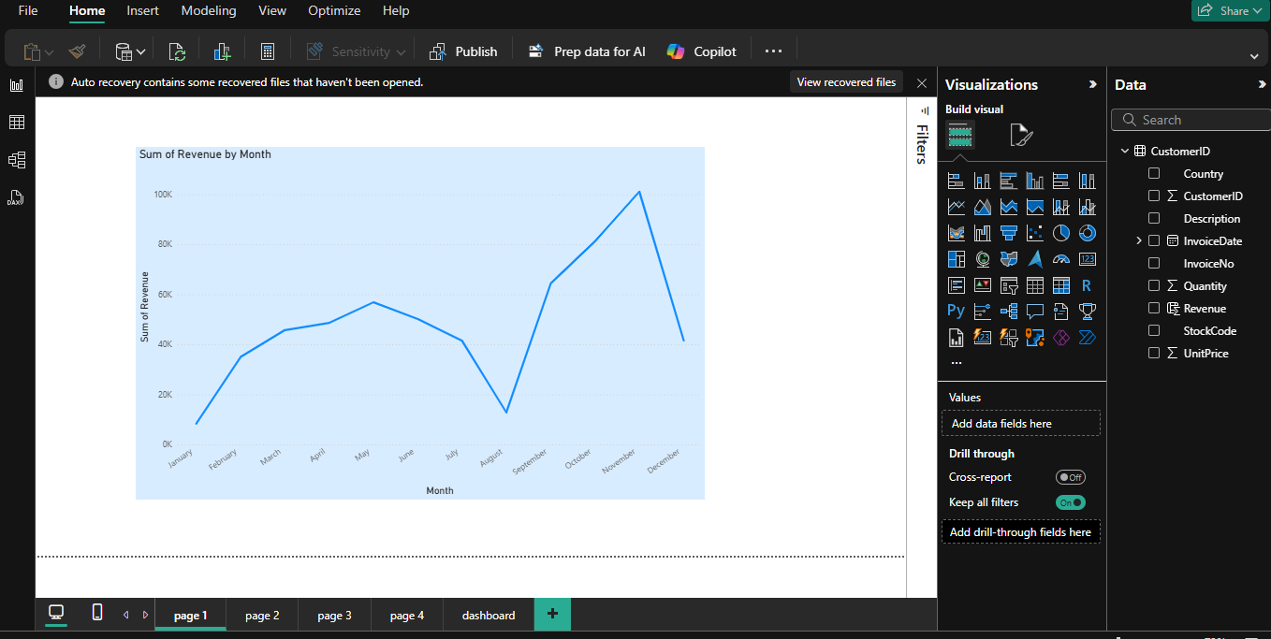

### **2. Top 10 Countries by Revenue (Excl. UK)**

**Stakeholder:** CMO  
**Goal:** Understand strong international markets + quantity sold.

📊 Visual used: Clustered Bar Chart  
💡 Insight: Netherlands and Germany show high revenue and quantity sold — potential key markets to focus marketing efforts on.

🖼️ 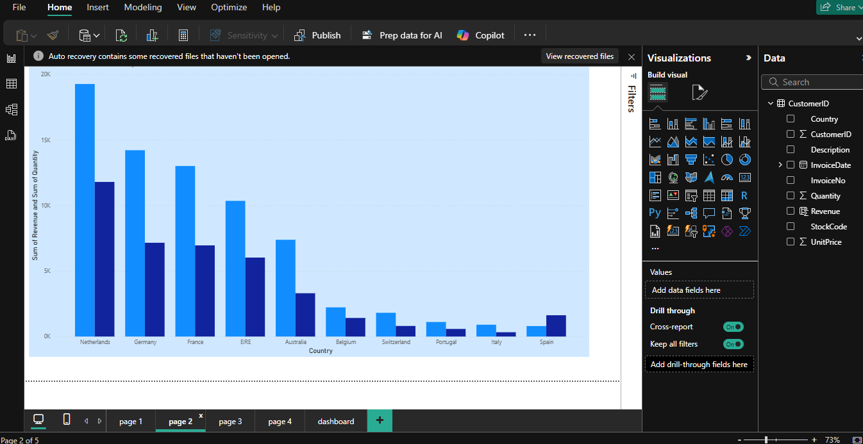

### **3. Top 10 Customers by Revenue**

**Stakeholder:** CMO  
**Goal:** Identify high-value customers to retain.

📊 Visual used: Sorted Horizontal Bar Chart  
💡 Insight: A small group of customers contributes a large % of revenue. Retention and loyalty programs are key.

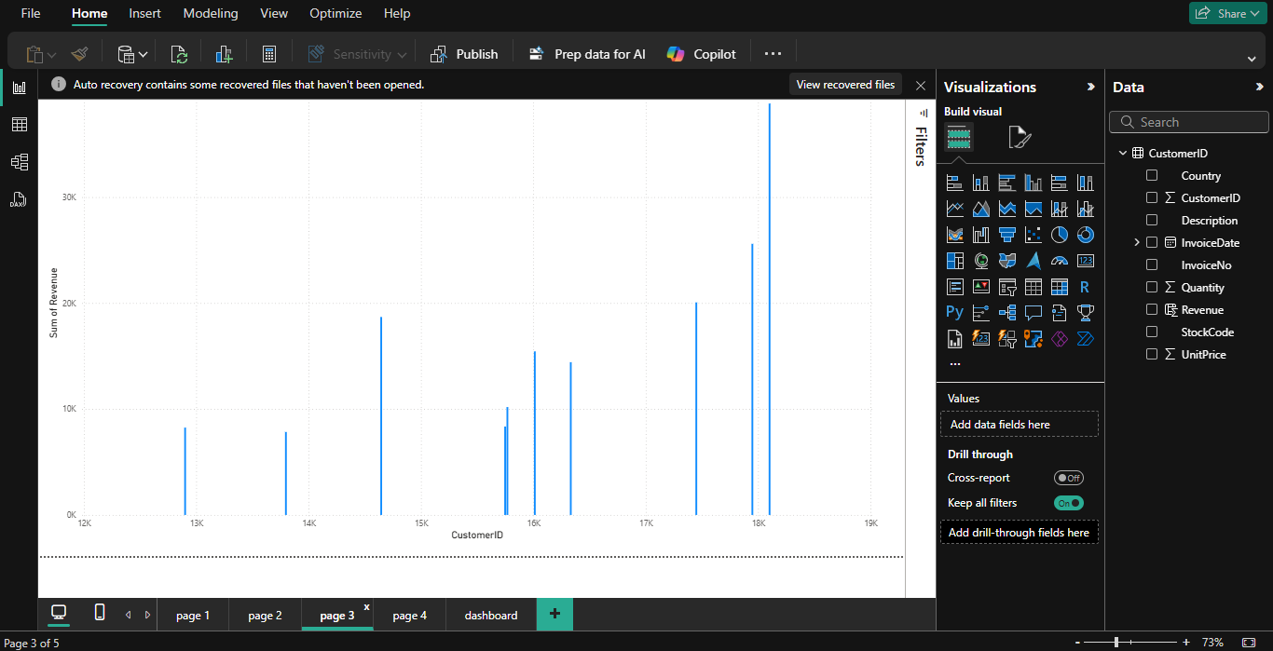

### **4. Demand by Country (Excl. UK)**

**Stakeholder:** CEO  
**Goal:** Find top-performing regions for expansion.

📊 Visual used: Treemap  
💡 Insight: France, Germany, and Netherlands stand out in product demand and are excellent candidates for regional expansion.

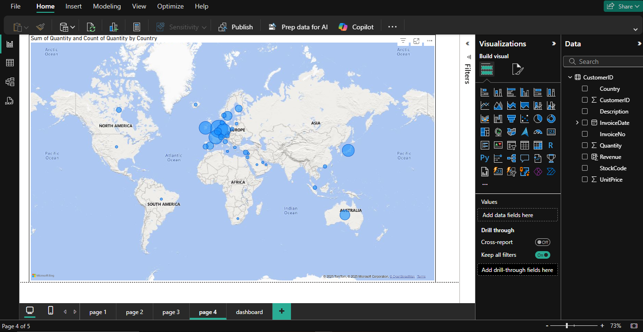

## ****Strategic Recommendations****

✅ Boost inventory and marketing budget in Q4 (peak demand season)  
✅ Expand into France, Germany, and Netherlands (strong demand)  
✅ Create retention strategies for top customers  
✅ Reassess low-revenue, high-quantity products (margin check)

### **End of Report**

This project was an opportunity to apply practical analytics, stakeholder empathy, and data visualization to simulate a real business consulting scenario.

