Deloitte Australia Data Analytics Traineeship

# Project Report

**Priyangi | July 2025**

# Executive Summary

This project was a part of the Deloitte Australia Data Analytics Virtual Internship on Forage. The goal was to extract insights from real-world telemetry data, presented in a large JSON format. After preprocessing the data using Python, I built a dynamic dashboard in Tableau that highlighted device health trends, anomalies, and factory-specific performance metrics.

# Project Objectives

• Convert a raw nested JSON file into structured data  
• Perform data flattening using Python  
• Explore and classify data in Excel  
• Visualize key metrics in Tableau for stakeholder insights

# Data Overview

The dataset was provided in a complex JSON structure, consisting of over 160,000 rows. Each entry captured telemetry readings of devices located in different factories and sections. Important fields included:

• Device ID and Type  
• Timestamp  
• Location (country, city, factory, section)  
• Health Status  
• Temperature Readings

# Tools and Techniques

• **Python** – for flattening the JSON data using `json_normalize` from pandas  
• **Excel** – for basic classification and validation  
• **Tableau** – to build an interactive dashboard

# Process

1. **Loading JSON Data**: Used Python’s `json.load()` to read and inspect the structure.  
2. **Flattening**: Employed `pandas.json_normalize()` to convert nested fields into a flat dataframe.  
3. **Exporting**: Saved the output as a CSV for further use in Tableau.  
4. **Exploration** **in** **Excel**: Performed early-stage sorting and tagging.  
5. **Dashboard** **Building**: Used Tableau Public to visualize ‘Unhealthy’ device count by factory and device type.

# Dashboard Sample

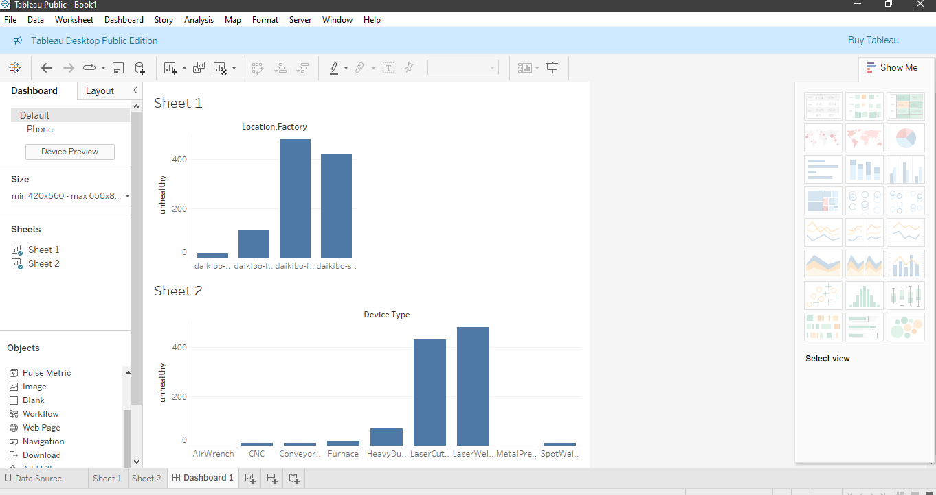

# Key Insights

• Daikibo-factory-meiyo reported the highest number of unhealthy device statuses.  
• CNC and LaserWelder devices were more prone to health issues.  
• Location-based clustering of issues could indicate systemic problems in certain factories.  
These insights can help the operations and maintenance team prioritize inspections.

# Skills Gained

• Gained hands-on experience with nested JSON structures  
• Learned how to use Python and pandas to preprocess data for visualization tools  
• Strengthened dashboarding skills using Tableau  
• Improved data storytelling by identifying operational bottlenecks

# Appendix – Sample Code

```python  
with open('daikibo-telemetry-data.json') as f:  
 data = json.load(f)  
  
df = pd.json_normalize(data)  
df.to_csv('flattened_data.csv', index=False)  
```