## ASSIGNMENT-06

## Uploading a static website in Amazon S3

## Step 1:Sign in to AWS and Open Amazon S3 Console

## Go to AWS and sign in.

## 2.In the AWS Management Console,navigate to Amazon S3.

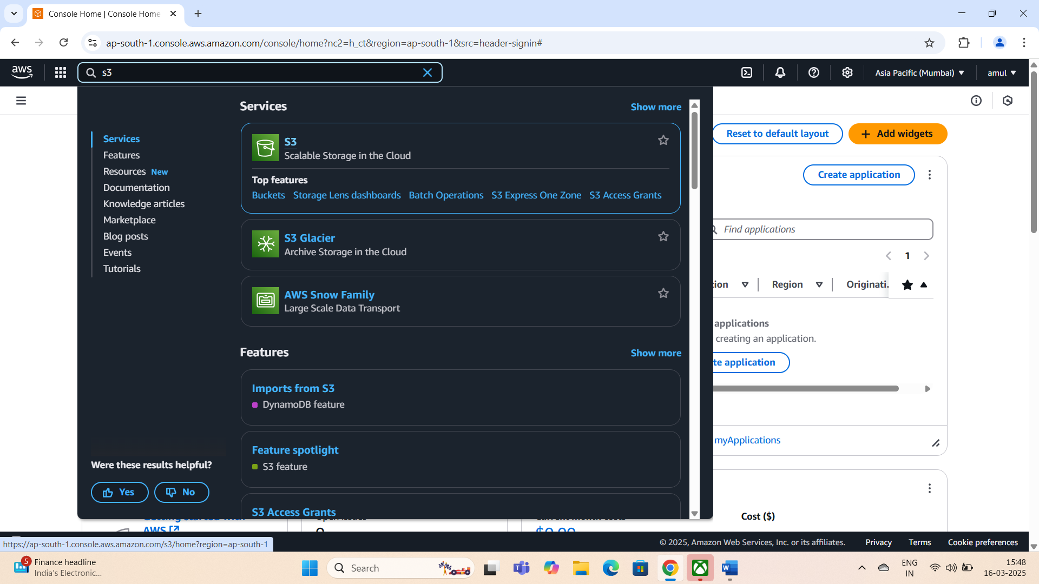

## Step 2:Create a Public S3 Bucket

## 1.In the left panel,click Buckets.

## 2.Click Create bucket.

## 3.The Create bucket page opens.

## 4.Enter a bucket name(e.g.aneeshpublicbucket).

## 5.Choose the AWS region where the bucket will reside.

## 6.Enable ACLs under Object Ownership.

## 7.Modify Public Access Settings:

## .Uncheck Block Public Access settings for this bucket.

## .Tick the Acknowledgment Box.

## 8.Click Create Bucket.

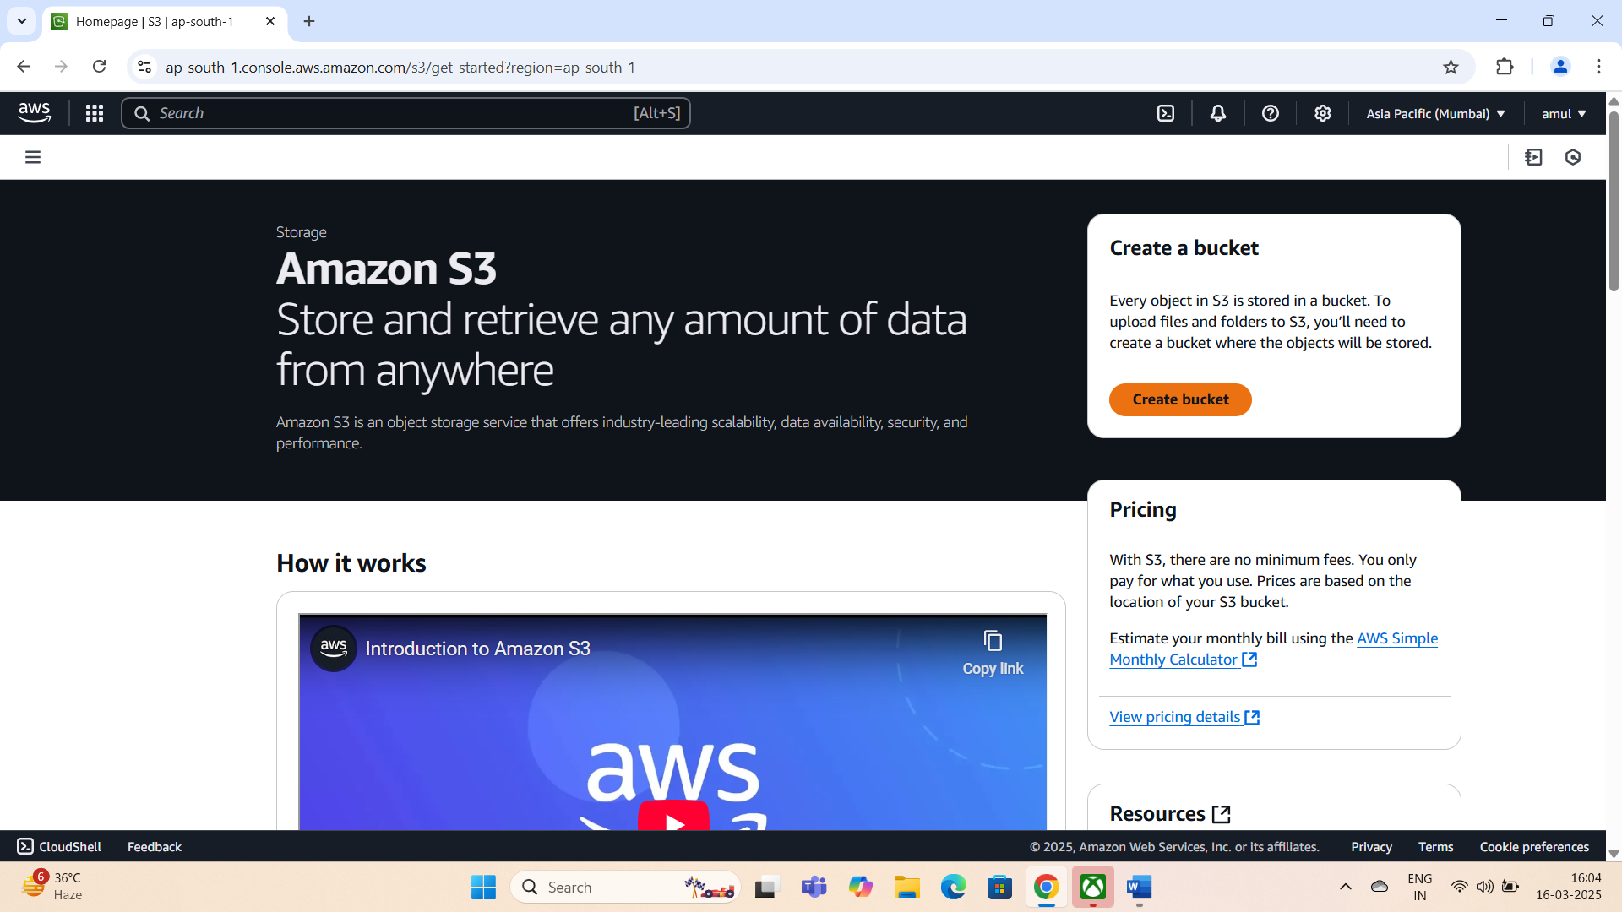

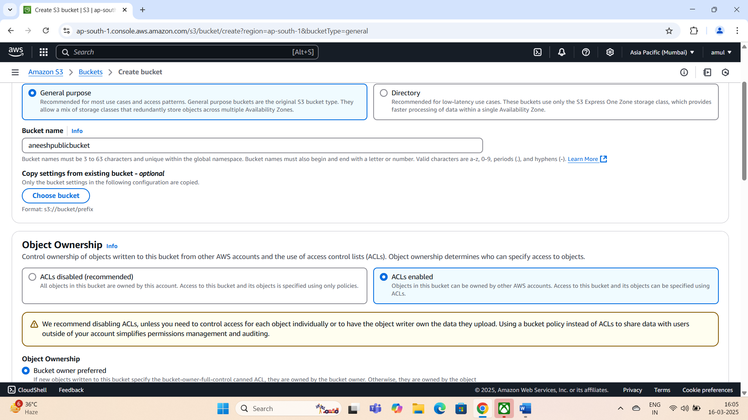

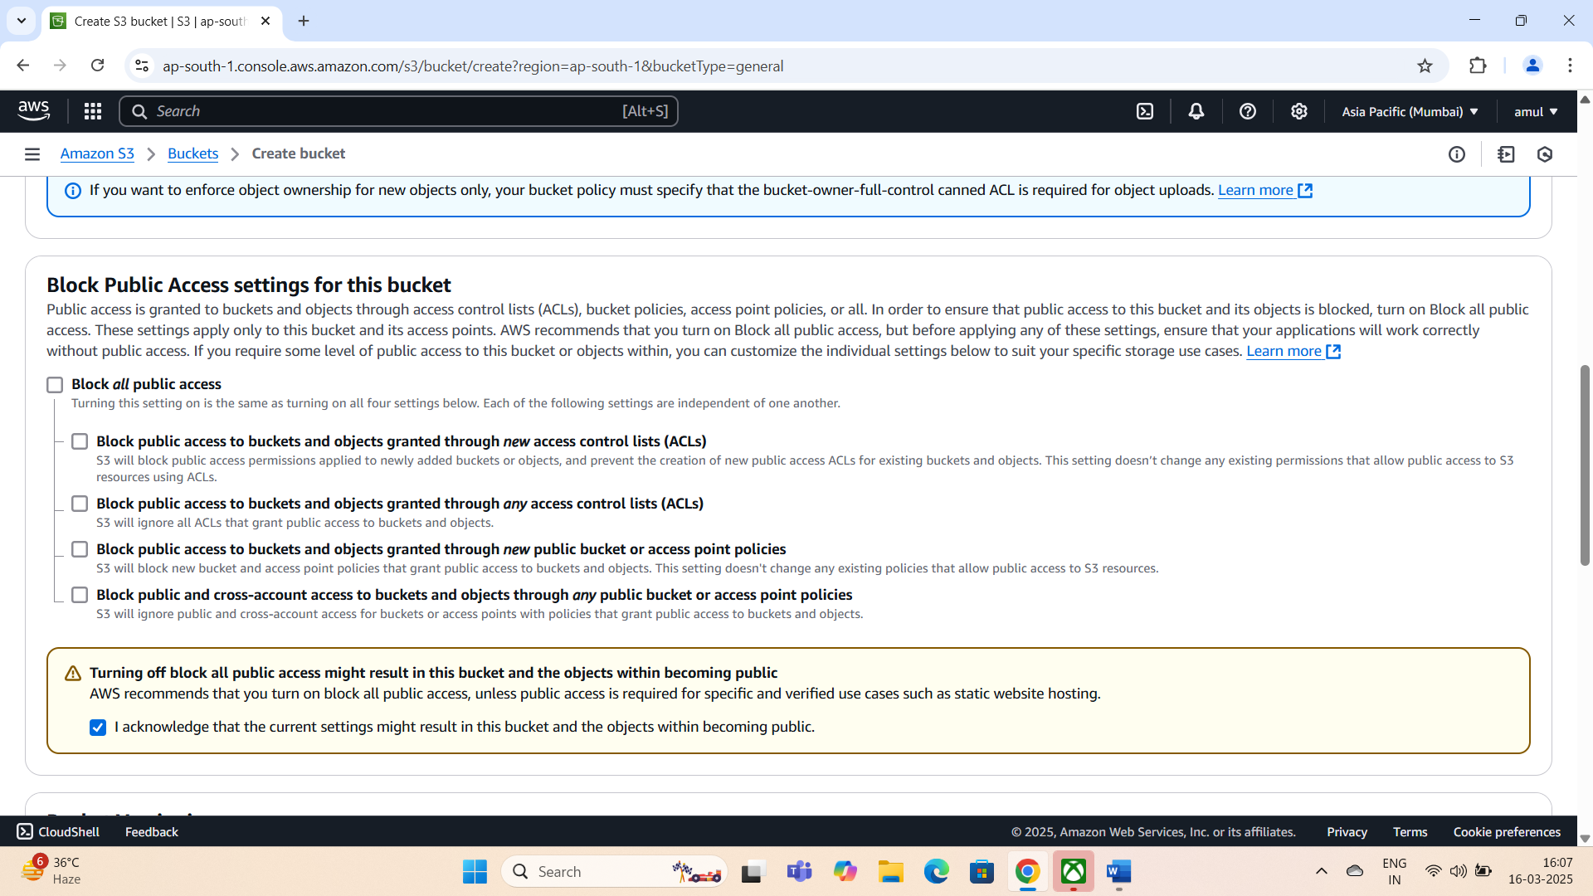

## Remark:The bucket itself is public,but individual files must also be made public.

## Step 3:Enable Static Website Hosting

## 1.Open the newly created bucket.

## 2.Go to the Properties tab.

## 3.Scroll down to Static Website hosting and click Edit.

## 4.Enable Static Website hosting.

## 5.Set the Index document as index.html.

## 6.Click Save changes.

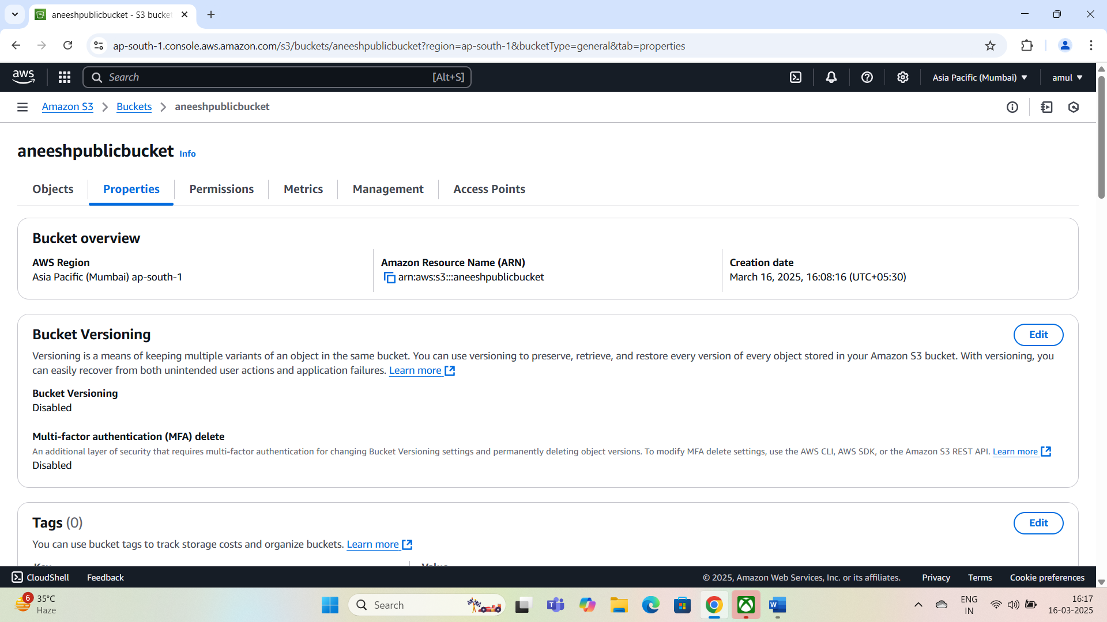

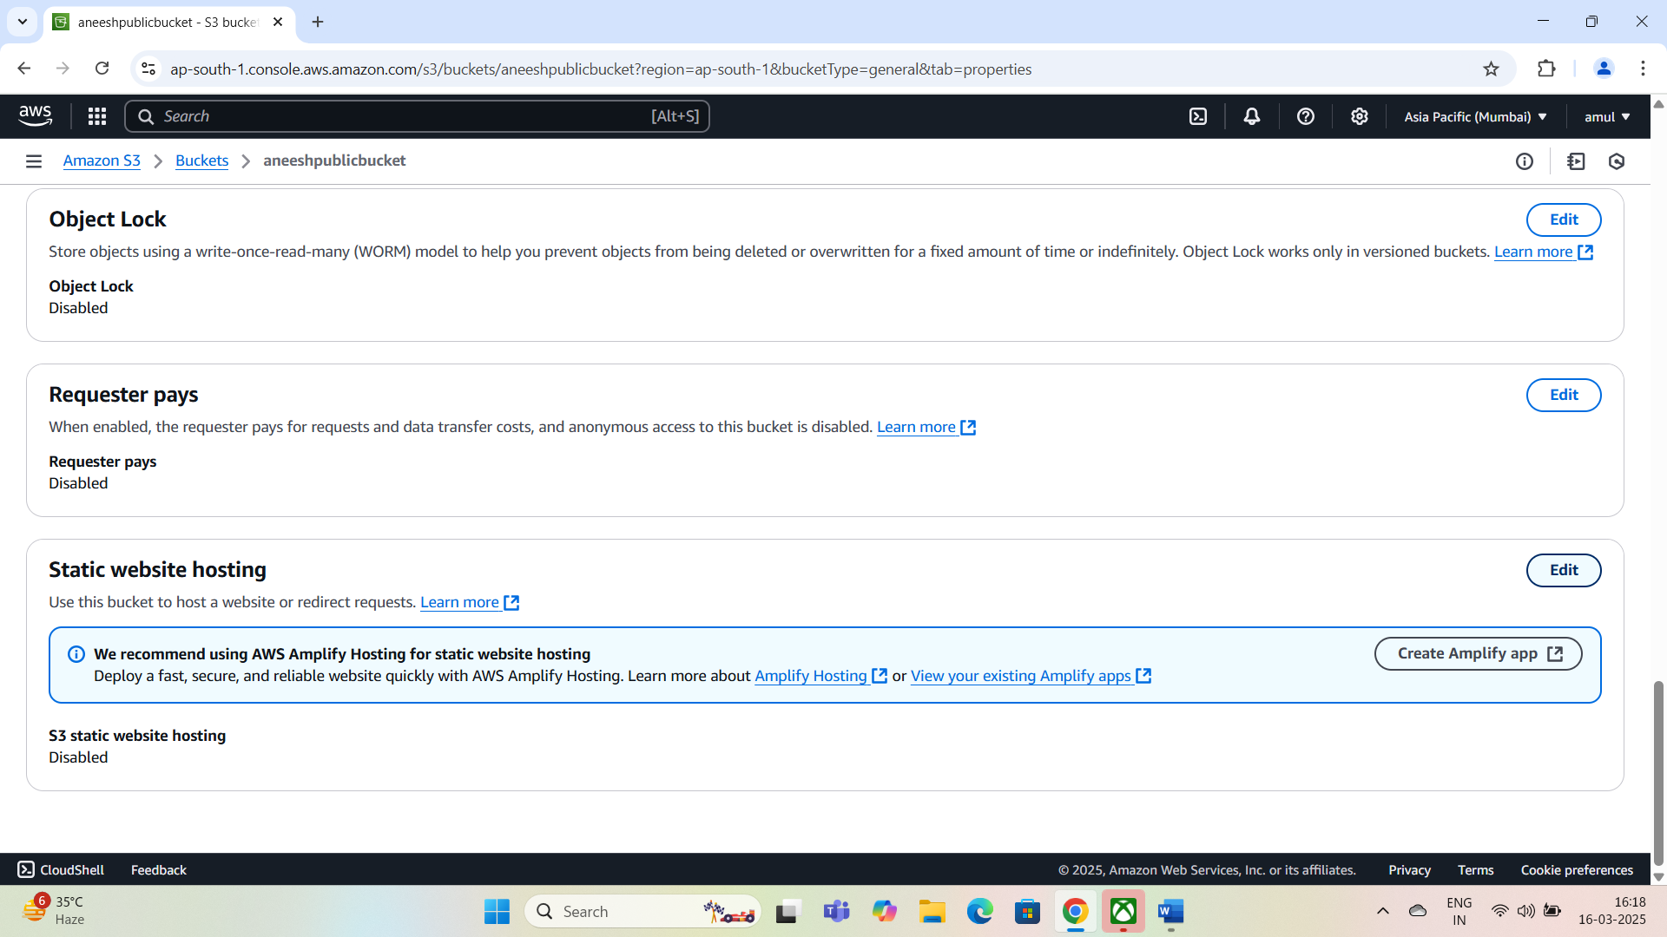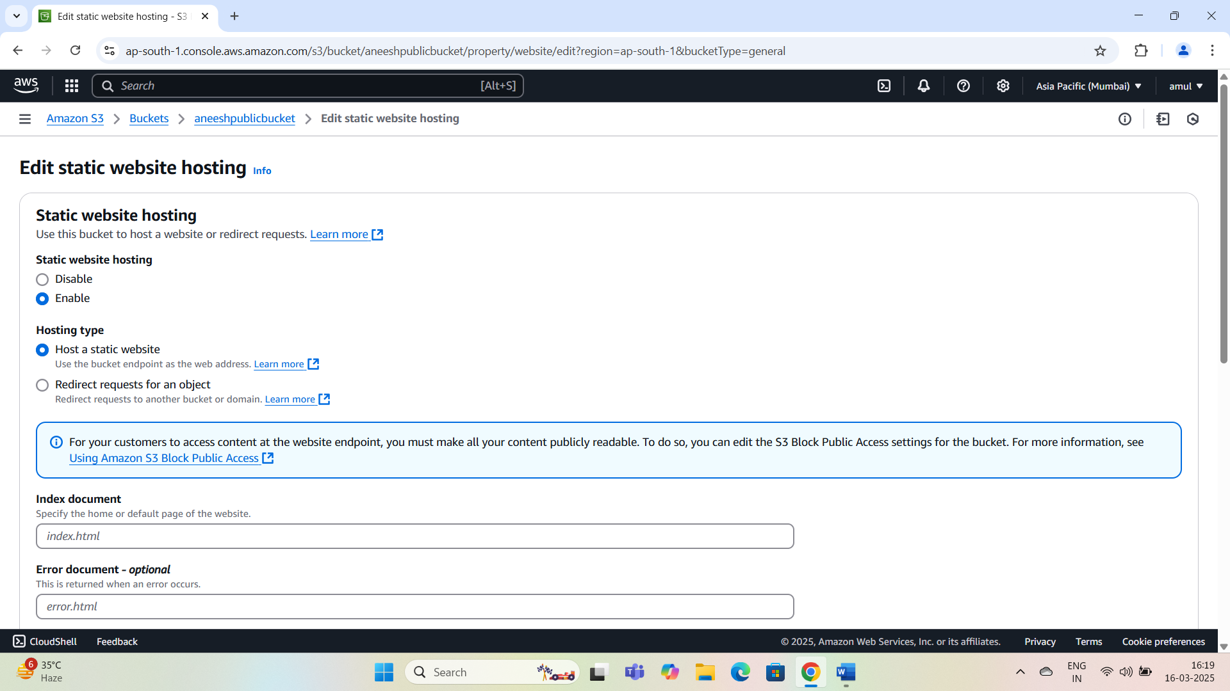

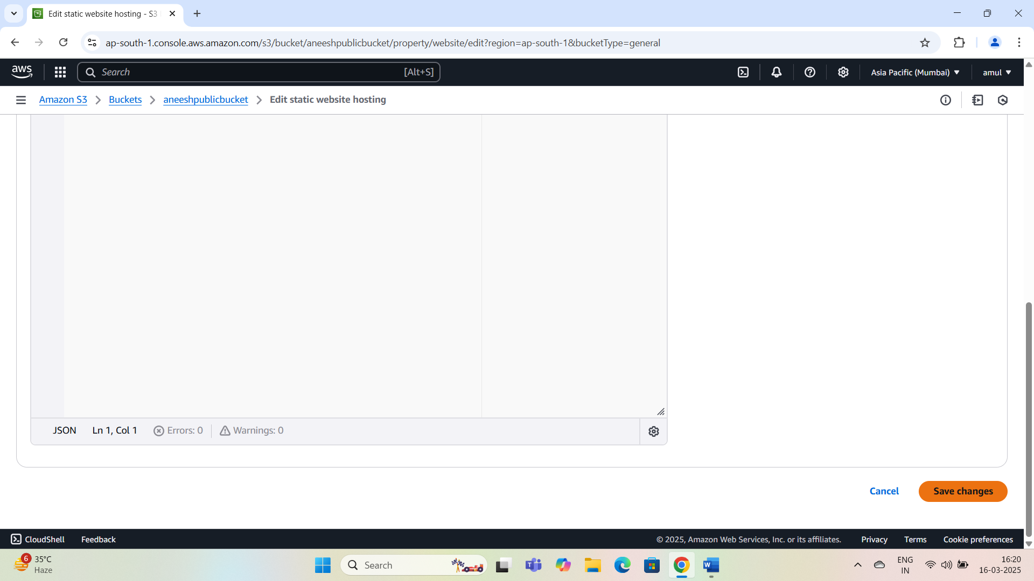

## Remark:The index.html will serve as the home page for the website.

## Step 4:Upload Website Files

## 1.Click Upload.

## 2.Click Add folders and select the folder containing the website files(index.html).

## 3.Click Upload to complete the process.

## Step 5:Make Files Public Using ACL

## 1.Select all uploaded files.

## 2.Click Actions->Make public using ACL.

## 3.In the Make Public page,click Make Public.

## Remark:This step ensures that files can be accessed by anyone.

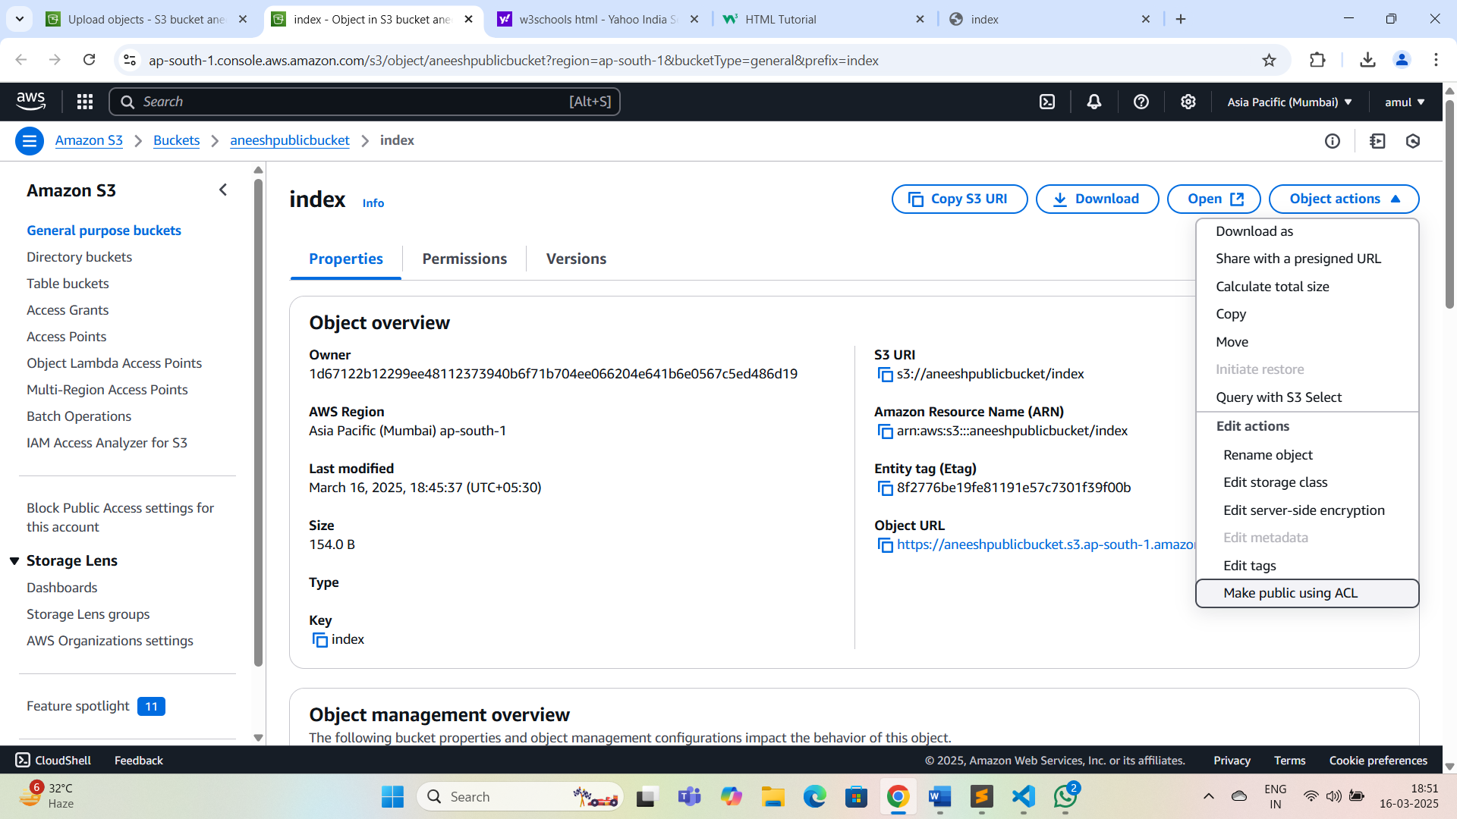

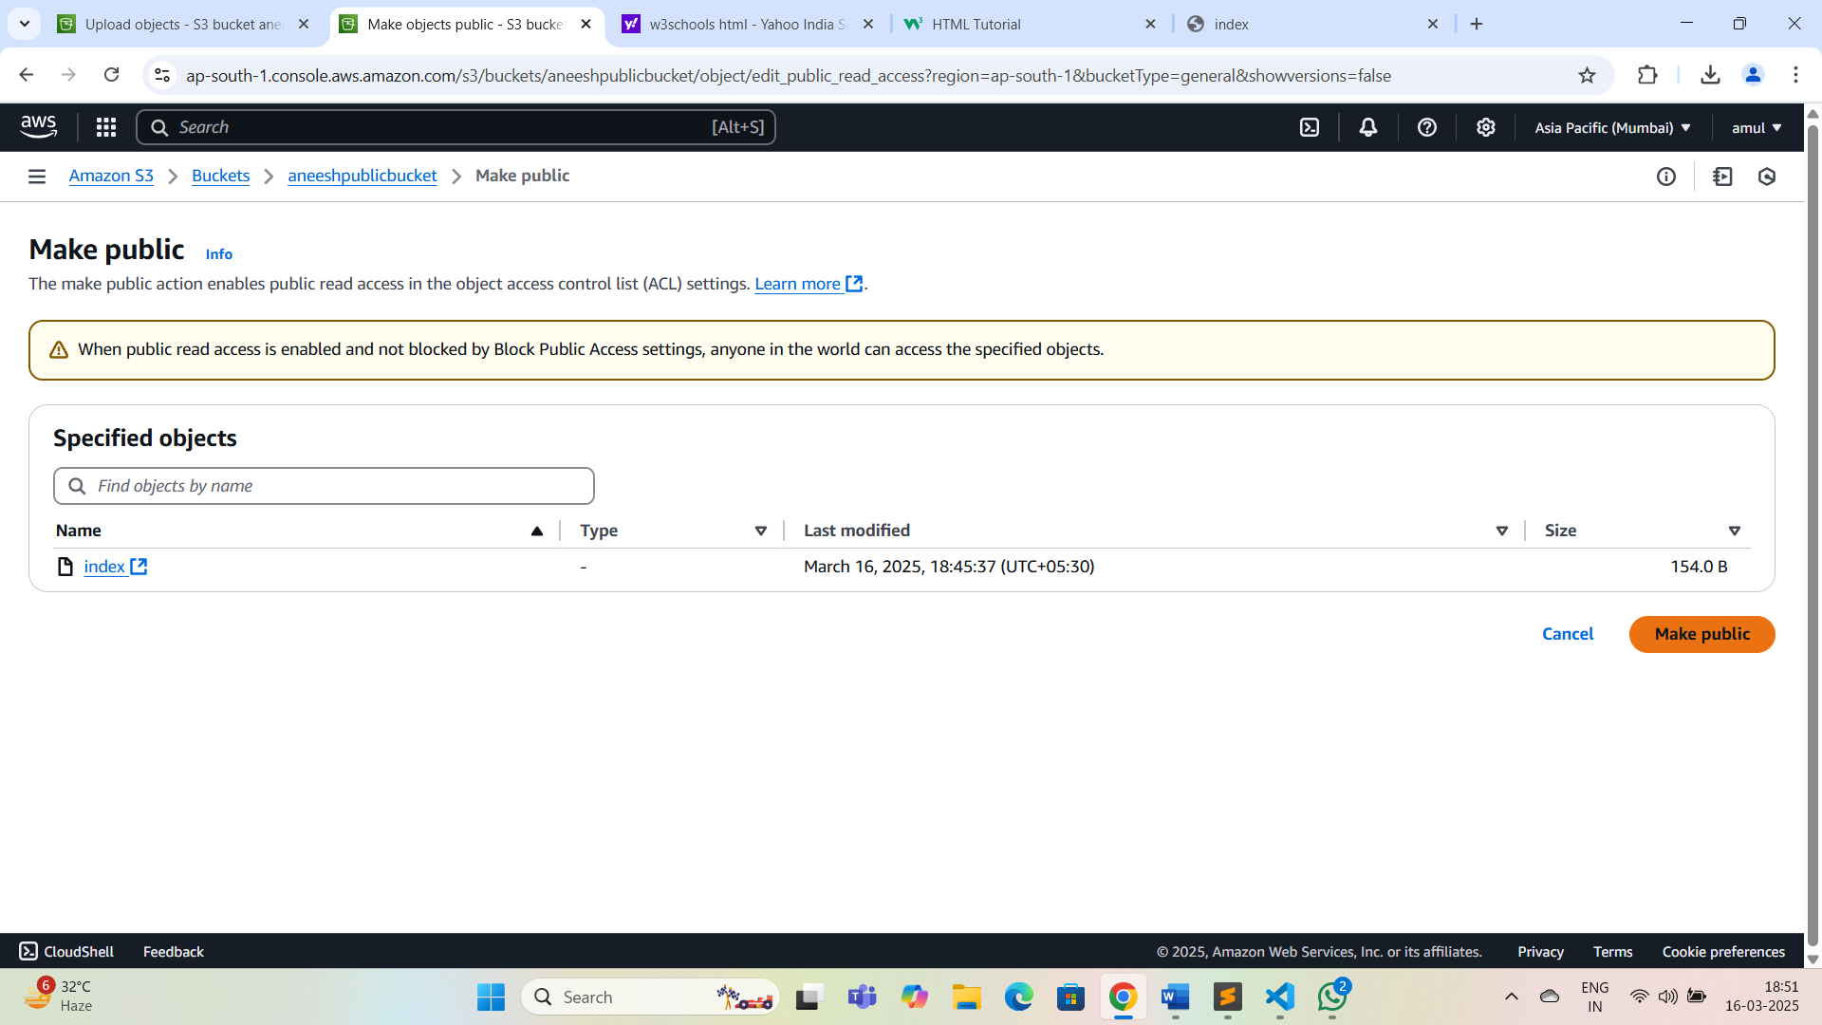

## Step 6:Access the Website

## 1.Click on index.html.

## 2.Navigate to properties tab.

## 3.Under object overview,copy the Object URL.

## 4.Paste the URL in a web browser.

## 5.The static website would be visible.

