# CLOUD COMPUTING LAB

# Assignment-9

# 🔧 Deploy a Project from GitHub to EC2

📝 **Objective**

Deploy a Node.js project from a GitHub repository to an Ubuntu EC2 instance using Bitvise SSH.



# ✅ Step 1: Launch an EC2 Instance

1. **Open EC2 Console**

* Go to <https://console.aws.amazon.com/ec2/>
* Click **Instances (Running)** > **Launch Instance**

1. **Configure Instance**

* **Name**: e.g., RobertEC2WebServer
* **Application and OS Image**:
  + Choose **Ubuntu** under **Quick Start** (Free Tier Eligible)
* **Instance Type**: t2.micro (default, Free Tier)
* **Key Pair (Login)**:
  + Click **Create new key pair**
  + Name it e.g., robert1234
  + Type: RSA, File format: .pem
  + Save the .pem file securely (you’ll need it to connect)
* **Network Settings**:
  + Under **Firewall (Security Groups)**, check:
    - ✅ Allow SSH
    - ✅ Allow HTTP
    - ✅ Allow HTTPS

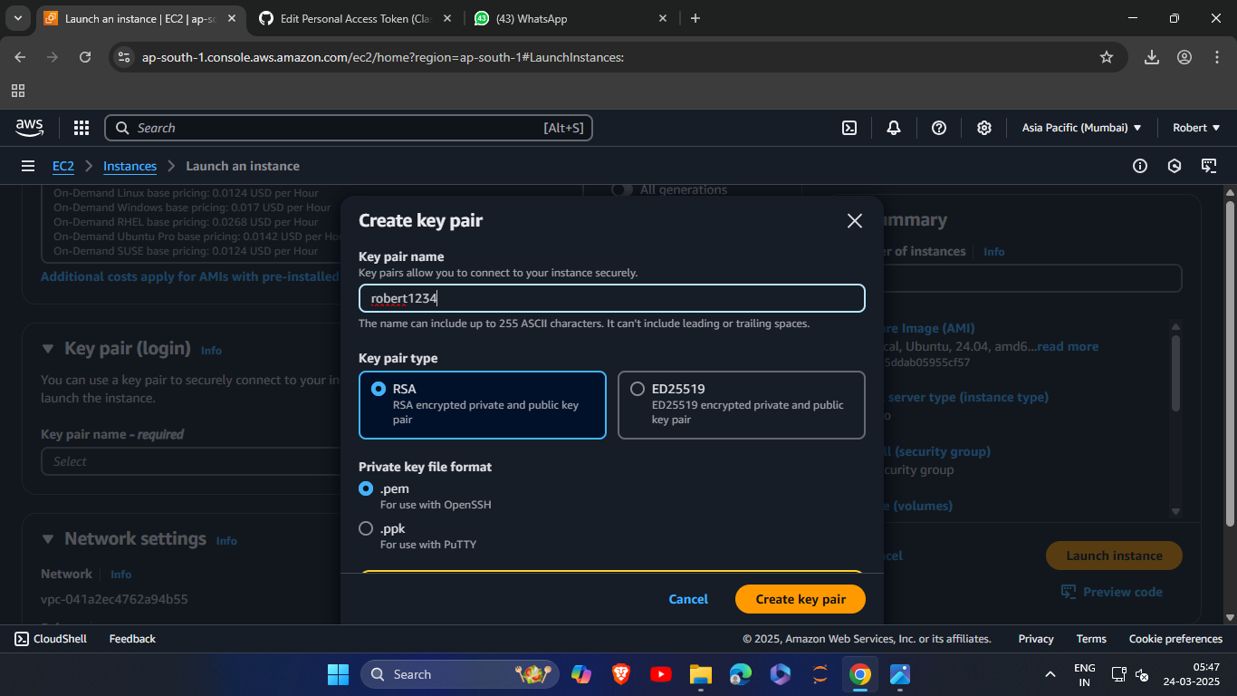

1. **Launch the Instance**

* Click **Launch Instance**
* Click **View all instances** to go back to dashboard.

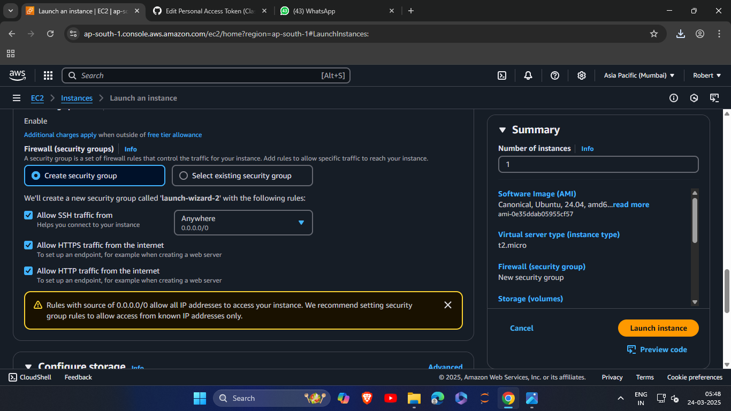

# 🔌 Step 2: Connect to EC2 via Bitvise SSH Client

1. **Get Public IPv4**

* Click your instance’s **Instance ID**
* Copy the **Public IPv4 Address**

1. **Open Bitvise SSH Client**

* Download: <https://www.bitvise.com/ssh-client-download>
* Open Bitvise and do the following:
  + **Server - Host**: Paste EC2’s Public IPv4
  + **Username**: ubuntu
  + Click **Client Key Manager**
* Click **Import** and load your .pem file
* It will appear as **Global 1**
  + Set:
  + **Initial Method**: publickey
  + **Client Key**: Global 1
  + Click **Log in** → Accept & Save

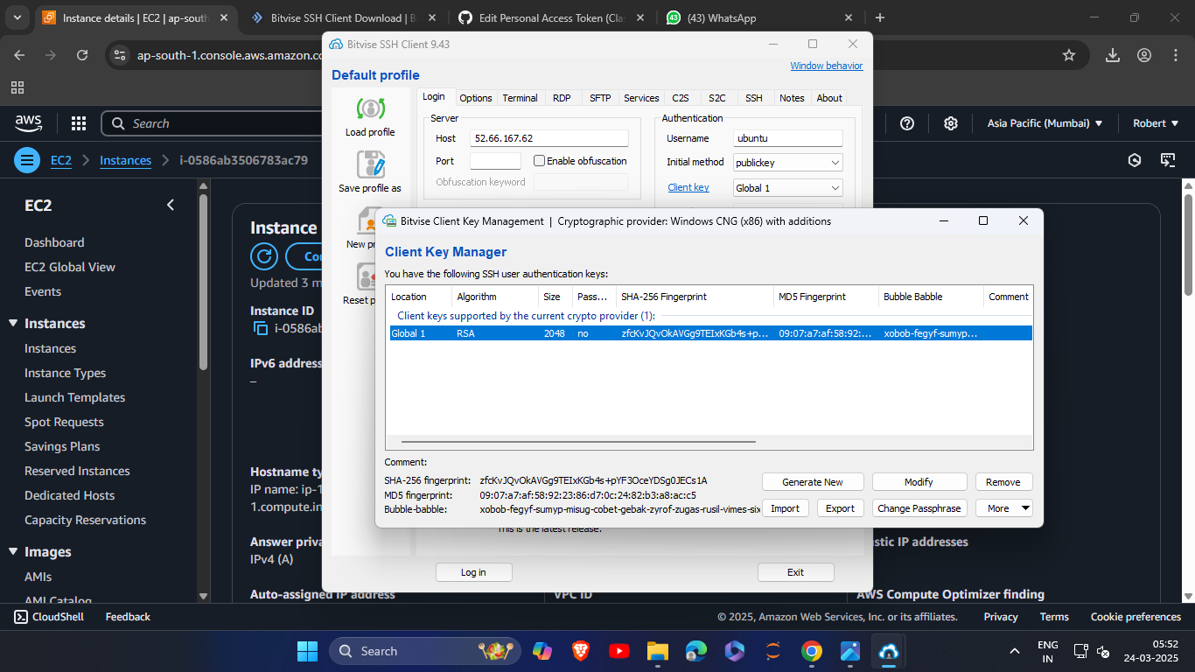

# 🖥️ Step 3: Set Up Server Environment in Terminal

Once inside Bitvise terminal:

1. **Update Packages**

*sudo apt-get update && sudo apt-get upgrade*

Type y when prompted.

1. **Install NGINX**

*sudo apt-get install nginx*

Type y when prompted.

1. **Install Node.js**

*curl -sL https://deb.nodesource.com/setup_16.x | sudo -E bash - sudo apt install nodejs*

1. **Clone GitHub Repo**

*git clone https://github.com/Robert0-7/college.git*

o When prompted:

* + **Username**: GitHub email
  + **Password**: GitHub token (not your password)

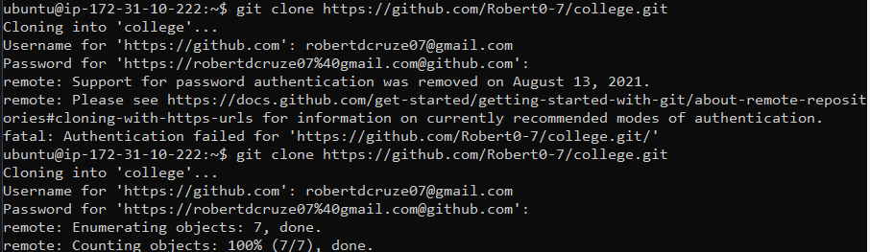

5.**Go to Project Directory**

*cd college*

6. **Install Project Dependencies**

*npm install*



# 🌐 Step 4: Allow App Port (e.g., 4000) in Security Group

1. Go to **EC2 Dashboard**
2. Click your **Instance ID**
3. Go to **Security > Security Groups**
4. Click **Edit Inbound Rules** o Click **Add Rule**
   * **Type**: Custom TCP
   * **Port Range**: 4000
   * **Source**: Anywhere (0.0.0.0/0)
5. Click **Save Rules**

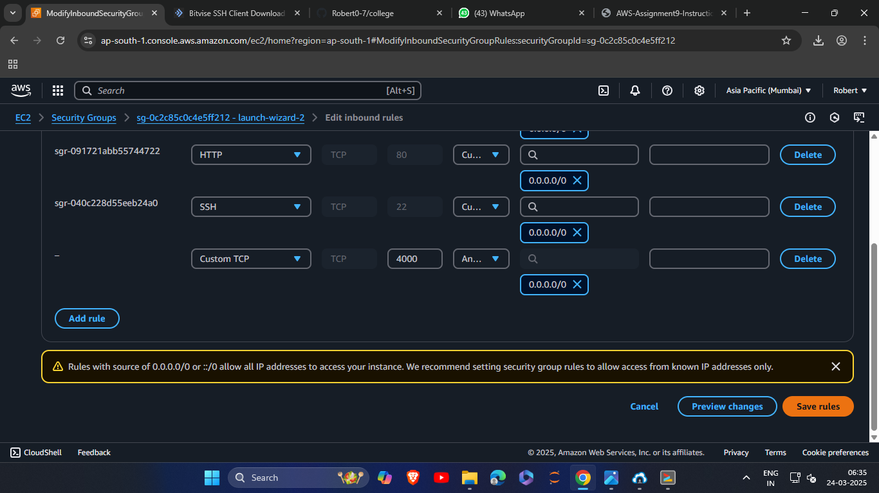

# 🚀 Step 5: Run the Node.js App

In Bitvise terminal:

*node index.js*

• If no error appears, the server has started. • Open your browser and enter:

http://<your-ec2-public-ip>:4000

E.g., http://3.91.123.45:4000

You should now see the deployed application running from the GitHub repo.

# 📌 Summary of Commands

*sudo apt-get update && sudo apt-get upgrade*

*sudo apt-get install nginx*

*curl -sL https://deb.nodesource.com/setup_16.x | sudo -E bash - sudo apt install nodejs*

*git clone https://github.com/itsmesneha/MYNEWREPO.git cd MYNEWREPO npm install*

*node index.js*