Automated Ticket Categorization Using
BERT and Azure ML

Priyank Raj
8th sem, CSE(AI&ML)
RNSIT, Affiliated to VTU
Bangalore, India
priyankraj0307@gmail.com
Raj Aryan
8th Sem, CSE(AI&ML)
RNSIT, Affiliated to VTU
Bangalore, India
1rn21ai095.rajaryan@gmail.com
Dr. Andhe Pallavi
Prof. & HoD, CSE(AI&ML)
RNSIT, Affiliated to VTU
Bangalore, India
pallavi_ap@yahoo.com

Abstract— In this paper the project titled ‘Automated Ticket Categorization Using BERT and Azure ML’, focuses on automating the categorization of queries received by the Service Desk using advanced machine learning techniques. Traditionally, routing queries to appropriate departments involves significant manual effort, causing delays and potential misclassifications. To address this, we propose the creation and deployment of an automatic Service Desk Ticket Issue Categorizer Model utilizing BERT-based classification methods, significantly improving over existing logistic regression techniques.
The primary objectives of this project are: (1) to create an automatic Service Desk Ticket Issue Categorizer Model, and (2) to deploy this model as a web service. Through a rigorous literature survey, it has been observed that traditional models, although effective, often faced challenges like model degradation over time and the need for frequent retraining. By leveraging the power of BERT and Azure ML, the model aims to ensure continuous learning, quick adaptation to new data, and reduction of ticket misclassification rates.
Keywords— BERT, DistilBERT, TinyBERT, Ticket Categorization, Azure Machine Learning, Service Desk Automation, Text Classification, Cloud Deployment, Sentiment Analysis, Retrieval-Augmented Generation, FAISS, BLEU score.
Introduction
Customer support is a critical aspect of business success. Companies are using artificial intelligence (AI) to improve their customer service capabilities and provide a seamless experience for their customers. The current AI-powered chatbots and virtual assistants can handle a wide range of customer queries, reducing the workload on human agents, and improving response times. The most critical aspect of developing an automated customer support model is the identification and routing of the customer queries to the concerned department. Better accuracies in this part of the model development leads to an overall customer satisfaction, even though a bot is answering their queries. The development of models in this aspect has seen the publication of many papers. A brief survey of the current literature available is presented below.

Literature review
The authors of Paper [I] present the need for automation of receiving queries at the service desk and then routing these queries to appropriate department. This automation process helps in performing automation of ticket issuing and routing that queries to concern department by decreasing the waiting time and also decreasing the miss classification of ticket issuing. Automation of the queries using machine learning algorithms. In this paper, emphasis is made to identify the best algorithm, which can be used for classification of queries. The various algorithms used are Multi-class Neural Network, Decision Tree, Multi-Class Logistic Regression Techniques, etc.
In Paper [2], Samlink develops robotic process algorithms for its banking customers to perform mechanical tasks and improve business efficiency. Unfortunately, these robots often encounter errors, and bank clerks have to manually complete the tasks they leave behind. The errors are reported by the bank clerks to Samlink technical support team as technical support tickets which are then investigated by the development team. Logs written by the robotic process algorithms are essential for fixing the issues. Due to the number and extent of the logs, debugging is very laborious. This paper explores the possibility of utilizing a cloud-based machine learning environment to find a connection between the support tickets and log events. This will be used to develop a log monitoring machine learning system, capable of alerting developers of a potential incoming ticket even before bank clerks themselves detect the error.
Automation of support ticket classification is crucial to improve customer support performance and shortening resolution time for customer inquiries. Paper [3] shows that AutoML can be used to train ML models with good classification performance. It also shows that developing AI solutions without a dedicated professional by utilizing AutoML, makes this technology more accessible for companies without specialized AI departments and staff.
An essential aspect of prioritizing incident tickets for resolution is efficiently labeling tickets with fine-grained categories. Paper [4] discusses the following issues. Ticket data is often complex and poses several unique challenges for modern machine learning methods: (i) tickets are created and updated either by machines with pre-defined algorithms or by engineers with domain expertise that share different protocols, (ii) tickets receive frequent revisions that update ticket status by modifying all or parts of ticket descriptions, and (iii) ticket labeling is time-sensitive and requires knowledge updates and new labels per the rapid software and hardware improvement lifecycle.
TicketBERT trains a simple yet robust language model for labeling tickets using our proposed ticket datasets. Experiments demonstrate the superiority of Ticket-BERT over baselines and state-of-the-art text classifiers on Azure Cognitive Services. The authors further encapsulate Ticket-BERT with an active learning cycle and deploy it on the Microsoft IcM system, which enables the model to quickly finetune on newly collected tickets with a few annotations.
Paper [5] showcases how to build a continuous learning system for document classification. A project done at CGI NEAAS, aimed to create an automated classification cloud endpoint for predicting service ticket categories. The data used for predicting mostly consisted of human-typed text. A detailed solution architecture on the Azure cloud platform is proposed. The resulting system uses a combination of CI/CD pipelines called Azure Pipelines and a machine learning-specific pipeline called ML pipeline. The solution puts MLOps principles and practices into action, focusing on adding continuous training or CT functionality to set of pipelines, alongside CI and CD. This allows for new machine learning models to be automatically trained and deployed when ticket data changes and the model performance degrades.
Papers [6], [7] showcase the features and issues in developing models to support Scalability and also the Deployment Using Azure ML for automated Customer Support implementation. Azure ML's Support for Large Language Models (LLMs) have included the following.
Large language models (LLMs) like GPT-4 and BERT require substantial computational resources, especially in customer support contexts where fast, reliable responses are essential. Azure ML supports LLMs through distributed training on GPUs and TPUs, which accelerates training times and allows models to process high volumes of tickets in real-time.
• Microsoft’s Azure AI Documentation highlights the use of Azure ML’s parallel processing and distributed training to handle large datasets and complex models, reducing bottlenecks in model development and scaling. Case studies indicate that distributed training on Azure ML can decrease model training time by up to 40%, a significant advantage for organizations that need to deploy updates frequently.
Similar to paper [3], the authors of papers [8-14] present the current state of the various AI Architectures in Customer Support Automation.
The deployment part of the model requires the development of User Interfaces [UI]. Papers [15], [16] present the currently available UIs used for raising tickets.
The complete AI based automated customer support models are discussed in papers [17-19].
Based on the inputs from the literature review, the following models were identified and methodology developed.

PROBLEM STATEMENT
The primary goal of this project is to develop an AI-powered ticket classification system that leverages Large Language Models (LLMs) such as BERT and its variants and deploy using using Azure Machine Learning. This system should automatically categorize support tickets based on their content and urgency. It should be able to prioritize tickets to ensure that critical issues receive immediate attention.
By automating these tasks, the project aims to streamline customer support processes by reducing the response times and hence improving the overall customer satisfaction.

METHODOLOGY
The methodology for this project involves several key steps to develop and deploy the automated ticket classifier:

Azure ML Workspace Setup
• Configure an Azure Machine Learning workspace to provide the necessary infrastructure for model training, deployment, and scaling.
• Set up data storage, compute resources, and environment configurations to support seamless model development and deployment.

Data Collection and Preprocessing
• Data Collection: Gather a representative dataset of customer support tickets, including metadata such as ticket urgency, category, customer sentiment, and historical responses.
• Data Cleaning: Handle missing values, standardize ticket text, and remove irrelevant or noisy data to ensure data quality and consistency.
• Data Annotation: If necessary, annotate the data with labels for sentiment, urgency, or category to assist in supervised training and improve model accuracy.

Exploratory Data Analysis (EDA)
• Perform an in-depth analysis of the dataset to identify key patterns, ticket categories, and customer sentiments.
• Visualize trends, distributions of categories, and common ticket topics to identify potential biases, imbalances, or patterns that may impact model performance.

LLM Integration for Embeddings and Initial Response Generation
• Integrate a pre-trained Large Language Model (LLM) such as GPT-4 or a similar model to convert ticket text into vector embeddings, capturing semantic meaning and context.
• Use these embeddings to generate initial responses and provide insights into each ticket’s content and required actions.

Sentiment Analysis and Ticket Categorization
• Implement sentiment analysis to assess the customer sentiment of each ticket (e.g., positive, neutral, or negative), which will help prioritize urgent or high-sentiment tickets.
• Develop a classification model to categorize tickets by type (e.g., technical issue, billing inquiry) for streamlined handling by support agents.

Response Generation and Sampling
• Use the LLM to generate responses for each ticket based on its category and priority level.
• Implement response sampling to generate multiple response candidates, allowing customer support staff to choose the most appropriate response for each situation.

User Interface Development (Streamlit UI)
• Develop a user-friendly interface using Streamlit, where support agents can view categorized and prioritized tickets, select responses, and provide feedback on the model's performance.
• The UI will display ticket details, recommended responses, and priority levels, facilitating efficient ticket handling by customer support agents.

Deployment and Scalability on Azure ML
• Deploy the finalized model to Azure ML, optimizing it for real-time processing and ensuring it can handle varying volumes of support tickets.
• Implement monitoring and logging systems to track model performance, ensuring scalability and addressing any issues related to response accuracy and operational efficiency.
This methodology outlines a comprehensive approach to developing an intelligent, responsive, and scalable customer support solution. By leveraging the capabilities of Azure ML and GenAI, the system will automate ticket categorization, prioritization, and response generation, improving operational efficiency, reducing costs, and enhancing customer satisfaction. The continuous feedback loop ensures that the system remains adaptive and effective, while the deployment on Azure ML provides the necessary infrastructure for handling large-scale operations in a reliable manner.

IMPLEMENTATION
This project utilized the customer support dataset ‘Customer_Support_Training_Dataset.csv’. The dataset includes customer queries organized by issue type, priority level, and sentiment. It also contains sample responses, resolution times, and customer feedback scores, which will help train the AI model in the tasks of categorization, prioritization, and response generation for support tickets.

The labeled data in the dataset will be crucial for training and evaluating the model’s ability to accurately categorize tickets and generate appropriate responses. Initially, publicly available datasets, such as those from Kaggle, was used to develop a proof-of-concept system. For real-world deployment, the model can be fine-tuned with company-specific data to enhance the relevance and performance of the solution.

The AI architectures used include the following: BERT (Bidirectional Encoder Representations from Transformers) for detecting customer sentiment, enabling prioritization of negative or urgent cases. Later as the BERT version required GPUs and was slow in training phase, the light weight versions of DistilBERT and TinyBERT were implemented. GPT-4 (Generative Pre-trained Transformer 4) was used for generating accurate, contextually appropriate responses to customer queries.

The regular metrics such as Accuracy, Precision, and Recall performance metrics were used in training and testing the model for ticket classification and sentiment analysis.

The AI generated response was evaluated using the BLEU Score. A good BLEU score depends on the context. For general machine translation tasks:
40-60: High-quality translations (close to human-level)
30-40: Good translations but might have some errors
20-30: Understandable but has noticeable errors
Below 20: Poor translation quality
For low-resource languages: A BLEU score of 10-20 can still be considered reasonable because training data is limited. Scores above 25 in low-resource settings are often impressive. BLEU is more useful for comparing models rather than as an absolute measure. A small increase (e.g., 1-2 BLEU points) can be significant.

RESULTS & DISCUSSIONS

Automated Ticket Categorization Performance
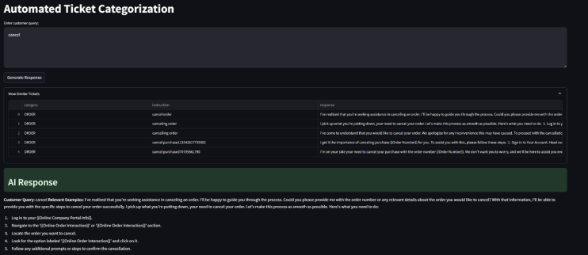Fig.1. Automated Ticket Categorization Example

Fig. 1 showcases the ability to classify customer queries related to order cancellations. The system identifies relevant examples and maps them to predefined categories such as “cancel order” or “canceling center,” ensuring accurate routing.

Response Quality Evaluation
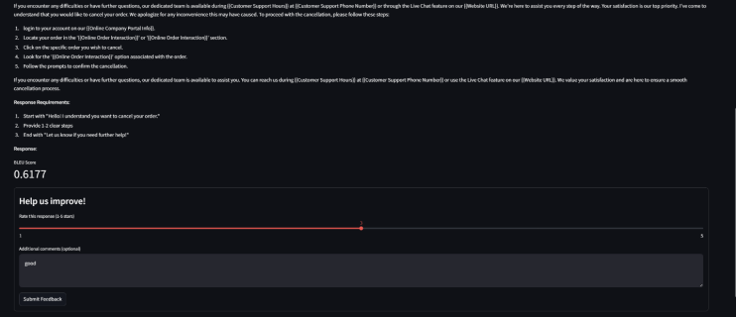
Fig.2. Customer Support Response Workflow

The model-generated responses were evaluated using the BLEU score, as shown in Fig.2. The structured workflow ensures compliance with response requirements, such as clarity and step-by-step guidance, achieving a BLEU score of 0.6177.

Query Distribution Analysis
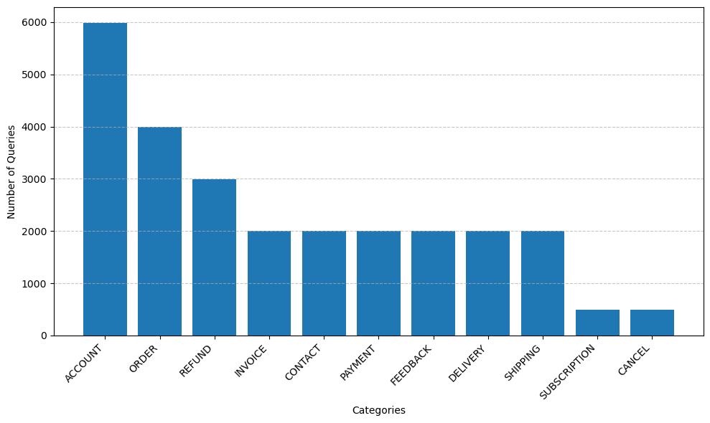Fig.3. Distribution of Support Ticket Categories

The most common categories and their frequencies in the datasets are as follows. ACCOUNT-related queries are the most frequent, totaling 5,986 entries. ORDER-related issues follow with 3,988 queries, while REFUND requests account for 2,992 entries. Several other categories, including INVOICE, CONTACT, PAYMENT, FEEDBACK, DELIVERY, and SHIPPING, each contain 2,000 queries. SUBSCRIPTION & CANCEL requests are the least frequent categories in the dataset. This distribution highlights the areas where customer support interactions are most concentrated.

The above outcomes showcase an intelligent, efficient and customer-centric support system. By transforming the support function from a reactive to a proactive service, the system will help businesses scale and meet evolving customer demands while ensuring high levels of customer satisfaction and operational efficiency. By automating routine tasks, the system will enable support teams to focus more on complex problem-solving and strategic initiatives, optimizing the allocation of human resources for higher-value work.

REFERENCES
- Mr. Jyotheeswar, Dr. Manohar Kapse, Dr. Joseph DuraiSelvam, ‘Issue Categorization Machine Learning Model using Azure ML’, in IMI Disha, Issue 1, Vol. 8, Feb 2020, pp. 13-30. ISSN: 0974 – 293X
- Matti Haukilintu, ‘Machine learning approach to support ticket forecasting from software logs’, Automation and electrical engineering, Aalto University, Aug. 2022, pp. 63-69.
- Truss, Mario, and Stephan Boehm. "AI-based Classification of Customer Support Tickets: State of the Art and Implementation with AutoML." arXiv preprint arXiv:2406.01789 (2024).
- Zhexiong Liu, Cris Benge, Siduo Jiang, ‘Ticket-BERT: Labeling Incident Management Tickets with Language Models’ Microsoft Journal of Applied Research (MSJAR), Volume 18, January 2023. https://doi.org/10.48550/arXiv.2307.00108
- Leo Heinsuo, ‘SMART TICKETING: Continuous learning system for document classification’, Tietotekniikan DI-tutkinto-ohjelma - Degree Programme in Information Technology, MSc (Tech) Thesis, 2020-08-05, https://urn.fi/URN:NBN:fi:tuni-202005155363.
- Borra, Praveen. "Advancing Data Science and AI with Azure Machine Learning: A Comprehensive Review." International Journal of Research Publication and Reviews 5, no. 6 (2024): 1825-1831.
- Pandi, S. Senthil, P. Kumar, and TA Salman Latheef. "Cloud Platform Optimization Using Azure Machine Learning to Improve Performance and Reliability." In 2024 International Conference on Computational Intelligence for Green and Sustainable Technologies (ICCIGST), pp. 1-6. IEEE, 2024.
- Kalusivalingam, Aravind Kumar, Amit Sharma, Neha Patel, and Vikram Singh. "Enhancing Customer Service Automation with Natural Language Processing and Reinforcement Learning Algorithms." International Journal of AI and ML 1, no. 2 (2020).
- Shareef, Farooq. "Enhancing Conversational AI with LLMs for Customer Support Automation." In 2024 2nd International Conference on Self Sustainable Artificial Intelligence Systems (ICSSAS), pp. 239-244. IEEE, 2024
- Al-Mekhlal, Monerah, Mohammed Al-Buraik, and Mohammad Al-Lubli. "Digital transformation: AI-Powered bot solutions and automation for customer services." In 2023 International Conference on Digital Applications, Transformation & Economy (ICDATE), pp. 1-7. IEEE, 2023.
- Zangari, Alessandro, Matteo Marcuzzo, Michele Schiavinato, Andrea Gasparetto, and Andrea Albarelli. "Ticket automation: An insight into current research with applications to multi-level classification scenarios." Expert Systems with Applications 225 (2023): 119984.
- Bonechi, Simone, Giulia Palma, Mario Caronna, Massimiliano Ugolini, Alessandra Massaro, and Antonio Rizzo. "Enhancing Customer Support in Banking: Leveraging AI for Efficient Ticket Classification." Procedia Computer Science 246 (2024): 128-137.
- Oliveira, Domingos F., Afonso S. Nogueira, and Miguel A. Brito. "Performance Comparison of Machine Learning Algorithms in Classifying Information Technologies Incident Tickets." AI 3, no. 3 (2022): 601-622.
- Oliveira, Domingos F., Afonso S. Nogueira, and Miguel A. Brito. 2022. "Performance Comparison of Machine Learning Algorithms in Classifying Information Technologies Incident Tickets" AI 3, no. 3: 601-622. https://doi.org/10.3390/ai3030035
- Bhowmik, Aditya, Samrat Paul, D. Usha Nandini, and S. Prince Mary. "Study of the Management of Tickets in IT Administration." In IOP Conference Series: Materials Science and Engineering, vol. 590, no. 1, p. 012006. IOP Publishing, 2019.
https://iopscience.iop.org/article/10.1088/1757-899X/590/1/012006/ pdf
- Gupta, Monika, Pankaj Jalote, and Alexander Serebrenik. "Improving software maintenance ticket resolution using process mining." PhD diss., IIIT-Delhi, 2019.
https://repository.iiitd.edu.in/xmlui/bitstream/handle/123456789/945/monika_gupta_thesis.pdf?sequence=1&isAllowed=y
- Pilaniwala, Pankaj, Girish Chhabra, and Ameya Naik. "Enhancing the MLOPS Deployment Process using Gen AI." In CS & IT Conference Proceedings, vol. 14, no. 20. CS & IT Conference Proceedings, 2024.
- Patel, Dhavalkumar, Ganesh Raut, Satya Narayan Cheetirala, Girish N. Nadkarni, Robert Freeman, Benjamin S. Glicksberg, Eyal Klang, and Prem Timsina. "Cloud Platforms for Developing Generative AI Solutions: A Scoping Review of Tools and Services." arXiv preprint arXiv:2412.06044 (2024).
- Petrenko, Anatolii, and Oleh Boloban. "Generalized information with examples on the possibility of using a service-oriented approach and artificial intelligence technologies in the industry of e-Health." Technology audit and production reserves 4, no. 2/72 (2023): 10-17.

