MLB Pitcher Injury Risk Prediction
Syed Amaan Ahad, Viraj Sheth, Priyankkumar Chandrakant Patel, Mohammad Shahid Mahmood
1. Summary
Baseball pitcher’s injuries present themselves as a significant challenge in Major League Baseball (MLB), with increasing frequency and substantial financial and performance consequences for teams. Prior research has primarily focused on season-level injury prediction, which limits the ability to detect short term fatigue and intervene during the season. Our project aims to address this limitation by developing a game level analytical framework to identify patterns associated with increased injury risk among starting pitchers.
The dataset used in this study combines Statcast pitch tracking data and official MLB injury records spanning from 2015 to 2024, covering approximately 54,000 pitcher game observations across 356 pitchers. After preprocessing and cleaning the data, the final data set was around 50,000. Exploratory data analysis was conducted to examine injury distribution, workload trends, and fatigue related indicators such as days of rest and velocity changes.
The analysis reveals that workload related factors and pitching velocity are not the primary reasons for injuries rather prior injury history dominates as the strongest predictor, suggesting that pitcher arm health is cumulative rather than game-by-game. This project lays the foundation for future predictive modeling approaches that can enable real-time risk monitoring in professional baseball.
2. Methods
2.1 Data
The dataset used is constructed from two primary data sources. The first is Statcast (pybaseball), a python library which provides pitch mechanics data such as pitch velocity, spin rate, extension etc. The second is MLB Stats API, which provides official injury transaction records. These two primary data sets are joined together based on playerId and date. The resulting dataset (before data preparation) is of about 54,000 pitcher game performances. Each observation includes performance metrics such as pitch velocity, spin rate, pitch count, and game context variables, along with injury indicators specifying whether a pitcher experienced an arm related injury within a defined future window. The dataset is highly imbalanced, with injury cases accounting for approximately 3% of total observations.
2.2 Data Preprocessing
Several preprocessing steps were performed to ensure data quality and consistency. First, observations corresponding to games with fewer than 10 pitches were removed, as these typically represent incomplete appearances due to early injury or other anomalies that could distort performance metrics. Missing values in key variables such as spin rate and pitch extension were handled using pitcher specific median imputation to preserve within player consistency. Rest days of over 30 days were also removed as these indicate cross-season gaps.
Additionally, injury records were filtered to include only arm-related injuries, such as those affecting the shoulder, elbow, or forearm, as these are most relevant to pitching workload. These preprocessing steps were essential for creating a reliable and analyzable dataset. The final dataset after the preprocessing and cleaning was one with 49,792 rows (pitcher-games)
2.3 Feature Engineering
To capture fatigue-related signals, several derived features were engineered at the game level like rest days between consecutive starts, cumulative pitch counts over 7 and 14 day rolling windows, and deviations in velocity and spin rate from each pitcher's seasonal baseline.
Additional features were constructed to capture longitudinal injury risk. These included a binary flag for arm injury in the prior season, a count of injuries across the previous two seasons, and a late-season indicator for starts beyond game 25. Interaction terms were also derived such as workload divided by rest days (high load with insufficient recovery) and age multiplied by workload (older pitchers tolerating high loads less effectively). Notably, these history-based features proved to be the strongest predictors in the final model, outweighing the original Statcast biomechanics features by a significant margin.
2.4 Exploratory Data Analysis
Exploratory data analysis was conducted to understand the distribution of injuries and identify relationships between workload indicators and injury outcomes. Key analysis included examining class imbalance, visualizing injury frequency across seasons, and analyzing workload variables such as pitch count and days of rest in relation to injury occurrence.
Additional visualizations were used to explore trends in pitch velocity and other performance metrics, with comparisons between injured and non-injured observations. These analyses provided insights into potential predictors of injury risk and informed the selection of relevant features for future modeling.
2.4.1 Injury Distribution
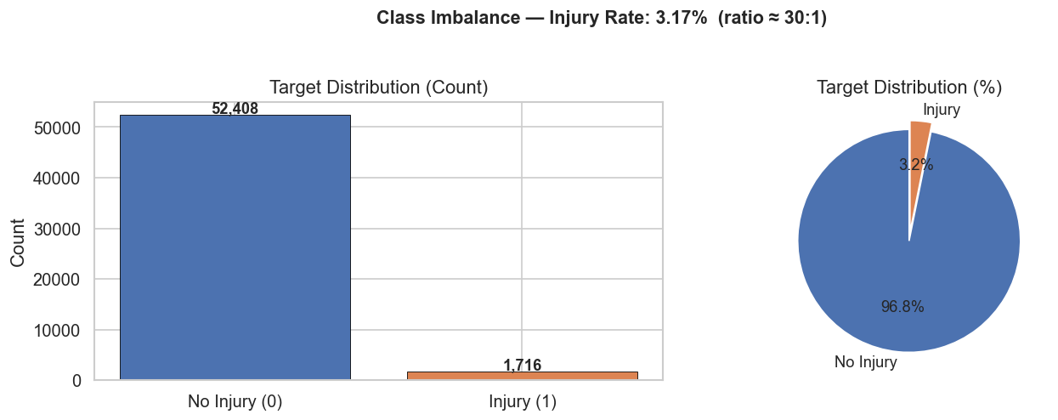
Figure 1: Distribution of injury vs non-injury observations.
The dataset exhibits a significant class imbalance, with injury cases accounting for approximately 3% of all observations (Figure 1). This confirms that injury events are rare, making accuracy an unreliable metric for model evaluation. Instead, precision, recall, and F1 score are more appropriate for assessing predictive performance.
2.4.2 Workload vs Injury
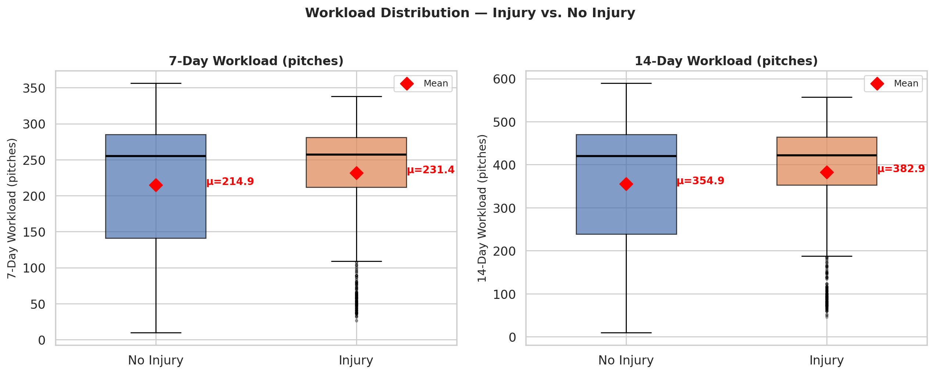
Figure 2: Recent workload comparison between injured and non-injured observations.
Analysis of workload-related variables indicates that pitchers with higher recent pitch counts, and shorter rest periods tend to have a higher likelihood of injury (Figure 2). Specifically, injured pitchers show lower median days of rest and higher workload accumulation over the past 7 and 14 days, supporting the hypothesis that fatigue plays a key role in injury risk.
2.4.3 Velocity Trends
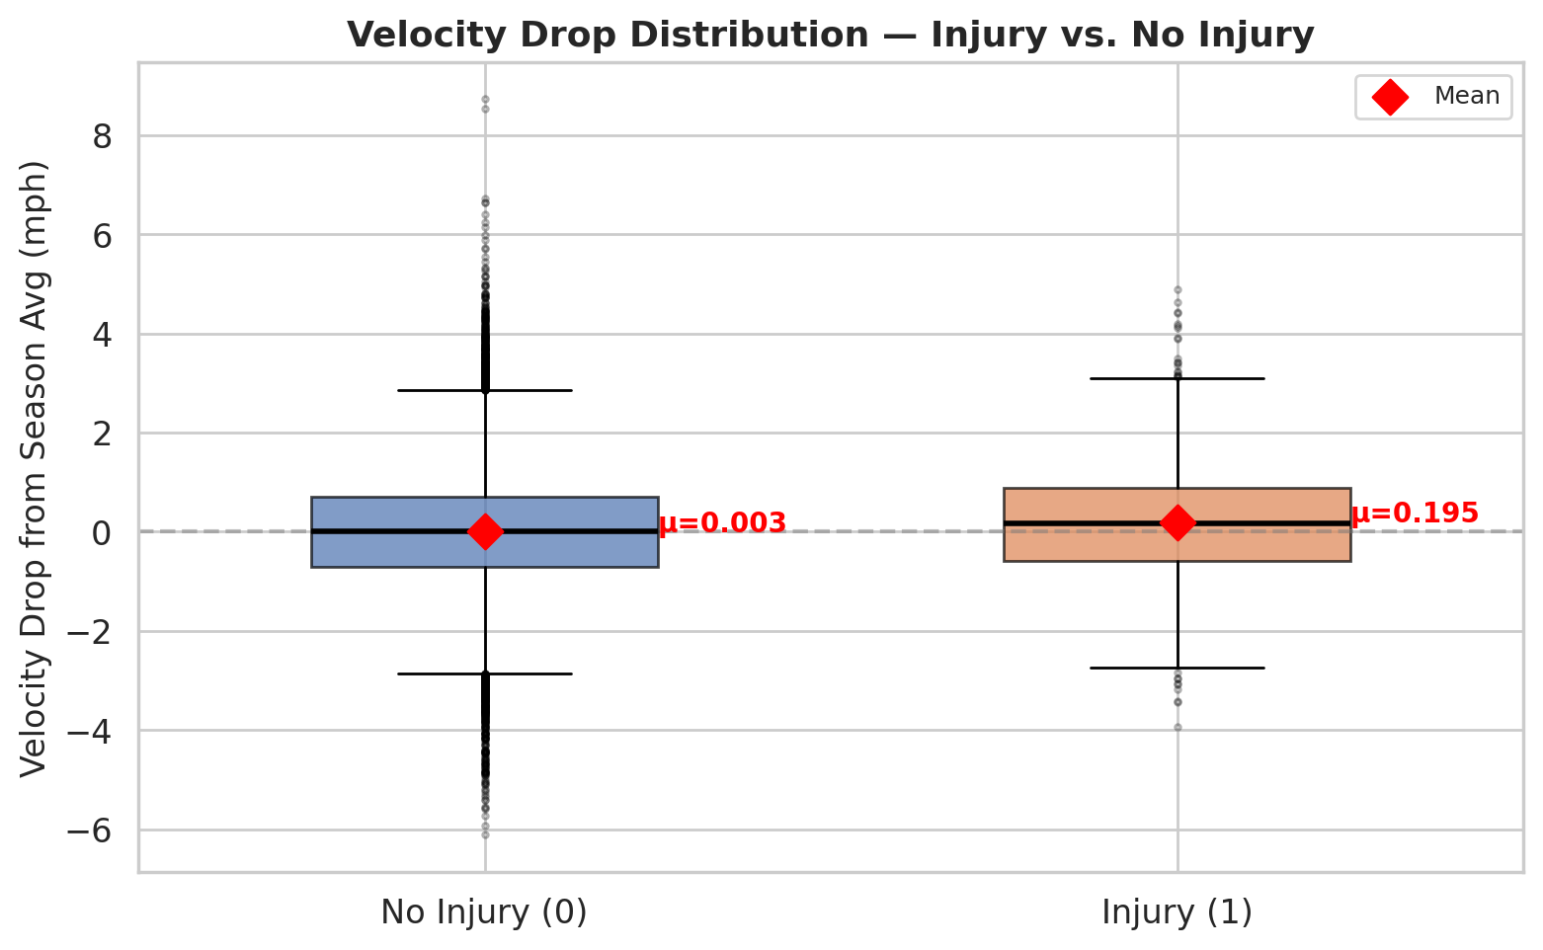
Figure 3: Velocity Drop from season average for injury vs non-injury cases.
Velocity-based features also show meaningful patterns (Figure 3). Injured pitchers tend to exhibit greater deviations from their season-average velocity, suggesting that sudden drops or inconsistencies in velocity may act as early warning signals of physical strain or underlying injury.
2.5 Modeling
Each row represents a single pitcher start, with the target variable indicating whether an arm injury occurs within the next 21 days. A temporal split was applied with training performed on seasons 2015 to 2021 and testing on seasons 2022 to 2024, ensuring that no future injury trends could leak into the training process. Before evaluating on the holdout set, 5-fold TimeSeriesSplit cross-validation was applied to the training data so that each fold only trained on past observations and tested on future ones, giving reliable performance estimates without touching unseen data.
Since only 3.2% of starts resulted in injury, class weights were applied across all models to handle the imbalance. Logistic Regression and Random Forest used balanced class weighting, while XGBoost used a scale_pos_weight of 31.4, which is the ratio of healthy starts to injury starts in the training set (35,499 divided by 1,130). This means the model was penalised 31 times more heavily for missing a real injury than for raising a false alarm. The decision threshold was also lowered from the default 0.5 down to 0.3, because at a 3.2% base rate even genuinely high risk pitchers rarely produce a predicted probability above 0.5, and keeping the default would cause most real injuries to be missed.
Three models were trained in total. Logistic Regression served as a linear interpretable baseline to establish a performance floor. Random Forest was included to capture non-linear interactions between features through ensemble bagging across multiple decision trees. XGBoost was selected for its sequential boosting approach where each tree corrects the errors of the previous one, making it well suited for identifying rare positive cases in imbalanced datasets. ROC-AUC was reported for completeness but PR-AUC and MCC were treated as the primary metrics, as ROC-AUC becomes overly optimistic when true negatives dominate the dataset, whereas PR-AUC and MCC focus on how well the model performs specifically on the minority injury class.
3. Results
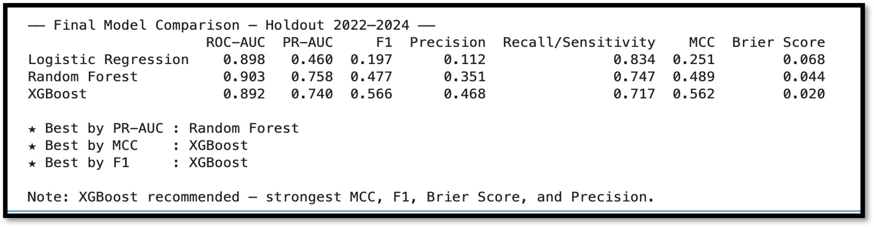
Figure 4: Model Metric.
Looking at this result tile (figure 4), all three models look similar on ROC-AUC at around 0.90 but as discussed, that metric is misleading here. Metrics PR-AUC and MCC, are able to better reflect performance in such highly imbalanced data. PR-AUC values are pretty similar for Random Forest and XGBoost. Using other metrics such as F1, MCC and brier score we observe strongest results from XGBoost making it the best model. It catches 72% of real injuries while generating 41% fewer false alarms than Random Forest, making it more operationally viable for decisions.
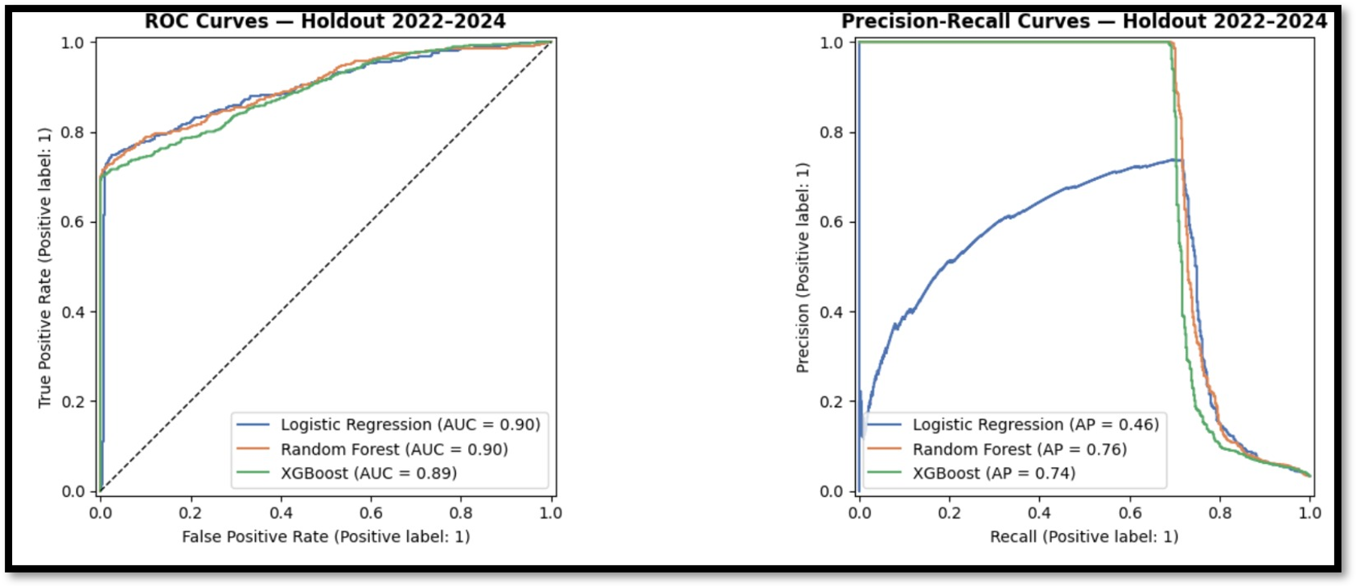
Figure 5: ROC Curve.
To evaluate model discrimination, two curves were plotted across all decision thresholds on the 2022–2024 holdout set. The ROC curve makes them appear equally capable. The Precision-Recall curve, which plots precision against recall across thresholds, revealed the real differences. Random Forest and XGBoost maintained high precision all the way to approximately 65% recall before a sharp drop, whereas Logistic Regression degraded much earlier. PR-AUC was therefore selected as the primary evaluation metric, as it focuses exclusively on the minority injury class and is not distorted by the abundance of true negatives
3.1 Model performance
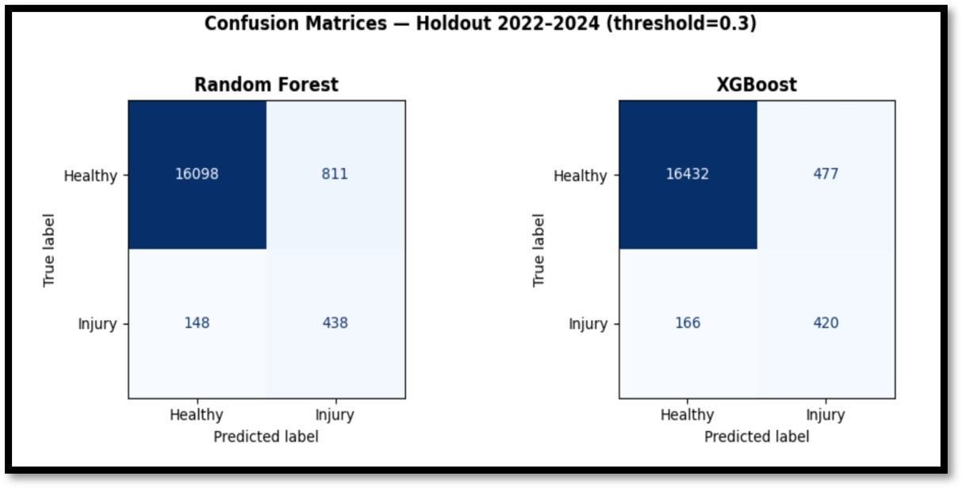
Figure 6: Confusion Matrix.
The default threshold of 0.5 missed too many real injuries hence it was lowered to 0.3 to prioritize recall, as not flagging an injury carries a far higher cost than a false alarm. XGBoost and Random Forest catch a similar number of true injuries, but XGBoost generates 41% fewer false alarms, meaning fewer healthy pitchers are unnecessarily flagged. In a real roster context, false alarms have a direct cost as resting a healthy pitcher affects game outcomes, making XGBoost the more operationally practical choice.
4. Discussion
Our project addresses the gap identified in previous research, which is basically the lack of a game-level, real-time injury risk model for MLB starting pitchers. Our results confirm that this approach is not only feasible but also produces a strong predictive performance, with XGBoost achieving strong AUC-ROC, F1 and MCC scores on the 2022–2024 holdout, exceeding the 0.66 AUC benchmark reported by Kusminsky, R., et al. (2024) at the season level. One of the most important findings of our project is that injury history is a far stronger predictor of future arm injury as compared to pitch-level fatigue signals, with the three most significant features capturing cumulative injury load rather than game-by-game mechanics, suggesting that pitcher arm health should be understood by cumulative workload and long term habits over time rather than a product of any single outing. Practically, this means that regardless of how their velocity is on a particular day, a pitcher who is recovering from an earlier arm injury and throwing far into the season is bound to an elevated risk profile, which directly affects how medical and coaching staff consider past injury history when managing workloads. Pitch-level indicators such as velocity drops and rolling workload contributed limited independent predictive value, suggesting that biomechanical signals are most useful when interpreted alongside a pitcher's injury history rather than in isolation, consistent with the broader sports science literature suggesting that biomechanical signals are best understood when interpreted alongside a pitcher's medical background, something that Statcast data alone cannot fully capture. The injury labels used are taken from MLB Injured List placement records, which is primarily a roster management tool rather than a clinical record, meaning some true injuries may go unlabeled, and our model was trained only on starting pitchers in the major leagues and should not be generalized to minor league pitchers or amateur athletes. Beyond these limitations, teams spend millions of dollars per year on pitcher contracts, and a single surgery can sideline a pitcher for two-three years, meaning a model that identifies elevated risk even a few starts prior to injury could provide teams with a meaningful window to adjust workload and modify pitch selection, and future research should investigate the integration of genuine biomechanical data, such as elbow stress readings from wearable sensors, with Statcast parameters to improve the prediction signal that pitch mechanics alone were unable to offer in this project.
5. Statement of Contributions
- Proposal - All group members
- Data Collection and Processing - Mohammad Shahid Mahmood and Priyankkumar Chandrakant Patel
- Modeling and results - Syed Amaan Ahad and Viraj Sheth
- Report - All group members
6. References
- Kusminsky, R., et al. (2024). Pitch-Tracking Metrics as a Predictor of Future Shoulder and Elbow Injuries in Major League Baseball Pitchers.PMC / American Journal of Sports Medicine. https://pmc.ncbi.nlm.nih.gov/articles/PMC11369970/
- Karnuta, J. M., et al. (2020). Machine Learning Outperforms Regression Analysis to Predict Next-Season MLB Player Injuries. Orthopaedic Journal of Sports Medicine. https://journals.sagepub.com/doi/full/10.1177/2325967120963046
- MLB Advanced Media. (2015-2024). Baseball Savant: Statcast Search. https://baseballsavant.mlb.com/statcast_search

